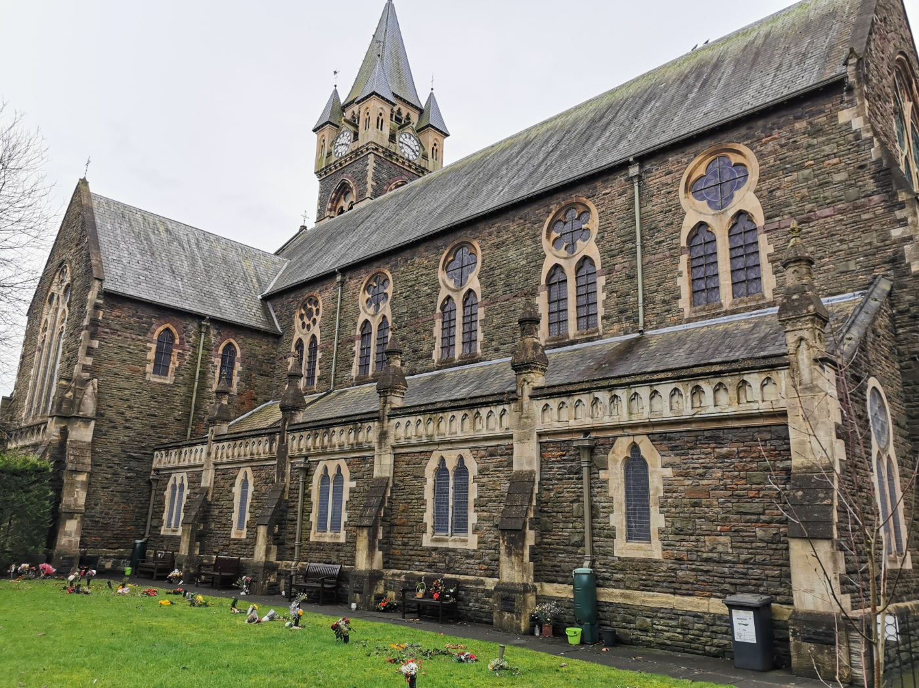

Architecture in your home town.

22 JAnuary 2021

History & Theory 1 (M4X01975)
Written by: Michelle Benalcázar.



Architecture in your home town.

A tale of two churches.

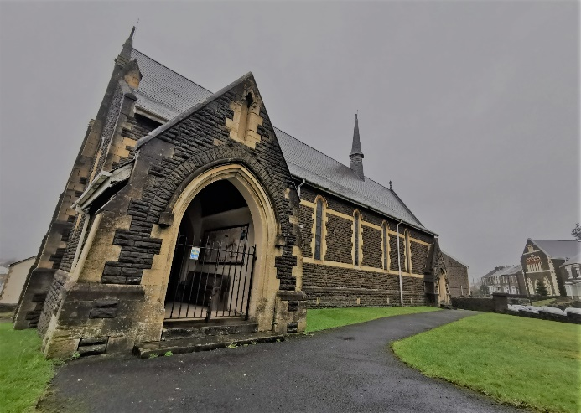  Image 1  St. Catherine  Photo by Michelle Benalcázar. | 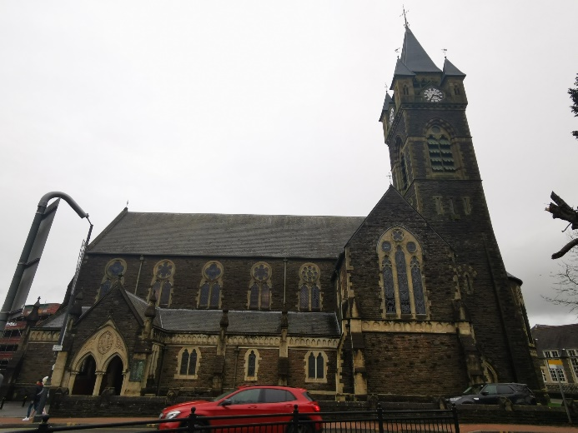  Image 2  St. David  Photo by Michelle Benalcázar.

For this essay I will be talking about two of the churches located in Neath town, they are: The church of St. Catherine and the church of St. David. Booth churches are built in the second half of 1800, they have the similar architectural style, and yet, they are very different from each other.

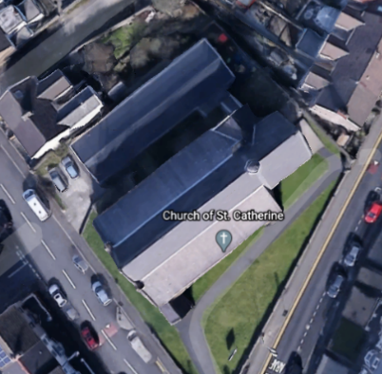
The church of St Catherine is been designed with an austere early gothic style by the architect J. Coates and the collaboration of D.M. Davies of Neath(1), built between 1888 and 1891 it opened its doors the 23th of April 1891 in the town of Neath(2), in the Melincryddan community, the simplicity of the church is because is located 10 minutes driving south from the town centre, surrounded by houses and a walking distance from the Melyn park.

It´s main entrance is situated south while the apse is facing North-east for an easy access from Old Rd.

Image 3

St. Catherine

Photo by: screen shoot from google earth.

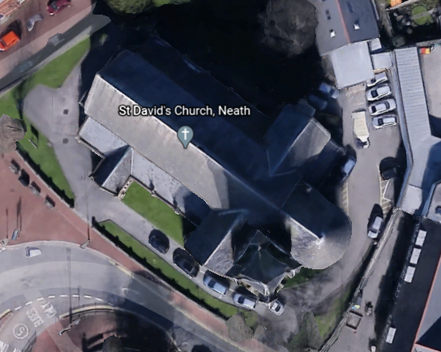
While the church of St. David was designed in a French gothic style by the architect John Norton of London in the years 1864 to 1866 in the centre on Neath town(3), becoming a focal point for the town, it´s surrounded by many points of interest like: the Victoria gardens located just in front of the church, the main bus station, the town council building and a primary school among shops, bars and restaurants.

The apse of the church is facing south-east while the main entrance is facing west for an easy access from the Victoria gardens or bus station.

Image 4

St David

Photo by: Screen shot from google earth.

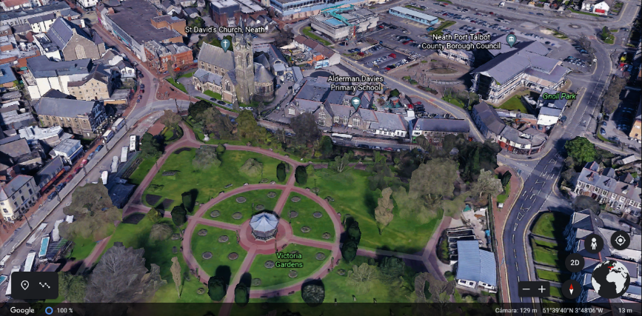
Image 5
St David
Photo by: Screen shot from google earth.

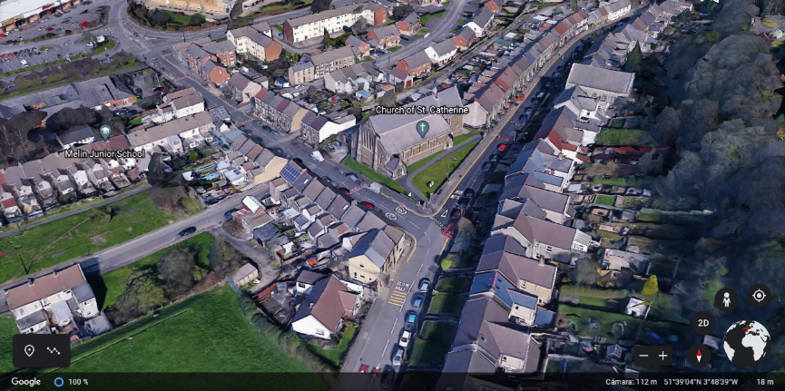
Image 6
St. Catherine
Photo by: screen shoot from google earth.
Despite of the two buildings being constructed in the last half of the 1800 and both having the same architectural style you can see a clear difference between them: St. David, because its location, in the middle of the town, has a more detailed and complex shape, it is clearly noticeable that more time and money has been spent in the construction of this church, than St. Catherine, that is located a bit further from the town centre and has a simpler character.
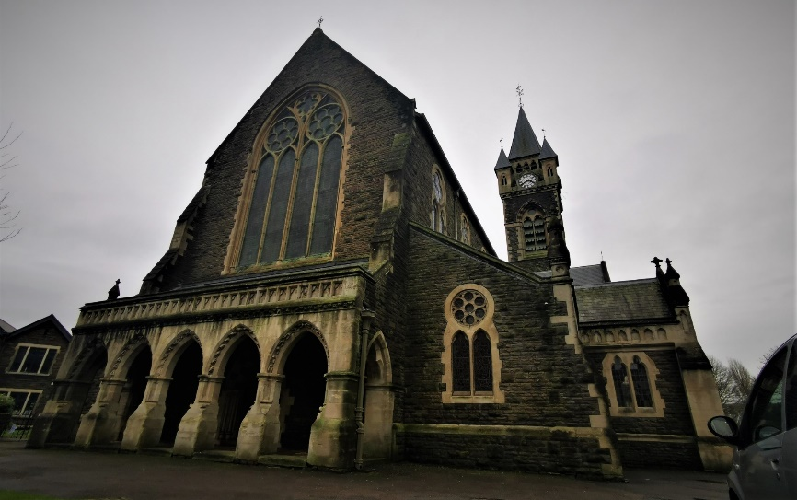
Image 7
St David church.
Photo by Michelle Benalcázar.

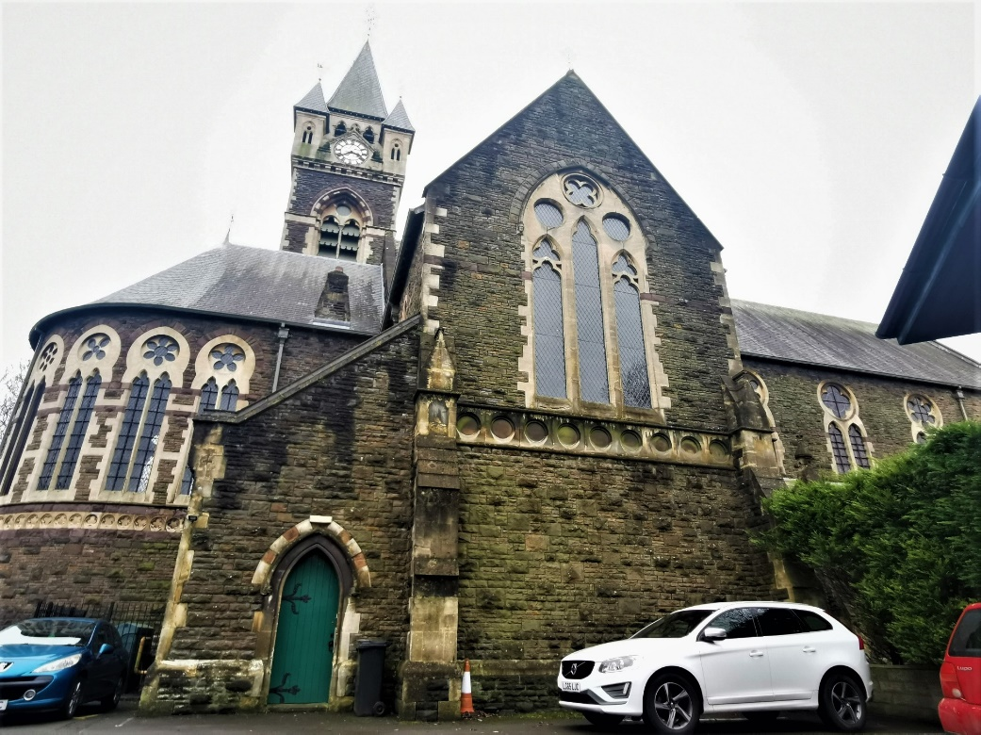
Image 8
St David church.
Photo by Michelle Benalcázar.

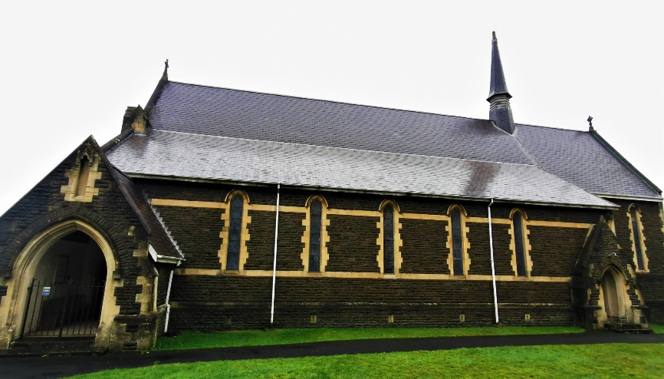
Image 9
St. Catherine
Photo by Michelle Benalcázar.

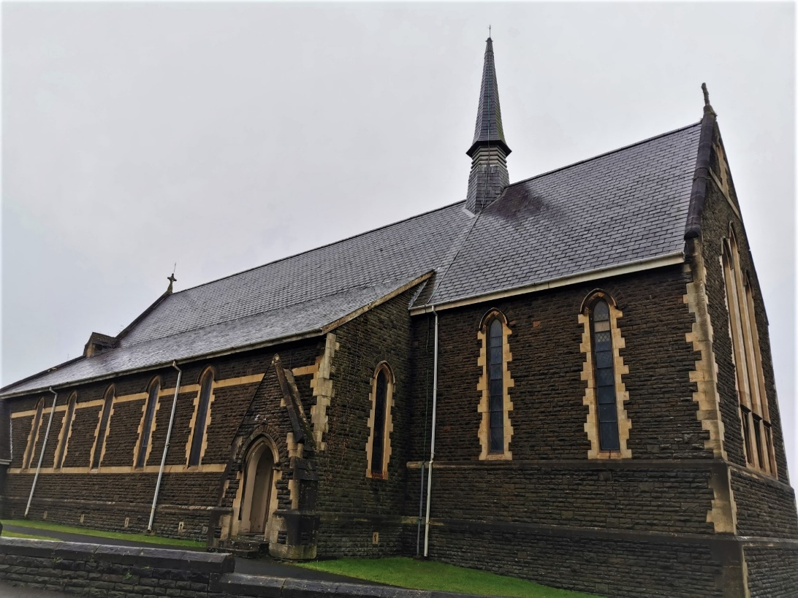
Image 10
St. Catherine
Photo by Michelle Benalcázar.

Some of the difference between these two churches are:
St David´s church has a cross shape with a nave, an apse, two transepts, and a clock tower by the right transept. (4)This church, has different styles of gothic windows, nonetheless all of them have stained glass. The windows along the nave and apse are two-light windows (13th century), the windows on the transepts are three-light windows the big window on the front porch is a simpler version of a geometrical Tracey (14th century) also all the small windows along the aisle on the ground floor are lancet; while, all the outside arches and the doors are equilateral arches with little decorations.
The main material of this edifice is stone. The windows, arches and buttresses are built with white stone to contrast the grey one of the exterior facade while the interior walls are decorated with red and blue bricks and to cover the roofs, slate was the best choice.
In the inside the doors are oak, the ceiling of the nave is a fine wood work, the walls and floors are highly decorated. In the main altar there is a series of small stained glass windows in honour of the ancient worshipers of the church(5). The choir wall is decorated with an oil painting "The Three Magi" and its pulpit is decorated with marble(6).
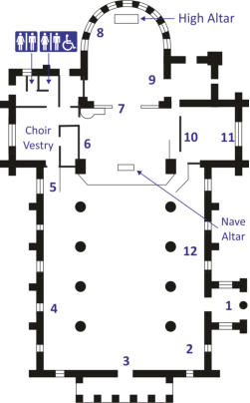
Image 11
St Davies plan
From the official web page

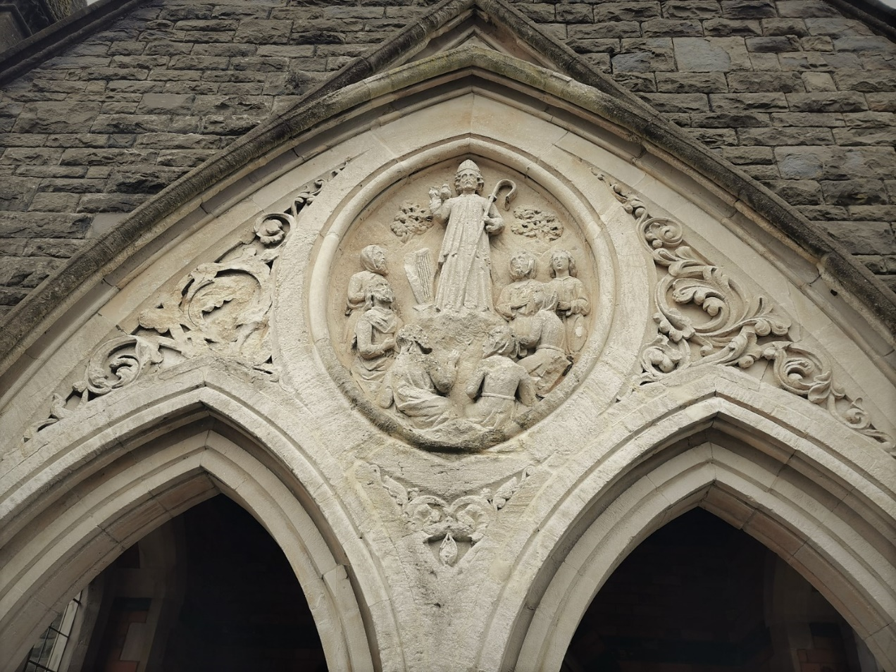
Image 12
St David.
Photo by Michelle Benalcázar.

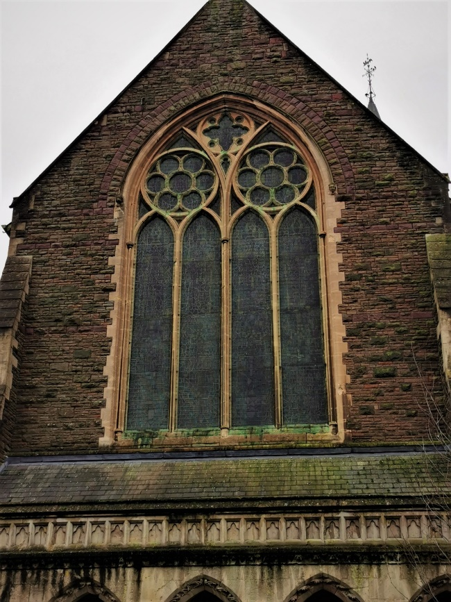
Image 13
St David.
Photo by Michelle Benalcázar.

St Catherine’s modest figure with only a central nave, apse, and two aisles makes it an unpretentious church. The windows along the aisles are Lancet (12th century) and the ones on the apse and front porch are three lance windows together(7). All of them have stained glass, meanwhile the main door as well as the other ones are equilateral arches with very little decoration.
The exterior facade is built with grey stone, the buttresses are made of a combination of grey and white stone, while the door and window frames have white stone, the window glass is stained glass and the entrance doors are made of iron, while the inner door has an oval moulding and slate is utilized to cover the roofs.
The interior is composed of 7 wooden bays with high stone bases; on the second level there is a ventilation system that works with arched wooden blinds. It has contemporary accessories such as: a granite pulpit, a stone presbytery screen with an iron rail(8).
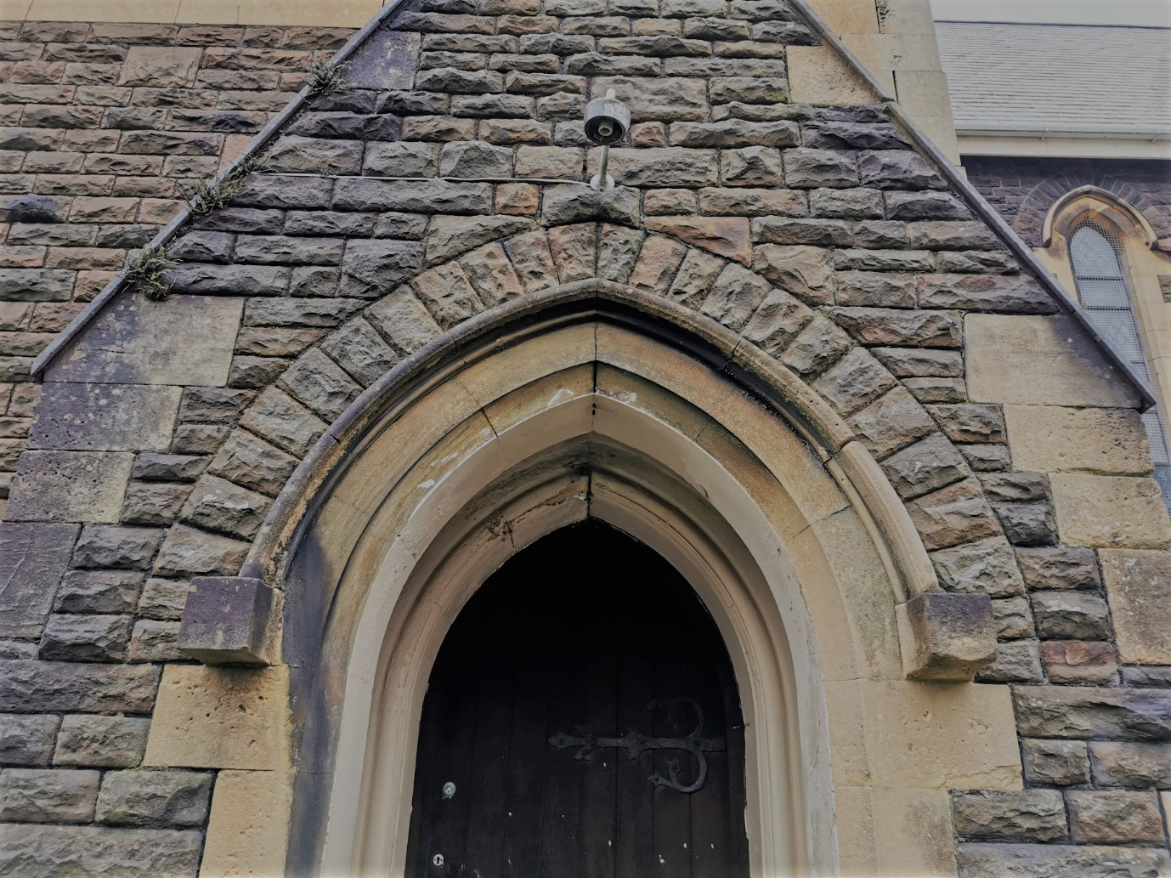
Image 14
St Catherine
Photo by Michelle Benalcázar.

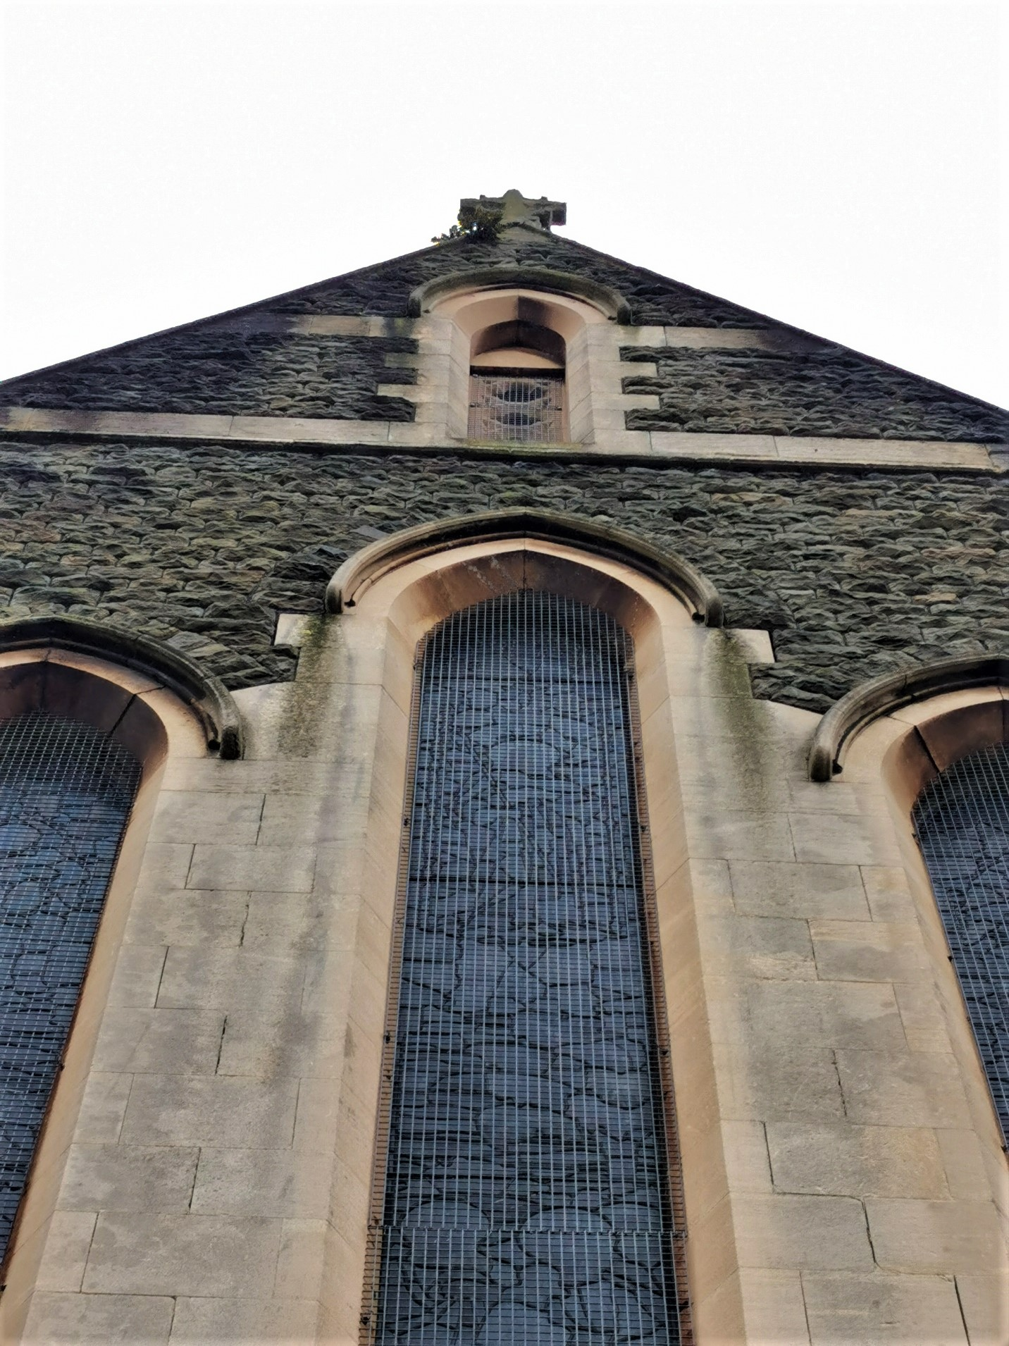
Image 15
St Catherine
Photo by Michelle Benalcázar.

The church of St David is one of the most popular churches in Neath, due to its location. There are masses several days a week, the village choir bands use it for their recitals and in the largest religious celebrations there is always something planned by the people of the church. People also use the church as a meeting point or as a point of reference, turning the benches in front of the church in a busy place in a beautiful sunny day.
Meanwhile. The church of St Catherine, being in a quiet residential area and almost on the outskirts of town, is a church a little ignored since the only people who pass through that area are the people who live there, even so, there is mass twice a week and a couple of choir bands use it for their practices.

In conclusion, these two churches are a clear example that it does not matter if they were built in the same half of the century and designed in the same style, what matters in order to create a successful design is to take into account where it will be built and what use is it going to be given to create the ideal design in each situation.

Reference list.
(1) Full Report for Listed Buildings. Description. History.
Listed Buildings - Full Report - HeritageBill Cadw Assets - Reports (cadwpublic-api.azurewebsites.net)

(2) The Church of St. Catherine. History of the Church. Line 3
The Church of St. Catherine (parishofneath.org)

(3) Full Report for Listed Buildings. Description. History.
Listed Buildings - Full Report - HeritageBill Cadw Assets - Reports (cadwpublic-api.azurewebsites.net)

Image 3, image 6 St Catherine. Screen shots from google earth,
https://earth.google.com/web/search/Neath/@51.65180812,-3.8105907,17.22416324a,166.10221946d,35y,0.00000001h,55.00354321t,0r/data=CigiJgokCcTW_tP_Z0RAEdNWRkL_NR5AGYzXb-ceKVJAIYQVakaNAlPA

Image 4, image 5 St Davies. Screen shots from google earth,
https://earth.google.com/web/search/Neath/@51.66189124,-3.80237439,9.20268575a,311.46853011d,35y,0.00000001h,55.00461413t,0r/data=CigiJgokCcTW_tP_Z0RAEdNWRkL_NR5AGYzXb-ceKVJAIYQVakaNAlPA

(4) Full Report for Listed Buildings. Description. Exterior
https://cadwpublicapi.azurewebsites.net/reports/listedbuilding/FullReport?lang=&id=11818

(5) Rectorial Benefice of Neath. The Church of St. David A History and Guide to the Church. Paragraph 5.
The Church of St. David (parishofneath.org)

(6) History points. St David’s Church, Neath. Paragraph 4
History Points - St David’s Church, Neath

(7) Full Report for Listed Buildings. Description. Exterior
Listed Buildings - Full Report - HeritageBill Cadw Assets - Reports (cadwpublic-api.azurewebsites.net)

(8) Full Report for Listed Buildings. Description. Interior.
Listed Buildings - Full Report - HeritageBill Cadw Assets - Reports (cadwpublic-api.azurewebsites.net)

Plan of the church. Rectorial Benefice of Neath. The Church of St. David. A History and Guide to the Church.
http://www.parishofneath.org/david.htm

