Assignment Title: Wellbeing in An Educational Setting
Student Number; 1708009
Module: Mental Health and Wellbeing
Module Code:
Lecturer: Ken Dicks
Date: 09/05/2019
Introduction

This essay will be discussing wellbeing in an educational setting and will be exploring how schools ensure the wellbeing of pupils while referring to the correct policy and legislation and attempting to name any acts or laws that have been passed that have helped make this possible, The assignment will be focussing on all schools in general rather than one specific facility and pinpointing any future developments that may be arising or may already be put into practice to maintain and improve the wellbeing of pupils of all ages whilst they start or continue their journey through education.

Wellbeing

The idea of wellbeing will be different for everyone, but in basic terms, it is a state of being comfortable and feeling at ease and happy in everyday life. Wellbeing is usually measured by how someone is feeling in a certain situation over a space of time, seeing as emotions and mental health and physical health can deteriorate from day to day and can also improve from day to day, usually depending on the situation an individual finds themselves in, how they are treated and also the people they surround themselves with will all have an impact on that individuals well-being. Past experiences can also affect personal wellbeing if someone has suffered from a bad childhood or a bad experience in earlier life, specific incidents or trauma this can have an extremely negative effect on their future wellbeing and their attitude towards wellbeing in general. Usually, in basic terms, a good state of wellbeing would be achieved by maintaining good social connections with family and friends, a good mental and physical health state, financial comfort and for a person’s basic needs to all be met.

Maslow Argued that in order to feel content in life, five simple basic human needs must be met, this is now known as Maslow’s hierarchy of needs (Pyramid of needs) which he proposed in 1943 after studying what he called exemplary people, such as Einstein or Roosevelt. The five needs Maslow argued that must be met are as follows and are the basis for most wellbeing plans today-

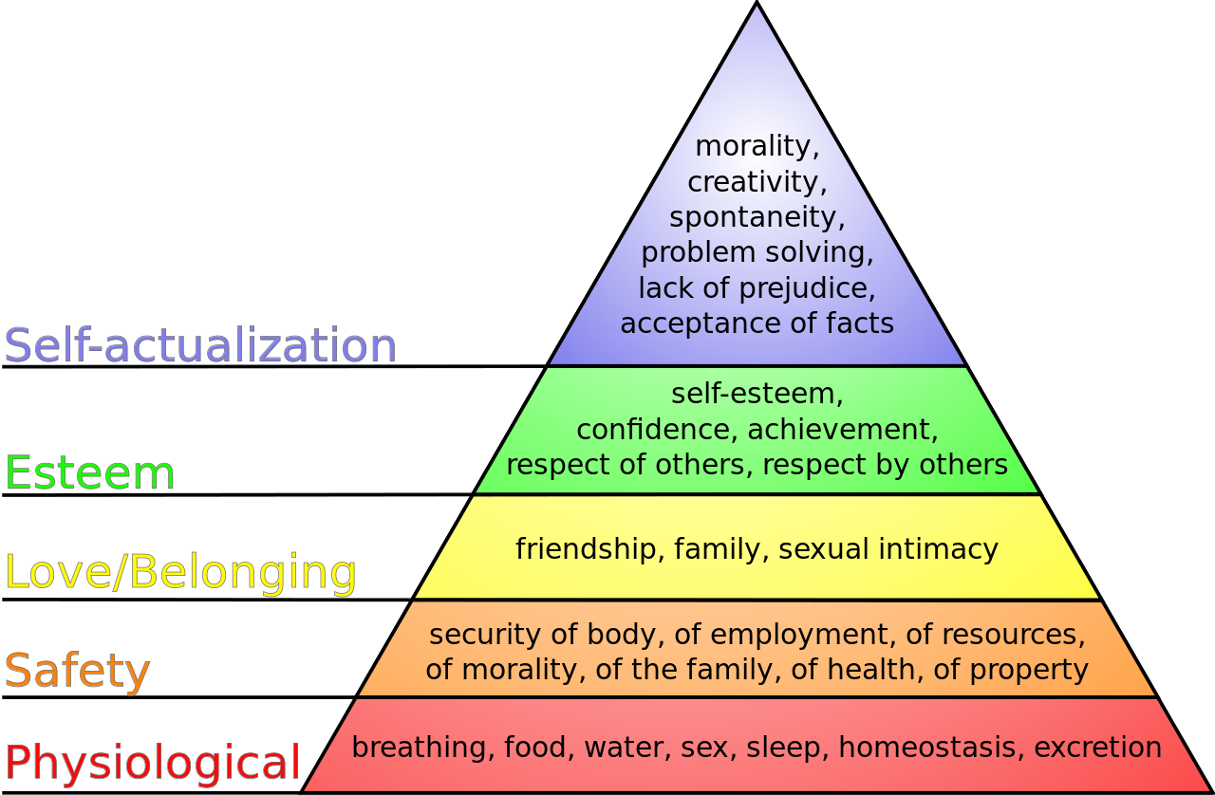
(Chinese University of Hong Kong, 2014)

‘Abraham Maslow argued that the failure to have needs met at various stages of the hierarchy could lead to illness, particularly psychiatric illness or mental health issues. Individuals whose physiological needs are not met may die or become extremely ill. When safety needs are not met, posttraumatic stress may occur. Individuals who do not feel love or belonging may experience depression or anxiety. Lack of esteem or the inability to self-actualize may also contribute to depression and anxiety’

(Good therapy, 2015)

Wellbeing in Education

Most schools will claim to priorities the wellbeing of their students, in Britain and elsewhere and many have taken essential steps to ensure wellbeing for pupils as they start their educational journey and to maintain it throughout by creating safe, healthy, happy teaching and learning environments. Schools have an anti-bullying policy and encourage students to talk about their problems at home and in the classroom setting and priorities the mental health of the children attending of all ages, backgrounds, and genders. The attempts to ensure the pupil's wellbeing isn’t always successful and some children have extremely unhappy experiences in school, which eventually damage their future wellbeing, whilst others flourish and would describe their school life’s as happy.

The education act was put into practice by parliament in the United Kingdom in 2011, making it the first major piece of education legislation to be introduced by the coalition government. The act changed many areas of educational policy, these changes included the power staff had to discipline students, how qualifications were regulated, changes to student finance in higher education, how teachers were trained and many more improvements to the way students are taught and the environments in which they are taught in. In section 175 of the education act, it states that schools have a responsibility to safeguard and promote the welfare of all pupils

What are schools doing to promote wellbeing?

‘According to research, there is a growing mental health crisis in British schools, with over 90% of school leaders reporting an increase in the number of students suffering from anxiety or stress over a five-year period and this is only expected to escalate as time goes on. It's estimated that the average individual spends more than 7,800 hours at school in their lifetimes so it's essential that they feel at ease in their classroom environments and schools usually provide this, whilst attempting to identify any mental or physical issues the child may be experiencing in the home or school life. With such added pressures on pupils nowadays to succeed in education, its essential that emotional wellbeing is prioritized in schools, Prominence is given to exams and academic attainment within the education system is evidently having a negative impact with over 80% of students reporting that exam pressure has significantly impacted on their mental health and as a result their wellbeing has suffered.’
(Amber Cowburn, 2019)

‘School years are key to developing social and emotional skills, knowledge and behaviors. This period sets a pattern for how a young person will manage their own mental health and wellbeing into adulthood. Notably, half of all lifetime cases of diagnosable mental health problems begin before the age of 1410. Whilst we know that one in three of all diagnosable mental health conditions in adulthood relates directly to adverse experiences in childhood11.
Despite this, school-related stress is a serious problem. A recent survey found that two-thirds of primary school children say they worry all the time about at least one thing to do with their home life or school life12. YoungMinds’ research with over 5,000 young people also found school stress to be one of the top five factors that contribute to their mental health problems13.
We also know the problem is getting worse. 90% of school leaders reported an increase in the number of students experiencing anxiety or stress, and low mood or depression, over the last five years14.
These childhood mental health problems can affect academic development, and often have long-term consequences for the health, social and employment outcomes of young people.
An ONS study found that children with mental health problems are less likely than their peers to gain academic qualifications, and more likely to have significant time off school, be excluded or get into trouble with the police15. Furthermore, a recent analysis of the British Cohort Study16 demonstrated that emotional health in childhood is by far the most important indicator of life satisfaction and personal outcomes as an adult.
The economic costs associated with an increased prevalence of emotional and mental health problems in children and young people are severe. NHS England estimates that poor mental health costs the economy, NHS and society £105 billion a year in England – roughly the cost of the entire NHS17. The cost of young people’s mental health problems has been estimated at £1778 per person per year, with 90% of the cost falling on the education system18. ‘
(Amber Cowburn, 2019)
Some schools have even introduced wellbeing teams, where they employ a group of qualified people whose main focus is wellbeing, there are some disadvantages to this unfortunately as there is an extra cost but the schools who have introduced the scheme have noticed improvements not only in academic performance but also student’s behavior in general.
Researchers followed schools with good wellbeing practices and ‘Curriculum opportunities for promoting wellbeing were planned for and mapped out. Consideration was given to the social, emotional and physical aspects of wellbeing. This involved teachers:
- nurturing student dispositions that support their learning (for example, persistence, identity as learners)
- teaching students how to support one another's learning (for example, by giving explanations and peer feedback)
- being seen by their students as caring about their learning (more than caring about them or simply liking them)
- demonstrating a caring pedagogy that values and honors diversity
- supporting student participation while engaging critically with students' views, ideas, and understandings
- using debate rather than assertion to resolve intellectual conflict
- organizing the environment (for example, grouping students and designing tasks) to develop inclusive learning communities.’
(Education Review Office, 2016)

‘The schools with good wellbeing practices had common themes in their approach to promoting wellbeing for all students and responding to specific wellbeing concerns and issues. The motivation to do better was underpinned by the desire for the school to be a good place for students. All of the schools focused on improvement for wellbeing.
The following themes were clear in the talk, actions, and approaches to wellbeing in the schools with effective practice:
- We can do better.
- Improvement focus.
- Recognizing the need for a balanced focus on wellbeing and achievement.
- Providing layers of support.
- Systems, people and initiatives ‘wrap around’ students.
- Making implicit school values explicit.
- Schools using restorative practices.
- We want the best for all of our students.
These schools had carefully developed a culture of wellbeing. They recognized the need to plan for wellbeing in the curriculum. Students in these schools had opportunities to show leadership and have their opinions heard and acted on. Each school had the right systems, people and initiatives to fit their culture and their needs.’
(Education Review Office, 2016)

Acts and Organisations That Promote Wellbeing

- Social services and wellbeing act of 2016
- The Education Act 2011
- The Social Action, Responsibility and Heroism Act 2015
- Localism Act 2011
- The Social Services and Well-being act (Wales) 2014
- The Well-being of Future Generations Act Wales 2015
- Wales We Want
- Children and Families Act of 2014
- Public Services Act of 2012
- National Planning Policy Framework
- Serious Crime Act

Education and local authorities In Wales

The education system in Wales and elsewhere are always trying to priorities pupil’s wellbeing, although this can be costly and have many failings along the way, the usual outcome is positive
‘Pioneering Welsh schools shared their experiences of embedding health and wellbeing into the new national curriculum at an event hosted by Public Health Wales.
The Health and Well-being in Schools event in Cardiff (21 May) brought together stakeholders from education, public health, the Welsh Government and the Third Sector to explore the role of health and well-being in schools and education reform.

Health and wellbeing are one of the six core Areas of Learning and Experience (AoLE) set out in the new curriculum for Wales for young people aged 3-16 and will be a separately structured part of the curriculum for the first time. This new perspective provides an emphasis on equipping young people for life, including through experience and skills-based learning.
The event introduced the Health and Wellbeing area and shared the progress of some pioneer schools in developing the new curriculum. Stakeholders were encouraged to continue the conversation around the integration of health and well-being into our education system, through a series of workshops.’ (NHS, 2018)

Wales are attempting a new curriculum, the Welsh Government has come up with a series of ideas and goals and the main focus of this is wellbeing, not only for education but for Wales in general. The Welsh Government explain the curriculum as the following:
‘Achieving the full benefits of Successful Futures for our children and young people, together with Teaching Tomorrow’s Teachers1, and the New Deal for the Education Workforce will require us all to engage fully and work together. It will be a collaborative process that will involve the teaching profession, Estyn, local authorities, academics, parents/carer’s, businesses and a wide range of other stakeholders, experts, and groups. To ensure we get it right, we will need to strike the right balance between proceeding at a pace so that the new curriculum is available as soon as possible, with our desire to develop the new curriculum in partnership with schools and other partners to ensure we get it right. As we move forward together the development of the new curriculum will be ›› evidence-led ›› based on subsidiarity ›› ambitious and inclusive ›› manageable, with pace, passion and professionalism ›› unified.’
(The Welsh Government, 2015)

Conclusion

Wellbeing for students in the educational system has certainly been prioritized a great deal more in the UK and other countries in the last decade even, but especially in recent years and most of the attempts to prioritize well being have been successful, but there are still many faults with the educational system as we know it. This isn’t always a fault that lays with the educational leaders, lack of funding is a massive downfall in this category and lack of support. The growing pressures on students to succeed in their academic studies is continuing to increase and their mental health seems to be deteriorating as a result, and with no plans to change the educational structure or to eliminate or make these exams any easier as of now, there is a risk that this downfall in mental health in young people may continue. A large number of pupils in schools all over the UK reported suffering from anxiety due to these exams, and although many schools are doing their utmost to promote wellbeing and also prioritizing mental health and how to recognize it, there’s still a long way to go. Bullying is also another crisis in education, some cases resulting in suicide and social media having a negative effect on any solution to bullying isn’t helping, once again schools claim to be doing everything in their power to stop this and have introduced anti-bullying policies but once again the result of these policies aren’t always a success unfortunately.

References

Abraham Maslow, Maslow’s Hierarchy of needs, Good Therapy (2015)
Available at:
https://www.goodtherapy.org/blog/psychpedia/maslow-hierarchy-needs
Amber Cowburn, National Children’s Bureau, Young Minds. (2019) Page 4
Available at:
https://youngminds.org.uk/media/1428/wise-up-prioritising-wellbeing-in-schools.pdf
Amber Cowburn, National Children’s Bureau, Young Minds. (2019) Page 7
Available at:
https://youngminds.org.uk/media/1428/wise-up-prioritising-wellbeing-in-schools.pdf

Chinese University of Hong Kong Motto, (2012)
Available at:
https://swonge.wordpress.com/2014/06/09/maslows-hierarchy-of-needs/
Education Review Office, Wellbeing for success: effective practices. (2016)
Available at:
https://www.ero.govt.nz/publications/wellbeing-for-success-effective-practice/schools-with-good-wellbeing-practices/
Wales NHS, (2018)
Available at:
http://www.wales.nhs.uk/sitesplus/888/news/48559

