DISSERTATION

AN ANALYSIS OF ISSUES AND CHALLENGES OF ROMANIAN IMMIGRANTS’ RECRUITMENT IN A WORKPLACE: A CASE STUDY OF GIST INTERNATIONAL

Student name: Ana- Maria Rizea
Student number: 1917143
Lecturer name: Mushfiqur Rahman

Abstract
Immigrants in the UK have been increasing after the lift of restriction, therefore, individuals from Romania are seeking job opportunities, economic feasibility, and many more. Based on that, the current research aims to identify the key issues and challenges that are being faced by GIST while recruiting Romanian immigrants.
Table of Contents
Chapter 1 5
Introduction 5
Aims and objectives of the research 6
Research question 6
Background of the study 6
Research gap and contributions 7
Rationale of study 8
Figure 1.6.1: Foreign-born population in the UK 9
Research of Outline 9
Figure 1.7.1: Research outline 10
Chapter-2: Literature Review 10
2.0 Factors affecting employee motivation regarding working with immigrants in the workplace 10
Figure 2.0.1: Factors affecting employee motivation regarding working with immigrants in the workplace 12
2.1 Challenges faced by local workers associated with working with immigrants in a workplace 13
Figure 2.1.1: Challenges faced by local workers in working with immigrants 14
2.2 Impact of immigrants on local workers within a workplace 15
Figure 2.2.1: Impact of immigrants in a workplace 16
2.3 Theoretical Discussion 17
2.3.1 Strategic Contingency Theory 17
Figure 2.3.1: Strategic Contingency Theory 17
2.3.2 Objective Factor theory of Recruitment 18
Figure 2.3.2: Objective Factor Theory of Recruitment 18
2.4 Literature Gap 19
Chapter 3: Methodology 19
3.1 Research philosophy 19
3.2 Research approach 20
3.3 Research strategy 20
3.4 Data sampling 20
3.5 Data collection method 21
3.6 Data analysis technique 21
3.7 Ethical considerations 21
3.8 Research limitations 22
Chapter 4: Data analysis 22
4.1 Thematic data analysis 22
4.1.1 Impact of recruiting Romanian immigrants over the business of Gist International 22
4.1.2 Issues arises during the recruitment of Romanian immigrants 23
Figure 4.1.2: Literacy rate in Romania 25
4.1.3 Challenges faced by immigrant workers within the Gist International 25
Chapter 5: Conclusion 26
5.1 Conclusion 26
5.2 Future scope of the study 27
References 28

List of Figures
Figure 1.6.1: Foreign-born population in the UK 9
Figure 1.7.1: Research outline 10
Figure 2.0.1: Factors affecting employee motivation regarding working with immigrants in the workplace 12
Figure 2.1.1: Challenges faced by local workers in working with immigrants 14
Figure 2.2.1: Impact of immigrants in a workplace 16
Figure 2.3.1: Strategic Contingency Theory 17
Figure 2.3.2: Objective Factor Theory of Recruitment 18

Chapter 1

Introduction
Immigrants are those individuals or groups of individuals who have permanently shifted to another country intending to seek shelter. As per Lombard (2019), there are different views regarding the shift of the people which are to find economic opportunities, persecution, trade relation, and many more. In the UK the number of immigrants seeking shelter or looking for job opportunities makes up 14.4% of the total population (Migration Observatory, 2022).
After the imposition of Brexit, highly skilled immigrants from Romania have thus shifted to the UK to look out for opportunities. The impact of Brexit and coronavirus has thus negatively impacted the well-being of Romanian immigrants in the UK. 1,067,200 Romanians have thus applied for the EU Settlement Scheme which assists them to be part of the UK and get benefitted from employment and different apprentices in the UK (Pulitzer Center, 2021). This also involves them with the additional benefits that the company can get accustomed to different skills increasing efficiency which can help them to increase the potential of its business. As per Sharfuddin (2020), democracy in the country allows them to have free will and the power is dependent upon the will of the people. UK democratic decision thus allows the immigrants to have a view regarding maintaining an equal right which focuses mainly on discrimination, job opportunities, and many more. Most Romanian jobs in the UK cover technical and construction jobs. This allows many Romanian immigrants in the UK to increase their potential physical and technical skills required for higher jobs. The inclusion of the UK’s Points-Based immigration system also allows the UK business to get accustomed to high-skilled workers, students, and a range of other specialist workers in their field and innovators (Assets, 2020). The point-based system allows the organisation to share draft Immigration Rules with potential shareholders to ensure the safety and the rights of the immigrants.
The points-based system also allows different possibilities in raising skills such as increasing the skill through effective training and accustoming the immigrants to the English language and other native languages which are being spoken in the UK. Sponsors' licenses are thus associated with this system which allows the company to benefit from different skill-enhancing programs and many more (Assets, 2020). The tradeable points thus allow the immigrants to increase their pay scale with the assistance of an approved sponsor for fair exposure in different companies. Therefore, the study highlights these challenges and the issues that were faced by GIST to recruit Romania Immigrants.

Aims and objectives of the research
Aims
The research aims at identifying the issues and challenges that are being faced during the recruitment process of Romanian immigrants in Gist International.
Objectives
- To analyse the key issues faced during the recruitment process by the Romanian immigrants in Gist International.
- To identify potential challenges during the recruitment process of Romanian immigrants in Gist International.
- To channelize the impact of recruitment of Romanian immigrants in Gist International.

Research question
- What are the key issues faced by Romanian immigrants during the recruitment process and the impact of the recruitment in Gist International?
- What are the potential challenges during the recruitment process of Romanian immigrants in Gist International?

Background of the study
GIST is one of the trusted end-to-end supply chain management which supports the deliverable of many SMEs in the UK. GIST is a UK-based supply chain and logistics company that supports the different business compliances in the places of supply chain network (GIST, 2022). M&S is now the sole owner of GIST and is now associated with supporting the logistics and supply chain transformation for Mark & Spencer. M&S, on the other hand, is one of the British multinational retailers in the UK. GIST, on the other, is the country leading logistics and supply Chain Company which had been disrupted due to the impact of Covid-19 as the country imposed a lockdown (GIST, 2022). The company is thus involved with maintaining and delivering the products and managing logistics in its business. GIST supply chain management is entitled to maintaining end-to-end transition in the company. The company also supports sustainability and fair practice in the organisation which allows them to recruit diversified employees according to the efficiency of their skills. GIST's mission value is oriented towards facilitating the transport and warehouse through quality assurance which does not only focus on the domestic but also the global market which allows them to design and optimise the work in the different international markets (Gist World, 2022). This allows the company to maintain global freight management between 70+ countries on exporting and importing products by air, road, and sea. The tailored and specialist handling helps the organisation to support different other companies in supplying the products to its potential customers at different points of contact. The company also follows a single point of contact to maintain simplicity in the higher service levels.
It can also be considered that the efficiencies of the management also help the organisation to support the entire level of management by having a broad spectrum of flexibility and visibility to maintain relationships and improve the efficiencies of their performance. As per Baharin, Kamarudin, and Manaf (2018), key skills help in efficiently managing the entire duties, developing problem-solving skills, and many more. Gist international is thus associated with recruiting talent who have prolonged key skills and knowledge of the work ethics in the organisation. The company has thus been focusing on increasing the skill-efficiencies in the places of HGV drivers, warehouse operatives, management functions, and many more. Thus the increasing number of Romanian citizens can be benefitted from getting recruited by Gist international which can also assist Romania with an opportunity to enhance the experience through the practical approaches to managing global freight. It can be observed that the number of immigrants from Romania to the UK has subsequently increased after the UK lifted the labour restrictions in 2014 (Romania Insider, 2021). This has provided an opportunity for GIST to recruit Romanian immigrants as the migration has the potential for a high-skilled labour market which has been in the public interest of many companies.

Research gap and contributions
The main purpose of the research thus identifies the potential issues of Covid-19 and Brexit that have been considered as the issue for hiring talents in Gist International. Since the gap involved in the study was considered to be lacking a presence of information on the current trade facilities and policies of the management and practice of Romanian immigrants in the UK for job facilities. The research signified the inclusion of an increasing number of Romanian immigrants for getting job facilities. Thus it can be highlighted that Gist International has been supporting the inclusion of various talents and diversified employees in the company which can manage the efficiency of the organisation. The global freight and site management thus ensured that the company has been potentially focused on logistics consultancy, communications, and different relevant knowledge. This has been beneficial for cities in England and Wales to add reinforcement which has been lacking due to the impact of the pandemic and Brexit which has resulted in increasing diversified employees. The study, therefore, signifies the importance of Bulk hiring in the Gist to support the trade facilities in the global supply chain.

Rationale of study
The cross-cultural issues in the organisation have also been the major focus that has been impacting the scale of employees in Gist international. As per Kifokeris and Koch (2020), the role of communication and cross-cultural management is considered to be an integrated part of managing the collaborative approach as it creates the opportunity to increase efficiency through collaboration. The company thus considers recruiting, developing, and retaining people who have efficiencies to adapt to the change in the organisation and supply chain management. Thus the company is involved with maintaining the combination of its people, technology and innovative approach which has been assisting the company to increase the speed and the quality of its services (Gist world, 2022). However, the company has been identified as potentially impacted by Brexit which has created a substantial impact on its management approach.
After Brexit, the global supply chain has been disrupted as the company had to cut ties due to the prevention of EU workers. Companies had to now consider immigrants from different countries which have been the major reason for the increasing cross-cultural issues in the organisation. The increasing level of skill efficiency Romania immigrants have benefited from such a skill-increasing and sponsorship-based system which is helping them to get fair treatment in the UK. Companies in the UK thus ensure that the company is offering fair treatment to each of its individuals and the company follows transparency and ethical practice to conduct the right policies in the company (Politico, 2018). Thus it can be identified that the companies in the UK considered giving fair treatment and diversity approaches in the organisation for valuing the interest of the immigrants working under them. The inclusion of Brexit has thus indulged many organisations to break ties with the different EU states which have also impacted the global supply chain management. The companies have a limited set of global supply networks with a limited number of employees managing the entire transition. This has been the major place for organisations to include immigrants in the global supply chain managing the entire functional characteristics and increasing the potential employee base.
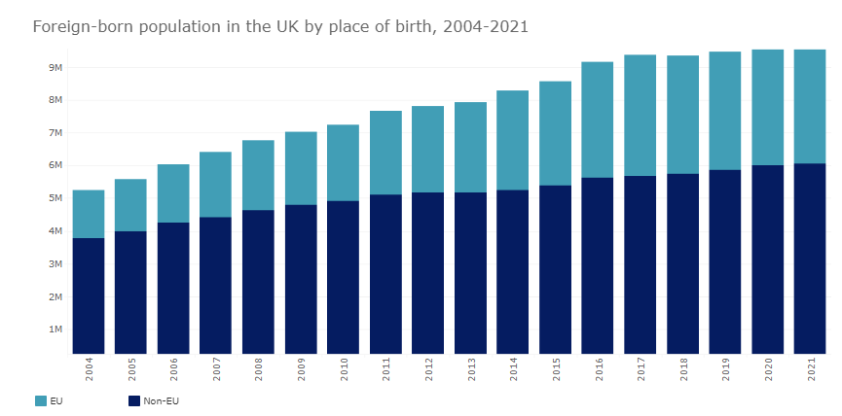

Figure 1.6.1: Foreign-born population in the UK
(Source: Migration Observatory, 2022)
This represents immigrants seeking long-term benefits to find economic stability and employment opportunity (Migration Observatory, 2022). Romania is ranked seconds for the highest foreign population in the UK which has mostly increased due to Brexit in the UK (Romania Insider, 2021). On the other hand, Romania immigrants have been beneficial for many companies to support the entire management functions. Many Romanian workers have thus flown to the UK to fill the labour shortage gaps in places such as agriculture, supply chain, and many more (Forbes, 2020). The immigrants are thus making for the seasonal EU workers who are prevented to travel in the country due to Brexit policies. The UK thus also has been prominently saving and securing the protection of the child support subsidies and employment benefits of the migrants in the UK. Thus the research shed light upon that the cross-cultural issues have been one of the reasons Romanian immigrants shifted to the UK.

Research of Outline

Chapter 1: Introduction

Chapter 2: Literature review

Chapter 3: Research methodology

Chapter 4: Results and Discussion

Chapter 5: Conclusion

Figure 1.7.1: Research outline
(Source: Created by the author)

Chapter-2: Literature Review

2.0 Factors affecting employee motivation regarding working with immigrants in the workplace
Immigrants are generally persons who are volunteered to settle down in a foreign country for certain purposes. Thus, there are various factors that might affect immigrants when switching their countries, lifestyles, and works. One of the major factors is the leadership style maintained in the new workplace as it explicitly impacts the motivation of the employees (Heng et al. 2020). A company with a good leadership style would be able to create a peaceful environment among the immigrants as well as the local employees. They have the ability to encourage workers to give their bests without facing trouble in adjusting, discrimination, and other inequal treatments from the staff of the company. In contrast to this, a poor leadership style would fail to maintain the expected work culture inside the organisation. As a result, the immigrants would lack satisfaction at their jobs, their interest would be reduced.
Moreover, both the local employees along with the immigrant employees should be treated similarly in the same workplace. The discriminated treatment providence can affect the mindset of the employees which would give rise to major difficulties in performing to their best abilities. However, the providence of proper appreciation to the employees for their good performances can end discrimination. This would give recognition to the employees based on their performances rather than their country or origin. Additionally, the meaning and purpose of the company play a crucial role in implementing the correlation between immigrants and local employees. Mutual intentions and objectives would help the local employees bond better with the immigrants in the companies. Whereas the company follows different purposes may face more discrimination among the locals and the immigrants. A positive infrastructure should be maintained in a company in order to control the cross-cultures. Hence, a positive culture in a business can also be accounted as a factor that influences the correlation between the local employees and the immigrants. If a positive culture is maintained inside the company the people belonging to different communities would be safe from the bullies and unethical treatment of the locals. Otherwise, inequality in work, difficulty in adjusting, language barriers, different lifestyles, and other cross-cultural issues would disrupt the performance of the immigrants positioned in the company.


Figure 2.0.1: Factors affecting employee motivation regarding working with immigrants in the workplace
(Source: Ali and Anwar, 2021)
In order to maintain equality among the staff often the companies use professional-level advancement and promotions based on the annual or monthly performances of the employees (Asaari et al. 2019). This helps motivate the employees in their jobs by providing individual purposes and job security. Other than that, the financial benefits impact the correlation between the immigrants and the locals as well. As Piyapromdee (2021) stated, in a workplace where the immigrants are getting appreciation and wages similar to the locals, a good and equal environment can be seen in those places. Whereas the place where bonus and incentives are only provided to the locals and salary discrimination tend to be notable, the connection and communication rate among the staff are seen less there.

2.1 Challenges faced by local workers associated with working with immigrants in a workplace
The local workers often encounter a multitude of challenges associated with the correlation with immigrants of the company. The challenges directly affect the business’s outcomes as well. As Oltean and Găvruș (2018) claimed, due to the different communities, lifestyles, and cultures the local employees intentionally or unknowingly fail to build trust and communicate or connect well with the immigrants. Thus, loads of misconceptions, and misunderstandings can be seen among them. The reason behind this can be counted as the barriers between cultures, languages, and other differences. Language barriers can lead to miscommunications or no communication at all (Li et al. 2018). Hence, the immigrants fail to convey their perceptions as they are unknown of the local language. This would gradually make them feel uninvited in the groups of local employees. Moreover, the immigrant might follow different cultural activities or perceptions than the locals. This makes connection development even more impossible. Hence, the company often fails to provide them job satisfaction to the locals as well as the immigrants due to cultural differences. Baldo (2019) stated that every country has different education policies and these differences in individual education levels often create a challenge inside the company. This might make the immigrants feel less knowledgeable about their job in some aspects. However, it impacts negatively their reputation towards the local employees.

Challenges

Educational
barriers

Cultural
barriers

Diminishing
opportunities for the local employees

Figure 2.1.1: Challenges faced by local workers in working with immigrants
(Source: self-developed)
Apart from that, the local employees often seem to feel that they are lacking opportunities due to the arrival of immigrants. The wages are similar to the immigrants who joined newly in comparison to the local employees who are born in the origin country of the company. This demotivates the employees and makes them feel unappreciated. The immigrants are often seen with poor in knowledge in comparison to the locals yet they waged the same as the skilled locals (Kaushik and Drolet, 2018). Moreover, due to language barriers, the locals hesitate to communicate with the immigrants. This limits them to share their perceptions and including the immigrant's point of view while working as a team. Hence, both of them fail to represent their best qualities as their abilities are being restricted due to certain barriers. Moreover, the immigrants are provided additional services and facilities regarding their living, food, and financial issues from the country which has tended to become a major concern for the local employees. The immigrants even after joining a company later, get similar wages as the local workers. As Villazor and Johnson (2019) claimed, the local workers seemed to have a lack of communication with the immigrants as according to them the recruitment of immigrants is limiting work opportunities for the local employees. In concern to that, the rising number of immigrants has evaluated a questionable state for the local employees. The local workers are losing job security and job opportunities seem to be diminishing for them.

2.2 Impact of immigrants on local workers within a workplace
The emergence of immigrants impacts local workers in multiple ways. Immigration allows the company to input diverse workforces in their companies (Dale-Olsen and Finseraas, 2020). As a result, the local employees are open to various cultural norms and differences that impact both negative and positive in their behaviours. Being open to diversity implements multiple changes in organisations among them the smart changes and perceptions mentors other for the wellbeing of the company. In such cases, the local employees also seem to adopt the positive sides of workplace diversity. The diverse workforce also brings creativity that boosts the experiences and confidence of the local employees. As Delgado Ozgen (2021) stated while working as a team the workers might come up with different and unique ideas due to working with people from different diverse. However, the differences can cause high discrimination as well which often becomes stressful for the local workers. As per Gómez-Flors and Alguacil (2018), the good performances of the immigrants lead the workplace to a competitive edge where the locals always tend to compare themselves with the immigrants. Due to the continuous appreciation of the immigrants, the locals feel unvalued and often stressed about their job positions. They lose their job security due to the increasing number of immigrants which creates work tensions among them. Eventually, the work tension disrupts them by communicating or helping the immigrants and the teamwork in a company thus seems to disappear.
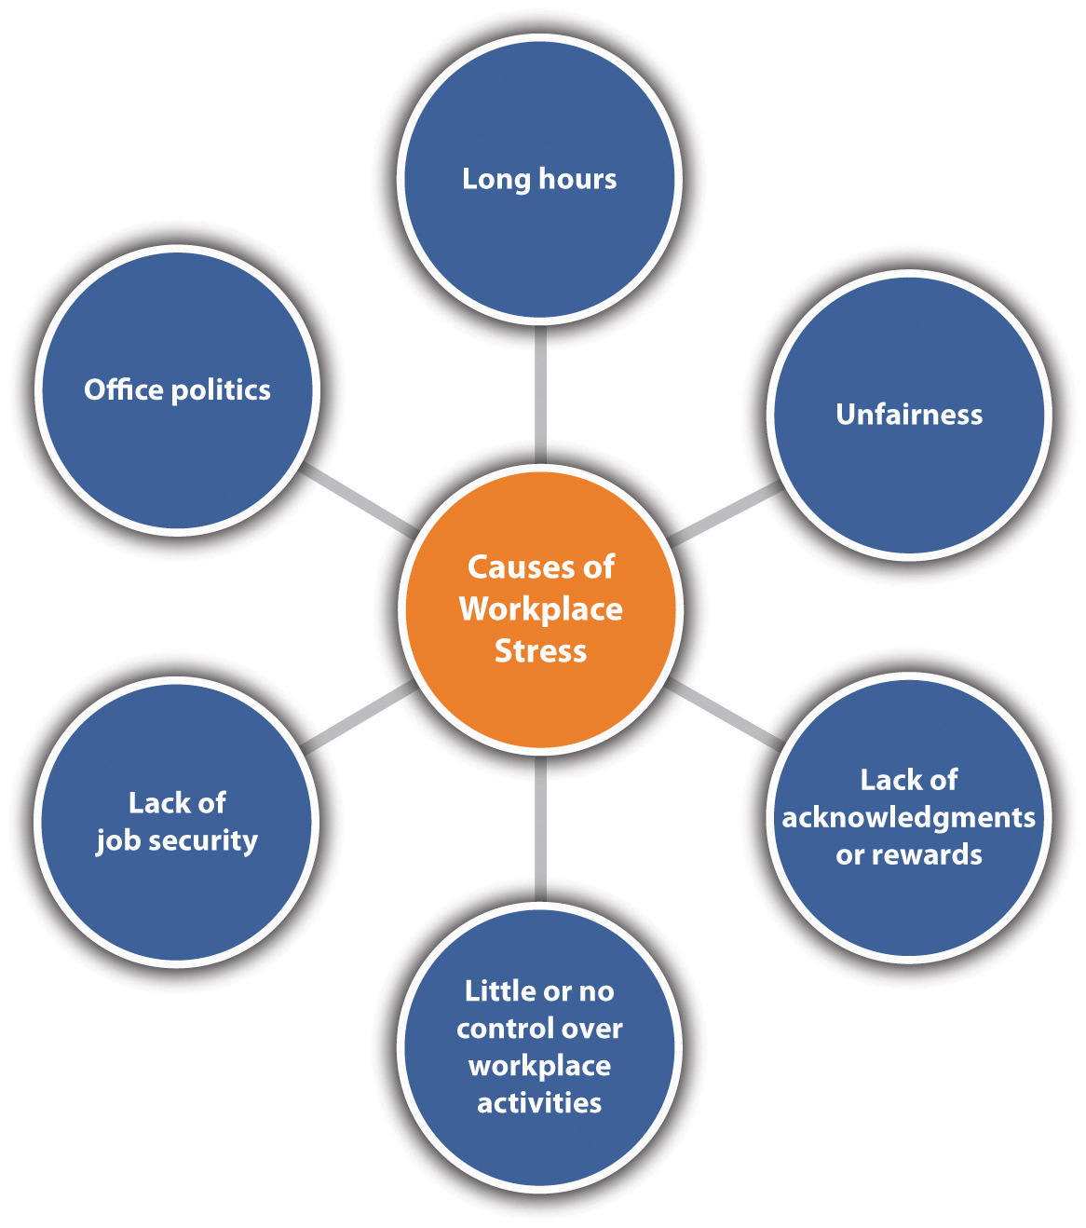

Figure 2.2.1: Impact of immigrants in a workplace
(Source: Drydakis, 2022)
The consequences also lead to the reduction of opportunities for local employees. As per Ayón (2018), the hiring of immigrants is continuously increasing as the company gets to save operational costs by hiring employees with low payoffs and similar qualified and skilled as the locals.
The hiring of immigrants in higher ranges thus resulting an increment of jobless local employees. Moreover, immigrants are getting provided with all the financial opportunities and benefits whereas the local employees are facing salary cut-offs (Drange and Helland, 2019). This is also impacting the job security of the local employees. Hence, the situation can be controlled by reducing the dependency on immigrants for companies and implementing opportunities for local employees so that an equal work environment can be executed.

2.3 Theoretical Discussion

2.3.1 Strategic Contingency Theory
The strategic contingency theory emphasises the ability of a leader who is evolved with the central part of the organisation to solve organisational issues by applying his/her own skills and ideas. As per Safari and Saleh (2022), the contingency theory is the most accepted theory because of its simplicity as it strictly focuses on the usage of the centralised power of an organization, and contingent variables by eliminating the leader’s personality.


Figure 2.3.1: Strategic Contingency Theory
(Source: Abba et al. 2018)
The theory has been used in this particular piece as it illuminates the responsibilities of the leader in developing a safer place in their organisations for immigrants. The effectiveness of a good leader reflects in the organisational environment (De et al. 2018). Thus, it is the leader’s responsibility to ensure an equal workplace without any discrimination while assuming organisational certainty. Moreover, the theory believes that the leaders are the ones who not only organise a corporation and make the decision but also lead the entire organisation to take actions contingent upon the situation. Thus, the theory would be favourable in application to the organisational benefits as this would make the leaders take initiative actions and encourage the whole organisational departments to imply more acceptance towards the Romanian immigrants.

2.3.2 Objective Factor theory of Recruitment
As Geetha and Bhanu (2018) said, the objective factor theory portrays the belief that the applicants are rational and thus, rationality can be exercised after an assessment objective that would tangibly benefit the company. Here, the theory is mainly applied by the managers and HRM of the company who are associated with the recruitment process. The theory is preferred by them as it helps them identify the necessary potential in the immigrants and offers them job opportunities.
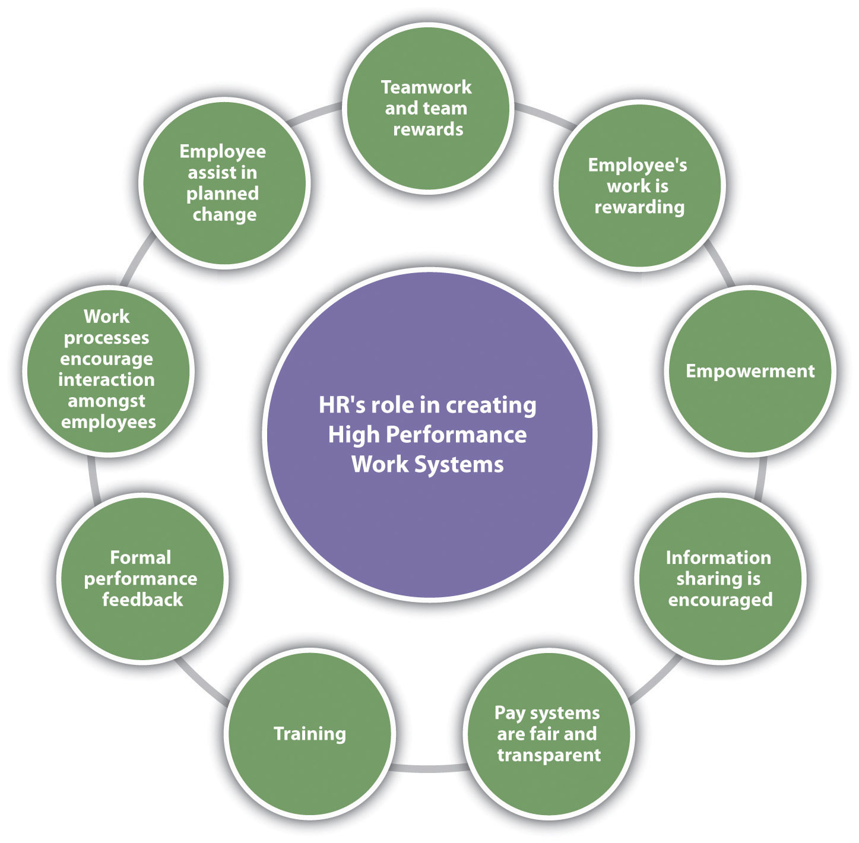

Figure 2.3.2: Objective Factor Theory of Recruitment
(Source: Tumasjan et al. 2020)
The recruitment factors include opportunities, benefits, salary, location and career advancement (Hamza et al. 2021). Hence, the HRM of the companies uses this theory to provide the necessary employee needs to the Romanian immigrants as well as local employees. This also implements a fair recruitment process to develop the work culture to ensure a mutual goal for all the employees. Thus, the practice of these theories clarifies the objective of recruitment that revolves around the identification of the required qualities, streamlining the hiring processes, encouraging the development of leadership, and improving the perception of the company and others. In this perspective, the organisation thus succeeds to recruit skilled immigrants who would be able to cope with the local employees and work for emphasising the profit of the organisation.

2.4 Literature Gap
The above review has integrated the factors influencing the workplace where immigrants and local employees work together, which are the leadership styles variants, recognition, financial support, professionalism and others. The chapter has also shown that the maintenance of the factors can provide a safe and secure job for both of them. Additionally, from the review, the researcher came across some issues that local employees often face while working with immigrants. The disability to adjust and miscommunication due to different barriers are the potentials of causing misunderstandings among the workers. Moreover, the existing literary sources also depicted the challenges faced by immigrants while working in a domestic work culture in a host country. However, they have not analysed in an in-depth manner the mitigating strategies of those challenges. Hence, this research focused on critically analysing those challenges and also provided mitigating strategies for operating in the domestic work culture within a host country.

Chapter 3: Methodology

3.1 Research philosophy
Research philosophy is the most essential element of research methodology. Research philosophy is a tool that focuses on how a researcher interprets data using a variety of religious and philosophical notions (Hürlimann, 2019). Although research philosophy has three parts like ontology, epistemology and axiology, the researcher has opted for ontology research philosophy in order to analyse the issues and challenges associated with the recruitment of Romanian immigrants in Gist International in an objective manner while epistemology and axiology is mainly used in the studies based on subjective or holistic viewpoint. Eventually, this particular philosophy has proved positivism as the most suitable paradigm for this research.

3.2 Research approach
While research philosophy stands for reflecting the philosophical assumptions of a researcher, research approach stands for the plans and procedures partakes in spanning the broad assumptions into actions (Roos et al. 2020). The analysis of Romanian immigrants recruitment challenges for Gist International opted for deductive approach since as compared to inductive approach, deductive approach is more flexible in understanding the relationships between the concepts and variables.

3.3 Research strategy
The general design of a research project is embellished as the research strategy in the framework of research methodology (Sovacool et al. 2018). Amongst so many like descriptive, explanatory, correlational, this study has employed exploratory research strategy for the purpose of deducing distinct variables of the study and obtaining an in-depth understanding of the identified research problems and objectives.

3.4 Data sampling
As per the statement of Sawangarreerak and Thanathamathee (2020), data sampling is included in the modern research methodology as it is a useful process of filtering required data from a large population in order to find the best solution of research problems. Although the concept of data sampling technique introduces a number of relevant techniques, this specific study is able to collect the sample of data adequately with the help of random probability sampling. This particular method of data sampling increases the validity of this study by avoiding the risk of biases and systematic errors. Under the prevalence of this technique, the researcher is permitted to acquire data from 10 to 12 relevant journals and articles only, filtering them by the date of publications from 2018 to 2022.

3.5 Data collection method
Considering data as the main foundation of a research, data collection technique has become a quintessential component of modern research methodology. In the views of Taherdoost (2021), data collection is an essential process of research since it involves researchers to retrieve data from various sources and measure them for finding an optimum solution of the concerned research problem. In general, the data collection technique is classified into two prime segments and those are primary and secondary data collection methods. However, in an attempt to analyse the issues and challenges arising in the process of recruiting the Romanian immigrants at Gist International, the researcher has been found to be relying on the secondary data collection method since it is acknowledged to be more effective compared to the primary one in this case. While the primary data collection method is quite expensive and time- consuming at the same time, the secondary data collection method has helped this study to reach the completion within the stipulated time by avoiding a lot of expenses.

3.6 Data analysis technique
Data collection is not at all sufficient for a complete research since an accurate analysis of collected data results in better data interpretation that further helps in concluding a study with better findings and optimised solutions. As per the statement of Fauzi and Pradipta (2018), the technique of data analysis is mainly bifurcated into two parts such as statistical data analysis and thematic content data analysis. Since, the method of data collection generally determines the adoption of the appropriate data analysis technique, this study is supposed to rely on thematic content analysis according to the secondary data collection method. Under this method, the research is responsible for generating several themes through which different perspectives of various scholars regarding the issues and challenges of recruiting immigrants can be examined in a critical manner.

3.7 Ethical considerations
Ethical considerations are considered to be a significant element of modern research and thus, it has been deeply integrated into the concept of research methodology. In the course of conducting research, several scope arises where data misinterpretation and plagiarism can take place. As per the statement of Liebe and Hunter (2021), ethical considerations are embraced in the form of various principles and guidelines that provide an accurate shape to the designs and applications of various methods for reaching accurate findings. Hence, it can be said that being an integral part of research methodology, ethical considerations influence the researcher to maintain the principles of Data Protection Act 2008 and also to properly cite the works and opinions of other scholars derived from existing academic articles and journals as well.

3.8 Research limitations
Considering the importance of adequate management of recruiting foreign workers, this specific research is thoroughly involved in analysing the issues and challenges of recruiting Romanian immigrants within the workplace of Gist International. However, there are several limitations such as time and budget constraints that have been found for delimiting the success rate of this study. There is a strict deadline within which this study is supposed to draw an optimum conclusion and thus, a secondary data collection technique has been adopted. On the other hand, due to strict budget constraints, the researcher is unable to get access to paid journals and articles. Eventually, the overall quality and findings of the research have been forced to be compromised.

Chapter 4: Data analysis

4.1 Thematic data analysis

4.1.1 Impact of recruiting Romanian immigrants over the business of Gist International
Gist is generally embellished as a UK-based logistic company that is currently running as a part of one of the leading retailers of the UK, Mark and Spencer (Gistworld, 2022). Interestingly, this company is also found for expanding its business boundary across the global market chain and thus, the recruitment of foreign immigrants beholds major implications over the business. In the view of Kühn (2021), recruiting foreign immigrants not merely strengthens the organisations to get an easy access to the pool of international talents, yet it can be considered as another significant way of encountering new markets at the same time. Most significantly, hiring foreign immigrants reflects the tendency of GIST’s human resource management regarding the consolidation of the entire workforce with cultural diversification and a profound knowledge-base. Since Romania is a country located in Southern Europe, the local employers and also the employees are able to become acquainted with the religion and culture of Romania and a positive communication and frequent interaction can be even more effective in spreading new skills and perspectives across the entire workforce. Mergener and Maier (2019) posited that immigrants with various experience is more effective in terms of further growth of a business since this aspect provides beneficial results in increasing the overall problem solving capabilities of the workforce in a faster and effective manner. Hiring Romanian immigrants deeply impacted the standard of productivity and also the profit margin of GIST explicitly. Romanian immigrants with different skill-sets not merely predominant for reducing the negative impact of vulnerable labour market status in the UK, yet also helps GIST in heightening its profitability by facilitating 24*7 logistics services and satisfying clients with favourable services. However, this company is currently seen struggling to recruit Romanian immigrants due to the arousal of several issues and challenges in managing the diversified workforce.

4.1.2 Issues arises during the recruitment of Romanian immigrants
Although the idea of recruiting Romanian immigrants seems to have majorly positive impacts on the business of GIST International, there are a number of issues being highlighted for creating a huge hindrance in the overall recruitment process and making the recruiters highly concerned about such a crisis. Some of the issues arising during the recruitment of Romanian immigrants are given in the following.
Less human contact
Romanian immigrants are the foreign workers for the UK establishment, GIST international. As per the statement of Wolff and Burrows (2021), the advent of modern technology and growing practices of digitalisation has already made the hiring of foreign workers feasible and effective for modern recruiters so that the business organisations can remain productive, profitable and competitive at the same time. However, it is worth mentioning that online or virtual recruitment removes the significant scope of human contact. Chaisson and Ashton (2021) argued that in the absence of human contact, the employers fail to assess foreign applicants based on their expressions and body languages. Like many other organisations, GIST International also recruits Romanian immigrants based on their online assessment as the companies are unable to afford their individual travel expenses and eventually face severe issues in recruiting talented employees with right knowledge, skill-sets and positive body languages.
Decreased job opportunities for locals
It is believed by maximum recruiters and organisations that the international labour market consists of different skill-sets and experience that can be adequately beneficial for modern businesses and their further growth. The GIST International is not at all exceptional and thus, this organisation is currently focused on drawing the attention of talents massively from international labour markets, specifically of Romanian immigrants. In particular, it can be said that the UK business market is highly diversified and thus, it continues to invite foreign immigrants to be a part of it. However, in this scenario, the local job seekers are seen to struggle for better job opportunities as this process is highly criticised for decreasing the job opportunities for locals.
Vulnerable labour market
There are several reports carrying out the evidence that Romania has a higher literacy rate. As per the reports documented in 2018, the overall literacy rate in Romania is estimated up to 98.60% which is quite higher as compared to some other countries like Mexico, China, Albania and others (Macrotrends, 2022). However, lack of techniligical knowledge, rather poor technical skills makes the labour market of Romania somewhat vulnerable. Being a part of the UK logistics sector, GIST is able to take the maximum advantages of modern technology and remain innovative and competitive at the same time. While Romanian immigrants with poor technical skill-sets require extensive training in technology and generate crises in the recruitment process of Gist International.
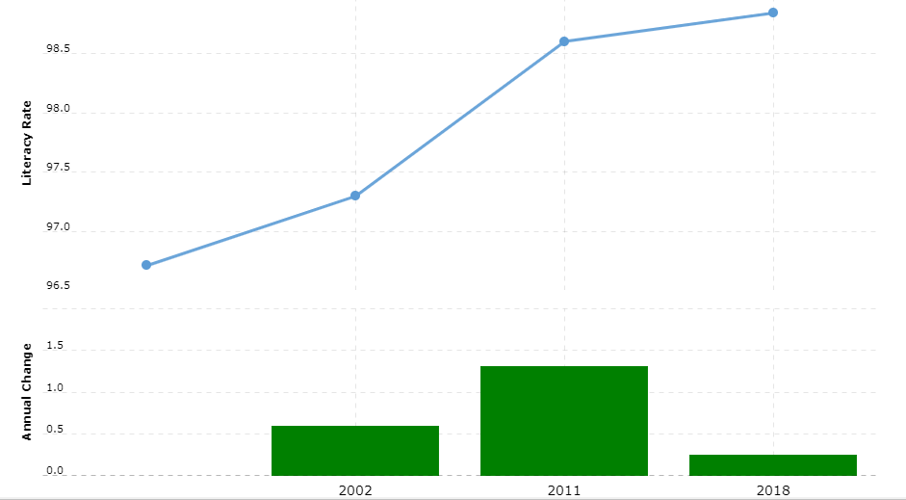

Figure 4.1.2: Literacy rate in Romania
(Source: Macrotrends, 2022)

4.1.3 Challenges faced by immigrant workers within the Gist International
Not only the issues arising across the recruitment process of GIST and drawing the major concern of the recruiters and local job seekers, but this process often creates challenges for the immigrant workers as well. Some of the noticeable challenges are as in the following.
Global payscale
As per the statement of Ali et al. (2022), while payscale indicates the salary range of an employee, global pay scale determines the amount of wage is determined to be provided to the employees of an organisation according to the job role and positions in the organisation. Following the migration in the UK, the Romanian immigrants are able to increase their financial security by being associated with several UK based organisations. It is undeniable that the standard of payscale in the UK is quite higher than any other country. However, they are getting the wages similar to the local employees in return while the standard of living and household expenses are quite high in the UK as compared to Romania.

Communication
Communication plays an important role in every successful business management. However, Shepherd et al. (2019) highlighted that in the culturally diversified workplaces, the adequate practice of communication can be postulated as a major challenge. In the case of GIST, the presence of different accents in the language highlights the lack of confidence within Romanian immigrants while communicating with others and even in sharing their insights regarding various problems and discussions. In fact, such communication challenges often lead the Romanian individuals to lose their intrinsic motivation of working with a renowned logistics company, GIST.

Chapter 5: Conclusion

5.1 Conclusion
After studying the entire literature that mainly highlights the issue and challenges of recruiting Romanian immigrants across GIST International, it is understood that GIST is identified to be one of the renowned and globally leading supply chain and logistics brands continuing to grow in both the UK and global business market. Currently, this company is successfully running its business under the ownership of Mark and Spencer. It is evident that being a part of the UK business sector, GIST is powerful in attracting a massive number of foreign immigrants with better employment opportunities as well as financial stabilities. As per several reports, Romania has ranked in the second position in terms of foreign population migration and the number is even more increased following the Brexit movement. Notwithstanding, the in-depth analysis of the case study of GIST International sheds light on the findings that following the largest Romanian population has motivated this leading logistic company to hire Romanian immigrants and consolidate the workplace culture with huge diversification and inclusion. In this regard, it is worth mentioning that such an initiative is supposed to have a massive impact over the business of GIST. Following the hiring of Romanian immigrants, GIST International has gained a number of positive results such as this company has been successful in strengthening its workforce with international talents that have distinctive knowledge, skill-sets and experiences. This aspect is not merely beneficial for increasing the problem solving capabilities of the GIST workforce, but also increases the scope of profitability by encountering new markets as well as the client base. However, in recent days, the company is facing some issues while recruiting Romanian immigrants and managing a diversified workplace. Oftentimes, the modern recruiters are preferring to conduct online interview sessions for the purpose of saving time and money at the same time whereas on the other hand, the assessment remains ineffective in respect to expression and body language. Lower rate of technically educated laborers and less job opportunities for local job seekers have become another issue as a result of immigrant recruitment.

5.2 Future scope of the study
The increasing issues and challenges of recruiting Romanian immigrants across the Gist International has driven this study to be concerned about such phenomena that eventually conduct an informative research. During this research, all the essential data required for this study have been collected relying on the secondary data collection that only permits researchers to get access in the existing literature consisting academic journals as well as newspaper articles. However, inadequate presence of information relevant to the concern seems to highlight a clear void in the existing literature which is likely to be reduced with the help of further thematic data analysis. Yet, the future scope of this study lies in consolidating this research by adopting primary data collection and respective analytical techniques. This particular methodology is likely to assist researchers deriving accurate information from various direct sources through survey and interview process. As a result, the study is able to increase its validity and reliability to the modern readers.

References
Abba, M., Yahaya, L. and Suleiman, N., (2018). Explored and critique of contingency theory for management accounting research. Journal of Accounting and Financial Management ISSN, 4(5), p.2018.
Ali, B.J. and Anwar, G., (2021). An empirical study of employees’ motivation and its influence job satisfaction. Ali, BJ, & Anwar, G.(2021). An Empirical Study of Employees’ Motivation and its Influence Job Satisfaction. International Journal of Engineering, Business and Management, 5(2), pp.21-30.
Asaari, M.H.A.H., Desa, N.M. and Subramaniam, L., (2019). Influence of salary, promotion, and recognition toward work motivation among government trade agency employees. International Journal of Business and Management, 14(4), pp.48-59.
Assets, 2020. The UK’s Points-Based Immigration System. Available at: https://assets.publishing.service.gov.uk/government/uploads/system/uploads/attachment_data/file/899716/UK_Points-Based_Immigration_System_Further_Details.pdf (Accessed 5th October 2022).
Ayón, C., (2018). “Vivimos en jaula de oro”: The impact of state-level legislation on immigrant Latino families. Journal of Immigrant & Refugee Studies, 16(4), pp.351-371.
Baharin, N., Kamarudin, N. and Manaf, U.K.A., (2018). Integrating STEM education approach in enhancing higher order thinking skills. International Journal of Academic Research in Business and Social Sciences, 8(7), pp.810-822.
Baldo, A.N., (2019). Urban to Rural Migration for Employment Reasons: An Examination of Immigrant Settlement Needs in Rural Ontario (Doctoral dissertation, University of Toronto (Canada)).
Dale-Olsen, H. and Finseraas, H., (2020). Linguistic diversity and workplace productivity. Labour Economics, 64, p.101813.
De Haan, E., Kannan, P.K., Verhoef, P.C. and Wiesel, T., (2018). Device switching in online purchasing: Examining the strategic contingencies. Journal of Marketing, 82(5), pp.1-19.
Delgado Gómez-Flors, M. and Alguacil, M., (2018). The impact of immigrant diversity on wages. The Spanish experience. Sustainability, 10(9), p.3312.
Drange, I. and Helland, H., (2019). The sheltering effect of occupational closure? Consequences for ethnic minorities’ earnings. Work and occupations, 46(1), pp.45-89.
Drydakis, N., (2022). Adverse working conditions and immigrants’ physical health and depression outcomes: a longitudinal study in Greece. International Archives of Occupational and Environmental Health, 95(2), pp.539-556.
Forbes, (2020). Romanian Workers Are Flying In To Fill U.K. Labor Shortages And Remainers Are Loving It. Available at:
Geetha, R. and Bhanu, S.R.D., (2018). Recruitment through artificial intelligence: a conceptual study. International Journal of Mechanical Engineering and Technology, 9(7), pp.63-70.
Gist world, (2022). GLOBAL FREIGHT MANAGEMENT. Available at: https://www.gistworld.com/What-we-do/Global-Freight-Management (Accessed 5th October 2022).
Gist World, (2022). CONTRACT LOGISTICS. Available at: https://www.gistworld.com/What-we-do/Contract-Logistics (Accessed 5th October 2022).
GIST, (2022). Corporate Responsibility. Available at: https://www.gistworld.com/Who-we-are/Corporate-Responsibility (Accessed 3 October 2022).
Hamza, P.A., Othman, B.J., Gardi, B., Sorguli, S., Aziz, H.M., Ahmed, S.A., Sabir, B.Y., Ismael, N.B., Ali, B.J. and Anwr, G., (2021). Recruitment and selection: The relationship between recruitment and selection with organizational performance. International Journal of Engineering, Business and Management, 5(3).
Heng, K., Hamid, M. and Khan, A., (2020). Factors influencing academics' research engagement and productivity: A developing countries perspective. Issues in Educational Research, 30(3), pp.965-987.
https://www.forbes.com/sites/freylindsay/2020/04/17/romanian-workers-are-flying-in-to-fill-uk-labor-shortfalls-and-remainers-are-loving-it/?sh=691256385f4b (Accessed 5th October 2022).
Kaushik, V. and Drolet, J., (2018). Settlement and integration needs of skilled immigrants in Canada. Social Sciences, 7(5), p.76.
Kifokeris, D. and Koch, C., (2020). A conceptual digital business model for construction logistics consultants, featuring a sociomaterial blockchain solution for integrated economic, material and information flows. J. Inf. Technol. Constr., 25(29), pp.500-521.
Li, J., Xu, L. and Chi, I., (2018). Challenges and resilience related to aging in the United States among older Chinese immigrants. Aging & mental health, 22(12), pp.1548-1555.
Lombard, M., (2019). Informality as structure or agency? Exploring shed housing in the UK as informal practice. International Journal of Urban and Regional Research, 43(3), pp.569-575.
Migration Observatory, (2022). Migrants in the UK: An Overview. Available at: https://migrationobservatory.ox.ac.uk/resources/briefings/migrants-in-the-uk-an-overview/ (Accessed 3 October 2022).
Oltean, O. and Găvruș, G., (2018). Economic migration and challenges in an emerging Eastern European destination country: evidence about immigrant labor market integration in Romania. Social Change Review, 16(1-2), pp.35-72.
Ozgen, C., (2021). The economics of diversity: Innovation, productivity and the labour market. Journal of Economic Surveys, 35(4), pp.1168-1216.
Piyapromdee, S., (2021). The impact of immigration on wages, internal migration, and welfare. The Review of Economic Studies, 88(1), pp.406-453.
Politico, (2018). Britain’s new (Romanian) working class. Available at: https://www.politico.eu/article/romania-immigrant-workers-london-uk-new-working-class/ (Accessed 5th October 2022).
Pulitzer Center, (2021). Away – UK Romanian Immigrants After Brexit. Available at: https://pulitzercenter.org/projects/away-uk-romanian-immigrants-after-brexit (Accessed 5th October 2022).
Romania Insider, (2021). A new home: A glimpse into the life of Romanians in the UK. Available at: https://www.romania-insider.com/stefan-paiu-story-romanians-uk (Accessed 3 October 2022).
Safari, A. and Saleh, A.S., (2020). Key determinants of SMEs’ export performance: a resource-based view and contingency theory approach using potential mediators. Journal of Business & Industrial Marketing.
Sharfuddin, S., (2020). The world after Covid-19. The Round Table, 109(3), pp.247-257.
Tumasjan, A., Kunze, F., Bruch, H. and Welpe, I.M., (2020). Linking employer branding orientation and firm performance: Testing a dual mediation route of recruitment efficiency and positive affective climate. Human resource management, 59(1), pp.83-99.
Villazor, R.C. and Johnson, K.R., (2019). The Trump administration and the war on immigration diversity. Wake Forest L. Rev., 54, p.575.
Hürlimann, C., 2019. Research Philosophy and Ethics. In Valuation of Renewable Energy Investments (pp. 111-126). Springer Gabler, Wiesbaden.Hürlimann, C., 2019. Research Philosophy and Ethics. In Valuation of Renewable Energy Investments (pp. 111-126). Springer Gabler, Wiesbaden.
Roos Lindgreen, E., Salomone, R. and Reyes, T., 2020. A critical review of academic approaches, methods and tools to assess circular economy at the micro level. Sustainability, 12(12), p.4973.
Sovacool, B.K., Axsen, J. and Sorrell, S., 2018. Promoting novelty, rigor, and style in energy social science: Towards codes of practice for appropriate methods and research design. Energy Research & Social Science, 45, pp.12-42.
Sawangarreerak, S. and Thanathamathee, P., 2020. Random forest with sampling techniques for handling imbalanced prediction of university student depression. Information, 11(11), p.519.
Taherdoost, H., 2021. Data Collection Methods and Tools for Research; A Step-by-Step Guide to Choose Data Collection Technique for Academic and Business Research Projects. International Journal of Academic Research in Management (IJARM), 10(1), pp.10-38.
Fauzi, A. and Pradipta, I.W., 2018. Research methods and data analysis techniques in education articles published by Indonesian biology educational journals. JPBI (Jurnal Pendidikan Biologi Indonesia), 4(2), pp.123-134.
Liebe, H. and Hunter, C.J., 2021, October. Ethical considerations of academic surgical research. In Seminars in Pediatric Surgery (Vol. 30, No. 5, p. 151097). WB Saunders.
Gistworld, 2022. Who we are- Our History. Available at: https://www.gistworld.com/Who-we-are/Our-History. [Accessed on: 20th November, 2022]
Kühn, M., 2021. Immigration strategies of cities: local growth policies and urban planning in Germany. In Dislocation: Awkward Spatial Transitions (pp. 47-62). Routledge.
Mergener, A. and Maier, T., 2019. Immigrants’ chances of being hired at times of skill shortages: results from a factorial survey experiment among German employers. Journal of International Migration and Integration, 20(1), pp.155-177.
Wolff, M. and Burrows, H., 2021. Planning for virtual interviews: residency recruitment during a pandemic. Academic pediatrics, 21(1), pp.24-31.
Chaisson, N.F. and Ashton, R.W., 2021. Virtual interviews and their effect on cognitive load for graduate medical education applicants and programs. ATS scholar, 2(3), pp.309-316.
Macrotrends, 2022. Romania Literacy Rate 1992-2020. Available at: https://www.macrotrends.net/countries/ROU/romania/literacy-rate [Accessed on: 20th November, 2022]
Ali, N., Ali, R.N., Muhammad, G. and Adnan, M., 2022. Basic pay scale dilemma: Does it reflect discrimination? Case of teaching faculty of Pakistani public sector universities. Kasetsart Journal of Social Sciences, 43(3), pp.755-762.
Shepherd, S.M., Willis-Esqueda, C., Newton, D., Sivasubramaniam, D. and Paradies, Y., 2019. The challenge of cultural competence in the workplace: perspectives of healthcare providers. BMC Health Services Research, 19(1), pp.1-11.

