Developing Workplace Critical Thinking

Submitted by
Jean Jacque Ngandu

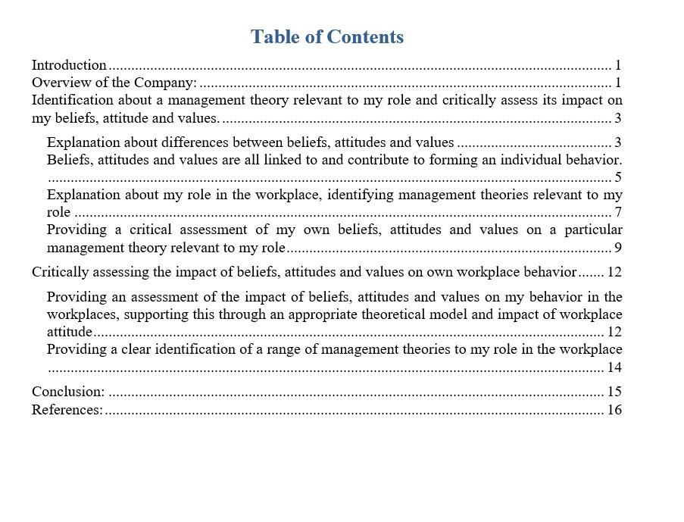

Introduction:
Critical thinking refers to the soft key skills which are very essential to achieve the organizational success. To solve different kinds of organizational problems, effective teamwork is very important within the workplaces. In the age of competitive business world, various kinds of problem solving processes are used for developing workplaces critical thinking to build the organizations. In the coming decade, the usages of critical thinking in workplaces have been a great challenge for all kinds of organizations. So, it is very essential for organizations to develop workplace critical thinking for problem solving and decision making issues. Critical thinking helps to solve individual and organizational problems, decision making, expending opportunities for successes, introducing ideas and situations and imagine different ways to respond. In this assignment, I will discuss about differences between beliefs, attitudes and values, Beliefs, attitudes and values are all linked to and contribute to forming an individual behavior, about my role in the workplace, identifying management theories relevant to my role, a critical assessment of my own beliefs, attitudes and values on a particular management theory relevant to my role, an assessment of the impact of beliefs, attitudes and values on my behavior in the workplaces, supporting this through an appropriate theoretical model and impact of workplace attitude and a clear identification of a range of management theories to my role in the workplace. Here is the selected organization is Nando’s and as Customer Service Assistant, I have to develop workplace critical thinking.
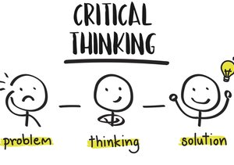
Figure: Critical Thinking
Source: (Jakubowicz, 2018).
Overview of the Company: Nando’s is an international casual dining restaurant and private type company chain originating in South Africa. The company was founded in 1987, 32 years ago in Johannesburg, South Africa. The names of the founders of the company are Fernando Duarte and Robert Brozin. Headquarter is situated in Johannesburg, South Africa. Key peoples of the company are Dick Enthoven as owner. Products of the company are Chicken and related Portuguese cuisine. The company operates their business activities over 1,000 outlets in 35 countries. The logo of the company is designed based on the Rooster of Barcelos. The main website of the company is www.nandos.com

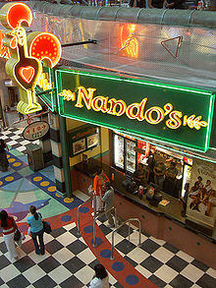

Figure: Nando’s Company
Source: (Nandos, 2018).

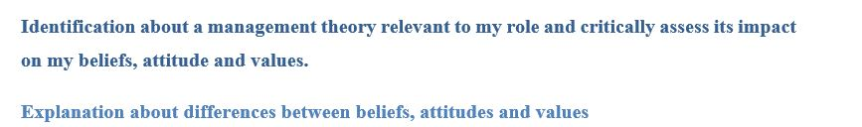
Belief: Belief indicates an internal feeling that something is true. Belief can be proved or unproved for any kinds of issues. For example of belief, some people of the world like Muslim, they believe that there is a life after death. This is the belief that comes from internal feeling.
Attitude: Attitude refers to the way of a person’s expression based on their belief and values through talks and behavior. Actually, behavioral activities have great impact on the personal and social issues. So, attitude is an essential issue for the employee to success in organizational perspectives (Kuhn, 2018).
Values: Values refer to the measurement of the worth or importance of a person which can be attached to something. In our society, there are different kinds of values like freedom of speech, values of family etc. according to the living our life, values are reflected in their own way.
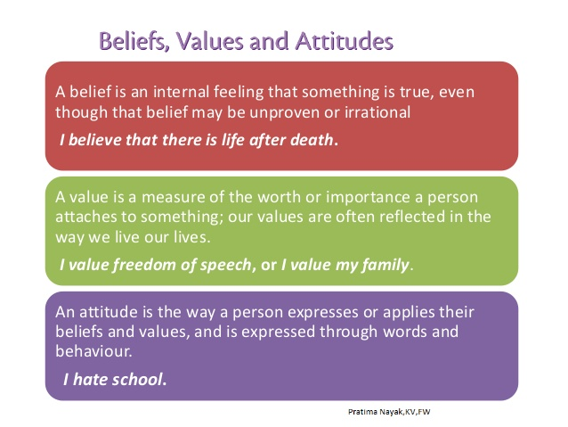
Figure: Beliefs, Values and Attitudes
Source: (Erdman, 2018).

Business organizations try to fix up their business goals and determine their objectives, planning and other function for the development. Every organization tries to contribute their business criteria for fulfill of their business purposes as well as determine their business targets for the betterment of the business organization and customers. For the business industry like restaurant industry, management is very essential to deal the variable things independently and for the assignment NANDO’S. It is very essential for the business organization to manage the whole business process and that is helpful for the contemporary developments and also influences the internal and external factors for the business goal. In this current age of business, there are some policies to meet the standard in management as well as the NANDO’S Restaurant Company is one of the leading restaurant manufacturers that expand their products and services all over the world. For the business organization, there is some significant part of the report those are very essential as well as the improvement of the business growth (Paul and Elder, 2009).
Differences between beliefs, attitudes and values:
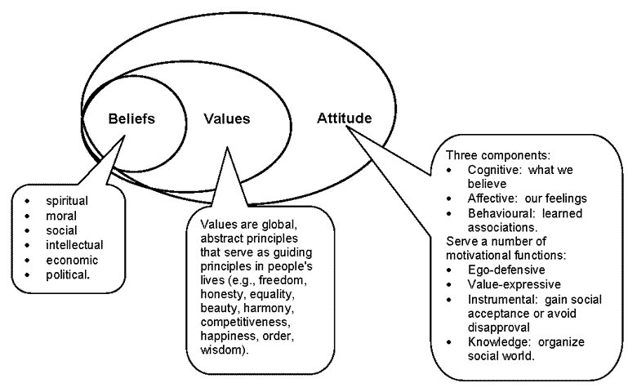
Figure: Differences between beliefs, attitudes and values
Source: (Goetsch and Davis, 2014).
In the age of globalization, as a multinational company try to operate their business activities for the betterment of the business activities and in a country, there are lots of business company operate their business and the competition of the business are being increasing day by day not only their local production company but also their international companies all over the world. Lots of restaurants are being producing all over the world in a day but NANDO’S produces their exceptional luxurious and delicious chicken for the betterment of the business organization and their customers. In the era of the globalization, the company maintains the international policy, laws and marketing strategy as well as their good quality production helps the business organization to make profit, renowned and capable to stay in the competitive business world (Gokhale, 2018).
As a Customer Service Assistant, I have to link beliefs, attitudes and values and those are very helpful to contribute to forming an individual behavior. Primary external factors influence the business concept and other controller of the business systems for the all kinds of business operational and those change the all from of the business organization and create the newly operational activities (Ma and Schapira, (2017).
Social factors: for the business purposes, NANDO’S restaurant company try to maintain their project outside South Africa and the company try to collect the information from the Middle East country where different of socio and cultural aspect of employee as well as workers and others making issues for the products and services. The company manages the cultural aspects and other important problems issues for the betterment of the business organization as well as health security also need to restaurant e in the sectors of the NANDO’S.
Technological factors: For any kinds of business organization, technological changes are also very vital for the all perspectives and the all employees have lots of experiences for the technological issues and the companies try to handle the problems for the betterment of the business organization. NANDO’S restaurant company must be upgraded their employees and their technological setting and reject the inexperienced workers for the betterment of the business organization (Harvey and Allard, 2015).
Environmental policy: all the business organization must follow the environment code for the waste management and the business organization like NANDO’S try to maintain the code for the business in the public perspective. The business organization tries to provide the health security for the peoples with a better security of the environment. Any kinds of business activities must be prohibited for the common peoples security and follow the rules and regulation which is antisocial. For the production, NANDO’S company try to manage the business activities in their field by deigning the limited hamper of the environment as well as business material, gas, electricity and others are being limited usages. The business organizations have to be more restaurants for the planning of usage of the materials and these companies try to control the wastage of the industries that is not harmful for the environment (Halpern, 2013).
Economic factors: for the maintaining and the continuing the production of the organization, NANDO’S company is concern the millions of pound and the cost of the whole business organization vary for the all cost of the organization and the economic factors vary from organization to organization and those will be dependable for the materials and others cost of a business organization. NANDO’S is a restaurant company, so the material cost that is steel cost is a great factor for the business organization and the expected cost and budget is very essential for the business organization, the manager of the company try to combine those things for the betterment of the business organization. NANDO’S have to decide the business for the analyzing the profits and cost of the organization and taking decision is to be maintaining for the betterment of the business organization.
Political factors: as a multinational company, NANDO’S Company has to maintain the rules and regulation for the international business and discuss the host countries for the business rules. Political factor is very valuable for the international business and the business company gives the host company with high rate tax for the betterment of the business organization and it decrease the business profits for the company and the company have to fail with the clearance of the consideration of the business purposes. Political factors influence the internal and external issues for the business purposes and international market and also maintain the rules and regulation for the international dealing. Monopoly marketing is prohibited in the international laws for the international issues and one company cannot maintain their price marketing which is very essential for the international business. As South African company, NANDO’S Company has to maintain the EU rules and regulation but the after rejecting the EU, the UK follow their own business rules and regulation for the international business (Alfaro-LeFevre, 2015).
Competitive policy: in this competitive business world business, the NANDO’S Company try to produce their luxurious products, the restaurant of the company is taken a better place in all over the world and the business organization has to face lots of barrier in their business purposes in competitive policy in UK and outside the UK. In the international business marketing, there are lots of rules and regulations and the competitive business policy must be maintained to improve the business organization (Qian, et al., 2017).
Form the following theme, management theories are selected for the task and the business organization influences the factors for the business purposes as well as the theme is very essential for the organization, NANDO’S Restaurant Company operates the luxurious restaurant for the customers and also betterment for the organization. The era of globalization, changing the marketing economy influence the business organization as well as the increasing competition and others problems for the business organization (Belton, 2018).
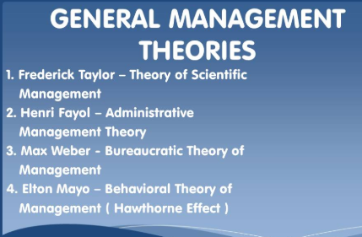
Figure: management theory
Source: (Harvey and Allard, 2015).
NANDO’S Company tries to manage the business company to their technological way for the luxurious production of restaurant with their legal entry for the development of the productions. . To solve different kinds of organizational problems, effective teamwork is very important within the workplaces. In the age of competitive business world, various kinds of problem solving processes are used for developing workplaces critical thinking to build the organizations. In the coming decade, the usages of critical thinking in workplaces have been a great challenge for all kinds of organizations. So, it is very essential for organizations to develop workplace critical thinking for problem solving and decision making issues. Critical thinking helps to solve individual and organizational problems, decision making, expending opportunities for successes, introducing ideas and situations and imagine different ways to respond.

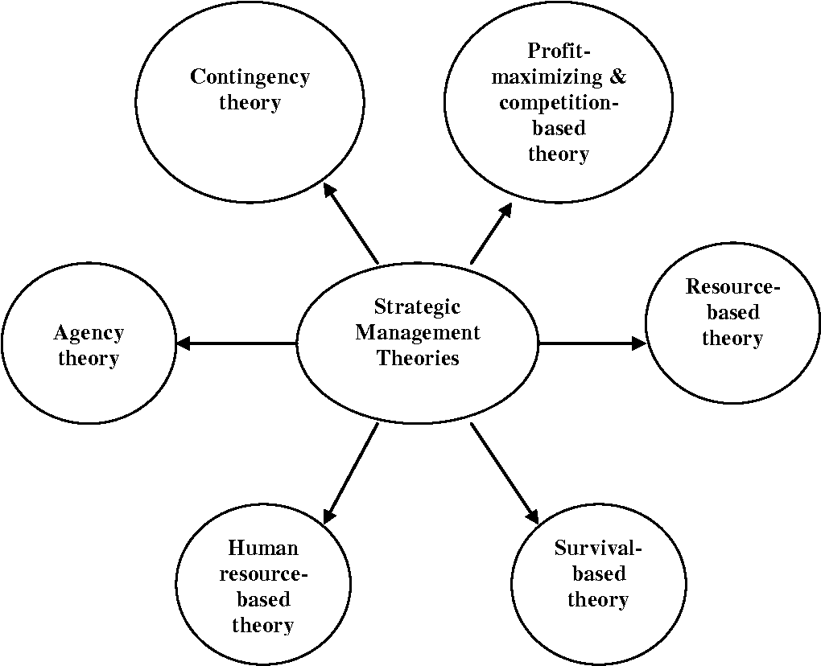
Figure: Management theories
Source: (Danczak, et al, 2017).
The human resources management of the company and employment opportunity will be the best magical implementation for the business improvement. The performance of the organization helps to fulfill the objectives and culture success orientation for the betterment of the business organizations. The theme of the whole process of the company and modern technology will be able to avoid the traffic jam for the magical ways and the whole performance helps the business organization to reach their business goals.
In this age of globalization, the organization has a great change for the business organization and has a great change in increasing the competitive as well as selling problems in the marketing for the business organization. In the restaurant industry, customer’s relationship, direct sales models has been committed in the UK and also in the USA and the business organization like restaurant company try to fulfill the customer’s relations and satisfaction for the improvement and restaurant industry has a potential for the business growth and development and the betterment of the business organization (Clark, et al, 2018). The relevance of the organization influences polices and making decision and how it works details in the below:
Training and Technological development: in the era of the globalization, international marketing is a very essential for the business with the nature of the demand conditions and a vast of sharing technology in this globalization world, international marketing play an vital role for the business organization for the all kinds of business projects and a marking competitor has a great influence for the business sectors. For NANDO’S the nature of demand conditions has a great importance for the improvement and for the betterment of the business organization, those threat has to rejected for the helping of European trade and others (Gokhale, 2018).
Environmental concern: environment concern is very important for the organization and has a great influence for the organization as well as the change of European marketing it is very competitive for the business organization for the business purposes. For the betterment of the organization, NANDO’S has a wide range of business issues like political and global scale. For the technological development, all kinds of safety development have to be ensured for the customers and implementation of the green restaurant needs to be upgrade for the environment protection. Restaurant industry tries to maintain the international rules and regulation for the betterment of the customers and labor unions policies also influence the business process and influence on the overall marketing sectors (Qian, et al, 2017).

Justification of services with thousands of Companies: it is very essential for the business organization to justify the others companies services and the business organizations try to handle the business purposes. The same company produces lots of same products like restaurant and the services will be the factors for the business organization as well as has a great intention for the business organization for the competitions of the international market. NANDO’S restaurant company try to rethink about the competition as well as the services for the business organizations and that will be the important work for the company to justify the thousands of the services of the companies (Morrison, 2017).
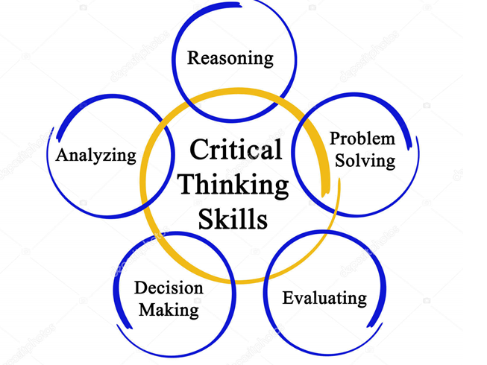
Figure: Critical thinking skills
Source: (Zuriguel Pérez, et al, 2015).
Full competitive market: in this word business market, the business organization try to apply various kinds of business strategy as well as well-mannered for the betterment of the business organization in a different way of the business planning and the following rules and regulation is helpful for the competitive policy for the current market. EU countries and other business organizations country try to competitive for the improvement of the business organization as well as maintain the market. In this age of competitive business world, the local company and the multinational company try to complete their level to reach their business goals and NANDO’S also has become intensive for the improvement. In this world business age, the Company tries to manage their target in their traditional way for the corporation as well as their rationale ways to maximize the business conditions for the betterment of the business. On the other hand, the NANDO’S Company tries to manage the business company to their technological way for the luxurious production of restaurant with their legal entry for the development of the productions. The human resources management of the company and employment opportunity will be the best magical implementation for the business improvement. The performance of the organization helps to fulfill the objectives and culture success orientation for the betterment of the business organizations. The theme of the whole process of the company and modern technology will be able to avoid the traffic jam for the magical ways and the whole performance helps the business organization to reach their business goals (Stoyanov, 2018).
New skill and competency: for the betterment of the business organization, there are some essential things for the competency and skilled employees are developed the business quality and services in the marketing. For the current world business competition vary from the marketing strategy, marketing price, employee skills and other economic factors. NANDO’S restaurant company try to maintain their own policy to produce their luxurious restaurant and the marketing strategy vary from the other internal company and the companies also try to maintain the original material for the production and technology for the betterment of the customers as well as the betterment of the business organization (Wechsler, et al, 2018).

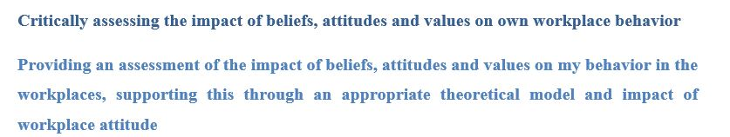
As a multinational business organization, Company has a great successfulness for producing the luxurious restaurant for the world’s peoples and the company has a great reputation for the productions and services as well as competitive business environment in the company. The company makes delicious foods like chickens for the betterment of the peoples and the usage of technology, management and other skilled employees helps the business organization to change the business policy. But there was a little form of marketing in local as well as international marketing, but the NANDO’S restaurant company expands their business market with a rage of policy and development (Paul and Elder, 2009).
For the betterment of the business organization, the business organization tries to apply the marketing strategy and business structure to make change for the improvement as well as try to reach their business. From the beginning of the company, there was a traditional strategy of the company to maintain the technological usage as well as original material of the production like steels and the skilled employees for the betterment of the company and the customers. The company tries to distribute their products all over the world from the beginning of the company and the infrastructure made the company strong and better development for the business market as well as the change of sales and management has a great effect for the improvement of the business organization.
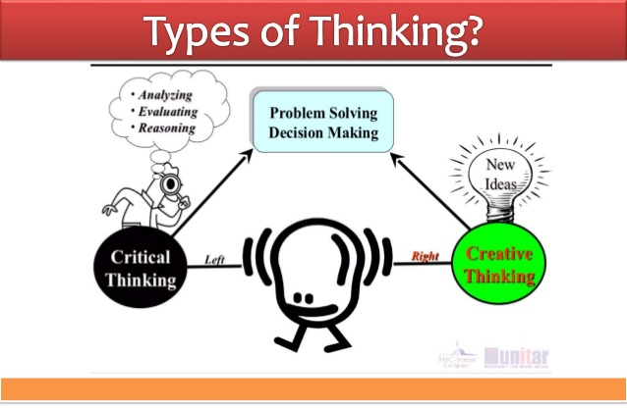
Figure: Types of thinking
Source: (Szenes, et al, 2015).
In this competitive business world, the NANDO’S Company tries to give the best services for the customers and the company tries to maintain the business law for the international business purpose. The structure and the constructional sectors of the restaurant industry are being developed by the grace of the some companies like the business organization and the competitive business process makes the business profits for the relation of the previous years and for the cash position and reduction of the group increase in the recent years (Noddings and Brooks, 2016).
For the skilled employees of the business organization, the health security of the industry and the marketing place of the employees, the company undertake various kinds of steps to reduce the risk of the organization and information show that there are a only few accident in last ten years in this business organization. In UK and other countries of the world, the development of the business organization is seen clearly. To solve different kinds of organizational problems, effective teamwork is very important within the workplaces. In the age of competitive business world, various kinds of problem solving processes are used for developing workplaces critical thinking to build the organizations. In the coming decade, the usages of critical thinking in workplaces have been a great challenge for all kinds of organizations. So, it is very essential for organizations to develop workplace critical thinking for problem solving and decision making issues. Critical thinking helps to solve individual and organizational problems, decision making, expending opportunities for successes, introducing ideas and situations and imagine different ways to respond. (Whiley, et al, 2017).
For the good performance of the business organization, NANDO’S Company has to make the overall change for the development of the business organization and the business organization make a great change in the restaurant industry in competitive environment and there are few issues where the company need to improve the services. The company also proves their business quality with the productions and services as well as with renowned criteria the company focus their all sectors in strength and reduce their weakness for the betterment of the restaurant industry (Stupple, et al, 2017). Few issues and services needs to be developed and some recommendation to improve:
- The current quality of the products and services are very fine for the customers and needs to continue the quality of services and with the skilled employees the company operates their business productions and continues to monitor the productions and services.
- The company has skilled employees and with the competitive business world, by giving training the company has to need upgrade their employees for the betterment of the business organization.
- Health security must be needed for the employees and the NANDO’S company gives the best security for the employees in their workplaces and the possibility of the business organization of accident is much and the business organization ensure the reward systems for the best security for the business organizations.
- For the betterment of the business organization, NANDO’S should analyze the profit rate and cost of the project and that will be important issue for the company.
- The management of the company must try to understand the culture of the workers and as a multinational company, NANDO’S try to ensure understanding all employees in the world for the betterment of the company.
- Ethical factors must be considered for the business organization and the business organization should follow the personal and professional issues that are very important for the organization.
NANDO’S should ensure the taxation on other policy and for the betterment of the business organization, the company produces restaurant and minimize the cost and take decision if any decision is needed. It is very clear that NANDO’S Company has no consider for the security of the employees, safety, technical issues and services and quality of the productions and services. In this competitive business world, the international marketing is very essential for the business and the company operates experience services and marketing for the betterment of the business organization. As a multinational company, the NANDO’S has to face various kinds of barrier for the improvement but the quality of the production and services gives the company with a famous criteria. The marketing planning of the company and the external and internal factors gives the company to produce the best products. For the restaurant industry, NANDO’S try to improve the condition much better than today and this wishes help the business organization to reach their business goals (Stupple, et al, 2017).

Conclusion:
At the end of the assignment, it is very clear that Critical thinking is a vital skill to create ideas, solving different kinds of problems in difficult situation and effective decision making for the betterment of the organization like Nando’s. In this assignment, I discussed about differences between beliefs, attitudes and values, Beliefs, attitudes and values are all linked to and contribute to forming an individual behavior, about my role in the workplace, identifying management theories relevant to my role, a critical assessment of my own beliefs, attitudes and values on a particular management theory relevant to my role, an assessment of the impact of beliefs, attitudes and values on my behavior in the workplaces, supporting this through an appropriate theoretical model and impact of workplace attitude and a clear identification of a range of management theories to my role in the workplace.

References:
Alfaro-LeFevre, R., (2015). Critical Thinking, Clinical Reasoning, and Clinical Judgment E-Book: A Practical Approach. Elsevier Health Sciences.
Belton, P., (2018). Ludwig von Mises's The Theory of Money and Credit. Macat Library.
Clark, A.Y., Li, Y. and Jiang, Y., (2018), March. Using Natural Language Processing and Qualitative Thematic Coding to Explore Math Learning and Critical Thinking. In Proceedings of the 2018 International Conference on Big Data and Education (pp. 38-43). ACM.
Danczak, S.M., Thompson, C.D. and Overton, T.L., (2017). ‘What does the term Critical Thinking mean to you?’A qualitative analysis of chemistry undergraduate, teaching staff and employers' views of critical thinking. Chemistry Education Research and Practice, 18(3), pp.420-434.
Erdman, K., (2018). Culture's Consequences: Comparing Values, Behaviors, Institutes and Organizations across Nations. Macat Library.
Gokhale, A., (2018). Guided Online Group Discussion Enhances Student Critical Thinking Skills. International Journal on E-Learning, 17(2), pp.157-173.
Goetsch, D.L. and Davis, S.B., (2014). Quality management for organizational excellence. Upper Saddle River, NJ: pearson.
Halpern, D.F., (2013). Thought and knowledge: An introduction to critical thinking. Psychology Press.
Harvey, C.P. and Allard, M., (2015). Understanding and managing diversity: Readings, cases, and exercises. Pearson.
Jakubowicz, K., (2018). Griselda Pollock's Vision and Difference: Feminism, Femininity and Histories of Art. Macat Library.
Kuhn, D., (2018). A role for reasoning in a dialogic approach to critical thinking. Topoi, 37(1), pp.121-128.
Ma, C. and Schapira, M., (2017). The bell curve: Intelligence and class structure in American life. Macat Library.
Morrison, R., (2017). Teaching Toward the Telos of Critical Thinking: Genre in Business Communication. Business and Professional Communication Quarterly, 80(4), pp.460-472.
Nandos, (2018). Nando's | The official worldwide home of Nando's. [online] Available at: http://www.nandos.com/ [Accessed 10 Dec. 2018].
Noddings, N. and Brooks, L., (2016). Teaching controversial issues: The case for critical thinking and moral commitment in the classroom. Teachers College Press.
Paul, R. and Elder, L., (2009). The miniature guide to critical thinking-concepts and tools (Thinker’s guide). Dillon Beach, CA: Foundation for critical thinking.
Qian, J., Song, B. and Wang, B., (2017). Abusive supervision and job dissatisfaction: The moderating effects of feedback avoidance and critical thinking. Frontiers in psychology, 8, p.496.
Settle, Q. and Shaw, E., (2018). Integrating Creative Thinking, Critical Thinking, and Team-Building Activities into Lessons. NACTA Journal, 62(1), pp.100-101.
Stoyanov, S., (2018). Chris Argyris's Integrating The Individual and the Organization. Macat Library.
Stupple, E.J., Maratos, F.A., Elander, J., Hunt, T.E., Cheung, K.Y. and Aubeeluck, A.V., (2017). Development of the Critical Thinking Toolkit (CriTT): A measure of student attitudes and beliefs about critical thinking. Thinking Skills and Creativity, 23, pp.91-100.
Szenes, E., Tilakaratna, N. and Maton, K., (2015). The knowledge practices of critical thinking. In The Palgrave handbook of critical thinking in higher education (pp. 573-591). Palgrave Macmillan, New York.
Wechsler, S.M., Saiz, C., Rivas, S.F., Vendramini, C.M.M., Almeida, L.S., Mundim, M.C. and Franco, A., (2018). Creative and critical thinking: Independent or overlapping components?. Thinking Skills and Creativity, 27, pp.114-122.
Whiley, D., Witt, B., Colvin, R.M., Sapiains Arrue, R. and Kotir, J., (2017). Enhancing critical thinking skills in first year environmental management students: a tale of curriculum design, application and reflection. Journal of Geography in Higher Education, 41(2), pp.166-181.
Zuriguel Pérez, E., Lluch Canut, M.T., Falco Pegueroles, A., Puig Llobet, M., Moreno Arroyo, C. and Roldan Merino, J., (2015). Critical thinking in nursing: Scoping review of the literature. International journal of nursing practice, 21(6), pp.820-830.

