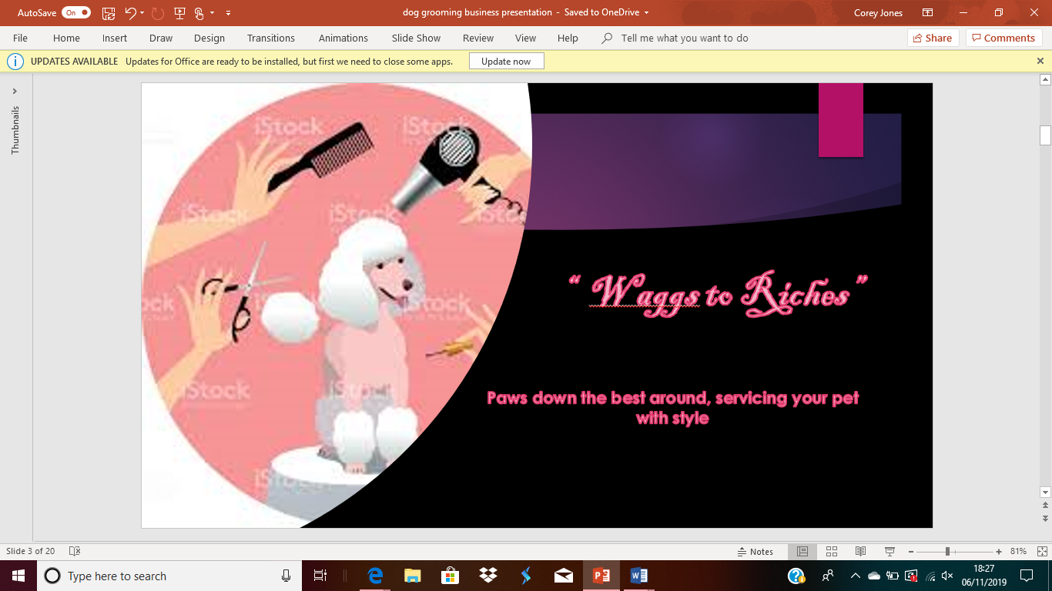
Business Proposal

Business overview
Our business ‘’Waggs to Riches’’ is a family run dog grooming salon which will be situated in an easy accessible area with parking in a busy shopping park called Trostre, Our vision is to create a highly good and effective dog grooming services business that will become the number one choice for both individuals and to corporate with dog shelter organizations.
Our business journey started as a hobby of interest, owning our own poodle and the maintenance that was involved and had the constant frustration of local groomers being fully booked not taking on new customers we realised there is a gap in the market, our vision is to open a family run business in which will share equal responsibility, we would like to open a dog grooming salon situated within Trostre, a popular area , with parking
Mission statement/aims and objectives
- Our mission is to make your pets grooming experience a positive one and to provide the best and most thorough dog grooming service available in a fun and loving environment!
- We will do our best to educate owners so that they have an understanding of how to care for their pet's properly.
- we make a concerted effort to listen and respond to the needs and concerns of our clientele and take in full consideration the client’s requests; however, the animal’s wellbeing, treatment and health and safety will always come first
- We invite you to give “wags to Riches” a try. We are committed to maintaining a clean, no stress environment and making sure your pet is comfortable while they are our care.
Type of product services
We can’t say this enough: dogs and humans are very similar!
Different people have different hair types and face shapes. Therefore, people require different cuts when they visit the salon. Some people just want a trim and others want a complete style. Usually groomers offer breed specific cuts. These vary according to a dog’s breed, owners preferred style.
The point is that people and their hair vary and we’re here to tell you that dogs are no different!
Services we offer:
- Brush and a bath
- Conditioning treatments
- Teeth treatments
- De-matting and de-shedding
- Specialty shampoos and skin therapy – scented, hypoallergenic, treatment for skin conditions, etc.
- Flea and treatments
- Drop an Shop ( drop your dog of to us whilst you go shopping)

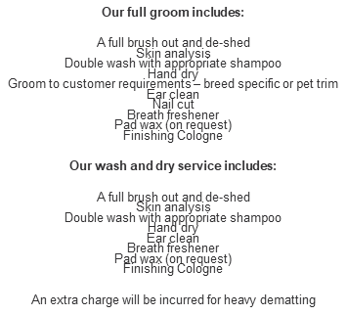

Physical Resources

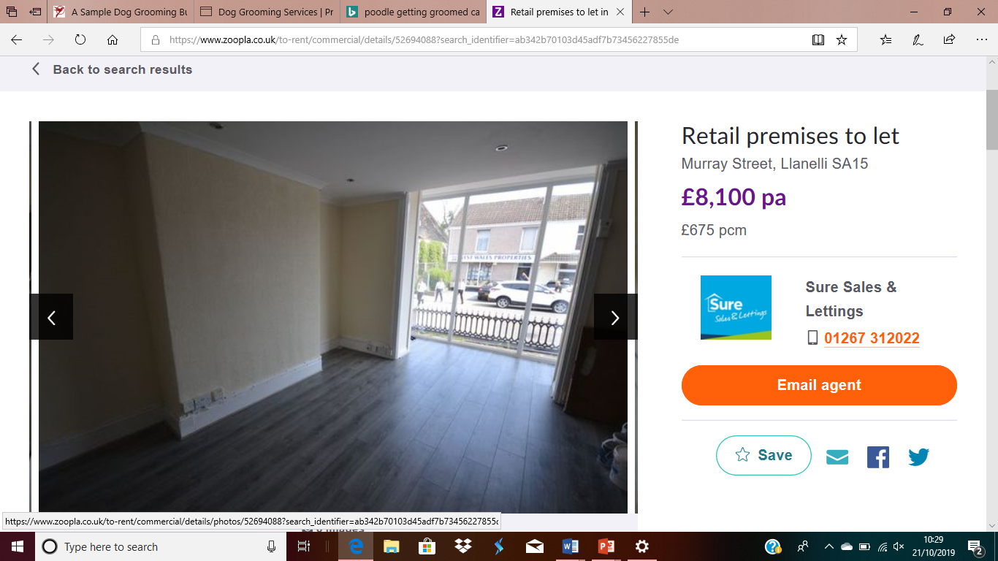
The property we have choose is located in a busy end of Llanelli town, with plenty of traffic driving past all day long with our business situated in the heart of Trostre near Trostre retail park, our eye-catching logo above this shop would catch so many people’s attention advertising our business. Our business would thrive in this area as there is a gap in the market, there is not a nearby groomer.
This property is also fantastic for us to set up in as it was previously run salon so saves on works, also the location is very central, great for start-up business, flexible lease terms available.
The equipment we would need in order to start up our business:
- Liquid products.we need to consider what shampoos, conditioners and styling product we will need catering for all dog types.
- A professional quality bath. This will make bathing lots of animals quicker and easier. A quality professional bath should allow you to cater for small and large dogs with ease.. Try to find a bath that is height adjustable, or one that has a ramp to save you from lifting the larger heavier dogs.
- A professional grooming table. This should ideally be height adjustable.
- A professional standard dryer. Groomers offer a range of dryers, including blasters, cabinets and handheld dryers. A combi-dryer is best for most start-up businesses, however, as they are particularly versatile.
- Essential brushes and combs. These include a universal slicker brush, a combination comb, a de-matter, a bristle brush and a shedding tool depending on your clientele hand striping tools and coat kings,
- Hair cutting tools. You will need a selection of scissors, as well as a clipper and some trimmers, if you do not already have them. Attachment combs are good option if you do not want to splash out on a variety of clipper blades quite yet.
- hygiene products. This should include nail clippers, facial wipes/ear cleaning solution.
- Salon hygiene and safety products. It is also important that you consider our own professional environment. Ensuring we have a first aid kit, and sterilising equipment such as Barbicide solution or a UV steriliser.
- non-slip rubber floor matting also consider protective clothing. Protective clothing should include a waterproof apron, appropriate footwear and protective gloves.

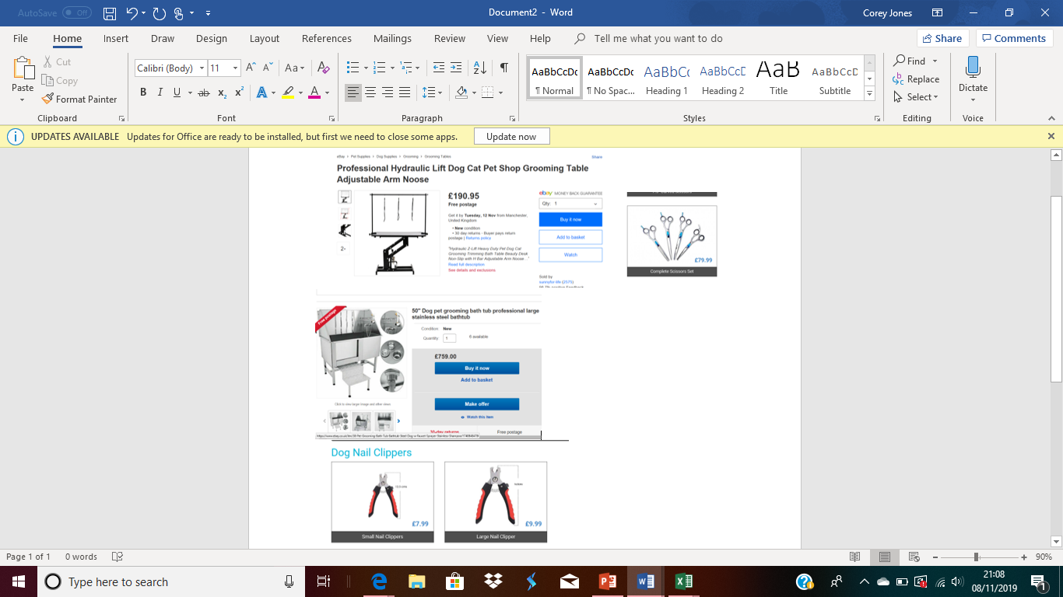

Human Resources

Our business will start off as a partnership and as we are related, we will be known as a family run business, we will both be sharing the roles and responsibilities which will be equal. We have both done dog grooming courses and have qualifications and the same goal which will help us work together as a team, increasing effectiveness by communicating effectively taking accountability providing direction for the business.
- Our roles will include:
- Taking/ recording bookings handling money
- Answering telephone/call in enquires
- Ordering products
- Grooming /Bathing
- Nail clipping
- Hygiene services ears, teeth, etc
- Promoting the business marketing
- Listening to customers preferences
- general care wellbeing of pets
- Making customers/pets are stratified
- Engaging with dog trust charities

Marketing

Once we have developed our marketing strategy there are 7 “P” s to consider the evaluate the business the 7 p’s being:
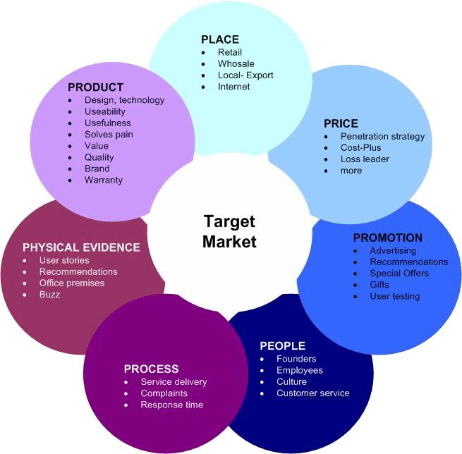

People

Pet owners are shifting towards the use of premium products for their pets as they are treating their pets as part of their family and want to provide them with the best services. Also, the concept of pet parents is rising considerably where childless or single parents or even elderly for companions are increasingly adopting pets. With pet owners going for premium pet grooming products and pet accessories, the manufacturers are launching products to cater to the rising consumer demand.

Not many months ago it was revealed the results of a pet owner study conducted by the Blue Cross which revealed Wales was the dog ownership capital of the UK
Research from National Pet Month shows how our nation’s love for pets is stronger than ever due to companionship needs, security or just simply for more family fun. There are 27 million pets in the country and 43% of households contain at least one furry, feathery or scaly family friend, making pets well and truly part of the UK’s landscape.

As part of our market research, we tried to find out as much as we could about the types of people - and their pets - living in our area. Pets are popular with families and also with older people.
A lot of elderly own pets as companions and are not able to groom their pets themselves that’s where we come in handy.
Promotion we aim to use Social as a platform target to reach out to the public we aim to get our business known by sharing ideas and having feedback of the public via social media such as Facebook as nowadays technology
keeps improving and more companies are moving online we can promote our business by doing deals 2for1 or percentage of grooms, making loyalty cards with special offers on next grooms we aim to make flyers with our eye catching logo as well as business cards making connections with Dog shelters and having them on board with our project grooming pets before their forever homes.
Price
We will be sensibly priced and will have offers we need to make enough to pay for premises and bills along as that is covered as to us it’s a hobby.

Process
Our business is very relevant as we believe there is a gap in the market with us being the only one in the area and the two other competitors are in and dated and cannot take any more clients in which gave me the idea of my own grooming salon due to being able to book my own poodle in for a groom locally, our business is relevant as majority of pet owners use a professional groomer due to the coat type they need to be professional groomed.
Place
We will be located in a busy central area within Trostre, easy access and parking facilities, walking distance from Trostre retail park. With our competitors being in the Llanelli town centre there is a gap in the market in this area.
Target Market being:
- owners of breeds that require regular grooming. Many owners will have neither the necessary skills nor the time to groom their pets regularly and so prefer to have a professional do it for them
- professionals and enthusiasts who breed and show animals - particularly dogs and cats
- owners who are not physically able to groom their own pets - perhaps because they are elderly or because they have a disability
- owners of animals that need flea or other parasite treatments, or which need an identity microchip implanted
- proprietors of animal boarding kennels and pet shops that offer a grooming service to their customers but are not able to do the grooming themselves
- owners of animals that have been referred to you for grooming by a vet

The SWOT Analysis on ‘’Waggs to Riches’’

Strengths

- Experience- A lot of experience in dog grooming will mean that you already have a high level of skill and can offer better service than competitors. Also, if you have skilled staff it will reduce training time and increase customer satisfaction.
- , you can keep your start-up costs to a minimum.
- Being in a busy location in Trostre
- Parking facilties
- Access to shopping centre shop while your furry friend gets pampered
- Passion- Your passion for your work and love for dogs will help improve customer experience and increase positive feedback, which is very effective publicity

Weaknesses
- Lack of brand recognition- It’s hard for any new business to make a name for itself, especially if the market is full of established brands. Advertising and clever marketing can help improve brand recognition.
- Low budget- Initial start-up costs can be very expensive for a new company, especially if you’re opening a shop. You can look into things like business loans to help get your brand up and running.
- Lack of business experience- When you enter a new market it will take time to find your feet as a business owner. Having a passion for dog grooming is essentially but you will also need to learn what it takes to be a good business person.
Opportunities
Once we get our business off the ground and show people how good we are with their furry friends, there are a lot of opportunities which we could take advantage of, even at our the early stages of development.
- Profit- Our passion for dogs will come first but the opportunity to eventually make profit is a great incentive. Once our company becomes profitable there are many other opportunities that come with it.
- Expansion- After getting a foothold in the market and increasing our customer base we will have the opportunity to expand by opening new locations or increasing our staff.
- Working together with animal charities

Threats
We can’t always predict the future but it’s important to consider any potential scenarios so we can be prepared for the worst.
- Competition- Competition is one of the biggest threats to any new business venture. If our local dog grooming market is already highly saturated, we may struggle to establish our brand initially.
- Increased costs- There is always a chance that business and material costs will increase. Utility prices could increase over time and if we are leasing our building then the rent price may be liable to change.
- Issues with the economy- Just like any other business, our dog grooming company can be affected by downturns in the economy. If local customers experience household budget cuts you may see a reduction in demand.
- Sick days- Unfortunately we all get sick sometimes, which means you may struggle to keep up with business activities if you have to take time off. This can be particularly problematic if you are a dog groomer and you’re self-employed.

SMART Analysis on ‘’Waggs to Riches’’
- SPECIFIC- Our mission is to make your pets grooming experience a positive one and to provide the best and most thorough dog grooming service available in a fun and loving environment!
- MEASURABLE- We are planning to achieve this business open by Feb 2020 aiming in the next 12weeks to promote and get our name out there via advertisements.
- ACHIEVEABLE- To open a family run dog grooming business that will be a success leading on to business growth expanding our business in different directions
- RELEVANT – We believe there is a gap in the market for us as there are so many pet owners some of which are elderly and some of which are working and find it difficult to manage time to groom their pets themselves and find it easier to drop them off to a groomer professional as they have the right equipment. With there only being two dog grooming palours in our area, they are in and dated with appointments refusing to take more workloads and turning away custom not by choice.
- TIMEBOUND-We are currently Advertising our business via social media and business cards/Flyers we are opening our Business in Feb 2020

GANTT CHARRT ON OUR BUSINESS PROPOSAL
Company Name | 'Waggs to Riches''
 | Project Start: |  | Sep-19
TASK | ASSIGNED  TO | PROGRESS | START | END
Research
Contact dogs trust | Corey |  | 1.09.19
Dog Owners Servey | Lisa |  | 1.9.19
Planning
Location | Lisa |  | 43709 | 1-10-19
Premises | Corey |  | 43711 | 43716
Loan ideas
apply for a government grant | both |  | 5.01.2020 | 30.01.2020
Markerting Ideas
Websites | Lisa Corey |  | 5.12.2020 | 30.12.2020
Leaflets | Lisa |  | 30.1.2019 | 30.01.2020
Business cards | Corey |  | 30.1.2019 | 30.01.2021
Radio | Lisa |  | 1.02.2020 | 1.04.2020
Shop windows | Corey |  | 01.11.2019 | 30.01.2021


Sources of finance

We are putting together £5,000 each which would secure our property as a depsit and also give a good start to equipment, we will mtherefor turn to a government loan to help start up Our business, being as we are starting on our own we have not yet got stress of overheads, also applying for a loan to start up would benefit as we would have support and guidance and if we are successful can continue to have guidance for a further 12months.
Cash flow | Start up | Month 1 | Month 2 | Month 3 | Month 4 | Month 5 | Month 6 | TOTAL
INCOME
CASH FROM SALES | £0
CAPITAL/LOANS RECEIVED | £10,000
TOTAL INCOME
EXPENDITURE material | £1,470.95
PREMISES RENT, RATES, |  | £675.00 | £675.00 | £675.00 | £675.00 | £675.00 | £675.00 | £4,050
TELEPHONE BROADBAND |  | £25.00 | £25.00 | £25.00 | £25.00 | £25.00 | £25.00 | £200
ADVERTISING AND PROMPTION |  | £50 | £50 | £50 | £50 | £50 | £50 | £300
INSURANCES | £6.00 | £6.00 | £6.00 | £6.00 | £6.00 | £6.00 | £6.00 | £36.00
EQUIPMENT MAINTANENCE |  |  |  |  |  |  | £100
TOTAL EXPENDITURE | £1,476.95 | £756.00 | £756.00 | £756.00 | £756.00 | £756.00 | £856.00 | £6,112.95
INCOME LESS EXPENDITURE | £8,524.05
OPENNING BANK BALANCE |  | £8,524.05 | £7,768.05 | £7,012.05 | £6,256.05 | £5,500.05 | £4,744.05 | £3,780.05
CLOSING BANK BALANCE | £8,524.05 | £7,768.05 | £7,012.05 | £6,256.05 | £5,500.05 | £4,744.05 | £3,888.05 | 43692.+A1:I2235

References
Bing Maps. (2019). Bing Maps. [online] Available at: https://www.bing.com/maps?q=dogs+shelters+llanelli&FORM=HDRSC4 [Accessed 23 Oct. 2019].
Bing.com. (n.d.). dogs in carmarthenshire - Bing. [online] Available at: https://www.bing.com/search?q=dogs+in+carmarthenshire&form=EDGEAR&qs=AS&cvid=5cd2ab61ed5c4b0d80cfc38bf6a5377d&cc=GB&setlang=en-GB&PC=HCTS [Accessed 23 Oct. 2019].
Masterclip.co.uk. (n.d.). Search Results - Award Winning Clippers by Masterclip. [online] Available at: https://masterclip.co.uk/search-results?keyword=dog+shampoos [Accessed 23 Oct. 2019].
O'Meara, R. (2019). UK Pet Owner Statistics. [online] Dog News. Available at: http://www.dognews.co.uk/uk-pet-owner-statistics/ [Accessed 23 Oct. 2019].
Top Dog Tips. (n.d.). How to Write a Dog Grooming Business Plan – Top Dog Tips. [online] Available at: https://topdogtips.com/write-dog-grooming-business-plan/ [Accessed 23 Oct. 2019].
Zoopla.co.uk. (2019). Property to Rent in Llanelli - Renting in Llanelli - Zoopla. [online] Available at: https://www.zoopla.co.uk/to-rent/property/llanelli/?gclid=COG2m5PG2-UCFdYRGwodTkUDMA&gclsrc=ds [Accessed 23 Oct. 2019].

