Student Name: Rifat Bashir
Student ID: 1814479
Module: Developing Workplace Critical Thinking
Module Code: BMSW 5101
Lecturer: Ernest Ovia
Assignment Title: How Individuals’ beliefs, attitudes and values impact on workplace behaviour

Contents
Introduction …………………………………………………………………. Page 3
Individual Beliefs and values ……………………………………………. Page 3
Management theory- The Great Man Theory …………………………. Page 4
Fig 1 (Acquired, Kruger, 2020) Leadership Model Thinking ………. Page 5
Fig 2 …………………………………………………………………………… Page 6
Critical thinking ……………………………………………………………… Page 8
Conclusion ……………………………………………………………………. Page 9
References ……………………………………………………………………. Page 10

Introduction
Individual values and beliefs are regarded as a necessary toolkit for the workplace. They are likely to have a positive impact on the individual and the workplace. Individual beliefs and values ensures efficiency and effectiveness to fulfil its purpose for the organisation. Each organisation has its own values and beliefs, whereas they can be strengthened by individual values and beliefs. The organisation can achieve much more with added values and beliefs and it is likely to have a positive effect on the business. In this report will be discussed the beliefs and values of individuals and its impact. We will also analyse the ‘Great man theory’ and how this applies in the workplace, whilst discussing its effectiveness. Finally, we will explore the term ‘critical thinking’ of what it means and how as a student I have applied critical thinking within my own learning.
Individual beliefs and values
Individual beliefs and values have a positive impact within an organisation, if those beliefs and values are positive and support the organisations aims. Values are the essence of who we are as human beings, they tend to influence the decisions we make in our life and help us choose what decisions we make in pour lives. When an individual has personal values and discovers an arrangement between values of their employer a strong connection is therefore created. This helps the individual and the organisation to grow productively in many ways (Dean, 2008). This is likely to strengthen the organisation and reinforce its own core values. There are different generations that base their values on different things. For example, baby boomers are competitive and loyal, they value individual freedom and apply hard work to the task that they are given. These tend to be the workaholics. Then there is generation X, they have a balance between their work and their family. They are independent and are informal. Finally, there is Generation Y, these are optimistic and ambitious, and they tend to get easily bored (Gibson, Greenwood, Murphy, 2009). Therefore, we learn there are different people with different individual beliefs and values. These individual beliefs and values are effective for an organisation, if their beliefs and values correspond to the organisations aims. There is an unitarist ideology that the organisation works around shared goals and a common identity between the employee and the employer (Geare, Edgar, McAndrew, Harney, Cafferkey, Dundon, 2014). During the recruitment process, an organisation is likely to find out if the individual has similar individual beliefs and values that best represent beliefs and values of the organisation. If these correspond, the employer and employee should be able to make the organisation more productive and efficient. So, these individual values and beliefs can transform or become part of shared common beliefs and goals that represent the aims of the organisation in the best possible way. In this way, the individual is expanding their own skills but also enhancing the productiveness of their organisation. There is also evidence that suggests individuals strive to connect themselves with groups and workplaces that are committed to similar core values (Williams, Ferris, 2000).
There is also learning within the workplace, where the organisation provides opportunities or creates platforms for these individual beliefs and values to be further stimulated. So, individuals are providing with the opportunities to engage in work activities and enjoy the benefits of direct and indirect support which is seen as a key determinant of the quality of learning within the workplace (Billett, 2001). Individual beliefs and values can also be reinforced through strong cultures within the organisation that monitor the behaviour for consistency, and this will help to align personal beliefs with organisational beliefs (Estes, Wang, 2008). Within this, it is important that employees feel values and accepted within the organisation. If employees feel valued within their workplace, they are more likely to support the aims and values of the organisation. This connection is likely to be strengthened even more and make the organisation productive and efficient, it is likely to maximise this productivity within the organisation.
Management theory- The Great Man Theory
The Great Man theory was introduced within the 19th century by Thomas Carlyle, he said that the ‘history of the world is but the biography of great men’. That some humans have attributes that allow them to be an effective leader. Early leadership was first connected with males and therefore it is called the ‘Great Man Theory’. Then, later is was identified as the great person theory, as there was a recognition of great women leaders in the world. This theory suggests that some people are born with certain characteristics that single them out from others in a good way. These characteristics allow them to gain power and authority that will ultimately make them a leader. That these people in power deserve to have that right because of their special endowment. This theory shows that these traits remain stable over time and across groups. Therefore, great leaders, whether it be leaders of the country or leaders within a small organisation, share these certain characteristics. It is not affected by where they live or the role they have (Management Study Guide, 2020). However, Organ disagrees with this view of the Great Man Theory, saying that ‘leadership is not a trait, it is learned behaviour and has little to do with innate personal qualities’ (Organ, 1996). Therefore, suggesting that an individual is not born with these qualities, they are only qualities that need to be learned and experienced by the individual. These skills and qualities need to be learned by an individual to become an effective leader within society. There are different views regarding ‘the Great Man Theory’, are individuals born with these traits or are they man made and learned behaviour over time?

Fig 1 (Acquired, Kruger, 2020) Leadership Model Thinking
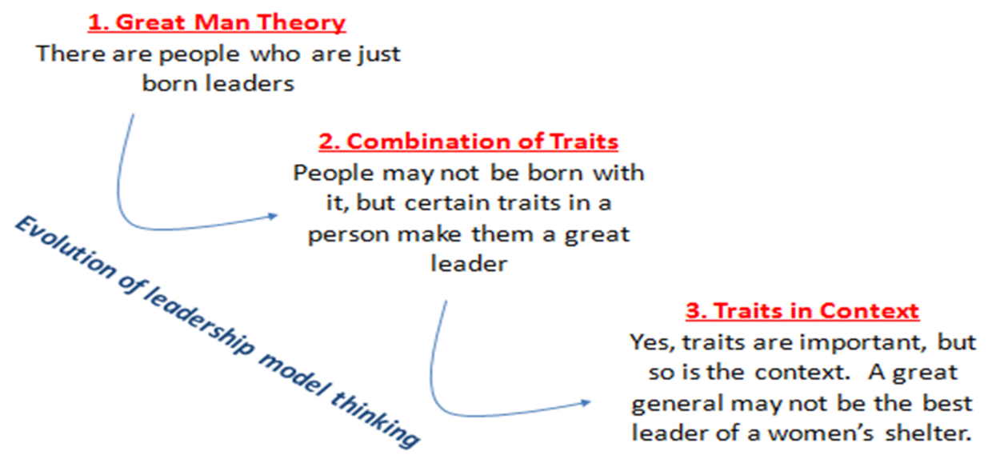

Figure 1 shows that the Great Man theory is those people who are just born leaders. That they are born with these qualities and skills that allow them to become an effective leader. Going down the model, is that that these people may not be born with it, but they are born with certain traits that make them a great leader. These qualities and skills may be, effective communication skills, leadership skills, confidence, being decisive, resilience, etc. Thus, an individual might be born with these skills that allow the individual to become a leader within society. Then, the last component of this model is that traits are important, but it also depends on the context. A great general may not be the best leader of an organisation that he has no experience of. For a leader to be effective, they need to acknowledge the context that they are in. The leader needs to know its environment well, in order to apply leadership skills. Therefore, being a leader is not enough, rather an effective leader will be able to maximise their leadership skills efficiently in their best-chosen field and that is the context which is explained above.

Fig 2
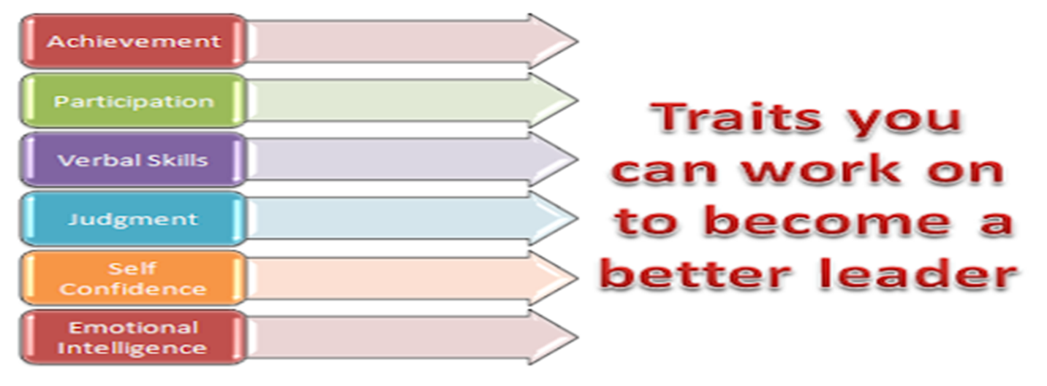

Figure 2 shows the traits an individual can work on to become a better leader. It may be that an individual is born with these traits or naturally has these traits, but they may need to be developed in order to maximise their potential. These traits are, achievement, participation, verbal skills, judgement, self-confidence and emotional intelligence (Acquired, Kruger, 2020). Some of these traits have been mentioned above. Within an organisation, the manager may adopt these skills or enhance them through experience of working within that workplace. A mangers trait can be further enhanced through experience and hard work within that organisation.
Leadership is important within an organisation as ‘it helps to maximise efficiency to achieve organisational goals’ (Management Study Guide, 2020). A leader is seen as the one who initiates action, motivates, provides guidance, creates a confident stimulating environment, builds morale, builds work environment and coordination. This can help to define managerial leadership which is necessary for managers that work within an organisation. If a manager has possessed these certain skills and qualities, it is likely to have a positive effect within the organisation. It can also reinforce the bond between individual beliefs and values and the organisations. A manager can create an environment that works towards shared goals between the employer and the employee. This allows the Great Man Theory to be applied within this context. That ‘great leaders are heroes, according to this theory, that accomplish great feats against the odds-on behalf of followers’ (Villanovau, 2020). Managers need to be brave and decisive in order to make the correct decisions for the organisation, they may be faced with difficult decisions or all odds may be against them. A true and effective manger is the one who is confident with his decisions. The manager should think about the best interests of the organisation yet taking in consideration employees. it is important that the beliefs and values of the organisation try to support some personal beliefs and values of the employee. The employee should not be singled out.
There were also oppositions to The Great Man Theory which may undermine its credibility. For example, Herbert Spencer, a political theorist of the Victorian era, stated that the ‘Great Man Theory was childish, primitive and unscientific’ he believed leaders were products of their environment’ (Villanovau, 2020). He believed for a great leader, society needs to make him, suggesting that an individual is not born with these qualities, but they are learned, and society needs to make this leader. In the same way, if an employee has these personal qualities and beliefs, they can work hard in that organisation and become a manager. Therefore, the organisation provides a platform where these qualities can be explored. Thus, an effective manager is created by the organisation itself. Those with these opposing views state that a ‘great leader is shaped and moulded by their times as the traits necessary are learned and honed’ (Villanovau, 2020). It is essential, for the organisation to shape and mould an individual to become an effective manager. A suitable individual need to be chosen, where his individual beliefs and values match with the organisation’s beliefs and values. This chosen individual will be able to make the correct choices which are in the best interests of the organisation.
There was a study carried out of 25 individual differences which were related to effective leadership. In this study, there was a comparison on of trait- like which were personality and intelligence compared to state like individual differences which were knowledge and skills. ‘The results indicate that although both trait-like (achievement motivation, energy, dominance, honesty/integrity, self-confidence, creativity, and charisma) and state-like (interpersonal skills, oral communication, written communication, administrative/management skills, problem-solving skills, and decision making) individual differences were consistent predictors of effective leadership, the impact of trait-like and state-like individual differences was modest overall and did not differ substantially’ (Hoffman, Woehr, Maldagen-Youngjohn, Lyons, 2011). It is seen that individual differences are determinants of effective leadership and the comparison between state trait-like and state-like dd not differ as much. Therefore, individual traits are important for an effective leader and these skills again can be further developed by the organisation. Individual differences play a substantial role within effective leadership.
Effective leadership is necessary within an organisation, an effective manager can fulfil aims and values of the organisation effectively. A manger should have the right individual beliefs and values that correspond with the organisation’s beliefs and values. In this way, the individual’s skills are likely to be enhanced and the organisation should be able to function appropriately. The leadership model can be applied within an organisation for the managerial role. If the manager has the right skills and qualities and is has exceptional knowledge of the context of the organisation, efficiency, productivity and effectiveness is likely to be maximised within the organisation.
Critical thinking
Critical thinking is “the intellectually disciplined process of actively and skilfully conceptualizing, applying, analysing, synthesizing, and/or evaluating information gathered from, or generated by, observation, experience, reflection, reasoning, or communication, as a guide to belief and action” (Synder, Synder, 2008). Critical thinking is just thinking about something and thinking critically about this. For example, observing both the pros and cons of the subject that one is working on. Thinking critically is a skill and those students who have critical thinking skills they are more likely to solve problems effectively (Synder, Synder, 2008). A good student should be able to make the right decisions and solve problems so that they can think critically. Critical thinking has also been defined in other ways which ‘typically involves the individual's ability to do some or all of the following: identify central issues and assumptions in an argument, recognize important relationships, make correct inferences from data, deduce conclusions from information or data provided, interpret whether conclusions are warranted on the basis of the data given, and evaluate evidence’ (Halpern, 1998). These can all be applied to students who are in education. These modules help us explore our critical thinking skills. For example, within this assignment, I researched my findings and my management theory, the Great Man Theory. I was able to find the pros and the cons of the theory and the leadership model. I was able to deduce conclusions from the model and how they apply within organisations. I also evaluated the leadership model and discussed its credibility.
Critical skills are general skills, they can be applied to all disciplines and subject matters (Davies, 2006). Critical skills are thus seen as an important skill and an effective student should possess this specific skill. For example, I evaluated my research properly before drawing any conclusion. For example, the Great Man Theory is a credible theory but can also be questioned. Other arguments are presented by other theorists and this is one aspect of critical thinking. My research not only focused on one argument but presented different viewpoints. I was then able to draw a more perceptive conclusion as I had read different viewpoints. As a student, I should be able to take these critical arguments and analyse and reflect on these findings. I tried to link and apply theory to the subject matter of the organisation and its effectiveness. I reinforced researchers’ arguments with my own viewpoint. This allows me to base valid judgements on the work and provide my own viewpoint.
Critical thinking also incorporates effective questioning. Within this module, I have developed my critical thinking skills by questioning different theories and the effectiveness of them. For example, within this report, before I accepted the Great man theory. I myself had questions, such as, how an individual is born with these leadership traits, how effective is this argument, so does this mean every great leader in that past, present and future needs to be born with it. These questions allowed me to investigate more and find more research on this theory. Here, I was able to find opposing views on the theory and thus my critical thinking was enhanced. I did not just accept the theory for what is said but analysed the opposing views and thus was able to form a valid conclusion with the model and its effectiveness in the real world today.
Critical thinking also includes obtaining information and adding on or improving something or coming to a valid judgement backed up with enough evidence. Again, within this report I was able to find information, organise that information and improve that information with my viewpoints. I was able to obtain my own viewpoints through additional reading and research. The research was required as I had different questions along the way. The questions formed my research. The different arguments allowed me to form my own conclusions. I would love to develop and enhance this skill further as I believe it is necessary for a student. Critical thinking skills helps to increase academic performance, a student can attain these educational goals through critical thinking.
Conclusion
To conclude, individual beliefs and values are important for the workplace and the organisation, they should align with the organisation’s beliefs and values. If individual beliefs and values correspond to the organisation’s beliefs and values, it is likely to have multiplier positive effects for both parties. They beliefs and values can transform into shared beliefs and values between the employer and the employee. Also, the Great man theory is seen as an effective theory that can be applied specifically for managers within the organisation or employees that have some sort of lead role within the organisation. The leadership model explores the Great Man theory and explains leadership qualities that a leader may need to possess in order to fulfil aims and values of the organisation. Finally, as a student I applied critical thinking to present my findings and research on the significance of the Great Man Theory in an organisation today. The argument is credible that an individual is born with leadership qualities, but leadership qualities can also be learned from society. From the Great Man theory, we learn the importance of leadership skills within any field.

References
Acquired? I. and Kruger, A., 2020. Is Leadership Born or Acquired? [online] Makingthehippodance.blogspot.com. Available at: <https://makingthehippodance.blogspot.com/2010/12/is-leadership-born-or-acquired.html> [Accessed 14 July 2020].
Billett, S., 2001. Learning through work: workplace affordances and individual engagement. The journal of workplace learning, 13(5), pp.209-214.
Davies, W.M., 2006. An ‘infusion’approach to critical thinking: Moore on the critical thinking debate. Higher Education Research & Development, 25(2), pp.179-193.
Dean, K.W., 2008. Values-based leadership: How our personal values impact the workplace. The Journal of Values-based leadership, 1(1), p.9.
Estes, B. and Wang, J., 2008. Integrative literature review: Workplace incivility: Impacts on individual and organizational performance. Human Resource Development Review, 7(2), pp.218-240.
Geare, A., Edgar, F., McAndrew, I., Harney, B., Cafferkey, K. and Dundon, T., 2014. Exploring the ideological undercurrents of HRM: workplace values and beliefs in Ireland and New Zealand. The International Journal of Human Resource Management, 25(16), pp.2275-2294.
Gibson, J.W., Greenwood, R.A. and Murphy Jr, E.F., 2009. Generational differences in the workplace: Personal values, behaviors, and popular beliefs. Journal of Diversity Management (JDM), 4(3), pp.1-8.
Halpern, D.F., 1998. Teaching critical thinking for transfer across domains: Disposition, skills, structure training, and metacognitive monitoring. American psychologist, 53(4), p.449.
Hoffman, B.J., Woehr, D.J., Maldagen‐Youngjohn, R. and Lyons, B.D., 2011. Great man or great myth? A quantitative review of the relationship between individual differences and leader effectiveness. Journal of Occupational and Organizational Psychology, 84(2), pp.347-381.
Managementstudyguide.com. 2020. Great Man Theory of Leadership. [online] Available at: <https://www.managementstudyguide.com/great-man-theory.htm> [Accessed 14 July 2020].
Managementstudyguide.com. 2020. Importance of Leadership. [online] Available at: <https://www.managementstudyguide.com/importance_of_leadership.htm> [Accessed 14 July 2020].
Organ, D.W., 1996. Leadership: The great man theory revisited.
Snyder, L.G. and Snyder, M.J., 2008. Teaching critical thinking and problem-solving skills. The Journal of Research in Business Education, 50(2), p.90.
Villanovau.com. 2020. [online] Available at: <https://www.villanovau.com/resources/leadership/great-man-theory/> [Accessed 14 July 2020].
Williams, S.L. and Ferris, G.R., 2000. The changing nature of the employment relationship: Reclaiming values in the workplace. Journal of Organizational Excellence, 20(1), pp.25-30.

