

Programme: Master of Business Administration

Module Name: International Business Concepts

Module code: LCMB7034

Title: International Business Management of the Japanese
Automotive EV Industry

Student Name: Deep Jitubhai Viththani

Student ID: 2508635

Lecturer Name: Jean Wang

Submission Date: 27th April 2026

Word Count: 5274
Table of Contents
Contents
Section 1: 2
1. Introduction to the report 2
2. Industry and Country Overview 2
a. Introducing Automotive (EV) Industry within the context of Japan 2
b. Describing the size, scope, and economic importance of the automotive EV industry of Japan 2
c. Identifying major domestic & multinational firms operating in Japan’s EV automotive industry with relative positioning 4
3. Application of Michael Porter’s Diamond Model of National Advantage 6
a. Factor conditions 6
b. Demand conditions 7
c. Related and supporting industries 7
d. Firm strategy, structure and rivalry 8
e. Role of government 9
f. Role of Chance 9
4. Identifying one MNCs/TNCs operating in the Japanese Automotive Industry 9
4.1 MNC overview with global footprint: Mercedes-Benz 9
4.2 Critical evaluation of factors impacting success of chosen MNC’s operation in Japan’s EV automotive sector 11
4.3 Market entry strategy chosen by Mercedes-Benz into Japan’s EV Automotive industry with justification 16
4.4 Strategic motives of chosen MNC in Japan 17
4.5 Factors that led to success of MNC’s in Japan 20
5. Conclusion to the report 21
Section 2: 22
Introducing the reflective model: Gibbs reflective cycle 22
Gibbs reflective cycle in reflecting on my process in researching, analysing, and preparing the previous section of the assessment 23
References 26

Section 1:

1. Introduction to the report
Japan's transition toward electric vehicles (EVs) comes as part of an evolving landscape in the global automotive sector where car manufacturers have gradually migrated to lower-cost regions with advantageous trade positions. Even though electric vehicles still require high production volumes to be cost-effective, the economies of scale for EV batteries production stays between the range of 400,000 to 500,000 units per factory (UNCTAD, 2024). The goal of the report here would be to critically analyse the structure of global competitiveness in Japan's EV automotive industry. Assessing the market attractiveness of Japan for multinational enterprises would be carried through examining strategic opportunities and identifying a list of challenges that automotive companies typically face. In particular referring to the position of Mercedes-Benz, the report would integrate recent industry data to present evidence over how external factors including political landscape in Japan, economic market output and competitiveness in the automotive industry can influence overall corporate performance.

2. Industry and Country Overview

a. Introducing Automotive (EV) Industry within the context of Japan
Japan's automotive industry is currently going through a significant transition, even with efforts of its transition for battery electric vehicles (BEVs) could be found to lag behind automakers of other developing countries such as US or Germany (Geels et al., 2026). With new BEV sales in Japan registered at only 3% in 2024, it shows early commitment to hybrid electric vehicles (HEVs) which largely constitute the majority of domestic passenger car sales in Japan (Geels et al., 2026). Historically, automakers like Toyota Motor Corporation and Nissan Motor have led the majority of development for HEVs in the Japanese market which has resulted in delayed large-scale BEV deployment compared to major EV markets like in China or European Union.

b. Describing the size, scope, and economic importance of the automotive EV industry of Japan
Size: Japan remains one of the largest automotive markets globally where JAMA (2024) reports total vehicle export in 2024 accounted for around 4.42 million units. Out of these sales, sales of passenger car exports increased by 19.8%, even though the penetration of EV has relatively remained slow in this period (JAMA, 2024).
Figure 1: Automotive sales in Japan
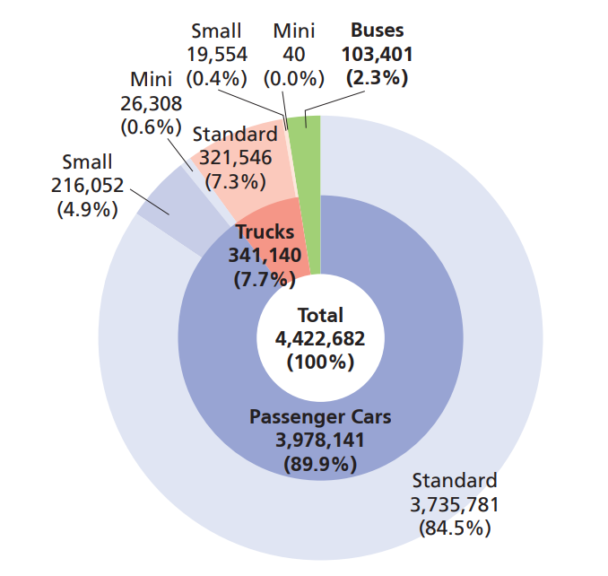
Source: (JAMA, 2024)
Scope: The scope of the Japanese EV industry extends beyond vehicle manufacturing and covering battery production or charging infrastructure deployment. For example, Japan has actively expanded its global trade footprint through economic partnership agreements (EPAs) and free trade agreements (FTAs) which makes it possible to abolish custom tariffs and thereby liberalise in facilitating trade and better investment in EV segment.

Figure 2: Japan's wider policies over EPAs and FTAs

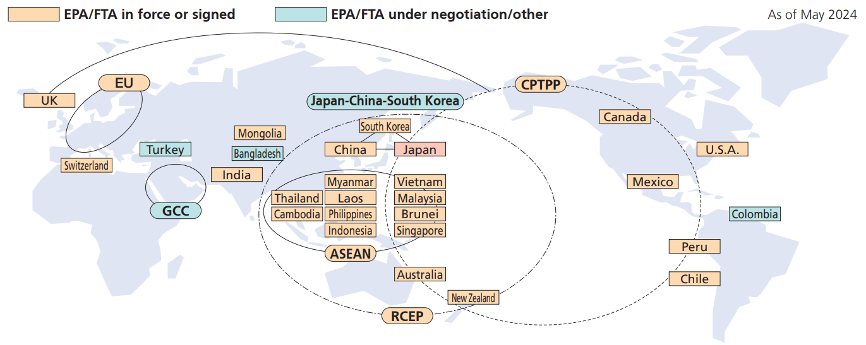
Source: (JAMA, 2024)
One use of such a framework could be Japan's involvement with the Comprehensive and Progressive Agreement for Trans-Pacific Partnership (CPTPP) which can help the Japanese automobile market to thrive better with exporting in-demand models (JAMA, 2024).
Economic importance: Japan's EV industry is currently going through a transition of traditionally being a mature automotive sector toward an emerging EV growth phase because of the structural shift in policies taken widely in Japan. For example, Koido (2024) finds the Japanese economy is reliant on the auto-making industry which accounts 15% of industrial production as the EV transition would bring a huge impact on current supply chain structure. The limited impact could only happen in case hybrid vehicles retain as high a share of production as the Japanese government currently expects. However, a smooth reallocation of labour across industries could be imperative for the transition to work successfully in the Japanese automotive industry.

c. Identifying major domestic & multinational firms operating in Japan’s EV automotive industry with relative positioning
Domestic firms operating in Japan’s EV automotive industry
Relative Positioning: Domestic EV market in Japan, led by key market players such as Nissan and Toyota currently focus on hybrid-first strategy. For example, Toyota Europe (2025) reports Toyota uses a multi-path electrification strategy with battery electric vehicles (BEVs), hybrids, and plug-in hybrids where the future plan of the company is to add 10 BEV models by 2026 and produce one million EVs annually.
Marketing strategies: Industry-wide, domestic firms focus on reliability and fuel efficiency by transitioning into electrification of automobile vehicles which allow Japanese domestic car manufacturers to promote hybrid models as a better practical alternative to BEVs. As a result, Kim et al. (2026) reports Honda’s vision of investing approximately $64 billion through 2030 for accelerating electrification efforts.
EV Automotive market share: Despite largely dominating the total automotive industry of Japan, domestic firms by margin fall behind adoption for EV segment. Falling behind competitively weaker EV adoption can be reported with EV sales in Japan registering less than 2% of total vehicle sales in 2024 (Kim et al., 2026) .
Target market segments in the industry: Domestic EV companies focus on targeting cost-conscious customers as the sales are aimed to promote EV transition marketed as benefit of autonomous driving, connected car solutions and cutting-edge safety systems for local Japanese customers (Vynn Capital, 2024).
Multinational firms operating in Japan’s EV automotive industry
Relative Positioning: In contrast to domestic manufactures, international firms like Tesla and BYD are adopting a technology-driven BEV-centric adoption, particularly where Asia (2025) reports BYD to accumulate sales over BEV and plug-in hybrid electric vehicle (PHEV) sales in Japan.
Marketing strategies: Asia (2025) reports that Japan lags behind other countries in its uptake of EVs where share of all sales for Chinese EV company BYD was registered at 1.9% in 2025, compared to its native Chinese market of a share around 54.8%. Therefore, many multinational manufacturing companies seek EV adoption to be marketed with innovation-led branding to push for stronger sustainability narratives and digital-first sales approach.
EV Automotive market share: Japan's automotive market has been dominated largely by popular domestic automotive brands with products such as Nissan LEAF, Toyota Prius, out of which Nissan remains a market leader in Japan's EV sector controlling about 50% of the market share (Phoon, 2025). This is where foreign brands can challenge EV-specific demand despite limited EV exposure in Japan.
Target market segments in the industry: International brands can consider the premium-luxury segment in addition with the emerging price-sensitive segment in Japan through competitive price modelling to challenge competitiveness on domestic auto-manufacturers.

3. Application of Michael Porter’s Diamond Model of National Advantage
Porter's Diamond Model, as defined by Hattangadi (2025), examines how each nation can have the capability to create competitive advantage unique to its own landscape for specific industries that typically can consider six factors. These include:
Figure 3: Michael Porter’s Diamond Model
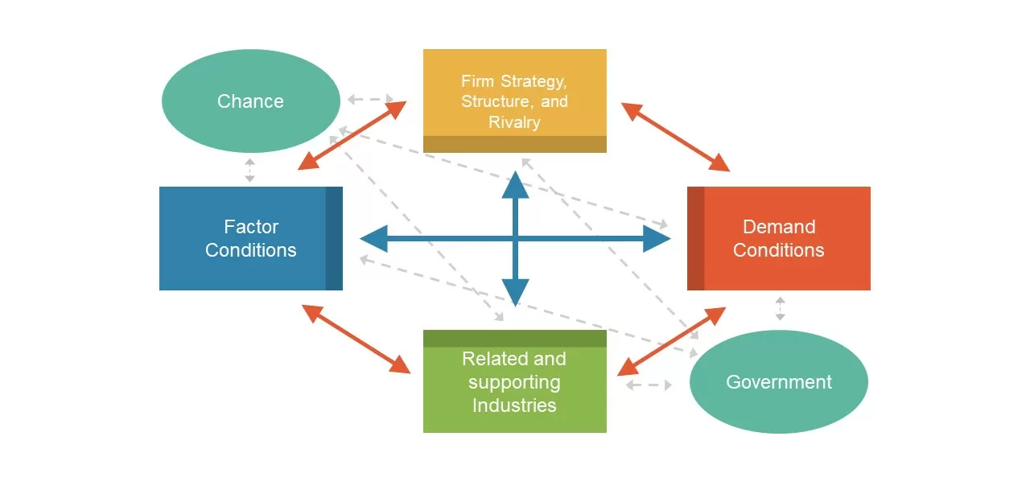
Source: (Hattangadi, 2025)

a. Factor conditions
The Japanese automotive industry comprises advanced manufacturing capabilities because of skilled labour force and technological expertise of year-on-year autocar manufacturing experiences. To put it simply, historically Japan has been once the leader of the global automotive industry. Before World War II, Japan had an underdeveloped automobile industry which produced fewer than 18,000 passenger cars when put into comparison with millions of passenger cars produced in the U.S. (EBSCO, 2024). However, the post-war era spurred economic growth and increased demand for vehicles which eventually allowed the Japanese automotive industry to emerge as one of the world’s leading sectors where prominent manufacturers like Toyota and Nissan came. Still, in specific to the EV market segment, the advantages could be uneven because even though Japan is one of the leading manufacturers in hybrid and battery component technologies, Japan still lags behind other nations in large-scale BEV production and battery cost competitiveness. This could be reflected in the reports of Qazinform.com (2026) that found limited charging networks across Japanese cities contribute to weaker demand growth of EVs. For example, Qazinform.com (2026) reports sales of electric vehicles in Japan in 2025 only increased by 1.6% from the previous years to around more sales of 60,677 units annually. Even though the traditional automotive market segment is strong in Japan, EV-specific factors such as newer infrastructure of charging components, wider availability of battery scale in EVs and software integration could be comparatively underdeveloped to developed countries (i.e., US or EU) and developing economies like China.

b. Demand conditions
Unlike China or EU markets, the EV market segment in Japan has been relatively weaker and more conservative in nature. While reports of IEA (2025) state future projections of Japan's sales to increase from 3% of total global sales of light-duty vehicles (LDVs) in 2024 to 20% by 2030, it is important to understand the preference of Japanese consumers of hybrid model could be mostly because of cost-efficiency and convenience of use. Recent reports of Makers Momentum (2026) discovers that vehicle Original Equipment Manufacturers (OEMs) have been a positive growth story in Japan where Japanese automobiles launched high integrated and compact electric drive units in 2024. These vehicle platforms launched in 2024 specifically featured innovative motor and inverted design to achieve 15% reduction in overall system weight and 10% increase in power density (Makers Momentum, 2026). It is important to note here that as the EV adoption remains marginal, the global trend of EV segment can put domestic demand under an impression which can put pressure on local firms to innovate aggressively in BEVs. As a result, the demand market is estimated to reach significant market growth by 2030 where demand-driven innovation for the advanced EV market would allow Japan to also compete in global standards.

c. Related and supporting industries
The Japanese EV market can benefit from a highly-developed ecosystem of automotive suppliers, electronic firms and supporting infrastructure of battery manufacturers. Strong collaboration between companies involved in battery production could be helpful in supply chain management for EV production that can contribute significantly to the growth of the EV production and distribution market in Japan. As IMARC Group (2025) reports, the battery industry of Japan is currently volume at 89.1 GWh in 2025 which is expected to grow up to 246.1 GWh by 2034 which would record a growth rate of 11.6% between 2026-2034.
Figure 4: Forecast of industry-level EV battery manufacturing in Japan
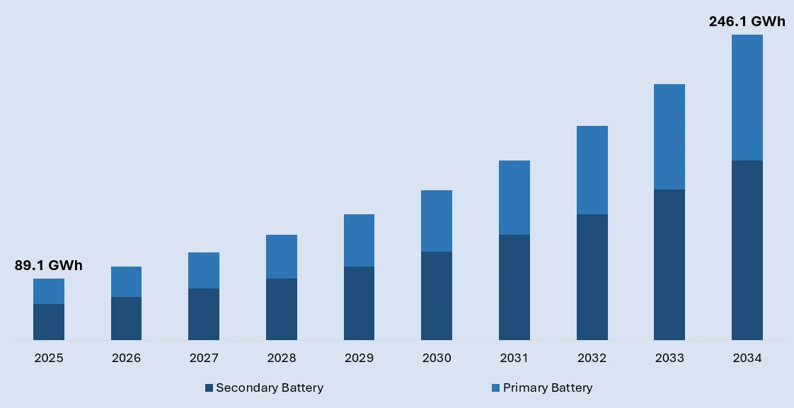
Source: (IMARC Group, 2025)
It would be important to consider here how the EV supply chain can expand rapidly where companies like Panasonic Corporation is reported to designate its Wakayama factory as the global mother factory for 4680-format cell development by 2031 (IMARC Group, 2025). These emerging trends in battery manufacturing and efficient supply chain management can build a supportive ecosystem for the EV market to grow exponentially in future and present a stronger competitive position aligned to global standards.

d. Firm strategy, structure and rivalry
The Japanese market can be characterised by a conservative approach with limited opportunity for domestic rivalry in BEVs. This is why Leussink (2025) reported how Japan’s Honda in May 2025 announced to scale back on electric vehicles, focusing on hybrid sales instead. The announcement for launching 13 next-generation hybrid models by 2027 reflects on the idea of how amidst the intensified global EV competition, the Japanese EV market has significantly fallen behind. This can also be seen associated with Leussink (2025) claiming Nissan’s decision to abandon an EV plant to build a $1.1 billion battery factory on Japan's island of Kyushu instead, one month after announcing the project.

e. Role of government
According to METI (2024), the Japanese government approved Clean Energy Vehicles (CEV) subsidies in 2024 under which the government allotted a budget of ¥129.1 billion, out of which ¥850,000 was specifically introduced for the EV segment. Tomoshige (2025) even reports the efforts of the Japanese government to popularise EV sales with subsidies as high as ¥900k ($6.12k) in 2025 to promote the EV sale, lowering customer cost in presenting strong competitive advantage to domestic EV manufacturers.

f. Role of Chance
With reports of IEA (2025) revealing global EV sales registering 17 million, increasing at a rate of 25% to sell more than 3.5 million cars in a year, it would naturally outpace the domestic transition of Japan. The growth primarily led by China and Europe intensifies competitive pressure on Japan which could put local automotive manufacturers seeking possible ways to leverage the global EV growth with investing more capital on EV segment growth in Japan.

4. Identifying one MNCs/TNCs operating in the Japanese Automotive Industry

4.1 MNC overview with global footprint: Mercedes-Benz
Mercedes-Benz is one of the successful German automotive companies that manufactures high-end EV passenger cars and premium vans. The company was founded by Carl Benz and Gottlieb Daimler in 1886. The investment in energy-efficient powertrains sets a transition course to an all-electric future. The company is headquartered in Germany with a total workforce of 164,000 in 2025. The EV production facilities of Mercedes-Benz were in Asia, Africa, Latin America, North America and Europe. By geographical distribution of company revenue, it is observed that Europe had the biggest share (40.4%), followed by Asia (27.2%), North America (26.7%) and other markets (5.7%) in 2025.

Figure 5. Geographical distribution of Mercedes-Benz revenue in 2025
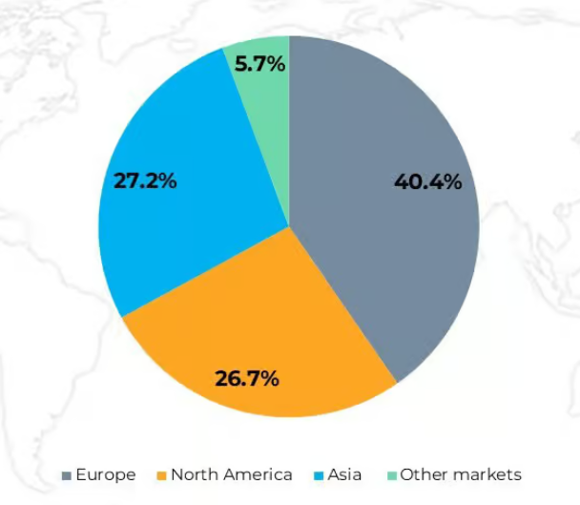
Source: (Market.us, 2025)
In terms of production performance, Figure shows that more than 2.1 million vehicles were sold in 2025, resulting in a net revenue of €132.2 billion and group EBIT rose to €5.8 billion in 2025 (Mercedes-Benz Group, 2024). In Quarter 4 of 2025, the global sales of BEVs (Battery Electric Vehicle) at Mercedes-Benz increased by 3%. Additionally, the global sales of PHEV increased to 368,600 (9% increase in 2025 in comparison to last year) (Mercedes-Benz Group, 2026). Region-wise, the highest sales share of EV achieved by Mercedes-Benz in Europe in 2025 (40% share in 2025) (Mercedes-Benz Group, 2026).

Figure 6. The 2025 performance of Mercedes-Benz globally

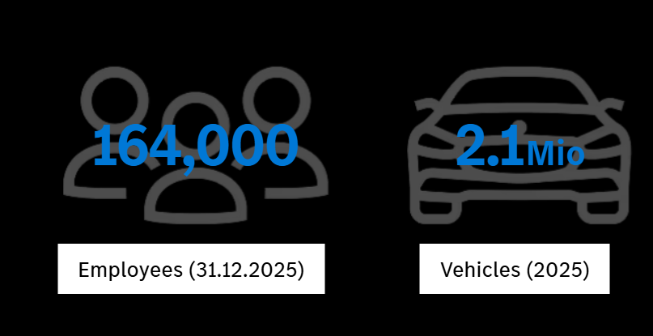
Source: (Mercedes-Benz Group, 2024)

4.2 Critical evaluation of factors impacting success of chosen MNC’s operation in Japan’s EV automotive sector
External factors
Table 1: STEEPLED framework
Factors | Description | Threat or Opportunity for Mercedes-Benz in the Japanese Automotive Industry
Social | - Persistent demand for hybrid EVs and growing numbers of environmentally conscious consumers in Japan (Chen, Khattak and Ahmad, 2024).  - The EV market in Japan is currently growing at 15.58% CAGR to reach a future valuation of USD 111.10 billion by 2030 (Richards, 2025).  - Growing Environmental consciousness in Japan driven EV sales of Mercedes-Benz in Japan | Opportunity
Technological | - Fast-charging EV stations in Japan accounted for only one-third of total gas stations (Xu et al., 2025).  - Only 9,237 fast-charging EV gas stations, resulting in road-level charging gaps (Xu et al., 2025).  - Insufficient charging infrastructure in Japan might act as barriers to selling Mercedes-Benz EVs in Japan. | Threat
Economical | - The Inflation rate in Japan in 2024 was 2.74% and in comparison to last year, there was a sharp decline of 0.53% (Macrotrends, 2024).  - Purchasing Power Parity (PPP) reached a maximum valuation of USD 460.97.43 USD in 2024 (Trading Economics, 2025).  - Low inflation rate and growing purchasing power parity improve the acceptance of high-end Mercedes-Benz EVs and also reduce manufacturing costs for the company. | Opportunity
Environmental | - The electrification technology and sustainable batteries used in EVs reduce the environmental impact of the Japanese automotive industry by 2.4% (Rinawati et al., 2025).  - Still, 60% of CO2 is emitted from the batteries used in BEVs and PHEVs (Nikkei Asia, 2023).  - More eco-conscious customers in Japan are motivated to buy sustainable EVs from Mercedes-Benz; however, the average CO2 emitted from the batteries acts as a hurdle. | Opportunity and Threat
Political | - The Japanese Government introduced subsidies, a maximum of 550,000 yen for a unit of PHEV and a maximum of 850,000 yen for a unit of EV (METI, 2024).  - The rise in tariffs by the Trump Administration in the US forced EV makers in Japan to downgrade the production (Katz, 2026).  - The subsidies will encourage Japanese customers to purchase EVs; however, a rise in tariffs might slow down the EV production at Mercedes-Benz in Japan, hence widening the supply-demand gap in Japan. | Opportunity and Threat
Legal | - New standards for safety and emissions of Passenger EVs were introduced by METI in Japan in 2020 (Road Transport Bureau, 2026).  - Strong emissions regulation for heavy-duty EV vehicles and provision for Net Zero Emission Powertruck.  - Mercedes-Benz was negatively impacted by the changing emissions and safety guidelines in Japan, raising its legal liabilities. | Threat
Demographic | - The aging population and low birth rates in Japan are pushing the demand for low-environmental impact EV transportation.  - Mercedes-Benz capitalised on the growth opportunities levied by urbanisation and the aging population in Japan. | Opportunity
Source: (Self-created)

Internal factors: SWOT
Table 2. SWOT Analysis on Mercedes-Benz
Strengths | Weaknesses
- Strong brand heritage of Mercedes-Benz and thoroughly supported by safety prioritisation, design elegance and engineering precision.  - In terms of EV sales in 2025, Mercedes-Benz comes in the top 11th position in Japan (Bekker, 2026).  - The automaker invested €8.6 billion in R&D of Mercedes-Benz Cars and €1.1 billion in Mercedes-Benz Vans in 2025 (Mercedes-benz, 2025).  - The robust qq distribution network and joint ventures of Mercedes-Benz with MB Service Japan Co. (33.40 equity stake) strengthened its local awareness (Mercedes-benz, 2025). | - Mercedes-Benz forces to delay the all-electric car goal in Japan due to supply chain bottlenecks, US-China Trade tensions and slower economic growth (Waldersee, 2024).  - Battery-electric car sales dropped by 25% due to high production costs, low-margin and premium-pricing strategy constraining its scale to mass markets (CBT News, 2025).  - Aggressive pricing policies by the competitors put enormous pressure on Mercedes-Benz to offer discounts in its premium EV models, hence, reducing the profitability (Mercedes-benz, 2025).  - The late entry of Mercedes-Benz in the Japan EV market, currently stands at 11th position in the Japanese EV market in terms of sales (Bekker, 2026).
Opportunities | Threats
- Growing demand for EV Market globally, for example, the EV market in Japan aims to reach a future valuation of USD 79,043.4 million by 2030 (Grand View Research, 2025).  - Japanese customers are slowly transitioning from combustion vehicles to EVs due to significantly less environmental impact (Statista, 2023).  - Reduce the cultural distance between host and home markets through partnerships and collaboration. | - Limited growth opportunities for the foreign EV automarkers in Japan.  - The majority of car registration share in Japan is occupied by Toyota (32.6%), followed by Suzuki (16%), Honda (15.3%), Daihatsu (9.4%) in 2025 (Tomoshige, 2025).  - Protectionist policies against China, Germany and other foreign markets, might raise the entry barriers and operational costs for foreign EV manufacturers.
Source: (Self-created)

4.3 Market entry strategy chosen by Mercedes-Benz into Japan’s EV Automotive industry with justification

Mercedes-Benzformed a Joint Venture strategy to establish a new subsidiary, MB Service Japan Co. in Hitachi in 1986 using the equity method (Mercedes-Benz Group, 2025). For example, 33.40% equity (majority) of the subsidiary is owned by Mercedes-Benz AG (Mercedes-benz, 2025). Apart from that, the company formed strategic partnerships with PowerX to establish a robust high-power charging network in Japan. The entry mode strategy helped in minimising the risk of entry barriers and wrong market fit for Mercedes-Benz. The above argument is also supported by Hennart (2022), which highlighted that joint venture strategy between local and foreign firms ease the transition of intangibles and local complementary sources in the foreign markets. For example, PowerX Inc. has adequate knowledge of the EV owners' need for fast-charging in Japan (PowerX, Inc., 2024). Thus, the decision of leading the operation and rolling out of the charging stations helped to scale the charging port infrastructure in Japan. For example, PowerX committed to expand the existing charging stations for BEVs and PHEVs beyond 100 charging ports and 25 locations in the next two years (PowerX, Inc., 2024). The above strategic announcement was made on G 580 with the EQ Technology Launch event held on October 23rd, 2024 (see Figure 7).

Figure 7. Strategic partnership of Mercedes-Benz with PowerX in 2024
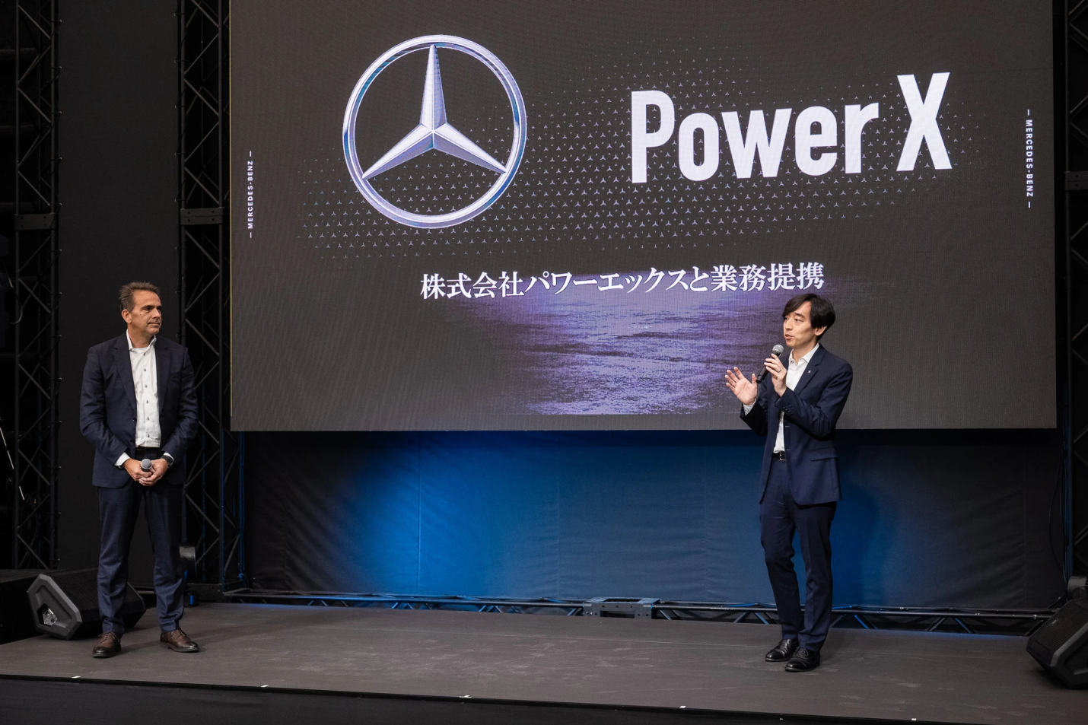
Source: (PowerX, Inc., 2024)

4.4 Strategic motives of chosen MNC in Japan
Target EV Market segmentation, positioning and marketing strategies
Mercedes-Benz segmented the consumers of premium EVs into executives, high-income professionals and business founders to sell its EV cars. For example, Tanja Bauer owns a Mercedes-Benz EV model and also has a stake in the company worth $151 million (More and Wissenbach, 2026). Simultaneously, Tadashi Yanai, the founder of Fast Retailing also owns a Mercedes-Maybach G650 Landaulet SUV (The Wire, 2026). In terms of Psychographic and Geographic attributes, Mercedes-Benz targeted the eco-conscious customers, who seek luxury as well as high performance experience in the urban areas of Japan. The brand positioned Mercedes-Benz ELF as an e-mobility luxury electric drive with Vehicle-to-X, Ultra-fast charging and automated solar charging (see Figure 8) (Group, 2025a).

Figure 8. Positioning Statement of Mercedes-Benz ELF in 2025
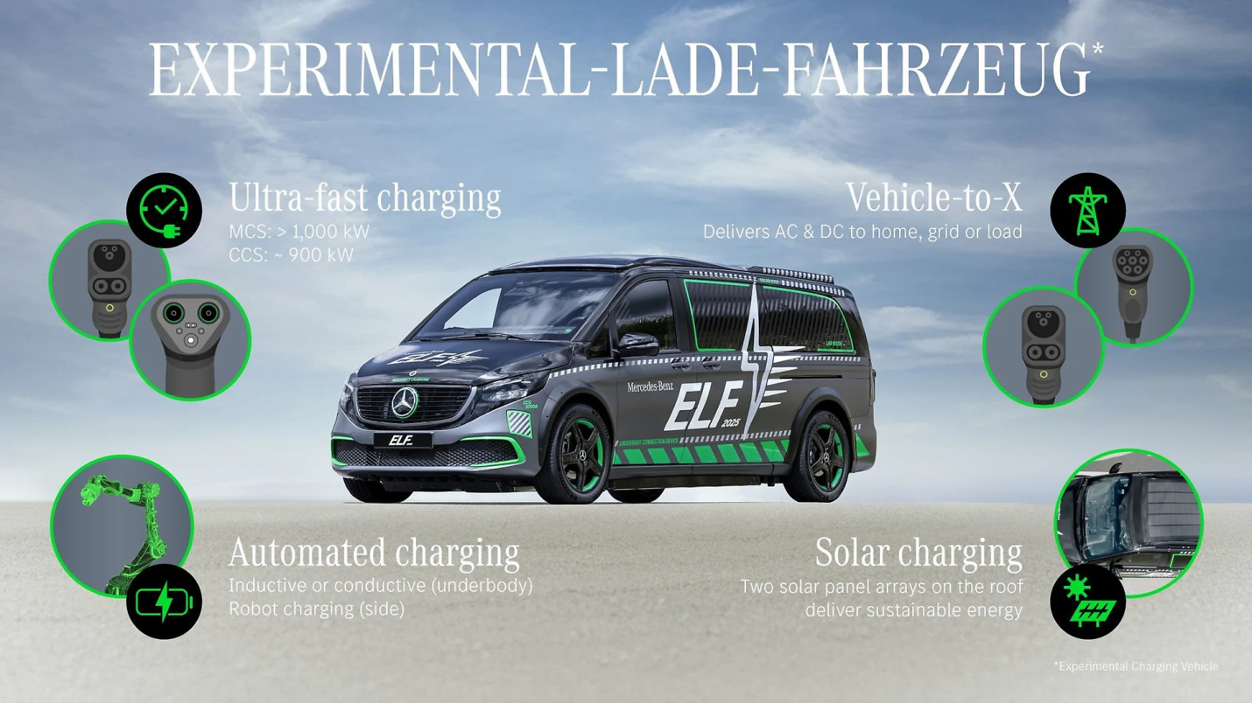
Source: (Group, 2025a)
The marketing strategies adopted by Mercedes-Benz is the mix of User Generated Content and digital marketing. For example, the Figure below shows that Mercedes uses its user-generated purchasing videos (Jozelle Diaz) for increasing the awareness of Mercedes G Wagon in Japan.

Figure 9: User-generated Content and Word-of-mouth communication by Mercedes-Benz

Source: (Instagram, 2026)
Resource seeking
Table 3: VRIO
Resource/Capabilities | Valuable | Rarity | Costly to imitate | Organisation to exploit | Competitive Advantage
Global Brand Identity | Yes | Yes | No | No | Competitive Parity
Distribution Network | Yes | No | No | Yes | Temporary competitive advantage
R&D resources | Yes | Yes | Yes | Yes | Sustainable Competitive Advantage
Craftsmanship and Quality | Yes | Yes | Yes | Yes | Sustainable Competitive Advantage
Source: (Self-created)
Analysis:
The global brand identity of Mercedes-Benz and robust distribution network merely tackled the risk company faced with its late entry into the Japanese EV Market. Additionally, the domestic protection policies of Japan put a less favour on the distribution network and global brand popularity of Mercedes-Benz. On the other hand, R&D investment and German Craftsmanship and Quality collectively contributed to sustainable competitive advantage for Mercedes-Benz in Japan. For example, Mercedes-Benz still remained as the largest foreign EV brand in comparison to BMW, Audi and Volkswagen in Japan in 2024 (Bekker, 2025)
Efficiency seeking
The brand uses intelligent modularisation, lean supply chain to optimise the production efficiency and maintaining the profitability at the highest level.

4.5 Factors that led to success of MNC’s in Japan
Core strategy used by Mercedes-Benz to internationalise into Japan using Ansoff matrix
Table 4. Ansoff Matrix strategy chosen
Market Development
- Mercedes-Benz sold its existing 1 million C-Class EV model in Japan, the sales figures growth by 3%, specifically from 43,000 units to 1 million units (Autointell.net, 2024).
- Mercedes-Benz used its owned subsidiary company, MB. Service Japan Co. to sell its EV models to the targeted Japanese eco-conscious customers.
Source: (Self-created)
Analysis:
From the Ansoff Matrix, it is interpreted that Mercedes-Benz used a joint venture strategy to establish its subsidiary unit (MB. Service Japan Co.) in Hitachi. The brand further used market development strategy to sell its existing C-Class EV model to Japan customers. For example, the sales figures of Mercedes-Benz C-Class increased from 43,000 units to million units in 3% (Autointell.net, 2024). In terms of effectiveness, the market development strategy strongly positioned Mercedes-Benz as the leading foreign EV brand in Japan in 2024-25.
CAGE analysis: evaluating attractiveness of Japan’s EV automotive industry for chosen MNC
Cultural Distance: The headquarters staff of Mercedes-Benz are accustomed with German or English language. Worlddata.info (2026) observed that Japanese is spoken by 122.86 million native speakers in Japan. As a result, the brand had to hire local staff in Japan to set up the subsidiary, Mercedes Benz (MB.) Service Japan Co.
Administrative Distance: The Euro gained 4% in comparison to Japanese Yen in 2025 (Mercedes-Benz, 2025). The strong position of the Euro in comparison to the Japanese Yen strengthens the financial position of Mercedes Benz in Japan. However, the fluctuating range of Yen from 155 to 175 yen per euro might have increased the degree of uncertainty in outsourcing internal resources from Germany to Japan.
Geographic Distance: There is a significant timezone difference between Japan and Germany, as a result Mercedes-Benz introduced the concept of managing time zones in its Owners’ Manual. For example, the staff could select from the automated time zone entry from the operating country list at Mercedes-Benz (Mercedes-Benz, 2026).
Economic Distance: The cost-of-living in Germany is approximately 42.4% higher than that of Japan (Numbeo, 2026). However, Mercedes-Benz also aimed to reduce the labour wages and production by 10% by 2030, under Mercedes-Benz’s cost-cutting measures (Mondal, 2025).

5. Conclusion to the report
The report has demonstrated the EV automotive industry of Japan which is currently going through a slow-paced transition. Even with strategic market positioning to align with the global competitive landscape, the report reveals that Japan's EV market segment still remains highly conservative, focusing more on selling hybrid car models because of the local preference of Japanese customers over EV models due to cost-efficiency and convenience-of-use. The report through the use of Porter's Diamond Model refers to how strong traditional advantages in the automotive industry through established supply chains, advanced manufacturing capabilities and globally-recognised firms such as Toyota, Honda or Nissan could be leveraged in the EV segment as well. Therefore, the internationalisation of Mercedes-Benz to Japan should value quality engineering and brand prestige to lean toward joint venture strategy in building new subsidiaries. This could possibly allow foreign companies like Mercedes-Benz to build new infrastructure such as improved charging options and can label EV infrastructure developments as convenience to promote the use of premium EV models to Japanese customers.

Section 2:

Introducing the reflective model: Gibbs reflective cycle
Graham Gibbs introduced the six-phase reflective model in 1988, which allows people to reflect on their experiences to define their strengths and weaknesses. The stages in the reflective model include description (things that happened during the situation), feelings (feelings they had during or after the situation), evaluation (value judgments of good and bad experiences), analysis (sense-making procedure of reflection), conclusion (findings from their evaluation & analysis), and action plan (future improvement plans) (Chiarelli and Parrish, 2025). Therefore, the use of this reflective model helped me to reflect on my experiences in completing the above section of this assessment.
Figure 10. Gibbs’ Reflective Cycle
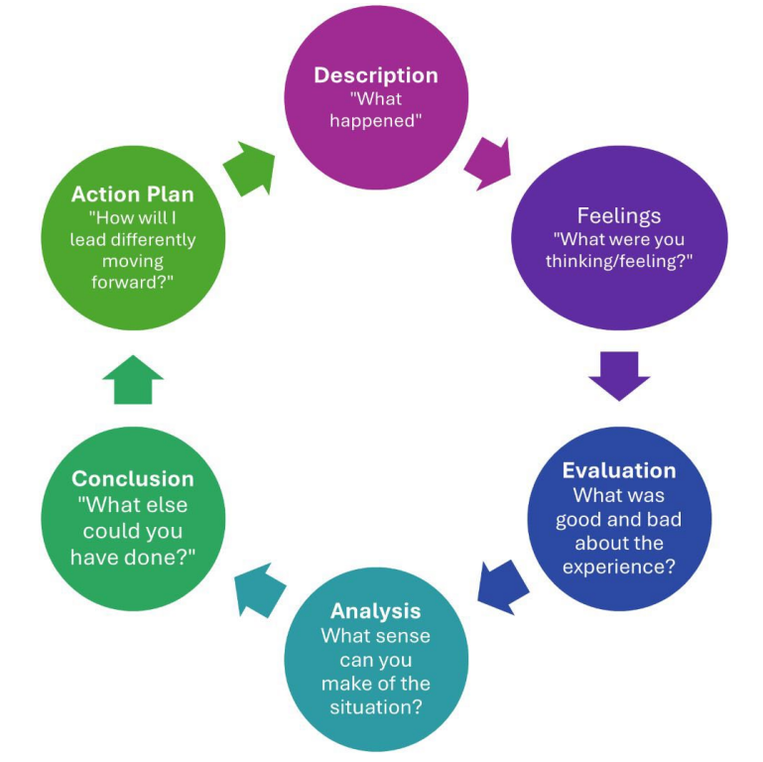
Source: (Chiarelli and Parrish, 2025)

Gibbs reflective cycle in reflecting on my process in researching, analysing, and preparing the previous section of the assessment
Description:
The first section of the current assessment is based on exploring the automotive sector of Japan through the integration of various strategic frameworks, including the Diamond model by Michael Porter (Muhammad and Hussain, 2025) and STEEPLED analysis (Sivula et al., 2025), in order to evaluate the external environment of the market for Mercedes-Benz. Moreover, the internal environment analysis frameworks, such as SWOT & VRIO, are also used to analyse the internal capabilities (Larbi, Asare-Danquah and Akua, 2024) of Mercedes-Benz to enter the Japanese automotive market. The Ansoff Matrix strategy has also highlighted that the market entry strategy and approach for the company to ensure the successful expansion of the business in Japan (Ferreira and Marques, 2024). The CAGE framework also helped in exploring the differences between the home country and the host country of the organisation (Li et al., 2023). The primary concept of this assessment was focused on investigating the complex operations and competition in the automotive market of Japan, where the findings showed that the country has become one of the top hubs for automotive businesses due to the external environment drivers, development factors, and market structure.
Perceptions:
During this assessment, I was very excited and motivated, as I think that I will be able to improve my knowledge and ability to apply several strategic frameworks for analysing the market conditions and capabilities of Mercedes-Benz for its expansion into Japan. However, I was also feeling saturated and nervous due to the topic complexity, as I have to organise information coherently for this broad subject. Although I was able to research and analyse the competitive landscape and opportunities for Mercedes-Benz in the automotive market of Japan, I have a reasonable and moderate understanding of the complementarity of these frameworks. In terms of applying Porter’s diamond model, I was able to understand the factors that contribute to the increased revenue of the automotive sector in Japan. After the completion of the study, I was feeling confident in my analytical and research skills, which enabled me to obtain an in-depth knowledge of the Japanese automotive sector, as well as the application of theories and models in assessing the conditions in the international market.

Evaluation:
This assessment provided me with an opportunity to apply theoretical models, such as the STEEPLED framework and Porter’s Diamond Model, with practical industry insights in terms of assessing the driving factors and restraints for Mercedes-Benz in Japan’s automotive sector. This helped me in developing my views on diverse strategic and competitive prospects related to the Japanese automotive industry. I have also used credible and valid industry, government, statistical, and academic reports in order to assist my evaluation of the market. I faced issues in accessing and evaluating recent data linked to the operations of Mercedes-Benz in the Japanese market, as most of the sources provided generic information, where a lack of detailed and in-depth information affected the quality of my work. I was also struggling with structuring the report and maintaining the word count of the assessment, which has also impacted the detailed evaluation of the topic with in-depth writing.
Analysis:
In this assessment, I have examined that these strategic frameworks helped me in evaluating the marketing opportunities and threats for Mercedes-Benz to expand its operations in Japan. Porter’s Diamond Model helped me in assessing the factor conditions (technological expertise and a skilled labour force), demand conditions (EV market segment and vehicle OEMs growth), and supporting & related industries (battery manufacturers, automotive suppliers, and electronic firms) in Japan to assess the expansion scope for Mercedes-Benz. STEEPLED analysis highlighted social (growing hybrid EVs and environmental consciousness in Japan), technological (insufficient charging infrastructure), economic (low inflation rate & high PPP), environmental (sustainable batteries and electrification technology), political (subsidies and tariffs), legal (new safety and emission standards), and demographic (low birth rates and aging population) factors of Japan. The CAGE framework analysis also indicated the differences between Japan and Germany based on cultural, administrative, geographic, and economic factors. The SWOT analysis revealed Mercedes-Benz’s strengths & weaknesses, whereas the Ansoff Matrix highlighted that the market development approach based on the joint venture market entry strategy can foster its expansion into the Japanese market.
Conclusion:
Based on the above discussion, it can be inferred that the previous section provided valuable insights in terms of developing my knowledge of the global automotive sector, as well as the business approaches that can be suitable for Mercedes-Benz to enter the automotive market of Japan. The use of the strategic models and frameworks offered me a systematic plan and process to complete my study on identifying the industry determination linked to Japan’s automotive sector, along with improving my academic writing, research, and critical thinking skills. I have also identified my weaknesses as poor stress management, time management, and problem-solving skills.
Action plan:
I have used my effective research & analytical skills to collect relevant and reliable information from academic journals, websites, news articles, and industry reports to improve the quality of the study results. However, I have to strengthen my stress management capabilities in order to stay active in every situation and control stress in my work. I will focus on active planning, acceptance, and coping strategies, as these approaches help to manage students’ stress in their academic work (Waterhouse and Samra, 2025). I will also improve my problem-solving skills through the incorporation of instructional strategies in my work (Musengimana et al., 2025). Moreover, the use of goal-setting, planning, and prioritisation practices helps students to improve their time management skills (Patzak, Zhang and Vytasek, 2025). Therefore, I will consider these tactics to improve my above skills by the end of 2026 to get more opportunities and improve my performance.

References
Asia, N. (2025). China’s BYD expands Japan sales network to promote brand trust. [online] KrASIA. Available at: https://kr-asia.com/chinas-byd-expands-japan-sales-network-to-promote-brand-trust.
Autointell.net. (2024). Mercedes Car Group: Historic Sales & Production Figures. [online] Available at: https://www.autointell.net/nao_companies/daimlerchrysler/dc-business-figures/mercedes-benz-sales/mcg-sales-historic.htm.
Bekker, H. (2025). 2024 (Full Year) Japan: Best-Selling Carmakers, Brands and Market Analysis - Car Sales Statistics. [online] Best-selling-cars.com. Available at: https://www.best-selling-cars.com/japan/2024-full-year-japan-best-selling-carmakers-brands-and-market-analysis/.
Bekker, H. (2026). Japan Best-Selling Carmakers and Brands – Full Year 2025. [online] Best-selling-cars.com. Available at: https://www.best-selling-cars.com/japan/2025-full-year-japan-best-selling-carmakers-brands-and-market-analysis/.
CBT News (2025). Mercedes-Benz announced plans to cut costs and expand its lineup. [online] CBT News. Available at: https://www.cbtnews.com/mercedes-benz-announced-plans-to-cut-costs-and-expand-its-lineup/.
Chen, Q., Khattak, S.I. and Ahmad, M. (2024). Impact of innovation in hybrid electric vehicles‐related technologies on carbon dioxide emissions from the transport sector in Japan. Natural Resources Forum. doi:https://doi.org/10.1111/1477-8947.12523.
Chiarelli, C. and Parrish, A. (2025). The Use of Reflection as an Effective Leadership Practice: An Overview of Two Reflection Models: AEC831/WC493, 12/2025. EDIS, 2025(6). doi:https://doi.org/10.32473/EDIS-WC493-2025.
EBSCO. (2024). Japan Becomes the World’s Largest Automobile Producer | EBSCO. [online] Available at: https://www.ebsco.com/research-starters/history/japan-becomes-worlds-largest-automobile-producer.
Ferreira, A. and Marques, M.B. (2024). The Importance of the Ansoff Matrix for the Study of the Information Services Market. Canadian Journal of Information and Library Science. [online] Available at: https://www.researchgate.net/publication/382141729_The_Importance_of_the_Ansoff_Matrix_for_the_Study_of_the_Information_Services_Market.
Geels, F.W., Stegen, K.S., Trencher, G. and Wells, P. (2026). The temporal evolution of resistance strategies during low-carbon transitions: Revealing the industry playbook of US, German, and Japanese automakers in the unfolding electric vehicle transition (1990–2025). Energy Research & Social Science, 131, p.104492. doi:https://doi.org/10.1016/j.erss.2025.104492.
Grand View Research (2025). Japan Electric Vehicle Market Size & Outlook, 2030. [online] Grandviewresearch.com. Available at: https://www.grandviewresearch.com/horizon/outlook/electric-vehicle-market/japan.
Group, M.-B. (2025a). Mercedes-Benz Group. [online] Mercedes-Benz Group. Available at: https://group.mercedes-benz.com/technology/e-mobility/electric-drive/elf.html.
Hattangadi, V. (2025). Porter’s Diamond Model. [online] Available at: https://rsisinternational.org/journals/ijrias/DigitalLibrary/volume-10-issue-6/690-693.pdf.
Hennart, J.-F. (2022). How Much Is New in Brouthers Et al.’s New Foreign Entry modes, and Do They Challenge the Transaction Cost Theory of Entry Mode choice? Journal of International Business Studies, 53(9). doi:https://doi.org/10.1057/s41267-022-00523-9.
IEA. (2025). Outlook for electric mobility – global EV outlook 2025 – analysis - IEA. [online] IEA. Available at: https://www.iea.org/reports/global-ev-outlook-2025/outlook-for-electric-mobility.
IEA. (2025). Trends in electric car markets – Global EV Outlook 2025. [online] IEA. Available at: https://www.iea.org/reports/global-ev-outlook-2025/trends-in-electric-car-markets-2.
IMARC Group. (2025). Japan Battery Market Size, Share, Demand and Forecast 2034. [online] Available at: https://www.imarcgroup.com/japan-battery-market
Instagram. (2026). Mercedes Benz of Massapequa on Instagram: ‘Thank you @jozelle.diaznp for trusting us with your beautiful G Wagon purchase and welcome to the Mercedes-Benz of Massapequa family! #mercedes #mercedesbenz #gwagon #amg #cars’. [online] Available at: https://www.instagram.com/reel/DWZgTtUCZti/ [Accessed 18 Apr. 2026].
Japan Automobile Manufacturers Association (JAMA). (2024). The Motor Industry of Japan: 2024. [online] Available at: https://www.jama.or.jp/english/reports/docs/MIoJ2024_e.pdf
Johnson, E.M. (2025). Japanese Billionaire Set to be First Private Passenger on SpaceX Moon Flight. [online] The Wire. Available at: https://m.thewire.in/article/space/japanese-billionaire-set-to-be-first-private-passenger-on-spacex-moon-flight [Accessed 18 Apr. 2026].
Katz, R. (2026). Japan Caught In Crossfire Of Trump-China Trade War. [online] LinkedIn. Available at: https://www.linkedin.com/posts/richard-katz-937308204_japan-caught-in-crossfire-of-us-chinatrade-activity-7432957725204131841-qay3 [Accessed 18 Apr. 2026].
Kim, B., Gong, Y., Choi, W. and Kim, I. (2026). Electric vehicle charging ecosystems: Integrated review of infrastructure development and pricing mechanisms. Energy Strategy Reviews, 64, p.102149. doi:https://doi.org/10.1016/j.esr.2026.102149.
Koido, Y. (2024). EV shift could pose a big challenge to Japanese economy. [online] Oxford Economics. Available at: https://www.oxfordeconomics.com/resource/ev-shift-could-pose-a-big-challenge-to-japanese-economy/.
Larbi, A.O., Asare-Danquah, G.A. and Akua, A. (2024). Utilization of Internal Analysis with the VRIO Framework and Development of Scale for Resource and Capabilities of Fashion and Design Organization. International journal of research and scientific innovation, XI(VI), pp.63–70. doi:https://doi.org/10.51244/ijrsi.2024.1106006.
Leussink, D. (2025). Japan’s Honda to scale back on electric vehicles, focus on hybrids. Reuters. [online] 20 May. Available at: https://www.reuters.com/business/autos-transportation/japans-honda-scale-back-electric-vehicles-concentrate-hybrids-2025-05-20/.
Li, F., Chen, Y., Liu, L. and Zhuang, M. (2023). Do cross-national distances still affect the international penetration speed of digital innovation? The role of the global network effect. Heliyon, 9(3), p.e13911. doi:https://doi.org/10.1016/j.heliyon.2023.e13911.
Macrotrends (2024). Japan Inflation Rate 1960-2024. [online] Macrotrends.net. Available at: https://www.macrotrends.net/global-metrics/countries/JPN/japan/inflation-rate-cpi.
Makers Momentum. (2026). Japan Electric Drive system Market: Outlook and Future Scope. [online] Available at: https://www.linkedin.com/pulse/japan-electric-drive-system-market-outlook-future-scope-wf48c/
Market.us. (2025). Mercedes-Benz Group AG (Formerly Daimler AG) Statistics and Facts. [online] Available at: https://market.us/statistics/automotive-companies/mercedes-benz-statistics/.
Mercedes-benz (2025). Annual Report 2025. [online] Available at: https://group.mercedes-benz.com/documents/investors/reports/annual-report/mercedes-benz/mercedes-benz-annual-report-2025-incl-combined-management-report-mbg-ag.pdf.
Mercedes-Benz Group (2024). Mercedes-Benz Group at a Glance. [online] Mercedes-Benz Group. Available at: https://group.mercedes-benz.com/company/at-a-glance.html.
Mercedes-Benz Group (2026). Mercedes-Benz Group. [online] Mercedes-Benz Group. Available at: https://group.mercedes-benz.com/company/news/sales-2025.html.
Mercedes-Benz Group. (2025b). Mercedes-Benz Group. [online] Available at: https://group.mercedes-benz.com/careers/about-us/locations/location-detail-page-5192.html.
Mercedes-Benz. (2026). Mercedes-Benz Owner’s Manuals. [online] Available at: https://www.mercedes-benz.co.in/passengercars/services/manuals.html/maybach_gls-suv-2024-03-x167-mbux/time-and-date/setting-the-time-zone [Accessed 18 Apr. 2026].
METI (2024). Subsidies Upgraded for the Purchase of Clean Energy Vehicles toward the Realization of GX in the Automobile Sector. [online] Agency for Natural Resources and Energy,METI. Available at: https://www.enecho.meti.go.jp/en/category/special/article/detail_199.html.
METI. (2024). Subsidies Upgraded for the Purchase of Clean Energy Vehicles toward the Realization of GX in the Automobile Sector. [online] Agency for Natural Resources and Energy,METI. Available at: https://www.enecho.meti.go.jp/en/category/special/article/detail_199.html.
Mondal, A. (2025). Mercedes-Benz to cut costs amid industry challenges – report. [online] Just Auto. Available at: https://www.just-auto.com/news/mercedes-benz-cost-cutting-measures/.
More, R. and Wissenbach, I. (2026). Mercedes investors warn luxury focus could hamper China recovery. Reuters. [online] 16 Apr. Available at: https://www.reuters.com/business/retail-consumer/mercedes-aims-up-600000-unit-sales-per-year-china-mid-term-cfo-says-2026-04-16/.
Muhammad, N. and Hussain, M. (2025). Leveraging Porter’s Diamond Model: Public Sector Insights. The critical review of social sciences studies, 3(2), pp.2255–2271. doi:https://doi.org/10.59075/kkteax93.
Musengimana, T., Yadav, L.L., Uwamahoro, J. and Nizeyimana, G. (2025). Instructional strategies for enhancing students’ problem-solving skills in physics: a systematic review. Discover Education, 4(1). doi:https://doi.org/10.1007/s44217-025-00733-x.
Nikkei Asia. (2023). Japan to require disclosure of CO2 emitted by EV battery production. [online] Available at: https://asia.nikkei.com/Spotlight/Environment/Climate-Change/Japan-to-require-disclosure-of-CO2-emitted-by-EV-battery-production.
Numbeo (2026). Cost Of Living Comparison Between Japan And Germany. [online] www.numbeo.com. Available at: https://www.numbeo.com/cost-of-living/compare_countries_result.jsp?country1=Japan&country2=Germany.
Patzak, A., Zhang, X. and Vytasek, J. (2025). Boosting productivity and wellbeing through time management: evidence-based strategies for higher education and workforce development. Frontiers in Education, 10. doi:https://doi.org/10.3389/feduc.2025.1623228.
Phoon, M. (2025). BYD Outsells Toyota In Japan In 2024: A Turning Point In Japan’s EV Industry | EV.com. [online] Available at: https://ev.com/news/byd-outsells-toyota-in-japan-in-2024-a-turning-point-in-japans-ev-industry.
PowerX, Inc. (2024). PowerX and Mercedes-Benz Form Strategic Partnership to Build Out High-Power EV Charging Network in Japan - Newsroom - PowerX, Inc. [online] Available at: https://power-x.jp/intl/newsroom/2024-10-23 [Accessed 18 Apr. 2026].
Qazinform.com. (2026). Japan’s EV sales rise 1.6% in 2025, growth slows due to charging shortage. [online] Available at: https://qazinform.com/news/japans-ev-sales-rise-16-in-2025-growth-slows-due-to-charging-shortage-4ad3f9.
Richards, D. (2025). Japan’s EV Market Expected to Have Compound Annual Growth Rate (CAGR) of 15.58% by 2030 - Climate Scorecard. [online] Climate Scorecard. Available at: https://www.climatescorecard.org/2025/03/japans-ev-market-expected-to-have-compound-annual-growth-rate-cagr-of-15-58-by-2030/.
Rinawati, D.I., Keeley, A.R., Itsubo, N. and Managi, S. (2025). Beyond carbon: Environmental and social impacts of Japan’s vehicle electrification transition. Journal of Environmental Management, 383, pp.125509–125509. doi:https://doi.org/10.1016/j.jenvman.2025.125509.
Road Transport Bureau (2026). EV regulation in Japan. [online] Available at: https://wiki.unece.org/download/attachments/5801244/EVE-05-09e.pdf?api=v2.
Sivula, A., Siakas, K., Naaranoja, M. and Lampropoulos, G. (2025). A STEEPLE Analysis and Information Technology Professionals’ Interview Insights Regarding the Platform Economy. International Journal of Human Capital and Information Technology Professionals, 16(1), pp.1–28. doi:https://doi.org/10.4018/ijhcitp.394507.
Statista. (2023). Electric Vehicles - Japan | Statista Market Forecast. [online] Available at: https://www.statista.com/outlook/mmo/electric-vehicles/japan?srsltid=AfmBOoqC7Tm1EM3Wq6UiQaAKXj3gu_1BeBoNaGHOz5-6nMYm6KJ2rzkO [Accessed 18 Apr. 2026].
Tomoshige, Y. (2025). Japan’s Automotive Electrification Trends (2025 H1). [online] Jato.com. Available at: https://www.jato.com/resources/news-and-insights/japans-automotive-electrification-trends-2025-h1.
Tomoshige, Y. (2025). Japan’s Automotive Electrification Trends (2025 H1). [online] Jato.com. Available at: https://www.jato.com/resources/news-and-insights/japans-automotive-electrification-trends-2025-h1.
Toyota Europe. (2025). Toyota reinforces its multi-pathway approach and its commitment to customer-focused innovation. [online] Toyota reinforces its multi-pathway approach and its commitment to customer-focused innovation . Available at: https://newsroom.toyota.eu/toyota-reinforces-its-multi-pathway-approach-and-its-commitment-to-customer-focused-innovation/.
Trading Economics (2025). Japan GDP per capita PPP. [online] Tradingeconomics.com. Available at: https://tradingeconomics.com/japan/gdp-per-capita-ppp.
UNCTAD. (2024). Shifting map of car production reflects changing patterns in trade and investment. [online] UNCTAD. Available at: https://unctad.org/news/shifting-map-car-production-reflects-changing-patterns-trade-and-investment.
Vynn Capital. (2024). Mobility Market Trends in Japan & South Korea. [online] Available at: https://vynncapital.com/wp-content/uploads/2025/04/Mobility-Market-Trends-in-Japan-South-Korea.pdf.
Waldersee, V. (2024). Mercedes-Benz delays electrification goal, beefs up combustion engine line-up. [online] Reuters. Available at: https://www.reuters.com/business/autos-transportation/mercedes-benz-hits-cars-returns-forecast-inflation-supply-chain-costs-bite-2024-02-22/.
Waterhouse, P. and Samra, R. (2025). University Students’ Coping Strategies to Manage Stress: A Scoping Review. Educational Review, 78(2), pp.1–41. doi:https://doi.org/10.1080/00131911.2024.2438888.
Worlddata.info. (2026). Japanese - Worldwide distribution. [online] Available at: https://www.worlddata.info/languages/japanese.php.
Xu, X., Yoshida, Y., Yong, J., Fukushima, S., Jiang, R. and Long, Y. (2025). Road‐Level Charging Gaps and Infrastructure Enhancements in Japan’s Electric Vehicle Transition. Earth s Future, 13(5). doi:https://doi.org/10.1029/2024ef005559.

