1901521
Katrina Millward-Jones

Tissues and issues
Ligaments
What are ligaments?
Ligaments are tissues that attach bone to bone, their role is to allow full range of movement at and around joints, to achieve this they are flexible and mobile. They are also responsible for maintaining a taught position when at the end of range to prevent dislocation of a joint. They are made up of two main components, collagen makes up the majority of the tissue with 70-80% of type 1 collagen. Collagen is not particularly elastic its quite stiff, therefore requires large amounts of force to make minimal changes to it’s shape. Elastin then makes up 10-15% of ligamentous structure, elastin differs from collagen in the fact that it requires minimal force to make big structural differences (Brukner et al., 2017, pp19-21). The elastin portion allows for plastic deformation at the start and middle of range of movement to allow the ligament to be flexible and pliable, the collagen portion then activates at the end of range to stop the bone exceeding normal range by stiffening up. If the ligament fails to act how it is supposed to it may be a cause for abnormal force through the structures surround the joint, this could cause injury to those areas.
(Karunaratne, Li and Bull, 2018)

What is the structure and how does it fail?
Ligaments are made up of two main components, collagen makes up the majority of the tissue with 70-80% of type 1 collagen. Collagen is not particularly elastic it is instead quite stiff, therefore requires large amounts of force to make minimal changes to it’s shape. The collagen fibres of ligamentous tissue are arranged in individual and differing layers of waves which are initially compliant in allowing movement, as the ligament reaches end of range the fibres stiffen up to prevent exceeding the end of range which could result in dislocation. There are fibroblasts located between the rows of collagen fibres which maintain the extra-cellular matrix, within the extra-cellular matrix are proteoglycans which make up between one and five percent of ligamentous structure. The proteoglycans provide the ligament with viscoelastic properties, this allows them to lengthen when put under tension and to return to resting length when tension is revoked. Elastin then makes up 10-15% of ligamentous structure, elastin differs from collagen in the fact that it only requires minimal force to make big structural differences (Brukner et al., 2017, pp19-21). The elastin portion of the makeup allows for plastic deformation at the start and middle of range of movement to allow the ligament to be flexible and pliable, the collagen portion then kicks in to action at the end of range of movement to stop the bone exceeding normal range by stiffening up. If the ligament fails to act how it is supposed to it may be a cause for abnormal force through the structures that surround the joint, this could cause injury to those areas. A minor injury or tear to the ligament is commonly referred to as a sprain.
(Brukner et al., 2017, pp19-21) and (Ristaniemi et al., 2018)

Strength of the structure
The strength of ligaments is anisotropic which means the strength of the structure depends on the direction of force versus the direction of the collagen fibres. Ligaments are strongest against tensile forces because the force can travel along the fibres which evenly distributes it. Abnormal forces are the common denominator in terms of failing ligaments, the forces may be intrinsic or extrinsic. Extrinsic forces are the most commonly occurred, they are caused by external factors such as collision, pivoting, subluxation of the joint and planting forces. (Hauser, R. A et al., 2013)

The attachment and transition of the ligament to bone also determines strength, a gradual transition also known as gradient mineralization is advantageous when stress is applied because it allows for the stress to be distributed evenly along the fibres. Ligaments are weaker when their attachment is abrupt because the force can’t be distributed evenly, the force is directed at one point rather than the whole length of the structure. There are two failure sites for ligaments, the bone to ligament interface attachment site is at risk when used at high speed and high force. This indicates that the outside portion of the ligament is at risk of failure, this may also occur in adolescent individuals as they will not have yet developed a large cross-sectional area. The cross-sectional area itself also determines the strength of the structure, the greater the cross-sectional area is the greater loads it can tolerate. The other section of the ligament which may be subjected to failure is the core of the ligament, the core differs from the interface in the fact that it fails under low speed and low force impact.

Fig. 1
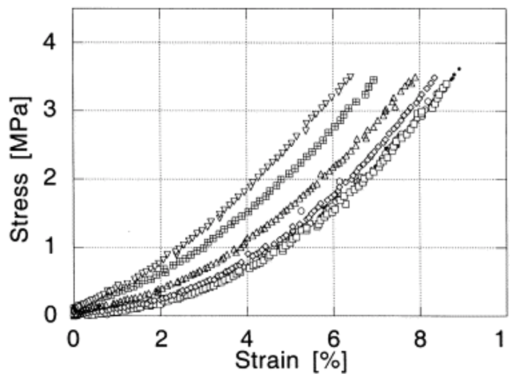

(Pioletti, Rakotomanana and Leyvraz, 1999)

Figure 1 describes the stress-strain rates of an anterior cruciate ligament. The graph shows that as strain is applied stress becomes greater, the ligament will be compliant at the start of the strain being applied. We see the compliancy through 0% strain to roughly 4%, at this point the ligament is on a stretch and nearing the middle to end of it’s range. The ligament will start to stiffen up when reaching the end of range, if it surpasses normal end of range the risk of injury significantly increases, there will be risk of overstretching, microtears and complete tears to the ligament itself and there will also be a risk of dislocation at that joint due to loss of stability and protection.

Additionally, ligaments have moderate strain-rate sensitivity which indicates that the stiffness of the ligament is greater when stretched quickly rather than slowly. This is a benefit when protecting the joint from sudden extrinsic forces because the ligament will react quickly to the force by stiffening up.
(Liao et al., 2015)

Injury grading
Ligament injuries are graded on a scale of one to three depending on the severity, the grade differentiates the healing time frame and measures to take to ensure a full recovery. A grade I ligament injury is categorised as a small disruption to the collagenous fibres, the patient won’t have great functional deficit and may have a normal range of movement but they may report tenderness when palpating and inflammation which will be visible. The patient will also have a normal end feel during the stress test used to diagnose but it may produce some pain.

A grade II injury is a considerable disruption to a proportion of collagen fibres, the patient will report significant tenderness and effusion of the joint will be visible to the therapist. When performing the stress test the joint will have increased laxity than the ligament would normally allow if it was functioning normally.

A grade III injury is the most severe diagnosis, it describes a complete disruption or tear to all of the collagen fibres.The patient may report hearing a pop sound when the injury occurred, immediate pain and rapid considerable swelling due to hemarthrosis. When the therapist performs the stress test on the ligament it will present with significantly increased joint laxity, lack of end point and it will have great functional deficit.
(Brukner et al., 2017, p20)

Healing
An injured ligament will have developed frayed stump ends at the site of the tear whether it be a grade I or grade III, the stump ends will undergo the inflammatory process which protects the injury site and removes damaged tissue to rebuild. The stump ends will then become surrounded by fluid, this adversely affects the tissue it makes the stump ends friable, this process will occur within the first hour of injury. The site will then be infiltrated 24 hours after injury by monocytes to induce an immune response and macrophages to deconstruct any bacteria in the area and release cytokines. Cytokines are important to ensure that an immune and inflammation response has been triggered. Fibroblasts will also begin to appear more significantly to start the process of producing the extracellular matrix, the fibroblasts will start to produce the matrix between forty-eight- and seventy-two-hours post injury. Between a week and two weeks post injury fibrocytes and macrophages are seen in large quantities to participate in wound repair, the monocytes will produce collagen fibres which will be visible. At this stage the extra-cellular matrix is continuing to be synthesised by fibroblasts ensuring ground substance for the collagen fibres to rebuild on. The next stage of between two- and six-weeks post injury is when the proliferation phase occurs, this is when the collagen and extra-cellular matrix have rebuilt, and the wound can start to contract. Macrophages and fibroblasts can then dissipate between the six week and twelve-month mark as the wound has started to close and the collagen fibres have rebuilt. The final stage of healing is up to the twelve-month marker, at this point collagen cross links are significant and type I collagen has been replaced by type III, the ligament will appear normal under a microscope and will be near to restoring normal tensile strength.

It is important to rest an injury to allow it time to heal, 80-90% of potential ligament strength can be maintained through normal daily living activities so there won’t be a great decrease in potential strength but there are studies that prove if the ligament is completely immobilised via a cast or boot there is a net loss of in the ligament of strength and stiffness. A cause for reinjury is patients straining an already damaged ligament or not allowing enough time for it to heal before putting force through it. The therapist and patient should ensure that the full twelve-month healing process is understood before they return to training, the most important aspect of returning to training is that the ligament can tolerate near to normal tensile strength and the patient isn’t experiencing any pain when using force through the joint.
(Frank, 1996)

Word count - 1649

References
Brukner, P., Khan, K., Clarsen, B., Cook, J., Cools, A., Crossley, K., hutchinson, M., McCrory, P. and Bahr, R. (2017). Brukner & Khan’s Clinical Sports Medicine. 5th ed. India: McGraw Hill Education, pp.19–21.

Hauser, R.A. (2013). Ligament Injury and Healing: A Review of Current Clinical Diagnostics and Therapeutics. The Open Rehabilitation Journal, 6(1), pp.1–20.

Pioletti, D.P., Rakotomanana, L.R. and Leyvraz, P.-F. (1999). Strain rate effect on the mechanical behavior of the anterior cruciate ligament–bone complex. Medical Engineering & Physics, 21(2), pp.95–100.
Ristaniemi, A., Stenroth, L., Mikkonen, S. and Korhonen, R.K. (2018). Comparison of elastic, viscoelastic and failure tensile material properties of knee ligaments and patellar tendon. Journal of Biomechanics, [online] 79, pp.31–38. Available at: https://www.sciencedirect.com/science/article/pii/S0021929018306134 [Accessed 18 Nov. 2020].
Liao, X., Kemp, S., Corner, G., Eisma, R. and Huang, Z. (2015). Elastic properties of Thiel-embalmed human ankle tendon and ligament. Clinical Anatomy, 28(7), pp.917–924.
‌Karunaratne, A., Li, S. and Bull, A.M.J. (2018). Nano-scale mechanisms explain the stiffening and strengthening of ligament tissue with increasing strain rate. Scientific Reports, 8(1).
‌
Lee, D.W., Kim, J.G. and Kim, H.T. (2020). Evaluation of Anterolateral Ligament Healing After Anatomic Anterior Cruciate Ligament Reconstruction. The American Journal of Sports Medicine. [online] Available at: https://journals-sagepub-com.ezproxy.uwtsd.ac.uk/doi/full/10.1177/0363546520908805 [Accessed 6 Nov. 2020].
‌
Shultz, S.J., Schmitz, R.J., Cameron, K.L., Ford, K.R., Grooms, D.R., Lepley, L.K., Myer, G.D. and Pietrosimone```, B. (2019). Anterior cruciate ligament research retreat VIII summary statement: an update on injury risk identification and prevention across the anterior cruciate ligament injury continuum, march 14-16,2019, Greensboro, NC. Journal of Athletic Training, [online] 54(9). Available at: https://web.b.ebscohost.com/ehost/pdfviewer/pdfviewer?vid=2&sid=1d77bde3-2730-4f64-85f8-2a10d114d588%40pdc-v-sessmgr02 [Accessed 6 Nov. 2020].
Frank, C. (1996). Ligament Healing: Current Knowledge and Clinical Applications. National Library of Medicine, 4(1), pp.74–83.
‌

