Name: Edward Walden
Student Number: 2203426
Date: 23/04/2023
Module: Introduction to Automotive Engineering
Module Code: ACHA4009
Assignment Title: Technical Report


Contents
Chapter 1
Introduction…………………………………………………………………………3
Chapter 2
Materials………………………………………………………………………………4

Manufacturing Purposes………………………………………………………5

Aerodynamics………………………………………………………………………6

Engine Design………………………………………………………………………7

Computational Simulation……………………………………………………8

Data Analysis……………………………………………………………………….9

Chapter 3
Current State of the Industry…………………………………………..…10
Chapter 4
Conclusion.………………………………………………………………………..11

References…………………………………………………………………………12
Chapter 1

Introduction
For this technical report I will be writing about the 6th Generation Honda CBR954RR Fireblade, nicknamed ‘The 954’, the model produced in 2002 to be exact. The reason for me choosing this specific motorcycle is not only because of my personal interest in motorcycles, but also, when the 2002 Fireblade was released, it seemed almost revolutionary with the amount of progress Honda had made from the previous models of Fireblade.
It has been widely agreed amongst the motorcycle community that the 954 is the best generation of the Honda Fireblade, as it finally showed the 11 years of research and improvement Honda had been aiming for, in one outstanding motorcycle. Not only has Honda made astounding progress in the development of this motorcycle but “Tadao Baba, designer of the original CBR900RR Fireblade through to the CBR954RR Fireblade, considered this to be the pinnacle” (Hooshmand, 2020)
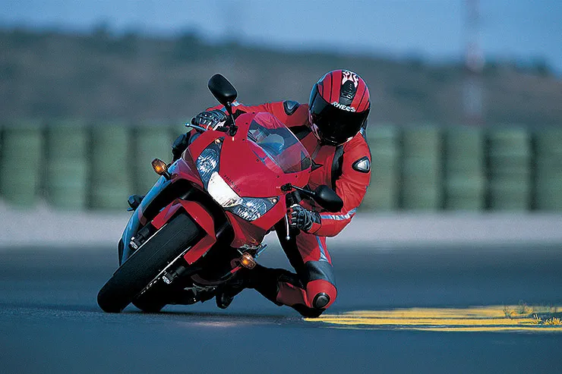
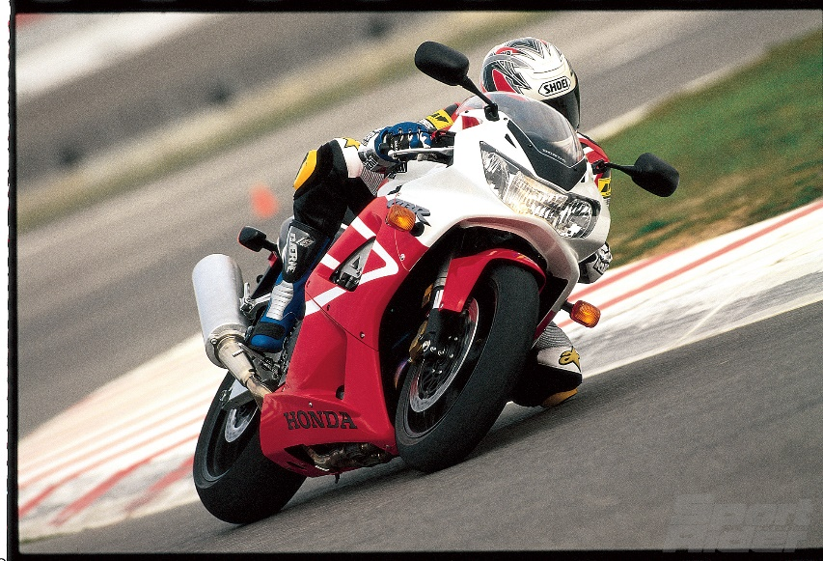
Because of this, as well as the 954’s reputation as the best Fireblade ever created, the 954 is now a sought-after classic. Once people saw the performance of this motorcycle and the way it was dominating in the 900cc class races, it swiftly became a desired, and now classic, motorcycle to own.

Chapter 2
Materials:
One main goal during the production of the 954 Fireblade was to make it as light as possible. Honda manufacturers managed to get the weight of the 954 down to a mere 167kg, which is roughly the same weight as a modern day CBR500R. One way in which the manufacturers achieved this was in the materials they decided to use.
For example, they used “forged steel camshafts, which were carburized and tempered, providing not only superior strength, but also a lighter weight”, (Motorsports Network, 2005), compared to the conventional cast designs used at the time. Additionally, Honda designed “aluminium composite cylinder sleeves, which were high pressure formed from sintered aluminium powder integrated with ceramic and graphite.” (Motorsports Network, 2005) These composite sleeves provided a lightweight alternative to traditional cylinder sleeves, as well as better wear resistance and superior heat dissipation.
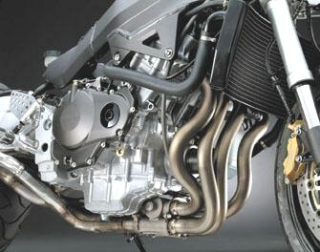
Additionally, Honda introduced a “lightweight twin spar extruded aluminium frame, which featured a pivotless swingarm design utilizing a cast aluminium bracket attached to the swingarm pivots.” (Motorsports Network, 2005). Not only did this design provide an excellent road feel and rigidity, but this design was exceptionally light. The aforementioned choices in materials not only helped the 954 achieve a very light motorcycle overall, but these choices also majorly improved the motorcycles performance on the track.
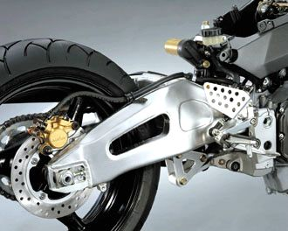

Manufacturing Purposes
The previous generations of the Fireblade had been performing well in their cc classes, however there was always one opponent who they simply could not keep up with. In the early 1990s it was Suzuki with their GSX-R11, in the late 1990s it was Yamaha, with their development of the R1 which made the Fireblade look like a touring motorcycle, causing Honda to go back to basics and attempt to rebuild their Fireblade from the ground up. This meant that when they were designing the 954, Honda had grand expectations of Tadao Baba, hoping for a well-designed bike that would be able to compete with the R1 and hopefully take the crown back from Yamaha.
Upon being given this task, Baba had an idea which he was determined to carry out, and that was to design a 900cc engine, which could fit inside the same chassis as a 750cc engine, and Tadao Baba was reportedly “ruthless in his obsession” (Hooshmand, 2020)
Additionally, one goal for Honda when designing the 954 was to not only make a motorcycle which had the capacity to compete on track, but Honda has always made a significance in designing motorcycles for the people, which is why they wanted to implement a comfier riding position. Sport bikes had become a lot more uncomfortable in the late 1990s and early 2000s, so Honda wanted to make their 6th generation Fireblade with a more relaxed riding position.
Below is a diagram which shows the riding position of the 954 compared to the GSX-R1000 of that time. From this diagram you can clearly see the difference in riding position, the 954 having a much comfier position than its competitors.
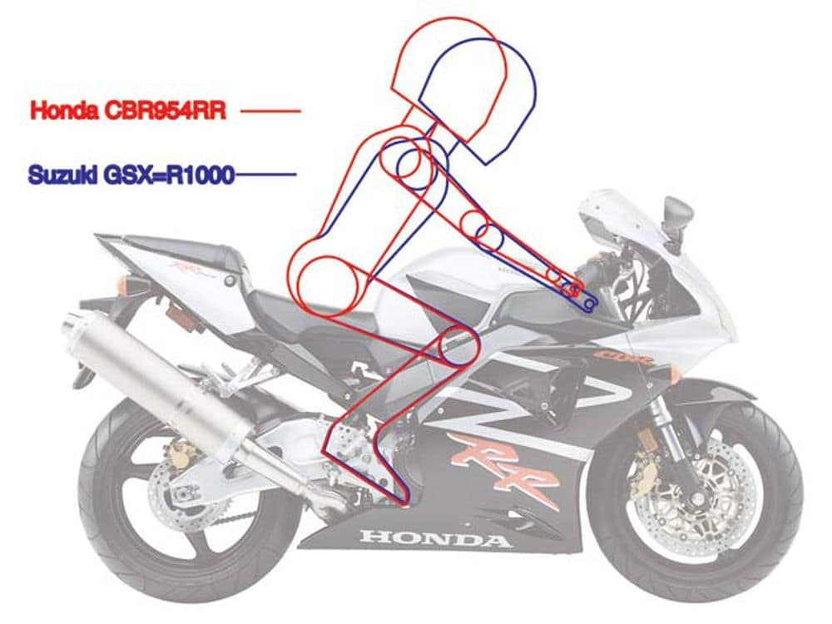
(Hooshmand, 2020)
This new comfier riding position for the 954 not only made it more comfortable for the racers, but also for the people who went on to own their very own 954, once again showing Honda’s goal of making a motorcycle for the people, not just the track.

Aerodynamics
When designing the 954, it was one issue reducing the weight and designing a comfortable riding position. The manufacturers also had to consider how the bike would move through the air, they wanted to make the 954 as aerodynamic as possible to get as much power as they could out of the 154 horsepower, 954cc engine.
The way Honda decided to do this was by introducing a new distinctive bodywork, which was more sharply angled and a more “aggressively designed front cowl alongside a lighter and slimmer seat cowl” (Motorsports Network, 2005). Additionally, they included a new rear fender which followed the curve of the rear tyre much more closely than the 954s predecessors. This would end up reducing the amount of drag the 954 had and allowed it to cut through the air when travelling at higher speeds.
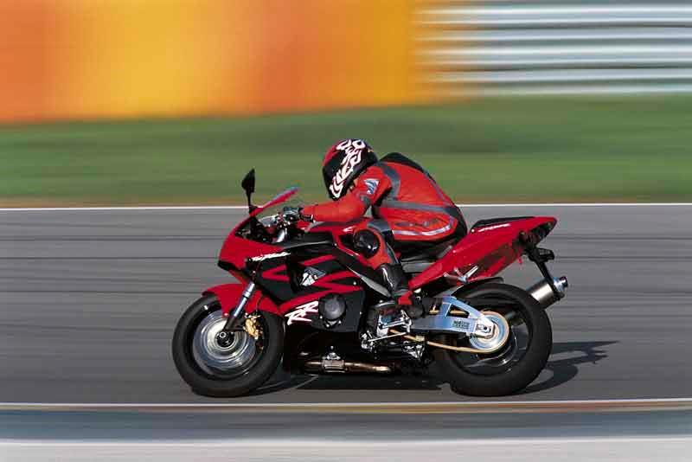
Another factor the manufacturers had to consider was the rider, and how they themselves would be affected when travelling at high speeds. What Honda decided to design was a fuel tank that was “reduced by 10mm in both height and length” (Motorsports Network, 2005). This would move the rider closer to the steering head. This provided not only a “more responsive control and greater maneuverability”, (Motorsports Network, 2005), for the rider, but the reduction in height allowed the rider to tuck in even closer to the bike, meaning the rider themselves would make nowhere near as much drag, and allow the 954 to achieve even faster speeds, both in a straight line and when cornering.
Engine Design:
When designing the engine for the 954, Honda wanted to make the best improvements they could, in order to compete for the top spot in the 900cc race classes.
Honda manufacturers made a considerable number of modifications, tweaks, and improvements to the Fireblade engine, however, some that stand out are; the “high-pressure programmed fuel injection system (PGM-FI)” which was said to deliver fuel at 50 psi to the four injectors mounted in each 42mm throttle body. Fuel was designed to be delivered through 12 laser-drilled nozzles in each injector which produced a very fine spray, giving the engine maximum combustion, efficiency, and power” (Motorsports Network, 2005).
Additionally, the 16 valve cylinder head featured 29mm intake and a 24mm exhaust valves, with a compression ration of 11.5:1 allowed for “efficient combustion and high horsepower.” (Motorsports Network, 2005). Honda also designed a narrow 25 degree included valve angle (13 degree intake and 12 degree exhaust) which provided a direct path for the incoming air/fuel charge for “improved engine breathing and increased power.” (Motorsports Network, 2005).
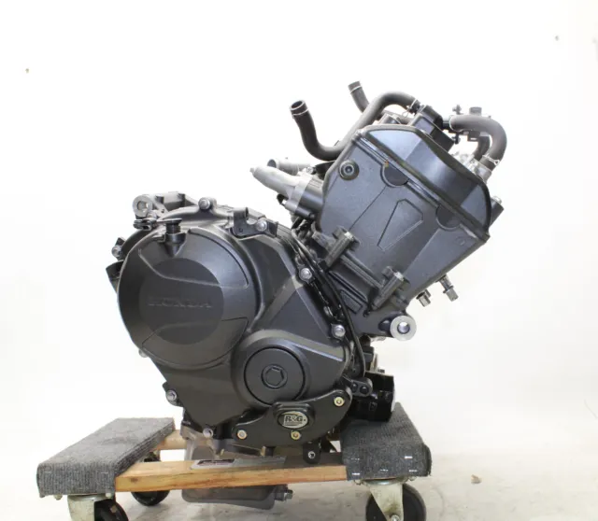
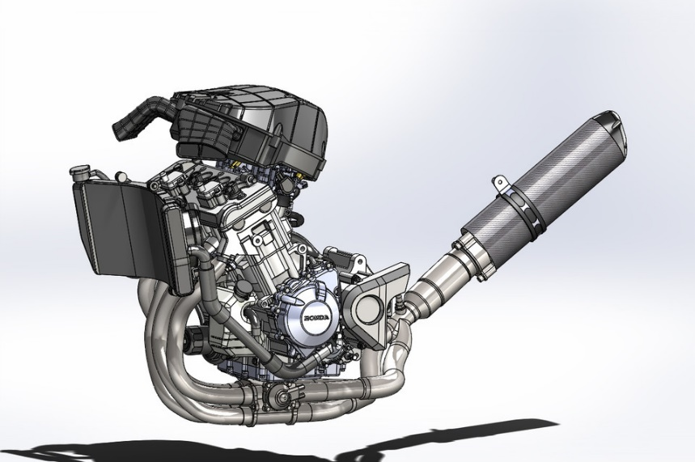
These upgrades, alongside smaller tweaks of the engine, like magnesium head covers, forged aluminium pistons and forged steel camshafts, all helped in partnership with the major upgrades to make the 954’s engine powerful, lightweight, and efficient.

Computational Simulation:
After the 954 had been built, the manufacturers at Honda needed to test it, to make sure everything they had done had taken effect, and hopefully they would be able to tell by these simulations, how the 954 would compete against rival bikes at the time.
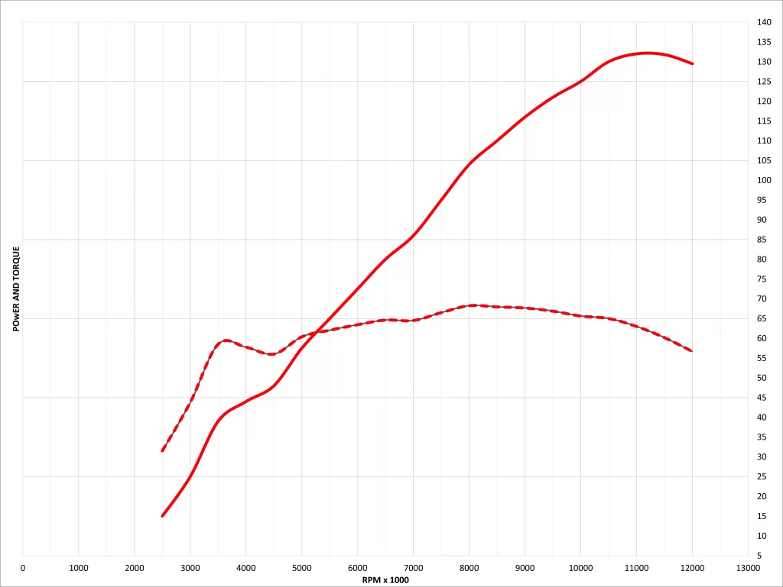

(Rossi, 2022)
The above graph shows the dyno curve for the CBR9545RR. When comparing this curve with its competitors, it could be seen that the Honda was similar to the Yamaha YZF-R1 in terms of peak power, however the 954 gave away a little when it came to the RPM range.
On the dyno runs for the 954, the horsepower value would usually come in between the high 120s or the low 130s, one example being “133 horsepower at the rear wheels with that peak coming in around 11500 rpm.” (Rossi, 2022)
Honda’s competitors, like Yamaha, Suzuki etc. appeared to have a much better machine, when looked at objectively on paper, however the Honda CBR954RR was the lightest in its class, and geared very intelligently, meaning the engine certainly packed a punch and apparently felt much faster than the numbers suggested.

Data Analysis:
Following on from the computational simulations used for the Honda CBR954RR, the Honda team had to analyse the data collected from the data collected by the tests and simulations. For example, when tests were done for the acceleration of the 954, the manufacturers had to look at the data and decide what would be the best course of action to try and make the 954 even better.
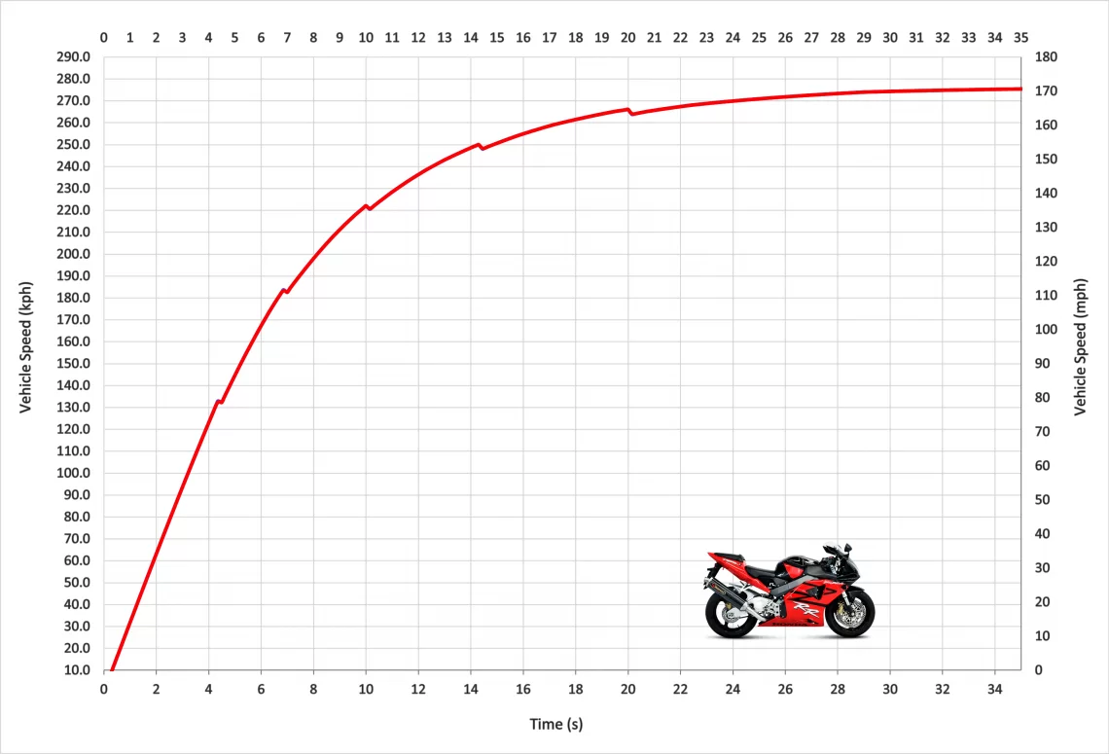
(Rossi, 2022)
The graph above shows the acceleration of the 2002 Honda CBR954RR. From this graph we can see that the 954 has a top speed of roughly 170mph, with a 0-60 mph time of just 2.98 seconds, and once in second the 954 would hit 100mph in only 5.70 seconds making it just as fast as some modern motorcycles, meaning the Honda wasn’t slow by any interpretation, but there is still room for improvement, as shown by the fact that some “riders could get the blade down to a 0-60 time in just 2.70 seconds” (Rossi, 2022)
For example, during a timed quarter mile sprint, it was shown that the 954 would hit its rpm limit in third gear as soon as it would get up to the quarter mile line, meaning the rider had to upshift, which impacted the time. However, a slight gear ratio change would solve this issue and could very well make the 954 clock in faster lap times.

Chapter 3
Current State of the Automotive Industry
The automotive industry is an ever growing, changing, and adapting market, filled with consumers from all occupations, additionally that means that all these diverse types of consumers have contentions over what direction the automotive industry should go towards next. One major area of contention in recent years is the hybrid and electric vehicle demand. People and/or groups of people believe that electric vehicles are the best place to be in reference to automotive transport, and this is for many reasons. For example, “electric cars are better, cleaner and kinder to the environment than their petrol- or diesel-powered counterparts.” (Peugot, 2022).
Additionally, it has been shown that electric vehicles are much better for the environment, as “In over a year, just one electric car on the roads can save an average 1.5 million grams of CO2” (EDF Energy, 2022) which a lot of people and activist groups, like Extinction Rebellion, would support greatly, as more electric cars would mean further reduced emissions.
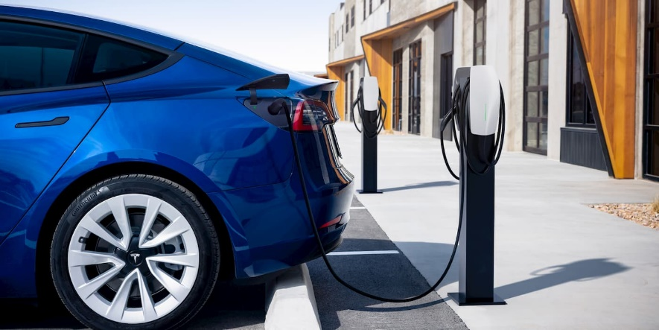

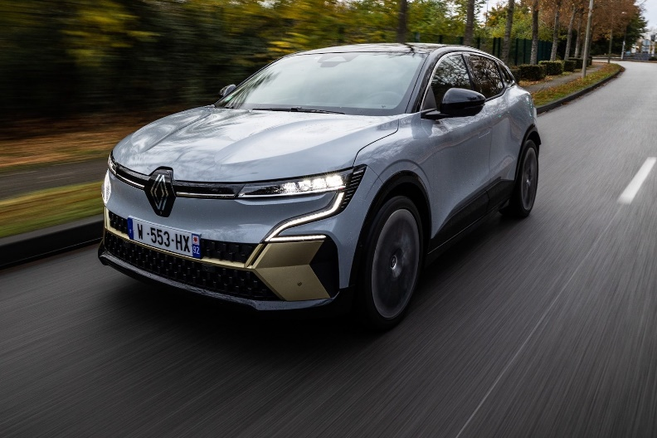

Chapter 4
Conclusion
In conclusion, the 954 was expertly researched, developed, and engineered, to create not only a motorcycle that was terrific performance wise, but also became a legend in the history of Honda motorcycles, as it has been described as the best Fireblade ever produced. However, the 954 in the modern world would serve better as a classic collector’s item, only used a handful of times throughout the summer months of the year.
This will be because the primary design for the 954 was to create a dominating race motorcycle, not an every day commuter, additionally global warming and climate control were not a pressing issue during the creation of the 954, back in the early 2000s. Meaning although it is a motorcycle and will naturally create less emissions than the average car, it will still push out pollutants which, if the automotive industry decides to move towards mainline production of electric vehicles, will mean the 954 could quite possibly have no place on future roads.

References
Introduction and Manufacturing Purposes- Hooshmand, D. 2020, The Best Honda FireBlade: the CBR954RR. Four Reasons Why!
Available at: https://motofomo.com/best-honda-fireblade-cbr954rr/

Materials, Aerodynamics and Engine Design- Motorsports Network 2005, 2002 Honda CBR954RR Model Overview
Available at: https://web.archive.org/web/20050410061117/http://www.motorsports-network.com/Honda/2002mc/954/954.htm

Computational Simulation and Data Analysis- Fabio, R. 2022, Honda CBR954RR Top Speed & Acceleration
Available at: https://motostatz.com/honda-cbr954rr-top-speed-acceleration/

Current State of the Automotive Industry- Peugeot 2022, The Advantages of Electric Cars
Available at: https://www.peugeot.co.uk/about-us/brand/news-articles/benefits-of-electric-cars.html#:~:text=Electric%20cars%20are%20better%2C%20cleaner,that%20runs%20on%20fossil%20fuels.

Current State of the Automotive Industry- EDF Energy 2022, Benefits of Electric Cars on the Environment
Available at: https://www.edfenergy.com/energywise/electric-cars-and-environment

