2026

Computational Methods: 2D Transient Heat Equation Solved with the Explicit Finite Difference Method (Report)

Rhys HOLMES 2117889

Executive Summary

This report presents the development, implementation, and validation of a numerical model for solving the two-dimensional transient heat conduction equation using the Explicit Finite Difference Method (EFDM). The governing heat equation is formulated for a homogeneous, isotropic solid with no internal heat generation and discretised in both space and time using finite difference approximations.

The numerical scheme is implemented in MATLAB with stability enforced through the Fourier number criterion. A combined convergence strategy is employed, incorporating both a numerical tolerance and a minimum physical simulation time to ensure that thermal equilibrium is identified in a physically meaningful manner.

Validation of the numerical solution is performed through direct comparison with an analytical steady-state solution for a rectangular plate subject to prescribed Dirichlet boundary conditions. Quantitative error metrics and qualitative comparison of temperature fields demonstrate close agreement between numerical and analytical results, confirming the correctness and accuracy of the implementation.

A comprehensive sensitivity analysis is conducted to investigate the influence of grid spacing, time step size, and convergence tolerance on the reported thermal equilibrium time. The results show that spatial and temporal discretisation parameters converge towards stable equilibrium times, while convergence tolerance has a pronounced effect when used in isolation, highlighting the importance of a combined convergence criterion.

Overall, the developed model provides a robust and reliable framework for transient heat conduction analysis under idealised conditions and demonstrates a strong understanding of numerical methods, stability considerations, and validation techniques.

Table of Contents

Executive Summary 1
Acronyms 3
Table of Figures 5
1.0 Introduction 6
2.0 Governing Equation 8
3.0 Finite Difference Method 9
4.0 Initial and Boundary Conditions and 11
4.1 Initial Condition 11
4.2 Boundary Conditions 11
4.3 Analytical Steady-State Solution 12
4.4 Use of Analytical Solution for Validation 13
5.0 Numerical Implementation 14
5.1 Stability Enforcement 14
5.2 Boundary and Initial Conditions 14
5.3 Convergence Criteria and Minimum Physical Time 15
5.4 Post-Processing and Output 15
6.0 Validation of Numerical Results 16
6.1 Error Definition and Metrics 17
7.0 Sensitivity Analysis 18
7.1 Influence of Grid Spacing 18
7.2 Influence of Time Step Size 19
7.3 Influence of Convergence Tolerance 20
7.4 Summary of Sensitivity Findings 21
8.0 Limitations of the Numerical Model 22
9.0 Potential Improvements and Future Work 23
10.0 Conclusion 24
Reference List 25
Appendix 27
Appendix 1 – Influence of Grid spacing, 4, 0.75, and 0.25 27
Grid Spacing 4 27
Gris Spacing 0.75 27
Grid Spacing 0.25 28
Appendix 2 – Influence of Time Step 2000 s and 200 s 28
Time Step 2000 s 28
Time Step 200 s 28
Appendix 3 – Influence of Convergence Tolerance (Loose tolerance and tight tolerance) 29
Tolerance 0.001 29
Tolerance 0.000001 29
Appendix 4 – MATLAB Code 30

Acronyms

EFDM – Explicit Finite Difference Method
FDM – Finite Difference Method
PDE – Partial Differential Equation
RMSE – Root Mean Square Error
Fo – Fourier Number
BC – Boundary condition
IC – Initial Condition
MATLAB – Matrix Laboratory
CPU – Central Processing Unit
$∆t$ – Time Step Size
h – Spatial Grid Spacing
T – Temperature
$T_{0}$ – Prescribed Boundary Temperature
$α$ – Thermal Diffusivity
k – Thermal Conductivity
$ρ$ – Density
$C_{p}$ – Specific Heat Capacity
$t_{min}$ – Minimum Physical Simulation Time
m – Metres
°C – Degrees Celsius

Table of Figures

Figure 1 - Example of a Cartesian Grid with Constant Spacing (1.5m x 0.5m, with 0.1m grid spacing) 9
Figure 2 - Five-point Stencil Used in the Explicit Finite Difference Method for the Two-dimensional Heat Equation (Authors own illustration Generated in MATLAB) 10
Figure 3- Schematic of the rectangular plate showing the imposed Dirichlet boundary conditions used in the numerical and analytical models (Authors own illustration generated in MATLAB) 12
Figure 4 - Numerical vs Analytical Steady-state Comparison 16
Figure 5 - Absolute Error Field 17
Figure 6 - Influence of Grid Spacing (Holmes, 2026) 18
Figure 7 - Influence of Time Step (Holmes, 2026) 19
Figure 8 - Influence of Tolerance (Holmes, 2026) 20

1.0 Introduction

Heat transfer by conduction is a fundamental physical process encountered across a wide range of engineering applications, including thermal management of electronic components, energy systems, heat exchangers, and structural elements subjected to thermal loading. In many practical engineering problems, temperature distributions evolve both spatially and temporally, making transient heat conduction analysis essential for accurate design and performance assessment (Incropera, 2011).
Although analytical solutions to the heat conduction equation exist for a limited set of idealised geometries and boundary conditions, most real engineering problems are not amenable to closed-form solutions. Consequently, numerical methods are widely employed to obtain approximate solutions to transient heat transfer problems. Advances in computational capability have further reinforced the importance of numerical techniques as core tools in modern engineering analysis.
Among available numerical approaches, the Finite Difference Method (FDM) is widely used due to its conceptual simplicity and ease of implementation. In particular, the Explicit Finite Difference Method (EFDM) provides a straightforward time-marching scheme for transient problems, although it is conditionally stable and requires careful selection of spatial and temporal discretisation parameters to ensure numerical stability and accuracy.
The aim of this report is to develop, implement, and validate a numerical model for solving the two-dimensional transient heat conduction equation using the Explicit Finite Difference Method. The model is implemented in MATLAB and applied to a rectangular plate subject to prescribed Dirichlet boundary conditions, for which an analytical steady-state solution is available. This analytical solution provides a benchmark for assessing the accuracy and reliability of the numerical results.
The specific objectives of this work are to:
- formulate the governing two-dimensional transient heat conduction equation for a solid with no internal heat generation;
- discretise the governing equation using finite difference approximations in both space and time;
- implement the EFDM in MATLAB while enforcing appropriate stability criteria;
- validate the numerical solution against an analytical steady-state solution;
- investigate the sensitivity of the numerical results to key numerical parameters, including grid spacing, time step size, and convergence tolerance.

This report is structured as follows. Chapter 2 introduces the governing heat conduction equation and its physical significance. Chapter 3 describes the finite difference discretisation and formulation of the explicit numerical scheme. Chapter 4 presents the boundary conditions and analytical solution used for validation. Chapter 5 outlines the numerical implementation, followed by validation of results in Chapter 6. Chapter 7 presents a sensitivity analysis of key numerical parameters, while Chapters 8 and 9 discuss model limitations and potential improvements. The report concludes with a summary of the main findings in Chapter 10.

2.0 Governing Equation

Heat conduction within a solid is governed by the transient heat equation, which describes the temporal and spatial evolution of temperature due to diffusive transport. For a homogeneous, isotropic material with constant thermal properties and no internal heat generation, the two-dimensional transient heat conduction equation is given by:
$\frac{∂T\left(x,y,t\right)}{∂t}=α\left(\frac{∂^{2}T\left(x,y,t\right)}{{∂x}^{2}}+\frac{∂^{2}T(x,y,t}{{∂y}^{2}}\right)$ (2.1)
where $T\left(x,y,t\right)$ is the temperature field and $α$ is the thermal diffusivity of the material (Jaeger, 1959). The thermal diffusivity is defined as:
$α=\frac{k}{{ρc}_{p}}$ (2.2)
where $k$ denotes thermal conductivity, $ρ$ the density, and $C_{p}$ the specific heat capacity of the material (Incropera, 2011).
Equation (2.1) represents a balance between the rate of change of internal energy and the divergence of heat flux within the material. Under steady-state conditions, where temperature no longer varies with time, the temporal derivative vanishes, and the governing equation reduces to Laplace’s equation:
$\frac{∂^{2}T}{{∂x}^{2}}+\frac{∂^{2}T}{{∂y}^{2}}=0$ (2.3)
which provides the analytical benchmark used later in this report for validation of the numerical solution (Obi, 2022).

3.0 Finite Difference Method

To obtain a numerical solution to the governing heat conduction equation, the spatial and temporal derivatives are approximated using finite difference schemes on a uniform Cartesian grid. The computational domain is discretised using a constant grid spacing h in both spatial directions, as illustrated in Figure 1, while time is advanced using a fixed time step $∆t$.
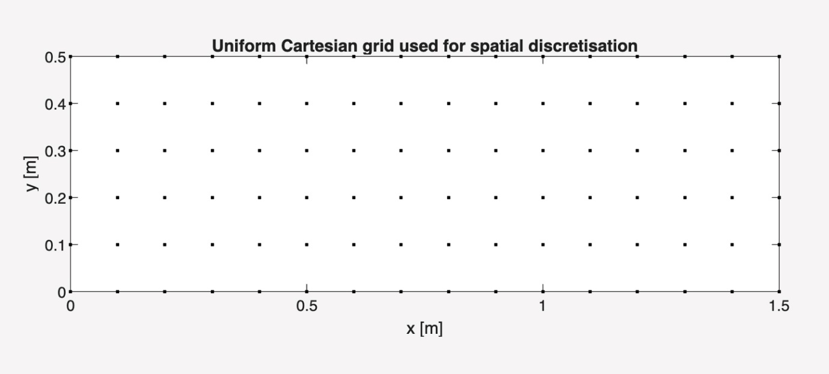
Figure 1 - Example of a Cartesian Grid with Constant Spacing (1.5m x 0.5m, with 0.1m grid spacing (Holmes, 2026))

Second-order central difference approximations are employed for the spatial derivatives, yielding truncation errors of order$O\left(h^{2}\right)$. Temporal discretisation is performed using a first-order forward Euler scheme with truncation error $O\left(∆t\right)$. The resulting five-point stencil used to approximate the Laplacian operator is shown schematically in Figure 2 (B. Cockburn, 2016).
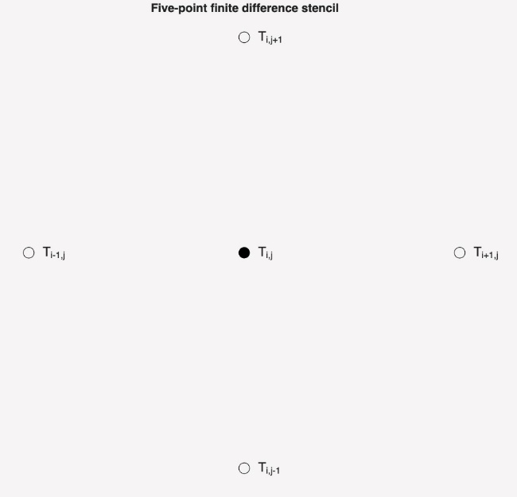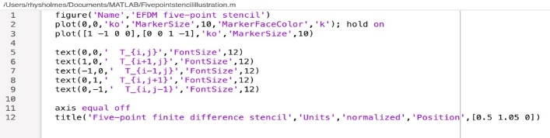
Figure 2 - Five-point Stencil Used in the Explicit Finite Difference Method for the Two-dimensional Heat Equation (Authors own illustration Generated in MATLAB (Holmes, 2026))

Substituting the finite difference approximations into the governing equation leads to an explicit update formula for the temperature at each interior grid point (Smith, 1985). The Explicit Finite Difference Method (EFDM) update equation for node $\left(i,j\right)$ is given by:
$T_{i,j}^{n+1}=\left(1-4Fo\right)T_{i,j}^{n}+Fo\left(T_{i+1,,j}^{n}+T_{i-1,j}^{n}+T_{i,j+1}^{n}+T_{i,j-1}^{n}\right)$ (3.1)
Where the Fourier number $Fo$ is defined as:
$Fo=\frac{α∆t}{h^{2}}$ (3.2)
The EFDM is conditionally stable and requires the Fourier number to satisfy the stability criterion:
$Fo≤0.25$ (3.3)
which imposes an upper bound on the allowable time step for a given grid spacing. This stability condition is enforced directly within the numerical implementation to ensure numerical stability (Salawu, 2023).

4.0 Initial and Boundary Conditions and

This chapter describes the initial and boundary conditions applied to the numerical model and presents the analytical steady-state solution used for validation. Careful specification of these conditions is essential to ensure that the numerical solution is physically meaningful and directly comparable with the analytical benchmark.

4.1 Initial Condition

The initial temperature distribution within the plate is assumed to be uniform and equal to zero throughout the domain, such that:
$T\left(x,y,0\right)=0 for all 0 ≤x ≤ X_{dim}, 0 ≤y ≤ Y_{dim}$ (4.1)
This initial condition represents a plate that is initially at a uniform reference temperature prior to the application of boundary heating. While the choice of initial condition does not influence the final steady-state solution, it directly affects the transient response and the time required to reach equilibrium (Herman, 2025). A uniform initial temperature simplifies interpretation of the transient behaviour and is commonly adopted in transient heat conduction analyses.

4.2 Boundary Conditions

Dirichlet boundary conditions are imposed on all edges of the rectangular plate (Figure 3). The south, east, and west boundaries are maintained at a constant temperature of zero, while the north boundary is held at a prescribed temperature T₀. The boundary conditions may therefore be expressed as:
$T\left(x,0,t\right)=0, T\left(0,y,t\right)=0, T\left(X_{dim},y,t\right)=0, T\left(x,Y_{dim},t\right)=T_{0}$ (4.2)
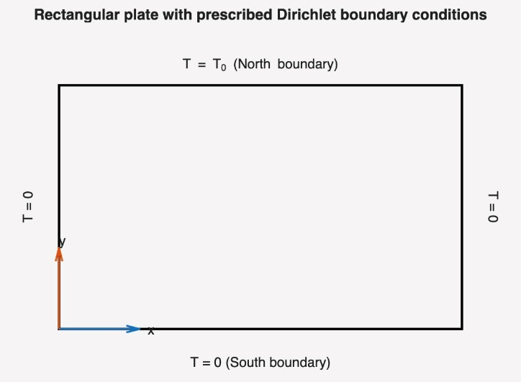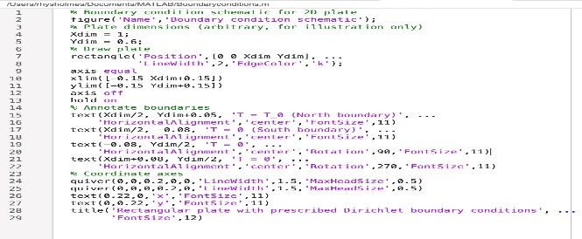
Figure 3- Schematic of the rectangular plate showing the imposed Dirichlet boundary conditions used in the numerical and analytical models (Authors own illustration generated in MATLAB (Holmes, 2026))

At the corner nodes, the temperature is set to zero to maintain consistency with the analytical solution and to avoid ambiguity arising from competing boundary specifications. This configuration represents a physically realistic scenario in which three edges of the plate are held at a reference temperature while the fourth edge is subjected to a constant thermal input.
In the numerical implementation, boundary conditions are applied once at the initial time step and subsequently preserved by excluding boundary nodes from the finite difference update. This ensures that the prescribed boundary temperatures remain fixed throughout the simulation while avoiding unnecessary reapplication of boundary constraints during time stepping.

4.3 Analytical Steady-State Solution

An analytical solution exists for the steady-state temperature distribution of a rectangular plate subject to the boundary conditions described above. At steady state, the temporal derivative in the heat equation vanishes, reducing the governing equation to Laplace’s equation:
$\frac{∂^{2}T}{{∂x}^{2}}+\frac{∂^{2}T}{{∂y}^{2}}=0$ (4.3)
Using the method of separation of variables, the steady-state temperature distribution can be expressed as an infinite series involving sine and hyperbolic sine functions. For the present boundary configuration, the analytical solution is given by:
$T\left(x,y\right)=\frac{4T_{0}}{π}\sum_{m=1,3,5,….}^{∞}{\frac{1}{m}sin\left(\frac{mπx}{X_{dim}}\right)\frac{sinh\left(\frac{mπy}{x_{dim}}\right)}{sinh\left(\frac{mπY_{dim}}{X_{dim}}\right)}}$ (4.4)
This solution satisfies Laplace’s equation within the domain and fulfils all prescribed boundary conditions. In practice, the infinite series must be truncated after a finite number of terms. In this study, a sufficiently large number of terms is retained to ensure convergence of the analytical solution and to enable a meaningful comparison with the numerical results (Daileda, 2012).

4.4 Use of Analytical Solution for Validation

The analytical steady-state solution provides a rigorous benchmark against which the numerical solution can be evaluated. Once the numerical simulation has reached equilibrium, the numerical temperature field is compared directly with the analytical solution evaluated at the same spatial locations. The accuracy of the numerical method is quantified using error measures such as the maximum absolute error and the root-mean-square error (Hodson, 2022).
The availability of an analytical solution for this configuration is particularly valuable, as it allows both the correctness of the numerical implementation and the influence of discretisation parameters to be assessed objectively. This validation process forms the basis for the numerical comparisons and sensitivity analysis presented in the subsequent chapters (Ereiz, 2022).

5.0 Numerical Implementation

This chapter describes the numerical implementation of the Explicit Finite Difference Method used to solve the two-dimensional transient heat conduction equation. The purpose of this chapter is to outline the solver structure, stability enforcement, and convergence strategy, rather than to document specific MATLAB programming details.
The numerical solver was implemented in MATLAB using a structured and modular approach. User-defined inputs specify the plate dimensions, grid spacing, and boundary temperature. From these inputs, a uniform Cartesian grid is generated, and a stable time step is selected in accordance with the Fourier number stability criterion derived in Chapter 3.

5.1 Stability Enforcement

The Explicit Finite Difference Method is conditionally stable and requires the Fourier number to satisfy the constraint $Fo≤0.25$ for two-dimensional problems with equal grid spacing. This condition imposes a maximum allowable time step for a given spatial resolution. To ensure numerical stability, the time step is checked programmatically before the transient simulation is initiated, preventing unstable parameter combinations from being used (Smith, 1985) and (Mayers, 2005).

5.2 Boundary and Initial Conditions

Dirichlet boundary conditions are imposed to match the analytical benchmark problem, with the north boundary held at a constant prescribed temperature and the remaining boundaries maintained at zero temperature. The initial temperature field is set uniformly to zero throughout the domain. Boundary values are applied once at the start of the simulation and preserved by excluding boundary nodes from the explicit update scheme, ensuring consistency and computational efficiency.

5.3 Convergence Criteria and Minimum Physical Time

Thermal equilibrium is identified using a combined convergence strategy based on both a numerical tolerance and a minimum physical simulation time. The numerical convergence criterion is defined as the maximum absolute temperature change between successive time steps, which must fall below a prescribed tolerance.
However, when small time steps are employed, the per-step temperature change may become arbitrarily small even though the system has not reached a physically meaningful steady state. To address this limitation, a minimum physical simulation time $t_{min}$ is enforced based on the characteristic thermal diffusion time of the plate. By requiring both criteria to be satisfied, the solver avoids premature termination and ensures that the reported equilibrium state corresponds to true thermal equilibrium.

5.4 Post-Processing and Output

Once convergence is achieved, the numerical temperature field is compared with the analytical steady-state solution. Quantitative error metrics and spatial error distributions are computed to assess numerical accuracy. Visualisation of the temperature and error fields is performed using surface plots with consistent colour scaling to facilitate interpretation.
The complete MATLAB source code used to generate the results presented in this report is provided in Appendix 4.

6.0 Validation of Numerical Results

The numerical solution obtained using the Explicit Finite Difference Method is validated by comparison with an analytical steady-state solution of the two-dimensional Laplace equation subject to identical boundary conditions. This analytical solution provides a reliable benchmark for assessing the accuracy of the numerical implementation.
Validation is performed once the numerical solution has reached thermal equilibrium, as determined by the combined convergence criteria described in Chapter 5. The analytical temperature distribution is evaluated at the numerical grid points to enable direct, pointwise comparison between the two solutions.
Figure 4 presents a comparison between the numerical and analytical steady-state temperature distributions. Close agreement is observed across the computational domain, indicating that the numerical implementation correctly reproduces the analytical benchmark solution.
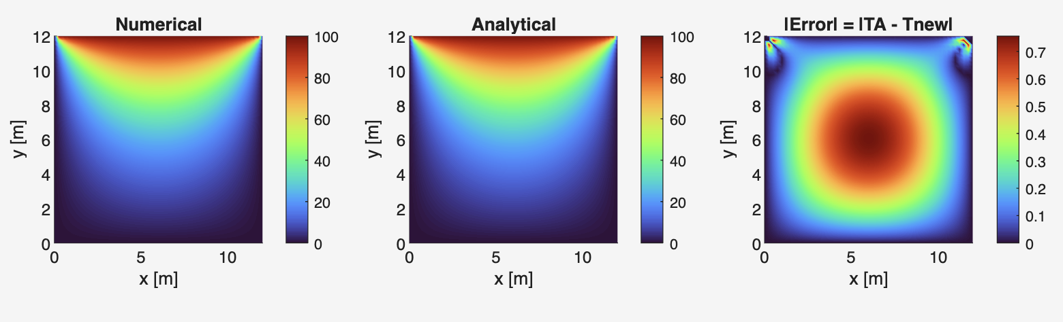
Figure 4 - Numerical vs Analytical Steady-state Comparison (Holmes, 2026)

6.1 Error Definition and Metrics

The local error between the analytical and numerical solutions is defined as:
$E(x,y)=T_{A} (x,y)-T_{N} (x,y)$ (6.1)
where $T_{A}\left(x,y\right)$ and $T_{N}\left(x,y\right)$ denote the analytical and numerical temperature distributions, respectively. The absolute error magnitude $E\left(x,y\right)$ is used to assess discrepancies independent of sign.
To quantify numerical accuracy, two standard error metrics are employed. The maximum absolute error provides a measure of the worst-case deviation across the domain, while the root-mean-square error (RMSE) characterises the overall accuracy of the numerical solution. The spatial distribution of the absolute error is shown in Figure 5, where the largest discrepancies occur near regions of high temperature gradient.

Figure 5 - Absolute Error Field (Holmes, 2026)

7.0 Sensitivity Analysis

This chapter investigates the sensitivity of the numerical solution to key discretisation and convergence parameters, namely the spatial grid spacing, time step size, and convergence tolerance. Sensitivity studies were performed by running the numerical solver multiple times while varying one numerical parameter at a time, with all remaining parameters held constant. For each simulation, the thermal equilibrium time was recorded directly from the MATLAB output using the combined convergence criterion described in Chapter 5. The resulting data were collated and visualised using Microsoft Excel. Sensitivity analysis is a standard tool in numerical modelling for assessing the robustness of solutions to discretisation and convergence parameters (Roache, 1998).
Unless otherwise stated, all simulations in this chapter were performed for a square plate of dimensions 12 x 12 m with a fixed heated boundary temperature of $T_{0}=100 °C$, while the remaining boundaries were held at 0 °C.

7.1 Influence of Grid Spacing

To investigate the effect of spatial discretisation, the grid spacing $h$ was varied while the time step and convergence tolerance were held constant at $∆t=150 s$ and $CC=0.001°C$, respectively. Figure 6 shows the variation of thermal equilibrium time with grid spacing.
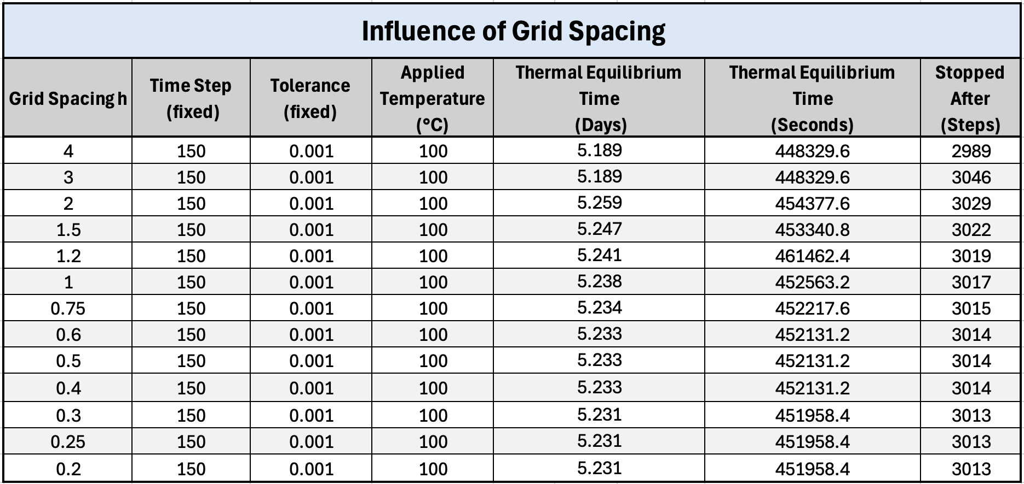
Figure 6 - Influence of Grid Spacing (Holmes, 2026)
For coarse grids, the equilibrium time is slightly underpredicted. As the grid is refined, the reported equilibrium time increases and converges towards a stable value of approximately 5.23 days. Beyond a grid spacing of around $h=0.75 m$, further refinement produces negligible changes in equilibrium time, indicating spatial convergence of the numerical solution.
This behaviour is consistent with the second-order spatial accuracy of the finite difference discretisation and demonstrates that sufficiently fine grids are required to accurately capture transient diffusion behaviour. However, excessive grid refinement offers diminishing returns while significantly increasing computational cost.
Additional numerical–analytical comparisons for selected grid spacings are provided in Appendix 1.

7.2 Influence of Time Step Size

The influence of temporal discretisation was examined by varying the time step $∆t$ while holding the grid spacing and convergence tolerance fixed at $h=0.75 m$ and $CC=0.001 °C$. The resulting equilibrium times are shown in Figure 7.
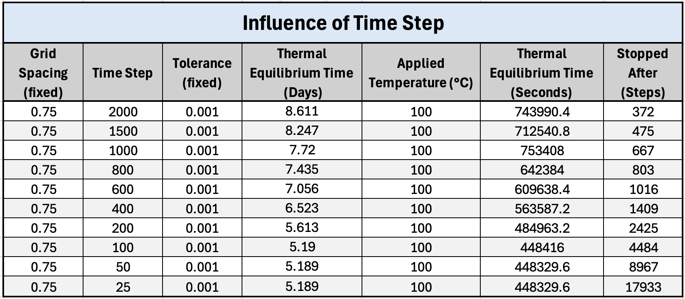
Figure 7 - Influence of Time Step (Holmes, 2026)

For large time steps, the equilibrium time is noticeably overpredicted. As the time step is reduced, the equilibrium time decreases and asymptotically approaches a stable value of approximately 5.19 days. Although smaller time steps require substantially more iterations to reach convergence, the final steady-state equilibrium time becomes largely independent of $∆t$ once numerical stability is maintained.
This result confirms that the steady-state solution of the heat equation is independent of time discretisation, provided that the stability criterion is satisfied and sufficient physical time is simulated.
Representative spatial error distributions for selected time step sizes are provided in Appendix 2.

7.3 Influence of Convergence Tolerance

The sensitivity of the numerical solution to the convergence tolerance $CC$ was investigated by varying $CC$ over several orders of magnitude while keeping the grid spacing and time step fixed at$h=1 m$ and $∆t=500 s$. The resulting equilibrium times are presented in Figure 8.
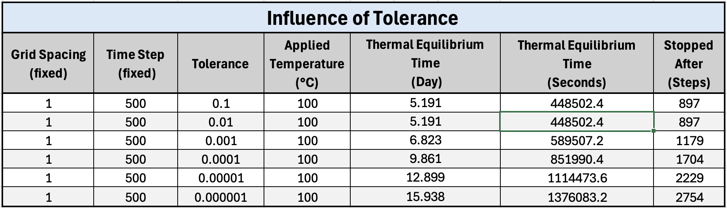
Figure 8 - Influence of Tolerance (Holmes, 2026)

The results show a strong dependence of the reported equilibrium time on the chosen tolerance. Loose tolerances lead to early termination of the simulation, while progressively tighter tolerances significantly increase the equilibrium time. This trend highlights the fundamental limitation of relying solely on an absolute per-step temperature change criterion, particularly when small time steps are used.
Importantly, this behaviour directly justifies the inclusion of a minimum physical simulation time $t_{min}$, as discussed in Chapter 5. By requiring both numerical convergence and a minimum diffusion time to be satisfied, the solver avoids premature termination and ensures that the reported equilibrium state is physically meaningful.
Representative spatial error distributions for selected convergence tolerances are provided in Appendix 3.

7.4 Summary of Sensitivity Findings

The sensitivity studies demonstrate that spatial resolution, time step size, and convergence tolerance all influence the reported thermal equilibrium time to varying degrees. Grid refinement and time step reduction lead to convergent equilibrium times, while convergence tolerance has a pronounced effect when used in isolation. The combined convergence strategy employed in this work provides a robust and physically consistent approach to identifying thermal equilibrium.

8.0 Limitations of the Numerical Model

While the numerical model developed in this work provides accurate and stable solutions for the two-dimensional transient heat conduction problem, several limitations should be acknowledged.
Firstly, the Explicit Finite Difference Method is conditionally stable and requires strict enforcement of the Fourier number stability criterion. This limits the allowable time step size, particularly for fine spatial grids, and can result in long computational times for high-resolution simulations (M. Hague, 2025). Although this issue is mitigated by careful parameter selection, implicit methods would offer improved stability properties.
Secondly, the model assumes constant and isotropic thermal properties. In practical engineering applications, material properties may vary with temperature or exhibit directional dependence, which is not captured in the current formulation. As a result, the model is best suited to idealised materials rather than complex composites or temperature-dependent systems.
Thirdly, the geometry considered is limited to a simple rectangular plate with uniform grid spacing and Dirichlet boundary conditions. More complex geometries or mixed boundary conditions would require alternative discretisation strategies or coordinate transformations.
Finally, the convergence criterion relies on a global maximum temperature change and a prescribed minimum physical simulation time. While this combined approach improves robustness, the definition of thermal equilibrium remains approximate and problem dependent. More sophisticated convergence metrics based on energy norms could provide improved accuracy.

9.0 Potential Improvements and Future Work

Several improvements could be made to extend the capability and efficiency of the numerical model developed in this work. One significant enhancement would be the implementation of an implicit time integration scheme, such as the Crank–Nicolson method. Implicit methods are unconditionally stable and would permit larger time steps, substantially reducing computational cost for fine spatial grids.
The model could also be extended to include temperature-dependent thermal properties, allowing more realistic simulation of materials whose conductivity or heat capacity varies with temperature. This would improve applicability to real engineering systems, particularly in high-temperature environments.
In addition, the current solver is restricted to simple rectangular geometries and uniform grids. Future work could incorporate non-uniform meshes or alternative discretisation techniques, such as the finite volume or finite element methods, to handle complex geometries and mixed boundary conditions more effectively.
Finally, further validation could be performed using experimental data or benchmark numerical solutions to strengthen confidence in the model’s predictive capability.

10.0 Conclusion

This report has presented the development, implementation, and validation of a numerical model for solving the two-dimensional transient heat conduction equation using the Explicit Finite Difference Method. The governing equations were formulated and discretised in space and time, and the resulting numerical scheme was implemented in MATLAB with appropriate stability and convergence controls.
The numerical solution was validated against an analytical steady-state solution, demonstrating good agreement and low error, thereby confirming the accuracy of the implementation. Sensitivity studies showed that grid spacing and time step size influence the reported equilibrium time until convergence is achieved, while convergence tolerance has a pronounced effect when used in isolation. These findings highlighted the importance of employing a combined convergence criterion incorporating both a numerical tolerance and a minimum physical simulation time.
Overall, the model provides a robust and reliable framework for transient heat conduction analysis under idealised conditions. The work demonstrates a sound understanding of numerical methods, stability considerations, and validation techniques, and provides a solid foundation for further development and application to more complex heat transfer problems.

Reference List

Alok Warey, T. H. (2025). General Motors Global Research and Development.

B. Cockburn, N. C. (2016). Hanbook of Numerical Analysis (17th ed.). North Holland.

Daileda, R. C. (2012). The Two Dimensional Heat Equation. San Antonio: Trinity University.

Edge, E. (2025). Engineers Edge. Retrieved January 23rd, 2026, from https://www.engineersedge.com/heat_transfer/thermal_diffusivity_table_13953.htm

Ereiz, S. (2022). Review of finite element model updating methods for structural applications. In Structure (pp. 684-723). Zagreb.

Herman, R. (2025). Libre Texts. Retrieved January 25th, 2026, from https://math.libretexts.org/Bookshelves/Differential_Equations/Introduction_to_Partial_Differential_Equations_(Herman)/07%3A_Green%27s_Functions/7.03%3A_The_Nonhomogeneous_Heat_Equation#:~:text=The%20steady%20state%20solution,%20%5C(w(t)%5C),%20satisfies%

Hodson, T. O. (2022). European Geosciences Union. Retrieved January 25th, 2026, from https://gmd.copernicus.org/articles/15/5481/2022/#:~:text=19%20Jul%202022-,The%20root%2Dmean%2Dsquared%20error%20(RMSE)%20and%20mean,Euclidean%20and%20Manhattan%20distance%2C%20respectively.

Holmes, R. (2026, January). Excel Document. MATLAB Runs. Milford Haven.
Incropera, F. P. (2011). Fundamentals of Heat and Mass Transfer. Hoboken: John Wiley & Sons.

Jaeger, H. S. (1959). Conduction of Heat in Solids (Second ed.). Oxford: Oxford University Press.

M. Hague, R. A. (2025). An Efficient Explicit Scheme for Solving the 2D Heat Equation with Stability and Convergence Analysis. Journal of Applied Mathematics and Physics.

Mayers, K. W. (2005). Numerical Solution of Partial Differential Equations. Cambridge: Cambridge University Press.

Nazmul Haque, R. A. (2025). An Efficient Explicit Scheme for Solving the 2D Heat Equation with Stability and Convergence Analysis. Journal of Applied Mathematics and Physics, 13, 11.

Obi, C. N. (2022). Analytical Solution of Steady State Heat Conduction in a Rectangular Plate and Comparison with the Numerical Finite Difference Method. International Journal of Mathematical Research, 11(1), 15.

Roache, P. (1998). Verification and Validation in Computational Science and Engineering. New Mexico: Hermosa.

Salawu, S. O. (2023). Two-step exothermic reaction–diffusion of hydromagnetic Prandtl–Eyring viscous heating fluid in a channel. International Journal of Thermofluids, 17, 57.

Smith, G. D. (1985). Numerical Solution of Partial Differential Equations . Oxford: Oxford University Press.

Appendix

This appendix presents additional numerical and analytical steady-state temperature fields and corresponding absolute error distributions for selected grid spacings, time step sizes, and convergence tolerances. These figures are provided to supplement the sensitivity analysis discussed in Chapter 7 and to demonstrate how variations in numerical parameters influence the spatial distribution of numerical error.
All results correspond to a square plate of dimensions 12 x 12 m with a fixed heated boundary temperature of $T_{0}=100℃$, while the remaining boundaries are held at 0 °C. The numerical solution was obtained using the Explicit Finite Difference Method and compared against the analytical steady-state solution.

Appendix 1 – Influence of Grid spacing, 4, 0.75, and 0.25

Grid Spacing 4
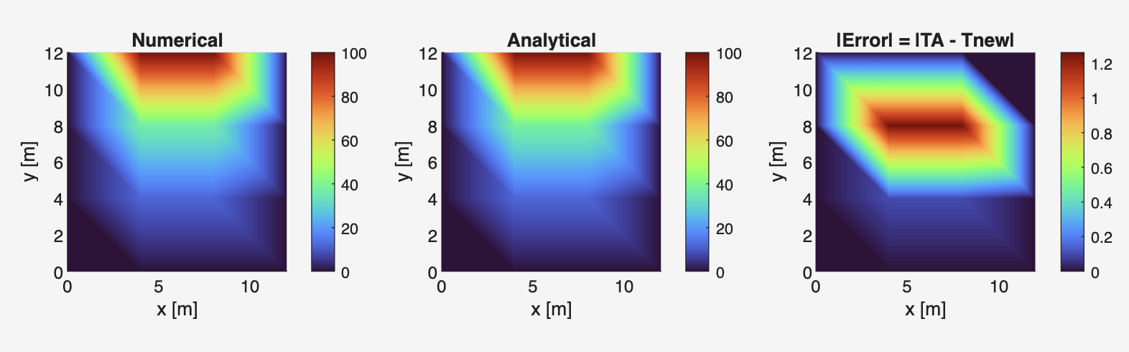

Gris Spacing 0.75
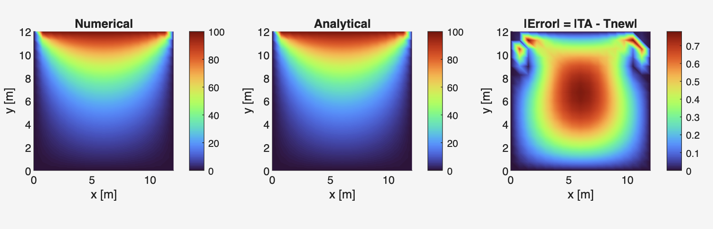

Grid Spacing 0.25

Appendix 2 – Influence of Time Step 2000 s and 200 s

Time Step 2000 s
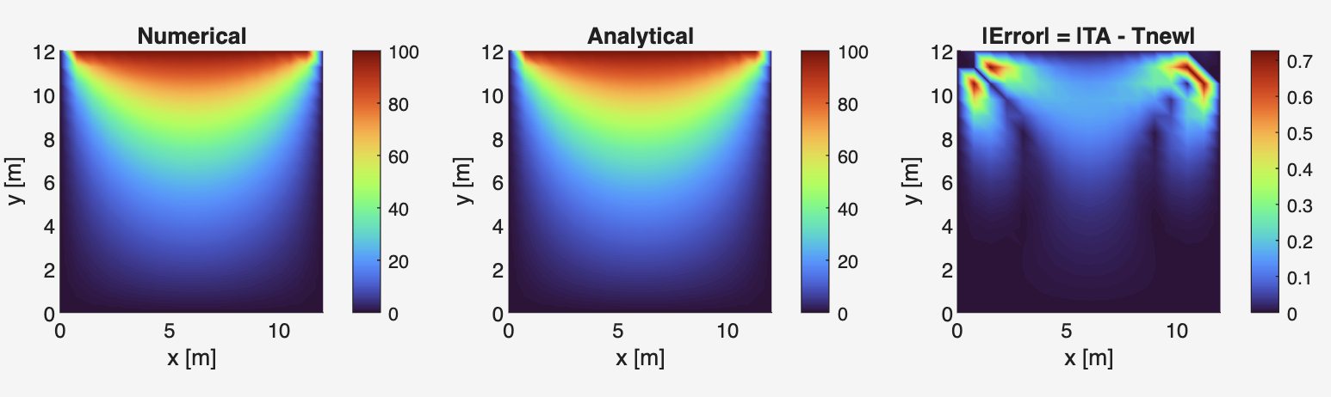

Time Step 200 s
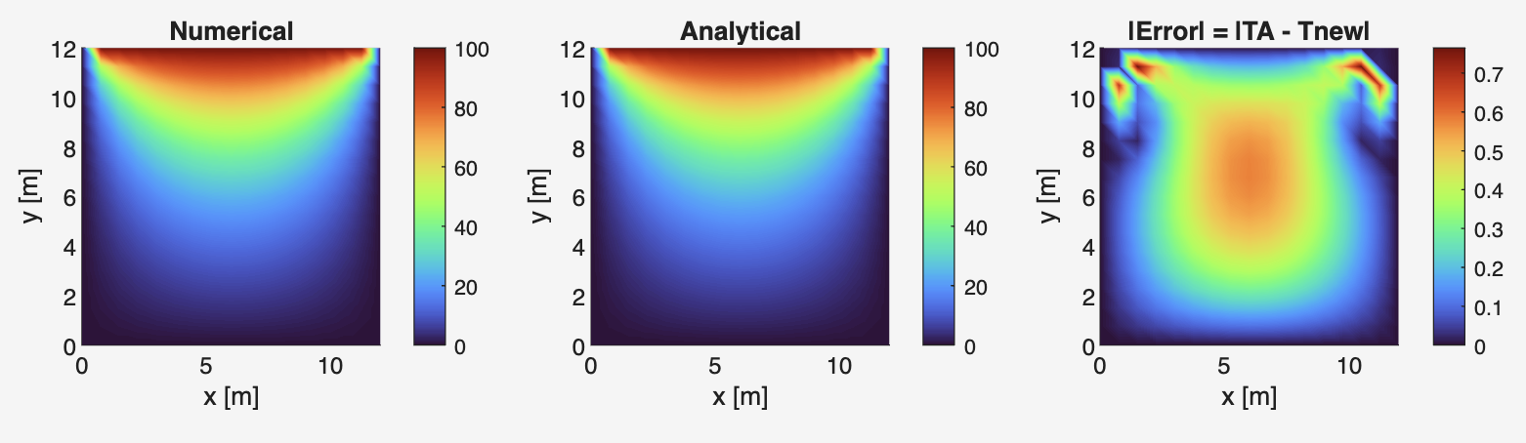

Appendix 3 – Influence of Convergence Tolerance (Loose tolerance and tight tolerance)

Tolerance 0.001
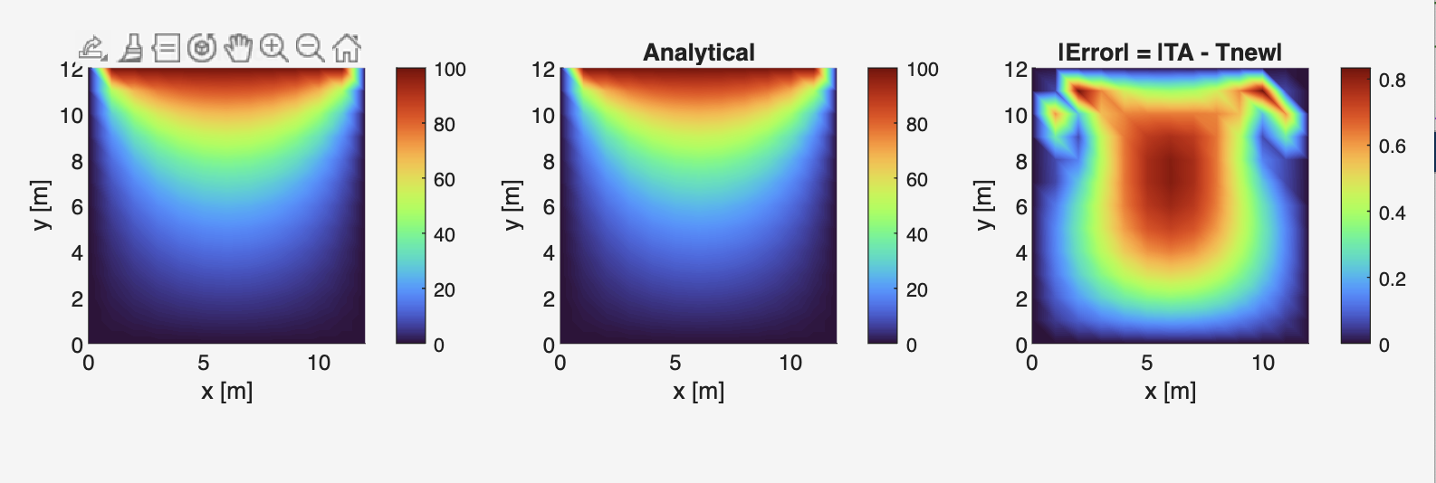

Tolerance 0.000001
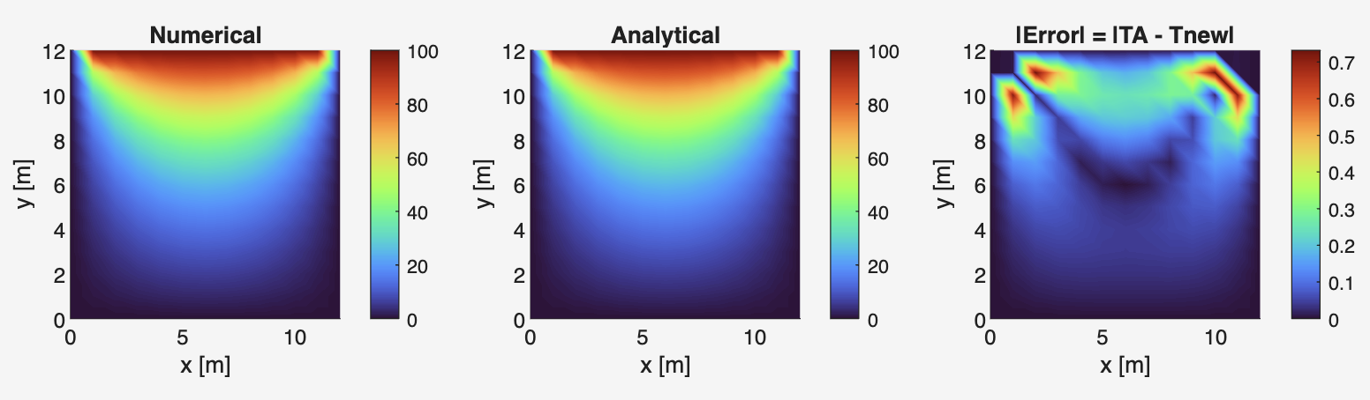

Appendix 4 – MATLAB Code

This appendix contains the complete MATLAB source code developed and used to generate the numerical results presented in this report. The code implements the Explicit Finite Difference Method for solving the two-dimensional transient heat conduction equation, including stability enforcement, convergence checks, validation against an analytical solution, and sensitivity analysis. The code is provided in full for completeness and reproducibility.

clear; clc; close all;

%% Physical properties (Aluminium)
k = 143; % [W/(m·°C)]
rho = 2.8e3; % [kg/m^3]
cp = 795; % [J/(kg·°C)]
alpha = k/(rho*cp); % [m^2/s]

%% Solver settings
CC = 0.000001; % Convergence threshold [°C]
N_terms = 10000;
plot_every = 200;

max_iter = 5e7; % Safety cap

fprintf('Reminder: enter dimensions in metres (e.g., 0.12 for 12 cm).\n');

% continueSim to allow multiple plate configurations in one run
continueSim = 'y';
while strcmpi(continueSim,'y')

fprintf('\n2D Transient Heat Equation – Explicit FDM solver\n');
fprintf ('Units: metres, seconds, °C\n\n');

%% Inputs
Xdim = getPositiveInput('Enter plate width Xdim [m] (must be > 0): ');
Ydim = getPositiveInput('Enter plate height Ydim [m] (must be > 0): ');
T0 = getPositiveInput('Enter north boundary temperature T0 [°C] (must be > 0): ');

h = getValidGridSpacing(Xdim, Ydim); % tolerant divisibility + coarse-grid guard
dt = getStableTimeStep(alpha, h); % stability-checked

%% Grid
Nx = round(Xdim/h) + 1;
Ny = round(Ydim/h) + 1;

% Memory/size safeguard
max_nodes = 2e6;
if Nx*Ny > max_nodes
fprintf(' ERROR: grid too large (%d nodes). Increase h.\n', Nx*Ny);
continue;
end

x = linspace(0, Xdim, Nx);
y = linspace(0, Ydim, Ny);
[X, Y] = meshgrid(x, y);

Fo = alpha*dt/h^2;
fprintf('Fo = %.5f (<= 0.25 OK)\n', Fo);
fprintf('Grid: h=%.6g, Nx=%d, Ny=%d\n', h, Nx, Ny);

%% Initial condition + boundary conditions
Told = zeros(Ny, Nx); % T(x,y,0)=0
Told = applyBC(Told, T0); % Apply Dirichlet BCs ONCE
Tnew = Told;

%% Safeguard against false equilibrium
t_min = 0.2 * (max(Xdim,Ydim)^2 / alpha);

%% Transient plot
if plot_every > 0
fig = figure('Name','Transient temperature evolution');
ax = axes('Parent',fig);
sh = surf(ax, X, Y, Told, Told);
view(2); shading interp; colormap(turbo);
colorbar; axis equal tight; clim([0 T0]);
xlabel('x [m]'); ylabel('y [m]');
title(sprintf('t = %.2f s', 0));
drawnow;
end

%% Explicit EFDM loop
i = 2:Ny-1; j = 2:Nx-1;
max_diff = CC + 1;
time_elapsed = 0;
iter = 0;

while ( (max_diff > CC) || (time_elapsed < t_min) ) && (iter < max_iter)
iter = iter + 1;

% EFDM
Tnew = Told;
Tnew(i,j) = (1 - 4*Fo).*Told(i,j) + Fo .* ( ...
Told(i, j+1) + Told(i, j-1) + Told(i+1,j) + Told(i-1,j) );

% Convergence metric
max_diff = max(abs(Tnew(:) - Told(:)));

% Time advance
time_elapsed = time_elapsed + dt;

% Update for next iteration
Told = Tnew;

% Plot update
if plot_every > 0 && mod(iter, plot_every) == 0
set(sh,'ZData',Tnew,'CData',Tnew);
title(ax, sprintf('t = %.2f s', time_elapsed));
drawnow;
end
end

if iter >= max_iter
warning('Safety stop: max_iter reached before meeting equilibrium criteria.');
end

% Convergence flag (must satisfy BOTH CC and t_min, and not hit max_iter)
didConverge = (time_elapsed >= t_min) && (max_diff <= CC) && (iter < max_iter);

% Final summary
fprintf('\nStopped after %d steps | final max|ΔT| = %.6g °C\n', iter, max_diff);

if didConverge
fprintf('Time to equilibrium ≈ %s\n', formatTime(time_elapsed));
else
fprintf('Equilibrium not confirmed (CC and/or t_min not satisfied before safety stop).\n');
end

%% Numerical equilibrium field
T_num = Told;

%% Analytical steady-state (stable) + errors
TA = analyticalSolutionStableRatio(X, Y, Xdim, Ydim, T0, N_terms);
E = TA - T_num;

%% Display key matrices in Command Window
disp('Numerical temperature matrix Tnew:');
disp(T_num);

disp('Analytical temperature matrix TA:');
disp(TA);

disp('Absolute error matrix abs(E):');
disp(abs(E));

%% Error stats
mask = isfinite(E);
if any(mask(:))
max_abs_error = max(abs(E(mask)));
rmse = sqrt(mean(E(mask).^2));
else
max_abs_error = NaN;
rmse = NaN;
warning('Analytical solution produced only NaN/Inf. Reduce N_terms or check inputs.');
end

fprintf('\nValidation vs analytical steady state:\n');
fprintf(' Max |TA - Tnew| = %.6g °C\n', max_abs_error);
fprintf(' RMSE = %.6g °C\n', rmse);

%% Comparison + error map
figure('Name','Steady-state comparison');
tiledlayout(1,3,'TileSpacing','compact','Padding','compact');

nexttile;
surf(X,Y,T_num,T_num); view(2); shading interp; axis equal tight;
colormap(turbo); colorbar; clim([0 T0]);
title('Numerical'); xlabel('x [m]'); ylabel('y [m]');

nexttile;
surf(X,Y,TA,TA); view(2); shading interp; axis equal tight;
colormap(turbo); colorbar; clim([0 T0]);
title('Analytical'); xlabel('x [m]'); ylabel('y [m]');

nexttile;
% Plot absolute error magnitude
A = abs(E);
surf(X,Y,A,A); view(2); shading interp; axis equal tight;
colormap(turbo); colorbar;
title('|Error| = |TA - Tnew|'); xlabel('x [m]'); ylabel('y [m]');

if any(mask(:))
amax = max(A(mask));
if amax > 0, clim([0 amax]); end
end

%% Repeat?
continueSim = input('Would you like to run a new plate configuration? (y/n): ','s');
while ~ismember(lower(continueSim), {'y','n'})
continueSim = input('Please enter ''y'' or ''n'': ','s');
end
end

fprintf('\nAll simulations completed successfully.\n');

%% ---------------- Helper functions ----------------
function val = getPositiveInput(prompt)
while true
val = input(prompt);
if isnumeric(val) && isscalar(val) && isfinite(val) && val > 0, return; end
fprintf(' Input must be a single positive number – try again.\n');
end
end

function h = getValidGridSpacing(Xdim, Ydim)
tol = 1e-10;
while true
h = getPositiveInput('Enter grid spacing h [m] (must divide both dims exactly): ');
Nx_cells = Xdim/h;
Ny_cells = Ydim/h;

if abs(Nx_cells - round(Nx_cells)) > tol || abs(Ny_cells - round(Ny_cells)) > tol
fprintf(' ERROR: h must divide both Xdim and Ydim exactly.\n');
continue;
end

Nx = round(Nx_cells) + 1;
Ny = round(Ny_cells) + 1;

if Nx < 3 || Ny < 3
fprintf(' ERROR: mesh too coarse – choose a smaller h.\n');
continue;
end
return;
end
end

function dt = getStableTimeStep(alpha, h)
dt_max = h^2/(4*alpha); % Fo <= 0.25
while true
dt = getPositiveInput(sprintf('Choose time step Δt [s] (must satisfy Δt ≤ %.6g for stability): ', dt_max));
Fo = alpha*dt/h^2;
if Fo > 0 && Fo <= 0.25, return; end
fprintf(' Unstable: Fo = %.5f > 0.25. Enter a smaller dt.\n', Fo);
end
end

function T = applyBC(T, T0)
% BCs: South=0, West=0, East=0, North=T0, with top corners = 0°C
T(1,:) = 0;
T(:,1) = 0;
T(:,end) = 0;
T(end,:) = T0;
T(end,1) = 0;
T(end,end) = 0;
end

function TA = analyticalSolutionStableRatio(X, Y, Xdim, Ydim, T0, N_terms)
% Stable odd-term analytical solution using overflow-safe sinh ratio:
% sinh(a)/sinh(b) = exp(a-b) * (1-exp(-2a)) / (1-exp(-2b))
TA = zeros(size(X));
b0 = pi*Ydim/Xdim;
for k = 1:N_terms
m = 2*k - 1;
a = m*pi*Y/Xdim;
b = m*b0;
ratio = exp(a - b) .* (1 - exp(-2*a)) ./ (1 - exp(-2*b));
TA = TA + (1/m) * sin(m*pi*X/Xdim) .* ratio;
end
TA = (4*T0/pi) * TA;
end

function s = formatTime(seconds)
if seconds < 60
s = sprintf('%.3f s', seconds);
elseif seconds < 3600
s = sprintf('%.3f min', seconds/60);
elseif seconds < 86400
s = sprintf('%.3f hr', seconds/3600);
else
s = sprintf('%.3f days', seconds/86400);
end
end

