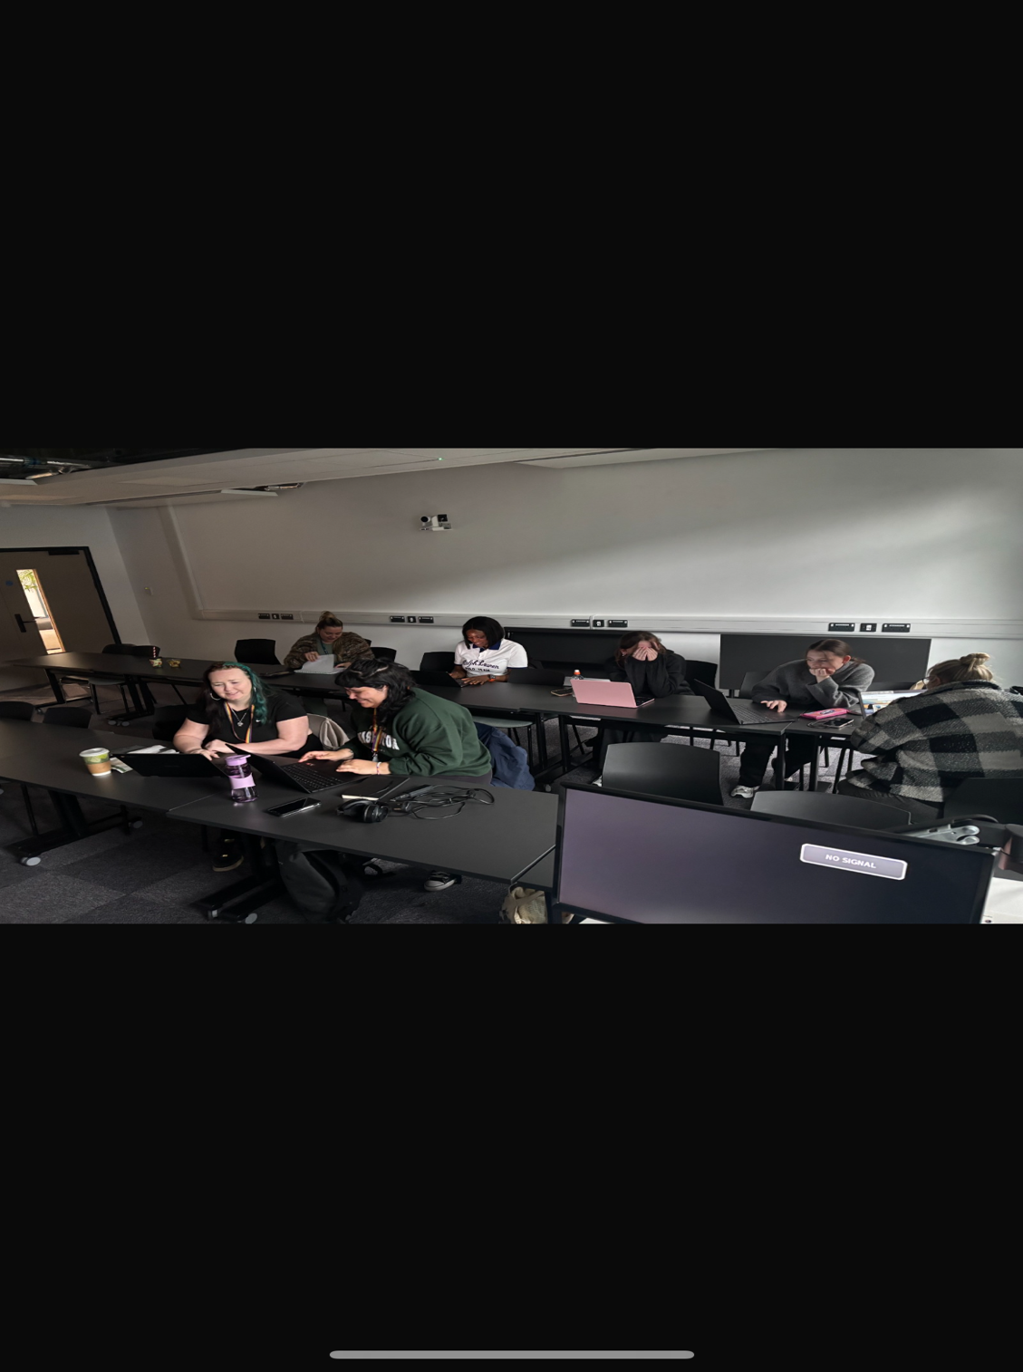
Networking
Me and some off my class mates went in to university early to speak about the assignments and help each other out with the up coming assignments that was due that week.

