ENVIRONMENTAL MARKETING ANALYSIS AND RECOMMENDATIONS - A CASE OF STARBUCKS IN COVID 19

TABLE OF CONTENTS
Introduction 3
Background 3
Aim & objectives 4
Analysis 6
SWOT 9
Recommendation 11
Conclusion 11
References 13

Introduction
Environmentally conscious marketing has become an important factor for organizations looking to stay competitive in the current market. Consumers are increasingly looking for organizations that are making an effort to reduce their environmental footprint, which makes environmental marketing a powerful tool. In this report, we will be focusing on an environmental marketing analysis and recommendations for Starbucks. The background of the report will focus on the development of Starbucks’ environmental marketing initiatives and how they fit into the overall marketing strategy. The aim is to assess the effectiveness of environmental marketing initiatives and identify areas of improvement. The objectives are to analyze the current environmental marketing initiatives, identify any trends, and make recommendations on how to improve the effectiveness of the environmental marketing initiatives. The analysis will focus on the environmental marketing initiatives implemented by Starbucks, and how they have impacted the overall brand image. The findings of the report will include an assessment of the effectiveness of the environmental marketing initiatives implemented by Starbucks. Based on the findings of the report, recommendations will be made on how to improve the effectiveness of environmental marketing initiatives. The conclusion of the report will be a summary of the findings and recommendations.

Background
Starbucks has long been a leader in environmental marketing initiatives. Since its inception in 1971, Starbucks has focused on sustainability and environmental stewardship. The company has always strived to reduce its environmental impact and has implemented a variety of strategies over the years to achieve this goal (Shim et al., 2021) . These strategies include using recycled materials in the production of its products, sourcing sustainable packaging, and using renewable energy sources. Starbucks has implemented initiatives to reduce its water and electricity use, as well as to increase its recycling efforts. Starbucks’ environmental marketing initiatives have been an essential part of its overall marketing strategy. Through its initiatives, Starbucks has been able to position itself as an environmentally responsible company, which has been beneficial to both its public image and its bottom line. Starbucks’ environmental initiatives have allowed the company to differentiate itself from its competitors and attract new customers.
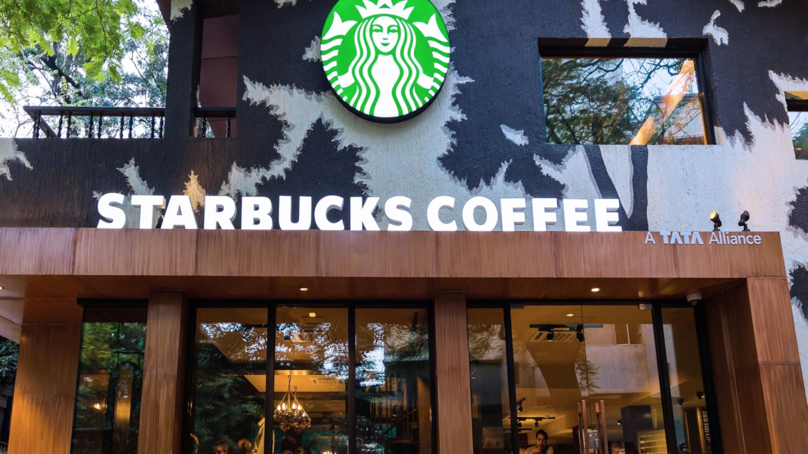
Figure 1: Starbucks
(Source: www.moneycontrol.com)
The company has also leveraged its environmental efforts to build relationships with customers, communities, and other stakeholders. Starbucks has implemented a variety of programs to engage customers and local communities, such as donating coffee to local charities, supporting sustainable coffee farmers, and offering eco-friendly coffee cups (He et al., 2021). Through these initiatives, Starbucks has been able to build loyalty and trust with its customers and other stakeholders, which has been beneficial to the company’s bottom line. Starbucks’ environmental marketing initiatives have been an essential part of its overall marketing strategy. Through its initiatives, the company has been able to differentiate itself from its competitors and attract new customers, while also building loyalty and trust with customers and other stakeholders. These initiatives have been beneficial to both the company’s public image and its bottom line.

Aim & objectives
Aim: The aim of this study is to investigate the effectiveness of Starbucks’ environmental marketing initiatives, implemented after the COVID-19 pandemic, and to identify areas for improvement. Specifically, the study will examine the company's environmental policies, its green initiatives and campaigns, and how well they have been received by customers (Lombardi et al., 2021). The results of the study will provide insights into how Starbucks can improve its environmental marketing efforts and better position itself as a sustainable business leader.

Objectives:
1. To analyze the current environmental marketing initiatives of Starbucks.
2. To identify any trends in the effectiveness of Starbucks’ environmental marketing initiatives during and after the pandemic.
3. To make recommendations on how to improve the effectiveness of Starbucks’ environmental marketing initiatives to survive the pandemic situation of COVID-19.
4. To create a framework for analyzing the effectiveness of Starbucks’ environmental marketing initiatives in the future.
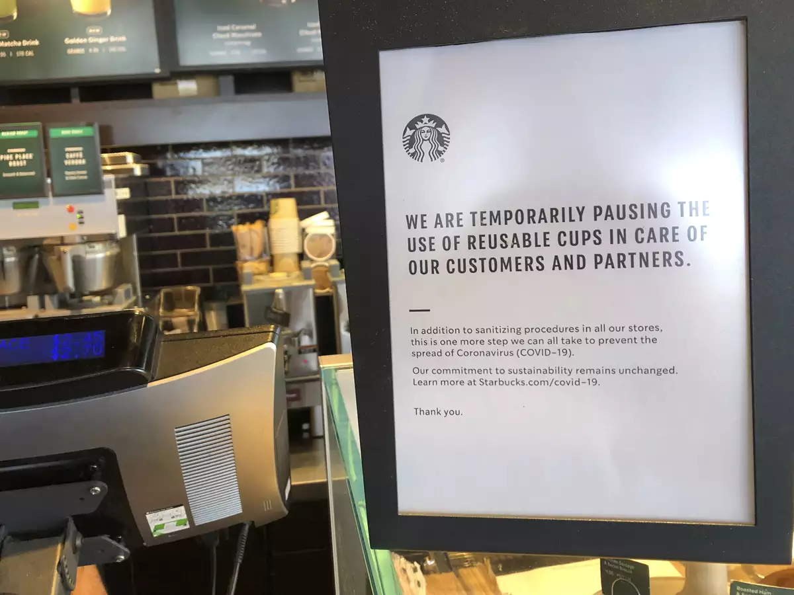
Figure 2: Initiative during the pandemic
(Source: economictimes.indiatimes.com)

Analysis
Starbucks is one of the largest and most recognizable coffee brands in the world. The company has a long history of environmental stewardship and has implemented a number of environmental marketing initiatives to increase its market share and remain competitive in the industry. This paper will analyze the environmental marketing initiatives of Starbucks and how it can increase its market share after the Covid-19 pandemic. the paper will discuss the key external influencing drivers and the role that marketing plays within the organization.

In order to remain competitive and increase its market share, Starbucks has implemented a number of environmental marketing initiatives (Sinha et al., 2021). The company has committed to using renewable energy sources in all of its stores and has achieved a significant reduction in its carbon emissions since 2009. Starbucks has introduced initiatives such as the reusable cup discount and the “Bring Your Own Cup” program in order to reduce the amount of waste produced by its customers. the company has implemented a number of initiatives that promote sustainability, such as the Starbucks “Green Apron” program, which encourages customers to bring their own reusable bags and compost their coffee grounds. Starbucks has partnered with organizations such as the Rainforest Alliance and Conservation International to promote sustainability and protect the environment.
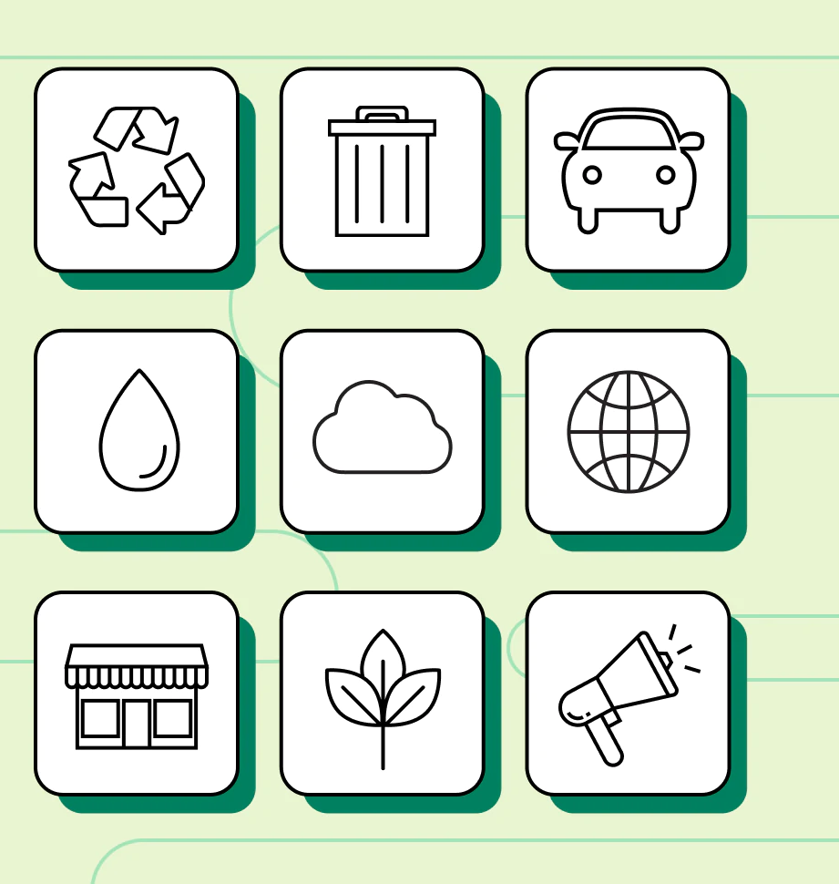
Figure 3: Green Marketing
(Source: www.shopify.com)
Starbucks is a major player in the coffee industry, having a strong presence in both the United States and global markets. Its main competitors, Dunkin’ Donuts and McDonald’s, are also major players, providing a wide range of coffee-based products and having a strong presence in the market. Dunkin’ Donuts focuses on convenience and affordability, while McDonald’s offers a wider range of products, including breakfast items and specialty coffees (Musonera, 2021). Both Dunkin’ Donuts and McDonald’s have implemented environmental initiatives, such as using renewable energy sources and reducing the amount of waste generated by customers. However, Starbucks has taken a more comprehensive approach to environmental marketing initiatives, which has helped it to increase its market share and stand out from the competition. Its initiatives include: recycling coffee grounds, providing reusable cups and lids, investing in sustainable agricultural practices, and reducing its carbon footprint. With the rise of the green movement and increasing consumer demand for sustainable products and services, Starbucks has taken a proactive approach to promoting sustainability. Through its comprehensive environmental marketing initiatives, Starbucks has been able to differentiate itself from the competition and increase its market share. This is a testament to its commitment to sustainability, which has been vital to its success in the coffee industry.
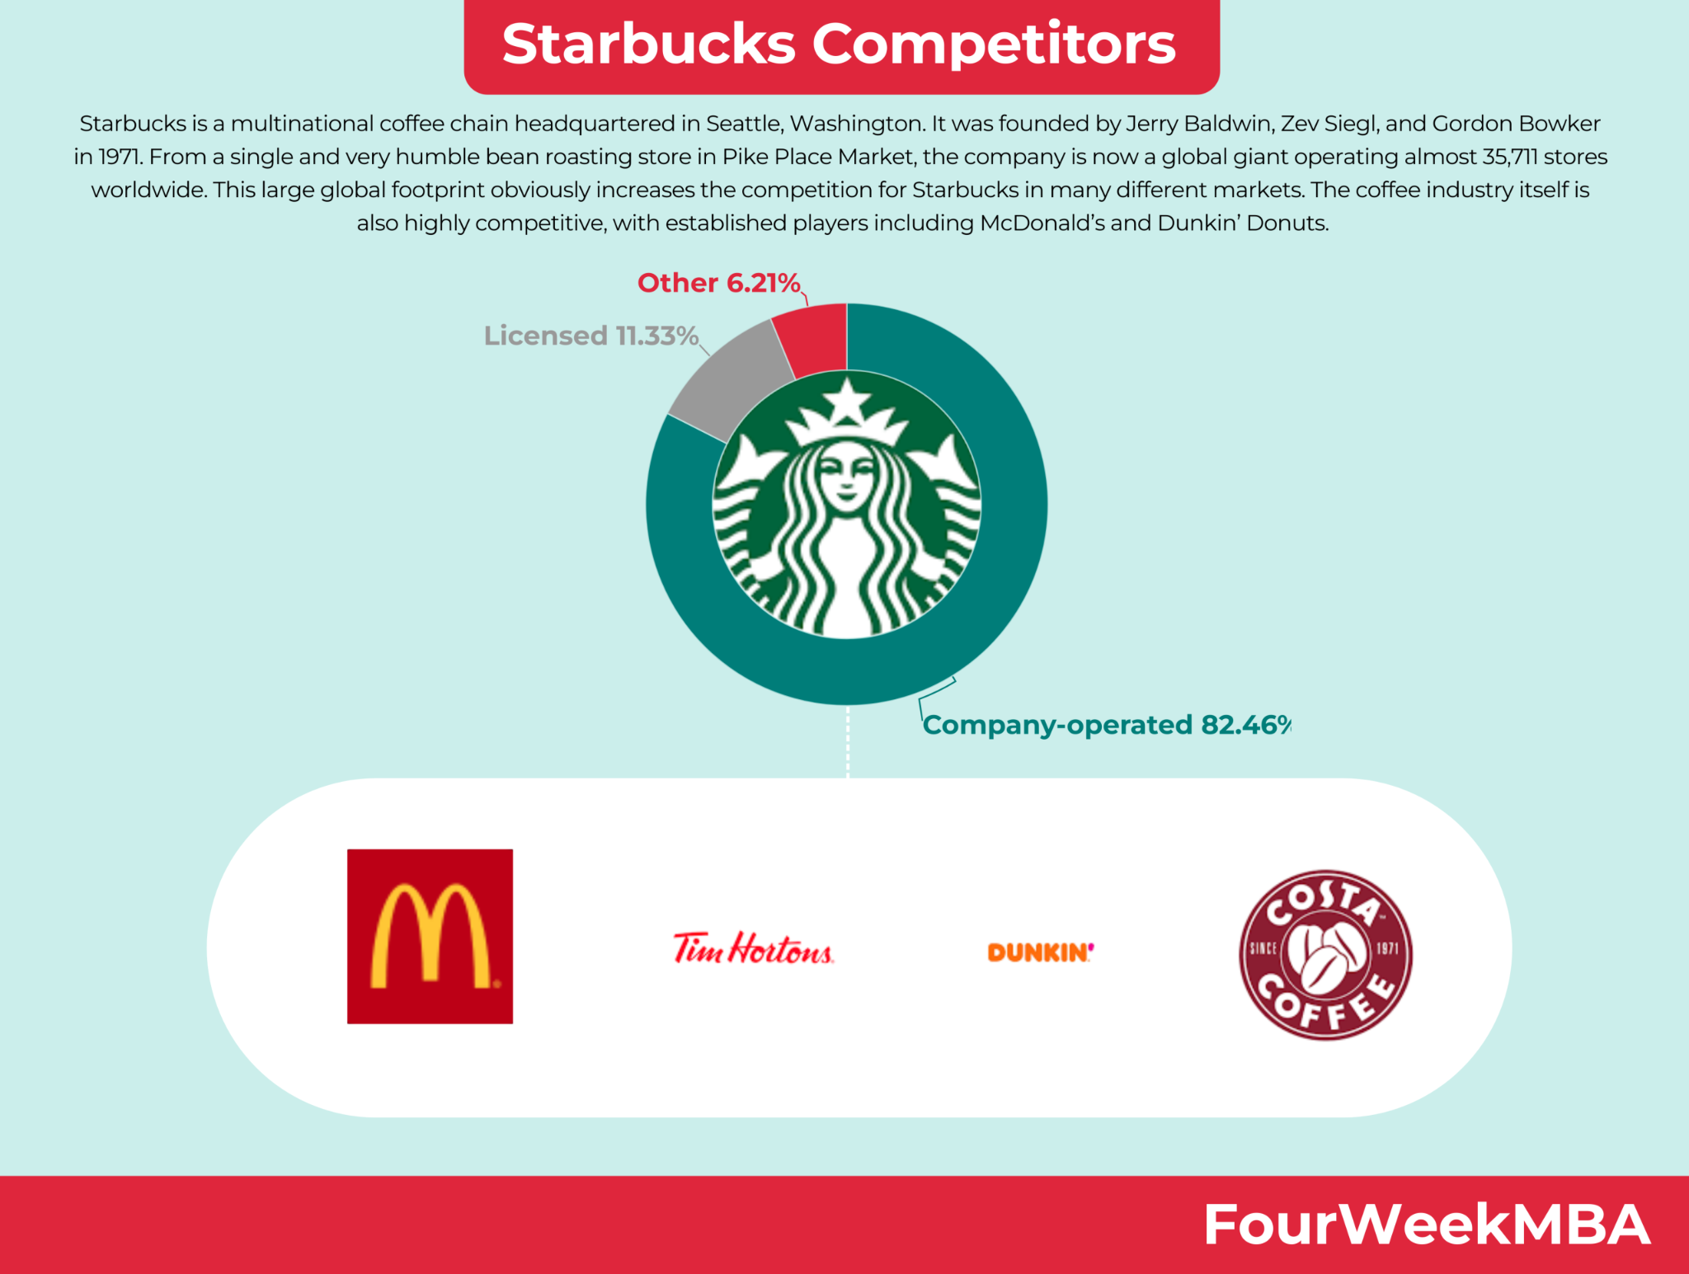
Figure 4: Competitors
(Source: fourweekmba.com)
The external environment has a significant impact on the success of an organization’s marketing initiatives. In the case of Starbucks, the key external influencing drivers are consumer preferences, economic conditions, technological advancements, and government regulations. Consumer preferences are constantly evolving, and Starbucks must remain up-to-date on the latest trends in order to remain competitive (Lim et al., 2022). Economic conditions affect the purchasing power of consumers and can affect the profitability of Starbucks’ products. technological advancements have enabled Starbucks to develop innovative products and marketing campaigns. government regulations can affect the way that Starbucks does business and can limit the company’s ability to implement certain initiatives.

Marketing mix strategies play an important role in developing and implementing a successful marketing plan. The marketing mix consists of four key elements: product, price, place, and promotion. Each element must be carefully planned and implemented to ensure marketing success. Product refers to the goods or services a company offers, while price is the amount charged for the product. Place involves the location of the product, and promotion is the means used to communicate the product to potential customers. The marketing mix must be carefully tailored to the target market and adjusted as the external environment changes (Kee et al., 2021). By utilizing the marketing mix, companies can increase awareness of their product and remain competitive in the marketplace.
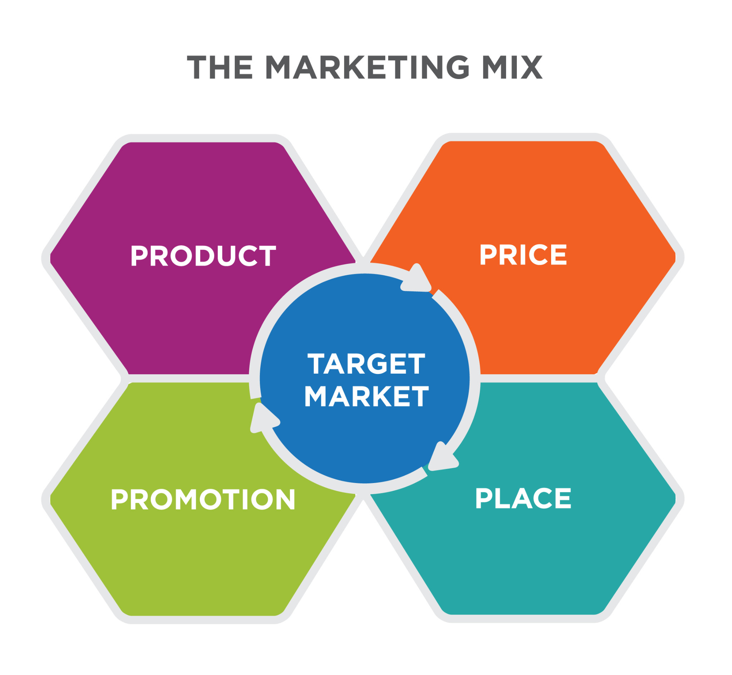
Figure 5: Marketing mix
(Source: courses.lumenlearning.com)

Starbucks has implemented a number of environmental marketing initiatives in order to increase its market share and remain competitive in the industry. The company’s initiatives have enabled it to differentiate itself from its competitors and to create a strong presence in the market. the external environment has a significant impact on the success of the company’s initiatives, and the internal environment plays an important role in the development and implementation of the initiatives (Ćosić and Hibler, 2022). As a result, Starbucks can continue to increase its market share by utilizing its environmental marketing initiatives and adapting to the changing external environment.

SWOT
Strengths: Starbucks has been able to leverage its strong brand reputation to effectively implement various environmental marketing initiatives during the pandemic. Its brand recognition enables it to quickly reach a large audience and create awareness about its sustainability efforts. It has also been able to use its global presence to launch many of its initiatives (Cao, 2022) . For example, Starbucks recently launched “Project Earth”, which is a global program that encourages customers to use reusable cups and tumblers as part of its commitment to reduce its environmental impact.

Weaknesses: Despite its efforts, Starbucks has been unable to fully capitalize on the environmental marketing opportunities that the pandemic has presented. It has struggled to shift its operations to a digital platform, which has hindered its ability to engage with customers and promote its environmental initiatives. Furthermore, it has faced criticism for its failure to address the root causes of climate change, such as deforestation and plastic waste.

Opportunities: The pandemic has presented Starbucks with a unique opportunity to expand its environmental marketing initiatives. It has been able to develop new technologies that reduce its environmental impacts, such as its “Coffee Sustainability Program”, which encourages customers to use reusable cups and tumblers (van Hest, 2022). It also has the potential to collaborate with other companies to create a global network of sustainability initiatives.

Threats: Despite its best efforts, Starbucks has been unable to fully capitalize on the environmental marketing opportunities that the pandemic has presented. It has faced criticism for its failure to address the root causes of climate change, such as deforestation and plastic waste. Furthermore, its competitors have also been able to launch their own environmental marketing initiatives, which has put Starbucks at a disadvantage.
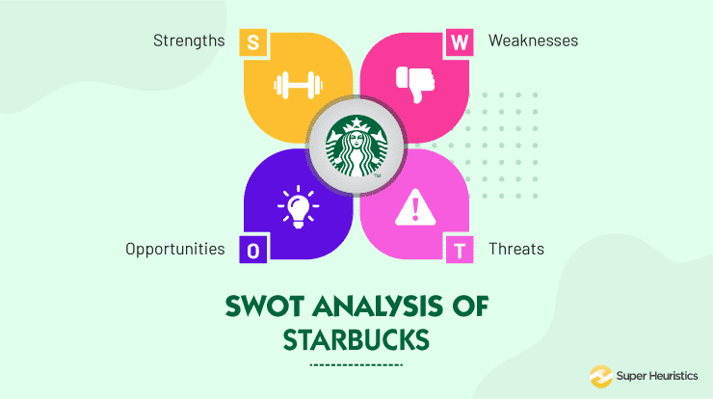
Figure 6: SWOT
(Source: cwww.superheuristics.com)

Recommendation
In order to improve its environmental marketing, Starbucks should prioritize the use of sustainable practices. This includes focusing on reducing their carbon footprint by increasing their use of renewable energy sources, reducing their waste, and utilizing reusable containers for their products. Starbucks should work with local communities to create sustainable projects that will benefit both their business and the environment (Li, 2022). For instance, they could create a program to reduce water usage and pollution, as well as support local farmers by sourcing their ingredients from them. Starbucks should focus on promoting its sustainability initiatives and policies through its marketing campaigns. Starbucks should focus on educating their customers about the importance of sustainability and the importance of their own sustainable practices. This can be done through their website, blog posts, and other digital content. they should create initiatives that reward customers who engage in sustainable practices. This could include discounts, exclusive promotions, or other rewards. Starbucks should focus on creating partnerships with environmental organizations and other businesses that are dedicated to sustainability. By doing so, Starbucks can create a network of supporters that will help further its sustainability goals. they can use these partnerships to create joint marketing campaigns that will help promote their environmental initiatives. Starbucks should focus on engaging its customers and stakeholders in environmental conversations (Ingrid et al., 2022). Through social media, forums, and other platforms, Starbucks can create an open dialogue about sustainability and the importance of protecting the environment. Doing so will help create a culture of sustainability within the company and help create more loyal customers who are passionate about protecting the planet.

Conclusion
In conclusion, it is clear that Starbucks’ marketing strategy was inadequate to deliver the expected growth in market improvement during the COVID-19 pandemic or after it. To improve environmental marketing, Starbucks should focus on strengthening its digital strategy, focus on customer retention, and innovate its campaigns to capture customer attention. the company should take advantage of the increased demand for convenience and delivery services during the pandemic and invest in customer retention to increase customer loyalty. Starbucks should also create more personalized and innovative campaigns to create a lasting impression and reinforce its brand. With these strategies, Starbucks can successfully improve its environmental marketing and increase its market share.

References
Journals
Shim, J., Moon, J., Song, M. and Lee, W.S., 2021. Antecedents of purchase intention at Starbucks in the context of COVID-19 pandemic. Sustainability, 13(4), p.1758.
He, G., Xiang, S. and Yin, J., 2021, December. Corporate Value Investing Research in Covid-19-A Case of Starbucks. In 2021 3rd International Conference on Economic Management and Cultural Industry (ICEMCI 2021) (pp. 2790-2796). Atlantis Press.
Lombardi, C.V., Chidiac, N.T. and Record, B.C., 2021. Starbucks coffee corporation’s marketing response to the COVID-19 pandemic. Innovative Marketing, 17(2), p.177.
Sinha, R., Ganatra, V., Pandey, P., Kee, D.M.H., Lekha, G.S., Kumar, N., Kew, S.D., Dhupad, A., Nair, R.K., Tenh, Y.Y. and Yue, H., 2021. Impact of Covid-19 on business performance: A Case Study of Starbucks. International journal of Tourism and hospitality in Asia Pasific (IJTHAP), 4(2), pp.13-27.
Musonera, E., 2021. STRATEGIC MARKETING CASE ANALYSIS: STARBUCKS. Journal of Business and Social Science Review, 2(11), pp.12-22.
Lim, S.Y., Liang, C., Li, M., Liang, M. and Smitha, M., 2022. Customer Satisfaction on Starbucks Malaysia Post-Covid 19 Pandemic. International Journal of Tourism and Hospitality in Asia Pasific (IJTHAP), 5(3), pp.92-104.
Kee, D.M.H., Faheem, M., Al-Anesi, S.A.L., Imran, M.Y., Hazrul, M. and Khairi, A.A., 2021. Navigating through the COVID-19 crisis: A Case study of Starbucks. International Journal of Accounting & Finance in Asia Pasific (IJAFAP), 4(1), pp.24-36.
Cao, Y., 2022. The Influence of Social Media on Customer Behavior: Case Study from Starbucks. Highlights in Business, Economics and Management, 2, pp.154-158.
Ćosić, E. and Hibler, M., THE CASE STUDY OF STARBUCKS. COMPANY ANALYSIS, p.319.
Li, X., 2022, December. Discuss Starbucks Under the COVID-19 Pandemic from the Finance. In 2022 International Conference on Economics, Smart Finance and Contemporary Trade (ESFCT 2022) (pp. 4-11). Atlantis Press.
Ingrid, R., Juned, M. and Afrimadona, A., 2022. Starbucks’ Efforts in Creating the Green Investment in Papua and West Papua. International Journal of Multicultural and Multireligious Understanding, 9(7), pp.390-405.
van Hest, I., 2022. Food market analysis. In Applied food science (pp. 429-452). Wageningen Academic Publishers.

