Sword-Slasher

Rebecca Jones - 2305750
Game Theory & Design - Game design document

SECTION 1

INTENDED PLATFORMS | Nintendo Switch

TARGET AGE / DEMOGRAPHIC OF PLAYERS
Targeted at a family-friendly ‘fitness game’ demographic, similar to the Wii.
Also suitable for rhythm or fantasy game enjoyers or those who would want to try wielding a sword.

INTENDED PEGI / ESRB RATING
The game would fall into either the PEGI 7 or PEGI 12 categories. PEGI 7 allows for mild or non-realistic violence, though may push into the PEGI 12 category based on the depiction of the swords.

SIMILAR AVAILABLE PRODUCTS/COMPETITORS
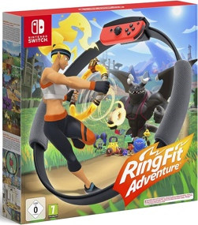
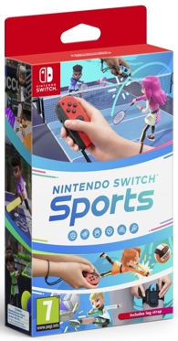
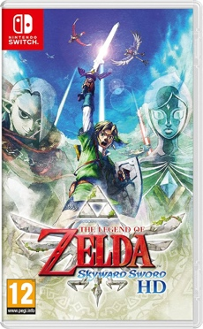
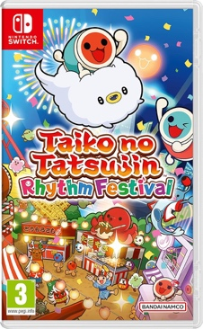
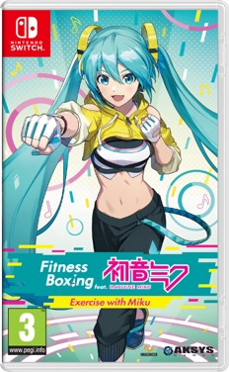
Above are game which either use motion controls or rhythm as a main element of gameplay on the intended platform for Sword-Slasher

SECTION 2: GAME OUTLINE

GAME STORY SUMMARY
Monsters invade the main character’s home castle, kidnapping its citizens and making off with their sword collection.

Using the only blade left behind, the player gives chase and discovers a hidden ability. The ability to hear the ‘rhythm’ of an enemy’s attacks. Using only the sword and this newfound ability, the player must recover what has been taken.

GAME FLOW
A fantasy fitness rhythm-game based on the idea of reclaiming a collection of swords from the monsters who stole them, as well as rescuing the citizens of your castle. With the completion of each area, a sword is reclaimed, as well as its unique move-set which can be used against monsters in order to rescue civilians.

SECTION 3: MAIN CHARACTER(S)
& PLAYER CONTROLS

CHARACTER APPEARANCE
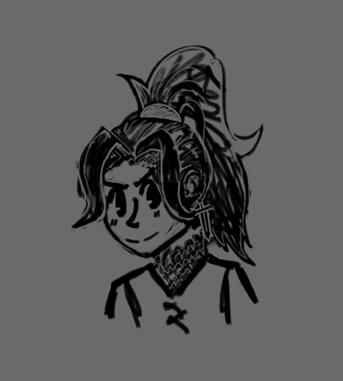
Possible main character appearance - has chainmail under the tunic, a sword shaped earring and hair tied up ready for action.
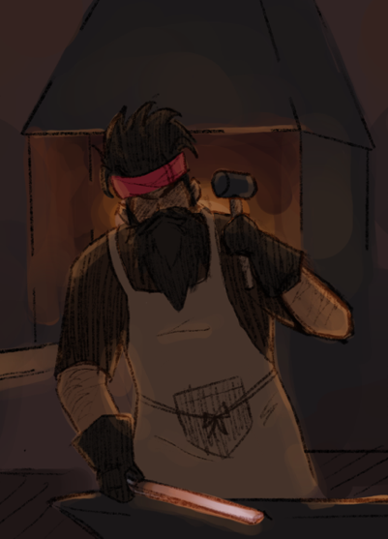
Blacksmith – shows up when you enter the smithy for upgrades.

CHARACTER DOSSIER / DETAILS
NAME: | Main character (Name is player determined)
GENDER: | (Player determined)
SPECIES: | Human
AGE: | Young adult
FACTION: | Protagonist, Player’s castle
KNOWN ASSOCIATES: | Blacksmith, Merchants, Citizens

CHARACTER DOSSIER / DETAILS
NAME: | Blacksmith
GENDER: | Male
SPECIES: | Human
FACTION: | Player’s castle
KNOWN ASSOCIATES: | Main character, Citizens

CHARACTER’S BACKSTORY
Main character –

Player character is a noble ruling over their castle and its citizens, whose predecessors have been collecting swords for generations. At the beginning of the game, the sword collection is stolen and citizens kidnapped by a group of raiding monsters. It is the players goal over the course of the game to retrieve these. The main character is a mostly silent protagonist, aside from small dialogue responses, so that players can project themselves onto the character.

Blacksmith –

The blacksmith works and lives in the main characters castle until the raid where he is kidnapped. As you need the blacksmith to upgrade your old sword, he is the first to be rescued as a part of the tutorial levels.

CHARACTER CONTROLS / PLAYER CONTROLS
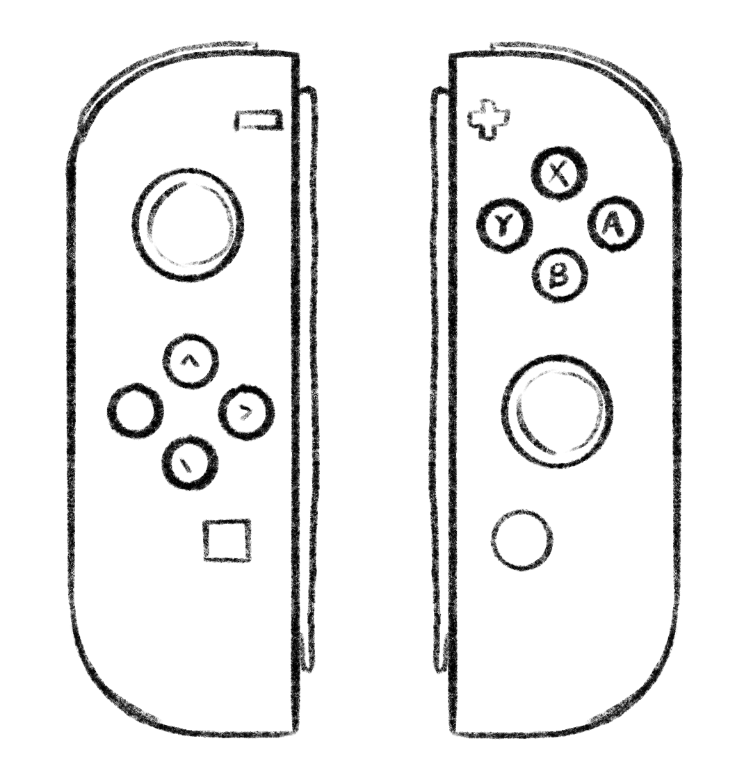
Motion controls –
Used for main gameplay, sword slashing.

X,Y,B,A buttons –
Used for menus and navigating dialogue.

Directional buttons –
Menu navigation, moving around the camp area.

Left stick –
Used to move the character around
the camp area, as well as navigating menus.

Plus button – Pause game, brings up menu.

SECTION 4: GAMEPLAY

SEQUENCE OF PLAY
The main game is separated into areas, with multiple levels/stages in that area. Each area ends with a boss monster using one of the stolen swords, defeating them adds the sword back to the collection and lets the player use it in future levels.

Outside of levels, the player can walk around the camp area to interact with saved civilians, merchants and accept side quests for upgrade materials and gold.

UNIQUE SELLING POINTS (USPs)
- Uses motion controls to mimic sword movements inspired by real life
- A series of different swords to collect each with unique move sets.
- Two people can slash swords together with a local multiplayer mode.

PLATFORM-SPECIFIC FEATURES
Sword-Slasher’s entire concept heavily relies on the Switch’s ability to use motion controls, as well as making use of the multiple controllers for a local co-op version of the game.

The motion controls are used to detect that the player is using the correct sword movement in time with the rhythm, providing a grade and score at the end of each level.

The Switch’s multiple controllers are used for two players in one household to play the game together, with one person’s profile acting as the ‘host’ and a second player able to bring over their custom character from their switch profile.

SECTION 5: GAME WORLD

LOCATION DETAILS
NAME: | Castle
WHAT DOES IT LOOK LIKE? | Medieval European style castle
WHAT MOOD IS BEING INVOKED IN THIS LOCATION? | A safe area for the beginning of the game, but later an imposing fortress as a setting for the final area of the game, having being taken over by monsters.
WHAT KIND OF MUSIC WILL BE USED FOR THIS LOCATION? | Calm happy music when it’s a safe location, but more dramatic during the raids and boss area versions
HOW ARE THE LOCATIONS CONNECTED IN THE GAME WORLD? | Used as the beginning of the game story, and then later on as a boss area when it’s taken over by monsters.

LOCATION DETAILS
NAME: | Camp
WHAT DOES IT LOOK LIKE? | A series of tents and travelling equipment which grows as more people are rescued over the course of the game
WHAT MOOD IS BEING INVOKED IN THIS LOCATION? | Used as a safe area for the player, a chance for a break between more intense gameplay areas.
WHAT KIND OF MUSIC WILL BE USED FOR THIS LOCATION? | Calm happy music suitable for a safe area.
HOW ARE THE LOCATIONS CONNECTED IN THE GAME WORLD? | Used as the player’s home base for a majority of the game, rescued civilians and merchants gather here and can be interacted with.

GAME FLOW
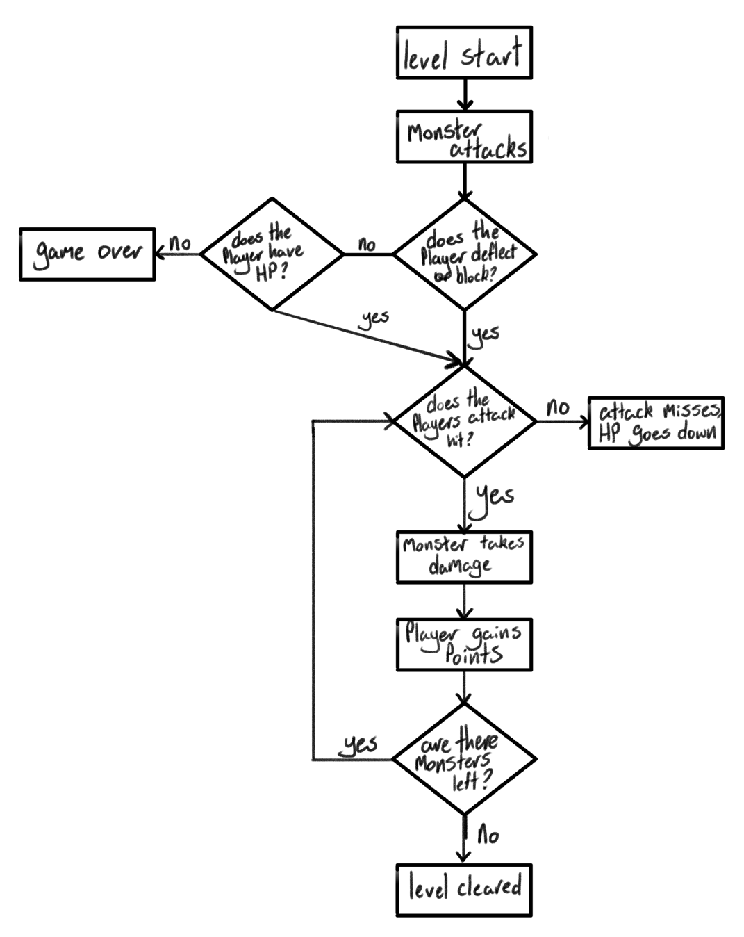

Flow-chart showing the events of a level.

SECTION 6: GAME EXPERIENCE

GAME EXPERIENCE
The main story goal for the main character is to rescue civilians, defeat the monster threat and reclaim the stolen swords while travelling to different areas to do so. Which means that the game is focussed on the player being an adventurous hero skilled at defeating these monsters.

As the target demographic is supposed to be families, the game maintains a cheery sort of cartoony atmosphere.

HOW IS THIS FEELING GOING TO BE PRESENTED TO THE PLAYER?
The player will be graded on their sword wielding skills in each level, allowing players to feel skilled at the game when they get a good end score/grade. Rescuing civilians and defeating evil monsters will make the player feel a sense of heroism, getting to different levels and collecting the swords will give a feeling of adventure.

The game will also use bright colours and cartoon-style graphics for the target demographic and cheerier atmosphere.

ARE THERE ANY SPECIAL MODES OR INTERFACES FOR GAMEPLAY?
“Sword-Master mode” is a harder difficulty version of the existing campaign for players who want an extra challenge

As well as a local co-op mode where a second player can join your game using the Switch’s second controller.

WHAT EMOTIONS ARE MEANT TO BE INVOKED BY THE GAME?
The game is supposed to make the player feel like the hero of the games story, as well as skilled with the blade via the scoring system. Wish fulfilment.

HOW ARE MUSIC AND SOUND GOING TO BE USED?
As Sword-Slasher is a rhythm game sound is very important to the main gameplay.

- Different sound-effects will play to indicate the correct timings to slash or block.
- Music will be timed with these sound effects so players can keep time with the rhythm.

- Different types of music will be used for each area to invoke different moods, for example more upbeat music for a green field area, or imposing music for a boss fight taking place in a fortress.

SECTION 7: GAMEPLAY MECHANICS

MECHANIC DETAILS
NAME: | Slashing
WHAT DOES IT LOOK LIKE? | Using motion controls to perform the correct on-screen movements.
EFFECT ON PLAYER: | Damages enemy monsters and points are awarded if the timing is excellent.
WHEN WILL IT FEATURE IN THE GAME? | In every level/stage.

MECHANIC DETAILS
NAME: | Blocking/deflecting
WHAT DOES IT LOOK LIKE? | When a monster starts to attack and the uses the correct movement to block/deflect it.
EFFECT ON PLAYER: | Players HP doesn’t go down, and extra points are awarded if the timing is excellent.
WHEN WILL IT FEATURE IN THE GAME? | In every level/stage.

HAZARD DETAILS
NAME: | Monster attacks
WHAT DOES IT LOOK LIKE? | When a monster attacks and the player fails to block/deflect it.
EFFECT ON PLAYER: | Lowers the players HP.
WHEN WILL IT FEATURE IN THE GAME? | In every level/stage.

COLLECTIBLE DETAILS
NAME: | Gold
WHAT DOES IT LOOK LIKE? | Gold coins
BENEFIT FOR PLAYER: | Can be used in the camp shops to purchase upgrades and cosmetics for both the player and the camp.
WHEN WILL IT FEATURE IN THE GAME? | All throughout the game, most often received at the end of every level as a reward.  Can also be gained by completing small side-quests for people in camp.
CAN IT BE USED AS CURRENCY? | Yes.
WILL IT EARN PLAYERS AN ACHIEVEMENT? | Yes, after certain milestones are reached.  For example, at 100, 1,000, or 10,000 gold obtained.

COLLECTIBLE DETAILS
NAME: | Swords
WHAT DOES IT LOOK LIKE? | Various different swords based on real-life designs.
WHEN WILL IT FEATURE IN THE GAME? | Rewards for completing areas.
CAN IT BE USED AS CURRENCY? | No.
WILL IT EARN PLAYERS AN ACHIEVEMENT? | Yes, after each sword collecting and also at certain points gained and monsters defeated milestones.

GAME ECONOMY
Gold coins are gained after each level is completed based on performance. The gold can then be spent at merchants in the player's camp and at the blacksmith for sword and armour (health) upgrades.

Money can be spent on both camp and player cosmetics at certain merchants, with the travelling merchants rotating after a level in the main game is completed, encouraging players to re-visit the camp often to check for new items.

Upgrade materials such as metals can also be obtained during gameplay and can be given to the blacksmith along with gold for upgrades.

SECTION 8: ENEMIES

ENEMY DETAILS
NAME: | Bats
WHAT DOES IT LOOK LIKE? | A round flying bat enemy with a row of pointy teeth.
ATTACKS: | Can tackle or bite the player.
WHEN WILL IT FEATURE IN THE GAME? | In levels.
HOW DOES THE PLAYER DEFEAT IT? | By using the correct movement shown on screen, bats will be harder to hit accurately as they are a flying enemy and move quickly.
WHAT DOES THE PLAYER EARN FOR DEFEATING THEM? | Bat wings (upgrade material) and gold coins

ENEMY DETAILS
NAME: | Orcs
WHAT DOES IT LOOK LIKE? | Green monster wielding either a club or a large sword.
ATTACKS: | Can hit the player with its weapon.
WHEN WILL IT FEATURE IN THE GAME? | In levels.
HOW DOES THE PLAYER DEFEAT IT? | By using the correct movement shown on screen, while not very fast orcs will be bulkier (have more hp/armour)
WHAT DOES THE PLAYER EARN FOR DEFEATING THEM? | Cold coins and upgrade materials.

BOSS CHARACTER DETAILS
NAME: | Minotaur
WHAT DOES IT LOOK LIKE? | Half man half bull wielding a large axe.
ATTACKS: | Can slash with the axe or kick.
WHEN WILL IT FEATURE IN THE GAME? | As a boss level at the end of a stage.
HOW DOES THE PLAYER DEFEAT IT? | By using the correct on-screen movements, but will be quicker and have more HP than regular enemies due to it being a boss.
WHAT DOES THE PLAYER EARN FOR DEFEATING THEM? | The player will gain a sword from the collection, rescue some kidnapped citizens as well as a large sum of gold.

SECTION 9: CUTSCENE

CUTSCENE DETAILS (use this table for each unique cutscene you include)
VISUAL STYLE: | 2D animated cutscene
BRIEF DESCRIPTION OF SCENE: | The main characters castle gets invaded by monsters, civilians get kidnapped and the player finds a single remaining rusty sword and gives chase to rescue people.
WHEN WILL IT FEATURE IN THE GAME? | At the creation of a new save file/character.
PURPOSE: | Sets up the story of the game, and introduces the main character

SECTION 10: BONUS MATERIALS

BONUS MATERIALS
- Player cosmetics (different armour styles and colours, accessories)
- Camp decorations/cosmetics (such as different tent styles and miscellaneous clutter)
- Armour upgrades, cosmetics are not considered different sets of armour
- Sword upgrades, increases the number of points, gold and materials gained when using that sword.
- Different merchants can be unlocked through gameplay, giving access to new cosmetics.

- “Sword-Master mode” difficulty for bragging rights
- Local multiplayer mode.

REPLAY VALUE
- Collecting player cosmetics
- Collecting decorations
- Upgrades
- Collecting merchants
- Completing every level on sword-master mode
- Completing the game with a friend
- Completing NPC side missions

Bibliography
- S. Rogers, Level up! : the guide to great video game design, 2nd edition. Chichester: John Wiley & Sons, 2014.

