
Sustainable Hospitality & Tourism Management
BMIH5006

Environmental Impact of Cruise Ships in the Hospitality Industry: Challenges and Sustainable Solutions

Student Name: Aiga Bordasa
Student ID: 2238996
Lecture: Daniel Payne

AI Declaration
I confirm that I have not used any AI tools in the research and creations of this assignment. I confirm that I have not presented any AI generated materials as my own work. I confirm I have copies of my drafts, notes, and other resources I used, which I may be asked to provide in evidence.

Executive Summary
This report discusses the impacts of cruise ships on the environment, within the hospitality context, through fuel consumption, emissions, and waste generation. The hospitality industry is one of the largest areas of transportation-creating modes of transport, cruise ships have been significant; however, their operations add to environmental degradation, especially through pollution in the air and water. The report includes the major issues related to cruises in the environmental aspect, from the carbon footprints to damaging emissions and poisonous discharges from the ships. The report elaborates on such sustainability initiatives launched by the cruising industry to fight these impacts as well, where cleaner fuels of LNG are consumed, advanced methods of waste handling, and assimilation of alternative sources of renewable energy. Hybrid propulsion systems, shore power to reduce emissions at port, and innovations in eco-friendly ship designs are intended to enhance energy efficiency and waste reduction. It is still expensive and not enough in terms of infrastructure, but these efforts point to the fact that the industry is gradually warming up to the idea of sustainability. Based on these recommendations and further improvements from the report's conclusions, "the cruise line industry must further improve towards moving more towards 'green' by reducing its harmful impact on nature and creating longer-term ecological sustainability.".

Table of Contents
Executive Summary 2
Introduction 4
Main Findings 5
1. Environmental Effects of Cruise Ships 5
1.1 Greenhouse Gas Emissions and Carbon Footprint 6
1.2 Waste production and marine pollution 6
1.3 Ecological Impact on Ports and Coastal Areas 6
2. Environmental Remediation Efforts 7
2.1 Cleaner Fuels and Energy Efficiency 7
2.2 Waste Management and Sustainable Practices 8
2.3 Sustainable Ship Design and Innovation 8
3. Cost-Effectiveness and Scalability of Sustainable Options 9
4. Environmental and community positive impacts 9
5. Challenges and Limitations 10
Conclusion/Recommendations 11
References 12
List of Figures
Figure 1: Sustainable Tourism 5
Figure 2: Environmental Impact of Cruising 7

Introduction
Hospitality transport encompasses all those modes of transportation the hospitality industry uses to move, or transport, its guests, staff, and products. This includes buses, taxis, cruise ships, private jets, and many other more specific transport. The prime role of hospitality transport is to ensure easy and efficient movement, whether it be for the leisure traveller on vacation, or moving guests to and from hospitality hotels, resorts, or cruise lines (Ramoa, Flores and Herle, 2020).
Cruise ships in the hospitality industry have become among the most highly sought and frequently used means of transport. While offering both transport and accommodation facilities, cruise ships allow travellers to travel through different seas around the world in lavish, all-inclusive settings. These ships convey thousands of people, giving access to several places while providing innumerable facilities for entertainment, dining, and leisure on the ship. However, like other large-scale transport systems, a cruise ship harbours significant environmental issues, notably energy consumption, waste generation, and emissions. This report explores the environmental concerns of cruise ships and the response within the sector in terms of the solutions to reduce their impact on the ecosystem.

Main Findings
This section explores the environmental effect of cruise ships in the hospitality industry and all the efforts in trying to make the carbon footprint of these cruise ships and their environmental degradation minimal. While cruise ships aid transportation and tourism in the hospitality industry, they contribute immensely to both atmospheric and marine pollution. This section will look at the level of environmental damage cruise ships have caused, the ongoing efforts to address these impacts, and the viability of these solutions.
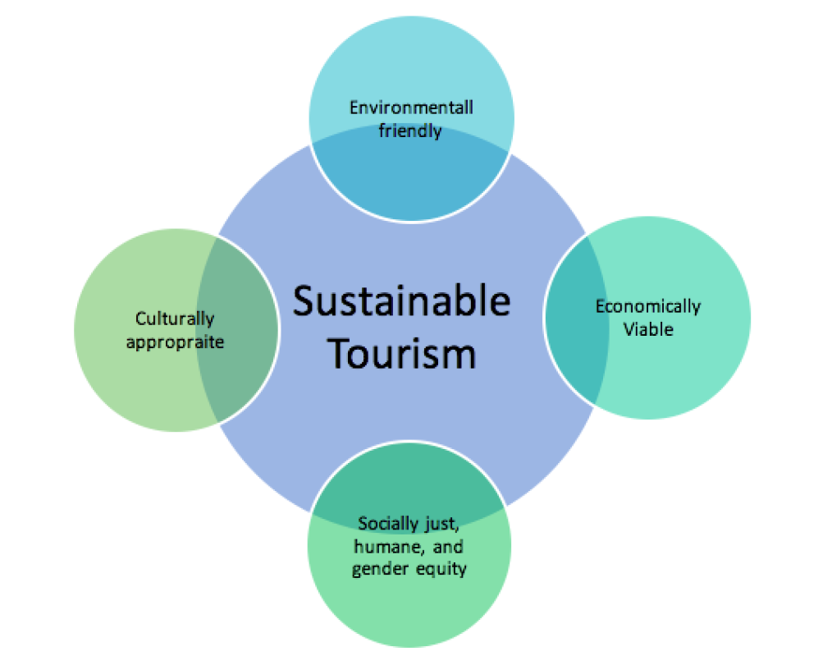
Figure 1: Sustainable Tourism
(Source: Patricia Lee, 2020)

1. Environmental Effects of Cruise Ships
The environmental impacts of cruise ships are diverse, including air quality, water quality, marine ecosystems, and the broader environment. Some of these impacts include greenhouse gas emissions, fuel consumption, air pollution, and waste disposal.

1.1 Greenhouse Gas Emissions and Carbon Footprint
Currently, this industry is responsible for accounting for a substantial chunk of greenhouse gas emissions through different types of emissions in terms of carbon dioxide (CO2) emissions. It is estimated that the associated transportation emissions of CO2 account for some 1 per cent of global levels due to significant volumes of heavy fuel oil consumed by ships when combusted. For instance, it is estimated that a cruise ship can emit CO2 in only one single day which is equivalent to carbon dioxide emissions for 12,000 cars altogether. Such emissions lead to global warming and climatic changes that impacts range from rising sea levels to extreme climatic conditions, and biodiversity loss (Honey and Bray, 2019).
There is a huge emission of air besides emission of CO2 by the ships due to the high consumption of fuel. This cruise ship further emits NOx, SOx, and PM besides being a carrier of CO2. This release causes acute sickness along with damage to health besides smog, respiratory disease, acid rain, and more (Paiano, Crovella and Lagioia, 2020).

1.2 Waste production and marine pollution
Cruise ships produce a lot of waste, most of which eventually finds its way into the oceans if not adequately treated. This includes solid wastes such as plastic, packaging, and food, liquid wastes such as sewage, greywater from sinks and showers, and ballast water taken onboard to stabilise the ship. If waste treatment systems are not in place, these pollutants can be discharged into the ocean, causing harm to marine ecosystems, and wildlife, and contributing to the increasing problem of marine plastic pollution (Kotrikla, Zavantias and Kaloupi, 2021).
One huge cruise ship may produce up to 210,000 gallons of sewage, 1 million gallons of greywater, and 255 tons of solid waste a year. That's a great amount of untreated waste that seriously endangers the life of the marine ecosystem and imbalances species in the whole environment (Sanches et al., 2020).

1.3 Ecological Impact on Ports and Coastal Areas
Cruise ships significantly affect the environments around their coastal and port areas. The enormous size and weight of the cruise ship cause physical damage to fragile ecosystems such as coral reefs and marine habitats. Additional crowding, mostly brought about by tourists, often leads to a burden of popular destinations on local resources and infrastructure (Lloret et al., 2021).
Ports which have a high intake of cruises experience pollution, congestion, and poor state of infrastructure. The littoral areas are affected by the destruction of the beaches, enhancement of pollution by exhaust fumes, and disruption of wildlife habitats (Kizielewicz, 2021).
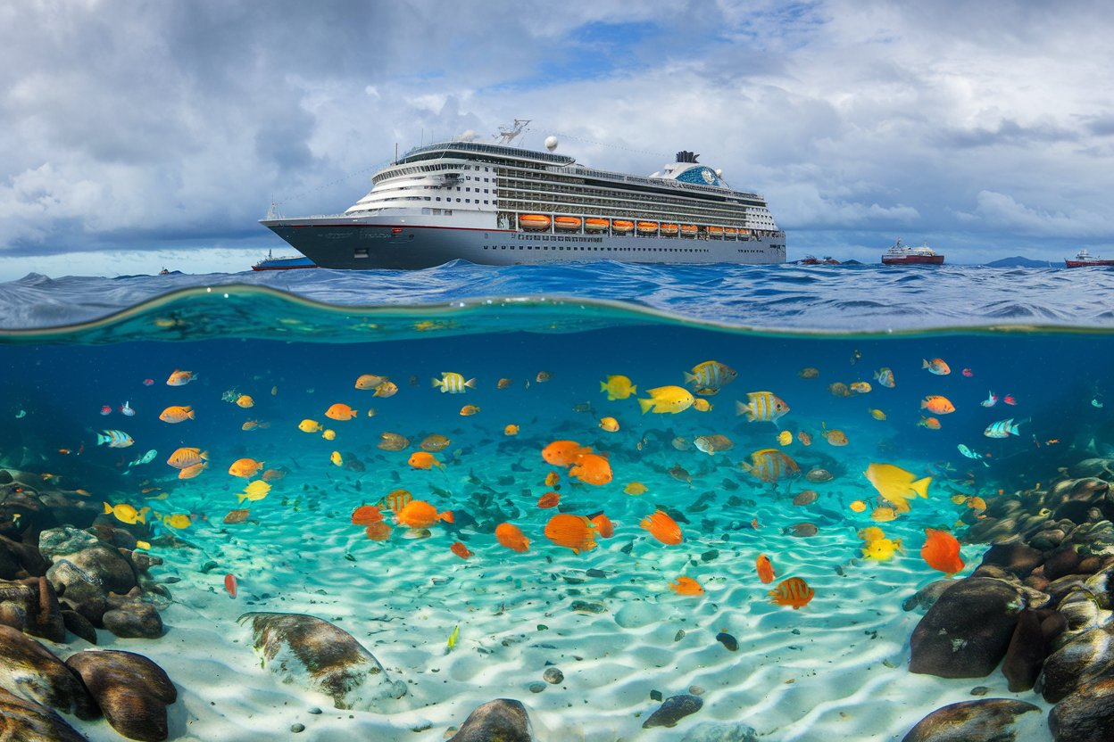
Figure 2: Environmental Impact of Cruising
(Source: Jo, 2024)

2. Environmental Remediation Efforts
The cruise industry is beset by numerous environmental challenges. However, there are various initiatives undertaken by both individual cruise lines and industry associations to mitigate the environmental impact. These solutions are aimed at fuel efficiency improvement, reduction of emissions, effective management of waste, and redesigning ships to be more sustainable.

2.1 Cleaner Fuels and Energy Efficiency
One of the most significant efforts to reduce environmental damage is the shift toward cleaner fuels. Traditional heavy fuel oil (HFO) used by cruise ships is highly polluting, so the industry is increasingly turning to liquefied natural gas (LNG) as a cleaner alternative. LNG produces fewer CO2 emissions, sulfur dioxide (SO2), and nitrogen oxides (NOx) compared to HFO, making it a more environmentally friendly option. Major cruise lines include Carnival Corporation and Royal Caribbean, which have committed to LNG-powered ships that cause less harmful emissions (Toneatti et al., 2020).
However, LNG is a fossil fuel that does not mean the end. It is considered a step in the right direction, but emissions are not zero. The ultimate goal for this industry should be to transition toward renewable energy, such as hydrogen, wind, and solar.
Fuel consumption is also being reduced through energy-efficient technologies. Modern cruise ships use advanced hull coatings to reduce the drag and improve efficiency. The Quantum of the Seas, as an example, has a streamlined hull design that brings fuel consumption down by 10%. Hybrid propulsion systems, which include traditional fuels together with battery storage, are being discussed for a reduction in fossil fuel use (Haniuk, 2020).

2.2 Waste Management and Sustainable Practices
Proper waste management would greatly help reduce the environmental footprint of cruise ships. Several lines of cruise incorporate sophisticated waste processing that ensures proper treatment of sewage, greywater, and solid waste. One good example is the Oasis of the Seas with its highly advanced waste treatment system where solid waste is converted into compost and also through the recycling of water and minimizing wastes going to landfills (Di Vaio et al., 2022).
Moreover, cruise lines are taking measures against marine pollution. For instance, Royal Caribbean and Princess Cruises have promised to eliminate single-use plastic items, such as straws, cups, and bottles, and instead use biodegradable or reusable alternatives. Recycling programs onboard are also encouraged by the cruise lines, reducing waste that ends up in the ocean (Tsai and Bui, 2020).
The other initiative is in the management of ballast water, which may harbour invasive species. Many cruise lines are installing ballast water treatment systems to prevent the spread of non-native species to new regions, thus protecting local ecosystems and biodiversity.

2.3 Sustainable Ship Design and Innovation
Sustainable ship design is another area in which the cruise industry is gaining ground. New ships are designed with energy-efficient technologies and environment-friendly materials. For instance, the AIDAnova is the world's first cruise ship to be powered entirely by LNG. The ship also uses advanced waste treatment systems, energy-efficient engines, and sustainable building materials, making its environmental impact relatively minimal (Boucht, 2024).
Beyond the cleaner fuels, cruise lines are now exploring other renewable sources. For example, Hurtigruten, an Arctic cruise line, is becoming one of the leaders in battery-hybrid propulsion systems that blend diesel engines with giant battery packs to cut down fuel consumption and emission levels, ensuring a quieter experience for the passenger (Mallouppas and Yfantis, 2021).
Another innovation adopted by some cruise lines is shore power technology, through which ships can be plugged into onshore electricity supplies while docked. This helps the ships cut off their diesel generators while at port, and hence reduce air pollution and emissions. An example of the implementation of such shore power infrastructure for cruise ships is the Port of Long Beach in California (Kulkov et al., 2023).

3. Cost-Effectiveness and Scalability of Sustainable Options
The sustainability alternatives mentioned in the previous part of the paper seem promising for reducing cruise ships' impacts on the environment. However, cost-effectiveness and scalability issues are open challenges to the cruise ship industry. A lot of capital investments will be needed to implement cleaner fuels such as LNG or hybrid propulsion systems (Niemi, 2021).
LNG-powered ships are more expensive than traditional vessels, and LNG fueling stations are not readily available in most regions that lack infrastructure. Installation of advanced waste management systems and energy-efficient technologies also increases upfront costs for building and operating a cruise ship. However, the investments made over time provide long-term savings. Fuel-efficient ships consume less fuel, thus reducing operational costs; waste management systems can also cut down on fees for disposing of waste (Barone et al., 2023).
Furthermore, in the long term, sustainable solutions can also help cruise lines meet more and more rigorous environmental regulations. For instance, the International Maritime Organization has set targets to reduce greenhouse gas emissions from ships by 50% by 2050, which will inherently work in favour of stricter standards for emissions and waste management.

4. Environmental and community positive impacts
The environmental aspects are crucial when it comes to these sustainability initiatives. With their reduction in carbon emissions, clean fuels adopted, and proper waste management, cruise lines can mitigate environmental impacts and show contributions to the fight against climate change (Chen et al., 2019).
The improvements are also beneficial to local communities. Sustainable practices conserve the natural environment of popular cruise destinations, and thus these places will remain attractive to tourists for a long time. For instance, reduced emissions and waste prevent damage to marine ecosystems that support tourism and the local economy. Sustainable practices reduce pressure on the local infrastructure and alleviate congestion in port areas as well as minimising the strain on local resources (Buzova, 2023).

5. Challenges and Limitations
These solutions for sustainability are promising; however, there are major challenges in achieving true sustainability for the cruise industry. It must initially overcome the reliance on fossil fuels dependence, particularly on LNG. LNG is cleaner than traditional fuels, but it is a fossil fuel, and the industry must shift to renewable energy sources in the end.
The cost of implementation of sustainable technologies is also an issue, mainly for smaller cruise lines that lack the necessary resources. Furthermore, the infrastructure needed to support sustainable solutions, including LNG fueling stations and shore power technology, is still developing and not widely available (Wang, Li and Xiao, 2019).
But the cruise industry is improving, and with ongoing investment in research and development, the sector will continue to make improvements in environmental performance.

Conclusion/Recommendations
The paper has discussed the environmental impact of cruise ships in the hospitality industry by majorly comparing their contribution to air and marine pollution. It mainly discussed the issues that cause significant conflict between the hospitality industry and the environment, such as the carbon footprint, fuel consumption, waste generation, and ecological damage to the coastal areas. As an after-effect, the report presented several initiatives being adopted to handle these issues, for instance, cleaner fuels, advanced waste management systems, sustainable ship design, and renewable energy solutions.
The cruise industry, therefore must continue its evolution towards sustainable practices to curb the adverse impacts of the industry on the environment. Cleaner fuels such as liquefied natural gas offer a short-term solution while renewable energy sources like hydrogen and solar power should be developed as alternatives in the long term. The industry will also have to improvise in waste treatment and reduce reliance on single-use plastics to prevent marine pollution. Energy-efficient technologies and hybrid propulsion systems must be encouraged as investments to help improve fuel consumption and reduce emissions.
Recommendations include increased cooperation among cruise lines to share best practices, more stringent regulations enforcing environmental standards, and continued investment in sustainable ship design. Through these solutions, the cruise industry can reduce its environmental impact for the betterment of the environment and local communities, ensuring sustainability for the long term.

Reference list
Barone, G., Buonomano, A., Del Papa, G., Forzano, C., Giuzio, G. F., Maka, R., ... and Vanoli, R. (2023). Improving the Energy Efficiency of Ships: Modelling, Simulation, and Optimization of Cost-effective Technologies. Modelling and Optimisation of Ship Energy Systems 2023.
Boucht, M. L. (2024). Navigating Sustainability: Environmental Impact Reporting and Biodiversity Challenges in the Cruise Industry.
Buzova, D. (2023). Cruise ships and sustainability. In The palgrave handbook of global sustainability (pp. 2067-2077). Cham: Springer International Publishing.
Chen, J. M., Petrick, J. F., Papathanassis, A., and Li, X. (2019). A meta-analysis of the direct economic impacts of cruise tourism on port communities. Tourism Management Perspectives, 31, 209-218.
Di Vaio, A., Hassan, R., D'Amore, G., and Strologo, A. D. (2022). Digital technologies for sustainable waste management on-board ships: an analysis of best practices from the cruise industry. IEEE Transactions on Engineering Management.
Haniuk, G. (2020). " Plugging-in" to Prevent Pollution: The Use of Shore Power Technology to Combat Cruise Ship Air Emissions. Tul. Mar. LJ, 45, 173.
Honey, M., and Bray, S. (2019). Environmental “footprint” of the cruise industry. In Cruise Tourism in the Caribbean (pp. 32-51). Routledge.
Kizielewicz, J. (2021). Eco-trends in energy solutions on cruise ships. Energies, 14(13), 3746.
Kotrikla, A. M., Zavantias, A., and Kaloupi, M. (2021). Waste generation and management onboard a cruise ship: A case study. Ocean and Coastal Management, 212, 105850.
Kulkov, I., Hellström, M., Tsvetkova, A., and Malmberg, J. (2023). Sustainable cruise tourism: Systematic literature review and future research areas. Sustainability, 15(10), 8335.
Lloret, J., Carreño, A., Carić, H., San, J., and Fleming, L. E. (2021). Environmental and human health impacts of cruise tourism: A review. Marine pollution bulletin, 173, 112979.
Mallouppas, G., and Yfantis, E. A. (2021). Decarbonization in shipping industry: A review of research, technology development, and innovation proposals. Journal of Marine Science and Engineering, 9(4), 415.
Niemi, E. (2021). Sustainable Maritime Power Alternatives for Cruise Business.
Paiano, A., Crovella, T., and Lagioia, G. (2020). Managing sustainable practices in cruise tourism: The assessment of carbon footprint and waste of water and beverage packaging. Tourism Management, 77, 104016.
Ramoa, C. E. D. A., Flores, L. C. D. S., and Herle, F. B. (2020). Environmental sustainability: A strategic value in guiding cruise industry management. Journal of Hospitality and Tourism Insights, 3(2), 229-251.
Sanches, V. L., Aguiar, M. R. D. C. M., de Freitas, M. A. V., and Pacheco, E. B. A. V. (2020). Management of cruise ship-generated solid waste: A review. Marine pollution bulletin, 151, 110785.
Toneatti, L., Deluca, C., Fraleoni-Morgera, A., and Pozzetto, D. (2020). Rationalization and optimization of waste management and treatment in modern cruise ships. Waste Management, 118, 209-218.
Tran, T. M. T., Yuen, K. F., Li, K. X., Balci, G., and Ma, F. (2020). A theory-driven identification and ranking of the critical success factors of sustainable shipping management. Journal of Cleaner Production, 243, 118401.
Tsai, F. M., and Bui, T. D. (2020). Assessing sustainable consumption practices on cruise ships. Maritime Business Review, 5(2), 229-247.
Wang, G., Li, K. X., and Xiao, Y. (2019). Measuring marine environmental efficiency of a cruise shipping company considering corporate social responsibility. Marine policy, 99, 140-147.

