Gemma Wilkinson 2407840
Bubbles Bounce and Play Centre – Venture Plan for Sustainable Delivery and Longevity

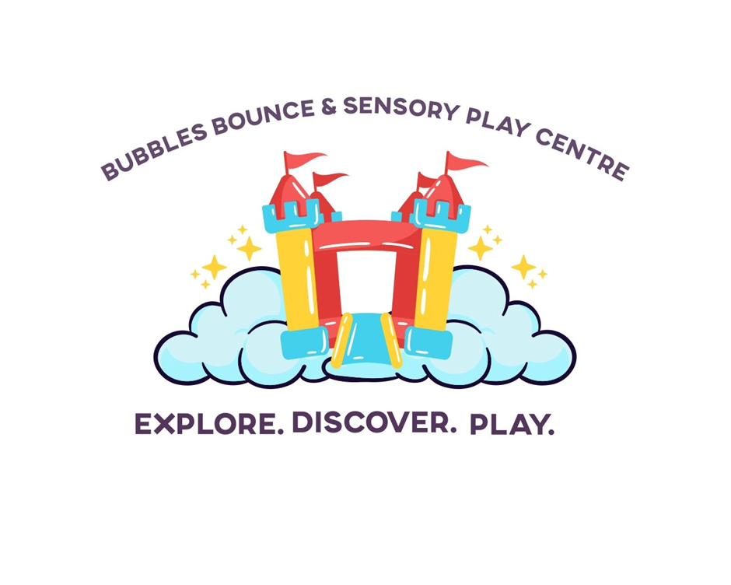

1. Executive Summary

Bubbles Bounce and Sensory Play Centre are a proposed inclusive indoor play facility designed for children and young people aged 0–18.
The venture aims to provide a safe, engaging, and supportive environment where all children, including those with additional needs or disabilities, can take part in physical, sensory, and social play.
The concept comes from recognising a clear gap in the market for this type of centre that not only provides ‘play’ and sensory experiences for young children but for older children and young adults that still crave that sensory input that many families have trouble accessing locally that are not just for young children. Inclusive and sensory-appropriate leisure environments are far and few between and this venture will hopefully provide a play that makes everyone feel welcome and understood.

The centre will offer a diverse range of play experiences including soft play, bouncy castles, sensory activities, role-play environments, and outdoor play, alongside additional services such as refreshments, party packages, and seasonal events. This wide selection of different activities on offer enables the business to attract a broad customer base, including families, schools, nurseries, and community groups. Financial sustainability will be supported through multiple revenue streams, including entry fees, group bookings, private hire, and product sales.

To ensure long-term viability, the venture will need to focus on customer retention, cost control, and continuous service improvement informed by feedback. Strategic partnerships with local organisations and cost-effective source of equipment will further support operational efficiency. By combining social value with commercial viability, Bubbles Bounce and Sensory Play Centre has strong potential to become a sustainable and impactful community-based enterprise.

2. Project Overview and Context

Bubbles Bounce and Sensory Play Centre are a proposed indoor play facility designed to support children and young people aged 0–18 through inclusive, play-based experiences that promote physical activity, sensory development, and social interaction.
The concept has come from recognizing that play is fundamental to child development, contributing to cognitive growth, emotional wellbeing, and social skills. Early childhood research highlights the importance of play in fostering curiosity and engagement, reinforcing the need for environments that support experiential learning. ‘Play helps children and babies make sense of the world, explore new possibilities and challenge themselves and others. It provides the foundations for their well-being, social and emotional, cognitive and physical development.’ (Partridge, I, 2024)
The venture specifically addresses the needs of children who are neurodiverse or have additional learning needs, a group that is often underserved by traditional leisure facilities. Many existing indoor play centres are not designed with sensory sensitivities in mind, resulting in environments that can be overwhelming or inaccessible. This represents a clear gap in provision within many communities. The proposed centre seeks to address this by offering a carefully designed, inclusive environment that enables all children to participate in play safely and comfortably.
According to Prof. K Hantak and Pro. V Van der Graaf (2019) ‘Often adults are hesitant to offer a child opportunities to participate in sensory play as this type of play can be messy and loud, or could result in disruptive behavior.’ This is why by providing type of facility where children and young adults can still access this stimulation and parents can join in it could benefit both the parents/caregiver and the child. This will not only provide the stimuli but also could encourage communication and a closeness between the families.
The play centre will have scheduled slots for the different customer segments for example quieter sessions aimed at customers with ALN, parent and baby/toddler sessions, home education groups and open play sessions.
Located in Carmarthen, the business will serve an area with a growing population of young families but limited access to inclusive indoor leisure facilities. Existing competitors, such as soft play centres and trampoline parks, often prioritise high-energy environments that may not be suitable for children with sensory processing needs. By contrast, this venture differentiates itself through its inclusive design, sensory-friendly features, and emphasis on accessibility.
From an entrepreneurial perspective, the business demonstrates opportunity recognition and innovation through the integration of multiple service elements, including sensory play, role-play environments, party services, and café facilities.
‘sensory play involves using the body to experience the world through touch, smell, taste, sight, hearing, and movement. It is play that engages one, many, or all of the senses: tactile, olfactory, gustatory, auditory, visual, kinesthetic, vestibular, or visceral. (Prendiville & Fearn, 2017,)(cited in Schaefer and Kaduson, 2021).
This multi-faceted approach not only enhances customer experience but also supports financial sustainability through diversified revenue streams. The target market includes families, educational settings, and community organisations, enabling the business to operate across multiple customer segments. Offering different sessions at play areas is important because it allows you to meet the varying needs, ages, and preferences of different customer segments, creating a more enjoyable, inclusive, and tailored experience for everyone. (Kottler, P, 2019)
Overall, the venture presents a viable and socially valuable response to an identified market need, combining inclusive practice with a sustainable business model.

3. Strategy for Longevity
To ensure long-term viability, the venture requires a structured strategy for longevity that focuses on sustainability, adaptability, and customer engagement. Many new businesses fail due to inadequate financial planning or an inability to respond to changing market conditions. Therefore, this strategy prioritizes the development of a strong competitive position, effective customer retention, targeted marketing, and robust financial management. ‘Customer retention is essential, as repeat customers provide stability and long-term revenue’ (Kotler et al., 2019).
A key source of competitive advantage lies in the centre’s inclusive and sensory-focused design. Unlike traditional play centres, which often cater to general audiences, this venture addresses the specific needs of children with sensory sensitivities and additional learning requirements. By providing specialist equipment, quiet areas, and structured play opportunities, the business differentiates itself within the market and delivers unique value to customers. This positioning is likely to attract underserved customer segments and build a strong reputation within the community.
Customer retention is paramout to long-term success, as repeat visitors provide a stable and predictable income stream. This will be supported through loyalty schemes, membership options, and targeted session offerings such as sensory play sessions and toddler groups. In addition, birthday party packages and private hire options will not only generate higher revenue but also function as a marketing tool by increasing visibility and customer engagement.
Marketing activities will adopt a cost effective and community focused approach. According to (Pollák, F, 2024). ‘ Social media is a new paradigm that is very dynamic and fast-moving. In other words, what is up to date today could be outdated tomorrow and, therefore, naturally vanish from the virtual space. Due to that, it is crucial for companies to very carefully select a set of rules or guidelines which should be used in the virtual space to promote effective marketing.’
Social media platforms will be used to promote services, events, and customer experiences, Marketing this way will utilise cost-effective strategies which is widely recognized as an effective tool for small business promotion (Chaffey & Ellis-Chadwick, 2019) To further reduce marketing expenditure, the business will seek collaboration with local colleges and universities, where students studying media or marketing may contribute to content creation as part of their coursework or work experience.
This approach not only minimizes costs but also strengthens community links. Additional promotional activities will include partnerships with schools, nurseries, and support organisations, as well as reliance on word-of-mouth recommendations, particularly within the additional needs community.
A key competitive advantage lies in the centre’s inclusive and sensory-focused design. Differentiation is essential in competitive markets, enabling businesses to stand out and attract specific customer segments (Porter, 2008). By offering a unique service tailored to children with additional needs, the business creates strong value for an underserved market.

Financial sustainability will be achieved through a diversified revenue model. Income will be generated from entry fees, group bookings, private hire, seasonal events, refreshments, and future product sales.
This reduces reliance on a single income source and enhances resilience during periods of fluctuating demand. Cost management will remain a priority, with careful monitoring of fixed and variable expenses such as rent, staffing, and maintenance.
Risk management will involve ongoing monitoring of performance indicators, including customer feedback and attendance patterns. This will enable the business to adapt its offerings in response to demand. Maintaining high standards of health and safety will also be critical, both for regulatory compliance, building customer trust and financial stability.
Regular inspections of all play equipment will be carried out to ensure it remains safe, well-maintained, and suitable for use. This will include checking for wear and tear, damage, or potential hazards that could pose a risk to children.
Within Wales, there is also a statutory duty to ensure children have access to safe and appropriate play opportunities under the Children and Families (Wales) Measure 2010, which reinforces the importance of providing safe and inclusive environments for children. (Welsh government, 2010)
In addition, all areas of the centre, including play zones, sensory rooms, café spaces, and entrances, will be routinely inspected to identify and minimise potential risks. Staff will be trained to recognise hazards and respond appropriately, ensuring a safe environment at all times.
Extra security measures will also be implemented, such as controlled entry and exit points, supervision of play areas, and clear safeguarding procedures to protect children and families using the facility. By taking a proactive approach to risk management, the business will reduce the likelihood of accidents while creating a safe and trusted environment for customers.
Overall, the strategy for longevity is based on delivering consistent value, maintaining strong community relationships, and ensuring financial resilience, thereby supporting sustainable growth over time.
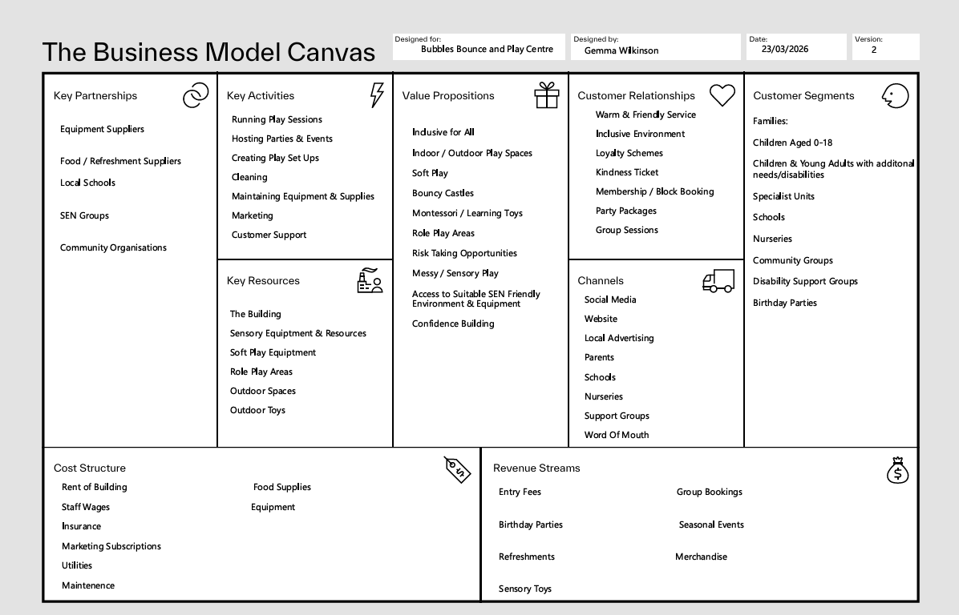
4. Business Model Canvas

The Business Model Canvas illustrates how the venture creates, delivers, and captures value. (Osterwalder & Pigneur, 2010). The primary customer segments include families, educational institutions, and community groups, while the value proposition centres on providing an inclusive, sensory-friendly play environment that is accessible to all children.
Revenue generation is supported through multiple streams, including entry fees, private hire, events, and refreshments. Key resources include physical facilities, specialized equipment, and trained staff, while core activities focus on service delivery, maintenance, and customer engagement.
The cost structure is primarily composed of operational expenses such as rent, wages, and utilities. The model demonstrates a balanced and sustainable approach to value creation.

5. Viability, Finance and Resources
Financial viability is essential to the long-term success of the venture. The business must generate sufficient revenue to cover operational costs while maintaining service quality.
Financial viability is essential for business sustainability. Effective cost control and resource management are key factors in small business success (Burns, 2021). By sourcing equipment second-hand and in bulk, the business reduces initial investment while maintaining quality.
Key expenses include rent, staffing, insurance, utilities, and equipment. To minimise initial investment, equipment and sensory resources will be sourced through cost-effective methods such as second-hand purchasing and bulk buying.
Revenue will be generated through a combination of entry fees, group bookings, private hire, seasonal events, and refreshments.
Additional income may be derived from merchandise and sensory products in the future. This diversified income structure enhances financial stability and reduces risk.
‘Multiple revenue streams, including entry fees and events, support financial stability and reduce risk’ (Burns, 2021)
Effective cost management and regular financial monitoring will ensure that the business remains profitable. Staffing will be adjusted in line with demand, and operational efficiency will be prioritised. Overall, the financial model supports sustainable operation while maintaining accessibility and quality.

6. Implementation and Learning Loop
The implementation process will be undertaken in phases, beginning with securing a suitable premises and installing equipment. A trial phase will allow the business to test its operations and gather feedback from initial users.
Continuous improvement will be achieved through a learning loop that incorporates customer feedback into service development. Feedback mechanisms will include direct communication, social media engagement, and surveys. This will enable the business to adapt its offerings and improve customer satisfaction.

7. Conclusion
The venture represents a sustainable and socially valuable business opportunity that addresses a clear gap in the market. Through effective planning, inclusive design, and diversified revenue streams, the business has strong potential to achieve long-term success while delivering meaningful benefits to the community.

References
https://www.communityplaythings.co.uk/learning-library/articles/the-importance-of-sensory-play

Accessed 18.4.2026 The importance of sensory play
Prof. Dr. Kelly Hantak, Prof. Dr. Vanessa van der Graaf | May 2019

Burns, P. (2021) Entrepreneurship and Small Business. 5th ed. London: Palgrave.

Chaffey, D. and Ellis-Chadwick, F. (2019) Digital Marketing. 7th ed. Harlow: Pearson.

Dodd, S. (2014) Understanding Autism. London: Sage.

Irvin, M. (2017) The Importance of Play in Early Childhood Education.

Kotler, P., Keller, K. and Chernev, A. (2019) Marketing Management. 16th ed. Pearson.

Osterwalder, A. and Pigneur, Y. (2010) Business Model Generation. Wiley.

Piaget, J. (1962) Play, Dreams and Imitation in Childhood. New York: Norton.

Porter, M. (2008) Competitive Strategy. Harvard Business Review.

Schumpeter, J. (1934) The Theory of Economic Development. Harvard University Press.

Pollák, F. (2024) Effective Management of Marketing Communication in Social Media. In: Management in Marketing Communications.
Chaffey, D. and Ellis-Chadwick, F. (2019) Digital marketing. Seventh edition. Harlow: Pearson.

Schaefer, C.E. and Kaduson, H. (eds.) (2021) Play therapy with children: Modalities for change. Washington, District of Columbia: American Psychological Association.

Welsh Government (2010) Children and Families (Wales) Measure 2010. Accessed

