Daniel Stone Student ID:1803523
Assignment 1
Swansea foreshore Ice cream parlour

Introduction
The City and County of Swansea have chosen to a joint agreement with the Marriot Hotels to create a new restaurant, ice cream parlour and managers apartment on Swansea foreshore. The site is located between the County Hall and the Marriot Hotel.
As this is a new build the ground floor level of 300 square meters approximately which will contain the restaurant, café bar, ice cream parlour, kitchen, and food stores and other little facilities. The first and second-floor levels to have a self-contained managers apartment and staff welfare facilities.
During the process of this task, there will be a desktop study carried out prior to the site evaluation by also doing a site walk over to look for any problems to the construction site. such as soil testing and previous research to what existed there before the Marriott hotel and the county hall. as well as finding the correct foundation that is suitable for this restaurant that is to be built.
Desktop study
Site investigation on the walk over examination for the new build of the ice cream parlour.
Ground study: The ground information that I had gathered from doing the site walk over, has many details to it that could lead to a possibility of a lot of problems such as ground vegetation, services such as main pipes running under the grounds of the marked out plot to work on, and the main concern and massive problem was the foot path as this was marked down as a public right of way.
The vegetation: on the site walk I gathered lots of information about this by just looking at the vegetation on the site, on the site there were many big trees as you can see in the pictures that I took , this will become a problem due to the roots that are buried under the ground the way that this problem could be solved is when the foundations are being dug such as ground prepping for construction to take place the tree roots have to be dug up completely and all the cavities of the roots to be filled in as you cannot build near trees due to collapse of the roots.
The services around the car park: when doing this site walk over there were a lot of services that are a possible problem to the start of the site as these would have to be relocated and dug up as they were still in use to the existing buildings such as the Marriott hotel and the county hall, the mounds of dirt that were around the site also contained some services that were buried underneath this means that they would have to be located and re located to another direction and the mounds levelled to suite the structure of the ice cream parlour.
Brief history on previous existence: before the County hall and the Marriot hotel there were factories that were based on the coastal path way making this the marina finding out that there were factories that were based on the land where the ice cream parlour and restaurant is going to be built the land and soil of the foundation structure would have to be tested and is to become likely contaminated due to the history of the previous existing land.

General desktop study
What types of foundation is suitable: Gathering the information that is given to build this ice cream parlour and restaurant, the types of foundations that are suitable for this depends on the design of the build but on general terms the suitable foundations that I would choose would be either pad foundations or pile foundation as they can hold up a greater strength of the building ad is more reliable on supporting the building .

What foundation I am going to choose and why: The foundation that I am going to choose for this build is pile foundation as this will be suitable for the design and the structure of the building that I am going to create I have chosen pile foundation because large diameter piles can be formed to suit the ground that I am working with also with using the bored and cast institute piles the drilling tools can break any boulders and rocks out the way which is most likely to be under the ground in the purposed site meaning there will be no displacement on pile.

Keeping public out of harm’s way: the suitable way to keep the public out of harm’s way is to re locate the cycle path that has been observed on the site walk so that there is no access to it and then horde the site with fencing around the site keeping the minimal distance from the coastal path ways and the rest of the car park so that no members of the public can gain access to the sight and get injured.

Accessibility to car parking: from doing the walk over study the access to parking will still be there amongst the construction work that will be carried out as there is paring in the county hall and the Marriott hotel but there will also be parts of the car park used up for the site meaning g slightly less spaces for the members of the public. This may have an effect on some of the parking but will be located or expanded once the site is complete.

Accessibility to services water and drainage: from looking from the walk over study there were many drainage systems in place around the car park and a few of them were in the areas and boundaries of the site this mean that they would have to be re located this also means that the new drainage systems can interlock with some of the existing services and pipes once they are located with water and electricity there would be services running into the ground as it is close to the county hall and Marriott this means that there is a local mains supply around the site that can be linked up during the prepping of the work being carried out .

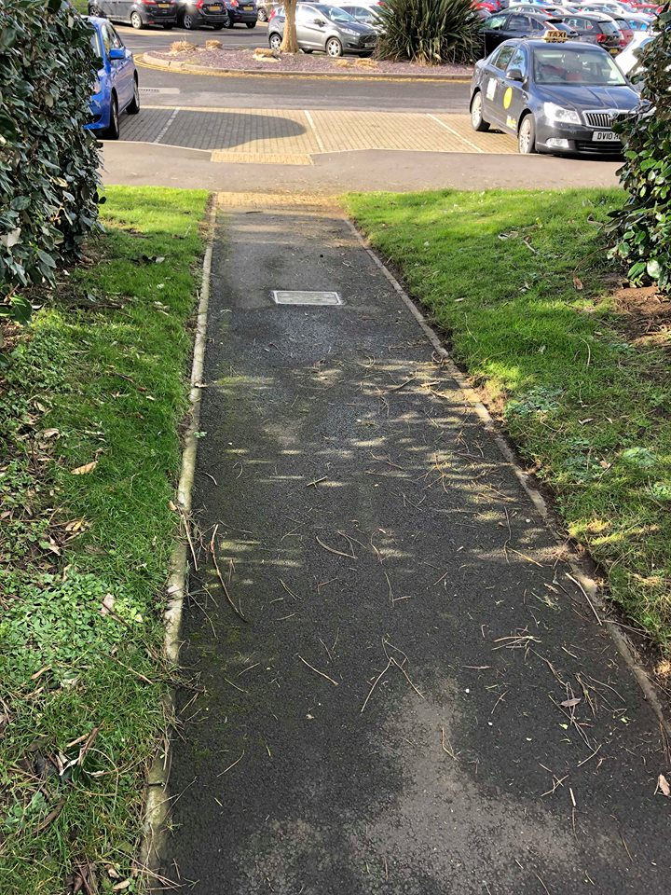
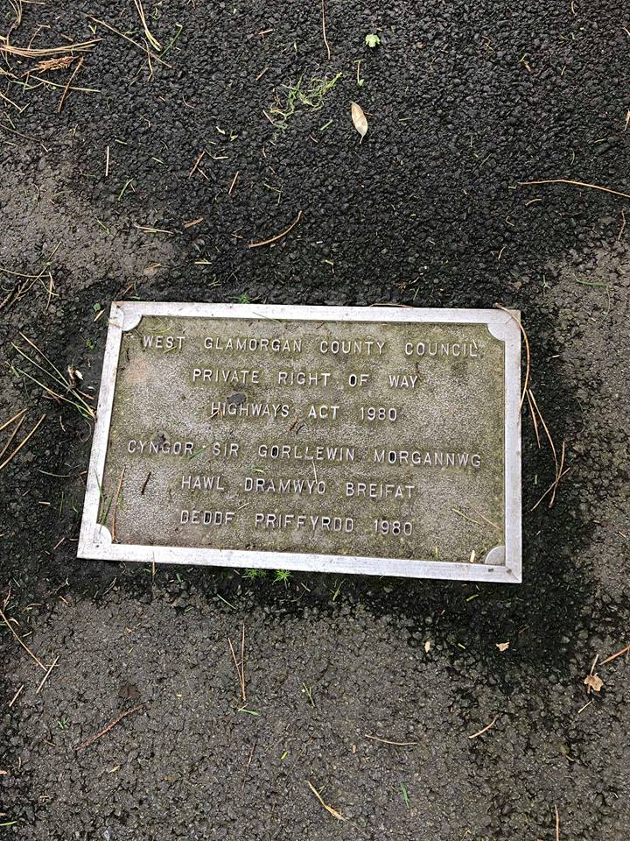
As you can see from this picture it shows you the full length of the private right of way, which also joins on to the Swansea coastal cycle track.
I took this picture from the site walkover this is one of the biggest problems that has come up on the site observations as this plaque states that kits a private right of way, which is a [part of the highways act 1980, meaning that this path way cannot be touched or moved in any certain way.
Site walkover observations
This picture shows the coastal cycle path that is situated on the centre of the marked-out proposal site for the new restaurant and ice cream parlour to be built this could be a problem to the public as there will have to be closures on this path.
Another thing that this picture shows is the vegetation in the background such as the big trees that are a major problem to build next to due to the root structures of the trees that can cause collapsing in the building.
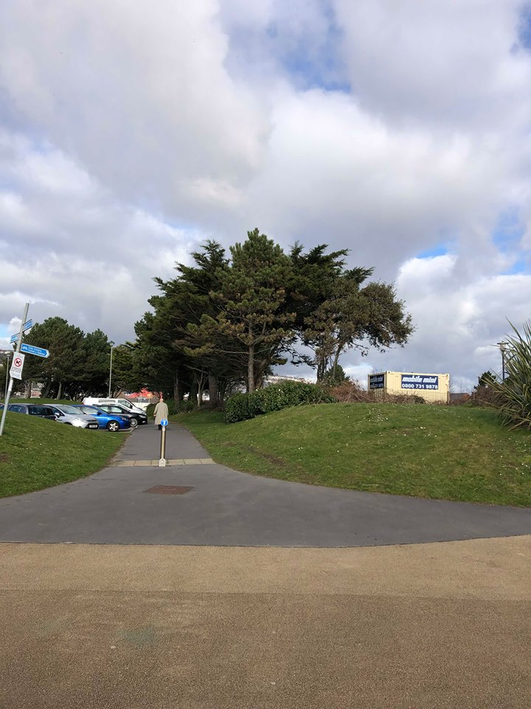
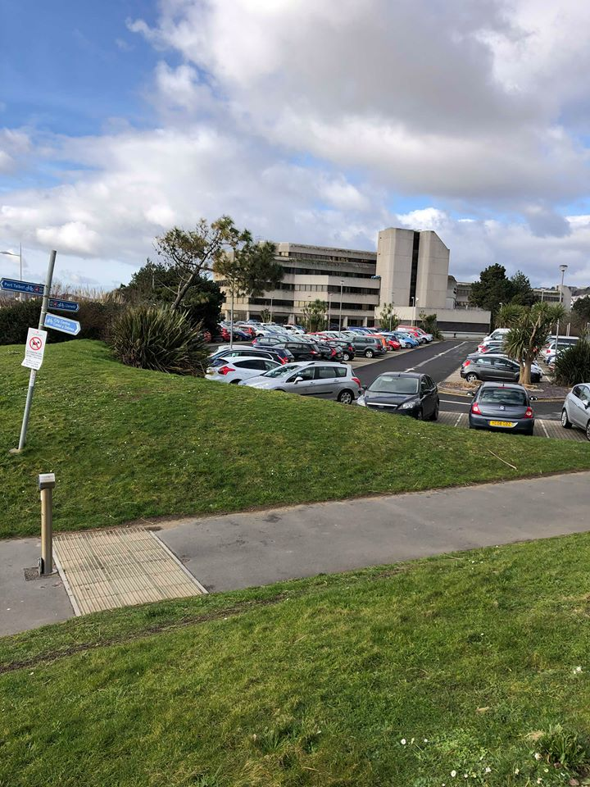
Again, in this picture it shows the coastal cycle track that is in the picture above, but this time taken in the left-hand side of the site. This also shows the amount of un even ground that is needed to be removed and level. In and amongst that mound of vegetation there are drainage manholes this indicated that there are services running under the ground.

This picture was taken on the right-hand site of the site being the Marriott hotel car park side, the picture shows more of the vegetation that is around the site such as more of the big trees that overlook the car ,park there are services that run through this car park such as the water drains for the rain water to escape but this is also where the construction side of things will take place and where I will build the restaurant.
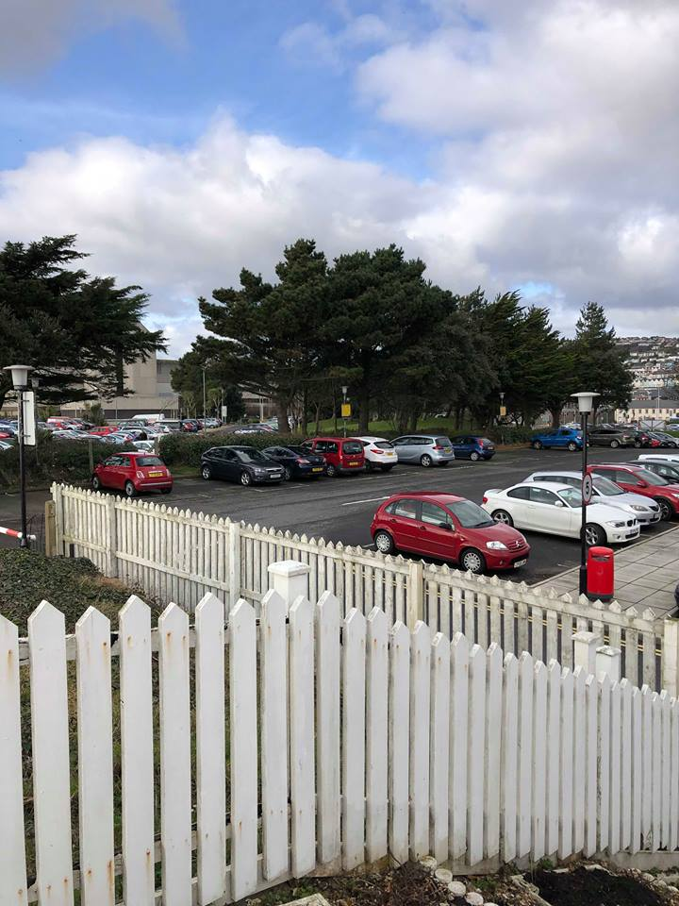
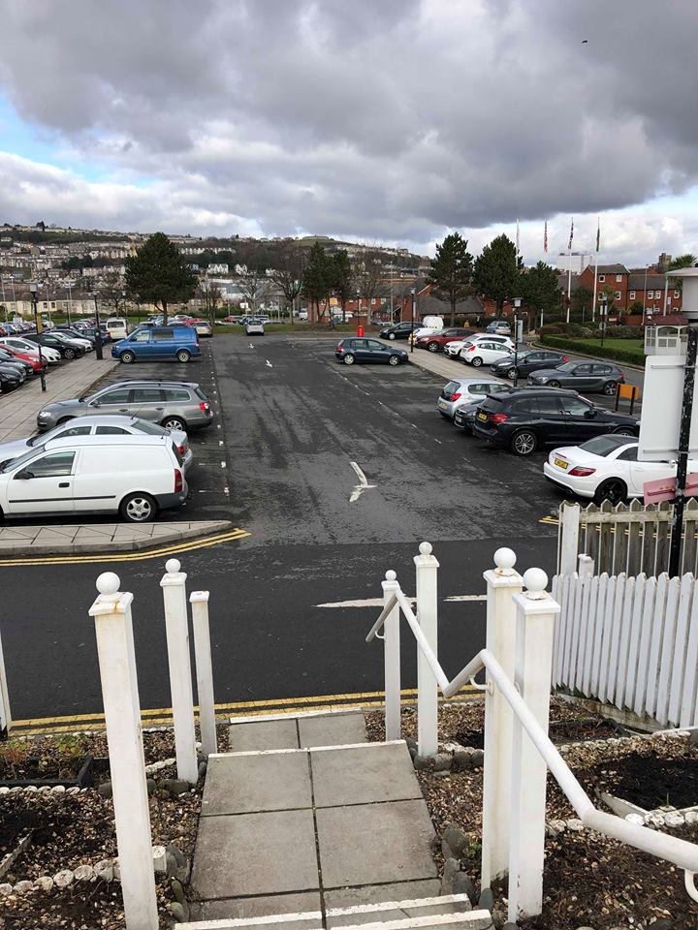
This picture is on the same side as the picture above which shows more of the car park and more of the services that run through the car park and the un even ground such as the one I’m standing on as I took this image.

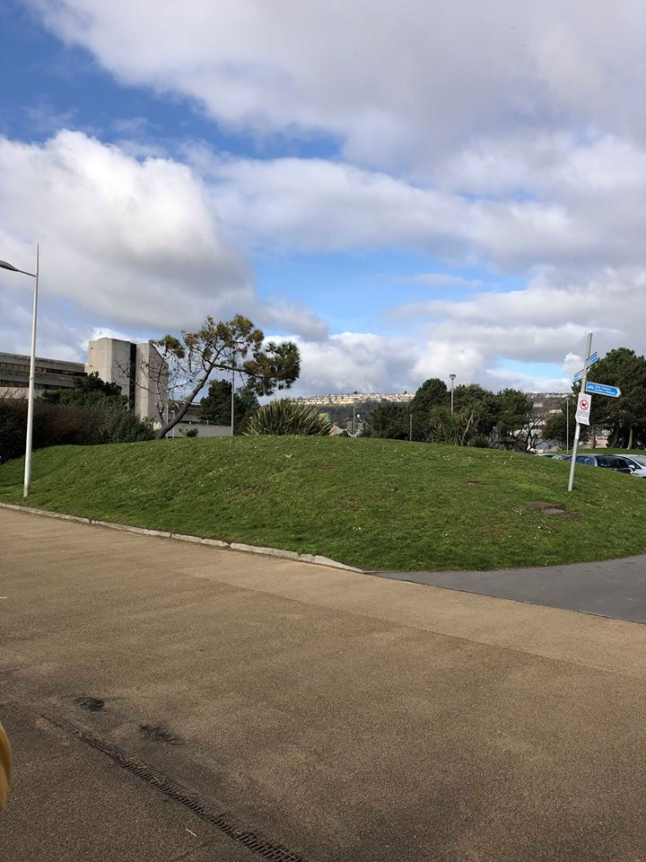
This picture shows more of the left-hand side of the site and shows the full mound of vegetation that is there such as the big mound of earth and grass that is there
This shows more of the right-hand side of the site but on the boarder edge of the site which looks into the construction site, this also show again more vegetation and uneven ground that needs to be level during the prosses of building the restaurant.

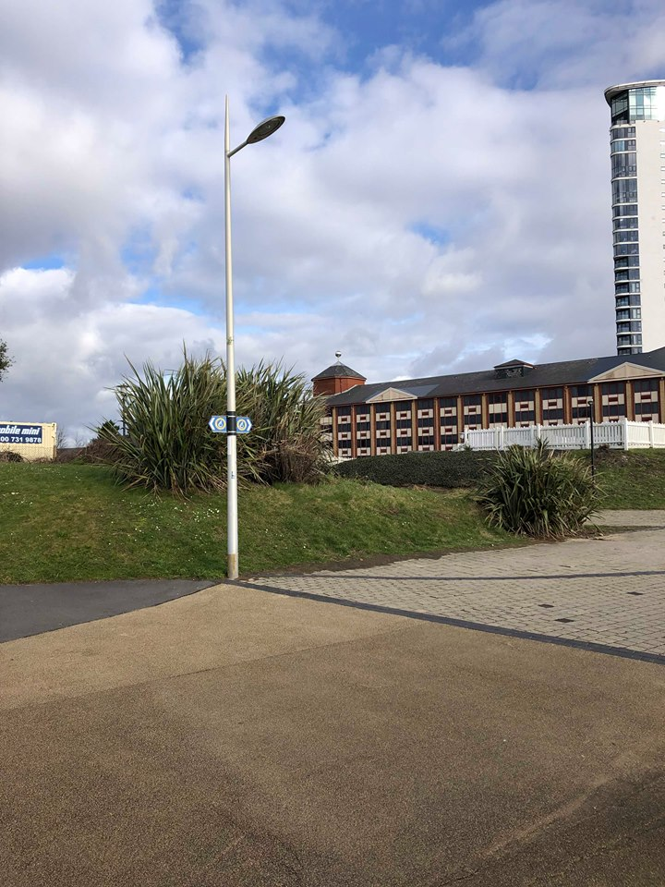

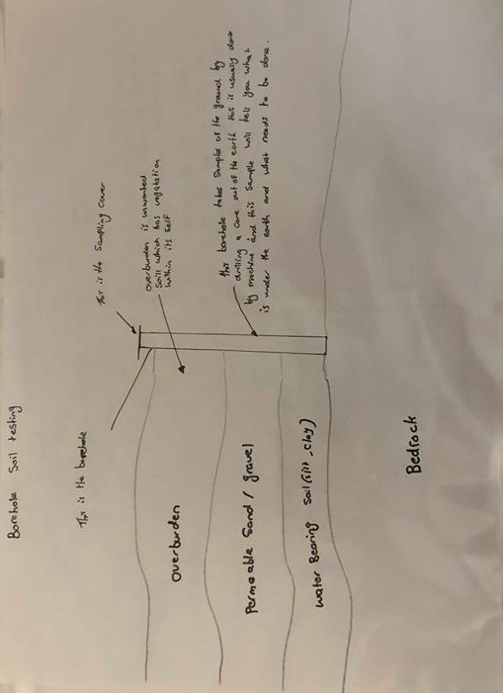

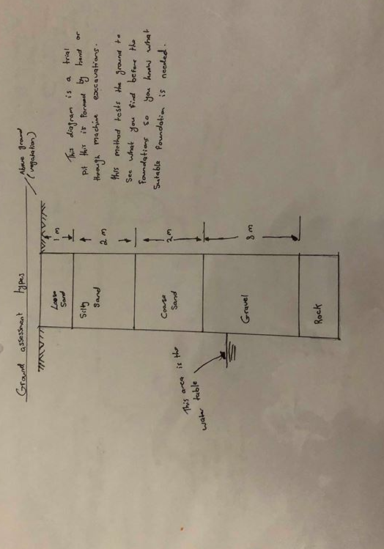

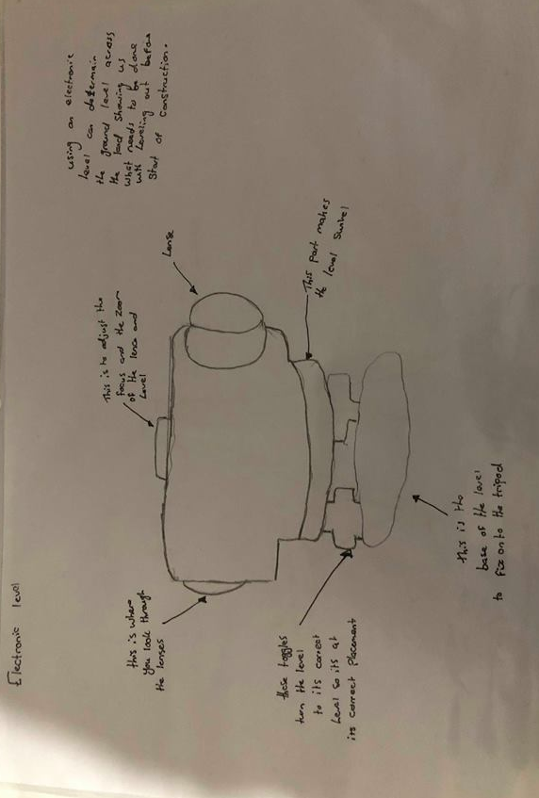

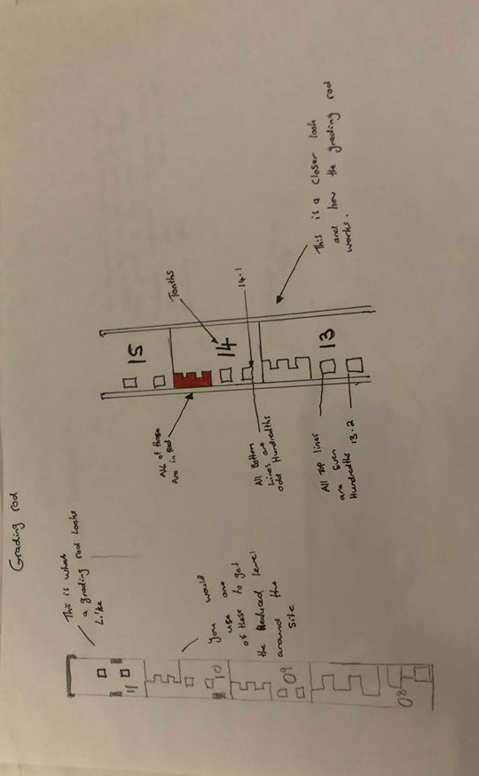

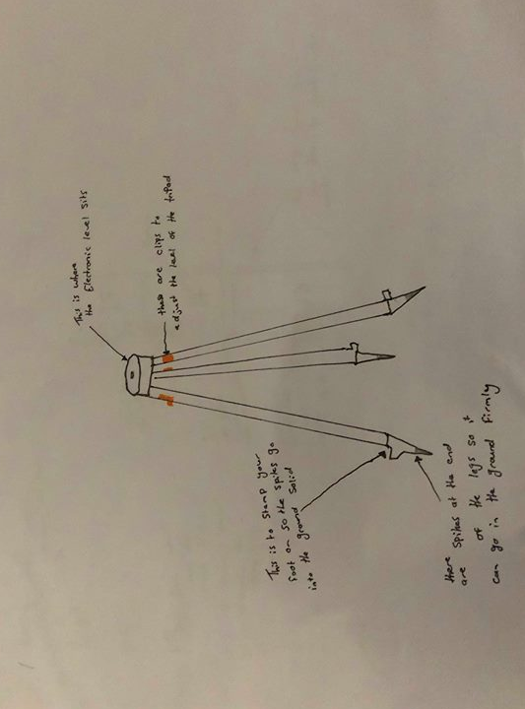

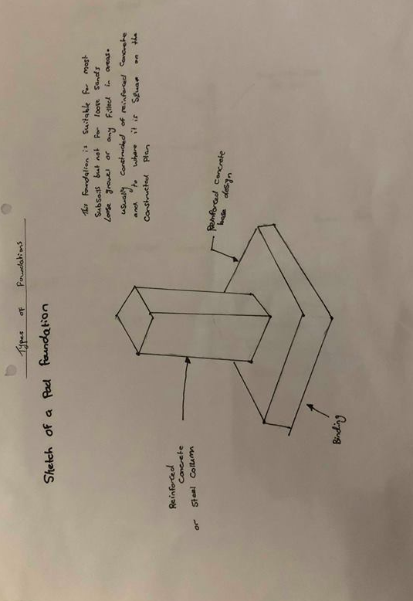

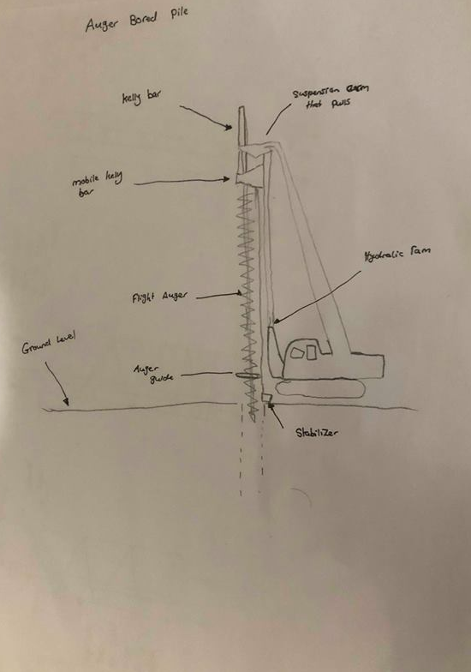

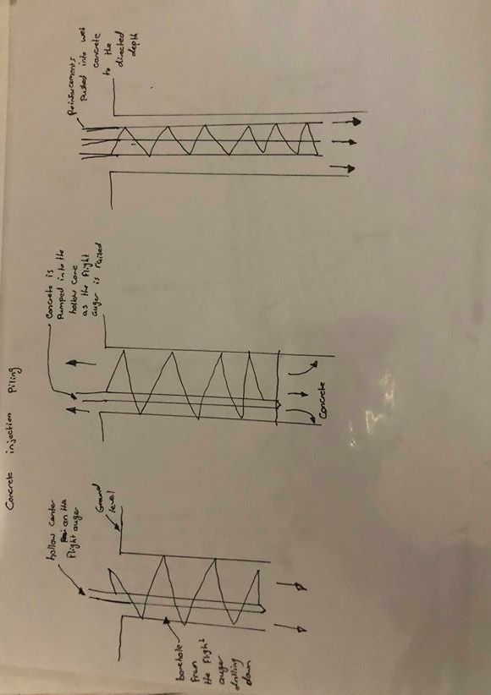

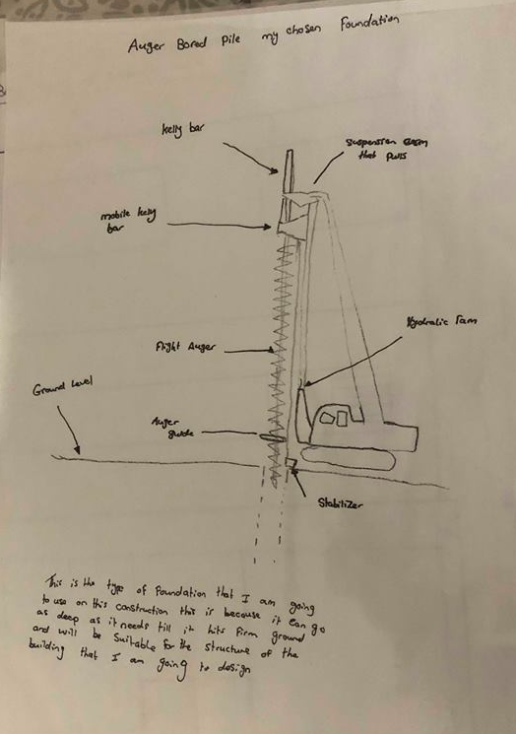

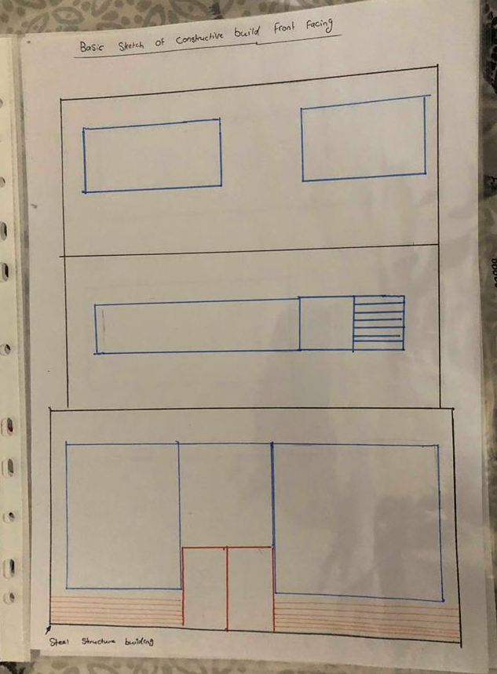

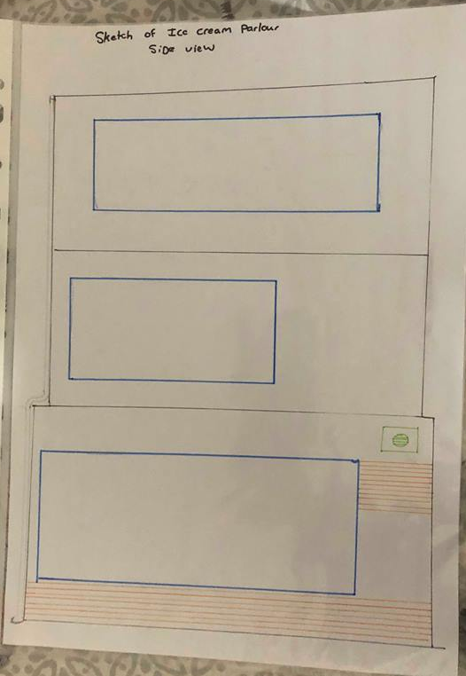

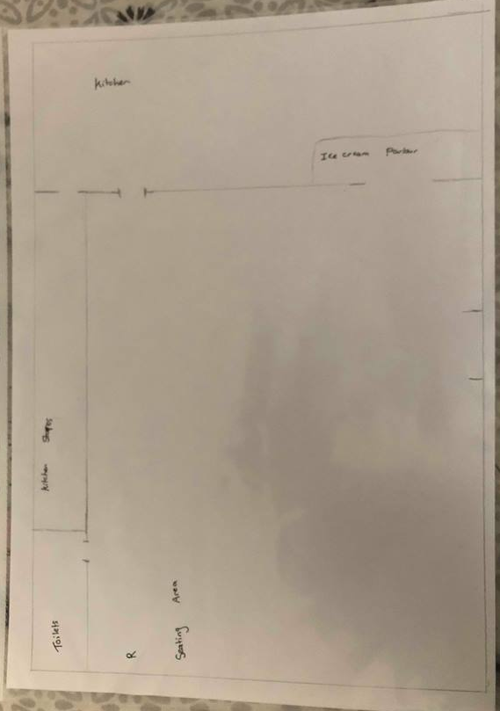

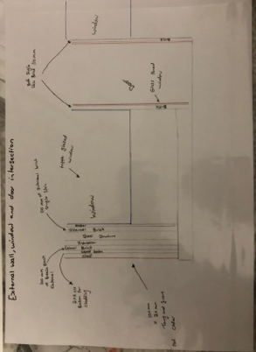

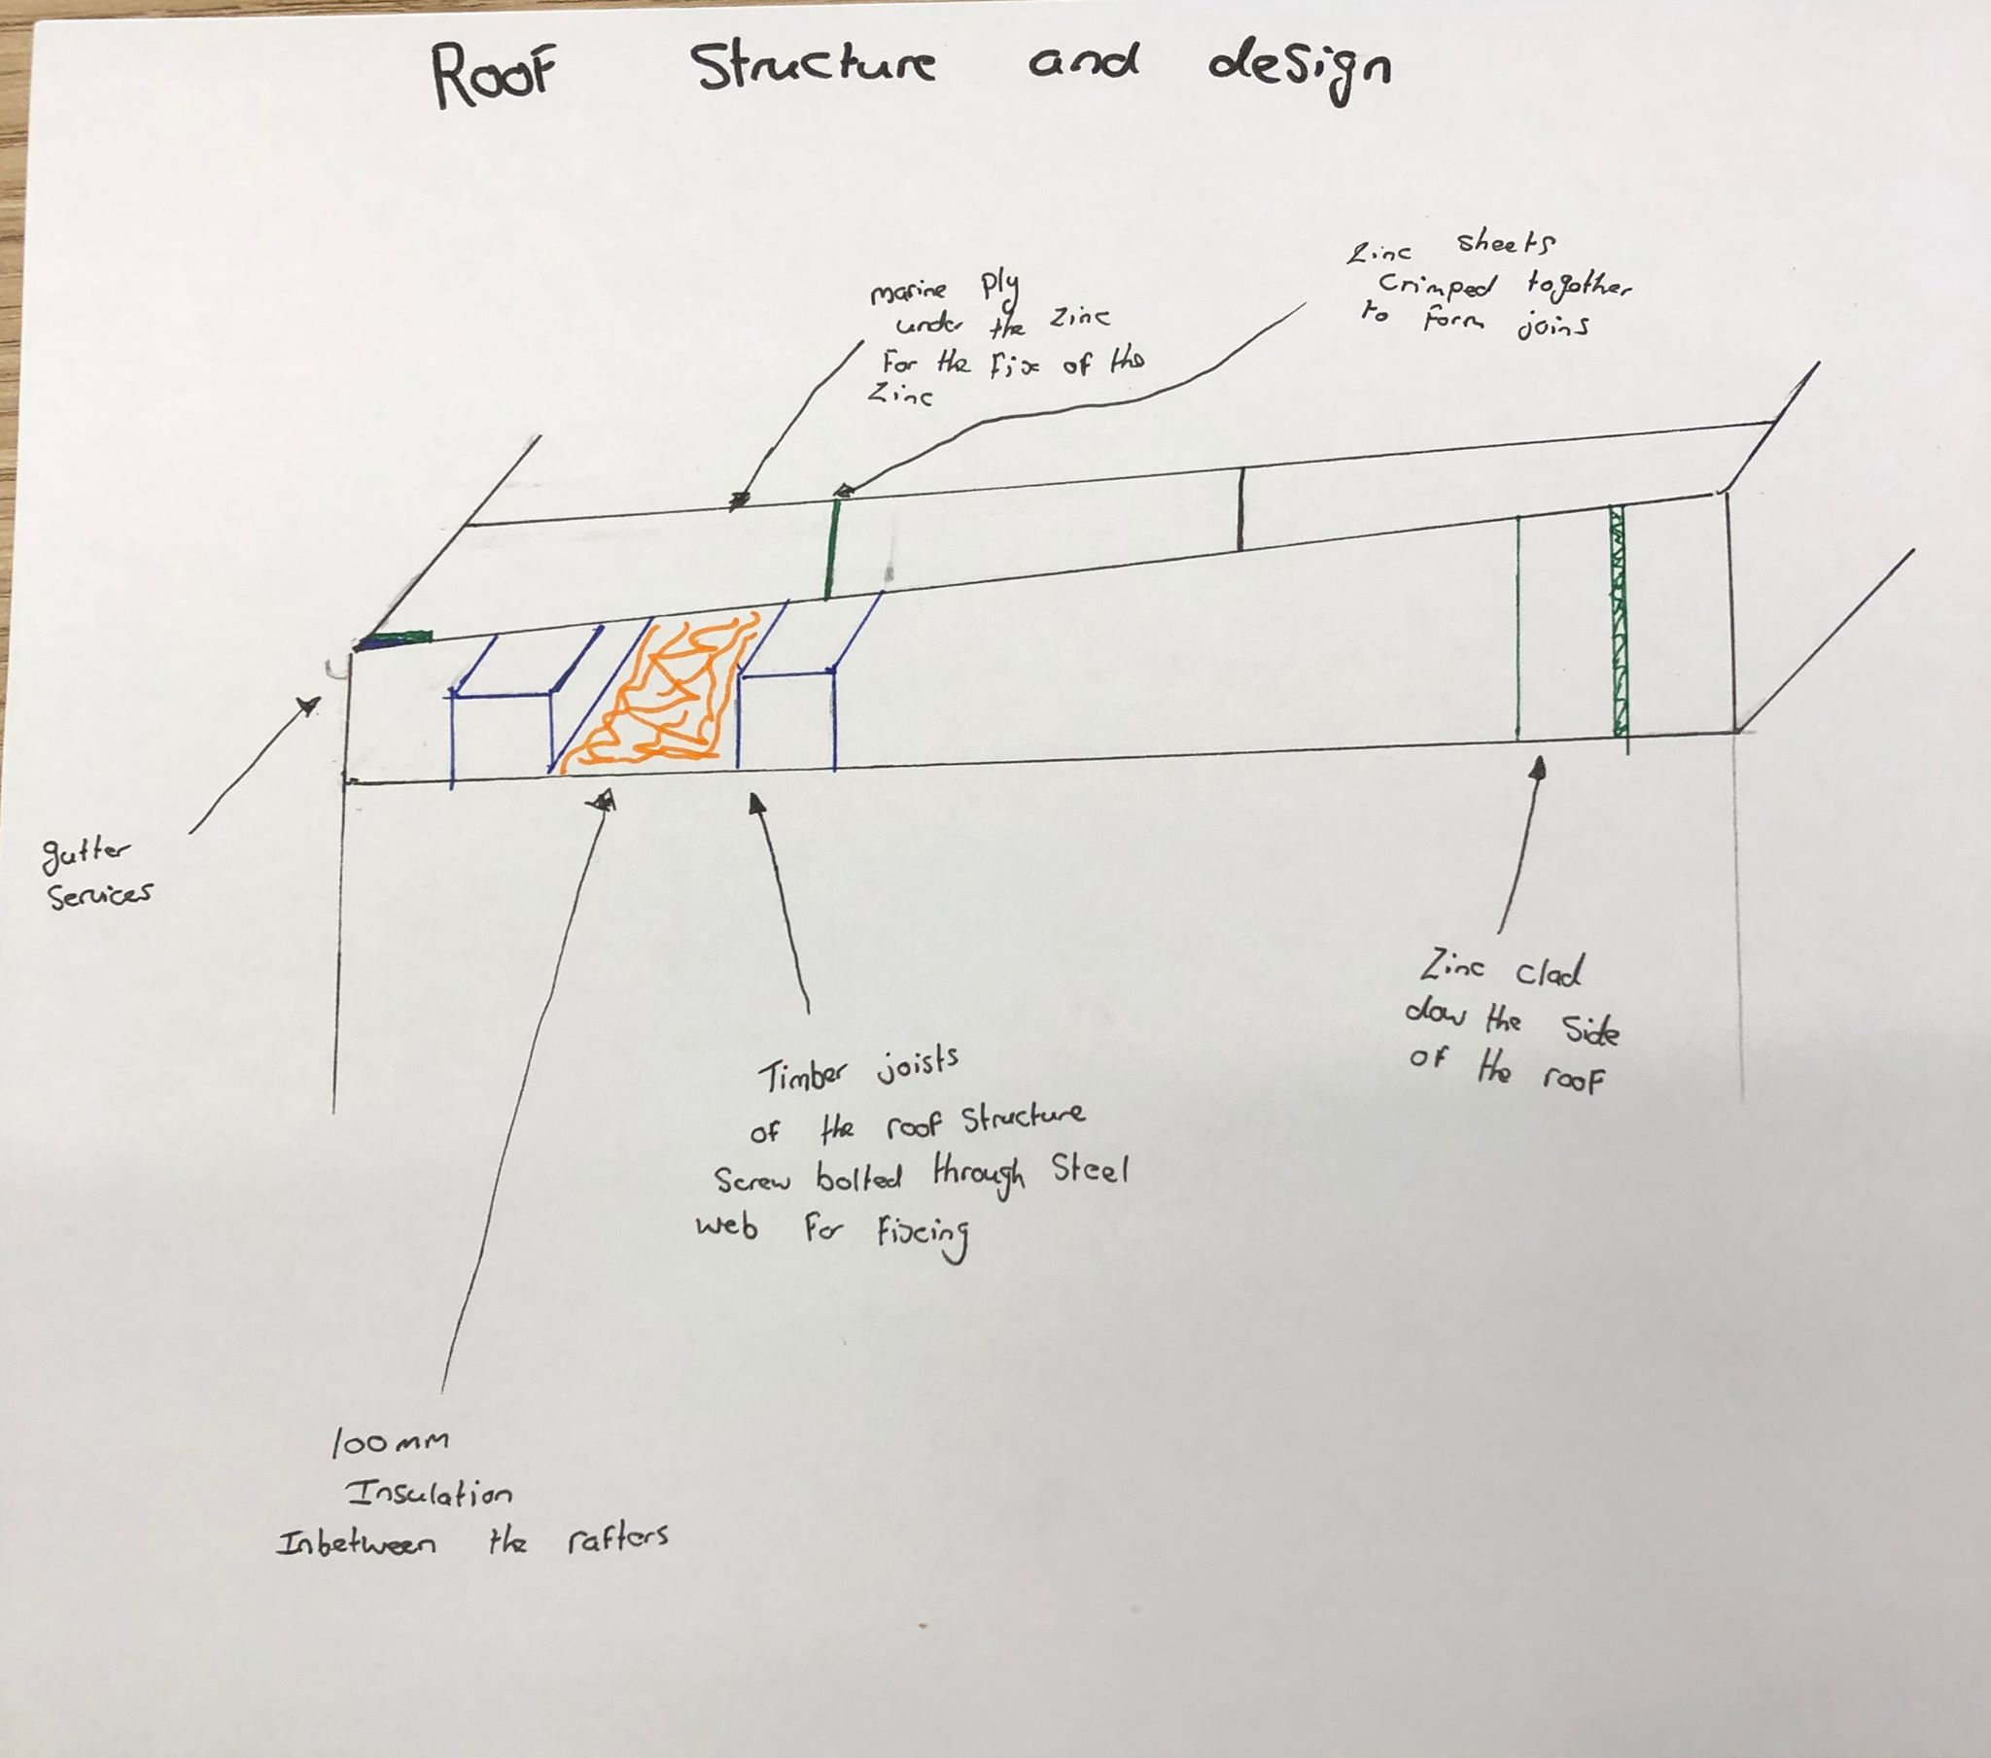

The materials that I have chosen is made up of many different types, I have started the structure by firstly going for pile Foundation this is because it will be suitable for any ground such as the one that is being built on not only is the foundation good for the ground but it's good for the size of the structure.
The materials that I have chosen to use for the main structure of the building is steel this will be a quick way of erecting the building as well as a stronger way of constructing it is also be suitable for building on the coast.
I've decided to go for triple glazed windows as you can see in the sketch followed by a solid glass door the external look of the building will have a Red cedar cladding effect on this and it will give that coastal vibe.
In order to do this, it will follow up on building the internal of the steel with brick and insulation followed by 2x2 external treated lengths of timber fixed into brick running down the building along with 100mm x 20mm planed tongue and groove red cedar wood cladding.

Roof structure and weathering:
By looking at my basic sketch on the side elevation I have decided to go for a flat roof for the building, this roof will have a slight slope of 30 degrees, the roof will be made up from wooden joists that will run inside the steel structure and fixed with screw through boats followed by this the roof structure would be fitted by marine ply sheets of 20 mm thick zinc sheeted over the top given that waterproofing that the roof needs, the weathering on a zinc sheet won't be so often as it can take the salt air that is around the area meaning that this would be suitable choice for the coastal area.

Plant used and working in a safe manner:
The plant that will be needed to be used during the process of the build would be heavy machinery, such as cranes to lift up the steel structure so that there is no heavy manual lifting, also there will be a crane to drill the auger pile foundations, there will be many other small machinery such as a forklift to lift small materials around the site this also means there will be no heavy lifting on materials around the site with regards to fixing the external look to the building there will be cherry pickers and Scissor lifts on site so that you can get to the correct height needed to work safely and so that the work on the external side of the building is done in a safe Manor.
For the members of the public the site will be secluded away from the public this will be done by using site hoarding to keep the members of the public away, also the Costa psychopath will have to be relocated through the car park and then join back onto the other side of the coastal path, any scaffolding works around the building will have green nets around the structure this will stop any debris falling off the scaffolding and injuring any workers or members of the public.

References:
Chudley.R (2014) Building Construction Handbook (10th Ed) 2 Square Park, Milton Park.
(Brief history of Swansea) http://www.localhistories.org/swansea.html

