STUDENT NAME: FATEMA UDDIN
STUDENT ID NO: 2131514
BMIH5007 - FINANCIAL MANAGEMENT FOR THE HOTEL INDUSTRY
BUSINESS REPORT – COMPARISON OF MANDARIN ORIENTAL HOTEL GROUP AND PREMIER INN
TUTOR: TRISTAN HAWKINS

Executive Summary
This report has been prepared as part of the course requirement for financial management of the hotel industry. This business report mainly focuses on the financial performance of Mandarin Oriental Hotel Group and Premier Inn. First of all, the revenue and revenue trends of the two business organisations have been analysed with a graphical presentation as well as trend analysis. Secondly, the market share position of Mandarin Oriental Hotel Group and Premier Inn has been assessed from the perspective of brand position, market share, and customer demographic. A comprehensive turnaround strategy will be developed to revitalise the resort's financial health and restore its reputation as a premier vacation destination or most viable financial outcomes. The growth opportunity and Corporate Social Responsibility activities of the two business organisations have been presented and narrated in the third and fourth part of this report.

Table of Contents
Executive Summary 2
Introduction 3
Analysis of the revenue of Mandarin Oriental Hotel Group and Premier Inn. 4
Major sources of revenue: 4
Revenue Trends: 5
Driving factors of revenue: 6
Market position analysis of Mandarin Oriental Hotel Group and Premier Inn………………………………………………………………………………………….…8
Market share: 8
Customer demographic: 8
Brand perception: 8
Growth potential analysis of Market position analysis of Mandarin Oriental Hotel Group and Premier Inn. 9
Analysis of Financial Commitment to CSR………………………………….………..11
Conclusion…………………………………………………………………………….…..12
References………………………………………………………………………….……..13

Introduction
This report has been prepared to compare the financial position and financial strategy of Mandarin Oriental Hotel Group and Premier Inn. The main objective of the preparation of this report is to assess the financial performance of these companies, market position strategy, potential growth opportunity, and fulfillment of CSR activities (Berk & DeMarzo, 2021). Revenue of Mandarin Oriental Hotel Group and Premier Inn is analysed in this report. Evaluating the major sources of the revenue, revenue trends, driving factors of revenue, the driving factors are further divided into four factors that are customer segmentation, demand forecasting, inventory management, and pricing. Market position is analysed by evaluating the market share, customer demographic, and brand perception. Analysing the Ansoff matrix the growth potential analysis of market position is analysed in this report. Tracking the model making the detailed financial budget, annual budget creation, reporting structure generation for assisting managers for keeping a tab on P and L data are the most important activities of financial management in the industry of tourism and hospitality. These activities will be analysed through this report for Mandarin Oriental Hotel Group and Premier Inn.

Analysis of the revenue of Mandarin Oriental Hotel Group and Premier Inn
The performance of the company depends on the revenue growth and revenue drivers as the net profit margin has a direct relationship to the revenue. The business organisation can report good Earnings per Share and net profit margin when the business organisation has positive revenue growth and multiple sources of revenue (Deloof et al, 2023). In this portion of the report, we will discuss sources of revenue, revenue trends, and driving factors of revenue for Mandarin Oriental Hotel Group and Premier Inn.
Major sources of revenue: The business organisations that are operated under the hospitality and tourism industry generate revenue from room and accommodation, meetings and events, food & beverage, and ancillary services. From the above-mentioned revenue sources, the maximum business organisation has obtained its revenue from room and accommodation services and food & beverage services (Ball, 2021). The room and accommodation service includes the renting of different types of rooms like luxury rooms, suite rooms, couple rooms, and family rooms. The financial performance of the hospitality and tourism business organisation depends on the occupancy rate of the different rooms. The hospitality and tourism business organisations face loss when the room occupancy rate is below the expected level. Parking, spa, laundry, and concierge services are provided to clients of the tourism and hospitality industry under the ancillary services. The minimum revenue has been earned by the tourism and hospitality business organisation from the ancillary services (Arsaqe N, 2018).
Mandarin Oriental Hotel Group has reported in this financial statement that its major revenues are obtained from the Hotel Ownership, hotel and residences branding and management, and rental income (Tan, 2018). As per the financial statements of Mandarin Oriental Hotel Group, this company earned 88.28% revenue out of the total revenue from the Hotel Ownership segments and earned 3.98% revenue out of the total revenue from the rental income (Novianti, 2019).

Mandarin Oriental Hotel Group financial statement | Revenue
Europe and Middle East Region. | 52.78%
Hotel Ownership segments | 88.28%
Rental income. | 3.98%
Premier Inn financial statement | Revenue
Accommodation | 69.67%
food and beverage | 30.32%
United Kingdom | 97.55%

Further, Mandarin Oriental Hotel Group has segmented its revenue based on geographical areas like Asia Region, Europe, Middle East & Africa, and America Region. As per the financial statements of Mandarin Oriental Hotel Group, 52.78% revenue of total revenue was obtained from the Europe and Middle East Region. So, the management of Mandarin Oriental Hotel Group has emphasised Hotel Ownership function and Europe & Middle East Region to ensure its profitability and business growth. Providing delightful customer service, working together, delighting the colleagues, becoming the best service provider, working with responsibility the growth of business is ensured (Saltor Clavero, 2019).
Premier Inn has reported in this financial statement that its major revenues are obtained from accommodation and food and beverage revenue. As per the financial statements of Premier Inn, this company earned 69.67% revenue out of the total revenue from accommodation and 30.32% revenue out of the total revenue from food and beverage revenue. Further, Premier Inn has segmented its revenue based on geographical areas like the United Kingdom, Germany, and Others. As per the financial statements of Premier Inn, 97.55% revenue of total revenue was obtained from the United Kingdom Region. So, the management of Premier Inn has emphasised on accommodation function and the United Kingdom Region to ensure its profitability and business growth. The growth will be continued as the goal of the business is to increase the profitability, market share overall the business growth day by day. As the hotels follow sustainable strategies obviously the growth will be improved for the next year and future.
Revenue Trends: To analyse the revenue trends of Mandarin Oriental Hotel Group and Premier Inn, the revenue for the period from 2019 to 2022 has been obtained from the annual report and presented below in the graphical form:

Figure 1: Revenue of Mandarin Oriental Hotel Group and Premier Inn.

From the above graphical chart, it is observed that the revenue of Mandarin Oriental Hotel Group has followed consistency over the last three years (from 2020 to 2022). The revenue of Mandarin Oriental Hotel Group decreased significantly during the year 2020 due to the pandemic of Covid 19. After COVID-19, this business organisation has tried to increase its revenue as well as to return to pre Covid-19 period. However, this company cannot improve itself like the pre-COVID-19 situation. That means the flow of service generation and revenue creation that has happened before the pandemic has slowed down since the pandemic and it will take time to be the same as pre-covid19 situation. Such as the flow of earnings has damaged as the international tourists movement was stopped. Services were stopped so the revenue generation was slowed down (Tan, 2018). From the above graphical chart, it is also observed that the revenue of Premier Inn has consistency in first two years in 2019 and 20 except for the year 2021. The revenue of Premier Inn decreased significantly during the year 2021 due to the pandemic of Covid 19. After COVID-19, this business organisation has tried to increase its revenue as well as to return to the pre Covid-19 period. Mandarin Oriental Hotel Group revenue is more consistent than Premier Inn after Covid-19 period as the revenue is fluctuating in Premier Inn.
MANDARIN ORIENTAL INTERNATIONAL LIMITED 2022 PRELIMINARY ANNOUNCEMENT OF RESULTS

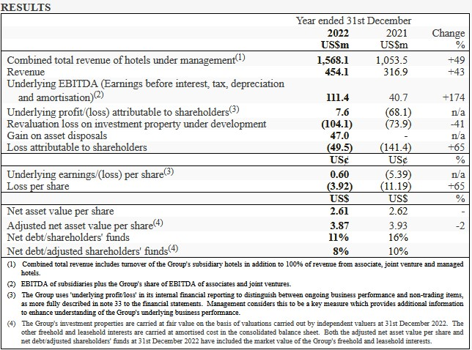
Driving factors of revenue: The success of the tourism and hospitality industry has been affected by revenue management since the profitability has come from revenue. Hence, the Mandarin Oriental Hotel Group and Premier Inn need to manage its revenue cautiously and prudently (Gillespie, 2019). The following are considered as main factors driving to increase or decrease in revenue of Mandarin Oriental Hotel Group and Premier Inn:

Figure 2: Revenue Driving Factors
Customer Segmentation: For tourism and hospitality business organisations, customer segmentation is considered as the most influencing factor (Gupta, 2020). During the making of the customer segmentation, the tourism and hospitality business organisation may consider the demographic factor, the purpose of the trip; stay duration, travel status, and booking channel (McClave & Sincich, 2021)
Demand forecasting: The ability to identify reasonable demand forecasting of customers for room and accommodation service is another crucial factor for the success of the tourism and hospitality business. (Pandey, 2021). Therefore, Mandarin Oriental Hotel Group and Premier Inn need to analysed the demands of customers with consideration of customers’ perceptions.
Inventory Management: In tourism and hospitality business organisations, the management needs to serve food and beverages on short notice. In that case, Mandarin Oriental Hotel Group and Premier Inn need to manage the inventory level following the internal policy and safety margin rate.
Pricing: For every business organisation, the pricing is the most important factor in increasing demand or declining demand for services (Parkin, 2023). During the setting of the price for accommodation and food services, the tourism and hospitality business organisation needs to consider the income level of customers, demands for services along with other economic factors.
Total revenue of Mandarin Oriental Hotel Group is 516.40m in USD in 20 February 2024 Changes in today is 0.01 to 0.67%. Net income is -100.40m. . In one night at London , Mandarin Oriental charges 591 dollars and Premier Inn charges 150 dollars and it has verities of rooms which is started from 20 dollars.
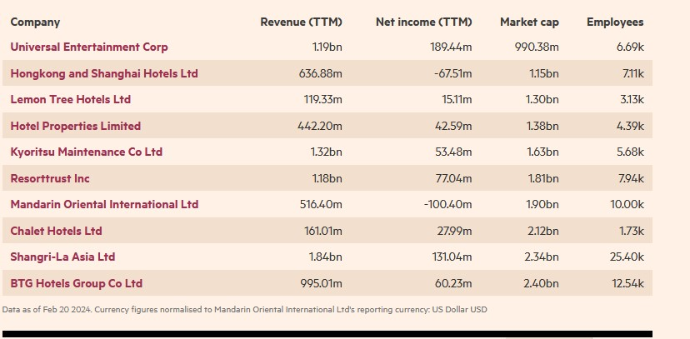
Financial Data of Mandarin Oriental Hotel Group
Since 2019 net debt is reduced 27% underlying the profit. Funding position and liquidity is remained robust and representing the growth in the portfolio at 7% in 2022 two residence and two hotels opened. There are 400 properties in Mandarin Oriental Hotel from front desk to channel manager all modules.
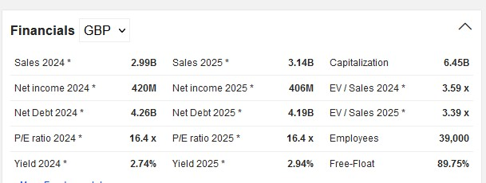

Financial data of Premier Inn
Net income of Premier Inn on 20 February 2024 is 420M. In London and other regions citing the strong demand in year on year the chain of hotels of Premier Inn is grown in 11% on the basis of the owner of Dunstable, Bedfordshire. Key offerings of Premier Inn are car park, front desk, free Wi-Fi, luggage storage, check-in/out, cash withdrawal, coffee shop and bar. Mandarin Oriental offers 24-hour doorman, concierge service, luggage and package received service, personalised mail delivery and housekeeping service.
Premier Inn uses dynamic pricing policy that fluctuates with the demand. The revenue in 2022 of Mandarin Oriental Hotel Group is 0.45 billion dollars. In UK Premier Inn has total revenue of 2.5 billion dollars from 900 hotels that is operated in UK (Berry, 2022).

Market position analysis of Mandarin Oriental Hotel Group and Premier Inn

The market position of any business organisation can be analysed through analysis of market share, customer demographics, and brand perception (Sloman et al, 2022). The market position of Mandarin Oriental Hotel Group and Premier Inn will now be analysed considering the above-mentioned factors:
Market share: The market share analysis helps the stakeholder to understand how much the market can be captured by the business organisation. From the annual report of Mandarin Oriental Hotel Group, it is identified that this business organisation holds almost 8.98% market share in the Middle East and Africa region under the Tourism and Hospitality industry. On the other hand, Premier Inn has also reported that this business organisation holds almost 10% market share in the United Kingdom under the Tourism and Hospitality industry (Sloman et al, 2022). Based on the market share analysis, Mandarin Oriental Hotel Group reflects a good position in the market but Premier Inn is in better position as it market share is higher than Mandarin Oriental Hotel Group. According to a report of UK revenue of Premier Inn is increased by 50% and the amount is 2.5 billion dollars and the business is expanded by 54% on the basis of average revenue for individual room. From 38.69 dollar the revenue is 59.45 dollars year on year.
Customer demographic: Both Mandarin Oriental Hotel Group and Premier Inn has focused on business customers as well as individual tourists to earn revenue. However, Premier Inn has earned more revenue from the business customers (Sloman et al., 2022). Further, Premier Inn has earned a significant portion of revenue from the United Kingdom, Qatar, Ireland, Germany, and Somalia. Mandarin Oriental Hotel Group depends on Europe and the Middle East to earn revenue. Premier Inn does psychographic segmentation based on values and beliefs. The male audience is 50% and female audience is 49.06%.
Brand perception: The brand perception of customers has been developed based on the service quality of the business and the loyalty of the customers. Mandarin Oriental Hotel Group reports that 63% of its customers have taken service again and repeatedly. On the other hand, Premier Inn reports that 86% of its total customers avail of its loyalty scheme programs (Wilson, 2018).
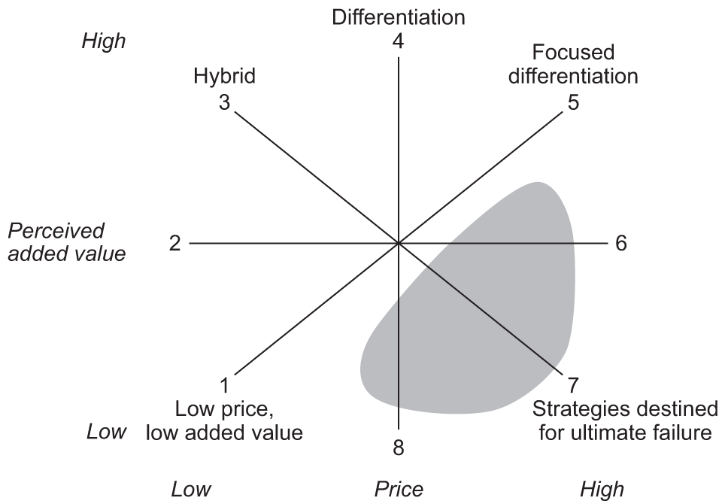
The competition of business and companies in the marketplace is comprehend by the beneficial model of Bowman’s Strategy Clock.
To compete in the market the Mandarin Oriental Hotel Group and Premier Inn can use competitive method for keeping price low though low price low value strategy. Offerings of the service and product price can be lower of Mandarin Oriental Hotel Group and Premier Inn according to this strategy of Mandarin Oriental Hotel Group and Premier Inn can make huge profits for high volume output generation, following low price strategy producing large quantities service. Product differentiation and low price two strategy is combined in hybrid strategy to offer consistent quality every day. Following differentiation strategy Mandarin Oriental Hotel Group and Premier Inn is created unique from of values. Utmost price level is focused by focused differentiation strategy and strategy Mandarin Oriental Hotel Group and Premier Inn produces products for the customers who are willing to pay more 10-20 times more comparing to economic competitors. The risky high margin is the short term strategy used by Mandarin Oriental Hotel Group and Premier Inn to exploit the disequilibrium of supply chain in short term.

Growth potential analysis of Market position analysis of Mandarin Oriental Hotel Group and Premier Inn

Potential growth of the Market position analysis of Mandarin Oriental Hotel Group and Premier Inn can be analysed by following the Ansoff Matrix.

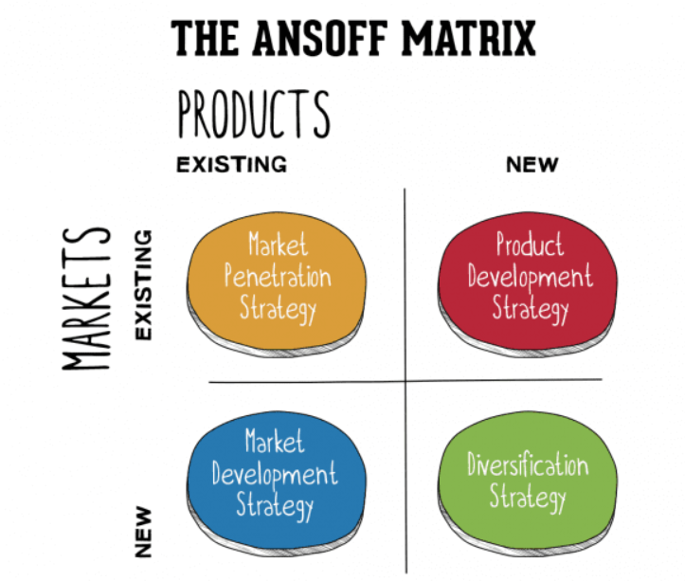
Figure 3: Ansoff Matrix
Reference: (Wilson, 2018)

As the products of Mandarin Oriental Hotel Group and Premier Inn are premium and highly standardised, they have limited opportunity to expand their business following the product development strategy. In that case, the business organisation can follow the market development strategy. Mandarin Oriental Hotel Group and Premier Inn has introduced many new product and service with the existing service. New opportunities are identified to sell products and services (Wilson, 2018). As a part of the market development strategy, both business organisation expanded their business in developing countries where some tourist areas existed. The market development strategy will help the Mandarin Oriental Hotel Group and Premier Inn to earn more revenue and profit within the short term although the market development strategy needs more investment. As a part of market development strategy, this business organisation is engaged with Franchise businesses, joint-venture businesses, and branch office businesses (Watson et al, 2023). There are some barriers to market development strategy like cultural issues, conflicts with the partners, regulatory issues, and compliance issues. Further, it is difficult to recover the investment and return the investment from foreign countries (developing countries) to home countries due to regulatory and compliance issues. Moreover, there are foreign exchange and interest rate risks in the market development strategy. Climate change and social equity is a major barrier for Mandarin Oriental Hotel Group. The environmental sustainability is highly maintained for social responsibility. The rule of government structure has five tiers and there has diversity inclusion councils. Every year huge a big portion of earnings is used for government rules, environment and society that’s slow down the growth.

Analysis of Financial Commitment to CSR
To ensure sustainable business growth and profitability, each business organisation needs to be committed to its society and its environment (Gupta, 2020). As a part of corporate social responsibility, Mandarin Oriental Hotel Group is involved in reducing the use of carbon and environment-friendly equipment in its office premises. The management of Mandarin Oriental Hotel Group is also concerned with performing energy audits and eight (08) energy audit has been performed since 2022. To protect the environment and water, the management of Mandarin Oriental Hotel Group has avoided serving 19 seafood’s which were prohibited by Mandarin Oriental Hotel Groups. According to the updated inclusion and diversity policy inclusive working environment, career support, fair HR practices is fostered. Human right policy is developed for preventing human trafficking and modern slavery to promote understanding among all people.WWF identified endangered seafood species and at the end of 2022 they are aimed to stop serving endangered seafood (Roblek, 2016).
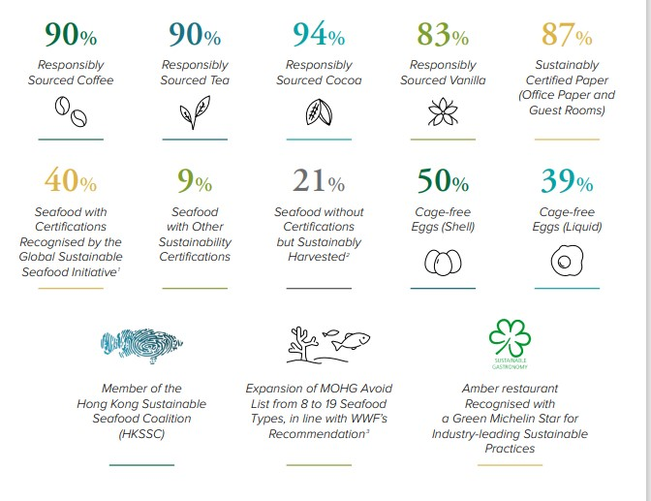
CSR activities of Mandarin Oriental Hotel Group’s
Like other business organisations, Premier Inn has supported its community and society. As a part of social activities, this business organisation has started to do with children and raised approximately £25,000 to support the orphanage children. During the pandemic situation of Covid 19, this business supported the general people and employees by opening food banks and providing medical support. Furthermore, Premier Inn is also conscious of its environment and tries to implement a green office environment concept. Mandarin Oriental Hotel Group is performing Corporate Social Responsibility work focusing on sustainability goal.

Conclusion
The financial position of Mandarin Oriental Hotel Group and Premier Inn has been compared in this report. The revenue creation activities, growth potentiality, Corporate Social Responsibility commitment are analysed in this report. Both hotels are committed to Corporate Social Responsibility work for sustainable business growth. The business management of Mandarin Oriental and Premier Inn had a strong financial and operating performance for further growth it is well set for the success in the future. The strength of the brand Group’s are strong pipeline and existing portfolio properties together. Through franchising, joint business both of the hotels earn profit across the globe expanding their territory. Both Mandarin Oriental Hotel Group and Premier Inn have maintained the corporate social responsibility properly to ensure ESG reporting. The health of Mandarin Oriental Hotel Group and Premier Inn and the future prospects is analysed by the financial statement analysis gaining insights. Cash flow, income statements, and other documents are processed to know the financial position of Mandarin Oriental Hotel Group and Premier Inn.

References
Arsaqe, N., 2018. Internship Report at Mandarin Oriental, Jakarta
Berry, C.T.P., 2022. Equity research-Whitbread PLC (Doctoral dissertation, Instituto Superior de Economia e Gestão)
Ball, S., 2021. Contemporary Hospitality & Tourism.
Correia, C. et al. (2019) Financial management. Lansdowne: Juta. (Accessed 01.10.23)
Deloof, M. et al. (2023) Corporate finance. Mortsel: Intersentia. (Accessed 03.10.23)
Gillespie, A. (2019) ‘Behavioural economics’, Foundations of Economics [Preprint]. doi:10.1093/hebz/9780198806523.003.0005. (Accessed 05.10.23)
Gupta, S. (2020) Empowered by economics: Macro economics. New Delhi: GenNext Publication. (05.10.23)
McClave, J.T. and Sincich, T. (2021) Statistics. Hoboken, NJ: Pearson Education, Inc. (06.10.23)
Novianti, E. and Fajar, A.N., 2019. Information technology investment analysis of hospitality using information economics approach. TELKOMNIKA (Telecommunication Computing Electronics and Control), 17(2), pp.609-614.
Pandey, I.M. (2021) Financial management. Noida: Pearson India Education Services. (Accessed: 10.10.23)
Parkin, M. (2023) Economics. Harlow, England: Pearson. (Accessed 11.10.23)
Roblek, V., Milenkovska, V. and Milojica, V., 2016. The impact of corporate sustainability in achieving business goals in hotel industry. In Faculty of Tourism and Hospitality Management in Opatija. Biennial International Congress. Tourism & Hospitality Industry (p. 388). University of Rijeka, Faculty of Tourism & Hospitality Management.
SaltorClavero, M. and Kukushkina, D., 2019. Financial Analysis of the Luxury Hotel Segment in Spain.
Sloman, J., Garratt, D. and Guest, J. (2022) Economics. Harlow, England: Pearson Education Limited. (Accessed 11.10.23)
Tan, L.Y., Lai, J.H., Lee, S. and Chew, W.S., 2018. Analyzing the Relationship between Financial Variables and Market Risk in the Tourism Industry. Available at SSRN 3182242.
Sol, J. (2019) ‘Economics in the anthropocene: Species extinction or steady state economics’, Ecological Economics, 165, p. 106392. doi:10.1016/j.ecolecon.2019.106392. (Accessed 14.10.23)
Watson, D., Head, A. and Chan, D. (2023) Corporate finance: Principles and practice. Harlow, England: Pearson. (Accessed 15.10.23)
Wilson, C. (2018) Financial management. South Melbourne, Victoria: Cengage Learning Australia. (Accessed 15.10.23)

