

Series Hybrid Vehicle CW2

ACEA7007: Hybrid Powertrain and Control

Student: 2109787 (Jaimishkumar V. Navadiya)

Lecturer: Mr. Mark Sandford
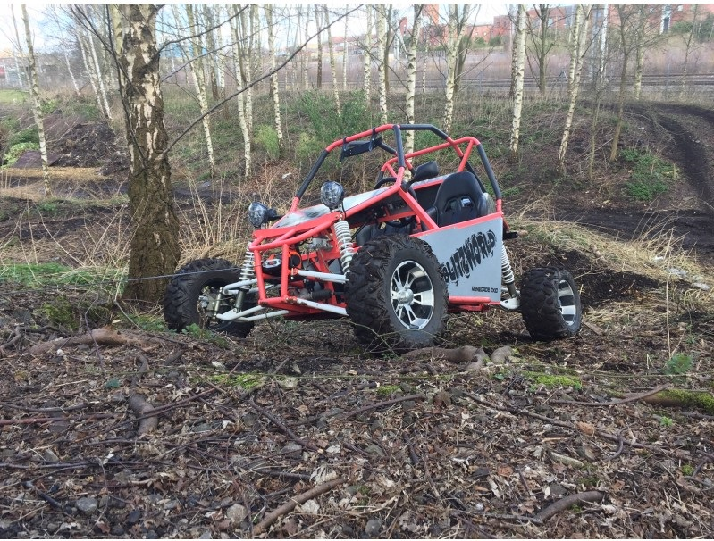

Content
- Purpose.……………………………………………………………………………..3
- Introduction………………………………………………………………………..4
- Design of series hybrid drive train……………………..……………………..5
  - Electrical coupling device (Controller) ………..……………………..5
  - DC/DC Converter…………………………………………………………6
  - Traction Motor……………………………………………………………10
  - Engine/Generator……………………………………………………….13
  - Battery……………………………………………………………………..13
  - Regenerative Braking……………………………………………….…..15
- Summery…………………………………………………………………….…….16
- References…………………………………………………………………………18

Index
Graphs
- Characteristic of motor…………………………………………………………………11
- Motor traction power……………………………………………………………………12
- Motor current……………………………………………………………….……………12
- Charging & Discharging current of battery………………………….……………14
- State of Charge (SOC) …………………………………………………….……………15
- Regenerative Braking Current………………………………………….…………….16

Tables
Summery Table……………………………………………………………………………….16,17

- Purpose
In previous course I studied and generated a duty cycle for off road buggy for the recreational and entertainment purpose. Now, in second part of the course I study and design a series hybrid for buddy and simulate and analyze the fuel consumption for all the same condition as same road terrain, same speed, same operator and so on. In this course, it is needed to design a generator, motor, controller, energy storage device (PPS- peaking power source i.e., battery). The mass of this new devices also considered in this study. The engine is running at best fuel efficiency point. In this study, engine will run at the 5500 RPM and 14Nm torque, in this operating point the break specific fuel consumption is 297.2 g/kWh. The other consideration and assumption for this study will discuss ahead.

- Introduction
The concept of series hybrid electric drivetrain was developed from the EV drivetrain. In ICE, the source of traction power delivered to the drive wheel is only depended upon combustion of fuel. The fuel consumption is directly proportional to the driver command. In different driving condition, the fuel consumption different.
A typical series hybrid electric drivetrain configuration is shown in figure 1. The vehicle is propelled by the traction motor. The traction motor is powered by a battery pack and/or an engine/generator unit. The engine will used to propel the generator which produced electricity and this electrical power will delivered to the directly traction motor or stored in the battery. In first design, the power is direct supply to the motor, in this case, the generated power from the generator is directly delivered to the motor. If motor required less power than generator supplied, in this case a remaining power is goes to charge the battery. while power required at motor is greater than generated power, this stored energy will help to provide. While in second case, in which generated power is supplied to the battery and battery will provide all the power to the traction motor. In this case, generated power is only used to charge the battery.
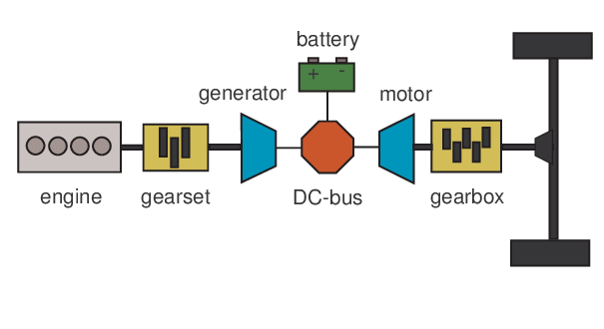
Figure 1: Schematic diagram of Series Hybrid Electric Drivetrain
- Design of series hybris drivetrain
The designing of series hybrid drivetrain is to achieve the desirable performance, such as acceleration, gradient power, high speed and high operating efficiency. The traction motor, engine/generator unit, peaking power source (energy storage device) and electrical coupling device (controller) are the main components of concern.

  - Electrical coupling device (Motor Controller)
The controller is the sole linkage point for combining three sources of power together: engine/generator power, battery power and traction motor power. Its major function is to regulate the power (electric current) flow between these power sources and sinks. The power (current) regulation is carried out based on the proper control of the terminal voltage. The simplest structure is to connect the three terminals together directly as shown in figure 2.
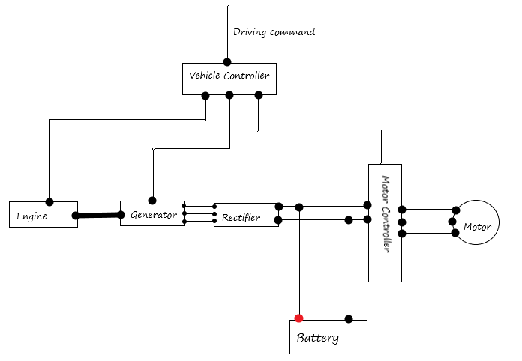
Figure 2: Directly connected power source and sink
In this configuration the controller controls the current flow between generator, battery and traction motor. When the motor required the power more than generated power, controller allows the battery to supply the additional power to the battery. While, when the during deceleration, the power required at motor by generator and/or battery is quite low, in this condition, controller supply all the generated power from the generator to the battery as well as supply regenerative power to the battery.

  - DC/DC Converter
The configuration of the DC/DC converter is shown in the figure 3.
Engine/Generator
And Rectifier
Motor
Motor Drive

DC/DC Converter

Battery

Figure 3: Configuration with the DC/DC converter on the Battery
Adding a DC/DC converter between the battery and the DC bus, and DC bus is directly connected with the generator rectified. The battery voltage is allowed to be different from the DC bus voltage, and the rectified voltage. The DC/DC converter is bidirectional. In this case of the rated voltage the battery being lower than the DC bus voltage, the DC/DC converter has to boost the battery voltage to the level of the DC bus to deliver its power to the DC bus and buck the DC bus voltage to the level of the battery charging voltage to charge the battery. In regenerative braking, if the voltage generated by the regenerative braking is higher than the battery voltage, the DC/DC converter in the battery charging direction is still usable. But if the regenerative voltage is lower than the battery voltage in this condition a step up/down converter needed.
Figure 4 shows bidirectional DC/DC converter connected between the low voltage of the battery and high voltage of the DC bus, boosting for the battery discharging and bucking for the battery charging from the generator or from the regenerative braking. In the battery discharging (traction) mode, switch S1is turned off, and S2 is turned on and off periodically. In the on period of S2, the inductor L_{d} is charged with energy from the battery and the load is powered by the capacitor C, as shown in the figure 5(a). In the period of S2, both the battery and the inductor supply the energy to the load and the charging C, as shown in figure 5(b).
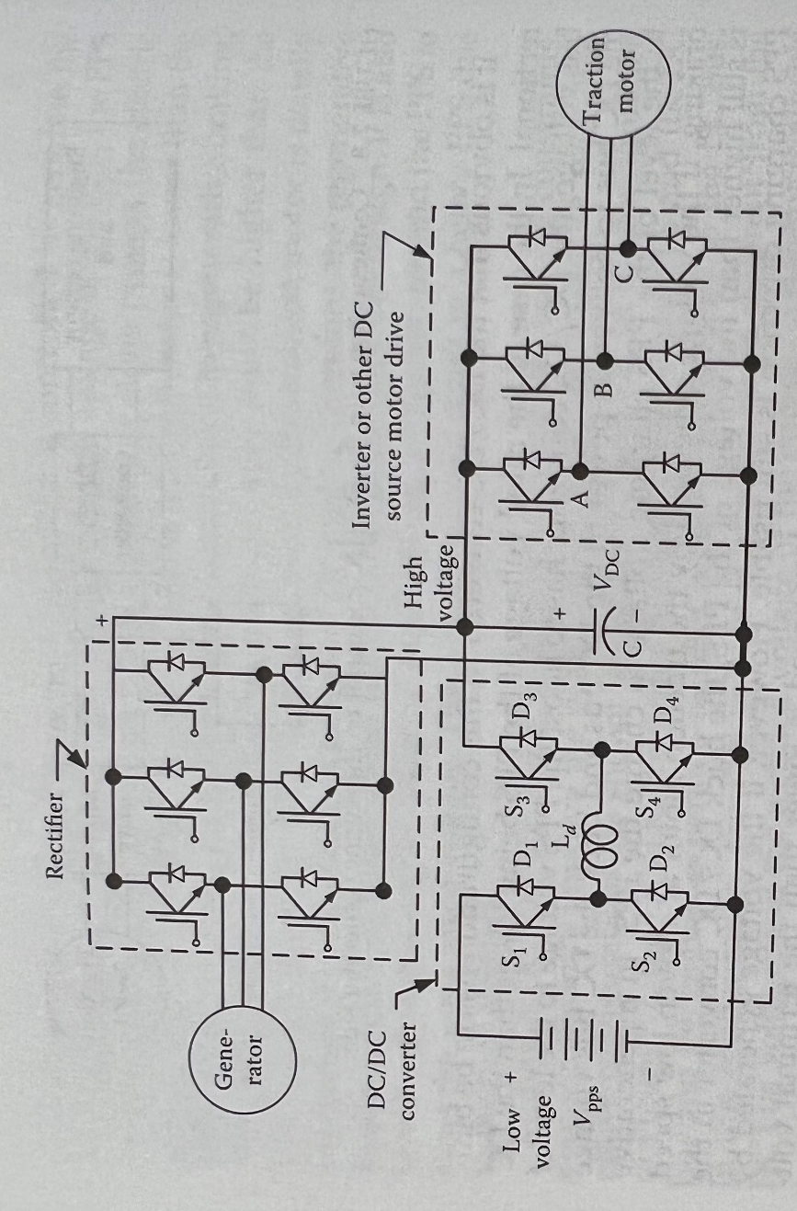
Figure 4: Bidirectional DC/DC with low voltage battery and high voltage DC bus
Figure 4: Bidirectional DC/DC with low voltage battery and high voltage DC bus
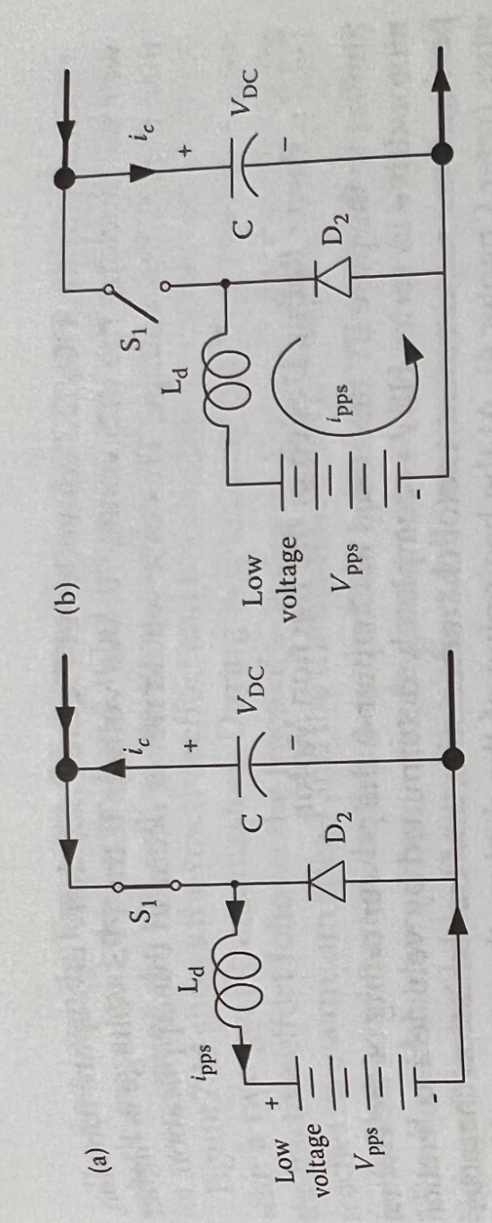
In the battery charging mode from the generator or traction motor in Figure 5: Current flow during discharging of battery: (a) S2 on (b) S2 off
regenerative braking, the DC/DC converter bucks the high voltage of the DC bus to the low voltage of the battery. S1 and diode D2 serve as a unidirectional buck converter. The current flows during the on and off period of S1 are shown in figure 6.
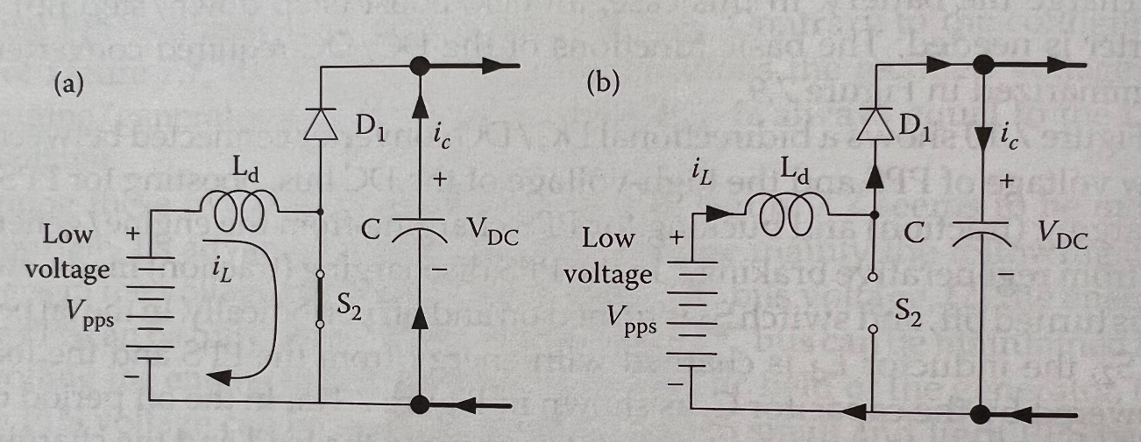
Figure 6: Current flow during charging of battery: (a) S1 on (b) S1 off
As mentioned above, when the generated voltage by the traction motor at low speed, in regenerative braking, is lower than the voltage of the battery, a bidirectional boost/buck DC/DC converter is required. A bidirectional buck/boost DC/DC converter is shown in figure 7. Its basic operation in charging and discharging in battery are as follows.
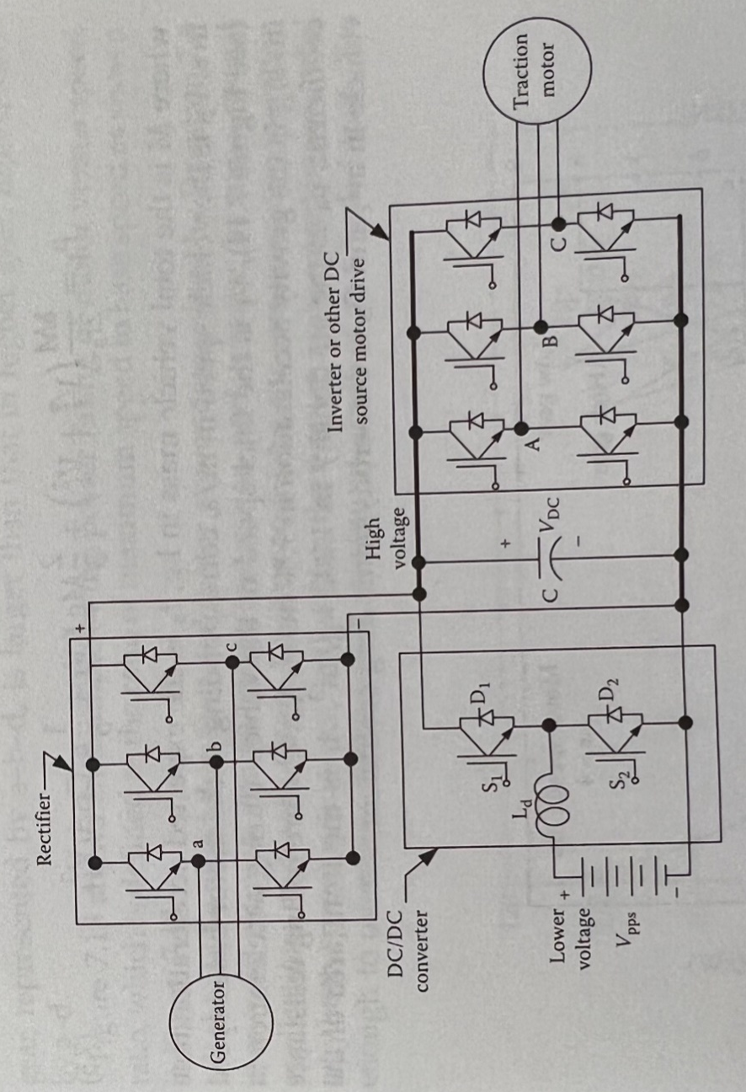
In the battery charging mode, that is boosting the battery voltage to the DC bus level, S1 is always on, S2and S3 are always off, and S4are turned on Figure 7: A boost/buck DC/DC converter.
and off periodically. In the charging mode with DC bus voltage higher than the battery voltage in regenerative braking or generator charging mode, that is bucking the DC bus voltage to battery level, S1, S2, and S4 are turned off, S3 are turned on and off periodically. In the battery charging mode with DC bus voltage lower than the battery voltage (regenerative braking at low speed), that is boosting the DC bus voltage to the battery level, S1 and S4 are off, S3 on, and S2 is turned on and off periodically. In the on period of S2, the inductor L_{d} is charged by the DC bus through S3 and S2in the off period off S2, both the DC bus and the inductor charge the battery through S3 and D1.
All the electrical components in this series hybrid buggy are run on 48V. So, here use 24V-48V 80Amps-250Amps Permanent Magnet Regenerative Controller.
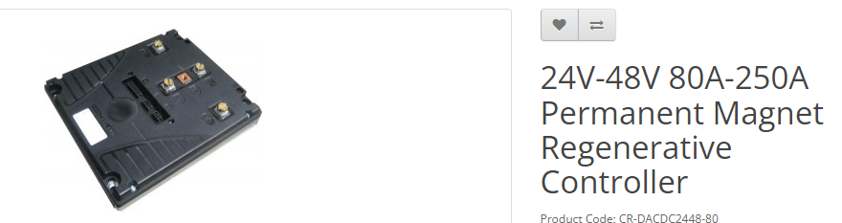
Figure 8: Controller
The maximum current flow in circuit is 243.6960 Amps as shown in graph 2. And the controller working range is up to 250Amps. So, in this duty cycle this controller can withstand and work effectively.

  - Power rating design of the traction motor
At the beginning of the traction motor design, the power rating of the motor drive can be estimated according to the acceleration performance using the following equation.
$$P_{t}=\left(F_{Rolling}+F_{Gradient}+F_{Areodynamic}\right)×V$$
Where V is the velocity of the vehicle.
In selection of traction motor, the main parameters that considered are motor torque and RPM.
In this course, assume that the vehicle running in gear 3 at the maximum speed of vehicle is 30 mph equals 13.4112 m/s. The radius of the traction wheel (driving wheel) is 0.295 m. So, the maximum RPM of the wheel
$=\frac{V}{2×π×R}=434.3474 RPM$.
And from the specification of the motor, the maximum speed of the motor is 3500 RPM.
So, 3rdGear Ratio $= \frac{3500}{434.3437}=8.058$
For design of first gear, maximum traction power at wheel is 500.5714 Nm at the initial stage due to inertia. And from specification of motor, at 3000 RPM and 15kW (efficiency 0.6).
So, torque of motor at this condition is 28.6624 Nm.
So, 1st Gear Ratio $=\frac{500.5714}{28.6625}=17.4644$.
The characteristic graph of the motor is shown in figure 9.
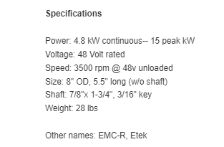
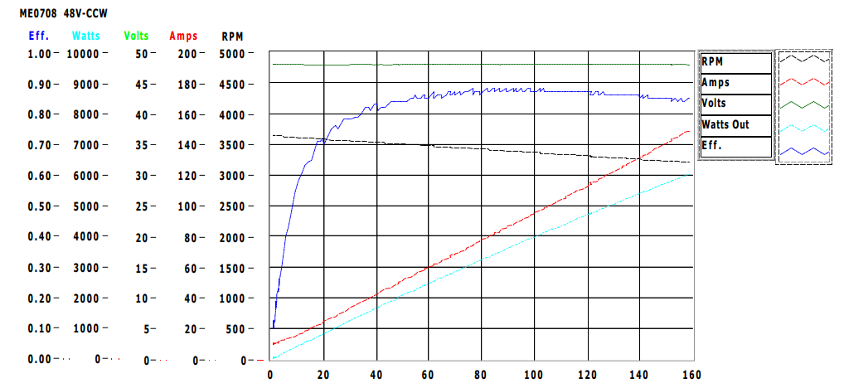
Figure 9: Characteristic of the motor
In this course the maximum power needed from the motor is 14.7897 kW. The selected motor has 15kW peak power and maximum 3700 RPM. The continuous power of the motor is 4.8 kW which is more than required average power. So, this motor (PMDC 48V 4.8kW cont. and 15kW peak) is suitable at above gear ratio selection for gain maximum speed and torque. The efficiency of this motor is considered 85%. Power requirements from motor are shown in graph 1. The maximum traction power required from the motor is 11.6974 kW which is under the operational region as per the specification. So, this motor can be used as traction motor for achieving desired output.
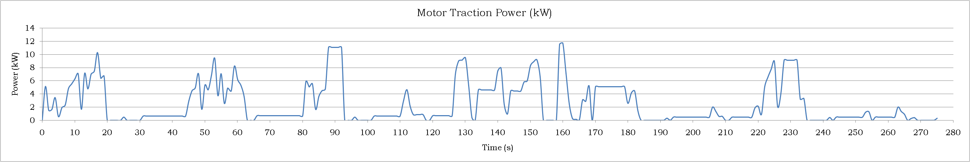
Graph 1: Motor Traction Power
As given specification of the motor, the maximum current that motor withstand is 200 Amps and as per design motor needs maximum current 243.7 Amps as shown in graph 2.
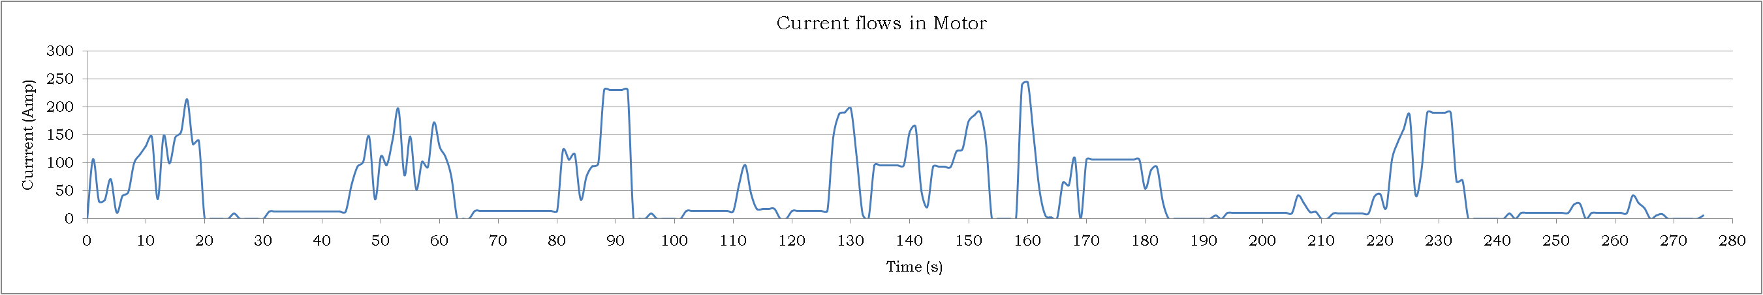
Graph 2: Motor Current

  - Engine/Generator
Generators generate the electricity to run motor as well as charge the battery. For this track duty cycle, buggy required 2.1kW average positive power. That means to achieve this power, its need slightly more than 2.1kW generator which can generate this power. So, here 4kW DC generator is chosen to generate electricity. The reason behind chooses 4kW instead of 2.2kW is power loss during generator working. If consider generator efficiency is 60%, then 4kW generator produce $4×0.6=2.4kW$ that fulfill the requirement.
But it is needed to engage reduce gear to decrease RPM. Generally, 4kW DC generators working on 3000 RPM-3500RPM. And engine optimum working region is 5500 RPM and 14Nm as per BSFC data. Well, this is not accurate because of lack of original data. So, to run the generator at 3500 RPM,
$$Reduction Gear Ratio=\frac{5500}{3500}=1.5714$$
Engine torque is 14Nm. So, after reduction gear generator gain torque
$$T_{G}=1.5714×14Nm=22Nm$$
Which is sufficient for 48V 4kW generator to generate 2.1kW.

  - Battery
For this course, additional maximum power from battery required to accelerate the vehicle is 14.2510 kW after consideration of all the components efficiencies. Here, the chosen battery is 12.8V with nominal capacity of 216Ah. I used 4 batteries to achieve 48V in series connection (below example) which is recommended by manufacturer. The specification of battery is given in table 1 below.
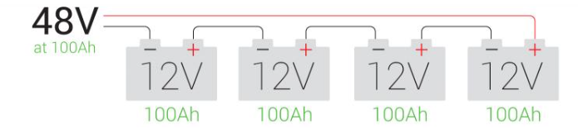
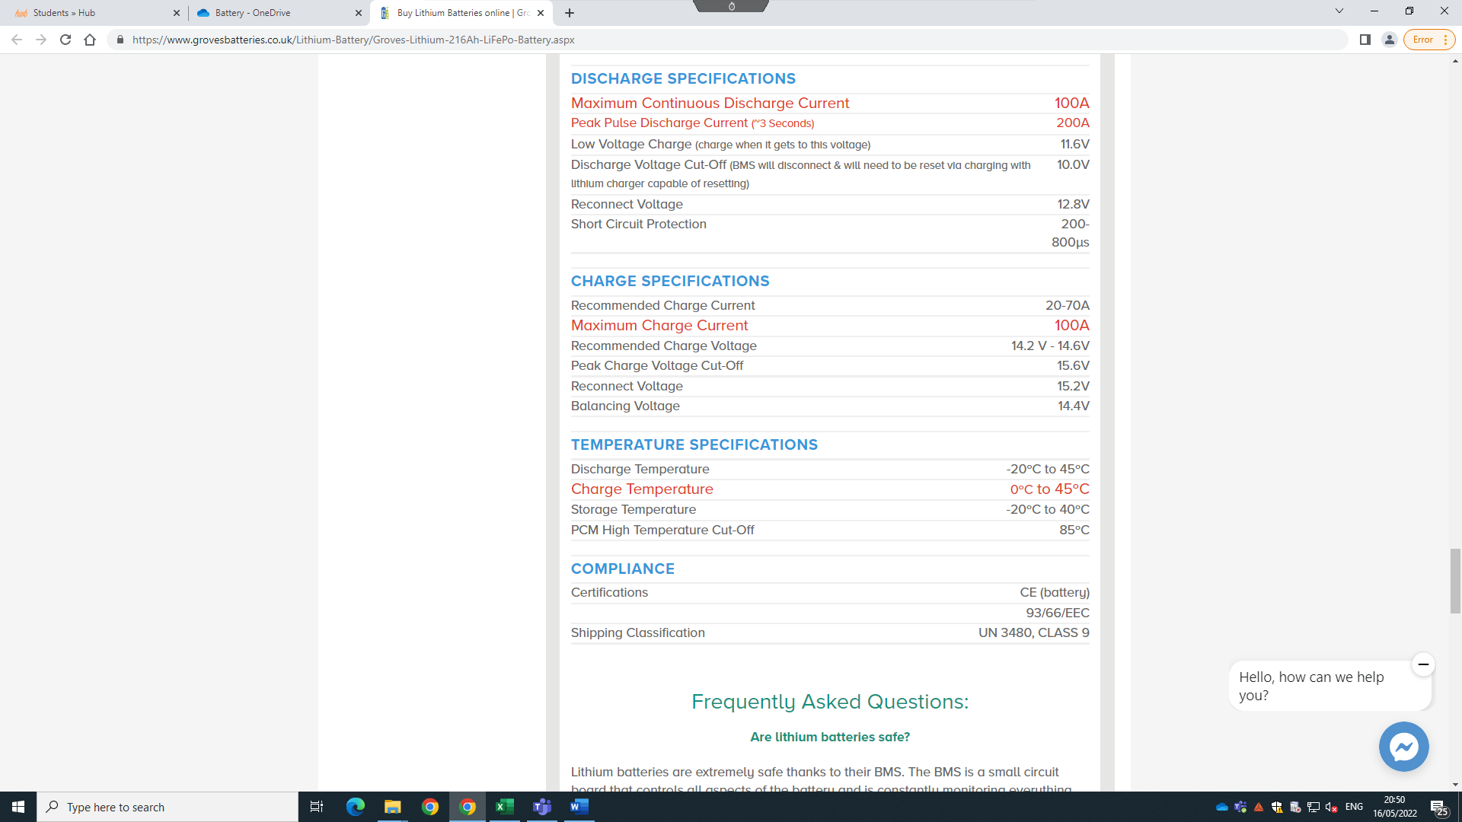

Table 1: Battery specifications
Graph 3 shows the charging and discharging current of the battery during duty cycle. As shown in the graph, the maximum discharging current that battery supplied is 200Amps. And in the specification, the maximum discharging current that battery can withstand is also 200Apms. Time for maximum discharge current that allows by the battery is less than 3 secs and, in this duty, cycle the maximum current required for just 1 sec, so ultimately it is safe to drawn maximum current.
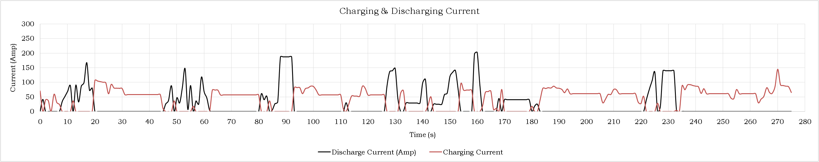
Graph 3: Charging & Discharging Current of Battery
While, in charging the maximum allowable current is also 100Apms by manufacturer and for this course battery gain maximum144.5442Apms for time of 1 sec. In this situation DC/DC step down converter increase the voltage at charging recommended voltage which is 14.2V to 14.6V and supply 100Apms to the battery. So, this series connection of 4 batteries can be used in this course.
But initially, it is considered that battery is 50% charged. And the efficiency of the battery is 98%. After all this consideration the battery state of charge (SOC) graph is shown in graph 4.
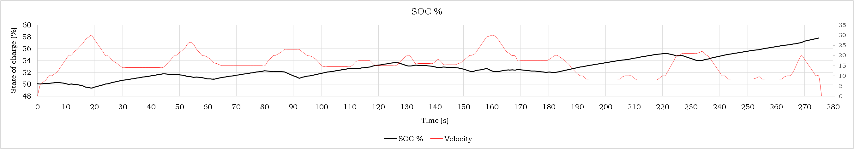
Graph 4: State of Charge (SOC)
SOC graph shows that after completion of one lap, the battery will charge by 7.8%.

  - Regenerative Braking
Regenerative braking can produce power during deceleration or braking if vehicle by converting kinetic energy into electrical energy. If the efficiency of regenerative braking is 60%, then current generate during one lap of duty cycle is shown in Graph 5.
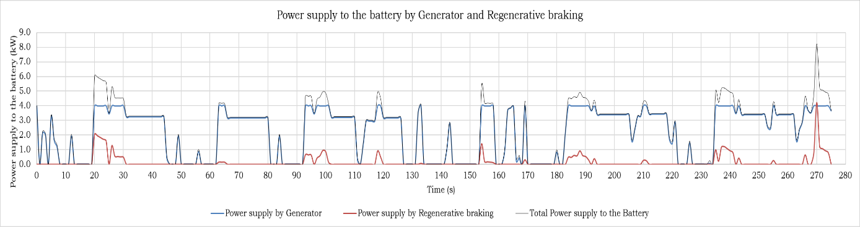
Graph 5: Current generated by Regenerative braking

- Summery
Total mass of buggy in increase by 135 kg due to all components.
Results of the series hybrid is shown in below tables. Using series hybrid, 0.04384 lit fuel can be saved. From simulation, I know in one lap battery will charged by 7.8%. So, in 12.82 lap (12.82*1.97=25.2564 km), battery will be fully charged.
Energy required in one lap is 0.17167 kWh. And fully charged battery can stored 10.368 kWh. So, by fully charged battery without used of engine power (engine off) can be travelled 106.3758 km. So, in one cycle we can travelled 25.2564+106.3758=131 km.
If assume that Battey life is 3500 cycles (however manufacturer says 5000 cycles). During life of battery, we can travel 460,712 km (mathematically).
Total fuel can be saved during life of battery 10252 lits.

Engine running power (kW) | 2.5
Total engine power in one lap (kW) | 690
Energy of engine in 1 lap (kWh) | 0.191666667
Total fuel consumption in 1 lap (g) | 56.96333333
Total fuel mass saving in one lap (g) | 32.79346667
Fuel saving in 1 lap (lit) | 0.043841533
Fuel saving during life if battery (lit) | 10252.97188

Energy of full charge battery (kWh) | 10.368
Energy required for 1 lap (kWh) | 0.192007557
Number of laps travelled by full battery | 53.99787461
Distance travelled by full charged battery (km) | 106.375813
Distance needed for 1 cycle of charging-discharging (km) | 131.6322232
Total distance can be travelled during life of battery (km) | 460712.7813

Battery charged in 1 lap (%) | 7.8
Lap to fully charge (number of lap) | 12.820513
Distance travelled for fully charged (km) | 25.25641
Life of battery (cycle) | 3500

Costing | £
Battery | 5600
Traction Motor | 550
Generator | 550
Controller | 500
DC/DC converter | 250
Regenerative Braking | 200
Total costing | 7650
Total saving by fuel | 15379.458
Gross saving | 7729.4578

If we consider today market price, total cost of this components is 7650£. On the other hand, we can save 15380 £ from fuel.
So, ultimately gross saving is 7700 £ something. Plus, we can reduce emission and save environment.

- References
- Mehrdad Ehsani, Yimin Gao, Ali Emadi 2010, Modern electric, hybrid electric and fuel cell vehicle, second edition.
- www.electricmotorsport.com

