Component 1

Cory Linton-Ottey
Student ID: 2540367

Course:
Cert HE Computing Skills for the Workplace
02/06/26

Table of Contents
Component 1 1
E-Portfolio 3
Task 1: Written Summary 4
Mind Map & Academic Poster 5
Task 3: Auto Referencing Tool 6
Task 4: E-Portfolio Creation & Review 7

E-Portfolio

link to e-portfolio: https://uwtsd2540367clo.my.canva.site/
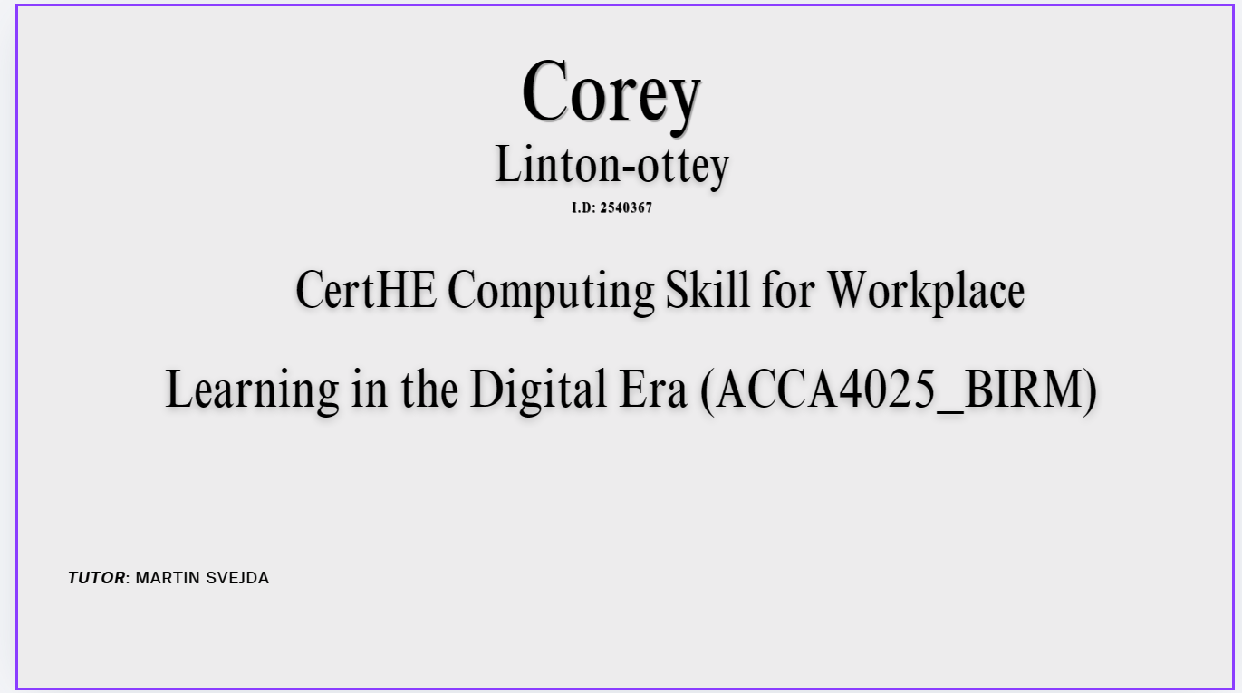
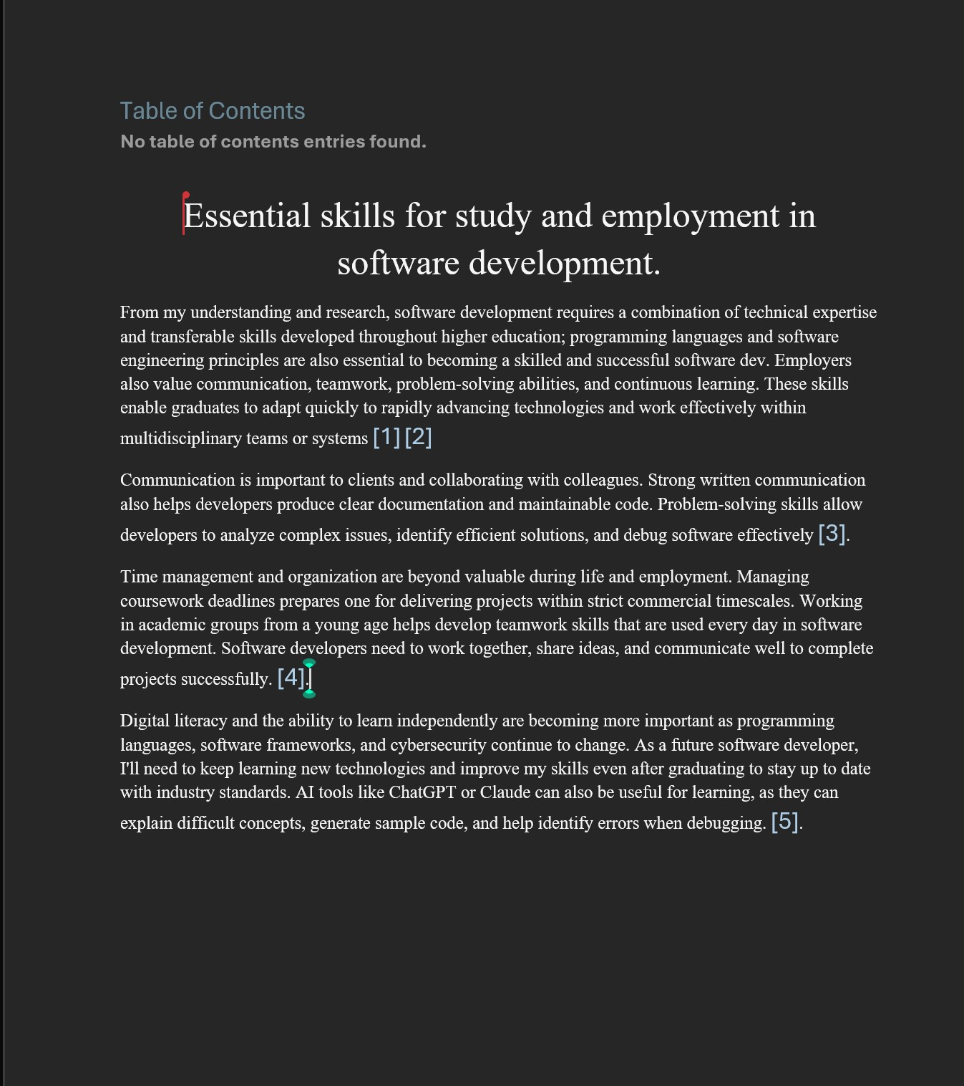

Task 1: Written Summary
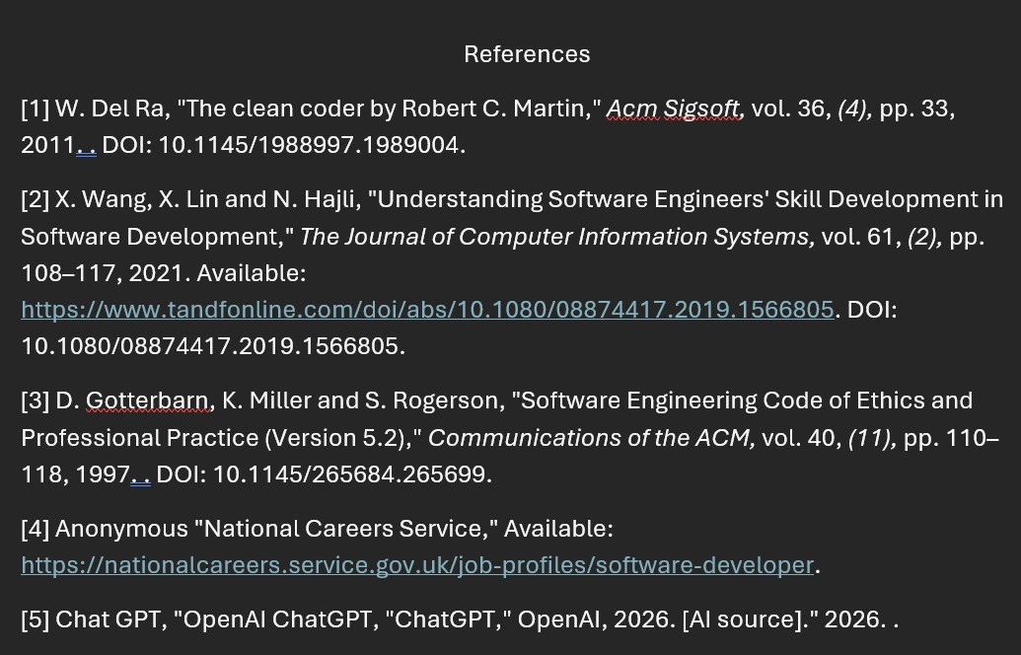

Mind Map & Academic Poster

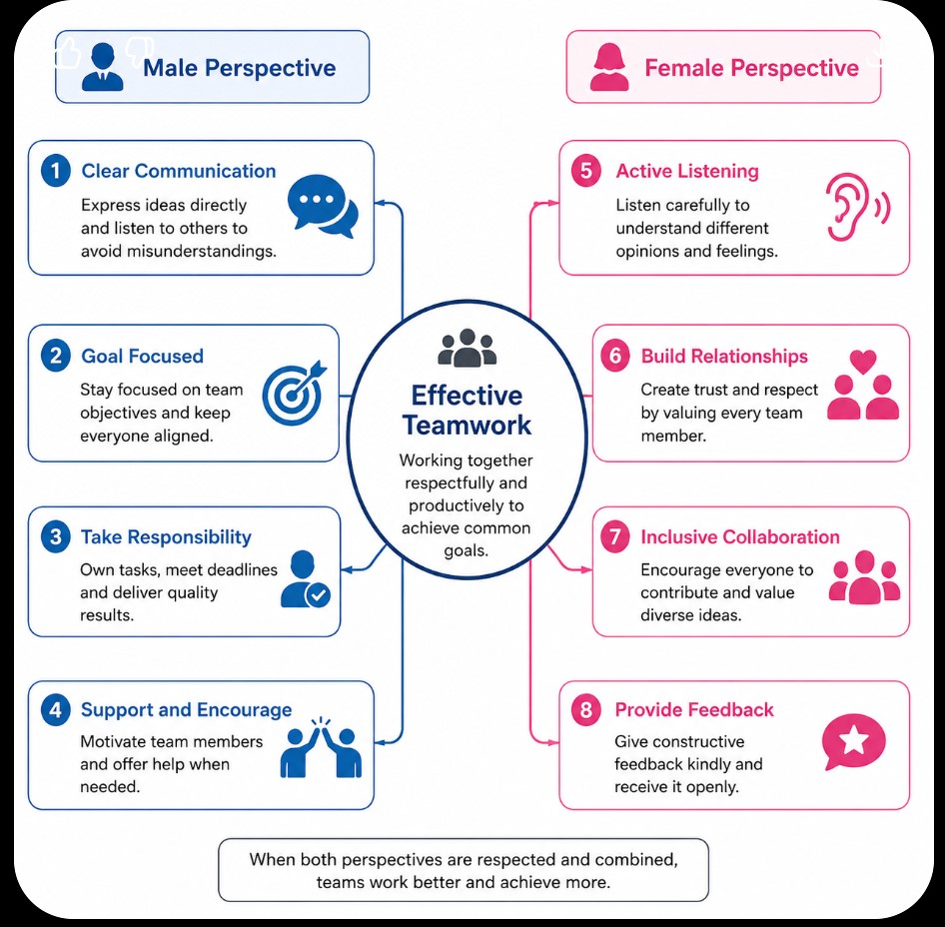
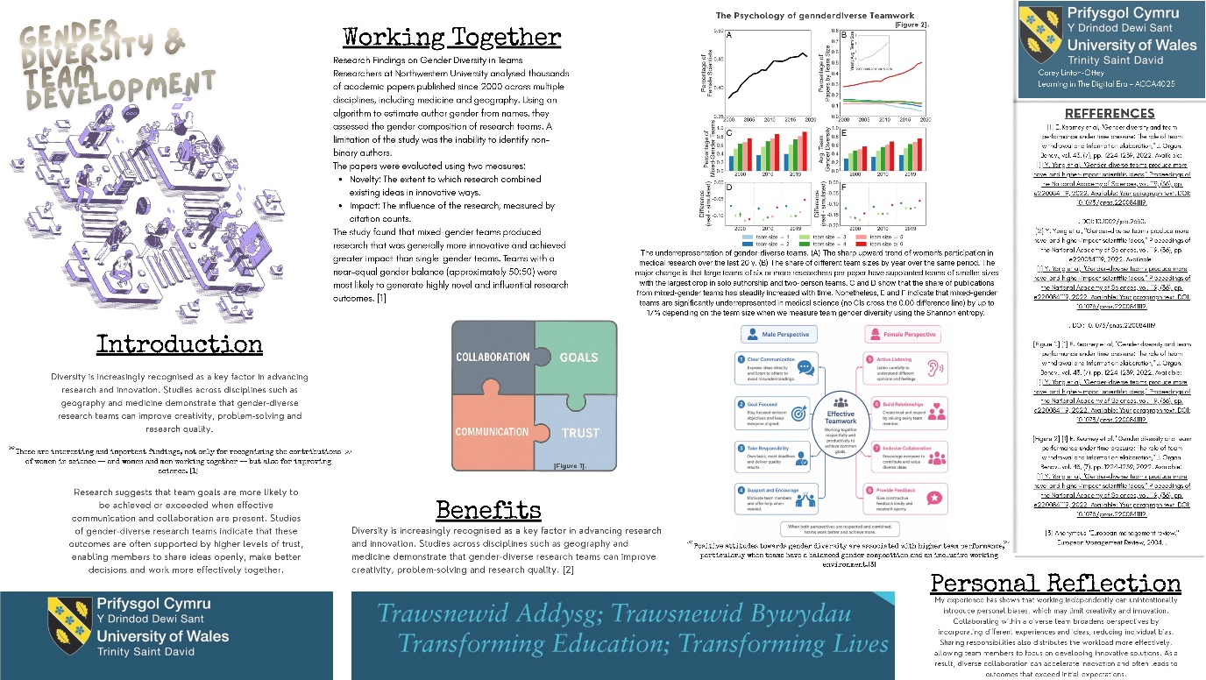
Figure 1. A mind-map showing the benefits of diverse teamwork
Figure 2. An academic poster displaying information on the benefits of diverse teamwork
Link to academic poster: https://uwtsd2540367clo.my.canva.site/academic-poster

Task 3: Auto Referencing Tool

Figure 3. A screen shot of RefWorks to show how I Cite my work.
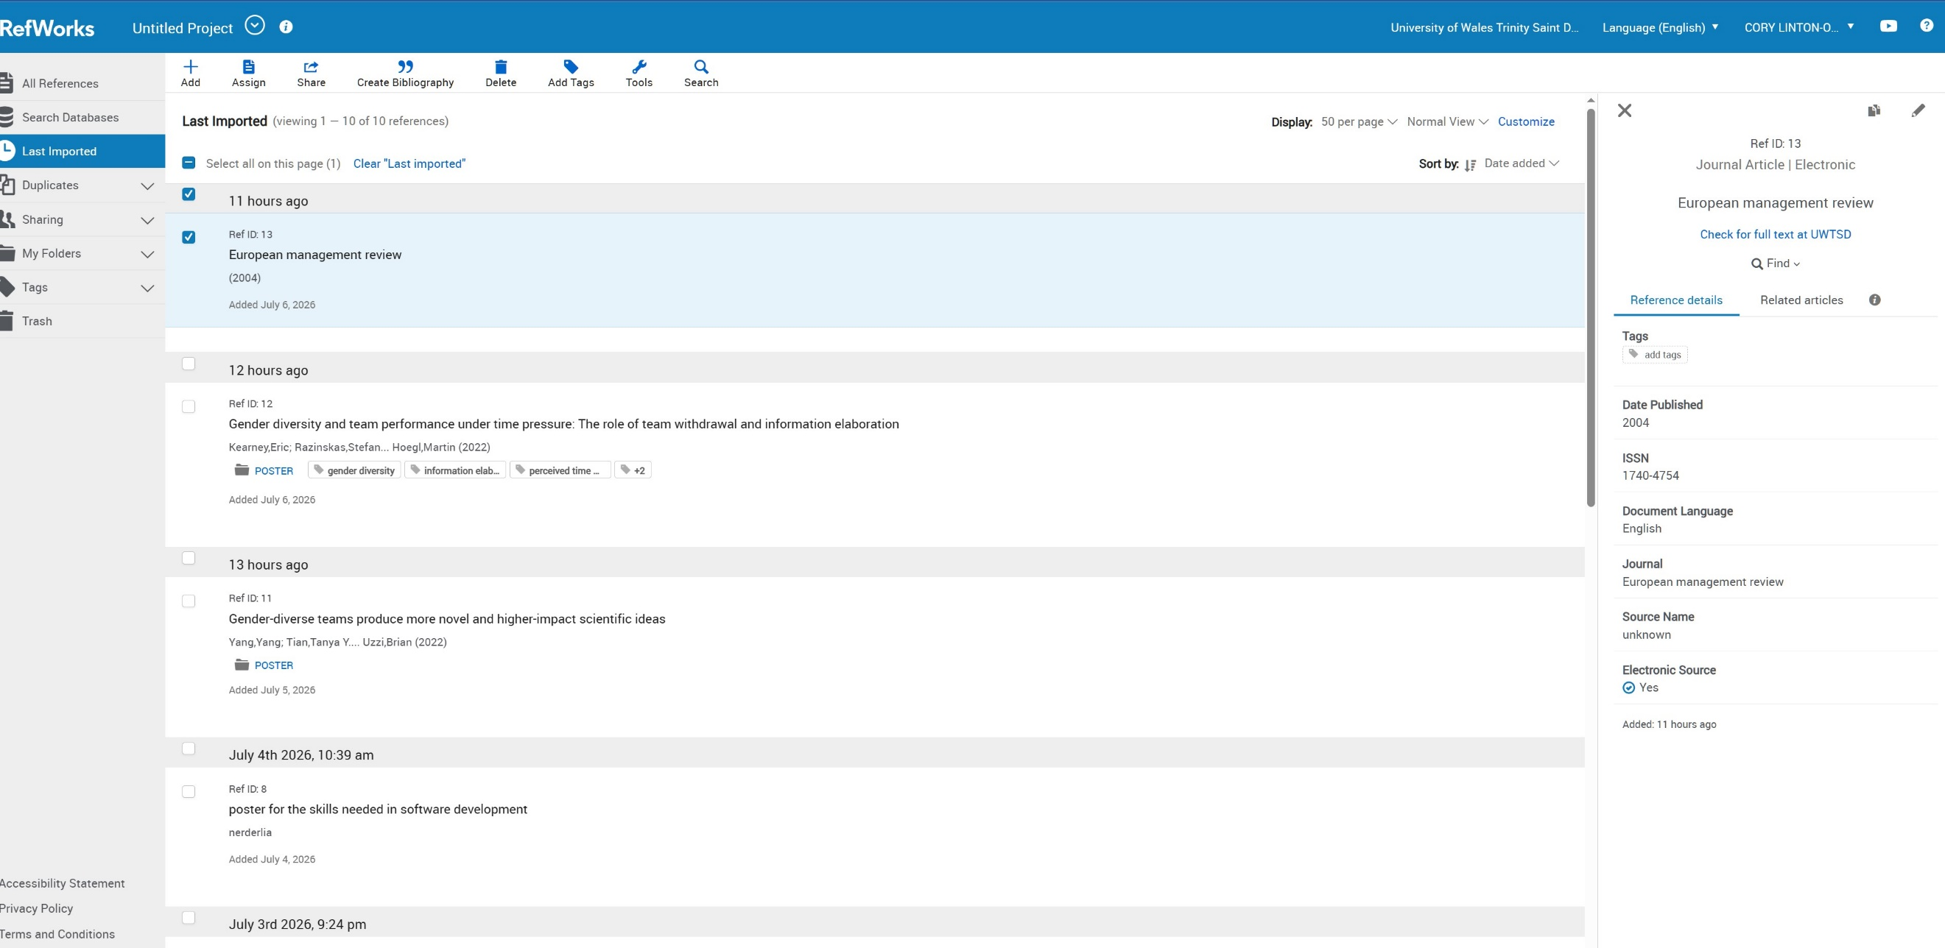

Task 4: E-Portfolio Creation & Review

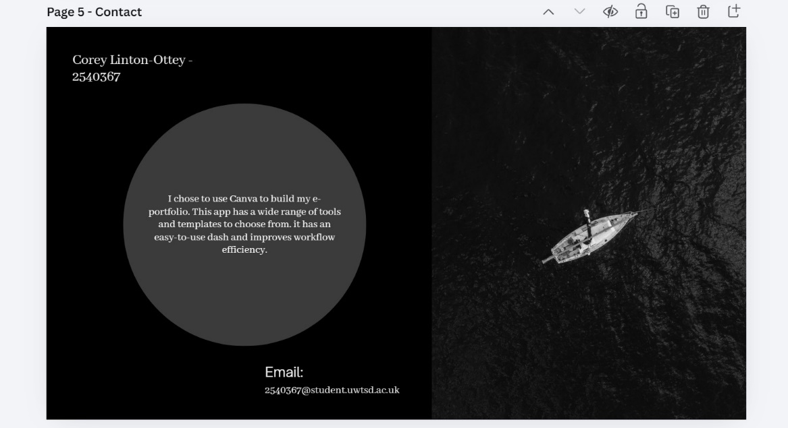
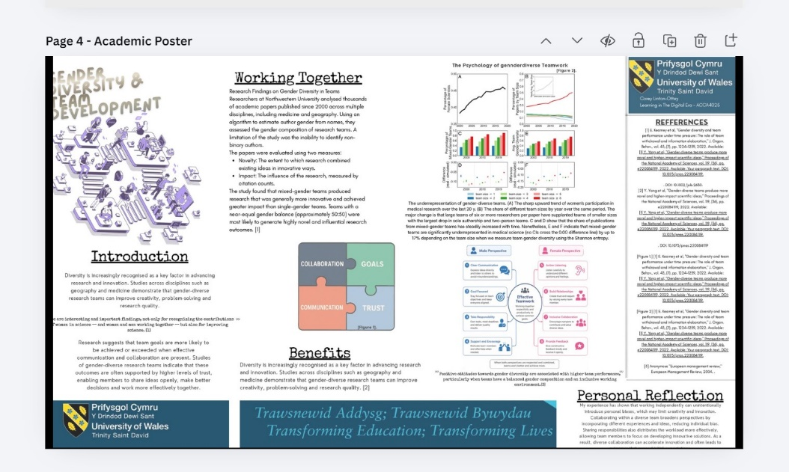
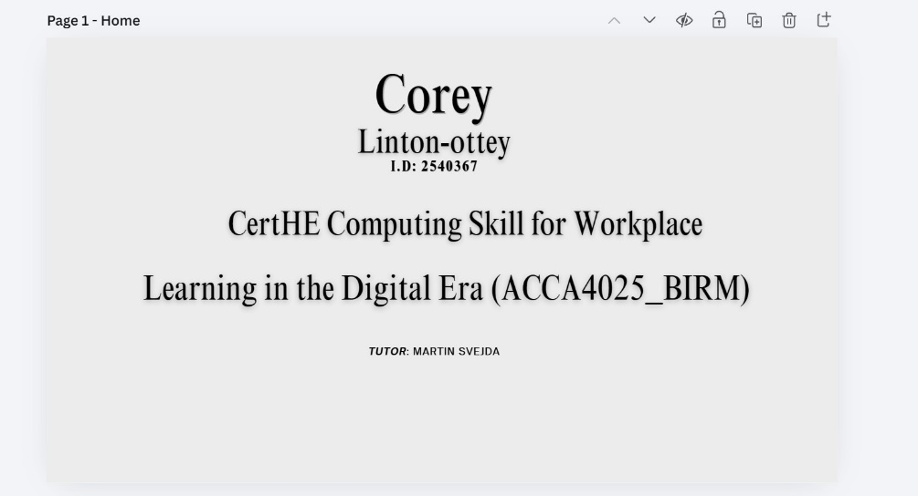
link to e-portfolio: https://uwtsd2540367clo.my.canva.site/
Figure 4. These are screen shots from my E-portfolio.

