

1810381
PENE
MODOU
DEVELOPMENT
UNIVERSITY
OF WALES
TRINITY SAINT
DAVID
PLAN
DEVELOPMENT
PLAN
PERSONAL
PERSONAL

SUMMARY

- INTRODUCTION………………………………………………………………………………
1.PERSONAL OVERVIEUW……………………………………………………………..
- SKILL EVALUATION………………………………………………………………
- ACTION PLAN………………………………………………………………………
- DATA PROTECTION……………………………………………………………….
- TIME MANAGEMENT …………………………………………………………….
- CONCLUSION………………………………………………………………………
REFERENCES………………………………………………………………………………
VII.APPENDICES………………………………………………………………………….
PDP PRESENTATION…………………………………………………………………….

I.INTRODUCTION

1.PERSONAL OVERVIEW

My name is Modou Pene, I come from Italy, but I also lived in France for a short period of time. Currently, I moved to London after finishing my diploma di maturità. Here, I live with my uncle while my parents are back in Italy. I am one that is very passionate about the English language for which I moved here, in fact, one of my dreams is to obtain a UK degree. Therefore, enhancing my personal and professional skill. About myself, I can say to be an open-minded, trustworthy, loyal, and hardworking individual. In addition, I would like to say that I am the kind of person who does further researches compared to what others do.

As already, I have been attending half of the high school period in France, where I stayed until the third year of school. Lately, when I was 15, I moved to Italy for finishing the diploma. In Italy is where I finally gained my diploma di maturità certificate. Among my favourite subject, there were computing, math and philosophy. Additionally, I developed a strong passion for reading books and spread my knowledge. However, my main interest is to learn more and more about the computing system and whatever is related to it. I do not have relevant work experiences, but I have always been studying even due to my young age. Moreover, I had the possibility to undertake some project experiences through my previous school.

As mentioned, I did not have any job experiences previously, but I do have clear ideas about where I want to be in the future. Since, my purpose is to be working within a position within position related to cybersecurity, which represent my second biggest passion. The opportunity of studying the cloud computing degree will permit to increase my possibilities to work in this field, therefore understanding more about this subject.

Since I finished my diploma di maturità my goal was to come to England to start university. This is why I decided to apply for University of Wales Trinity Saint David London, in order to realise my life goals and having the chance to study more about computing and this last could provide me with the skills which are required by the employers. Moreover, fulfilling my interest and my passion to develop more knowledge about the world of programming

That I have always been passionate about and in the world of programming there are various types of programmers, but the most fundamental ones are that of BACK-END and FRONT-END and I am trying to do both, and it is part of one of my fundamental goals.

In this personal overview, it is one of my personal vision through how I would like my future and also the right path to take to reach my goals. Thanks to the course in the class of the Academic skills and employability module of the Cloud Computing course.

2.SCREENGRABS POWERPOINT

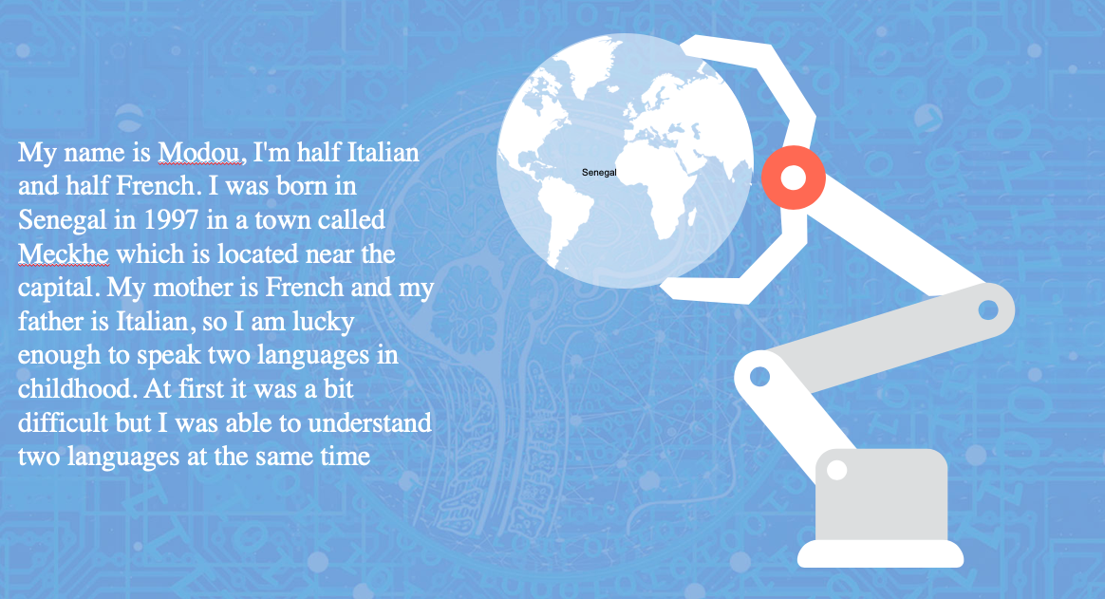

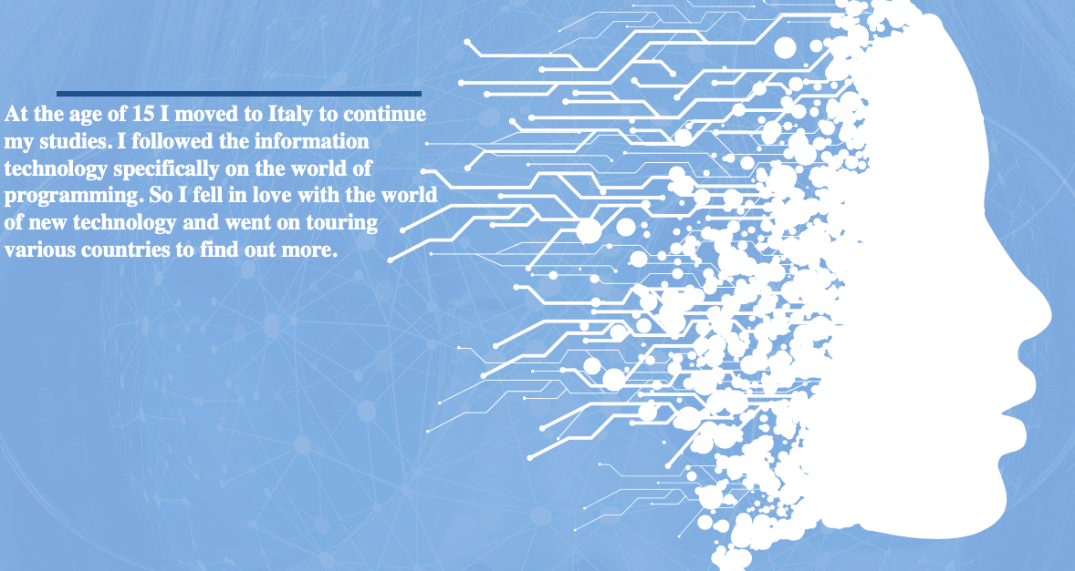
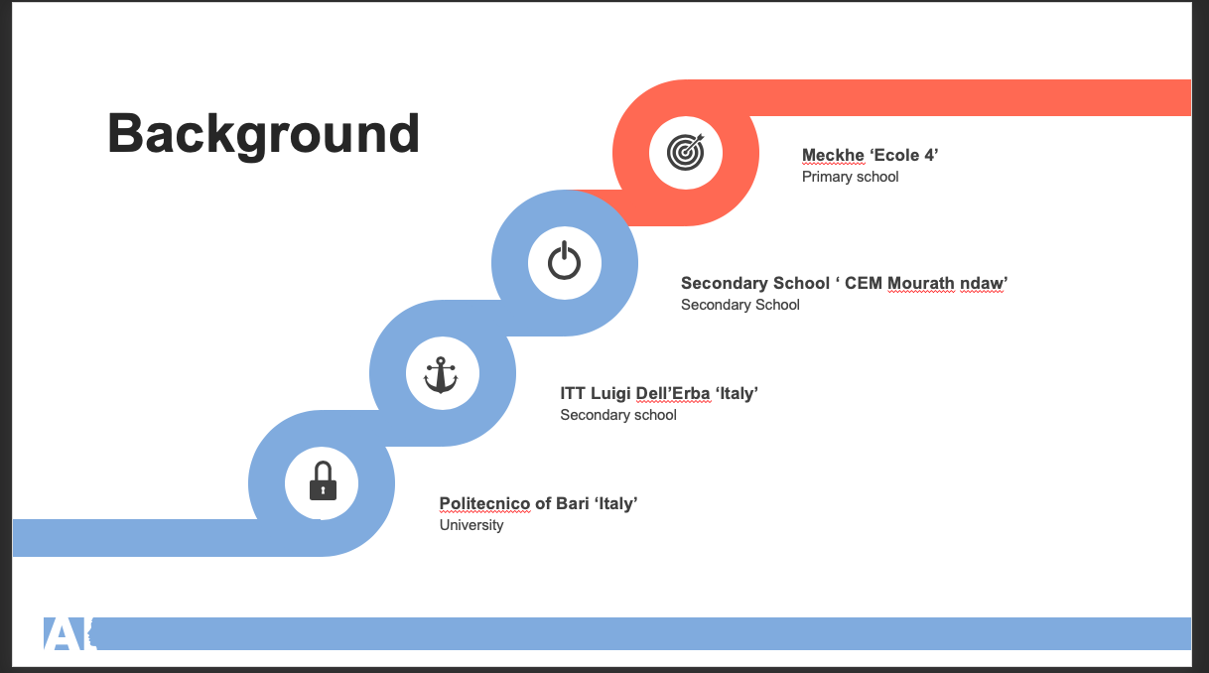

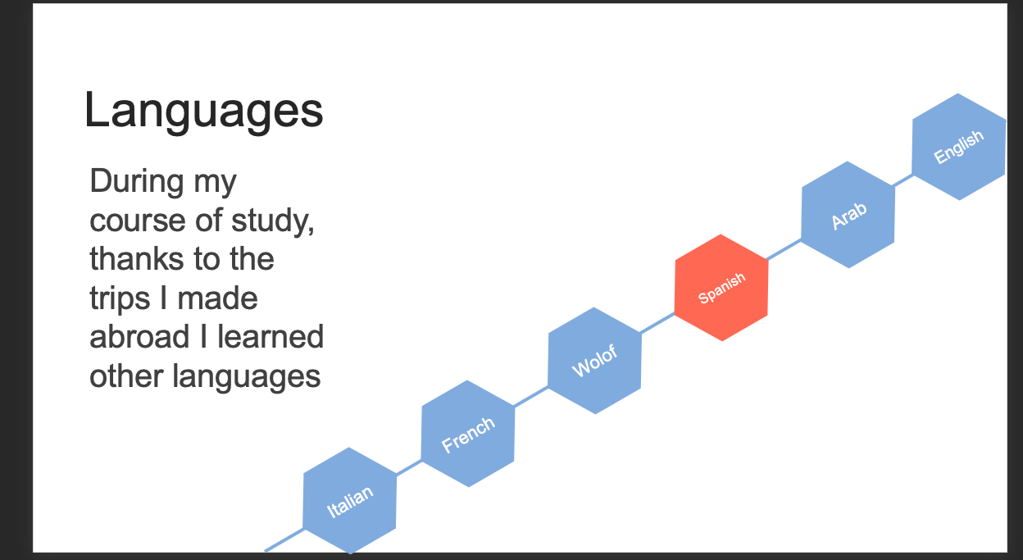

KEY POINT FOR SUCCESSFUL POWERPOINT

During the production and delivery for the success of a PowerPoint it is always necessary to take into consideration the various methods and how the context to be presented should be.
List of key points for success:

- Focus on simplicity of content
the slides must be simple. They must be clean, linear, effective. We don't need to fill a slide with endless texts, with all the news we want to convey

- Write the slides well
Writing is one of the codes to use in slides. People read what you write, so we need to concentrate all your web writer skills in creating useful slide texts because when the writing is small, they will have difficulty reading it

- Creativity
Ability to analyse and combine existing information in order to generate new ones. Ability to imagine and propose original ideas that are different from those already in use, from which to obtain non-conventional application elements.

- Use appropriate charts
Always ask: "How many details do I need?" Presenters are usually guilty of including too much data in their graphs on the screen. There are several ways to display t data in graphical form

II. SKILLS EVALUATION

Today's societies put individuals, who are confronted with the complexity in many moments of their lives, in the face of challenging demands. Defining these skills can improve the assessment of how well prepared we are for life's challenges, as well as helping to identify the main objectives of systems and lifelong learning.
A skill is something more than just knowledge or ability. Involves the capacity to
respond to complex requests by relying on and mobilizing psychosocial resources (including skills and attitudes) in a particular context. For example, the ability to communicate effectively is
a skill that can be based on an individual's knowledge of the language, on practical skills
in computer science and on the ability to think on the matter with the person in whom you are communicating.

SKILL HE LEARNING
- Adaptive thinking
In the digital age, things are turning exponentially. When employees learn the new software or program, a better version is coming. Future employers will have to continually adapt to changing conditions and be able to learn new things quickly and efficiently. We need to know how to learn

- Communication skills
there is still an emphasis on the ability to communicate. In the digital age, however, we have access to a wide range of new ways of communicating from video conferencing to social media, so we need to be able to communicate with people within their team, as well as people outside the team and organization.

- Creativity and innovation
This ability is often mentioned. I believe it correlates with the ability to ask good questions and the ability to solve problems. In the world of work, they will seek more and more employees for creative and innovative solutions to existing problems.

SKILL EMPLOYABILITY
- PROBLEM-SOLVING
Ability to identify and understand the essential aspects of the problems in order to be able to define their priorities, evaluate the significant facts, develop possible solutions using both experience and creativity, in order to arrive at an effective solution in good time. identifies the problem and places it within a specific frame of reference; it is also able to identify the most effective solution, correctly defining the priorities for action and structuring the actions to be taken.

- TIME MANAGEMENT
Ability to use time efficiently and effectively, identifying priorities in terms of importance and urgency. Ability to establish work times in line with the objectives to be achieved and with the resources available. Assign yourself and your collaborators (if required by the role) in an effective and efficient way the work times based on priorities and objectives to be achieved. Can develop a long-term action plan, respecting deadlines.

- TEAMWORK
Ability to collaborate and cooperate to achieve common goals. Knowing how to recognize and value the resources of others within the group. Ability to adapt in a functional way to the needs of the group, actively participating and attuning to the group. Collaborate with the group, sharing information and resources, and promoting a harmonious and cooperative climate. It is able to actively involve all members of the group to achieve common goals. It knows how to adapt to the needs of the context, modulating its contribution effectively.

SELF-EVALUATION

During the evaluation I made on the MIND TOOLS software, responding to 15 days gives people the chance to better their own skills.

Total of my test 55

Leadership and Management
(Questions 5, 7, 12)
Your score is 11 out of 15
Whether you're in a formal leadership position or not, you need good leadership and management skills if you're going to make the best use of the opportunities open to you. (After all, you can get much, much more done when you have the help of other people.) The good news is that you can learn how to lead and manage effectively!

Problem Solving and Decision Making
(Questions 2, 10, 14)
Your score is 11 out of 15
Problem-solving and decision making are two areas where you'll need to excel to be a success in your career. (Together with people skills, they're what makes up "good judgment" and "wisdom.") Like leadership and management, these two areas are closely related.

Communication Skills

(Questions 9, 11, 13)
Your score is 10 out of 15
The ability to communicate clearly is key to your success, whatever role you're in.

Time Management
(Questions 1, 4, 6, 15)
Your score is 17 out of 20
Time management is one of the most important career skills areas. Not only does it help you to be more productive; you'll also be much less stressed!

Personal Mastery
(Questions 3, 8)
Your score is 6 out of 10
When you know how to "lead yourself" and make good choices for your future, you'll be that much further ahead when it comes to the other skills areas that we've already looked at.

III.ACTION PLAN

 | LONG-TERM |  | SHORT-TERM
GOAL | - A career in Web developer  - Developing software for the security  - Cybersecurity agency |  | - Making trading online  - Marathon dev-hack  - Cloud computing
Skill and knowledge to be learned | Technical  Internet Protocol  Software development  E-Learning machine | Personal  Creativity  Leadership  Teamwork  Communication | Technical  Knowledge software  Math  Web design | Personal  Math skill  Presentation skill  Architecture machine skill

For the goals that I wrote in the table, I still need to increase my technical and even personal skills as shown in part II of the self-evaluation. Both for the technical skills and the goals I would like to achieve, it is the fact that I enrolled at the university to acquire the knowledge that will allow me to achieve my goals. I am also taking online courses on the security of our data. Everything will allow me to be able to master
I also have other action plans, I also have a study plan that allows me to remember all the information I want thanks to some techniques called "how to make the mind work".
During the course I always try to gather the most important information so once done, returning home I do not rely only on the information gathered at the university I am going to look for other information that is related to what is done. So let me implement my knowledge about the course. Once the course is over to be able to remember all that is said, I use these methods

-Read and repeat.
-Evidentiality
-Summaries.
-Mega general flouring.
-Absence of precise and scientific phases.
from the evaluation, you can see that I got a somewhat low result from the fact that I have a malady that does not allow me to get ahead of a crowd for which I have a low grade on Communication Skills.

- Communication skills
One of the best skills based on the result of the self-assessment test when I talk to others I explain very fast even knowing what I'm saying. This fear of being breathless in front of a crowd makes me forget everything I have to talk about, even if I want to work in the field of software marking I need to make a presentation so I'm trying to take steps and be able to master it

- Personal Mastery
Personal mastery "means facing one's life as a creative work, living life from a creative point of view as opposed to a reactive point of view"

In personal mastery, we find therefore the proactivity, the creativity, the awareness of oneself (who we are = identity and where we want to arrive = vision), but also that intuition attributable to the full access and use of the two cerebral hemispheres and, not least, the spirituality.

A little less evident, between the lines, those who speak of personal mastery also speak of quality of life, stress management, listening, empathy, respect for themselves, for other individuals and for the environment, speak of responsibility, or lack of judgment ... of profound knowledge of oneself, of wisdom, of patience, tolerance, temperance and compassion.

IV. DATA PROTECTION

Today Our digital data is travelling from all over the world and is everywhere for which data is vulnerable to threats from the outside. Our data is fundamental to a part of us or those of an organization. But even our data could encounter natural threats, so the only method we can do is to back up so as not to lose our data.
Backup is an activity of prevention and protection of your data. Equipping yourself with backup means having a copy of your data and then being able to recover it in the event of problems in the computer system. Our data are in fact unrepeatable, once lost they can cause enormous damage to a company, small or large. To avoid being in this situation, prevention becomes essential, to date the only way to safeguard your data.
First, when setting up a backup strategy, it is necessary to evaluate which data it
needs to back up and how often. The data can be of two types: static and dynamic.
Static data is data that does not change or rarely changes. Static data are the operating system, programs, virtual machines, data that can be "reconstructed".
Dynamic data, on the other hand, is data that varies continuously and that, if lost, cannot be reconstructed.
For static data, which does not vary, the need for backup is a less pressing procedure than that for dynamic data. For static data, it is sufficient to make a backup of the media, keeping the copy in a different place from the office.
For dynamic data, on the other hand, you need to back up whenever the data changes.
If the data changes daily, it is not appropriate to have a weekly backup, but the backup should be daily. In this way, if there is a problem in the computer system, with consequent loss of data, it will be possible to restore all the work, losing the maximum of one day.
Depending on the type of risk to be protected and the type of recovery to be adopted, it is useful to have certain backup locations.
You can opt for media relocation or choose Cloud Computing solutions for storing backups.
The data we store (especially those away from the office) must not be readable by unauthorized persons. As a result, backups must be performed with systems that encrypt the content by linking it to a password.
There are two types of addict strategies
Online backup: a backup is performed while data is still accessible to users.
Backup offline: a backup is performed on data that is not accessible to users
Accidents that can result in data loss
Data loss can be due to different issues:
• Human errors.
• Computer viruses (for example the famous CryptoLocker).
• Hardware or operating system failures.
• Theft of computer equipment.
• Accidental external events (electrical phenomena, incidents, atmospheric events and natural catastrophes).
These problems can be accidental or voluntary, but the fact remains that in the presence of these, the only way to recover their data is determined by being in possession of backups.
V.TIME MANAGEMENT
Good time management is the basis of my personal and professional success. Being the boss of your own time or, to put it differently, being a good time manager is fundamental to increase efficiency and productivity. Clearly, time management in work involves a series of activities, which represent the pillars of this discipline. We refer to a real cognitive process, which includes:
Effective planning
Definition of SMART objectives
Setting deadlines
Management powers
Time allocation based on priorities
Analysis and monitoring.
By acquiring solid principles of time management, I will be able to "dominate the flow" and be fully responsible for the scarcest resource on the planet.
Someone said that "time and tide wait for no one". Well, there is nothing truer: in its most philosophical sense, time is seen as a flow, as something that flows inexorably. This does not mean that it cannot be controlled and managed effectively, learning to work by objectives and to follow processes. There are dozens of resources and exercises on time management, from the now very famous tomato technique to the most advanced matrices. However, to understand the principles, it is necessary to understand why it is so important to manage time and what are the benefits that you could access. Speaking of time management in work, but also in private life, is essential because:
You can achieve more by striving for less: controlling time allows you to increase your concentration threshold, increasing your work efficiency;
Time is the most scarce resource there is: whether you like it or not, a day is made of 24 hours. There is nothing that can make you increase (or decrease) this range.
Improve your decision-making skills: When you feel stressed over time and need to make an important decision, you will be inclined to jump to conclusions without completely considering each option. This almost always leads to wrong decisions;
Increase your free time: everyone needs time to relax and dedicate themselves to their passions. Unfortunately, however, many of us never get enough. Time management helps you take responsibility and find time for you.
Learn to give yourself goals and ask yourself every time whether they are specific, measurable, achievable, realistic and temporary goals. If your goals are SMART, enter them in a list. Working with lists is the best solution to optimize your time, whether it is daily or on an annual basis. According to Brian Tracy, one of the leading experts in time management, the list system will increase your efficiency by 25% from day one .This translates, in practical terms, into two more hours of productive time in an eight-hour day, which you can get by simply making a list. Even at the level of stress it could be influenced because very often when we do not have enough time it is more likely to be stressed

VI. CONCLUSION
One of the longest and also difficult aspects is that of the individual. we need a lot of time and work to be able to create a professional plan that also requires patience. Thanks to these analyses, I am aware of and can distinguish my weaknesses and also those of total success

References
Mind Tools LTD. (2015). Retrieved January 2019, from www.mindtools.com: https://www.mindtools.com/pages/article/newTMC_5W.htm
Chuang, A. A.-T. (2017, May). Examining the Impacts of Demographic Factors on Communication and Job Outcomes. Conference in Business and Economics Volume.51(2), (pp. 183-202).

Aldinheacuk. 2019. Aldinheacuk. [Online]. [6 May 2019]. Available from: https://journal.aldinhe.ac.uk/index.php/jldhe/article/view/114

VII. APPENDICES
- Ransom.Cryptowall is a Trojan horse that encrypts files on the compromised computer. It then asks the user to pay to have the files decrypted. The threat typically arrives on the affected computer through spam emails, exploit kits hosted through malicious ads or compromised sites, or other malware.

2.PDP PRESENTATION


