Appendices
A - Observational notes
Take descriptive data on:
- Who is talking the most in pairs?
- Where the children are sitting in the class.
- What ability pairings are they? Same / mixed – what mix?
- Where is the teacher standing?
- How long is the teaching waiting in-between think and pair time?

____________________________________________________________________________________________________________________________________________________________________________________________________________________________________________________________________________________________________________________________________________________________________________________________________________________________________________________________________________________________________________________________________________________________________________________________________________________________________________________________________________________________________________________________________________________________________________________________________________________________________________________________________________________________________________________________________________________________________________________________________________________________________________________________________________________________________________________________________________________________________________________________________________________________________________________________________________________________________________________________________________________________________________________________________________________________________________________________________________________________________________________________________________________________________________________________________________________________________________________________________________________________________________________________________________________________________________________________________________________________________________________________________________________________________________________________________________________________________________________________________________________________________________________________________________________________________________________________________________________________________________________________________________________________________________________________________________________________________

B – Reflection


Description – what happened?
What happened? When did it happen? Where did it happen? Who were involved? What did you do yourself? What did other people do? What was the result of these actions?

Lesson 3 was in a year 1 class, straight after lunch break. The maths problem solving activity lasted approximately 25 minutes. The three pupils that were targeted had been identified as having low hands up participation. I led the lesson with Bethan and Emma observing.

Feelings?
What did you feel leading up to the event? What did you feel during the event? What did you feel after the event? How do you look back on the situation? What do you think other people felt during event? How do you think others feel about the event now?

- Felt like the pupils in the class enjoyed the activity and sharing with their partner
- They wanted to do more think, pair, share activities
- Majority of the class wanted to share their answers
- Children did not wait to think or pair, they just jumped into share

Evaluation
What went well during the event or activity? Why was that? What didn’t go so well?
Why was that? What was your contribution? What contribution did other people make?

- Thinking time was appropriate at ten seconds
- We timed the pair time using blooms taxonomy which was effective.
- Having the questions and timing on the board helped me keep to the structure

- The year 1 children found it more difficult to keep to the structure of think, pair, share and were just putting their hands straight up

Analysis – What have you learnt?
- The children enjoyed the think, pair, share strategies
- The strategy becomes less effective when you keep using it consecutively

Conclusion
To what positive experience did the event, situation or activity lead?
To what negative experience did the event, situation or activity lead?
What will you do differently if the event, situation or activity were to happen again in the future?
Which skills do you need to develop yourself in a similar event, situation or activity?

- Try and encourage more discussion during the pair phase as a lot of pupils would stop talking and put their hand up or talk about something else
- Pupils feedback still shows worry about them putting their hand up

Action Plan – Next steps.
- Further research is needed into levels of questioning and appropriate wait and pair time
- Partner allocation could be explored
- Measures of confidence need to be expanded
- Ways of interviewing foundation phase pupils needs improving

Additional Comments:

C - Lesson Plan

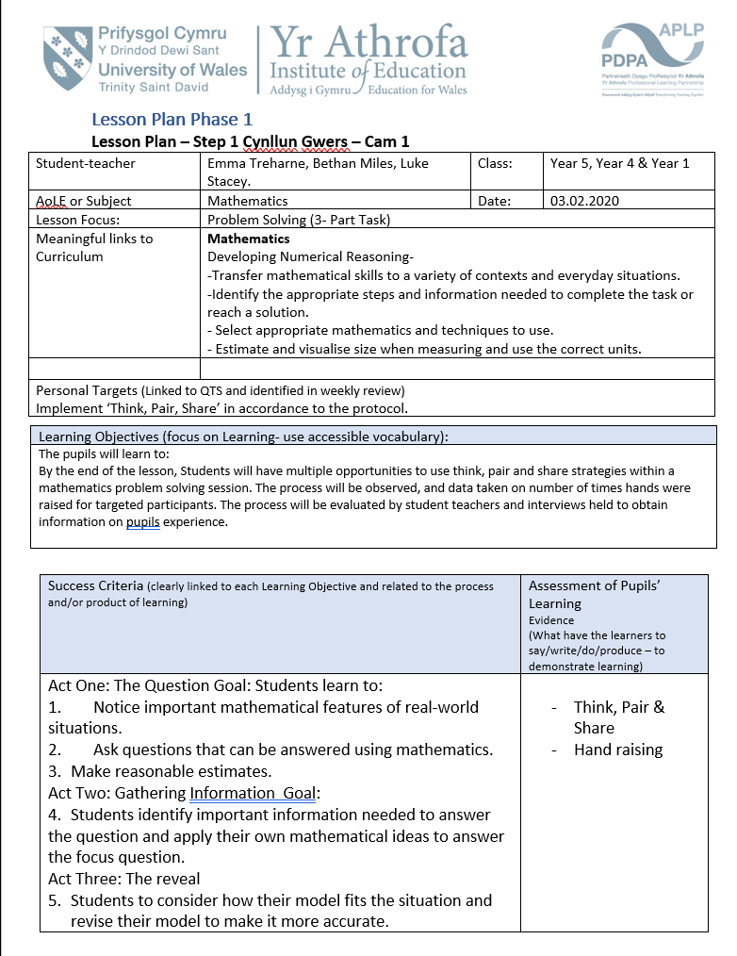
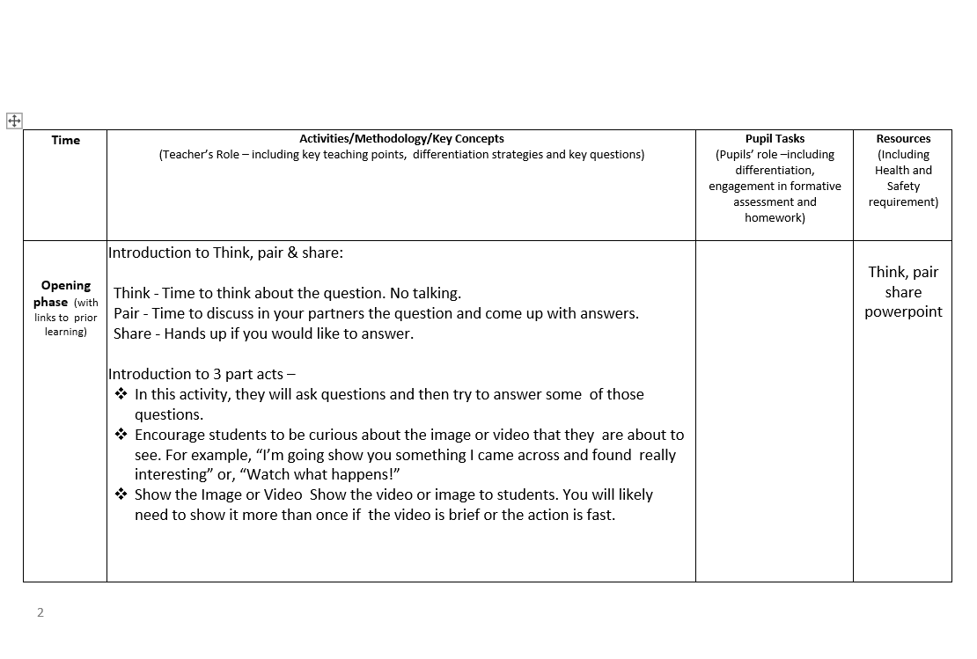
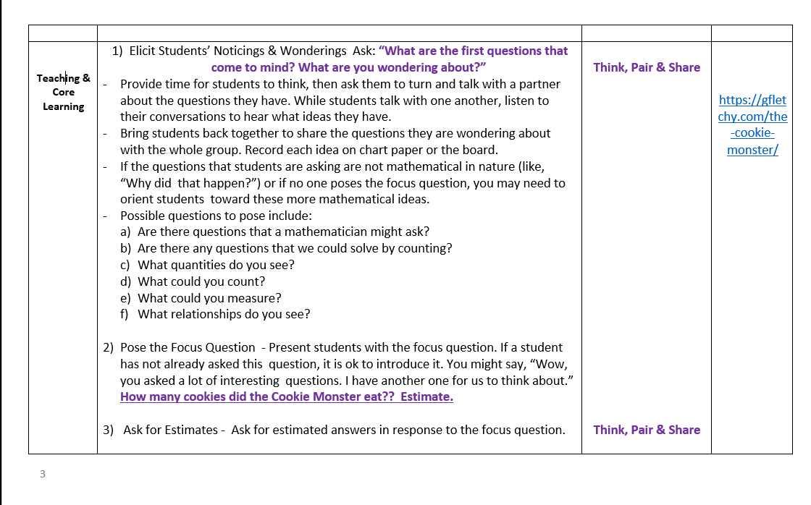

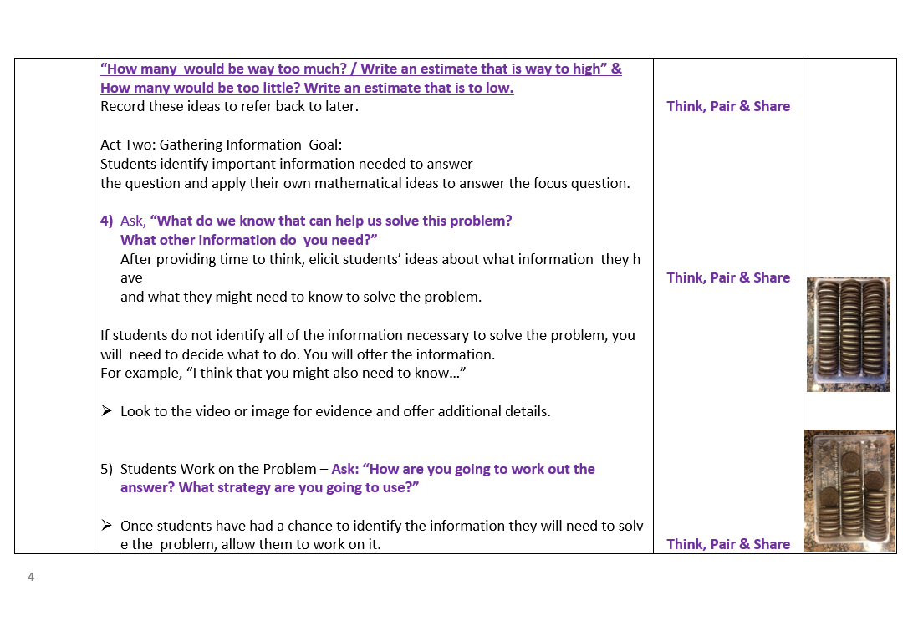
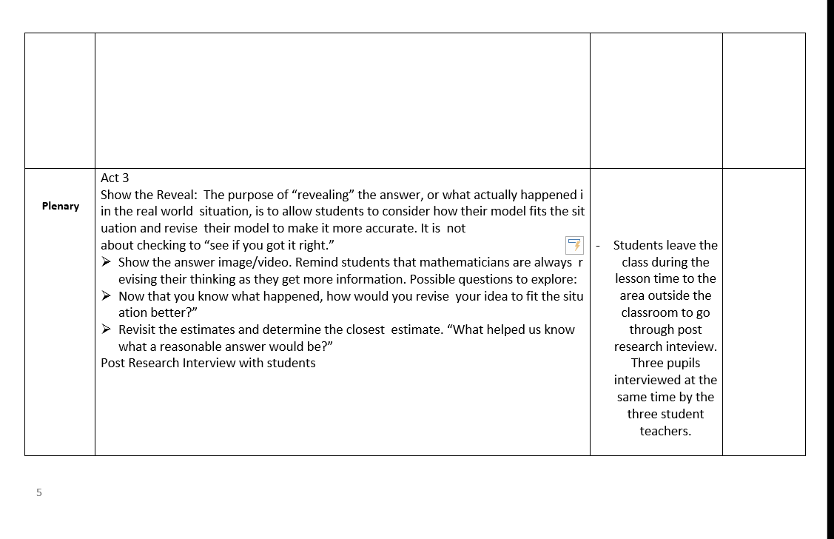
D - Lesson PowerPoint

Year 5


Year 4



Year 1

E – Interviews

Post Intervention Interview - Year 5

Q1. Did you enjoy talking to your partner about questions? Yes/ No.
Why/ Explain?
Child A- Yes.
Child B- Yes, I don’t like my partner. Max is a pain.
Child A- ___ is good at maths.
Child C- Yes.

Q2. Did you both have a turn to speak when talking in partner? If no, explain why?
Child B- No, ___ is a bit bossy.
Child C- Yes.
Child A- Yes.

Q3. Do you think having time to think before talking to your partner helps and why?
Child B- Yes, we need more time to think.
Child A- Yes, because you can think things through.

Q4. Do you think you put your hand up more when you have had time to think and discuss it with your partner? Explain.
Child A- Yes. Because I had more time to get things right, get more ideas.
Child B- No. Because I don’t like my partner.
Child C- Yes. Because I enjoyed problem solving.

Q5. Do you feel more comfortable answering questions when you have discussed with your partner? Explain.
Child A- Yes
Child B- With a partner of my choice.

Q6. Is there anything that we could do to make the questions better or how we can improve on the way we ask questions?
Child A- Make them a bit more easier to explain.
Child B- Same as Seren.

Q7. Would you like to use Think, pair, share again in the class? Yes/ No Why?
All yes.
Why?
Child C- Because it’s easier.
Child A- Much more fun.
Child B- I don’t know.
Child A & Child C- I like it.

Post Intervention Interview – Year 4

Group Interview Questions:

- Did you enjoy talking to your partner about questions? Yes / No
Why/ Explain.
All Participants: Yes
Child F: How to calculate
Child E: Share what we were thinking.

- Did you both have a turn to speak when talking in partner? If no, explain why?

All participants: Yes
Child E: Yes, we took turns.

- Think before talking to your partner helps and why?

All participants: Yes

Child E: When you have you have more time to think it makes it more easy. You can count things together.

- Do you think you put your hand up more when you have had time to think and discuss it with your partner? Explain.

All participants: Yes

- Do you feel more comfortable answering questions when you have discussed with your partner? Explain.

All participants: Yes

- Is there anything that we could do to make the questions better or how we can improve on the way we ask questions?

All participants: Yes
Child E: Yes, more explanation.
Child F: The explanation was good you did loads though.

- Would you like to use Think, pair share again in the class? Yes/No. Why?

All Participant: Yes
Child E: Yes - It is very fun and shows what we are thinking.

Year 1
Post Intervention Interview

Group Interview Questions:

- Did you enjoy talking to your partner about questions? Yes / No
Why/ Explain.
Participant H: Maybe, sometimes I do.
Participant G: Yes, because it was fun.
Participant I: Yes.

- Did you both have a turn to speak when talking in partner? If no, explain why?
All Participants: Yes

- Think before talking to your partner helps and why?

Participant H: No, because sometimes you get them wrong and they get sad. I always worry.
Participant G: I don’t know.
Participant I: I don’t know.

- Do you think you put your hand up more when you have had time to think and discuss it with your partner? Explain.

Participant H: Well, __ didn’t really want to. Yes, sometimes I struggle with who is going to put your hand up.
Participant G: I don’t like putting my hands up.
Participant I: -

- Do you feel more comfortable/happier answering questions when you have discussed with your partner? Explain.

Participant H: I really like it, I hoped __ would help more.
Participant G: No
Participant I: Yes, I put my hand up when I’m with someone else.

- Is there anything that we could do to make the questions better or how we can improve on the way we ask questions? - How would you like us to ask questions to you?
Participant H: Maybe.
Participant G: -
Participant I: -

- Would you like to use Think, pair share again in the class? Yes/No. Why?
Participant H: Yes
Participant G: Sometimes
Participant I: Sometimes

F - Observation Form
Student 1:
Question Number | Question asked | Share with partner | Hand up (Yes/No) | Comments/notes
1 |  | Engagement  1 2 3 4 5
2 |  | Engagement  1 2 3 4 5
3 |  | Engagement  1 2 3 4 5
4 |  | Engagement  1 2 3 4 5
5 |  | Engagement  1 2 3 4 5

Student 2:
Question Number | Question asked | Share with partner | Hand up (Yes/No) | Comments/notes
1 |  | Engagement  1 2 3 4 5
2 |  | Engagement  1 2 3 4 5
3 |  | Engagement  1 2 3 4 5
4 |  | Engagement  1 2 3 4 5
5 |  | Engagement  1 2 3 4 5

Student 3:
Question Number | Question asked | Share with partner | Hand up (Yes/No) | Comments/notes
1 |  | Engagement  1 2 3 4 5
2 |  | Engagement  1 2 3 4 5
3 |  | Engagement  1 2 3 4 5
4 |  | Engagement  1 2 3 4 5
5 |  | Engagement  1 2 3 4 5

F – Observation form


