Designing learning that sticks
Designing, Delivering and Evaluating Learning and Development
MA in Human Resource Management
BMHR7001 Julie Hayward
Word Count: 3777
Julia Rees
Student ID 2008523

Executive Summary

Purpose
This paper aims to identify a learning need within Juniper Education Ltd, an award-winning and comprehensive education support service founded in 2019 to help schools and academies go from strength to strength. It notes three objectives and aims to explore these objectives in more detail by featuring a review of literary resources.

Methodology
External and internal factors surrounding Juniper Education will be investigated to be able to gain more of an understanding of the effect they have upon learning and development within companies. Generational variances will also be considered with regards to how learning has changed with the ever-increasing popularity of online learning versus face-to-face, as well as examining different learning styles.

Limitations
Due to the acquisitions within Juniper, there were issues with being able to have discussions with the CRO and relevant decision-makers to gain definitive answers on how they wanted to proceed with the learning need.

Recommendations
The learning need will be discussed, and the relevance and importance of why this need is necessary. Recommendations will then be put forward in a proposed action plan setting out who will deliver the learning need along with where, when, and how this need will be rolled out.

Foreword
"Juniper Education (formerly EES for schools) is committed to providing products and services to help schools and staff to improve outcomes for children against a context of tight budgets and limited resource. Direct, highly relevant and clearly of great value to its clients.”
Judging Panel
Education Investor Awards 2018

Contents
Introduction 1
Part 1 - Discussing the learning need that has arisen due to changes in both the internal and external environments within Juniper. 1
i. What is the learning need? 1
ii. How have external and internal factors impacted the business and in turn, influenced the learning need? 1
Part 2 - Critically analyse the different measures and trends that have emerged in the last few years to create the ultimate learning experience for the learning need. 1
i. The new normal – a digital world? 1
ii. Online Learning concepts and ideas 1
iii So, what is the “Ultimate learning experience”? 1
Part 3 – Go into details about the learning need and develop an action plan to roll out the learning need to the relevant department/team. 1
i. How is a learning need identified? 1
ii. Why is sales training so important to Juniper? 1
iii. What is the proposed plan of action? 1
iv. What are the benefits of such an investment in training? 1
v. What is the final decision for the sales need? 1
Conclusion 1
Recommendations 1
References and Bibliography 1
Appendices 1
Appendix 1 – PESTLE analysis of Juniper Education 1
Appendix 2 – Juniper Education sales team training action plan 1

Introduction

This report looks at an identified learning need at Juniper Education (JE) – a medium sized business that supplies systems to schools and academies. JE was reformed in 2019, originally “EES for Schools” incorporated in 2013, and now services around 10,000 schools across 20 countries. However, the recent pandemic has hindered the quality of sales processes due to the recurrent lockdowns imposed on the UK.

Given that, JE has an array of different products and services to enable schools to operate – whether via core back-office systems like finance and payroll or “coalface” services that measure school effectiveness and pupil tracking – operating in 2021 requires a different approach.

The Chief Revenue Officer (CRO) has recognised the need for the sales team to have excellent product knowledge to effectively market, demonstrate and sell JE products and services in this new environment. This is the identified learning need for JE.

What is Learning and Development?

Stewart and Cureton (2014) point out that, with generational change comes the transitioning and replacement of the word training to learning as well as the shortening of courses to make them more “bite-sized” - therefore, a resource that can be accessed as a refresher.

Kolb (1984) believes “learning is the process whereby knowledge is created through the transformation of experience”. His theory is a cyclical four stage model of learning.

Figure 1: Kolb’s Learning Style (simplypsychology.org 2017)
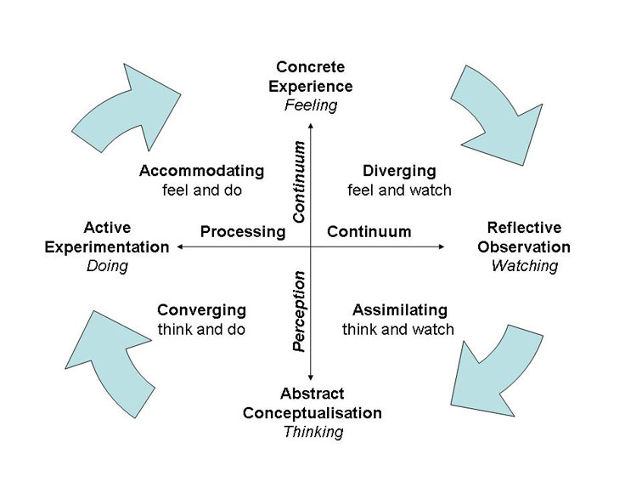

CIPD (2021) states a learning and development strategy as a way of setting out the workforce capabilities and identifying what skills and competencies the organisation requires to sustain a successful business.

This report will therefore:
- Discuss the learning need that has arisen due to changes within the internal and external environment within Juniper.
- Using credible resources, critically analyse the different measures and trends that have emerged in the last few years to create the ultimate learning experience for the learning need.
- Go into details about the learning need and develop an action plan to roll out
the learning need to the relevant department/team.

Part 1 - Discussing the learning need that has arisen due to changes in both the internal and external environments within Juniper.

- What is the learning need?

CIPD state that an organisation needs a learning and development strategy to ensure business success and is driven by the requirements and goals of the business. A questionnaire was developed by the revenues team at JE to capture the sales team feedback. The final questions of the questionnaire aimed to gather the participant's knowledge of the applications and software used by the sales team such as Sugar CRM, Target Tracker, Pupil Asset, and basic Microsoft office tools.

Figure 2: Juniper Sales Development Survey (surveymonkey.co.uk)


The CRO wanted to initially run a sales workshop for new and existing sales representatives that will span over 2 weeks during the summer months. JE has acquired a total of 9 companies over the past year and the goal is to create a team of generalists with pre-sales support to assist with finding, winning, and keeping customers. Pre-sales teams usually consist of technical experts with technological knowledge of the product itself, as well as knowledge of the industry and its main competitors of the prospective client. Sales knowledge of the suite of systems on offer is vital to the company’s survival to be able to demonstrate and support the products effectively.

- How have external and internal factors impacted the business and in turn, influenced the learning need?

UK businesses have struggled significantly during the current pandemic. Shops, along with the hospitality and leisure industry have had to rely on government funding to furlough staff and pay bills. Other businesses have managed to acclimatise to a “new normal” of working from home and collaborating online using a variety of technology.

Learning and development training relies on economic growth and the pandemic threw the UK into another major recession in 2020 – the first in over a decade with the Guardian (2021) reporting the UK reporting its worst economic performance for more than 300 years.

Brexit has also impacted businesses, particularly those who trade within the EU. Brexit has sped up the need for sales enablement tools with a recent report from Engage Employee (2021) stating that improving your organisation's dexterity and capacity to respond to changes in the internal and external environment “without losing momentum” is more important now than ever. The overall goal is to enhance team skills and communicate more effectively in a more virtual world where customer expectations have changed.

Social and environmental factors have also impacted JE which has several offices spread across the UK. Current conditions due to the global pandemic mean that people must work from home, therefore JE employees have to pre-book office attendance with a maximum capacity depending on the size of the building. This in turn has a knock-on effect on the ability to effectively deliver training to employees. A sales team needs to be able to obtain the practical experience required to confidently deliver the product demonstration and training and should be capable of supporting the future needs of a new or existing customer. A PESTLE analysis can be found in appendix 1 of this report.

Part 2 - Critically analyse the different measures and trends that have emerged in the last few years to create the ultimate learning experience for the learning need.

- The new normal – a digital world?

Jane Hart of Modern Workplace Learning states 2020 was an extraordinary year as the world of work has changed dramatically with only 50% returning to the office with remote learning still being prominent - a brilliant opportunity for organisations to adopt a new learning style and approach.

Learning styles heavily depend on the user and everyone has preferential learning styles with some favouring practicality over hours of reading and vice versa. Learning styles have been explored by both Kolb and Honey and Mumford (1992) who have designed “instruments” that highlight differences in learners and their learning styles to provide a better understanding of teaching and learning techniques in the workplace. Another perception is that some learn best interactively and some individually, some prefer facts and data, some prefer theories and concepts, and others prefer visual forms of information and some respond better to written and spoken explanations (Mupinga, Nora & Yaw, 2006).

Even though e-learning has evolved significantly, a study in 2016 found that 52% reported that ¾ of all learning takes place offline with classroom-based learning still popular. It was also reported that 36% state their employers use a combination of training methods including day-long and half-day workshops,1-2-1 coaching sessions, bespoke training, and coaching. It was also found that e-learning tended to be more "sector-led" and particularly common in the public sector (People Management 2016).

The last two decades has seen web-based learning becoming increasingly prevalent with many online classes providing user-friendly interfaces along with easily reachable materials that may be used and managed in a reliable and accessible manner (Zacharis 2010). A study carried out by the Journal of HRM (2015) stated that we live in an era of self-expression and customisation where we desire more independent treatment and that due to this element of individualisation, employees want employers to offer them “customised packages and distinct treatment”. Jones et all (2009) also believe that it is a very complex relationship when it comes to training and performance, with them believing that huge dividends are on offer to the company should an employee be profiled and trained correctly.

The way employees are managed in the workplace nowadays differs greatly from how they were managed 20 years ago. The “baby boomers” are reaching retirement age (1948-1963), with the “millennials/generation Y” (1979-1999) taking over the workforce. You then have “Generation X” (1964-1978) in between those age groups which is a significantly smaller group leaving an employment gap and all three generations have different beliefs and preferential learning styles (Learnworlds.com 2021). There is also Generation Z – those born after 2000. However, baby boomers are still significant in the world of work meaning that learning and development strategies must accommodate their online learning needs and requirements. Many in this age group are reluctant to make a change and use online training and prefer the traditional training they are used to (E-Learning industry 2019).

- Online Learning concepts and ideas

The E-learning industry has stated that online education is estimated to reach $325 billion by 2025. The pandemic has forced businesses to adapt to a “new normal” and more business owners are allowing their workforce to work from home with increased flexibility due to balancing home and work life as the two become blended. Many business owners should take this opportunity to modernise their workplace training and employee investment is essential. Employers should demonstrate keenness by investing in and developing a valued team member enabling them to feel appreciated. Compliancy training is normal when a new team member is employed, but investment in their personal and professional development can be achieved by providing customised learning. (HighSpeed Training 2021).
In 2015, the CIPD conducted a research report to determine how HR professionals can meet the needs across the 4 main generations. It was discovered that 53% of HR professionals found that they found differences with how young people like to learn in comparison to their peers with a strong preference for technology-based learning. However, they also conducted a study that found a blend of studies was preferential such as the “70-20-10” model which applies to all generations. Adams (2017) also states that research shows we learn 70% experientially and 20% socially – therefore learning in the classic way only accounts for10% meaning on the job learning is far more productive.

Figure 3: Development Model (Skillshub.com 2021)
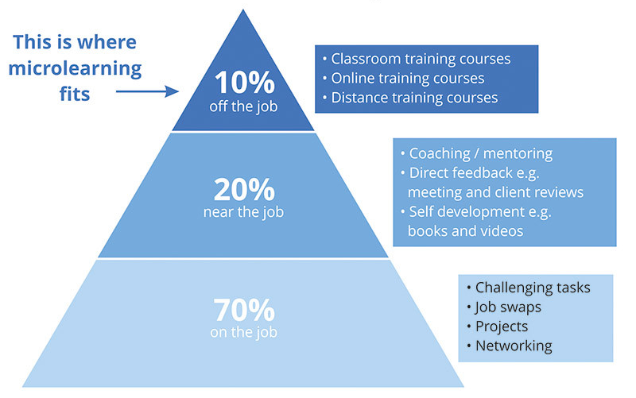

The Harvard Business Review published an article in 2019, discussing how learning should be part of everyday work based on the theory that we are a “Neotenic species”; therefore, we are born with the instinct to learn throughout our lives. However, it states we spend 61% of our 6.5-hour average working day looking at emails, sourcing data and attending informal meetings, and we are only allowing approximately 5 minutes of the working day for formal learning. They also mention a new concept dubbed "Learning in the flow of work" meaning that if we want to learn at work, then it must fit around our working day and life. They discuss two perspectives – bottom-up learning from the individual to top-down learning which is from a corporate angle.

Figure 4: The bottom up, top-down approach (smartsheet.com 2021)
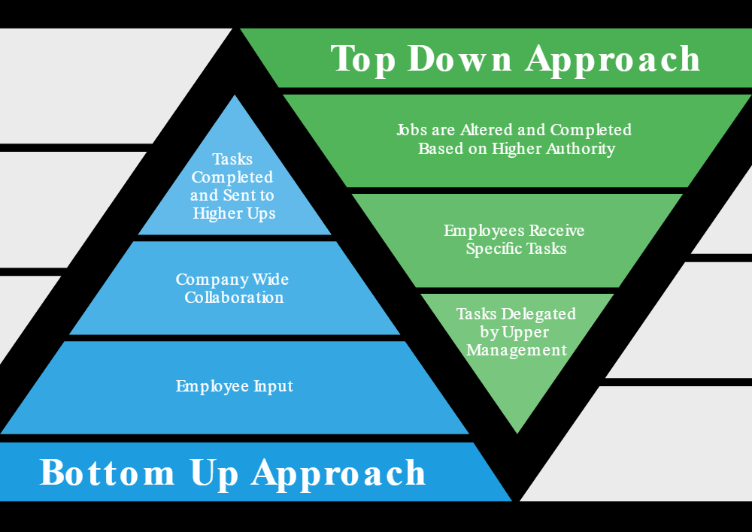

Forbes wrote an article in 2020 discussing the emerging trends they believe would be relevant in 2021. They state that the world of learning and development was digitised massively since the global pandemic. They believe that the learning and development industry has changed forever and that 5 trends will shape the start of the new era. Due to the massive shift from office to remote work, workers had to be upskilled which is a sharp contrast to 12 months prior where skills gaps were being planned for 2 years with talk of lengthy planning of courses scrapped as the luxury of time, we once felt we had, being a thing of the past. They also mention the change of attitude in upskilling being taken over by driving performance in the workplace, the rapid transformation to digital learning and the emergence of data-driven learning.

- So, what is the “Ultimate learning experience”?

The Training Industry reports in their 2020 article that it is important to deliver a rich and modern learning experience to retain, engage, and drive the performance of your staff. Stewart and Cureton (2014) state that to be able to decide which learning method is the most appropriate direction for learning, it is essential to investigate the company’s objectives for performance, the backgrounds of the proposed learners and what preparation is required. They also state that lectures, videos, and online learning lack practical experience and led to poor performance-related feedback. Shackleton Jones (2019) also states that we should be using resources as opposed to courses and one of his key quotes from his podcast was:

“Let’s not come to people with PowerPoint presentations when we have some time to have valuable time together to talk about what they think, to share experiences, and to learn from each other.”

The Guardian (2020) published an article about face-to-face learning vs online learning, which is particularly prominent during these challenging times where children through to adults switching from face to face to online learning in the blink of an eye, and their survey revealed that face to face was still preferred at a staggering 83%.

Work-based learning would usually include work funded opportunities such as apprenticeships or day release at college. Online learning has seen the dawn of a massive range of online apps and tools available for download on PCs and mobile phones. Toptools4learning regularly update their top 200 tools for learning featuring popular apps such as Microsoft Teams, LinkedIn, Instagram, and YouTube.

It can be summarised, that what is perceived as the “ultimate learning experience” will never and could never be a “one size fits all” scenario. Due to the multi-generational workforce in the workplaces today, along with the global pandemic, and the rapid increase of technology, learning needs are constantly evolving and changing.

Part 3 – Go into details about the learning need and develop an action plan to roll out the learning need to the relevant department/team.

The CRM has highlighted the need to run a sales training program to enhance sales product knowledge due to the many acquisitions over the year. It will be generalist training to enable the team to demonstrate, sell, train, and support customers in the future.

- How is a learning need identified?

McClelland (1991) and Barbazette (2006) both put together models for analysing training needs like that in figure 4. Goldstein and Ford (2002) also have an approach that focuses on specific analytical methods as opposed to the step-by-step approach above. Gold et al (2013) take a different approach by looking into identifying possible indicators for training needs including turnover and absenteeism, complaints, and operational delays.

Figure 5: Training Needs Analysis example (hrmpractice.com 2021)
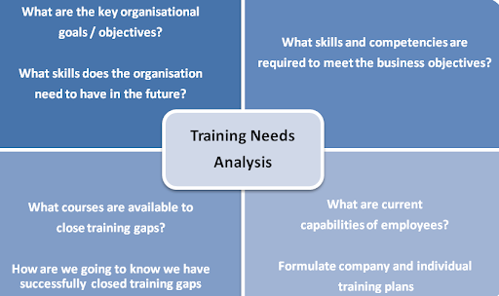

- Why is sales training so important to Juniper?

The CRO stated the key reasons for implementing training spans from increasing sales and profit, to generating more upsells and cross-sells, as well as enhancing sales processes making the team more productive and improving customer satisfaction.

HR magazine (2014) stated that “Customers are looking for sales professionals whose mindset is authentic and client-centric”.

Figure 6: SWOT for Sales training (Salessense.co.uk 2021)
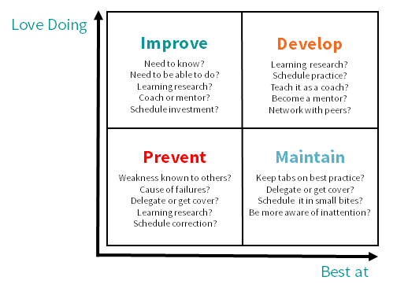

- What is the proposed plan of action?
The CRO wants to host a 2-week online course for the sales and customer success team. A Coggle© flow diagram was created to map out the training plan and to serve as a refresher for the trainees to refer to if need be.

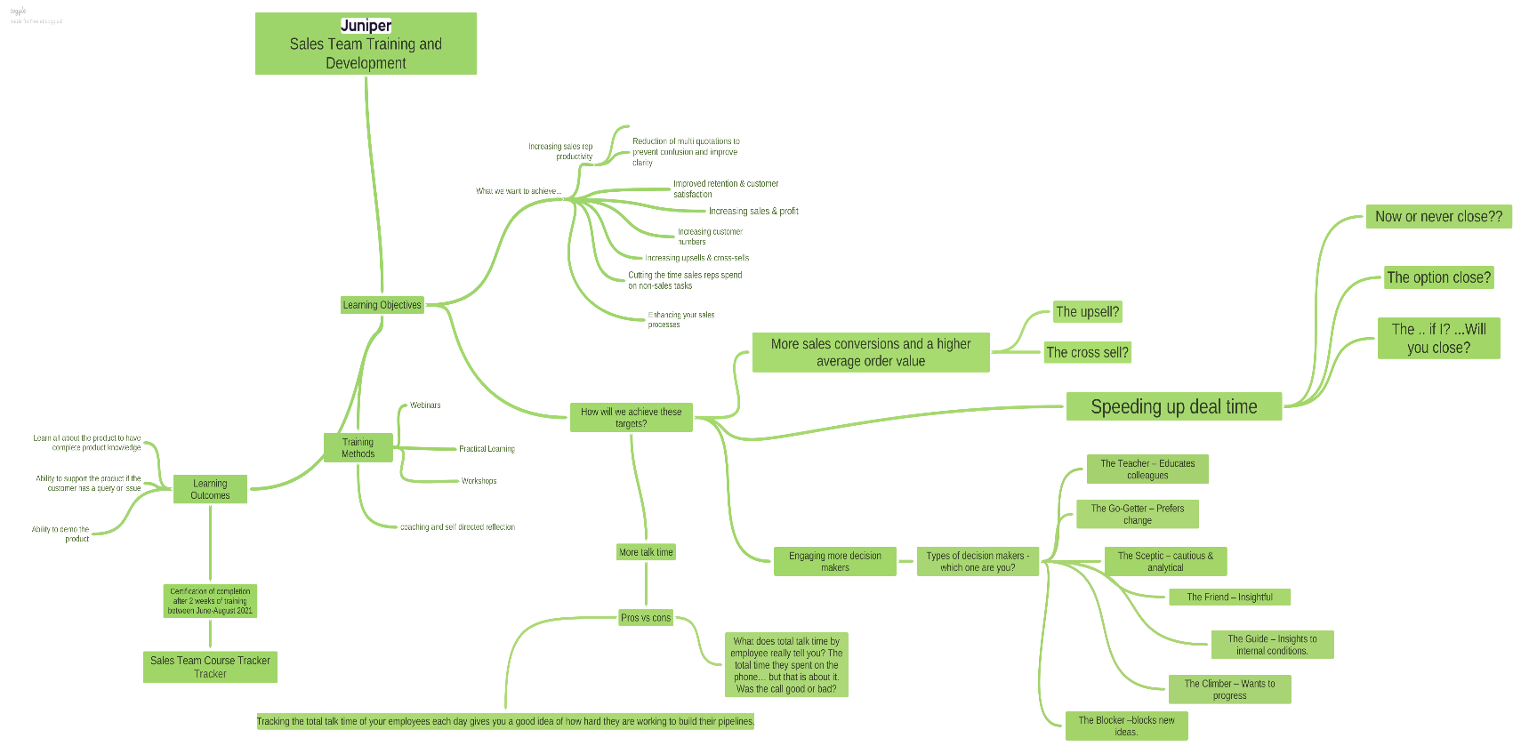
Figure 7: Sales team training and development Coggle (https://coggle.it)

JE has spoken to an external company called Optimal Performance Group (OPG) - a company with 80 years’ experience with passion for transforming sales teams through tried and tested methods. The presentation provided to the CRO highlighted their digital apprenticeship for an “IT Technical salesperson” and outline the benefits, course content and structure. Their apprenticeships should improve retention, with 89% of apprentices wanting to stay with their employer for at least 3 years on graduation as apprenticeship programs help to develop a culture of lifelong learning among digital employees, ensuring they remain willing to master future technologies that could benefit a company’s aims and objectives.
The apprenticeship will be a costly investment for JE at around £56 000 for 10 apprentices should they apply for the apprenticeship levy – a scheme introduced April 2017 where a payroll tax is imposed on large businesses to allow funds to be topped up by the Government, allowing organisations draw down on them to pay for apprenticeship training and assessment. (CIPD 2019)

- What are the benefits of such an investment in training?

Goldstein and Ford (2006) argued that investing in employee skills and knowledge can be a competitive advantage. Leitch (2006) states that UK employees are at a lesser advantage than their European counterparts when it comes to investment. Harrison (2009) believes that it is essential that investment is business-led to maximise a return on investment into employee development. The CIPD published a report in 2019 stating the case for a broader training levy. The report states that as the world of work is fast-paced and ever-changing, the competencies of a workforce are vital to economic sustainability and growth, but there has been a rapid decline of investment into workforces. The reasons behind this decline are not entirely well understood, however, it is believed a reason may be the growth of higher education systems as well as the “shift towards business models and competitive strategies requiring lower levels of skills”.

Identifying learning needs can be difficult as everyone within an organisation has considerably variable learning needs. Gurdjian et al (2014) found that companies achieve far better outcomes if it “cuts through the noise” and identifies a small number of essential skills for their business to succeed such as strong coaching skills or quality decision making. If there is no analysis of an employee’s individual learning needs, they are unable to perform at their level best. A potential employee should be recruited and selected in a systematic and aligned manner to ensure they perform at their optimum during their probationary period to avoid being exited. Stewart and Cureton (2016) developed the following model to demonstrate the impact of LNA on recruits.


Figure 8: Impact of LNA on new recruits – Stewart and Cureton (2006)
EXIT – end of a probationary period


Join
R & S
Process

LNA unplanned
Performance
Probationary period
Organisation
Learn by chance

LNA Planned!!

To be able to facilitate the design of internal and external training methods, it is important to instate a set of guidelines such as the emphasis on performance standards. Glaister et al (2013) state that the trainer can consider which path to follow to achieve their end goal if they have links between the training needs analysis and the design and delivery of training. Consistency should also be maintained meaning those who attend training should have the same information provided. Finally, objective outcomes should be achievable, realistic, and quantifiable. Kolb (1984) and Honey and Mumford (1992) go on to say that learning objectives and the design of learning methods should be geared to individuals, learning styles and needs.

A learning intervention may only succeed if all factors such as defining clear objectives and accounting for all the different ages and cultural diversities of learners has been taken into consideration. It is also important to prepare for the learning, before, during and after giving the trainee time and opportunity to practice what they have learned with those who requested the training having access to tools and advice to reinforce the training.

- What is the final decision for the sales need?
Originally the plan was to run a sales workshop for 2 weeks over the summer period, however, due to the many recent acquisitions, it is also likely that there will be an apprenticeship style course that would span over a few months. The pandemic has meant that the CRO may simply maintain the original plan to provide refresher training to the existing sales force to ensure sales methods are consistent. These would be remote sessions ran by the CRO leading to an internal certification once the trainees have met certain criteria.
Work based learning according to Warr and Allan (1998) can be either
- Cognitive - existing understanding is blended with information from new learning leading to decisions being based on new understandings
- Behavioral - learning from colleagues, course notes or practically via the application of new ideas.
Holman et all (2011) believe when employees enjoy control over their work, they have a positive influence on learning strategies and generating new ideas.

The CRO has decided the first instalment of training which will be the 2 weeks of training will be broadcasted and recorded using Microsoft teams initially with a provision, of course, notes to serve as a refresher. The trainees will need to complete a test to show they have understood the workshops and will be presented with an internal certificate. The CRO will then look to implement the apprenticeship courses after further consultation, in late 2021 – but due to restrictions, feels that this is currently not plausible.

Conclusion

It has been a tough decade with the start seeing the UK still in recovery from the 2008 recession, followed by the UK voting to leave the EU, followed by a global pandemic – with companies either sinking or swimming. JE, have thankfully done remarkably well, acquiring businesses to strengthen its suite of services on offer to the education sector.

Learning needs are critical to businesses. An individual’s learning need is recommended at the point of recruitment and selection, without which they fail to flourish and risk an early exit due to failing their probationary period. Learning interventions are most successful when all factors, goals and objectives are accounted for. It is also key to set aside time to practice what has been learned before "going live" to ensure best performance, with employers also having access to resources to support employees.

The CRO of JE decided that there is a need for sales training to create a “generalist” – someone who can sell all the products, with confidence and with the ability to be able to provide aftersales care and support. The first training event will likely be a short and sharp training provision in the coming months, and then a new opportunity to become an apprentice as an IT technical salesperson by the end of 2021.

Recommendations

JE has now acquired 9 businesses to facilitate its 10000 schools across the UK and beyond, and business is booming.
A successful and knowledgeable sales team are key to any business. The CRO therefore felt the need to get the sales team fired up and ready to sell the suite of services with confidence and passion.
An action plan for communicating the initial sales training over the summer months can be found in appendix 2. It sets out a clear vision for who will deliver the training and the trainees that will attend, what the training will involve, where and when the training will take place and the methods used to deliver the training. Budgets will also be put in place as well as the benefits of improving the sales team as opposed to the training not taking place.

References and Bibliography

- Adams, L. (2017) HR Disrupted: It's time for something different

- Barbazette, J. (2006) Training Needs Assessment: methods, tools, and techniques

- CIPD article dated 8/6/2020. Learning and skills at work. Available at www.cipd.co.uk. Accessed 14/05/2021

- CIPD report dated July 2019 - Addressing-employer-underinvestment-in-training. Available at www.cipd.co.uk. Accessed 16/05/2021

- CIPD Report dated June 2015 Developing-next-generation_tcm18-10268.pdf Available at www.cipd.co.uk Accessed 16/05/2021

- Coggle available at https://coggle.it. Accessed 13/05/2021

- Deloitte Report dated 14/08/2018. real-learning-in-a-virtual-world (1).pdf. Available at www2.deloitte.com. Accessed 11/05/2021

- E-Learning Industry article dated 12/03/2020 - Online Learning Vs. Face-To-Face Learning. Article available www.elearningindustry.com
Accessed 15/05/2021

- E-Learning Industry article dated 12/05/2019 Reasons Why Baby Boomers Cannot Connect with Your Online Training Course. Available at www.elearningindustry.com Accessed 15/05/2021

- Engage Employee article dated 17/03/2020. Post-brexit: Supercharging team collaboration. Available at www.engageemployee.com. Accessed 13/05/2021

- Financial times article dated February 2021 UK suffers biggest drop in economic output in 300 years. Available at www.ft.com. Accessed 12/05/2021

- Forbes article dated 23/12/2020 - Five Learning and Development Trends to Watch for in 2021. Available at www.forbes.com. Accessed 13/05/2021

- Glaister, C., Holden, R., Griggs, V., et al (2013) The practice of training: The design and delivery of training

- Gold et al (2013) Human Resource Development: theory and practice. 2nd Ed

- Goldstein, I.L and Ford, J.K. (2002) Training in organisations. 4th Ed.

- Gurdjian, P. and Halbeisen, T. and Lane, K. (2014) Why leadership development programs fail.

- Harrison, R. (2009) Learning and Development. 5th edition. CIPD

- Havard Business Review article dated 19/02/2019 - Making Learning a Part of Everyday Work. Available at www.hbr.org. Accessed 15/05/2021

- Highspeed Training article dated 13/11/2019 - Learning and Development in 2020 | 5 Top Trends. Available at www.highspeedtraining.co.uk. Accessed 14/05/2021

- Holman, D., Totterdell, P., Astell, C., Stride, C., Port, R., Svensson, R., and Zebarras, L. (2011) Job design and the employee innovation process: The mediating role of learning strategies Vol 27 pp177-191

- HR Magazine article dated July 2013 - Is HR ready to help ensure sales growth? Available at www.hrmagazine.co.uk. Accessed 15/05/2021

- Kolb, D.A. (1984) Experiential Learning: Experience as the Source of Learning and Development. 2nd Edition

- Jones, M. K., Jones, R. J., Latreille, P. L. & Sloane, P. J. (2009). Training, Job Satisfaction, and Workplace Performance in Britain

- Learnworlds article dated 06/02/2012 - How eLearning and Online Training Can Help in HR and Hiring. Available at www.learnworlds.com. Accessed 17/05/2021

- Leitch, S. (2006) Prosperity for all in the global economy – world class skills. London HM Treasury

- McClelland, S. (1993) Training Needs assessment: An option systems application

- Modern Workplace Learning 2021 – Building a continuous learning environment ready for the future. Accessed 15/05/2021

- MOOC: A complete list of MOOCs and free online courses. | MOOC List (mooc-list.com). Available at www.mooc-list.com. Accessed 13/05/2021

- Mupinga, D. M., Nora, R. T. & Yaw, D. C. (2006). The learning styles, expectations, and needs of online students. College Teaching, 54, 1, 185–189

- People Management article dated 5/5/2021 Covid has damaged older workers’ employment prospects, figures show. Available at www.peoplemanagement.co.uk. Accessed 13/05/2021

- PM Insight article dated August 2016 - Are employees making the most of online learning opportunities? Available at www.pminsight.cipd.co.uk. Accessed 14/05/2021

- Podcast dated 02/07/2019 - How People Learn with Nick Shackleton-Jones - The Learning & Development Podcast Available at www.omny.fm. Accessed 15/05/2021

- Sales Sense article diagram from B2B Sales Training Course, Professional Sales Course available at www.salessense.co.uk

- Simply Psychology article dated 2017 - Kolb's Learning Styles and Experiential Learning Cycle Available at www.simplypsychology.org accessed 18/05/2021

- Stewart, J. and Cureton, P. (2014) Designing, Delivering and Evaluating L & D: Essentials for Practice

- Skills hub article 2017 - Use Microlearning As Part Of Your 70-20-10 Approach To Development Available at www.skillshub.com accessed18/05/2021

- Smartsheet article 2018 - Top-Down vs. Bottom-Up Approach available at www.smartsheet.com. Accessed18/05/2021

- Telegraph article dated 24/08/2020 Which is better: online learning or face to face? Available at www.telegraph.co.uk. Accessed 12/05/2021

- Top Tools for Learning 2020 – Results of the 14th Annual Survey published 1 September 2020 Available at www.elearningindustry.com

- Training Industry article dated 22/01/2020 - 3 Ways to Create the Ultimate Learning Experience. Available at www.trainingidustry.com. Accessed 13/05/2021

- UWTSD Library Resources article dated 2010 - The effect of learning style on preference for web‐based courses and learning outcomes
2010 The Author. British Journal of Educational Technology
Accessed 12/05/2021

- UWTSD Library Resources article dated 2015 - Examining the Influence of Learning Style and Demographics on Instructional Method Preference – ProQuest - Available at https://www-proquest com.ezproxy.uwtsd.ac.uk/
Accessed 12/05/2021

- Warr, P.B. and Allan, C. (1998) Learning Strategies and Occupational Training: In IRIOP 1998 vl33 Edited by Cary L. Cooper and Ivan T. Robertson: © 1998 John Wiley & Sons, Ltd

Appendices

Appendix 1 – PESTLE analysis of Juniper Education

POLITICAL  BREXIT – Juniper deals with schools in 20 countries. Therefore, trade and payments may be affected  COVID-19 – Juniper has been affected in terms of.  - Remote working  - Travel to sites  Change in training initiatives made available by the government  . | ECONOMIC  Recession 20/2021 – Juniper managed to assist 9 companies by acquiring them and giving them a stronger opportunity for success.  Pandemic - Juniper has not furloughed or made any staff redundant during the pandemic and have managed to continue to make a profit and operate normally.  Wider competition with other companies such as Iris and | SOCIAL  Now that a deal has been made between the EU and the UK, it will be interesting to see what affects human behaviour and cultural trends have in store for Juniper?  Juniper has offices spread across the UK that must be pre-booked to attend  Increase in educational resources
TECHNOLOGICAL  2020 has been a year of rapid technological advancements due to COVID-19  Juniper currently delivers live training sessions either on site or via webinar, however thanks to the rise of AI, there is no reason to prevent an interactive recording of the training modules being introduced in the future to prevent labour costs. | LEGAL  Juniper deals with a lot of sensitive data due to dealing with the HR and payroll records of hundreds of schools, universities, and colleges.  Employment Law  Data protection  Consumer protection  Updates in legislation and code of conduct particularly now due to covid and Brexit | ENVIRONMENTAL  Training accessibility due to local lockdown restrictions  Resource Management  Health in the workplace – the Human Resources manager was very unwell with covid 19 for several weeks.

Appendix 2 – Juniper Education sales team training action plan

Goal | Objectives | Activity | Completion Date and venue | Lead | Budget
CONSULTATIVE  Week 1 | Account management  Sales and negotiation skills  Product knowledge  Presenting products  Virtual presentation | Icebreaker  Team training  Webinar  Role Play  Product demos  Test on knowledge | Date – TBC  Venue – Webinar based via MST | CG | £333.33 associated costs linked to course notes, trainers time, employees time, guests time.
ADVANCED  Week 2 | Dealing with a business situation quickly and effectively  How to negotiate successfully  Selling a solution  Asking the right questions  Providing the right answers  Understanding and selling value | Teams Training  Practical and scenario-based workshops  Question and answer sessions  Test on knowledge | Date – TBC  Venue – Webinar based via MST | CG | £333.33  associated costs linked to course notes, trainers time, employees time, guests time.
FOUNDATION  Week 3 | Building rapport  Telephone skills  Handling complaints  Drafting quotations accurately – first time | Team Training  Webinar based  Skills workshop  Final test for the 3 weeks  Fun Kahoot to end the training course | Date – TBC  Venue – Webinar based via MST | CG | £333.33  associated costs linked to course notes, trainers time, employees time, guests time.

.

