BSc/HND/HNC Civil Engineering and
Environmental Management

Contract Practise & Procedures
Module code: M5X01878
Assignment 2

A report focusing on:
There is a significant variation within the contract that impacts on the delivery timeframe of the project and cost.

Lecturer:
Report By: Thomas Hinder
Student number: 1701670

Content

- Introduction…………………………………………………….3
Figure 1: contract paperwork…………………….………………….3
- The Process…………………………………………………...4
Figure 2: The contract process…………………….……….………4
- Variations………………………………….…….….…………..5
- Conclusion……………………………………………………..6
- References………………………………………………..……7

- Introduction

A contract administrator is the individual responsible for the administration of standard contracts in construction. They play a critical role as they direct and oversee the lifecycle of a contract. He or she makes sure that the parties of the contract are aware of the terms, conditions, and obligations.

Contract administrators is a professional within a department or organization and are the main facilitators for approval, change management, negotiations, recommendations, monitoring, and record keeping. They serve as the liaison between independent contractors, vendors, customers, employees, and of course companies.

Contract administrators are first appointed by the client, but when decisions or assessments need to be certified they should act reasonably and honestly. Unless the contract is finalised and conclusive their decisions are open to challenge via the procedure of the dispute resolution.

The responsibilities of a contract administrator and their day to day role may change depending on type of project, location, and project size.



Figure 1: Contract paperwork

2.0 The Process

The acceptance letter is the first step to the process. Once the acceptance letter has been received by the contractor the contract has been formed. The contractor will now need to will need to put together the bonds and insurances and the programme together with the client and the engineer. There will be a setup meeting and the contract documents are prepared and signed. Once all the primaries are taken care of, the site will be handed over to the contractor. Normally the client owns the site but they hand over control of the site to the contractor for the duration of the works. Now the contract period starts and where the construction happens. The engineered team implementing changes required, their monitoring to make sure the works are being built properly, their doing inspections and approvals. The contractors team are concerned in construction management and making it happen. Making sure that the recourses they have to build the completed works and that the completed works apply with the contact. There will be many concerns with the contract, with the progress payments, site meetings and variations.

With variations within the contract such as cost and delivery time most employers will want to limit these as much as possible. This is where the contract administrator will have the power with instructing variations.

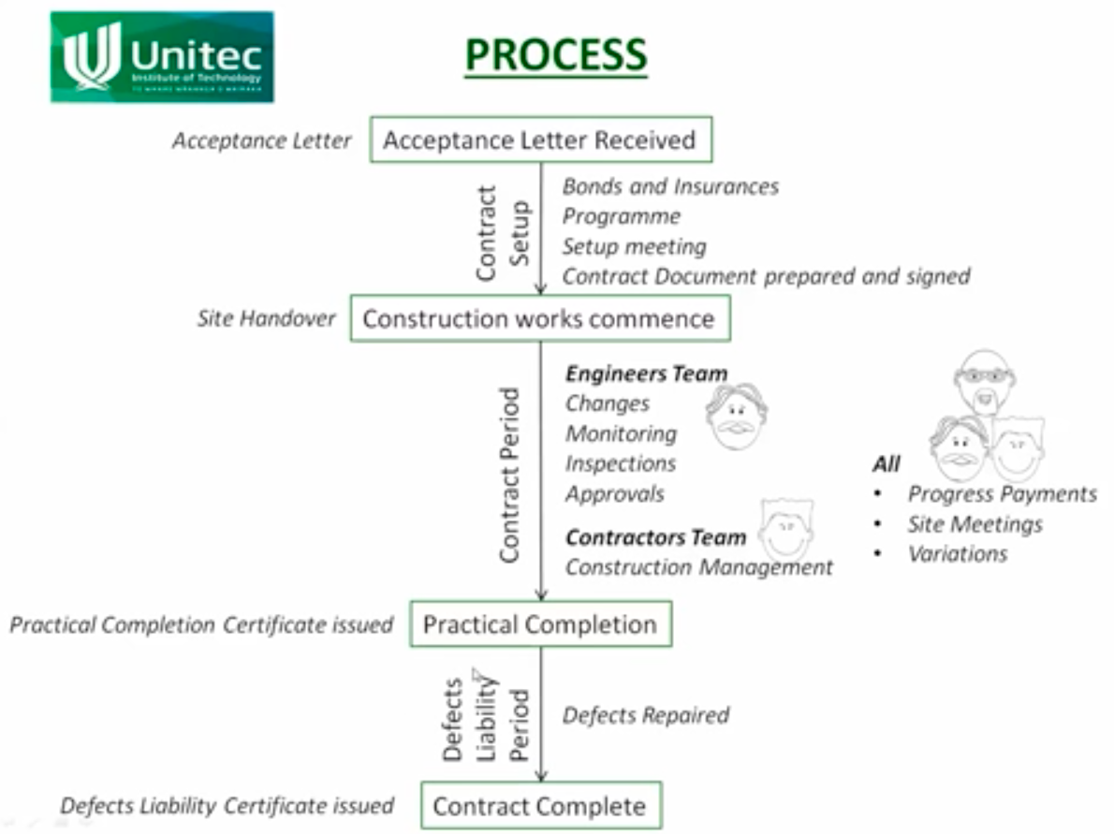

Figure 2: The contract process
3.0 Variations

To make sure all parties needs are met, the contract administer will oversee all the planning, administration and revision of contracts. Compliance of the contract is the main priority of a contract administrator. There make sure that all responsibilities for performance are met as outlined by the contract. During the duration of the contract there will be consistent monitoring of the performance. Tools such as electronic document management systems and spreadsheets will be used. Detailed records that include modification, payments, and original contract documents are also maintained by the administrator. They prepare and distribute information about the aspects of the contract to the appropriate individuals. When the contract terms are up they can then perform the necessary closing tasks such as making summaries for the related parties.

The most inevitable situation in construction projects is variation. In all types of projects this is common and it plays important role determining the closing time and cost of a project.

The contract administrator can’t change the nature of works because of the pretext of variation. For example, They can’t ask for diaphragm wall shoring if the if the contract provides for secant pile shoring as the entire nature of work will change.

In legal terms, variation within a contract is where there is an agreement by all parties to change some of the term of the contract. If no there is a disagreement of the variations implied, there will be express terms that have mentioned and agreed when the contract is made by both parties. The contractor may reject instructions for the variations in the absence of such express terms.

Standard forms of contract generally the engineer or architect make express provisions for the contract administrator to instruct variations. These provisions allow no need for a new contract as it enables a smooth administration.

Instructions of a variation must be clear on what is needed or what isn’t needed and also must propose what will be the method of valuation.

However, there may be some disagreements such as management and factory overheads which hard to deal with. With the length and the problems of the supply chain within the major building projects, it takes a significant amount of time getting forecast pricing from all of the affected parties, most often beyond the date that the contract administrator has to decide whether to instruct the variation or not.

A decision will then need to be made by the cost consultant based on the estimate cost for the variation, further on the estimated cost will be replaced by the actual cost. With the NEC contract the practicality can defeat the rationales related to making decisions and the control of costing.
If there is a delay with the construction period that is not the contractors fault the construction contracts allow an extension. This is known as an extension of time (EOT).
When it becomes clearly visible that there is, or it is very likely to be a delay this could result in an extension of time. The contract administrator will be given a written notice by the contractor indicating and identifying the event that has caused the delay.
A grant for an extension of time may be available if the contract administrator acknowledges and accepts that the delay was caused by a relevant event, this will also result with the completion date being adjusted.

4.0 Conclusion

Variations within a contract are most often the source of dispute, either agreeing if part of the work needs variation at all or mainly in valuing the variation. During the course of a contract this can have a significant effect on the time and money of the project.

While some variations are impossible to avoid it is most important to try and minimise potential variations future claims by making sure that all uncertainties are eliminated before the start of the contract.

Word count - 1,033

5.0 References

Suryakanta (03/06/2015). WHAT ARE THE ADVANTAGES AND DISADVANTAGES OF GRAVITY DAMS?. Retrieved from https://civilblog.org/2015/06/03/what-are-the-advantages-and-disadvantages-of-gravity-dams/

Sports Management DEGREE GUIDE. (2019). what is a Contract Administrator? Retrieved from https://www.sports-management-degrees.com/faq/what-is-a-contract-administrator/

Alisha Paulsen. (07/11/2018). Roles and Responsibilities of Contract Managers. Retrieved from https://www.concordnow.com/blog/roles-and-responsibilities-of-contract-managers/

Designing Building Wiki. (24/07/2018). Contract administrator for construction contracts. Retrieved from https://www.designingbuildings.co.uk/wiki/Contract_administrator_for_construction_contracts

Villanova University. (06/02/2018). How to Become a Contract Administrator. Retrieved from https://www.villanovau.com/resources/contract-management/contract-administrator-job-description/

Thomas Reuters. (20/05/2016). Contract administrators’ liability for variations. Retrieved from http://constructionblog.practicallaw.com/contract-administrators-liability-for-variations/

Figure 1: seek. (June 2018). What’s it like to be a Contracts Administrator? Retrieved from https://www.seek.com.au/career-guide/role/contracts-administrator

Figure 2: Hugh Wilson. (31/05/2013). EM17a Contract Administration Processes. https://www.youtube.com/watch?v=dnsIzqdhr3s

