E-Portfolio

Rachael Powell

Contents Page

- INTRODUCTION PAGE 2
- PLACEMENT PAGE 2 -5
- EVIDENCE PAGE 14
- Emails to Ty Conway page 5-12
- New Directions page 13
- Hospital placement emails page 13-14
- CV PAGE 15
- SMART ACTION PLAN PAGE 16-17
- REFERENCES PAGE 17-18

Introduction

I am a student currently studying DIP HE Nursing studies and health at the University of Wales Trinity St David. From studying this year, I have gained many skills beyond learning about the body; my academic skills have developed far beyond what I had before, and I am now able to write in a professional manner. My module personal and academic development allowed me to get on my feet at the start of the year as referencing in Harvard referencing style (Ukessays, 2019) was not something I was familiar with and allowed me to learn how to use the useful resources around me such as the library both online and in University, along with Moodle which is the learning platform used in UWTSD (Moodle.org, 2019) and I was able to learn that reflection in my work is key to the continuation of learning throughout my career and ensures I make the link between theory and practice (Jasper, 2013, p.1). The Health Research module gave me new insight into research papers and how important developing and reviewing these are to our current healthcare system. It allowed me to develop appropriate evaluation skills (Insight assessment, 2019) in order to correctly analyse these professional research papers and allowed me to learn new research terms. Physiology and Anatomy helped me build on my current knowledge of the body from previous study in health and social care and biology and build on this in further detail; I found this challenging but at the same time interesting to learn. Managing Organisation allowed me to look at our current health care system and evaluate what changes could be made and see what the problems we currently face are; as prior I would not have thought about the issues the current system faces or how to overcome these. All of these modules have laid the foundation for my further study and will be a huge value to the standard of work I create in the future.

Placement

Finding placement was a challenge, as I am relatively new to the area and haven’t had previous experience in a care setting which ruled out many options, as well as I do not drive. Many individuals in my course were able to sign up with an agency called new directions which would recruit them for placement however, you had to have 6 months prior experience (New Directions, 2019) , others eventually got to sign up to Trinity nursing services (Indeed, 2019) which allowed them to gain placement in a Hospital but you needed to drive and be able to work for at least 6 months. Therefore, I tried to find placement by emailing and visiting care homes, making an account on Swansea Council for Voluntary Service (Swansea CVS, 2015) and applying for positions to do with care and by searching online for care jobs. I gained placement at Ty Conway (Homecare.com, 2019) in February after going for a meeting at the Swansea Carers centre in January to discuss a placement opportunity. I was able to do so as I searched online for placements to do with the care sector particularly care homes and was directed to a page which gave me contact details to apply for a placement by email. After the meeting we discussed an induction day for the placement in February at Ty Conway. Ty Conway is a respite day care centre for those who need support in the day if their family member needs a break. Many of the individuals who visited for the day were elderly and suffered from dementia or Alzheimer’s. Dementia is a syndrome that causes a decline in brain function; particularly common in those over 65; it not only effects memory but other factors such as mood, movement and language (NHS, 2017) and Alzheimer’s is one of the most common factor causing dementia, Alzheimer’s is a disease that effects the brain causing connection between cells in the brain to be lost as well as brain tissue (Alzheimer’s Society, 2019).
Originally, we scheduled the induction for the eighteenth of February, but it was then moved to the 25th of February at 10:30 till 3. On this day I got to meet some people who worked and some who volunteered in Ty Conway along with those who visited it on the Monday. This was a busy day and after the placement we discussed moving to a Thursday as it would be easier to introduce me to. Overall the induction went well, and I enjoyed helping to give out the food, helping to clean, talking to individuals in the centre and listening to what they had to say and engaging in activities with the individuals there such as playing board games or cards. I again went for another day on the 7th of March and had a more relaxed experience as there were less people coming in to the day centre on this day but I still got to talk with them and helped to do activities, serve the food and clean up; this experience allowed me to develop my communication skills, learn more about who I am as a person as I was able to be patient with the individuals when they got confused and was more confident approaching them than I thought I would be; this experience allowed me to see what it is like in this type of care setting and what is required from such roles. This is beneficial as in the future I will have a point of reference when going into a similar setting. I also went back to Ty Conway on the following Thursday and got to meet other new people along with the individuals I had seen last week, we chatted with them, gave out tea and toast and then put on a movie that they wanted to see. After this I helped by asking what the individuals wanted for lunch out of the options given, and went lunch was prepared by the care home next door and the volunteers would collect the food. I then helped by setting up the table and giving the food out; additionally, I helped clean up after and wash the dishes. We then gathered and had a chat before playing a card game before I left. After this I was told that they had a number of volunteers waiting to start and were planning on arranging training for a group of us such as manual handling (Thehealth&safetygroup, 2019) and food hygiene so until this was underway, I had to wait to continue placement at Ty Conway. Manual Handling is a legal requirement for those whose job requires them to do some sort of lifting to prevent harm and teaches techniques to lift safely (Thehealth&safetygroup, 2019), whilst food hygiene is important in an environment where food is handled to ensure food poisoning is prevented (Food Standards Agency, 2018). At this point I had completed around 11 hours. However, after a few weeks I had still not heard back and decided to email the woman who organised the placement for me regarding it however received an email back that she was out of office so had to wait. I eventually send another email, but this time got no response therefore arranging further placement became tricky as I hadn’t heard about the training either. Currently I still am having difficulty contacting or getting a response about further placement hours there or training and as Trinity Nursing Services were having difficulties to do with a change of manager we had to wait to hear off them and didn’t hear till it was too late for me to start placement without leaving before six months as there were charges otherwise.

I contacted a lady in Morrisons Hospital as a friend of mine had been able to gain a week’s placement in child’s nursing there, and she was able to give me the contact details of someone who deals with Adult nursing placement however, an opportunity did not come from this and she suggested I apply for Nurse Bank to gain some hours doing adult nursing; however I decided not to as I have had no experience working in a ward and feel that doing bank nursing is something for someone who has had more training under their belt.

I then decided to go to local care homes in Swansea and drop my cv in with my contact details and current qualifications I had and discussed with the individuals I met at each care home that I was looking for placement for my current course at DIP HE Nursing studies UWTSD, I also did this back home as I often travel home in the week however I did not hear back from either the care homes in Swansea or in Powys.
Previously I had experience in a care setting however this was a nursery and was only for around 2 months for health and social care in school; which I enjoyed as I had not experienced this before, but I did not want to apply to these as I wanted to get a different experience.
In university our course leader for Managing Organisations told us about a talk that was arranged that not only benefitted our studies but also would be counted as hours; this talk was from 10am to 2pm with a one hour break in between. The talk was a Health, Wellbeing and Sustainable Development mini conference with guest speakers being Felicity Page, Rob Blake and Sue Maw. Felicity Page was giving the talk on Mindfulness, Rob Blake on how the wellbeing of future generations Act impacts upon the delivery of service and Sue Maw was talking about her sustainability journey with recommendations.

Evidence

Below I will provide evidence of my processes to try and find placement.

Emails to Ty Conway regarding Placement to keep identity anonymous I will not show names or emails apart from mine

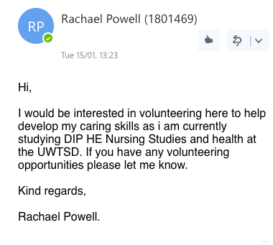

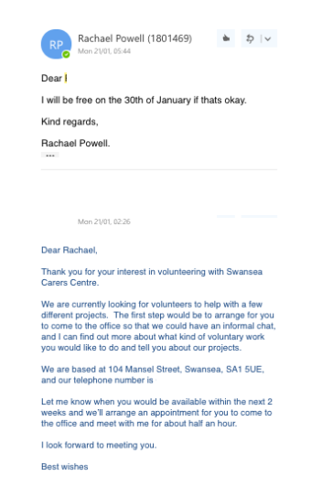

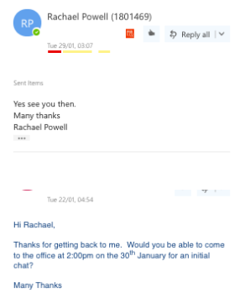

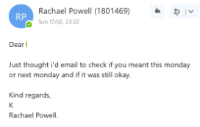
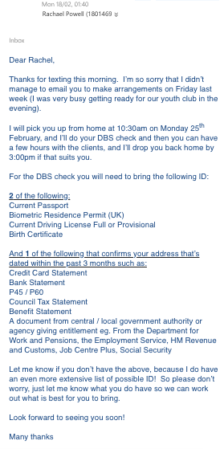
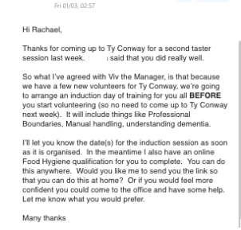

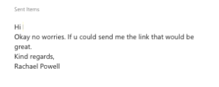

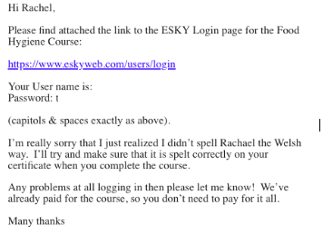

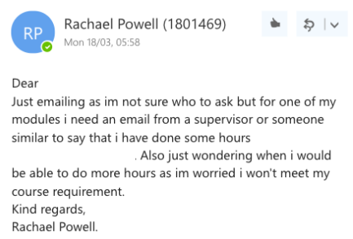

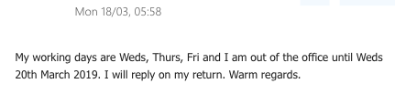
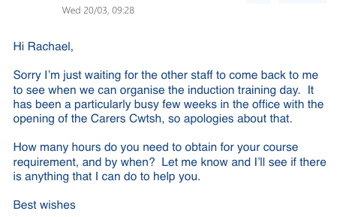

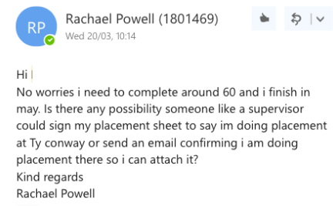

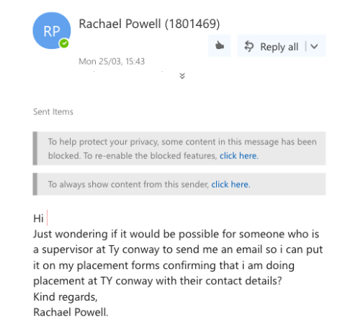

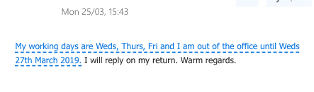

New Directions

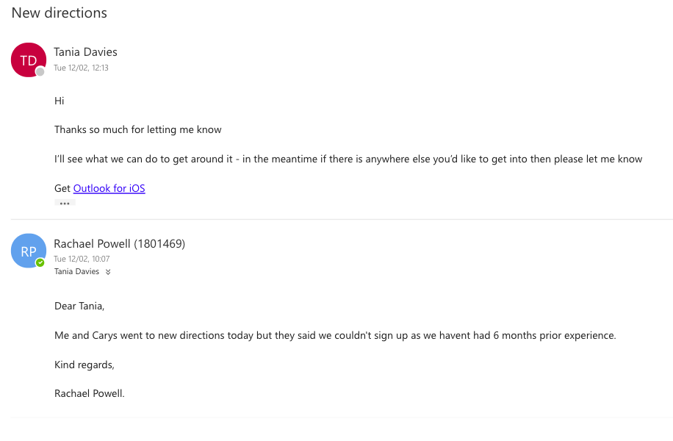

Hospital placement emails

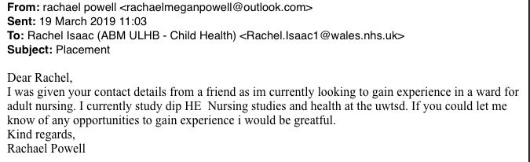

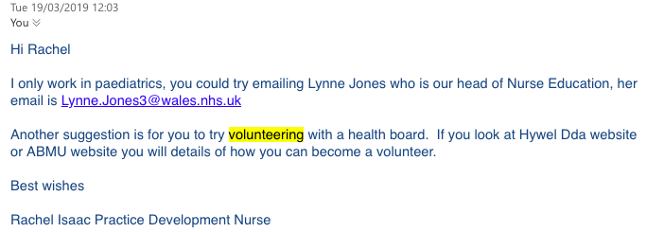

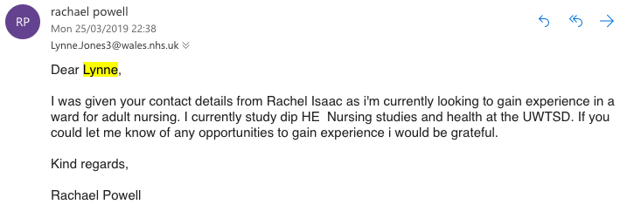

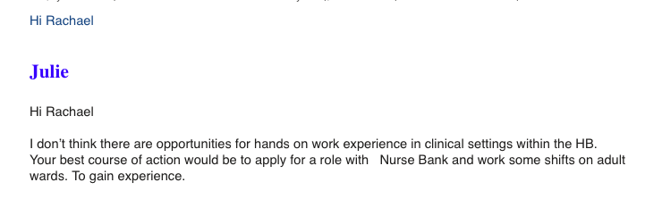

CV

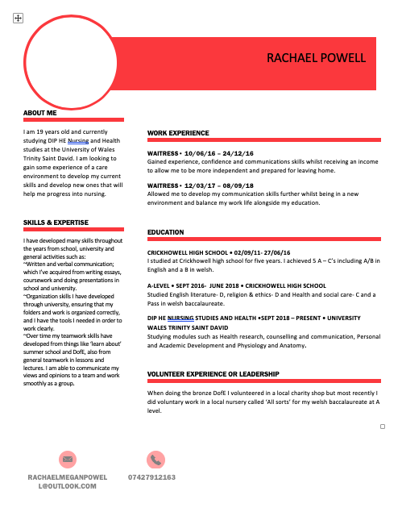

SMART Action Plan
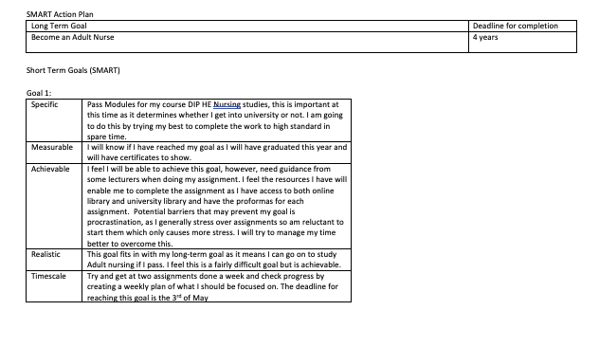

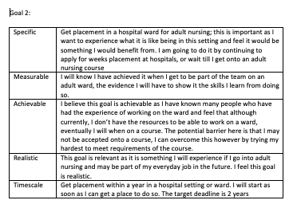

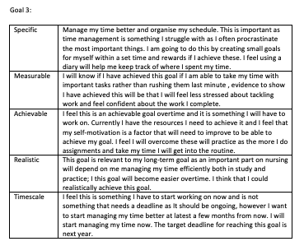

REFERENCES

Alzheimer’s Society. (2019) Alzheimer’s Disease. Available at: https://www.alzheimers.org.uk/about-dementia/types-dementia/alzheimers-disease [Accessed 30 April 2019]

Food Standards Agency. (2018) Food hygiene for your business. Available at: https://www.healthandsafetygroup.com/p/manual-handling-training-course {Accessed 30 April 2019]

Homecare.com. (2019) Swansea Carers Centre- Ty Conway. Available at: https://www.homecare.co.uk/homecare/agency.cfm/id/65432186539 {Accessed 30 April 2019]

Indeed. (2019) Trinity Nursing Services Ltd. Available at: https://www.indeed.co.uk/salaries/Healthcare-Assistant-Salaries-at-Trinity-Nursing-Services-Ltd [Accessed April 30 2019]
Insight assessment. (2019) Evaluative Reasoning. Available at: https://www.insightassessment.com/Resources/Measuring-Reasoning-Skills-and-Mindset/Measuring-Reasoning-Skills/Evaluative-Reasoning [Accessed 28 April 2019]

Jasper, M. (2013) Beginning Reflective Practice. Hampshire: Cengage Learning EMEA.

Moodle.org (2019) About Moodle. Available at: https://docs.moodle.org/36/en/About_Moodle [Accessed 28 April 2019]

New Directions. (2019) Swansea. Available at: https://www.new-directions.co.uk/education/offices/swansea/ [Accessed 28 April 2019]

Nhs. (2017) About Dementia. Available at: https://www.nhs.uk/conditions/dementia/about/ [Accessed 30 April 2019]

Swansea CVS. (2015) Swansea Council For Voluntary Service. Available at: https://www.scvs.org.uk/ [Accessed April 30 2019]

Thehealthandsafetygroup. (2019) Manual Handling Training Course. Available at: https://www.healthandsafetygroup.com/p/manual-handling-training-course [Accessed 30 April 2019]

Ukessays. (2019) Harvard referencing guide. Available at: https://www.ukessays.com/referencing/harvard/ [Accessed 28 April 2019]

