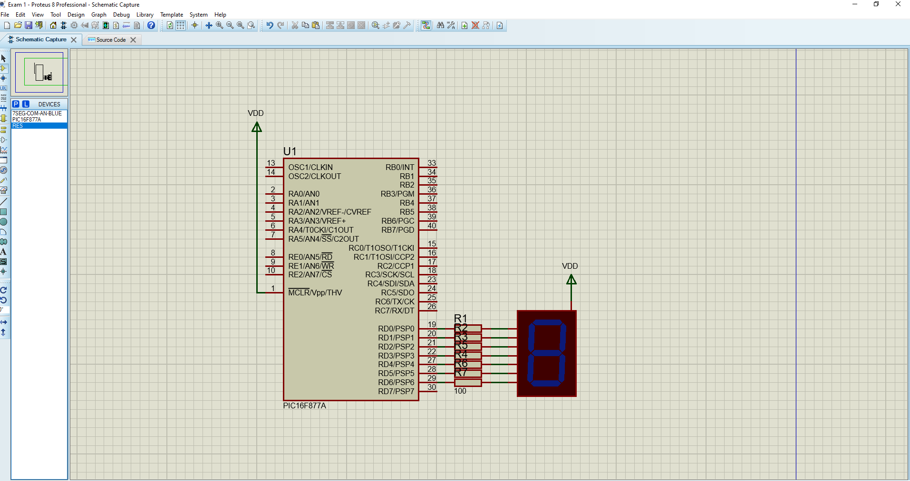
Q1) a) Circuit of 7 segment display with current limiting resistors connected to PORTD of the PIC16877A

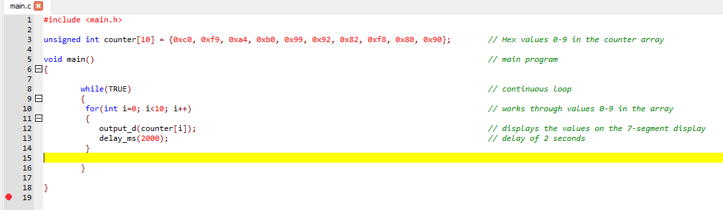
b) Code for the PIC to count from 0-9 in 2 second intervals between each number

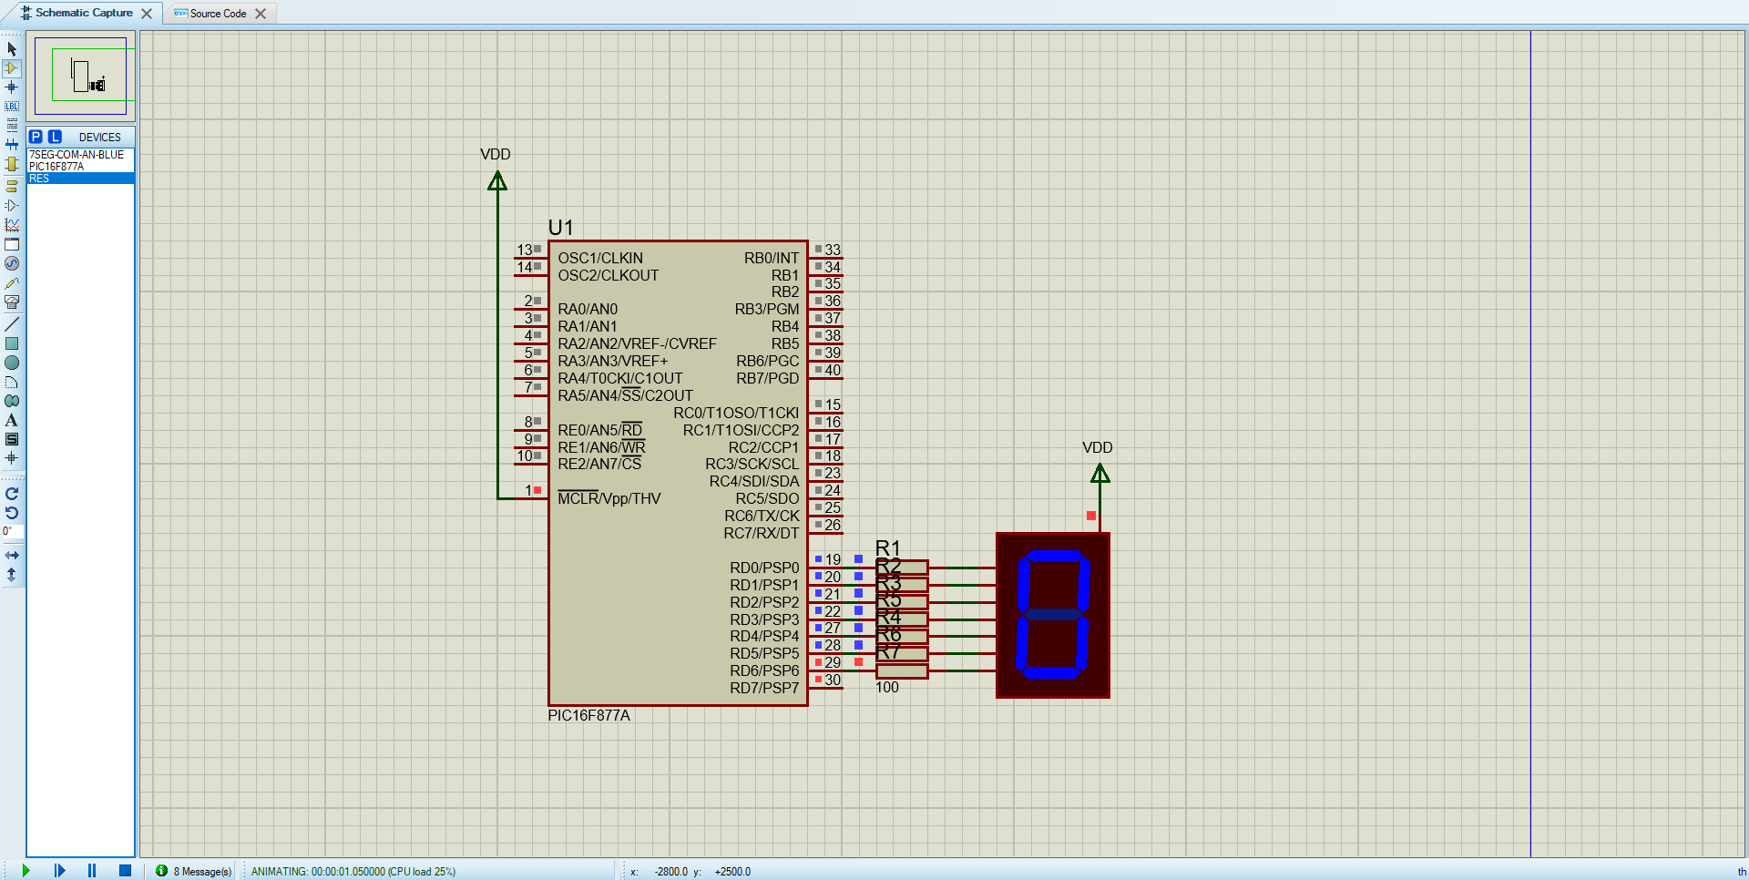
c) Verification the simulation works
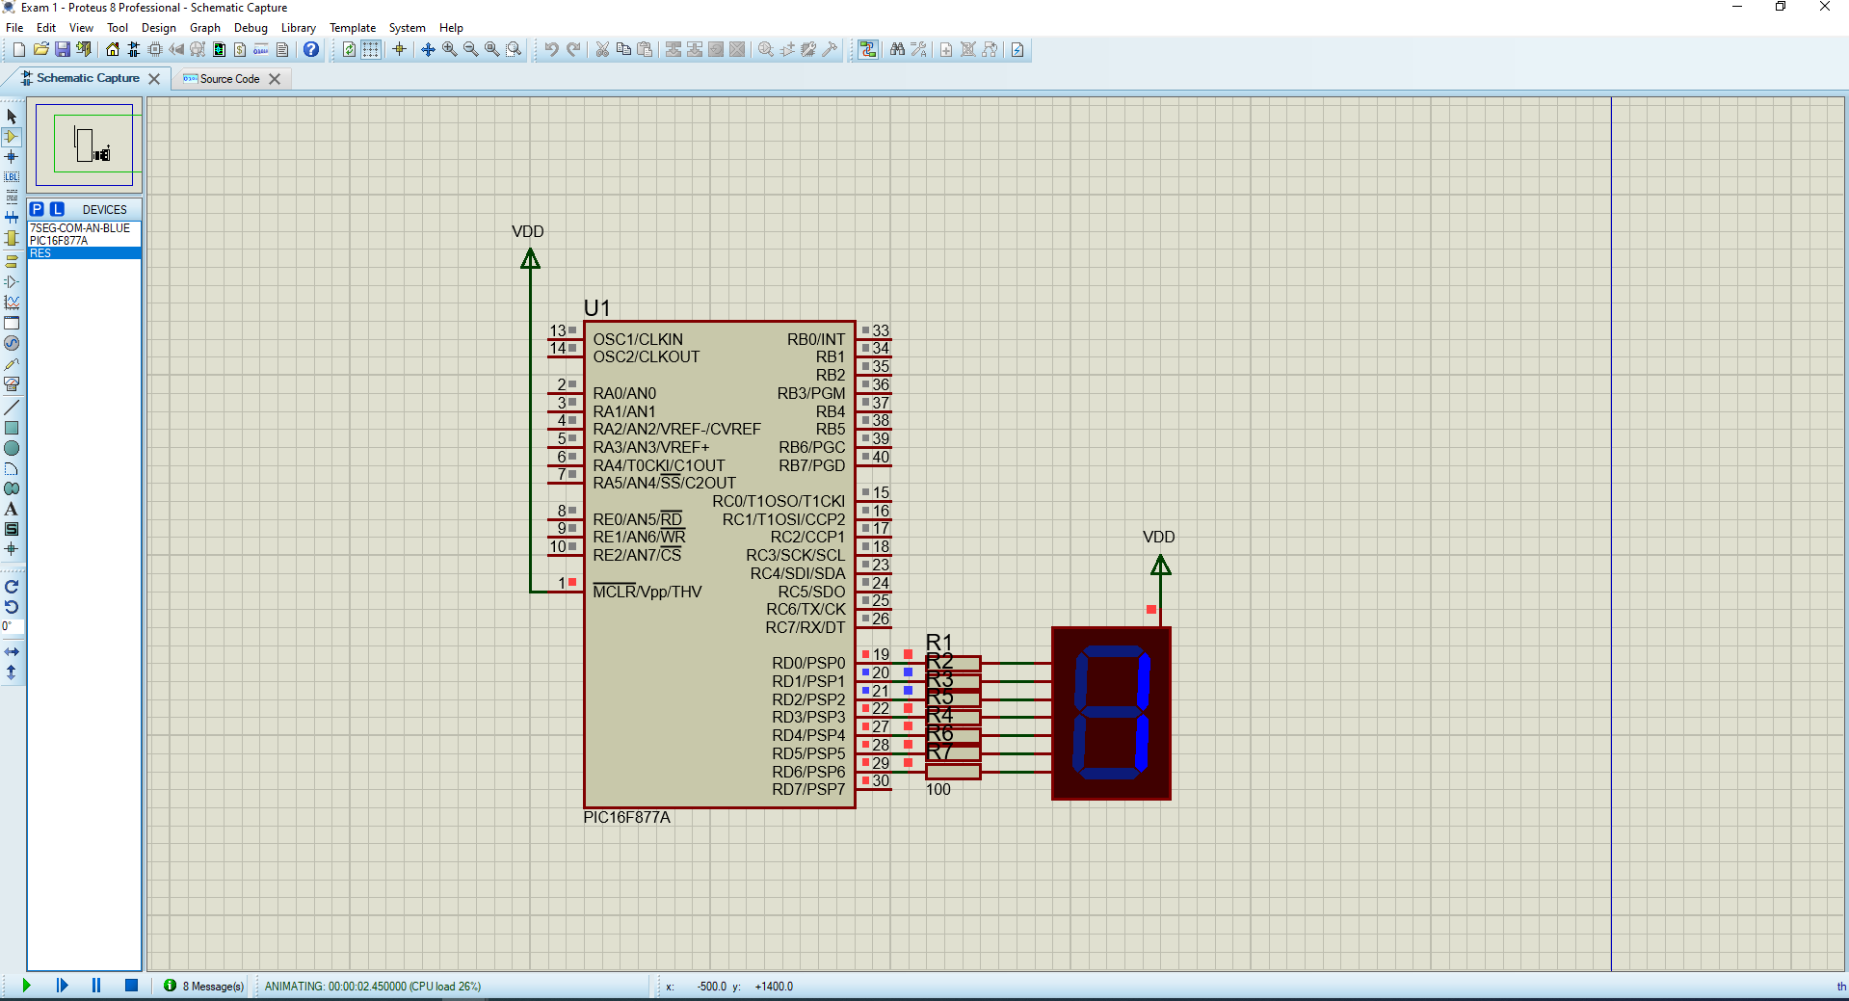
at 0 seconds of the animated time, the display shows 0.
At 2 seconds of the animated time, the display shows 1, showing the counter is changing value every 2 seconds.

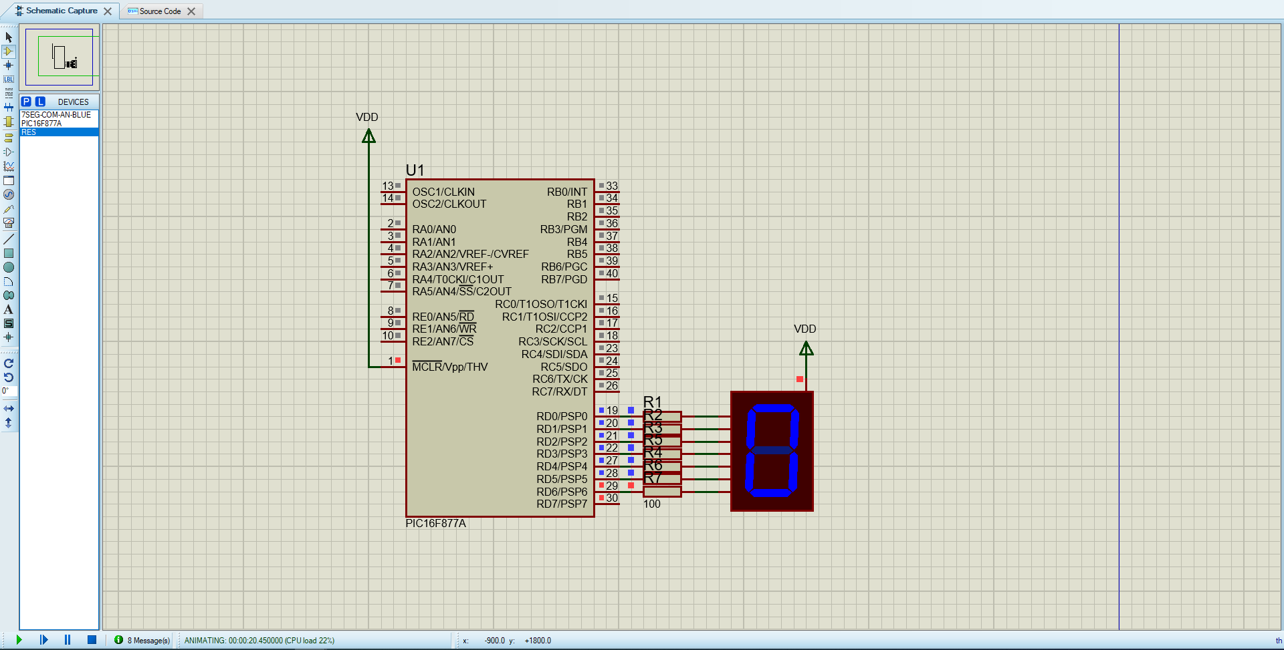
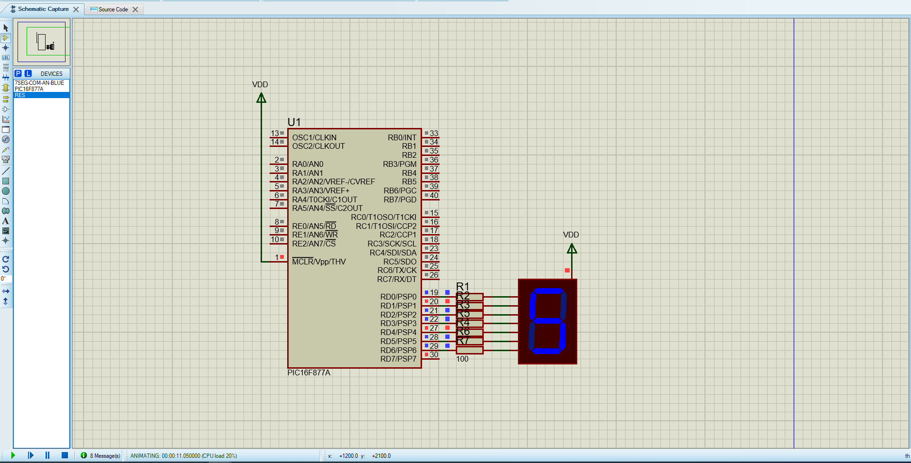
at 10-12 seconds of the animated time, the display shows 5
when the animated time reaches 20 seconds, the display is at 10/0 restarting the count from 0-9. This proves the counter works counting from 0-9 seconds at 2 second intervals.

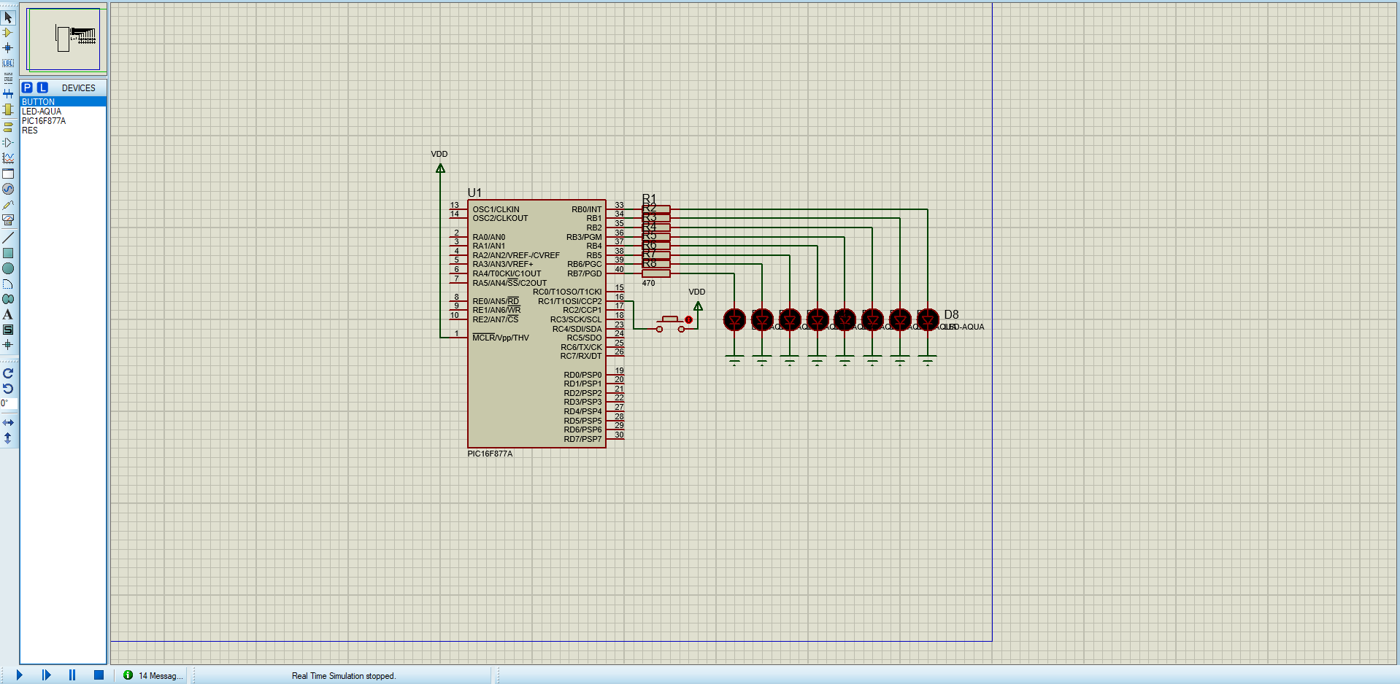
Q2)a) Circuit of the LEDs with 470 Ohm current limiting resistors, with a push button on C1 (second pin of PORT C) connected to the PIC16F877A
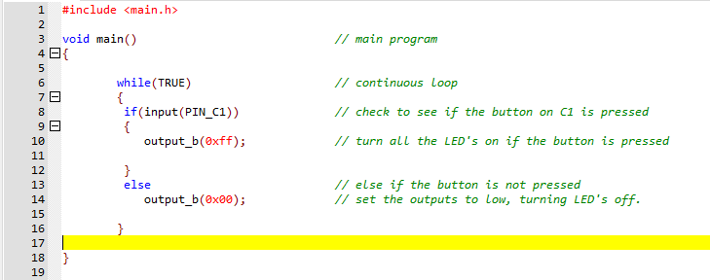
b) Code for the PIC to make all the LED simultaneously turn on when the button is pressed, and turn off if the button is released

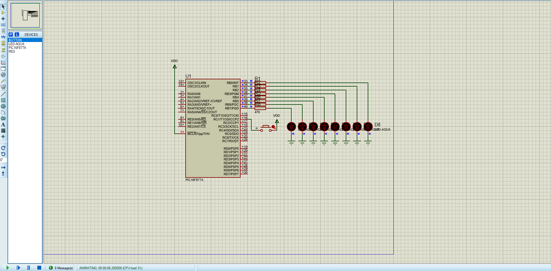
c) Verification the code works:
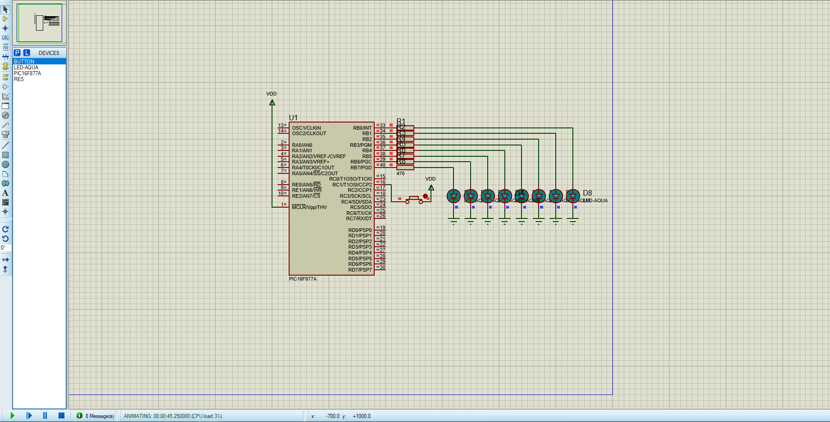
LED’s are initially off when the button isn’t pressed
When the button is pressed, the LED’s turn on

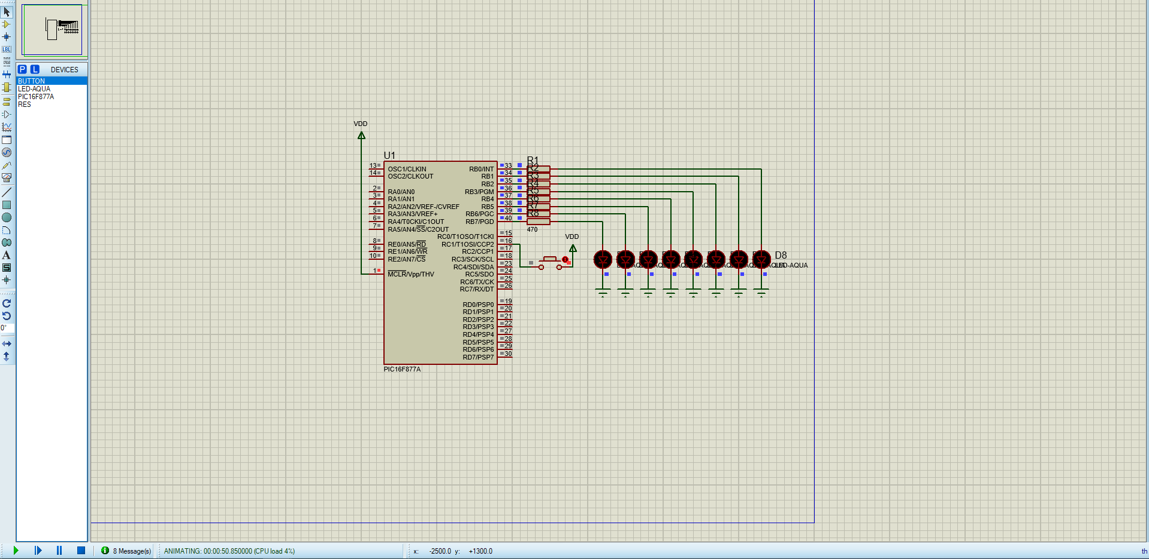
When the button is released, the buttons turn off

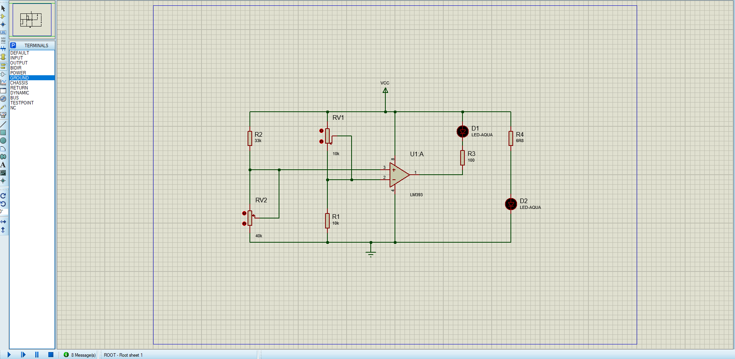
Q3) c) Designed and simulated circuit in Proteus
Circuit designed in proteus
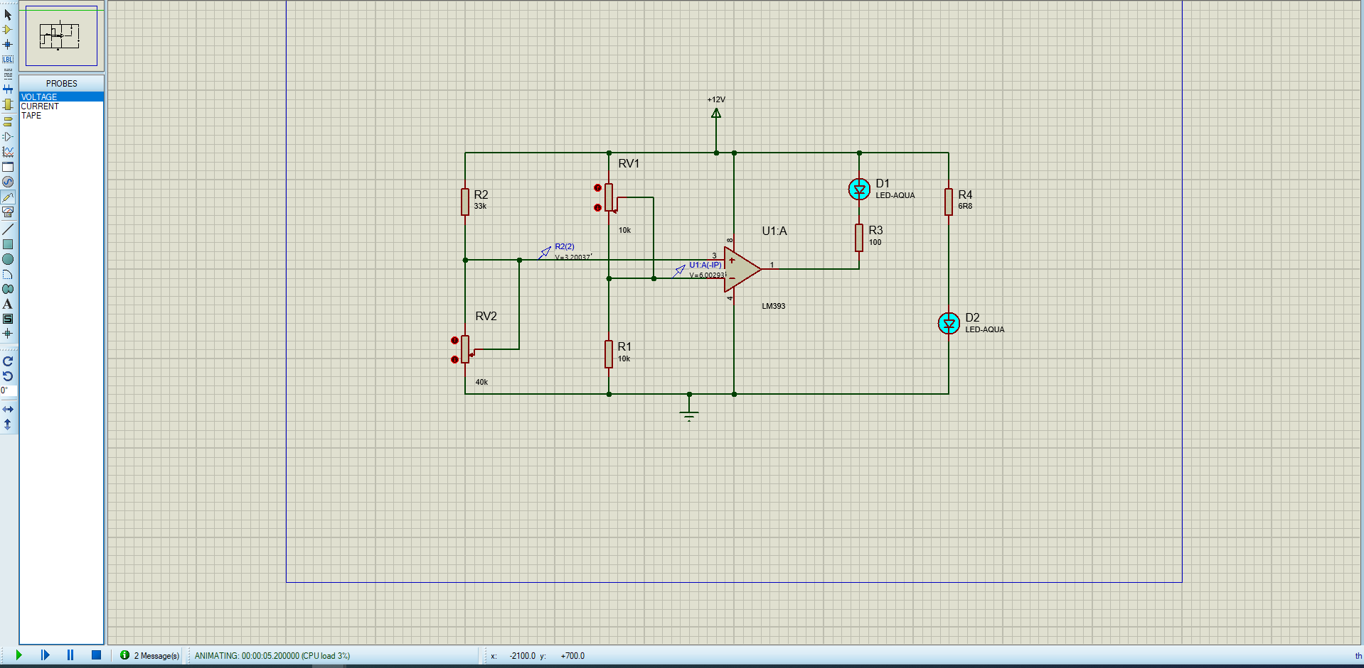
The simulated results can be seen below:
When humidity is high, resistance is low, voltage is low, non-inv is less than the inv input voltage, LED indicator comes on indicating moisture

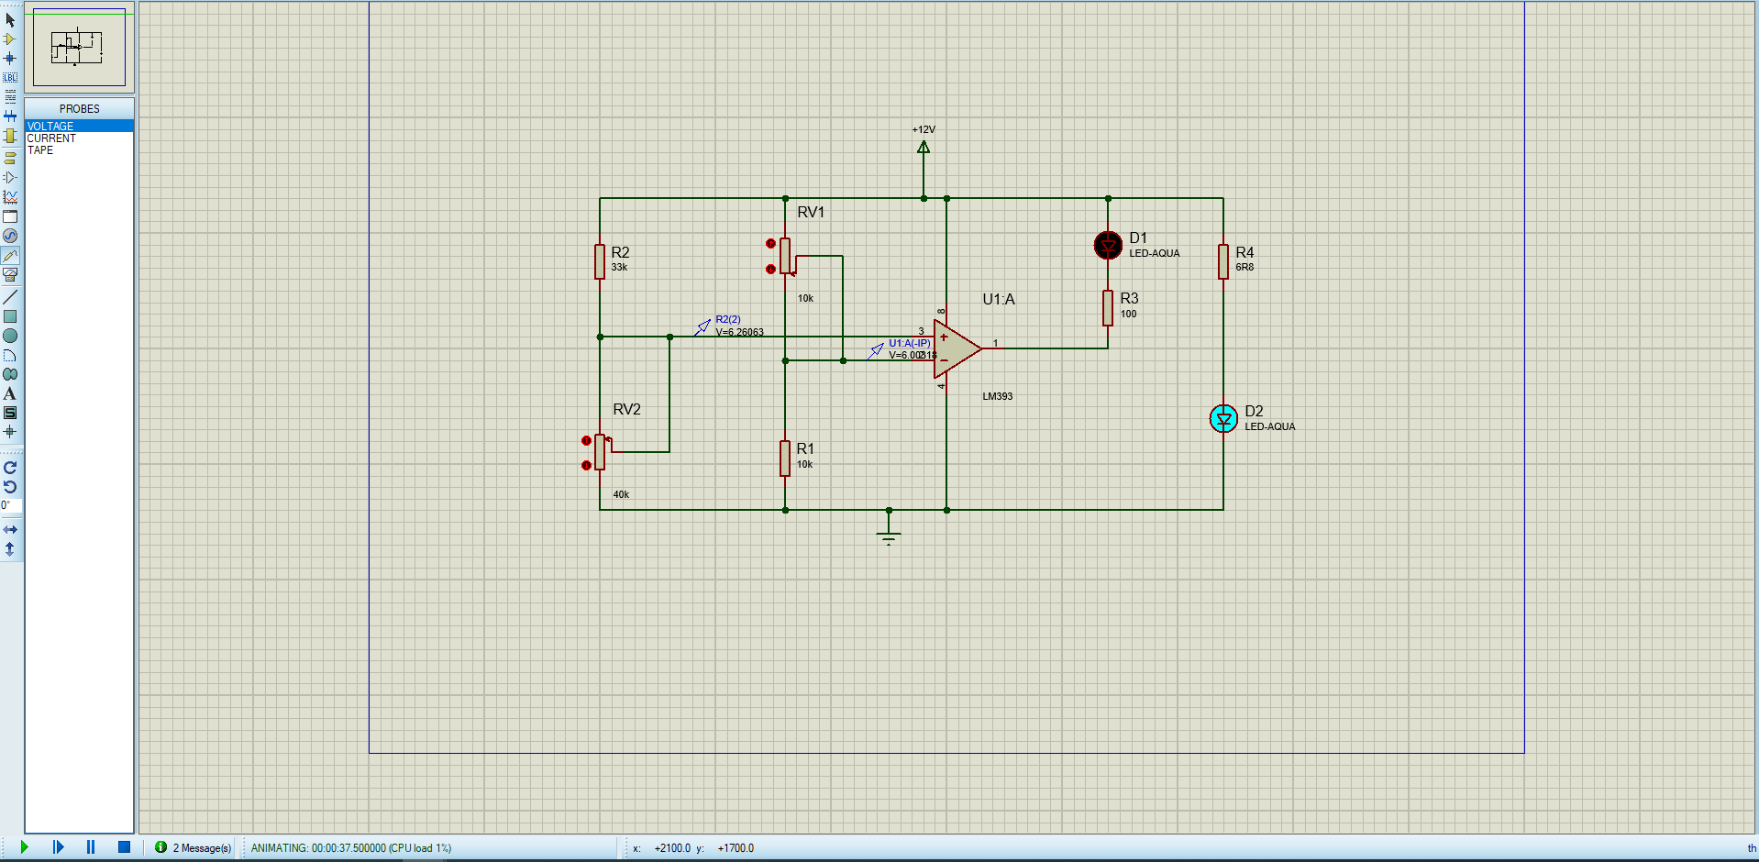
When the humidity/moisture drops, the resistance increases, increasing the voltage of the potential divider. When the non-inverting input is greater than the inverting input voltage, the LED indicating moisture turns off.

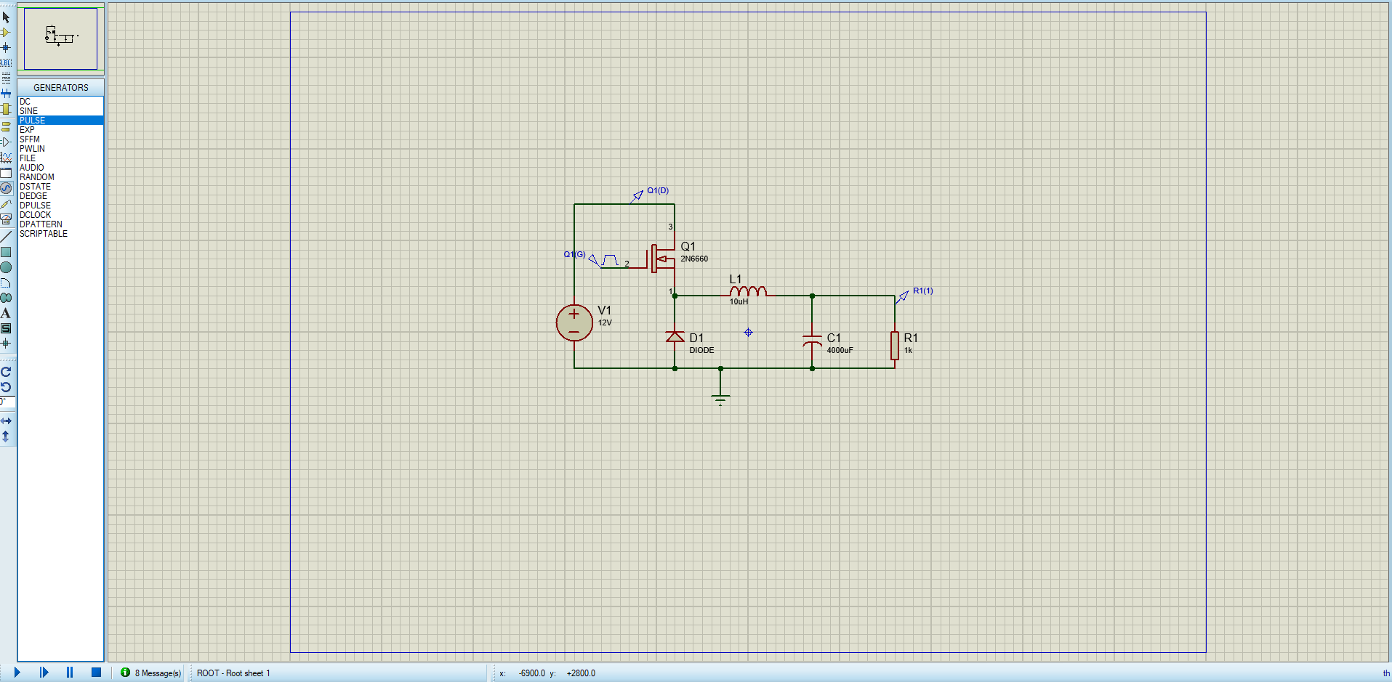
Q4) C) design and simulation of a switch mode power supply buck converter on proteus
Buck converter SMPS circuit designed on proteus

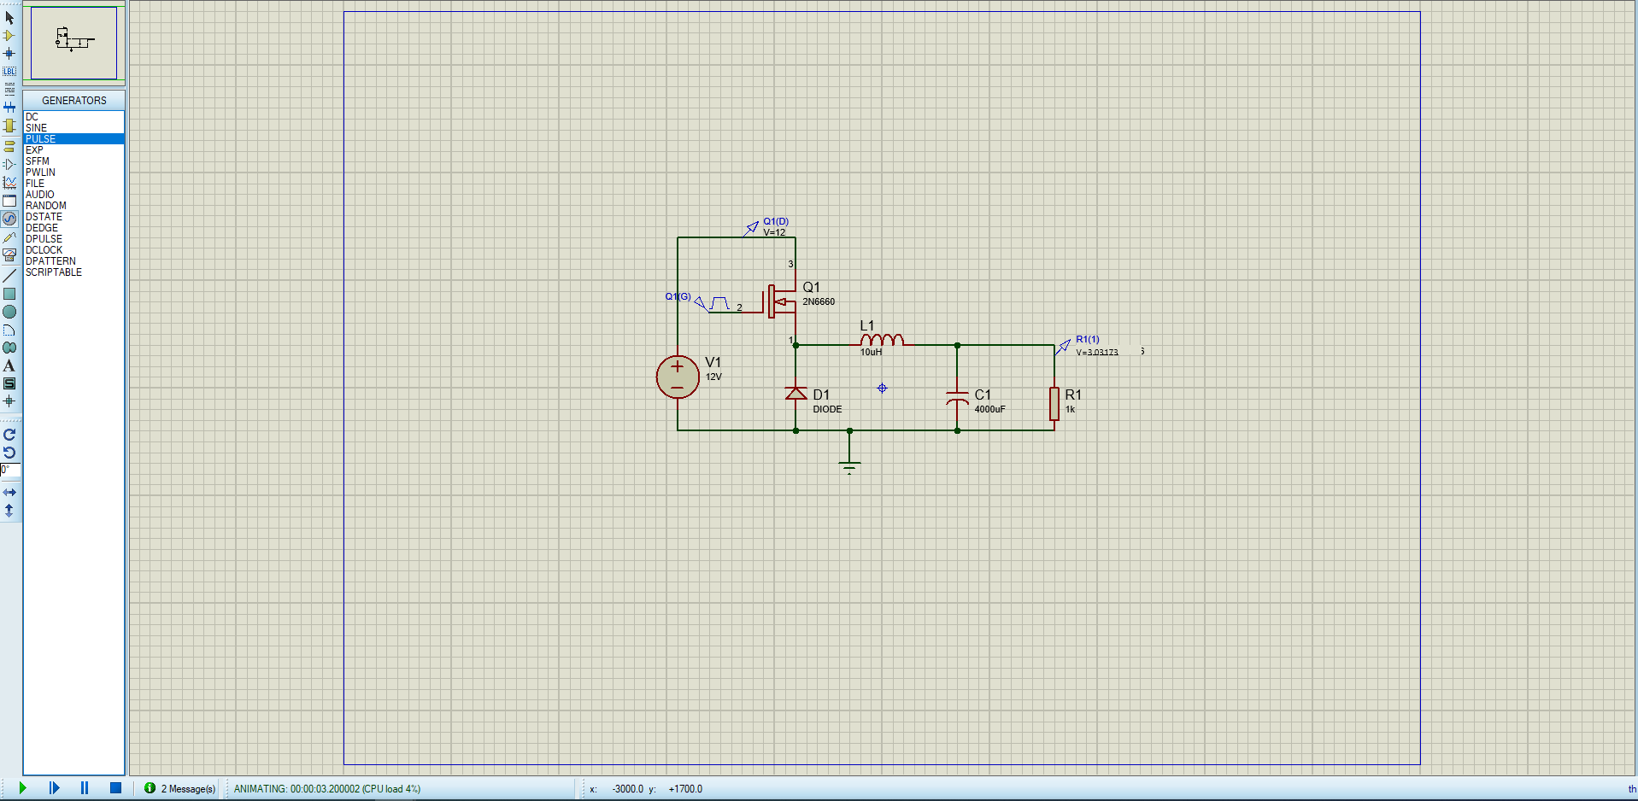
The buck converter takes the 12V DC input down to a stable 3V which could be used to power a microcontroller. The external pulse generator is set to 20Hz to switch the MOSFET on and off.

