The role of the professional within the Construction Industry

Created By:
Tomos Morgan Williams

Created For:
Sheila Holmes

Contents
1.0 Professionalism and ethics in construction 1
1.1 The importance of Professionalism and ethics within decision making in the construction industry. 1
1.2 Grenfell Tower Incident 2
1.3 Measuring professionalism within the construction industry 3
2.0 Professional Development 4
3.0 Leadership 6
3.1 Leadership Styles 6
3.2 Personal Experience of Differing Leadership Styles 9
3.3 Personal statement about my own leadership style, philosophy and key approaches 10
4.0 Teamwork 10
References 12
Appendices 13

Professionalism and ethics in construction

1.1 The importance of Professionalism and ethics within decision making in the construction industry.
When it comes to the construction industry, professionalism and ethical standards are extremely essential components. In addition to resources and a solid understanding of construction techniques, complicated construction endeavours call for a significant financial investment. To be able to satisfy the strict standards set on the projects that they work on in terms of completion time, cost, and quality, it is vital for all parties involved in the sector to behave themselves in a manner that is both professional and ethical. This is the only way that they will be able to succeed. When it comes to making judgements in the construction industry, professionalism is a fundamental must. Maintaining high moral standards and conducting one's company in a manner that is helpful to one's clients as well as one's employer and the general public is something that is expected of professionals who work in the industry. This necessitates decisions being made based on criteria that are both fair and objective, the requirements and concerns of all parties concerned being taken into consideration, and the credibility of the profession being protected at all costs. When it comes to making judgements in the construction industry, adhering to ethical standards is an absolute must. Construction projects may have significant effects not just on the environment but also on society and social life. As a consequence of this, industry professionals have the obligation to ensure that the decisions they make are both moral and sustainable by taking into consideration the long-term impacts of their actions on both people and the environment. This responsibility falls on them because of the fact that they are in a position to make such decisions. Ethical dilemmas span a wide variety of topics, such as social responsibility, safety, the effect on the environment, engagement in the society, and many more. The professionals who work in the construction sector have a responsibility to make sure that the decisions they make do not put the health or safety of their workers, the general public, or the environment in peril. This obligation extends to all three of these groups. They are expected to consider the social and economic impacts that their activities will have on the community surrounding them and to make an attempt to minimise the impact of any unintended consequences. Additionally, they are obligated to think about the effects that their actions will have on the community around them. When it comes to selecting choices in the construction industry, both professionalism and ethics are necessary components. The professionals who work in this industry have a responsibility to follow high ethical standards, to behave in the best interests of the public and of their clients, and to take into consideration the way in which their decisions will have a long-term influence on both society and the environment. By conducting themselves in this manner, they are in a position to provide assurances regarding the completion, longevity, and overall integrity of construction projects. (Anon, 2022).

1.2 Grenfell Tower Incident
The disaster that occurred at Grenfell Tower is a heart breaking illustration of the disastrous impacts that may occur when individuals working in the construction industry lack both competence and ethics. This tragedy occurred as a result of those working in the construction industry lacking both expertise and ethics. The fire that broke out at Grenfell Tower in June 2017 was responsible for the deaths of 72 people, countless injuries, and the eviction of a huge number of additional individuals. This disaster was brought about by a variety of different factors, the most important of which were the use of flammable cladding and the absence of proper fire safety precautions. The catastrophe that took place at Grenfell Tower brings to light the importance of an organisations adhering to the norms and standards that have been set up for it within the industry. The outside cladding of the Grenfell Tower did not meet the requirements for fire safety and was not intended to be put on structures of that height. This disdain for the standards and guidelines of the company is symptomatic of a lack of professionalism and a contempt for the requirement to place safety ahead of the necessity of placing an emphasis on either productivity or cost. The terrible event that took place at Grenfell Tower has raised moral concerns regarding the responsibilities of industry experts to act in the best interests of the general public. The installation of combustible cladding was given the go light by a variety of construction partners, including the owner of the building, the builders, and the manufacturers. These decisions were made with the purpose of making financial savings rather than taking into mind the health and safety of the tenants of the building, which was the reason why these choices were made. In addition, because there is a lack of accountability and openness in the construction industry, there is the potential for ethical issues to surface. The public inquiry that was undertaken into the disaster that occurred at Grenfell Tower discovered a culture of secrecy and non-disclosure. This meant that important information regarding the safety of the building and the utilisation of materials that did not conform with rules was kept hidden from the general public. In conclusion, the tragedy that occurred at Grenfell Tower shows the necessity for the building sector to maintain high standards of ethics and professionalism. The use of materials that do not meet the criteria of the industry as well as fire safety measures that are insufficient demonstrates a disdain for the norms of the industry as well as a preference for safety above the efficacy of the use of resources. A problem that has to be addressed on a moral level is the lack of accountability and transparency that exists in the construction business. This lack of accountability and transparency puts people's lives in danger and erodes public trust in the industry. Workers in the construction industry need to make safety a top priority and conduct themselves in an open and honest manner this will help prevent catastrophes like the one that occurred (Voutsadakis, 2018).

1.3 Measuring professionalism within the construction industry
In the construction sector, determining who is professional and who is not may be challenging. There are, on the other hand, a number of important indicators that may be used to evaluate the degree of professionalism possessed by persons and organisations operating within the sector.
- Certificates and licences: The acquisition of certificates and licences is one of the most obvious markers of professionalism in the construction sector. These serve as certification that a person or organisation has received rigorous training, completed tough examinations, and exceeded a set of fundamental knowledge and competency criteria. They can be awarded to either a people or an entity. Construction sector certifications and licences include the Project Management Professional (PMP) certification, the Leadership in Energy and Environmental Design (LEED) certification, and state contractor licences.
- Adherence to Codes and Standards: Adherence to Codes and Standards is an essential component of professionalism in the building and construction sector. In order to guarantee the safety, usability, and conformity of their projects, construction professionals are required to adhere to many industry standards, including building regulations, safety legislation, and others. The degree to which these policies, procedures, and standards are adhered to is a reliable measure of professional competence.
- Work Productivity: In the building and construction sector, a person or organisations work productivity is an essential indication of their level of professionalism. The work that is produced by professional constructors, engineers, and architects is of a high quality, fulfils or surpasses the requirements of the project, is finished on time, and does not go over the allotted budget.
- Competence in Communication: The ability to communicate effectively is a defining characteristic of professionalism in any business, and the construction industry is no different. Professionals who communicate with their customers, those who have a stake in the project, and other members of the team in a way that is both clear and effective have a greater chance of being seen as competent and professional.
- Professional Conduct: Conduct that is consistent with a professional is essential in the construction sector. People and businesses are given the impression of being more professional when they behave in an appropriate manner and treat their stakeholders, customers, and co-workers with the utmost respect, integrity, and honesty.
To recap, assessing whether or not someone is professional in the construction sector may be difficult and very subjective. If, on the other hand, we look at things like certificates and licences, adherence to norms and standards, job quality, communication skills, and attitude professionalism, we might be able to gain a sense of the amount of professionalism that individuals and organisations in the organisation possess.

2.0 Professional Development

It is critical to one's personal and professional development to understand the organisational behaviour of the businesses in which they work because this knowledge is required for one's evolution, and this ability is required for one to grow both personally and professionally. Understanding the organisational behaviour of the organisations in which one works is critical to one's development and should be prioritised accordingly. Organisation behaviour or, more colloquially, org behaviour refers to the study of how individuals behave while working within an organisation, as well as how they interact with one another, their environment, and the tasks they are responsible for. Its full name is organisational behaviour. Organisational conduct is also known as org behaviour. Because organisational behaviour is regularly used to summarise organisation behaviour, the phrase "org behaviour" is widely used to refer to organisational behaviour. This field of study includes the investigation of topics like as organisational culture, decision-making and decision-making processes, as well as collaboration and motivation. This area of study focuses on organisational culture in particular. Individuals may get a better grasp of how companies work as well as the factors that contribute to a firm's success or failure by participating in the study of organisational behaviour. People may have a better understanding of these issues by expanding their knowledge in this specific approach. People who have access to this knowledge may be able to improve their leadership and communication skills, as well as their decision-making abilities and interpersonal connections with team members and co-workers. You may be able to gain these talents if you have access to this information. There is a potential that this might be improved. Furthermore, people will have the opportunity to enhance their decision-making abilities anytime they are given the chance to do so, assuming that the opportunity is offered to them.
A complete understanding of organisational behaviour may be useful for an individual’s personal growth as well as advancement in general in a variety of circumstances, including the following:
- Improving ability to express oneself verbally and communicate with others. Employees that attend organisational behaviour courses learn about the various communication strategies employed by various people, as well as how to effectively communicate with a wide range of people in general. This material is provided to workers in order to better prepare them for working in a diverse work environment. It is possible that this will improve not just people's personal ties, but also their interactions in their professional life. This knowledge may be beneficial to both of these types of interactions.
- The development of one's own leadership potential as well as one's leadership capabilities. Those seeking to build adaptive leadership traits that can be applied in a number of scenarios may find that understanding how businesses operate can help them achieve this aim. These characteristics include the ability to adapt to and perform successfully in a variety of scenarios and work conditions. These abilities may be used to effectively lead other individuals and groups of people in a number of situations. They will have a higher chance of understanding how to motivate and inspire team members if they acquire the relevant abilities. In the course of learning, they may also discover how to make educated decisions and how to successfully resolve conflicts. As a result, they may have the opportunity to learn the skills required to understand how to motivate and inspire team members.
- Fostering an environment that honours the contributions of individuals who collaborate and work as a team. Individuals learn how to connect with their co-workers in a constructive and productively relates them to their occupations via the study of organisational behaviour. To do this, staff must be trained on how to overcome differences and collaborate with their co-workers to achieve common goals.
- Improving one's ability to inspire and encourage not just oneself but also others: Individuals may increase their capacity to inspire and motivate not just themselves but also people in their immediate area by acquiring a deeper awareness of what drives them. They are capable of making appropriate use of this information, which will be extremely beneficial to them in achieving both professional and personal objectives.
- The development of a healthy corporate culture in which the firm's actions can stimulate openness, cooperation, and communication among employees, so contributing to the creation of a more pleasant and enjoyable working environment. It is possible that workers will find this useful in increasing their levels of satisfaction with the activity in which they are participating.
People can become more productive in both their personal and professional lives if they learn about organisational behaviour that might help them. This is possible because organisational behaviour may help people. Individuals may benefit from the transmission of this knowledge in a variety of ways. It has the potential to help individuals improve their communication and leadership abilities, boost their ability to cooperate effectively in groups, and promote a healthy culture inside a firm. Its application may result in all of these advantages. The usage of this technology provides the possibility to benefit from the entire range of these potential benefits. One technique that individuals may adopt to boost their chances of success in any business is to engage in their own personal development by studying organisational behaviour. This is one method through which individuals might boost their chances of success. Several techniques to attaining this aim are feasible. This is true whether or not they work in a completely different area of the economy. Individuals have the choice of resolving the problem in this way, which is available to them (anon, 2022).

3.0 Leadership

The study of leadership theories is crucial for any aspiring professional who aspires to become a successful leader because an understanding of such a concept may help the evolution of the knowledge and abilities necessary for such a job. This understanding is essential for any aspiring professional who wishes to become a successful leader. Leadership theories give a framework for understanding the many different leadership styles and techniques that may be applied to create beneficial outcomes in a range of circumstances. These styles and methods can be used to lead an organisation, a group, or an organization's members. These management philosophies and approaches may be put to use to steer an organisation in the direction of accomplishing the objectives it has set for itself.

3.1 Leadership Styles
The following are the four basic types of leadership:
Pragmatist
Pragmatists don't only have high expectations for themselves; they also have high expectations for the people who work for them, and they want those employees to live up to those expectations. Pragmatists are people who are goal oriented and competitive, and they place the utmost priority on reaching their goals above all other worries. Pragmatists place the utmost importance on attaining their goals over all other issues. They have the ability to be fearless thinkers who are not afraid to take the path that is less travelled even in the face of disagreement or worry from other people. They are also dangerous drivers who frequently drive over barriers uncaring of the repercussions of their actions. The experience of working for Pragmatists can be challenging, but it also has the potential to be rewarding. People who are easily disheartened or who have sensitive skin should not apply for the position; nevertheless, those who are up to the task will have an unequalled opportunity to learn and grow as professionals under the leadership of the Pragmatist. There are instances when one could have the sense that they are working as an apprentice under a famous artist or educator. There is a possibility that this may lead to amazing intellectual development, but there is also the possibility that it could tyre people out and bring criticism. However, Pragmatist employees may discover that outcomes on the bottom line may occasionally transcend more subjective measurements like employee engagement. This is an excellent opportunity for those who are qualified to take advantage of it. Given that Pragmatist employees have a greater propensity to be pragmatic, this is a distinct option (Murphy, 2022).

Idealist
Idealists are high-energy achievers who have trust in the great potential that is possessed by each and every person. Idealists have a positive outlook on humanity. Idealists are driven by the desire to broaden their knowledge and progress their careers, and they encourage those around them to do the same. They exude a great level of charisma, and people are drawn to them due to the fact that they are extremely perceptive and idealistic. They are not resistant to novel concepts and place equal weight on both the ideas they generate and those generated by others. Working at Idealists allows you the freedom to express your creative side while also letting your true self shine through. The employees eventually realise that they can all be heard, and they gain knowledge as a result of this realisation. Working for the Idealist frequently gives the impression of taking part in very democratic procedures. When opposed to other sorts of leaders, such as stewards, there are less processes and structures in place. This can be considered as either a positive or a hindrance, depending on the individual, because there are fewer procedures and structures in place. When leaders have idealistic inclinations, they may often be seen engaged in creative activities, such as brainstorming with other individuals who share their beliefs. This is a common sign of an idealistic leader. A position at the Idealist can be a game-changer in one's professional and personal life for those who are qualified (Murphy, 2022).

Steward
The most essential members of every institution are the stewards of the organisation. They are dependable, trustworthy, and helpful, and they serve as a force that is both stabilising and soothing for the team that they are on. The responsibility of ensuring that there are norms, techniques, and collaboration falls on the shoulders of stewards. They follow the notion that a chain is only as strong as its weakest link, and as a consequence, they move at a speed that is no faster than what the capacity of the entire chain enables, taking care and making time to assist individuals who are having problems keeping up with the rest of the group. They move at a rate that is no faster than what the capacity of the entire chain permits. Working at Stewards provides you with the opportunity to take part in a system that is both well-organized and effective. The atmosphere encourages employees to have a sense of harmony, continuity, and stability in their work. In this area of work, there are not many opportunities for individual glory or a surge of adrenaline, but there are numerous opportunities for the team to be successful. Stewards are often stationed in the organization's mission-critical areas, and executives in other divisions frequently rely on them for advice and assistance. There is a significant presence of stewards in all mission-critical areas. Working as a Steward might be an excellent choice of profession for those individuals who meet the requirements (Murphy, 2022).
Diplomat
In order to be effective in diplomacy, it is vital to have the capacity to maintain amicable relationships. They fulfil the role of the social and affiliative glue that brings together a variety of diverse groupings. Diplomats have a reputation for being courteous, friendly, and generous people, and they tend to form close personal bonds with the staff members with whom they are employed. They have a reputation that is well-deserved for being able to resolve issues quietly and for avoiding confrontation in the first place when it is possible to do so. They are known for being able to handle disagreements amicably. When opposed to working for other types of leaders, most notably Pragmatists, working for Diplomats is often more enjoyable and sociable than the alternative. This is especially true when compared to working for an Autocrat. Diplomats place less emphasis on pushing their people and instead position them in situations that allow them to maximise on their talents. This is in contrast to military leaders, who place more emphasis on pushing their troops. This is in contrast to other professions, like as the construction industry, in which the primary focus is on pressuring workers. Diplomats put in a lot of work to make sure that other people don't get anxious or uncomfortable sensations while they're around them. In most cases, it is discovered that the standard indicators of employee satisfaction for Diplomats are rather high. If you meet the requirements, finding work at the Diplomat might be the beginning of a very satisfying career path for you (LaNoue, 2022).

3.2 Personal Experience of Differing Leadership Styles
In the course of a group project that I had to do in work, I saw how different types of leadership had a significant impact. The committee was tasked with developing a plan for the company's FSM (Free School Meals) Programme, and each individual member was assigned specific responsibilities to carry out. One member of the team quickly took charge and adopted an authoritarian leadership style, which included making choices on their own and dictating how the task should be carried out. This led to discord inside the group, with some of the members claiming that their ideas and efforts were not acknowledged or taken into consideration.
The analysis of this event can benefit from the application of a number of important leadership theories and models. The transactional theory of leadership, which is connected with the authoritarian leadership style, comprises a leader that either rewards or punishes team members based on how well they accomplish their assigned tasks. This strategy may be useful in some circumstances, but it also has the potential to foster hostility and low morale among members of the team. On the other side, the diplomatic leadership style is consistent with the notion of transformational leadership, which entails a leader who inspires and motivates team members to reach a shared objective. This type of leader is referred to as a transformer. This strategy has the potential to generate stronger levels of participation and buy in from team members, in addition to improved results. The authoritarian leadership style of the group member did not effectively engage or motivate the team in this scenario since it was not appropriate for the situation. A more diplomatic approach, in which all members of the team were engaged in decision making and felt valued, might have resulted in better outcomes and made the process more pleasurable for everyone involved.
Last but not least, it is essential for each aspiring professional to be familiar with various leadership ideas. The appropriate leadership style may make or break favourable outcomes, and different contexts call for the use of a diverse range of leadership styles and tactics. In the group project that I watched, an authoritarian leadership style did not provide the desired results, but a more diplomatic approach may have resulted in better outcomes. By gaining an understanding of and applying relevant leadership theories and models, aspiring professionals have the opportunity to grow the knowledge and skills necessary to become great leaders and achieve success in their careers.

3.3 Personal statement about my own leadership style, philosophy and key approaches
My approach to leadership is one that is democratic in nature and that actively invites involvement from the people who are responsible for them. As a result of the fact that we are going to utilise this strategy, it is up to me to decide what the team's objectives will be, to moderate their conversations about those objectives, and to make the ultimate decision. Having said that, I am also aware that the perspectives of others on a certain topic or approach may present me with information that is valuable to me, and as a result, I make it a point to ask them for their feedback on the issue. I believe that this awareness contributes to the fact that I make it a point to ask them for their opinion on the matter. As a direct consequence of this, I would most likely receive creative input and inventive ideas that I would not have been able to conceive of if I had been working by myself. These benefits would come to me in the form of immediate results. If I had been on my own when I was doing this work, I never would have thought of any of these ideas. As soon as I made the request for the team's involvement, it became my responsibility to address the various perspectives that were held by the members of the team. My objective is to create a situation in which individuals are able to engage in exchanges with one another that are rich in meaning, and it is my purpose to facilitate such interactions whenever possible. It is vital for me to serve as an example by exhibiting flexibility and openness in my own behaviour, to place a high priority on sustaining mutual respect, and to hone special talents in the field of conflict resolution in order to make sure that everyone participates in the activity. I can do this by demonstrating flexibility and openness in my own conduct.
It is essential for me to be conscious of the fact that the procedures have the possibility of becoming slow if members of the team are involved in each decision. It is imperative that I have this in the back of my mind at all times. Even if it is just for a little amount of time, I will need to exercise a great deal of judgement in order to determine whether or not I should adopt a more autocratic strategy.

4.0 Teamwork

To the best of my knowledge, successful cooperation requires the engagement of a number of different persons, each of whom brings a unique set of skills to the table in addition to their own distinct personality. Throughout the course of my studies, I've seen that successful groups share a number of features in common with one another. A devotion to the work at hand, open communication with one another, and mutual regard for one another are examples of these traits. These aspects are consistent with theories such as Tuckman's phases of group growth, which underline the significance of the forming, storming, norming, and performing stages in the development of the group throughout the course of time. These stages are listed in the order of forming, storming, norming, and performing. In terms of my own personal path, I have realised that effective communication is necessary for productive cooperation among members of a group if the group is going to be successful. This is something that I have discovered. It is the duty of the individuals that make up the team to interact with one another in a forthright and straightforward manner at all times. This is done to guarantee that everybody is on the same page and that any problems or worries are resolved as quickly as is physically possible. In addition, I have realised that it could be beneficial to have members of a team that come from a range of different backgrounds. This is something that I have seen. When individuals who originate from different places, have gone through different experiences, and perceive the world in different ways gather together, there is a possibility that they may bring to the table new ideas and views, which may lead to more effective decision making and the resolution of issues. This can lead to more effective decision making and the resolution of difficulties. This is in line with theories such as Belbin's team role theory, which postulates that every member of a team possesses a unique combination of strengths and limitations that may be used to the group's advantage if the proper opportunities are taken advantage of. This can be seen as an advantage for the group if the right opportunities are taken advantage of. This is consistent with the notion that every individual in a team possesses a one-of-a-kind combination of strengths and weaknesses that may be leveraged to the benefit of the group as a whole.
In conclusion, the experiences that I have had working with other people in a team atmosphere and seeing the supervisors that I have had have provided me with insight on how fruitful collaboration may be. Because of these experiences, I've gained some insight into the dynamics of productive collaboration. An open line of communication, mutual respect, a commitment to the task at hand that is shared by all members of the team, as well as a diversity of talents and points of view, are all crucial components for the establishment of effective teams. When individuals of a team demonstrate these traits, the team as a whole has a greater chance of reaching the goals it has set for itself and generating an environment that is conducive to the sort of work that is productive.

References
Anon., 2022. IMD. [Online]
Available at: https://www.imd.org
Anon., 2022. The team building company. [Online]
Available at: https://www.teambuilding.co.uk
anon, 2022. CIPD. [Online]
Available at: https://www.cipd.co.uk
Anon, 2022. designingbuildings. [Online]
Available at: https://www.designingbuildings.co.uk
LaNoue, 2022. criterion. [Online]
Available at: https://www.criterionhcm.com
Murphy, 2022. Forbes. [Online]
Available at: https://www.forbes.com
Voutsadakis, G., 2018. LSBU. [Online]
Available at: https://openresearch.lsbu.ac.uk/item/868q4

Appendices

Appendices 1.
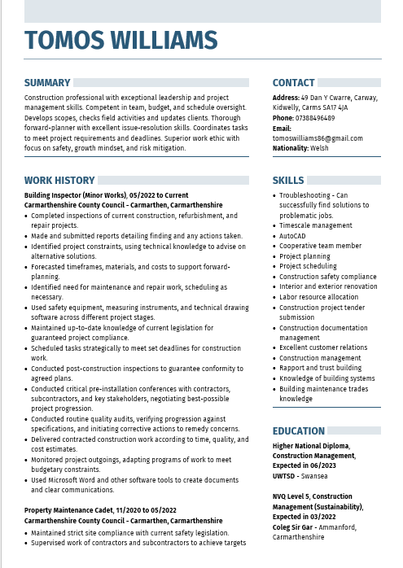
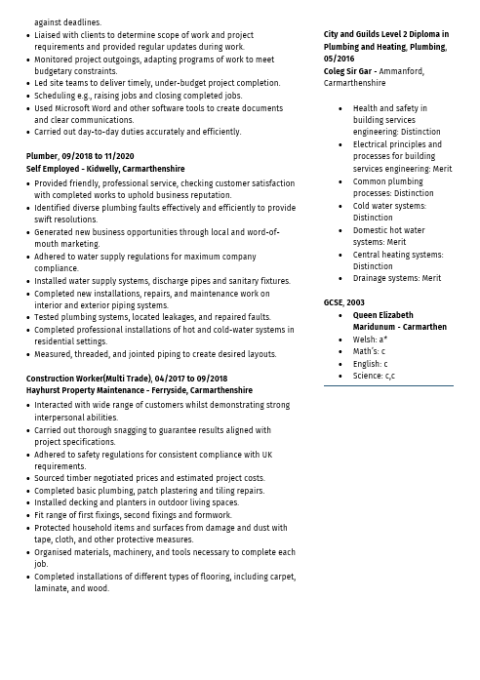



Appendices 2
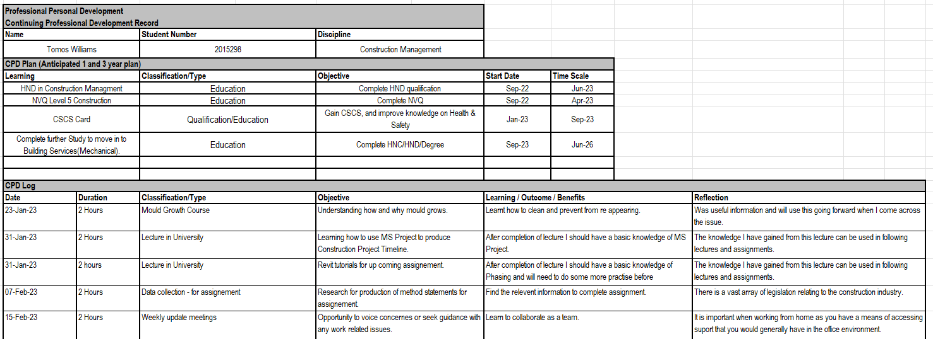
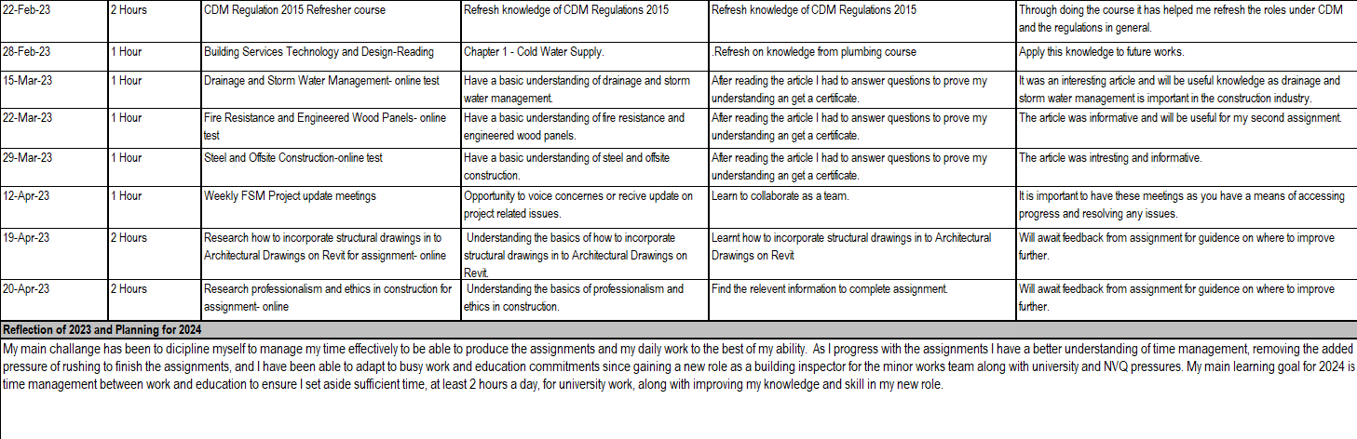

Appendices 3

Brief summary (bullet point list) of personal learning points gained across the module.
- Understanding the importance of effective communication in various contexts.
- Learning about different leadership styles and their respective strengths and weaknesses.
- Becoming aware of the different stages of team development and how to navigate them.
- Recognising the significance of emotional intelligence in interpersonal relationships and conflict resolution.
- Understanding the principles of effective decision making and problem solving.
- Learning about various motivational theories and how to apply them to increase individual and team performance.
- Developing an appreciation for the value of diversity and inclusivity in organisational settings.
- Learning about the ethical considerations involved in decision making and leadership.
- Understanding the impact of technology on the modern workplace and how to leverage it effectively.
- Developing critical thinking and analytical skills to evaluate complex organisational issues.

Overall, this module has provided me with a solid foundation in key concepts and theories relevant to organisational behaviour and management, which I can apply to a variety of real world scenarios.

