Sophie Louise Roberts (1904126)
ECGE4002- Academic Skills for Students
Level 4 Assignment Portfolio

Contents

- Page 1: Mind Map (Resources available to me as a student at UWTSD)
- Page 2: Current Audit Skills
- Pages 3-4: ‘What Success Looks Like to Me’
- Pages 5-7: Developing Critical Thinking
- Pages 8-10: ‘What I Think About Education in Wales’

Mind Map
Page 1

Current Audit Skills

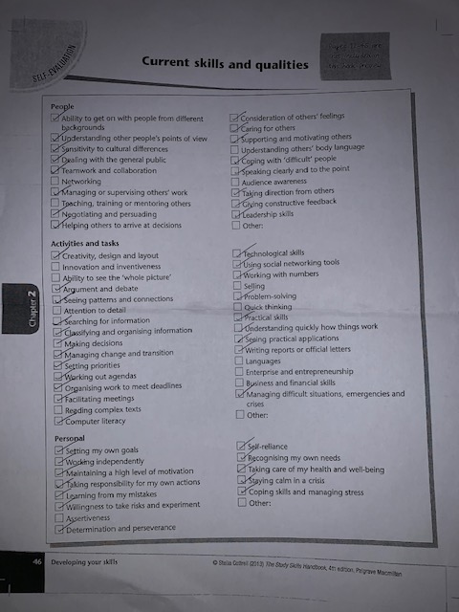

Page 2

What Success Looks Like to Me

To me, success is becoming an established and successful teacher with the ability to learn and better oneself continuously. To be able to be a part of this degree and come out with my goal of obtaining a 1st, I understand the need to increase skill levels within certain areas. I need to focus on critical reading and academic writing, and I am keen to do extra independent study and use the resources available, so that I can continue developing these skills. The University offers extensive resources to enhance skills, these include; library access to books and online resources; tutor led sessions and independent study tasks. The school experience days will also be a useful and insightful part of the study, to witness first-hand the current practice of learning and teaching between teacher and students. Then, being able to utilise those best practices to deliver a quality and inclusive education to young people. So that I can accomplish QTS and be able to teach the new curriculum ‘successful futures’ (Donaldson,2015), I will endeavor to be proactive and consistent academically throughout the degree. Coupled with determination and focus, these attributes will lead me to my desired qualification, and I will be able to teach and continue learning through experience to ensure our young people are equipped, skilled and educated for whatever lies ahead. In turn we can hope that children become ‘ethical, informed citizens of Wales and the World’ (Donaldson,2015) with our guidance and teaching of the new curriculum.
Page 3

Donaldson.G. (2015) Successful Futures: independent review of curriculum and assessment arrangements in Wales, Welsh Government.

Page 4
Developing Critical Thinking

Critical thinking Involves analysing and depicting evidence that supports an argument, assessing If the information is valid when presenting it in your work and when reading someone else’s work. In everyday life we utilise critical thinking, although it takes expertise, knowledge and enhancement of skills to scratch further than the surface, really examine what is in front of you, and dig below the surface. The first step of critical thinking is ‘recognising when we need to gain more information’ (Cottrell, 2005) and then select the right information at the right level whilst ensuring we recognise the predicate. Throughout this process, we take steps to ensure as much as possible, that the information is in fact true. As this will then lead to a more fair, structured and realistic conclusion.
In order to become a sound critical thinker, it requires development of ancillary skills such as analysis, observations and persuasion. It is vital to use a ‘structured approach to use doubt constructively’ (Cottrell,2005) and being able to put personal experiences and feelings to one side, to draw an appropriate conclusion solely based on evidence and research. It is important to remain focused on the validity of the information instead of being swayed by personal experience and feelings. This will ensure conclusions drawn are not biased and therefore valid, this is commonly known as ‘emotional self-management’. There are barriers when it comes to a person’s ability to think critically. These involve misunderstanding of criticism as criticism can be positive as well as negative in academic writing; We can overestimate our own reasoning abilities; we can find it difficult to challenge our own beliefs and this can leave us with mixed emotions; lack of methods and practice can affect the ability to critically think; mistaking information and missing important key facts and lastly, people can find it difficult to critique an expert, as this can leave a person feeling uncomfortable having to critique an ‘expert’ in that particular field. Of which could have many more years’ experience compared to the person giving the critique.
Page 5
In return of developing critical thinking, it comes with many benefits such as enhanced analysis skills; the ability to identify key points easier in a written piece e.g. Online article; knowledge on how to better get a point across in a life situation or a written piece of work; the ability to stay focused, coupled with improved attention and the ability to recognize if the text contains tautology and the points made are salience. These skills can benefit many areas of a person’s life and especially for students of which the assignments require heavy research and reference use.
People can develop their skills on critical thinking, but Bodner (1988) suggests students can ‘know without understanding’. He implies that chemistry students can learn in a classroom through books, but do not fully understand the information outside of the learning environment. He suggests the students need to ask questions to further deepen their understanding, such as ‘how do we know?’. Cottrell (2005) suggests that this could also stretch to students studying other subjects too. She also implies that people tend to ‘lean towards well known research, when this research could be outdated, has evidence of faulty reasoning and only based on a small population of the world’.Therefore, we need to use critical thinking in our work, to ensure validity of the evidence we want to incorporate into our own research. In summary, critical thinking is an essential skill in which you need to build upon, in order to become a successful writer and researcher in the academic field.

Bodner, G.M (1988) ‘Consumer Chemistry: Critical Thinking at The Concrete Level. Journal of Chemistry Education, 65 (3), 212-13.
Page 6

Cottrell, S. (2005) Critical Thinking Skills: Developing Effective Analysis and Argument, Hampshire, Palgrave Macmillan.

Page 7
‘What I Think About Education in Wales’

Education in wales has recently undergone a review by a current senior advisor to the Welsh Government, Professor Graham Donaldson. His radical report called ‘successful futures’ (2015) brings 68 recommendations which I assume, has the potential to create great teaching and learning in every Primary School classroom in Wales. The current curriculum I perceive to be focused on subject knowledge; is structured; timetabled; and has little space for movement. Foremost, educators are being ‘faced with the reality that one approach to teaching and learning does not fit all children’. (Roopnarine and Johnson, 2005, p.31). Children are taught at a steady pace within the curriculum instead of a pace that suits them individually with regards to abilities. The new report which rolls into Primary schools across Wales in 2022, focuses on less ‘watertight compartments but rather a means of organising the intentions for each child and young person’s learning’. (Donaldson. G,2005, p.39). This encompasses the need to reflect on individual progress and rate of learning, in order to effectively accommodate their needs in relation to education. This Is something I anticipate will create a positive distance between the current curriculum and the new ‘successful futures’ review.
In recent years there has been a decrease in the entries for Modern Languages. This is inferior to the entry levels before 2002, as ‘between 2002 and 2016 the entries for modern language at GCSE has dropped by 42%’. (Blake and Gorrara, 2019, P.25). It may be that limited knowledge or additional options being made superior to studying modern language, are contributing to these figures. It is suggested that ‘formal foreign language teaching starts at 11 and Is not compulsory past the age of 14’ (Blake and Gorrora, p.29). Therefore, this may also be contributing factors to the decrease in pupils choosing to enter. There are benefits of an increase in modern language selection including ‘career opportunities and the value of intercultural citizenship for pupils who are increasingly being positioned as global citizens within the school curriculum. (Blake and Gorrora, 2019, p.27). Which I believe can be a positive impact in Wales especially with trading partners German and French. The new curriculum ‘Successful Futures’ is going to put modern languages within the same category of Welsh and English in the Area of Learning and Experience; ‘Language, Literacy and Communications’. In my opinion, this will broaden the recognition of modern Language and will put it back on the map when it comes to pupil’s choosing their study options. Therefore, improving Welsh pupils’ career aspects in the future.
Page 8
In my opinion, Welsh education has been consistent in putting the educational needs of children at the forefront of their reviews. In an ever-evolving world, it may have been an ample time for a curriculum review. Professor Donaldson has shown to breathe fresh ideas into the curriculum. Building upon the current Foundation Phase whilst incorporating digital skills which will improve the competency in young children whilst equipping them with skills to be successful in the future. In an uncertain time, surrounding Brexit, Donaldson’s review has made it concrete that education in Wales will continue to thrive without any uncertainty.

Roopnarine, J.L. and Johnson, J. E. (2005) Approaches to Early Childhood Education, 4th Edn. New Jersey: Pearson Education.
Blake, S. and Gorrara, C. (2019) ‘Evaluating student mentoring as an intervention to support modern foreign language learning in secondary schools in Wales. Wales Journal of Education 21 (1), pp.24-45.
http://dx.doi.org/10.16922/wje.21.1.3
Page 9
Donaldson, G. (2015) Successful Futures: Independent Review of Curriculum and Assessment Arrangements in Wales. Available at: http://gov.wales/sites/default/files/publications/2018-03/successful-futures.pdf (Accessed: 25th October 2019).
Page 10
Page 10

