

Student name: Alisha Leigh Gocaj
Student ID: 2110659
Module name: Changemakers: Creativity and Value Creation
Topic: E- Portfolio
Module code: BMHP5014
Lecturer name: Eleni Koutsogeorgou

Content page

1. introduction

2. Artifact About the Flyer

3. Artifact on the Pitch

4. Conclusion

5. Refrences

Introduction
Tenagers and young adults with a neurdevelopment disorder are left out in soceity such as, group discussions, group activities, school activities, and even the workplace. This is because they are often judged on based on their disorder and their develompment needs. Neurodevelopment disorder is a range of functional problems that share similar dissabilites Such as (ADHD) attention defict hyperactivity disorder, autism spectrum disorder, learning disorder and, intellectual and communication disorder. Therefore, affect their social skills which could lead to loneliness and stress. (Morris, et al (2013)
Therefore, this e-portfolio will focus on teenagers and young adults and discuss why I chose this topic. I have chosen two artefacts, flyer and an evelated pitch. The purpose of these two is to advoctae an exsisting project in the local area where it will demostrate an active role of leadership that shows support to a local Youth club for teenagers and Young adults with an neurdevelopment disorder. Furthermore, discuss the challenges of these teenagers and young adults and explain why there is a need for Youth clubs and why they are important in the society and the indiviuals well-being.
Building Visions offer a range of activities
The two artifacts chosen can be useful for sharing the local Youth club around in the area for teenagers and young adults with neurodevelopment disorders like the flyer/ leaflet which can help teenagers and young adults themselves to be aware that there is somewhere they can come and feel belonged. Furthermore, the evelated pitch can be useful to share ideas and ask for help to other charitys and sponsors also the local community to express that the Youth club is in need for funding.

1.0 Artifact Flyer

This artifact flyer is to advocate, engage, and invite teenagers and young adults aged 14-19 years old with a neurodevelpment disorder to Building Visions a local charity Youth Club for teenagers and young adults. Youth Clubs provide a space for individuals to socilise outside of schools where there are different pressures to be managed as well as, enhanching an individuals development by activities that are not able to run day to day. (Scally Mag, 2021) As at this age it is important that they have somewhere to come, to be themselves, learn social skills and, make friends. However, neurodevelopment disorder can affect the individulals social skills, lifeskills, socilasing and making friends, and commuication, therefore need a different centred approach. Chaing et al (2017) stated according to Sparrow et al (2005) it is essential to have an independent adult life therefore, the individual must have appropiate life skills. Such as, self care, social interaction, employment and, community particiapation. Teenagers and young adults espicially those with dissability needs such as. Autism, ADHD, and aspergers need to be included through equality and diversity. Building Visions offer Teens and young adults support they need so the individual is not isolated or left out as a result of their neurodevelopment disorder. Moreover, Building Visions offer a safe haven for teens to come and gain trust and support to the teens and young adults. The Youth Club has a range of activities to suit ages. The individual can practice socialising skills, and independence skills such as, cooking, and money handleing (budgeting) more variety of activies include; arts and crafts, dance and drama, sporting activities, cooking, games and play station and outdoor visits. Activities can provide enjoyment to help teenagers with neurodevelopment to develop new skills furthermore, to help their full capacity. (youth Scotland, n.d.)
Moreover, this flyer could help Parents/Guardians and Carers to know they are not alone and there is support to help them with their child with a neurodevelopment disorder. As well as, giving opportunities for them to meet other parents as they could also be facing challenges with their teen. According to Blain, (2022) studies found parents,carers are at greater risk of stress caring for their child with a neurodevelopemnt disorder then those without. Therefore, Building Visions offer a tearoom to welcome parents/Guardians where there are support groups.
This Flyer could be shared at schools in the local area, child services,

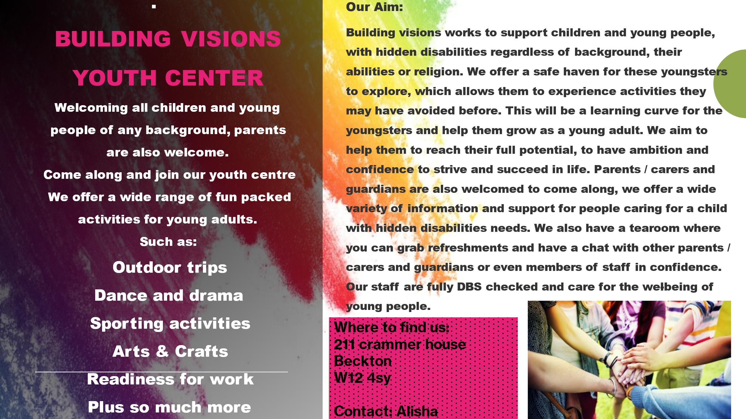

Artifact 2: Elevated Pitch
This artifact shows an elevated pitch. The aim is to get support from other charities, local councils and sponsor/sponsors to help with funding towards much needed essentials for the teenagers and young adults with a neurodevelopment disorder to help them in their social skills and learning. An elevator pitch can be useful to introduce oneself and to share concerns therefore, to make connections to see how others can help (What is an elevator pitch and why do I need one? N.d)
Therefore, this elevator pitch is reaching out to local communities, councils, other charities as well as, someone to sponsor Building Visions Youth club for teenagers and young adults with a neurodevelopment disorder to help with funding towards supplies for these children. Such as,
Musical instruments Kiln, (2019) suggests children and young adults with disabilities such as Autism spectrum can express themselves vocally with instruments, this could be the sounds and vibrations even the feel as sensory is a key finding in individuals with Autism. Therefore, music can engage a child and young adults furthermore, can stimulate, cognitive, emotional and, social development.
Art supplies teenagers and young adults with a neurodevelopment disorder have a hard time communicating. However, the individuals still wants to express themselves. Therefore art therapy can help the individual to be imaginative and creative as well as, help with self esteem, sensory issues and improve fine motor skills furthermore, can reduce stress (Kind, 2017)
Building Visions is a local Youth Club that offers support to teenagers and young adults with a neurodevelopment disorder that offers a wide range of activities and outdoor visits however lack funding towards a mini bus

- Hello, good afternoon professionals. Thank you all for joining me today within this especially important project that is close to my heart. My name is Alisha I am a Youth worker at Building Visions. I have been a Youth worker for 5 years now. My own child who has neuro disabilities has faced many challenges. One of his challenges was fitting in with other peers as no one understood his needs. Therefore, for this reason my child has inspired me to help other children. In my time here so far, I have found it to be pleasantly rewarding.
- What is Building Visions? You may be wondering, Building Visions is a charity run local Youth club for teenagers and young adults with a neuro disability such as, ADHD attention deficit hyperactivity disorder, Autism/ spectrum, and learning disabilities from ages 14-19 years of age. Building Visions is a fun space for these teens and young adults to come together to make lifelong friends. Furthermore, to build their confidence through interaction as well as, with support from our Youth workers to build on their social and life skills such as, teaching to cook, handling money, how to approach people and much more. And to prepare them for work and adult life that is vast approaching. At our Youth club we offer plenty of activities such as, arts and crafts, dance and drama, sporting activities, and outdoor trips. As we believe this will help them to strive and build relationships as well as building trust with one another.
- However, as a charity we lack funding towards art supplies, board games, music instruments, computers/ laptops, and a minibus. In order for us to continue inspiring these neuro children, we need to raise funds for us to purchase these to benefit the children/ young adults and to improve our Center.
- Here is how you can help; Our Youth club Building Visions are looking for a sponsor or sponsors to help with funding towards a minibus as this will make outdoor trips much more comfortable for our children then using public transport which can sometimes be stressful on them. We are also asking for music instruments as we believe this will improve their abilities and their self-esteem furthermore, music instruments can be a music therapy which can address a number of sensory needs for some of our teens with autism. We are also, looking for any donations towards art supplies as this can strongly strengthen their cognitive and physical skills as a neuro child need art as a way of expressing themselves through a therapeutic method.
- Thank you all for your attention. We are really excited about this project, and we hope that you will support us in our efforts to improve the well-being of our teens and young adults.

Conclusion

Inconclusion , by advocating and showing leadership by using the two artifacts chosen, this local Youth Club will be able to nurture and improve the lives of teenagers and young adults who have a neurodevelopment disorder. By getting the teenagers involved and included by use of a Youth Club they can engage and be themselves away from school settings. Furthermore, to be able to supply essentials to the Youth club can help the children with their learning and social skills. As well as, lead them to a better life using the skills they have learnt or improved on. The Youth club will also be help to parents/ Guardians and cares to support their child better.
Furthermore, with help from other charities, sponsors will help the Youth Club to strive and support the well-being of the individuals.

References

Blain, T. (2022). What To Know About Neurodevelopmental Disorders. [online] Verywell Mind. Available at: https://www.verywellmind.com/neurodevelopmental-disorders-definition-symptoms-traits-causes-treatment-5221231. [Accessed 03 Dec. 2022]

Chiang, H.-M., Ni, X. and Lee, Y.-S. (2017) ‘Life Skills Training for Middle and High School Students with Autism’, Journal of autism and developmental disorders, 47(4), pp. 1113–1121. Available at: https://doi.org/10.1007/s10803-017-3028-1.

Kind, T.M. (2017). Autism Art Therapy | The benefits of art for autistic children | The Mom Kind. [online] themomkind.com. Available at: https://themomkind.com/autism-art-therapy/#:~:text=The%20benefits%20of%20art%20for%20autistic%20children%201
[Accessed 14 Dec. 2022].
‌Morris, C., Janssens, A., Tomlinson, R., Williams, J. and Logan, S. (2013). Towards a definition of neurodisability: a Delphi survey. Developmental Medicine & Child Neurology, [online] 55(12), pp.1103–1108. doi:10.1111/dmcn.12218.
Scally Mag. (2021). Why Youth Clubs Are Still Important. [online] Available at: https://scallymag.co.uk/feature/why-youth-clubs-are-still-important/ [Accessed 13 Dec. 2022].
Support, B.A. (2022). Clubs and groups for autistic young people in and around Bristol. [online] Bristol Autism Support. Available at: https://www.bristolautismsupport.org/youth-clubs-groups-activities-autistic-young-people-bristol/. [Accessed 03 Dec. 2022]
‘The use of simple percussion instruments for stimulating the development of a child with disability and for support of their nearest family’ (2019) Psychiatria i Psychologia Kliniczna, 19(2), pp. 226–231. Available at: https://doi.org/10.15557/PiPK.2019.0023.
What is an elevator pitch and why do I need one? (n.d.). [online] Available at: https://careerdevelopment.princeton.edu/sites/g/files/toruqf1041/files/media/elevator_pitch.pdf. [Accessed 13 Dec. 2022]
www.youthgroupgames.co.uk. (n.d.). Why Set Up a Youth Group? [online] Available at: https://www.youthgroupgames.co.uk/why-set-up-youth-group.html [Accessed 16 Dec. 2022].
‌Youth Scotland. (n.d.). Youth Scotland is the network of Youth Groups in Scotland. [online] Available at: https://www.youthscotland.org.uk/youth-work-essentials/volunteer-induction/getting-to-know-the-youth-group/about-the-youth-club-or-group/ [Accessed 13 Dec. 2022].

‌

‌

