Jack Rout (1802047)

Information Engineering

(ACCB4013)

Introduction:
There was an in-class test that asked me to create 4 diagrams for Kids Club Cymru that could help them create an automated system instead of using hand written diaries and writing out invoices using pre-printed stationary from Microsoft word.
The 4 diagrams are of a context diagram, level 0 Data Flow Diagram, level 1 Data Flow Diagram and an Entity relationship diagram.

Context Diagram:

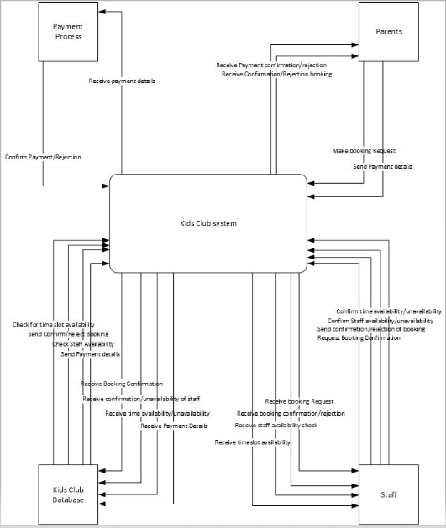

Above is the context level diagram, the idea was to have the parents/adults send a booking of a time into the system and have the staff receive the booking request and have the database check for time slot availability and have the database then confirm the timeslot availability or reject the timeslot availability and then there is the payment process which simply allows the parent to send payment details into the system which is then saved by the database and then the details sent to the payment process which is then confirmed for booking timeslots.

Level 0 DFD diagram:
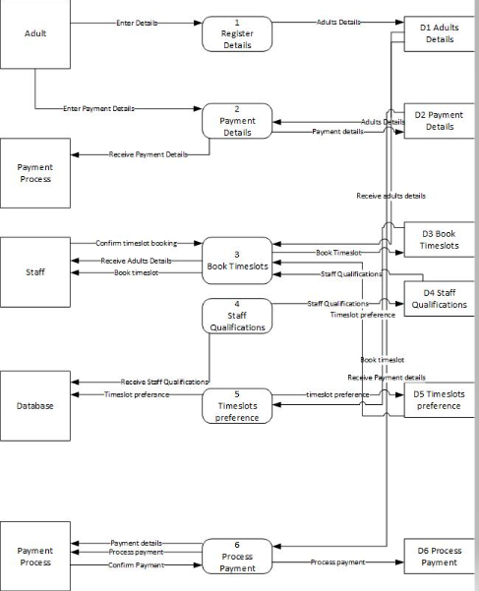

Above is the level 0 DFD diagram, the idea was to have the system save the details entered by the adults, payment details, timeslot bookings, staff qualifications, timeslot preferences and the payment process into datastores. The other ideas were to have the staff and the database to book times based on the details entered and have most of the process go between the staff and the timeslots since the staff is its own timetable and processes when timeslots can be confirmed.

Level 1 DFD diagram:
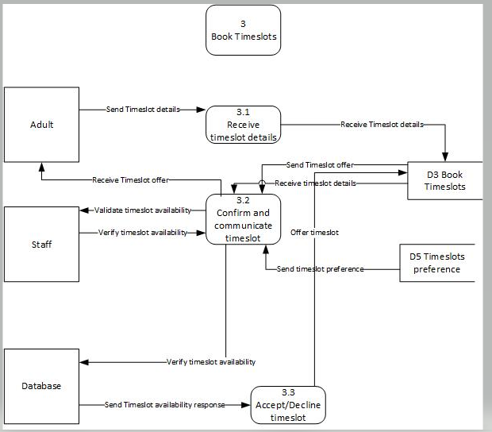
Above is the Level DFD diagram, I chose to go more into depth with the booking of the timeslots since this is what mostly is being focused on for the diagrams and it is showing how the data stores, the processes and interfaces speak to each other in more detail for booking a timeslot.

Entity Relationship Diagram:
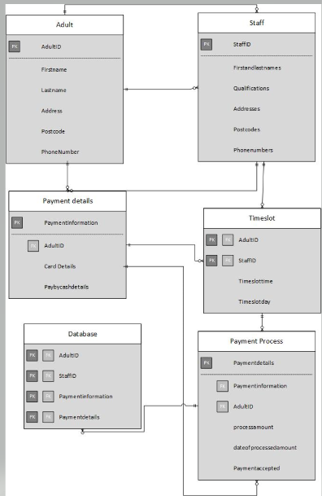

Above is the ERD, it was the most difficult to put into process but the idea was to have the database store all of the primary keys and foreign keys from the other entities and communicate with all of them and has each of the entities tie in with each other as foreign keys.

