Front Sheet
Smart Navigation with LEGO Spike
CANDIDATE NAME | Connor Morrison
MODULE | Integrating Project (Computing Foundation Year version) - ACHA4008
FACULTY NAME | Divya Chidambaram
DATE OF SUBMISSION | 08/05/2026

Table of Contents
Front Sheet 1
Introduction 3
Research and Background 3
Planning 3
Robot Design 4
Implementation and coding 6
Testing and Evaluation 9

Introduction
In this assignment the requirements are to design, build and program a LEGO Spike robot to autonomously solve a two-part navigation challenge using appropriate sensors and control algorithms. This was divided into two stages; the first stage was following a line with an obstacle blocking the route and the second stage was navigating a 3D maze. The practical aspect of this assignment was a group project, while the report written is individually done.

Research and Background
As using and creating a robot via LEGO Spike was new task with no background knowledge before the start of the project, research into how to use and design the robot was necessary before commencing with the project. The main form of information came from using the LEGO education spike website, with the tutorials on how to build various types of robots and how to do some of the basic programming needed to complete the practical aspect of the project it was used from beginning to end in the creation and implementation of the code necessary for the robot to complete the task given. Research for the group took a back seat in favour of trial and error working with the robot and the code, with each member of the group contributing their own thoughts and ideas to the project, being given time to try and implement these ideas to the design with input from the other team members when problem solving became necessary.

Planning
The groups solution to the project was to break down the task into smaller more manageable tasks, focusing on them individually before combining them all together for the final solution. These steps were, creating the robot design that could navigate the maze and follow the line, programming to allow the robot to follow the line without deviating and navigating through the maze without following a pre-set direction as the maze would change on the day of the test, creating the need for the program to solve the maze rather than follow a set path. The timeline for completing each of these tasks varied, with the shortest time allocated to the design and construction of the robot, this was due to the guides followed on the LEGO education spike website which taught the group how to correctly build the robot as well as allowing room for adding on extra features that became necessary for the completion for the maze. Programming the robot to follow the line was the next stage, this took longer than expected as while the code was correct and once again implemented from a tutorial from the LEGO education spike website, there was some technical difficulties causes the code to not respond as it should, thus increase the time in which it was worked on. As we had no reference point for the navigation of the maze this step took the longest amount of time and was the most difficult to implement, requiring trial and error to come up with a solution.

Robot Design
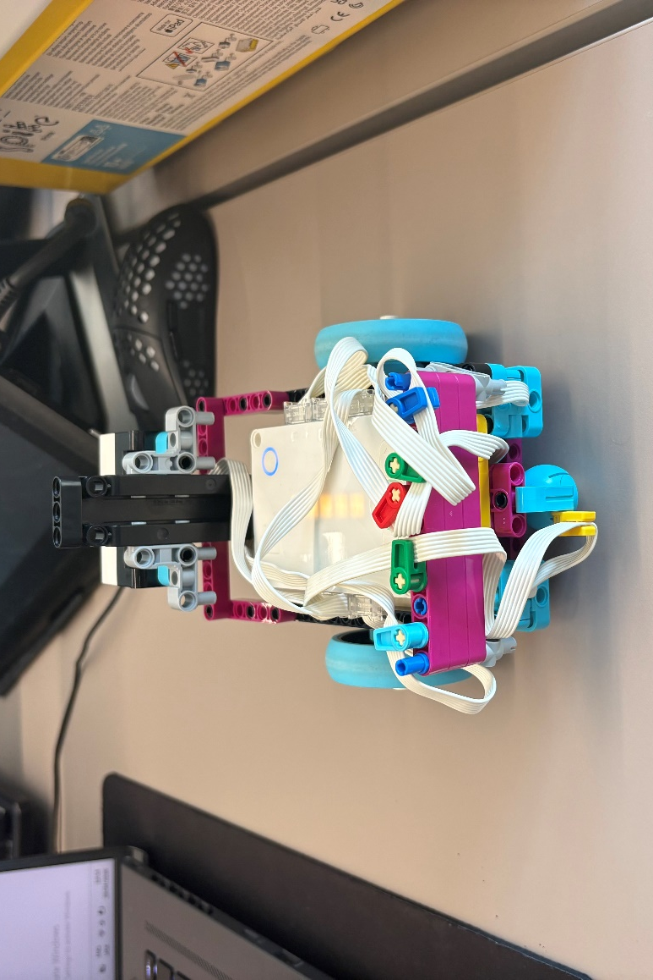
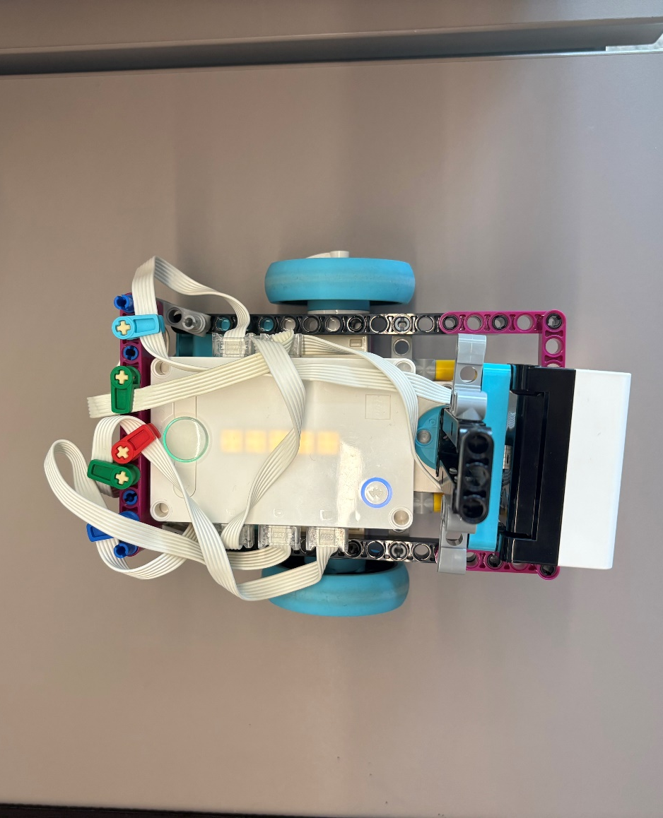
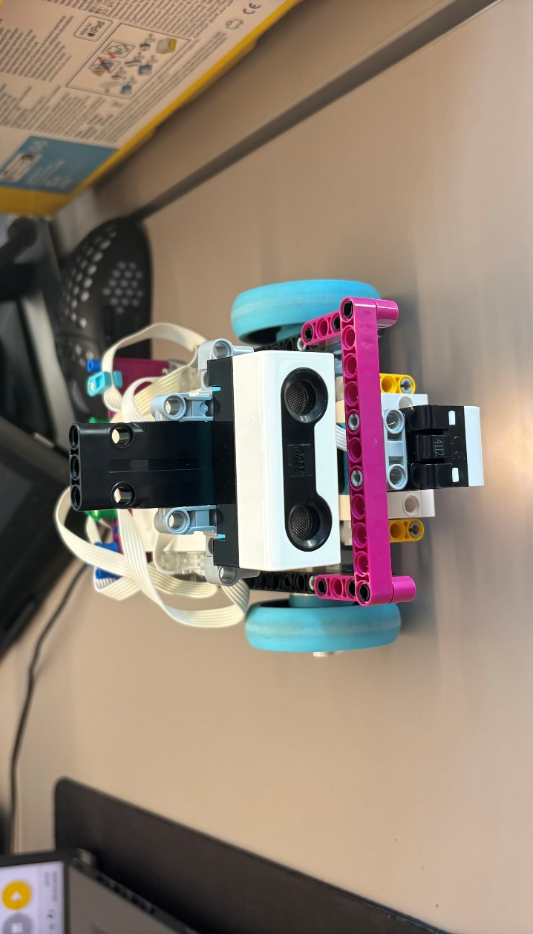
The groups design for the robot was simple but designed with the needs of the project, the robot needed to be as small as possible due to the task of navigating the maze as a robot larger in size would have the problem of getting caught while navigating through the maze. The robot would move via to wheels connected to the motors on the side, a colour and distance senser connected to the front and all the leads managed and kept tidy on the back to avoid them getting in the way or getting caught on the various obstacles of the task. Weight distribution needed to be considered and as such some extra blocks were placed on the back of the robot to counteract the two sensers on the front of the robot. The colour senser was connected to face downwards as to allow it to follow the coloured tape and the distance senser facing forward to allow the robot to know when to stop and implement the code designed to allow it to navigate through the maze. The distance senser is connected to a motor allowing it to look left and right for greater navigation purposes in the maze, this will mean it will be able to detect which direction the walls are so it can navigate through the maze using the instructions coded into it.

Implementation and coding
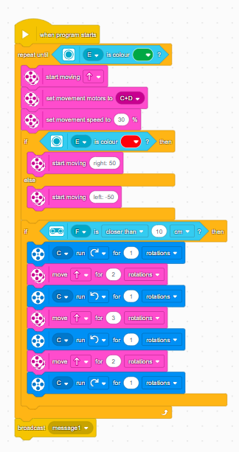
The first part of the code is shown to the right. When the program starts the robot will implement this code until it will come to the maze where it will sense the green tap at the maze entrance in which it will then receive the broadcasted message and start to implement the second phase of the code. This section of code controls the movement of the robot, including how it moves (the motors with the wheels attached to them), the direction the robot will head (forward) and the movement speed it will travel in (30% movement speed). This will happen until the colour senser senses the colour red, when this happens the robot will then make slight movement left and right continuously, which allows the robot to follow the line without deviating from it until it reaches the obstacle in the way. When the obstacle is detected it will be from a distance of 10cm as set in the code, as this point it has instructions to rotate the body of the robot and then move forward to get around the obstacle, it will do this until the robot gets around the obstacle and rejoins the red line. It’s able to do this as the instructions for it to navigate around the obstacle is connected to an if statement, meaning only if the robot senses something 10cm ahead will it implement this section of the code otherwise it will stick to the previously set up if statement which is the red coloured senser which allows it to follow along the line.

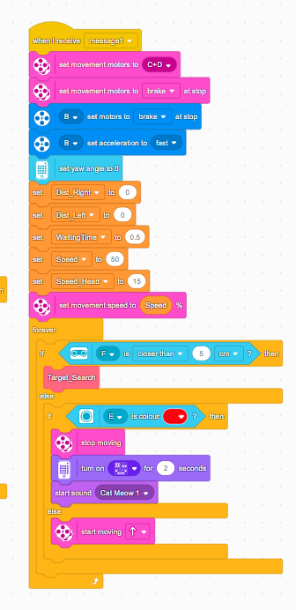
This section of code defines a different way for the robot to move, due to this being implemented when the robot senses the colour at the start of the maze it was necessary to change the way the robot would move due to the tighter constraints of the environment it would be in. The start of this section tells the robot to stop once it reaches the entrance due to the task of displaying an image before entering the maze, which is shown in the two-block code below. Once this image gets shown the robot will then begin to navigate the maze using the new parameters set for it, a yaw angle has been set up for the robot now which allows it to track its rotation around its vertical axis, indicating how much it has turned to the right or left. This is necessary due to the tight confines of the maze and the need for it to navigate without a pre-set direction. New instructions have also been implemented for the speed of the robot, which has been decreased as to allow for greater control of movement, a wait time for when it detects a wall ahead of it as well as the speed for the motor which causes the distance senser to look left and right. When the distance senser detects the wall in front, a custom set of instructions have been created which will be explained alongside a screenshot of the code.
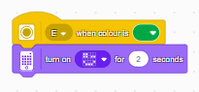
The last section of the code gets implemented when the robot reaches the end of the maze and senses the red line. Due to this code being in a different section than the last colour sensing code it does not interfere with each other as this will only activate once a broadcast message has been sent which happens at the start of the maze. Once this section of code gets activate by the senser it will stop moving a play a sound signifying the end of the practical test of the robot.

The code below sets instructions for the angle of the robot’s gyro to move; the gyro is built into the LEGO spike hub and measure the rotation and orientation.
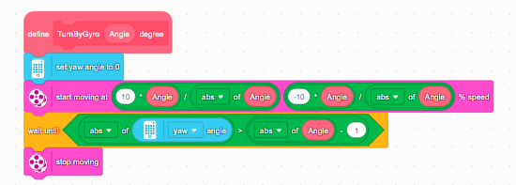

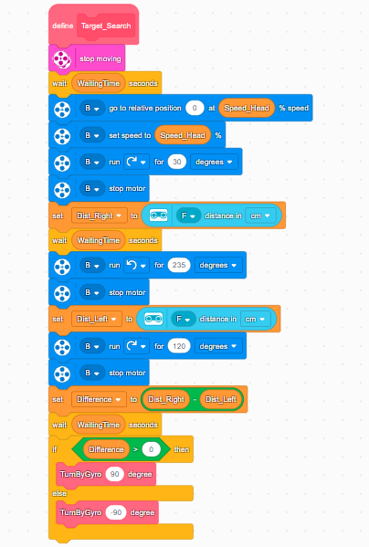
The code to the right controls the movement of the distance senser which allows it to know how to navigate through the maze, it has parameters for the amount of degrees for the motor to turn as well as implementing the wait time, once the distance senser has scanned around the robot it will then rotate in the direction it does not sense the wall and continue moving in that direction allowing it to navigate and complete the maze.

Testing and Evaluation
The group would test each part of the practical assignment by the steps the project had been dividing into, at first testing the built robot worked as intended, that the code implemented to follow the line did as instructed and finally that the distance senser and associated code could navigate the maze as envisioned. The robot and code worked as intended with the only problem being that the angle it would rotate at within the maze would cause it to collide with the maze wall, sometimes getting itself stuck. Unfortunately, while the group knew of that issue during testing of the robot any attempts to fix it would result in failure and sometimes causing further issue to the code already implemented. The only other issue when working on the project would be the technical issues the group had when first working on the following the line code, for reasons unknown, despite the code being correct the hub would not download and store the instructions or other times would just spin around in a circle at a clockwise angle, this caused significant time to be lost when working on the project.
For future iterations improvements will need to be made on the angle at which the robot travels through the maze, as while successful navigating it this time, it could have caused the project to result in failure had the angle been more significantly off.

