Hotel Handbook

Student Name: Raul Dobrican
Student ID no.: 2119259
Module name: BMIH5003
Lecturer Name: Rodrigo Aguilera

Table of Contents

Executive Summary 2
Introduction 4
Cross-cultural theory & model 5
Cultural intelligence and sensitivity 6
Guests' Experience with the Service 6
DO’s and DON’Ts for hotel workers 6
Prioritizing the preferences of guests from France 7
Summary 9
Recommendation 10
References 11

Executive Summary
This study analyses the degree to which hotel staff must have cultural understanding and sensitivity while serving guests whose native language is not French. The hotel I’ve chosen is the Premier Inn situated in the UK and the guests are from France. After an introduction of relevant cross-cultural concepts and models, a discussion on the importance of cultural intelligence and sensitivity in the hospitality industry is provided. The next portion of the study focuses on how different hotel departments may change their service offerings to better satisfy French clients' cultural norms and expectations. At last "Dos and Don'ts" serves as a reference guide for hotel personnel.

Introduction
Hotels are an essential component of the hospitality industry, which is critical to the economies of many countries owing to the popularity of tourism. With an ever-increasing stream of travellers from all over the globe, hotel personnel must learn how to satisfy their clients' diverse cultural norms and expectations. Hotel personnel must be culturally aware and sensitive to serve customers from various nations with a great stay. The Premier Inn in the United Kingdom was selected as the hotel of choice for this report, with the visitor originally coming from France. This report will examine how important cultural knowledge and understanding are for hotel Premier Inn UK personnel to create a wonderful stay for French customers.


Cross-cultural theory & model
Cross-cultural understanding ideas are used to detect and explain the differences and similarities that occur across cultures. One of the most prominent ideas is Hofstede's cultural dimensions model, which posits five essential cultural features. Individualism-collectivism, power distance, uncertainty avoidance, masculinity-femininity, and long-term orientation are some of these qualities. One of the most influential philosophies is individualism-collectivism. Utilizing the technique, comparisons and contrasts between different cultures are conducted, and the similarities and differences in persons of diverse backgrounds in terms of their beliefs, practices, and expectations are revealed (Quendler, 2019).
Hofstede's cultural dimensions model may assist in understanding cultural norms and values in France. This technique measures a country's cultural differences in six dimensions. This model demonstrates that French people value individuality above community interests. Higher collectivist nations have the opposite trend. Inequality is tolerated and expected in France. This indicator contrasts sharply with nations that scored lower (Rodríguez-Antón and Alonso-Almeida, 2019).
Staff at Premier Inn must be aware of individuality in French culture as well as the anticipated power imbalance. French visitors have different power expectations than visitors from other countries, thus hotel employees must satisfy them. Hotel personnel must be aware of the variances in etiquette norms between France and other nations (Jackson, 2020).
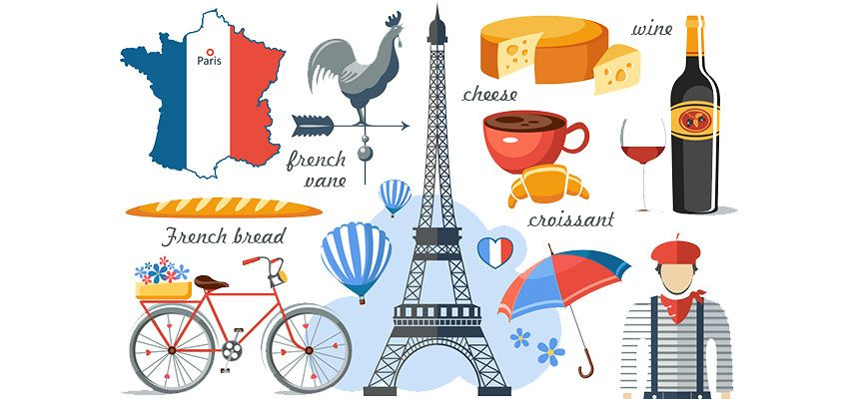

Cultural intelligence and sensitivity
Cultural intelligence is shown by knowledge about, respect for, and ease in dealing with people from a broad range of cultural backgrounds. To guarantee that visitors from different nations have a great stay, hotel employees must be well-versed in their cultures and beliefs. Understanding and respecting other people's traditions and values is part of being culturally sensitive. Hotel employees must be aware of and respectful of cultural standards that differ from their own to impress international visitors.

Guests' Experience with the Service
Those who work in the hospitality industry must have a strong awareness of the cultural norms and expectations of visitors from diverse countries. Some visitors from other nations, such as those from France, may have the expectation that they would be greeted in French, fed French cuisine, and given French-language tours of the landmarks in the surrounding area. It is also important to comprehend the social norms, practices, and etiquette that separate France from other countries.
While communicating with French guests, Premier Inn employees must consider several factors, according to French culture. Since French culture respects the individual, hotel employees must understand and satisfy customers' preferences. As a result, hotel workers must be prepared to accommodate the demands of each client. Hotel workers must also understand French etiquette. Hotel personnel in France must be more courteous and professional than those in other nations (Chun et al., 2021).

DO’s and DON’Ts for hotel workers
The hotel staff's acquaintance with the customs and beliefs of other countries is the single most critical element in deciding whether visitors from other countries had a favourable experience during their stay or not. To provide the best possible service to our customers traveling from France, we have created a list of "Dos and Don't" in the table below. This list is provided below.
Do's
- French is the language of hospitality and cordial welcomes.
- Please offer information in French on the area's activities and attractions.
- Serve traditional French cuisine.
- Maintain correct decorum and always conduct in a dignified way.
- Take your time and be considerate to others.
- Make your setting welcoming and comfortable to be in around you.
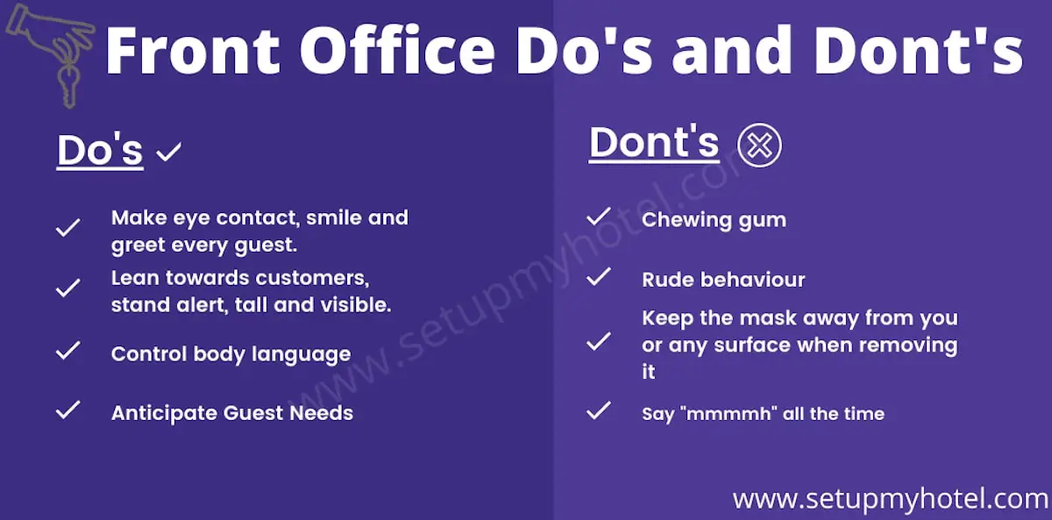

Don't
• Don't assume that all guests speak English
• Don't be too formal or too informal
• Don't be too intrusive
• Don't be too pushy
• Don't be too familiar
• Don't be too judgmental

Prioritizing the preferences of guests from France
The hotel personnel must prioritize the preferences of French clients. The package includes French-speaking employees, French-language food selections, and adherence to social norms, traditions, and etiquette. It's also vital for hotel personnel to realize that not all tourists will speak English, so they should be patient and kind when talking with those who don't (Carolina, 2019).

Summary
This report describes how crucial cultural understanding and sensitivity are in providing guests from France with an unforgettable experience. It has examined cross-cultural communication theories and models that may be used in the hospitality sector, the importance of cultural intelligence and sensitivity, and the numerous ways in which hotels can adjust their service delivery to better accommodate customers from diverse backgrounds. Last but not least, a table of "Dos and Don'ts" has been created as a briefing document for the hotel employees in charge of its execution.

Recommendation
It would be advantageous for hotel workers to prioritize meeting the needs of French visitors and to be aware of the cultural differences that exist between them and their French counterparts. Businesses should ensure that they adhere to all relevant social norms, traditions, and etiquette; give visitors information about activities and attractions in the region; provide truly French cuisine; and provide guests with information about the area in French as part of these efforts. As a result, hotel workers must show tolerance and politeness to clients who are unable to converse in English

References
Quendler, E., (2019). The position of the farm holiday in Austrian tourism. Open Agriculture, 4(1), pp.697-711.
Rodríguez-Antón, J.M. and Alonso-Almeida, M.D.M., (2019). The circular economy strategy in hospitality: A multicase approach. Sustainability, 11(20), p.5665.
Jackson, T., (2020). The legacy of Geert Hofstede. International Journal of Cross-Cultural Management, 20(1), pp.3-6.
Chun, D., Zhang, Z., Cohen, E., Florea, L. and Genc, O.F., (2021). Long-term orientation and the passage of time: Is it time to revisit Hofstede’s cultural dimensions? International Journal of Cross-Cultural Management, 21(2), pp.353-371.
Carolina, Ț., (2019). Dimensions of national culture–cross-cultural theories. Studies in Business and Economics, 14(3), pp.220-230.

