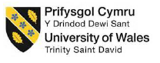

University of Wales Trinity Saint David
School of Engineering
Reflective project report
Faith Over
1904483
Manufacturing Systems Engineering
14/05/2021
ACMA5009 - Group Project

Contents Page

Contents
Contents Page ii
1. Introduction 1
1.1.1 Aims and objectives of this report 1
1.1.2 Aims of this report 1
1.1.3 Objectives of this report 1
1.1.4 Research & practical limitations/ implications 1
1.2 Aims & objectives of the project 1
1.2.1 Project background 2
1.2.2 Aims of the project 2
1.2.3 Objectives of the project 2
2. Project Plan/ Gantt chart 3
3. The importance of change management for Industry 4.0 transitions 3
4. Literature review on Change Management 4
5. An outline of the framework used (ADKAR) 6
5.1 Critical Appraisal of the ADKAR framework application in the case study of the COBOT implementation 9
5.2 Pros & Cons of ADKAR Theory 15
6. Recommendations 15
7. Conclusions 16
8. REFERENCES 17
Works Cited 17
Appendix 19

Introduction

Aims and objectives of this report

This reflective report was written 2 years after the project under analysis (COBOT implementation) was completed, thus is a retrospective analysis, focusing on the academic research surrounding change management frameworks and the effectiveness of the change management framework used (ADKAR).
All company and location names have been redacted from this report, in order to protect the business’ identity and honour non-disclosure agreements. From here on, the corporation in which the change was implemented within will be referred to as “Stark Industries” and the manufacturing site within Stark Industries which implemented the change will be referred to as “Asgard”.

Aims of this report
The aim for this report is to analyse the effectiveness of management methodologies used to prepare the workforce for the upcoming shift towards Industry 4.0. This report will analyse the sociological effect of this transition and recommend improvements to the current change management framework used.

Objectives of this report
The objectives of this report are to conduct academic on change management theories. This report will then ascertain the effectiveness of the change management framework currently utilised by Stark Industries’ Asgard location (the ADKAR framework), using the case study of their collaborative robotics (COBOT) implementation project as a reference. This paper will then suggest future improvements to the current change management policy.

Research & practical limitations/ implications
As this paper focuses on one plant in South Wales, the comparability of the effectiveness of discussed change management frameworks within other countries is limited as local culture will have a significant impact on how employees respond to stimulus. The research (interviews and surveys) were also conducted two years after the change management framework was utilised in the case study project, increasing the likelihood of external factors impacting or skewing results.

Aims & objectives of the project
The project which will be analysed is the implementation of a collaborative robot (COBOT). Not only was this the first COBOT to be implemented at the Asgard location but was also the first COBOT to be implemented within Stark Industries’ global Life Safety Division. It is therefore important to note the subsequent lack of internal capabilities and experience of such technology, and the divisional resources that Asgard usually relied upon for expertise with complex projects were also experiencing this new technology for the first time.

Project background
The manufacturing site implementing the change (referred to as Asgard) which completed this project is part of a large global power management company (referred to as Stark Industries). Stark Industries operates globally across multiple sectors and has multiple divisions, Asgard operates within the “Life Safety Division” and manufactures fire panels, sounders and beacons. Due to the nature of the tall hierarchical structure of Stark’s divisions and the heavy approvals governance and industry regulations within the fire safety market which Asgard operate within, Asgard is often a late adopter to change.
Though Asgard has been through various corporate acquisitions, their product portfolio and the main constructs of their processes remain largely the same for the past 20 years – with a heavy focus on manual assembly. All products assembled onsite at Asgard are had assembled by operators within small U-shaped manufacturing cells. Every U-shaped manufacturing cell accommodates the following simple three step process– 1) build, 2) test, 3) pack.

Aims of the project
The aim of the project was to lead Stark Industries’ Life Safety Division into Industry 4.0, by upskilling the current workforce and changing the dynamics of the company culture into accepting change, whilst achieving cost saving by automating a non-value add, repetitive processes (testing).
There is no conclusive prediction on the future for the production workforce as an effect of Industry 4.0; though some studies forecast an increase in employment and safer work conditions, most studies point towards algorithm based software and robotics outperforming humans, consequently leading the liquidation of jobs for those with less complex tasks and less qualifications. This is predicted to lead towards a change in the required competencies of the workforce (Grabowska, 2020).
In order to prepare Stark Industries for the transition into Industry 4.0, improving the workplace relationships between people and machines and attitudes towards automation is fundamental to decreasing pushback and increasing willingness to upskill. Therefore, one of the key focus points outlined in the project proposal is to cultivate a culture of swift adaptation and acceptance by the workforce.

Objectives of the project
Implement a collaborative robot (COBOT) into the facility to perform repetitive tasks. In this case, the Asgard plant chose to automate the testing step of a manufacturing process for one of their product ranges. The COBOT will operate in one of the 16 U-shaped cells between the build operator and pack operator, acting as a replacement for the test operator. The COBOT is to pick up a product from the build operator, test the unit and pass it to the packing operator. The investment in this project is to have a payback term under three years.

Project Plan/ Gantt chart
The project management team used a Gantt chart alongside their internal project management framework to ensure the timely delivery of the project. The project’s full Gantt chart can be found in the appendix.
Figure 1: Project Gantt Chart
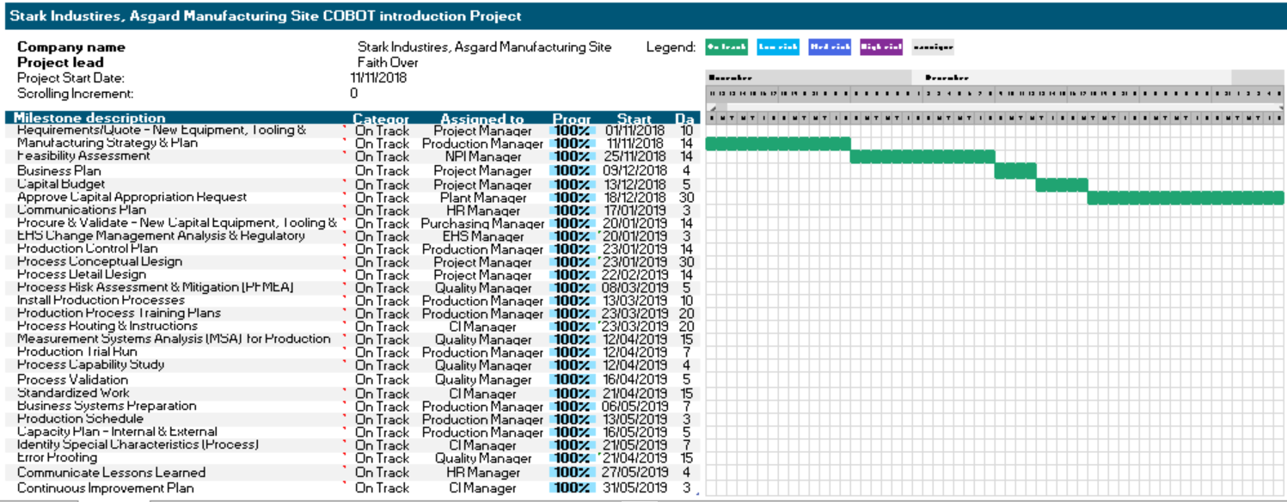

The importance of change management for Industry 4.0 transitions
Traditionally, the constructs of success for a business were thought of as stability and structure however due to external changes such as the development of mass production, rapid technology changes and the integration of global businesses, highly structured organisations have been pushed to change and adapt or be left behind. (Parker, et al., 2012). The ability to adapt to change is particularly crucial in places similar to Stark Industries, Asgard location – which is lacking in an extensive and comprehensive internal technological knowledgebase (Capatina, et al., 2017).
In effort to stay competitive, the Asgard location is attempting to take its’ first steps towards “Industry 4.0 – the 4th industrial revolution. This can be described as the digitisation and linkages of all production process across a products entire value stream – from customer order creation to down-stream servicers and delivery. These self-organised, integrated and data driven values creation networks will have significant impact on economic transactions, increasing flexibility in the value-stream and efficiency gains across the network (Wilkesmann & Wilkesmann, 2018). These opportunities for flexibility and cost saving could enable Stark Industries to; increase profit margin, increase market share by reaching a larger customer base or provided a wider product range.

Robot assisted production will decrease manual labour and increase ergonomics improvements. This will lead to less physical work for employees as routine jobs are consumed by robotics, instead the role of humans in the workforce will be in coordination, planning and supervision (Di Nardo, et al., 2020). The human workforce will also be needed for maintenance, problem solving, programming, monitoring and process control. Therefore, automation is the perfect opportunity to upskill and any investment in new machinery must be accompanied by investment in training (Grabowska, 2020).

As businesses are forced to adapt to external changes outside of their control, it is imperative that businesses have an understanding of the process of change and an effective change management framework to assist the business in navigating its ever changing reality (Parker, et al., 2012). Despite this necessity, many managers report a failure rate of up to 70% in change initiatives (Balogyn, et al., 2016). This is often attributed to the fact that, by nature humans are predisposed to familiarity and convenience and thus are risk adverse by default. Resistance to change is common and can stem from a multitude of perceived risks. Regarding automation, the most frequently perceived risk is job security (Sung & Kim, 2021). Furthermore, change management frameworks aide in Industry 4.0 transitions in more ways than simply increasing change acceptance; research has shown that change management factors also have a positive effect on innovative behaviour and overall organisational innovation (Sung, 2021).

Literature review on Change Management
Planned organisational change is the process of changing the organisational system, such as technology or management system to achieve the new organisational goals (Brown & Moberg, 1980). In this case study, this is the physical implementation of the COBOT. In contrast, change management revolves around intentionally changing thoughts, perceptions and behaviours regarding the change to reduce resistance in order to achieve specific targets (Sung & Kim, 2021). In this case study, this is how the management team utilised various techniques to ensure the workforce accept the COBOT and further technology introductions into the facility.
Kurt Lewin’s “unfreeze-change-refreeze” (otherwise known as “Change in Three Steps) is often seen as the original paradigm of change management (Cummings, et al., 2016). This process describes “unfreezing” old behaviour, transitioning to a new state and “refreezing” at the new desired level. The “unfreeze-change-refreeze” paradigm has become the foundation of multiple change management theories developed since. However, despite being a widely accepted foundation of change management theories and literature, it is often criticised for taking an over simplified linear approach (Kanter, et al., 1992), with some authors claiming it to be inappropriate to “re-freeze” in a market which is constantly changing and constant innovation and complex overlapping changes are needed (Cummings, et al., 2016).
change management theories and frameworks have built upon Lewin’s original framework.

Figure 2 (below) is Cummings’ (2016) summary of how various change management theories and frameworks have built upon Lewin’s original framework.

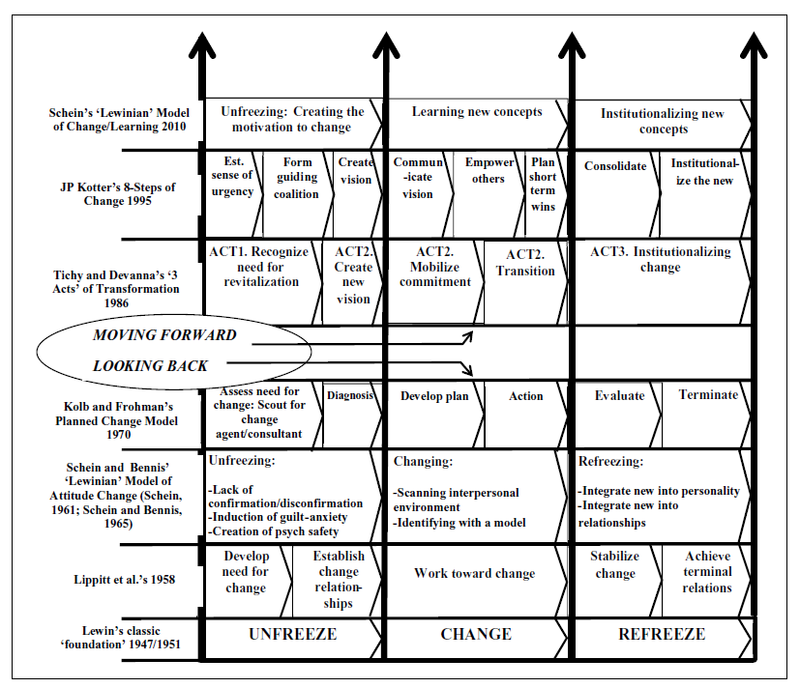
Figure 2: Cummings (2016) Review of change management theories built on Lewin’s theory of a step process

.
Though the theory of change management has evolved over time, and many have debated the subject, it is still evident that the elements of each well-known theory fits into this original “unfreeze-change-refreeze” model. Furthermore, Sung & Kim (2021) reviewed preceding studies on the main factors of change management and have found four common attributes which are commonly repeated as essential attributes in multiple change management theories:
- Organisational Goal - Communicate the desired future state and direction for activities, standards, and guidelines for decision making. This sets context for the organisation and ensures alignment
Cited by; Voelpel et al. (2004), Whelan-Berry and Somerville (2010),
- Transformational Leadership - how leaders increase trust through stimulation and consideration and motivate employees to drive change, meet targets and resolve problems. How leaders Cited by; Greiner (1972), Voelpel et al. (2004), Whelan-Berry and Somerville (2010),
- Participation and communication - how an organisation leverages a platform for clearly communicating, easily participating and sharing ideas, which is necessary to achieve common goals
Cited by; Greiner (1972), Kettinger and Grover (1995), Whelan-Berry and Somerville (2010),
- Education and training - the planned activities that improve competence, knowledge and skills within an organisation’s employees to help it achieve its goals.
Cited by; Greiner (1972), Kettinger and Grover (1995), Voelpel et al. (2004), Whelan-Berry and Somerville (2010),
(Sung & Kim, 2021).
Table 1 (below) is an extract of Sung & Kim (2021) summary and description of these four common attributes in change management theory:
Table 1: Sung & Kim (2021) Summary of preceding studies for component of change management
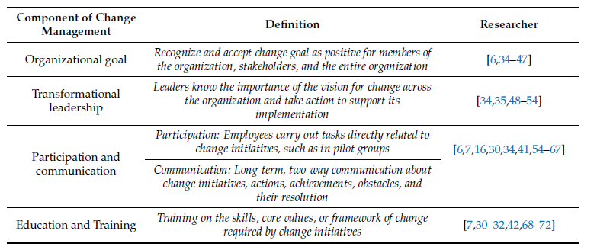
(Sung & Kim, 2021).

An outline of the framework used (ADKAR)
The change management theory followed by Stark Industries’ Asgard location was Prosci’s ADKAR methodology. This was chosen as it is already rolled out and well embedded across Stark Industries globally, and various corporate training materials and tools were readily available to the Asgard site in preparation for this change.
ADKAR is an acronym that outlines 5 distinct outcomes that people need to achieve for lasting change (Balluck, et al., 2020). Table 2 (below) is extracted from Balluck et al. 2020 is a tabular summary of each of the 5 steps and what needs to happen at every step.
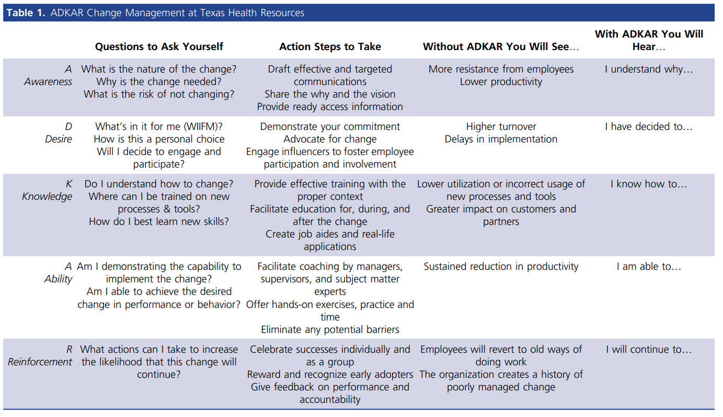
Table 2:Balluck et al. 2020 outline of ADKAR in relation to Texas Health Resource as a case study

ADKAR can also be easily fitted into Lewin’s “unfreeze-change-refreeze” process, with Awareness & Desire under unfreeze, Knowledge & Ability under change and finally, Reinforcement under freeze.

Stark Industries’ Asgard location followed the ADKAR framework by completing the following at every stage:

Awareness for the need for change: The concept of Industry 3.0 and Industry 4.0 was explained to the entire workforce during monthly “all hands” meetings, with emphasis on current global market trends and the importance of operating with leading technologies to stay competitive within the market. Emphasis was made on how this step was not in order to replace workers and save on head count, but to allow workers to increase focus on value-add activities. Positive past examples were presented where inspection technology was introduced to assist workers in their roles. This helped employees relate to benefits of automation and not focus on job security risks. This then became a regular feature “all hands” meetings and a way of updating employees monthly on progress with project.

Desire to support the change: Leaders at the Asgard facility identified which groups were most impacted by the change with the Prosci’s “Impact Index”. This can be seen below in Figure 3. They used this as a guideline for where they should focus their efforts and what unique challenges need to be addressed for each group. There was a focus on how the reduction of repetitive tasks would increase safety, training opportunities and assurance that there will not be any resulting job losses. Operators were involved in the design of their new workstation and in a “name the COBOT” competition to increase involvement and a sense of ownership in the project.
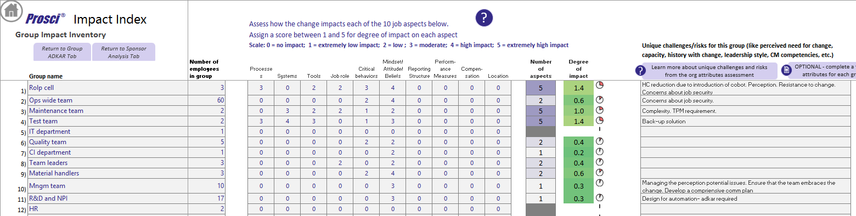
Figure 3: Asgard's Prosci Impact Index Analysis

Knowledge of how to change: As the Asgard site did not have sufficient robotics experience and there were not any adequate resources in the wider Life Safety Division for the facility to rely on internally to Stark industries, a third party contractor was used to install and set up the COBOT with relevant cell and guarding infrastructure, and train employees on site. The third-party contractor delivered the following training sessions:
  - Start-up/ shut down process with cell operators
  - Error recovery and fault escalation with cell operators and test department
  - Routine maintenance and fault recovery with production and maintenance team
  - Formal classroom learning events on application check, project creation and fault finding with test department engineer and production process engineer
  - Design for automation seminar delivered to R&D and operations department.

Ability to demonstrate skills and behaviours: The third-party consultant also Led a design for automation seminar delivered to both the R&D and operations departments to encourage automation to be at the forefront of future design ideas. There were also further mini projects run after implementation to increase the scope of the COBOT’s capabilities.

Reinforcement to make the change stick. After implementation, all operations managers paid special focus on the daily productivity and down time figures of the COBOT cell. Cross training a wider scope of operators were also delivered during this stage.

The project team subjectively analysed each group on the ADKAR scale on regular intervals to gauge whether they should move to the next stage. Figure 4 (below) shows the tools and generated graphs that the COBOT implementation project management team used for this analysis.
Figure 4: ADKAR analysis completed by the COBOT project management team at the final stage of the project.

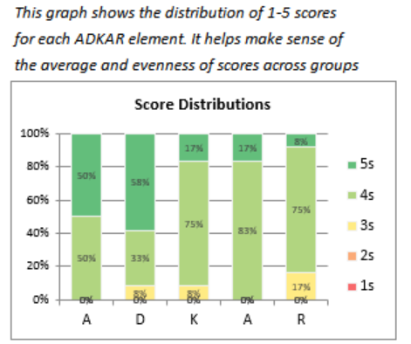
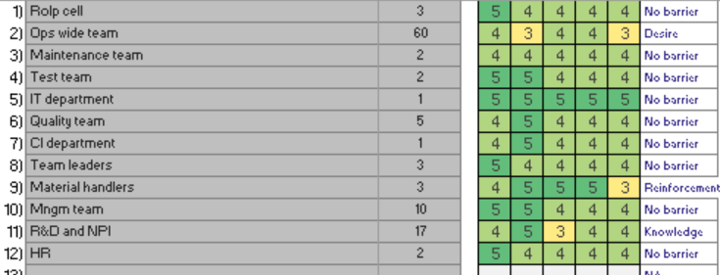
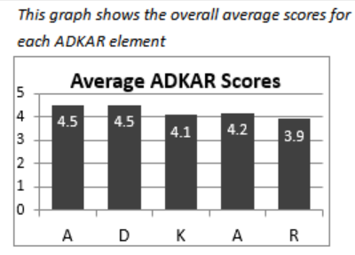

Critical Appraisal of the ADKAR framework application in the case study of the COBOT implementation

In the early stages of the project the Awareness and Desire elements of the ADKAR framework were implemented well, with high levels of excitement and interest in the project, evident in participation levels in events, questions and update requests. Heavy involvement of the leadership team proactively promoting and engaging in the project led to a positive impact in overall engagement.
Though there was a positive start with the Awareness and Desire elements, evidence shows that the enthusiasm has not sustained over time. After multiple interviews, it has transpired that the task of programming and problem-solving software issues with the COBOT is a lot more complex than initially anticipated. Furthermore, though there were multiple training sessions and classroom events, as the machine was utilised in mass manufacturing, there was no “allowed machine downtime” to give those trained a chance to practice these new skills. Because of this and the ease of having the third-party contractor readily available to act as a safety net, internal competencies were not developed to the required level. This led to unnecessary downtime when issues arose. Interviewees claimed there are prolonged COBOT downtime if the problem-solving activities are completed internally, compared to if the problem is solved by external third party contractors, as internal trained employees still struggle with how to fix the issue and often end up needing to call in the third-party contractors for assistance. The lack of successfully developed internal competencies led to unsustainable change, which led to delays in production and eventually frustration through the workforce whom is more directly in contact with the issues caused.
To quantify the issues raised during interviews and to help ascertain whether the COBOT implementation change was managed successfully or not, a survey of 43 participants was conducted. The questions and raw data can be found in the appendix. Of 43 participants, 25 were present during the COBOT change and 18 were not. 81% of participants were operators – the group most impacted by the change. The demographics of survey participants is represented in the chart below:

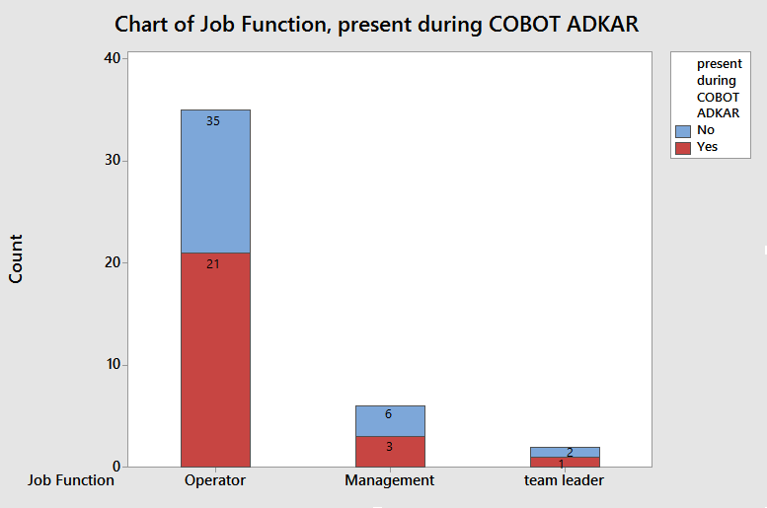

In the survey, participants were asked to rank on a Likert scale of 1-5, 1 being strongly disagree and strong being strongly agree on eight different statements (shown below in the “Question” column). However, if we split the respondents into two groups; those present during the COBOT implementation and those after, a clear trend appears; those whom went through the change framework responded more negatively than those who did not (mean value highlighted in red). This evidence rejects the hypothesis that the ADKAR change management framework was successful in this case study. It also suggests that, respondents whom were managed through the ADKAR change management framework by Stark industries hold more negative views about the case study change (the COBOT implementation) and are more reserved about the idea of any further changes involving increasing technology presence on site.
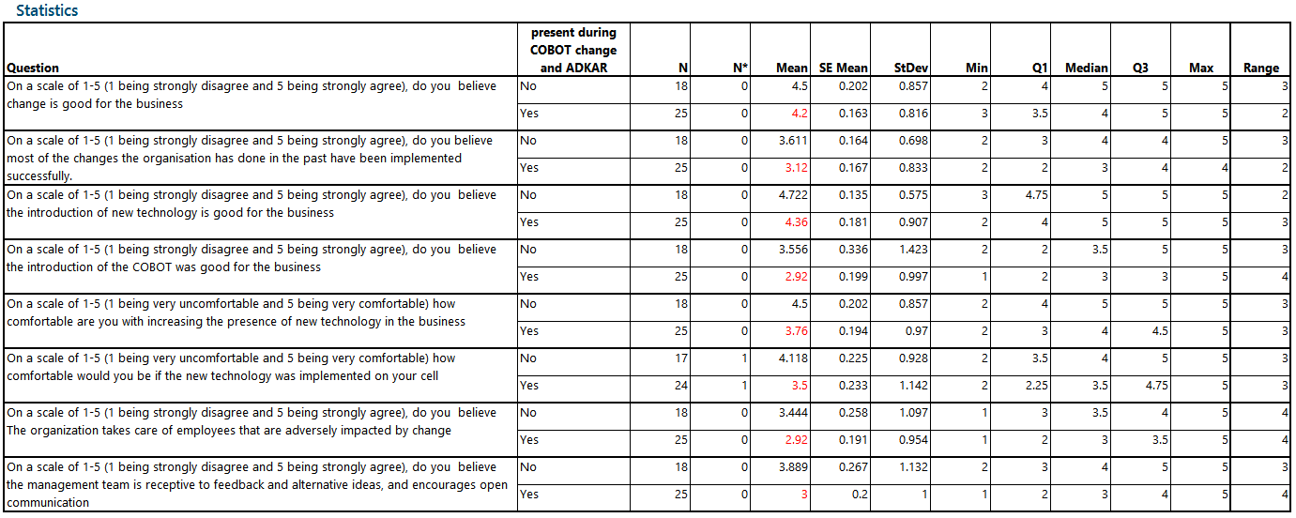
Table 3: Survey questions and responses, split by sub-groups; those who went through the ADKAR framework and those who did not

Below is a graphical representation of the question “On a scale of 1-5 (1 being strongly disagree and 5 being strongly agree), do you believe the introduction of the COBOT was good for the business”. The red dashed line represents those that were present during the change and thus those whom have been transitioned through all stages of the ADKAR framework. The blue line represents employees whom have joined after the implementation and thus were not transitioned through the framework.
The histogram demonstrates that those whom were transitioned through the ADKAR framework all consistently gave lower responses, with a lower standard deviation for this data set, represented by a steeper bell curve positioned lower on the Likert scale, whereas the bell shaped distribution curve of those who joined after the implementation is flatter, indicating higher variance in responses. These results (lower mean and smaller standard deviation), leads towards a hypothesis that; those whom were transitioned through this ADKAR framework were exclusively exposed to a common factor or collective experience which has negatively impacted their viewpoints in the change (COBOT), in comparison to the group which were not transitioned through the framework and seemingly not exposed to the negatively influencing factor.

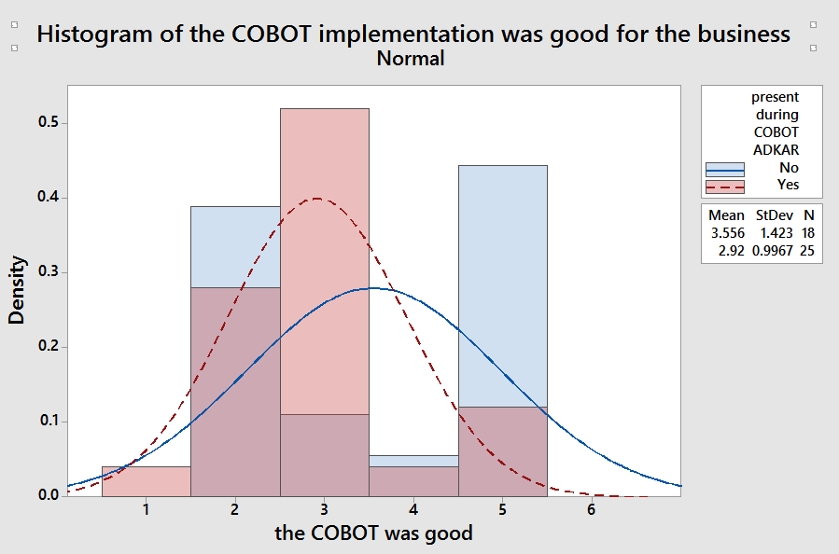
Figure 5: Histogram of responses for "The COBOT implementation was good for the business"

Though the results in Table 3 and Figure 5 show a negative correlation between those present through the ADKAR change management framework and responses, one must be wary to not assume correlation confirms causation, as there are multiple internal and external factors which can affect the respondents responses to these questions. Table 4 (below), shows the same questions and responses again, but this time instead of splitting the data into sub groups of those present during the change and those whom joined the business after, the data was split into subgroups of which researcher asked the questions. Researcher “Faith” is on the operations management team and spends less than 50% of her working hours on the shop floor with operators, in contrast researcher “Lee” is a process engineer who spends more than 90% of his working hours on the shop floor with operators. As you can see, respondents delivered more favourable results to Faith than to Lee. Though respondents were told their answers were anonymous and for third party research, there is still a strong likelihood that respondents either consciously or subconsciously have more favourable responses to the researcher perceived to be in a position of power, possibly due to fear of consequences, or simply due to the Hawthorne effect (the unexpected and unexplained reactions by human subjects who are aware of their participation in a study). (Konstantinou, 2012).
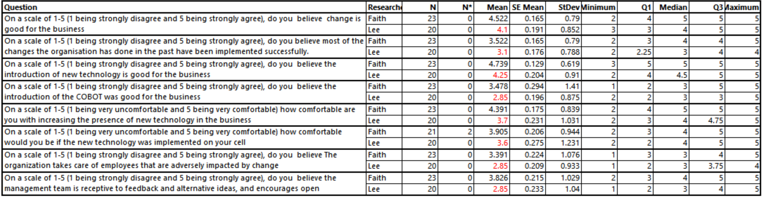
Table 4: Survey questions and responses, split by sub-groups of researcher
Similarly, if the same table is to be created but the respondent split into sub-groups by job function, those in higher positions (team leaders or managers) also tend to respond more favourably. This suggests that the ADKAR framework was more effective on these sub-groups, potentially due to the increased communication on the subject and involvement in decision making due to the nature of their roles. Furthermore, due to physical proximity of where their workstations are located, managers have more increased exposure to decision makers and project owners, thus have more opportunities to ask questions or vent concerns while simply in passing or during breaks.
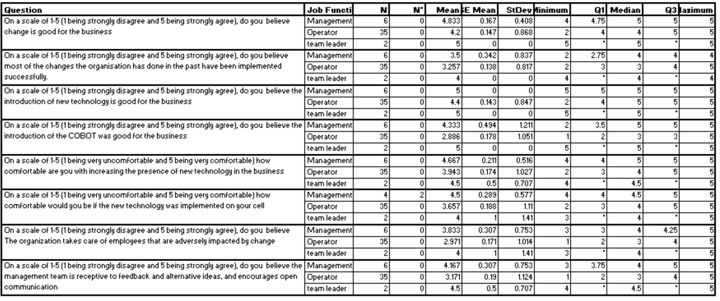
Table 5:Survey questions and responses, split by sub-groups of job title

5.2 Pros & Cons of ADKAR Theory
Though more in depth than Lewin’s original “unfreeze-change-refreeze” framework (see Figure 2), ADKAR is seemingly overly simplistic. There seems to be ample focus on involvement, communication, education and training but little mention of strategic alignment or how the actions and behaviours leadership impact the success of change, factors which are also commonly highlighted as imperative for a successful change management framework (see Table 1: Sung & Kim (2021) Summary of preceding studies for component of change management).
It is important to mention that ADKAR purely focuses on the social side of change management and thus cannot be standalone. Successful change management projects also utilise project management tools to ensure deadlines and milestones are met within a timely manner as consistent delays and disorganisation can also cause resistance, hesitation and pushback from employees (Parker, et al., 2012). The project management framework used by Stark Industries’ Asgard location for this COBOT implementation project was ProLaunch, an integrated internal project management framework with a gated approval system.
Though the project team analysed progress within each of the groups on the ADKAR scale (see Figure 4), the analysis was subjective and thus potentially may not be a true representation of each groups readiness to move to the next stage. Furthermore as the analyses were completed by the project management team, the risk of falling into various biases traps, for example - the sunk-cost bias trap; justifying past choices which may no longer seem valid, or the confirming-evidence bias trap; seeking out and only believing evidence that confirms current beliefs (Hammond, et al., 1998). The reliance on the subjective analysis has left to insufficient feedback channels which may skew the perspective of the project management team further.

Recommendations

It is recommended that in addition to using the ADKAR framework, Stark Industries incorporate any major changes into their annual strategies and to ensure appropriate alignment across different management teams and adequate funding and resourcing is planned.
The importance of the attitudes and behaviours of the leadership team and the examples they portray should also be highlighted, and it is also recommended that any future major changes should be considered in Stark Industries leadership system and leadership model. Those invested in the change should act as early change adopters should be leveraged as change role models by increasing their presence with groups affected by the change as much as possible.
When following the ADKAR framework it is also that Star Industries start utilising some form of change readiness survey or questionnaire, enabling honest anonymous feedback and increasing feedback methods directly from groups affected, instead of relying on the assumptions of the project management teams.
In the case study of the COBOT implementation, interview responses indicate that not enough attention was put into the knowledge and ability steps of the ADKAR process. The length of time needed to adequately train individuals in new machinery to a level where swift problem solving was possible was severely underestimated. In future change implementations, more time and opportunities should be given to “practice”, possibly setting time and incentives aside for programming competitions. As the safety net of the third-party consultants was present in the years after the project implementation, with a priority on troubleshooting being faster rather than internal due to sales pressures, the knowledge gained in classroom environments were not retained.

Conclusions
Despite the intentions of COBOT integration project to cultivate a culture of change acceptance in preparation to Industry 4.0, survey results indicate that the project negatively impacted the change readiness of respondents and negatively impacted their view on potential future changes. This suggests that change management framework used was ineffective. However, due to the vast number of factors which could impact results, further studies are required, with more data sets and other projects to use as a comparison before an accurate conclusion can be made.
A review of preceding change management studies suggests that the ADKAR change management framework is missing two key components to change management; the importance of transformational leadership and the importance of recognition and acceptance of the need for change within the organisational goals and strategies.
Furthermore, interview results suggest that a failure to properly implement steps in the later part of the ADKAR change management framework (knowledge, ability and reinforcement) has attributed to the limited success of the COBOT integration. Therefore, as the case study project did not properly follow the ADKAR framework, the results of the project cannot be conclusively indicative of the effectiveness of the ADKAR framework itself.
It is also recommended that to ascertain a true gauge of change readiness in employees, it would be more effectiveness to send out anonymous surveys and questionnaires to employees, rather than a small project management subjectively filling out an analysis tool.

REFERENCES

Works Cited
Balluck, J., Asturi, E. & Brockman, V., 2020. Use of the ADKAR® and CLARC ®Change Models to Navigate Staffing Model Changes During the COVID-19 Pandemic. Nurse leader, 18(6), pp. 539-546.
Balogyn, J., Hope, V. & Gustaffston, S., 2016. Exploring strategic change. 4th ed. United Kingdom: Pearson Education.
Brown, W. & Moberg, D., 1980. Organization Theory and Management: A Macro Approach. Michigan: Wiyle.
Capatina, A. B. G. M. F. V. V., 2017. Leveraging intellectual capital through Lewin’s Force Field Analysis: The case of software development companies. Journal of Innovation & Knowledge, 1(2), pp. 125-133.
Capatina, A., Bleoju, G., Matos, F. & Vairinhos, V., 2017. Leveraging intellectual capital through Lewin’s Force Field Analysis: The case of software development companies. Journal of Innovation & Knowledge, 1(2), pp. 125-133.
Cummings, S., Birdgman, T. & Brown, K., 2016. Unfreezing change as three steps: Rethinking Kurt Lewin’s legacy for change management. Human Relations, 69(1), pp. 33-60.
Davenport, T. H. &. P. L., 1988. Working knowledge: How organizations manage what they know. Boston, Massachusetts: Harvard Business School Press.
Di Nardo, M., Fornio, D. & Murino, T., 2020. The evolution of man–machine interaction: the role of human in Industry 4.0 paradigm. PRODUCTION & MANUFACTURING RESEARCH, 8(1), pp. 20-34.
Grabowska, S., 2020. Changes in the social architecture of business model in the perspective of the Industry 4.0 concept. Sciendo, 24(1), pp. 130-139.
Hammond, J., Keeney, R. & Raiffa, H., 1998. The Hidden Traps in Decision Making. [Online]
Available at: https://hbr.org/1998/09/the-hidden-traps-in-decision-making-2#
[Accessed 12 May 2021].
Kanter, R., Stein, B. & Jick, T., 1992. The Challenge of Organizational Change: How Companies Experience It and Leaders Guide It. New York: Free Press.
Konstantinou, G., 2012. Pragmatic trials: how to adjust for the 'Hawthorne effect'?. Thorax, 67(6), pp. 562-562.
Lee, J. B. B. K. H., 2015. Research Letters: A Cyber-Physical Systems architecture for Industry 4.0-based manfufacturing systems. Manufacturing Letters, Volume 3, pp. 18-23.
Parker, D., Charlton, J., Ribeiro, A. & Pathak, R., 2012. Integration of project-based management and change management Intervention methodology. International Journal of Productivity and Performance Management, 62(5), pp. 534-544.
Prosci, 2020. 5 Tenets of Change Management. [Online]
Available at: https://www.prosci.com/resources/articles/5-tenets-of-change-management
[Accessed 09 May 2021].
Sung, W. K. C., 2021. A Study on the Effect of Change Management Organizational Innovation: Focusing on the Mediating Effect of Members’ Innovative Behavior. Sustainability, 13(2079), pp. 1-25.
Sung, W. & Kim, C., 2021. A Study on the Effect of Change Management Organizational Innovation: Focusing on the Mediating Effect of Members’ Innovative Behavior. Sustainability, 13(2079), pp. 1-25.
Wilkesmann, M. & Wilkesmann, U., 2018. Industry 4.0 – organizing routines or innovations?. VINE Journal of Information and Knowledge Management Systems, 48(2), pp. 238-254.
Wirth, R., 2004. Lewin/Schein's Change Theory. [Online]
Available at: https://www.researchgate.net/publication/237112705_LewinSchein's_Change_Theory/citation/download
[Accessed 22 April 2021].

Appendix

