
Module:LCBB4004-Marketing Fundamentals
Lecture Name:Tushara Balendran
Student name:Aleksandar Lolov
Student number:2218455

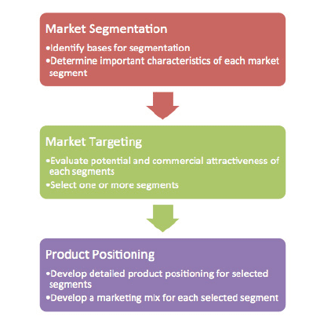
STP Analysis
STP analysis, also known as Segmentation, Targeting and Positioning analysis, is a strategic approach used by companies to identify and understand their target market, customise their marketing efforts, and successfully position their products or services (Kotler and Armstrong, 2010). Market segmentation is the process of separating consumers into subsets defined by common demographic, psychographic, or behavioural traits. Second, targeting is the process of zeroing down on one or more of these subsets to concentrate marketing efforts on; this decision is made after taking into account the overall size of the market, its growth potential, and the level of competition in the space (Maoheng, 2018). Positioning entails separating the product or services from rivals and ensuring that it is in line with consumer wants and aspirations within the selected market category. Companies may benefit from STP analysis to fine-tune their marketing strategy.

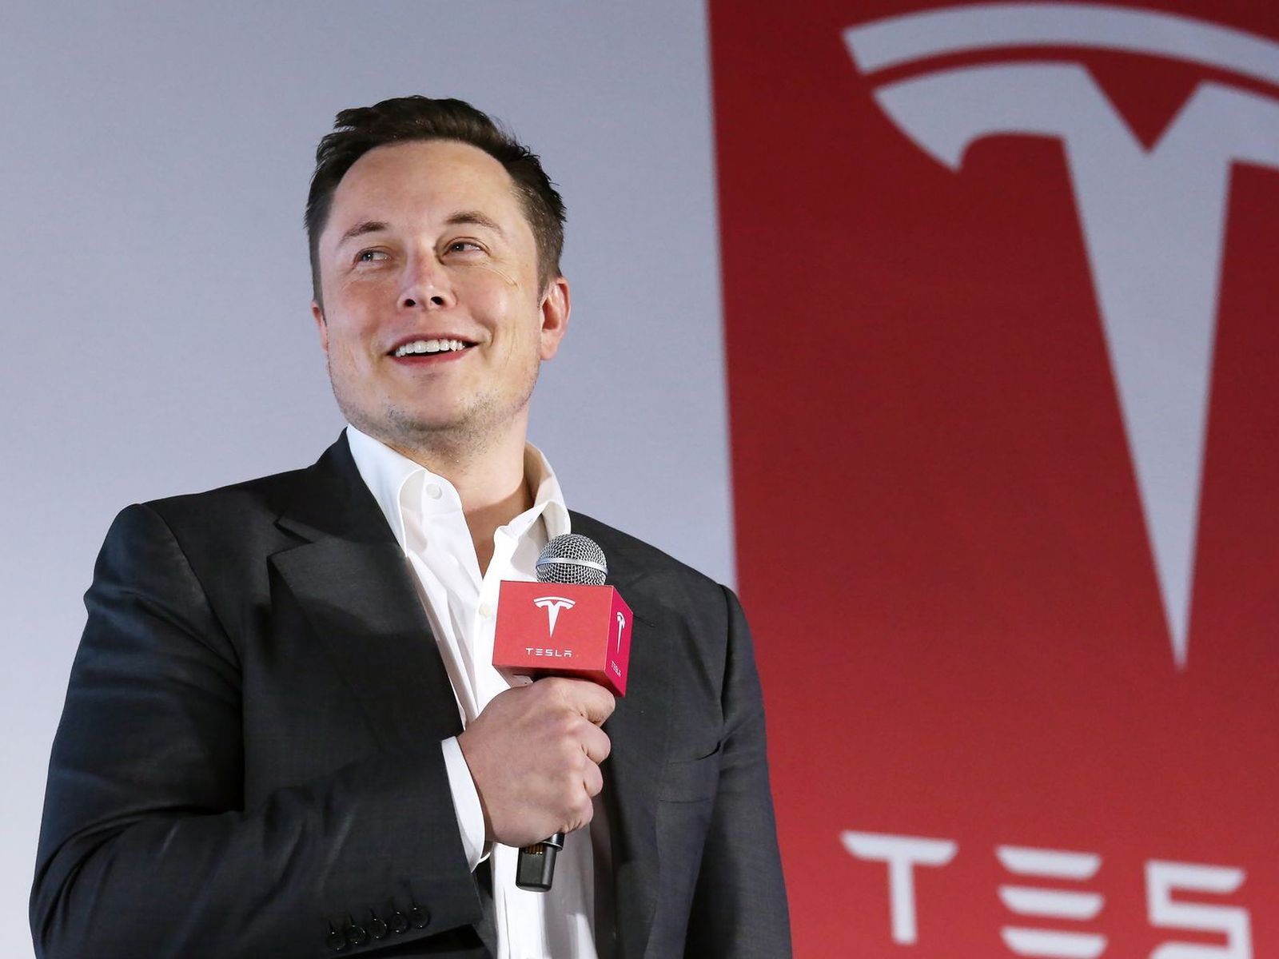

Introduction
Elon Musk and his team of engineers started Tesla Motors in 2003, and they have been at the forefront of the EV movement ever since. Tesla has become a byword for eco-friendly transportation because to its reputation for innovation (Eberhard and Tarpenning, 2006). Model S, Model 3, Model X, as well as Model Y are just a few of the vehicles in its broad product line, all of which are geared towards providing top-notch performance and cutting-edge autonomous driving features. The proliferation of storage of renewable electricity options is being fueled in part by the high-capacity batteries produced by Tesla's Gigafactories, which are strategically placed all over the world. Beyond electric vehicles, the firm is also investing in solar power and developing energy-saving goods like the Solar Roof as part of its commitment to a sustainable future. Tesla's impact extends well beyond the auto industry, motivating initiatives to curb carbon emissions and speed up the switch to sustainable electric power throughout the world.
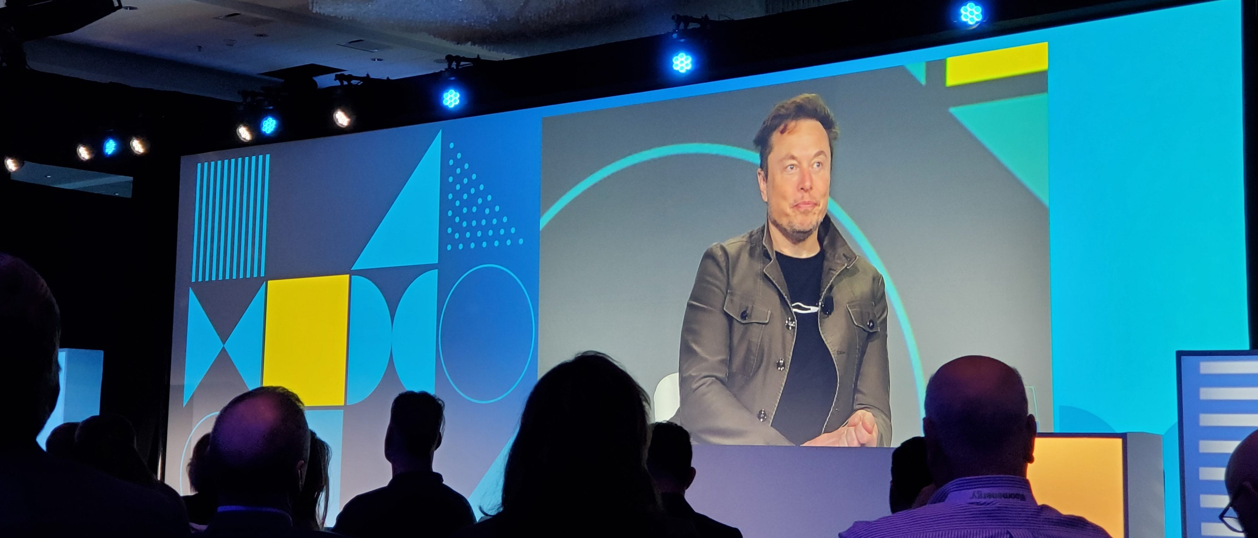
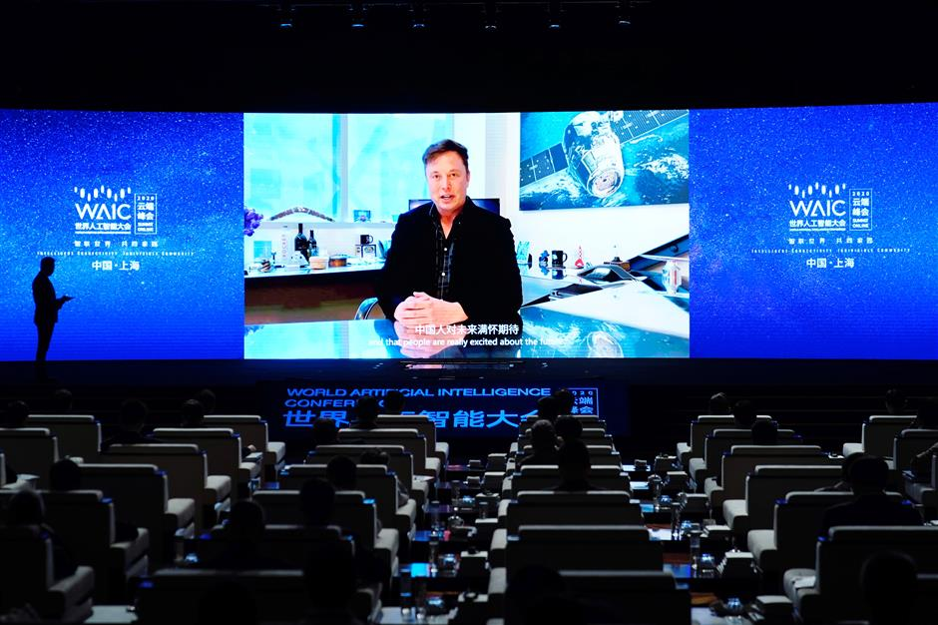
Targeting Analysis for Tesla
As part of its STP, Tesla is aiming for a very narrow subset of the British consumer market. Tesla's target market consists mostly of well-to-do city and suburb residents who value sustainability and are looking for cutting-edge technology to meet their mobility needs. These buyers have greater discretionary spending and are therefore more likely to purchase expensive electric automobiles (Mangram, 2012). Tesla's strategy for reaching its target market in the UK takes advantage of the country's rising interest in environmentally friendly transportation options. Tesla hopes to strengthen its position as the UK's preeminent provider of luxury electric automobiles and related sustainable technology by targeting this specific market.
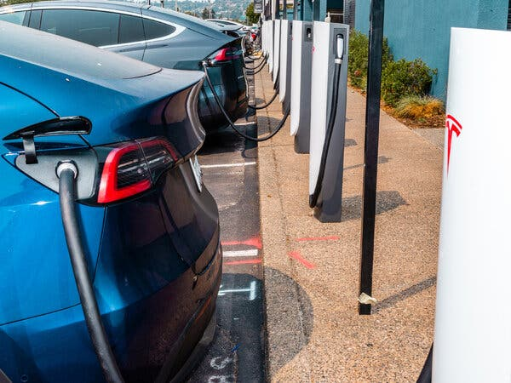
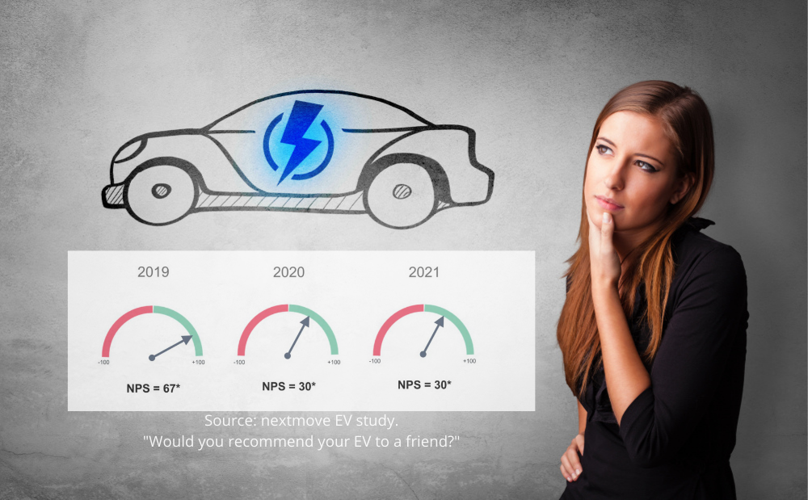
Segmentation Analysis for Tesla
Tesla uses STP (Segmentation, Targeting, Positioning) analyses to establish a strong presence in the UK's electric vehicle (EV) industry. First, market segmentation classifies customers according to characteristics including age, income, urbanicity, environmental awareness, technological sophistication, and EV adoption rates. Since there is a rising demand for EVs in the UK, Tesla is marketing to well-off city and suburb dwellers who value environmental friendliness and cutting-edge innovations (Zhou, 2023). Last but not least, Tesla distinguishes itself from rivals by positioning itself as a premium EV brand requesting cutting-edge technology, long-range features, and a commitment to sustainability. This message should ring true with the UK's environmentally conscious consumer base, helping the company to establish itself as a frontrunner in the country's EV market.
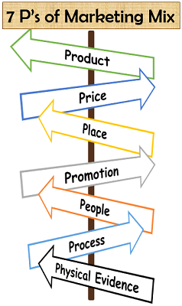
7P of Marketing
The 7Ps of marketing are an expanded framework for the marketing mix that adds three more pillars on top of the standard 4Ps (Product, Price, Place, and Promotion). Processes, People, and Physical evidence make up these extra Ps. The 7Ps are an all-encompassing framework for developing and executing a successful marketing plan. Product is the fundamental offering, Price is the process of selecting a price that is both competitive and profitable, Place is the distribution channels, and Promotion is the marketing and communication strategies used to promote the product. Physical evidence refers to the visible indicators that back up the service or product and increase customer confidence and happiness (Fayvishenko, 2018). Processes address the processes and procedures in providing value. This all-encompassing approach shines brightest in service businesses, where the quality of interactions with customers and the products they receive are crucial to marketing success.
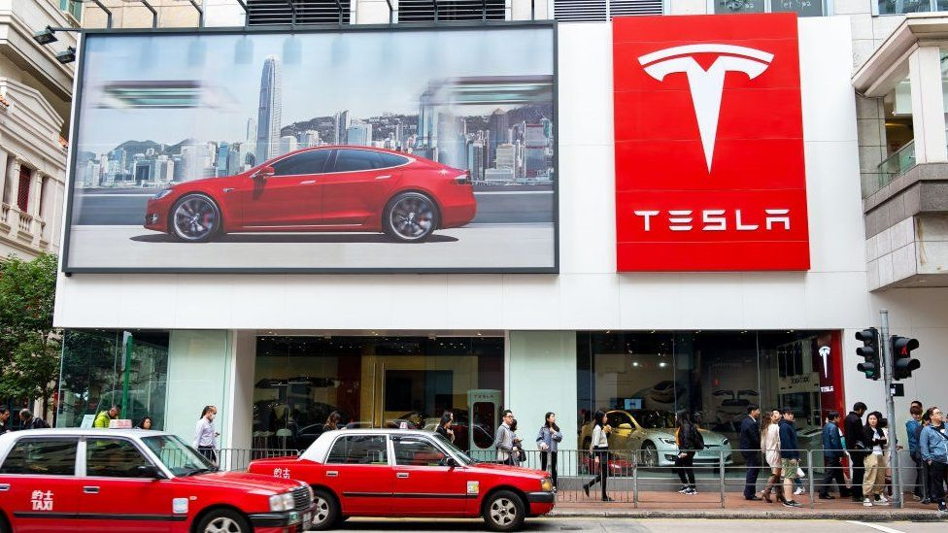
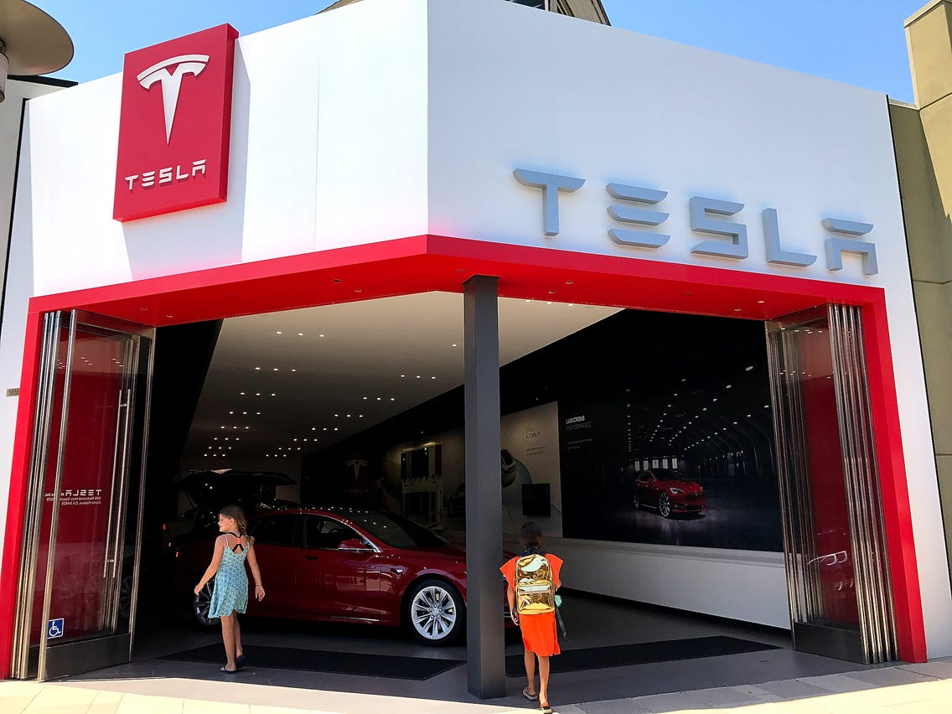
Positioning Analysis for Tesla
As an early user of environmentally friendly transportation technology, Tesla's posture in the UK market is deliberate. By showcasing Tesla's cutting-edge engineering, extensive range, and eco-friendly ethos, the STP sets the firm apart from its rivals. It promotes its name as a byword for progress, speaking to the hopes of eco-conscious consumers who also place a premium on high-end design and solid performance (Thomas and Maine, 2019). Tesla's status as an innovative leader in the field of electric vehicles (EVs) resonates with the UK market's need for eco-friendly and cutting-edge transportation options. With this strategy, Tesla has positioned itself as the smart and environmentally friendly option for motorists in the United Kingdom.
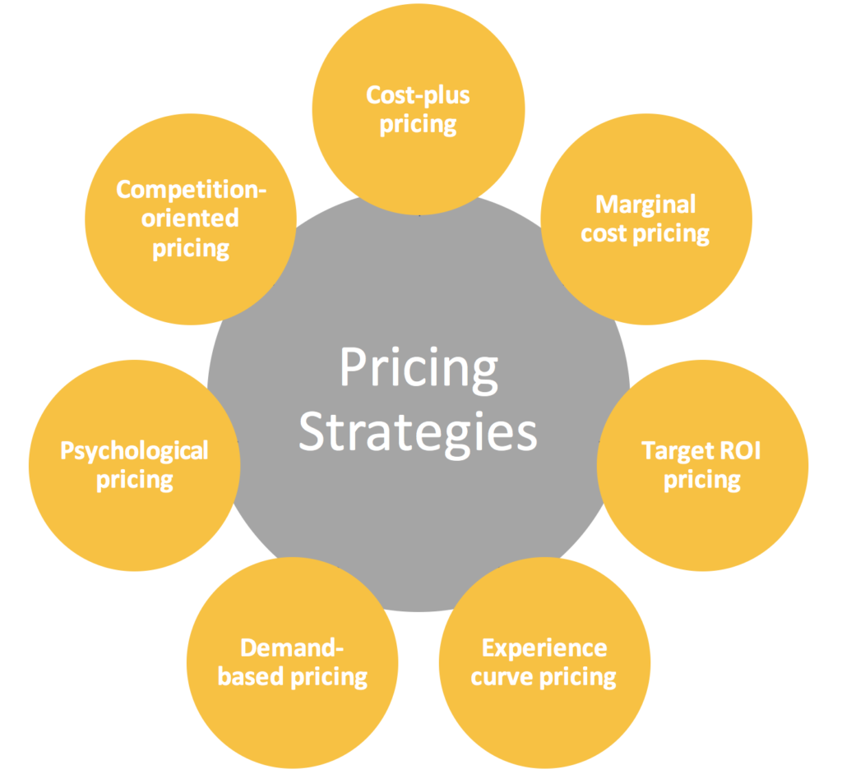
Price
Tesla's dedication to developing environmentally friendly products is shown in the breadth of offerings in the UK market. The range includes the Model S, the Model 3, the Model X, and the Model Y. The base price of a Model S, a high-end vehicle, is roughly GBP 83,000. The base pricing of a Model 3 electric vehicle is around GBP 42,000. The Model X is an adaptable and spacious electric SUV that can be had for about GBP 87,000 (Car and Driver, 2023) thanks to its low starting price. Finally, at a starting price of roughly GBP 54,000, there's the Model Y, a compact SUV that combines cutting-edge technology.
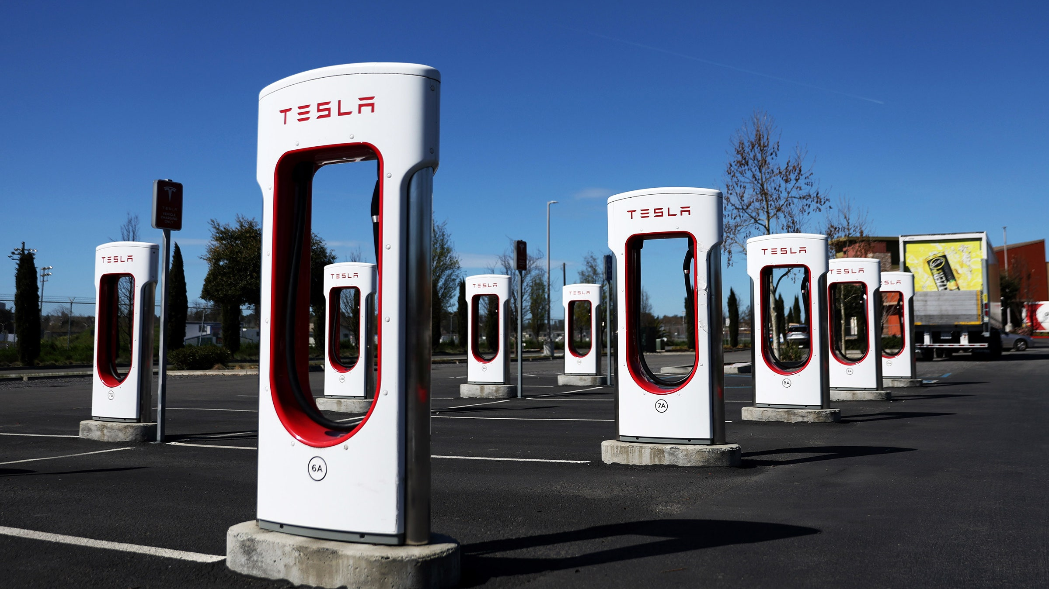
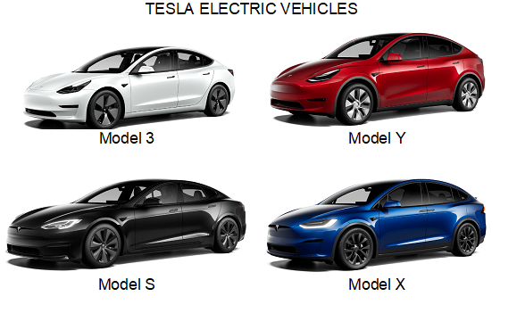

Product
Tesla's dedication to innovation and sustainability is reflected in the company's product analysis under the 7P framework in the UK market. Tesla's 'Product' is its lineup of innovative electric cars (EVs), which are lauded for their speed, power, and range. Its extensive lineup includes the Model S, Model 3, Model X, and Model Y, all of which are designed to deliver exceptional performance and innovative autonomous driving capabilities (Gu et al., 2018). As an added bonus, Tesla offers its customers a one-of-a-kind ownership experience by way of features like over-the-air software updates and the Supercharger network.
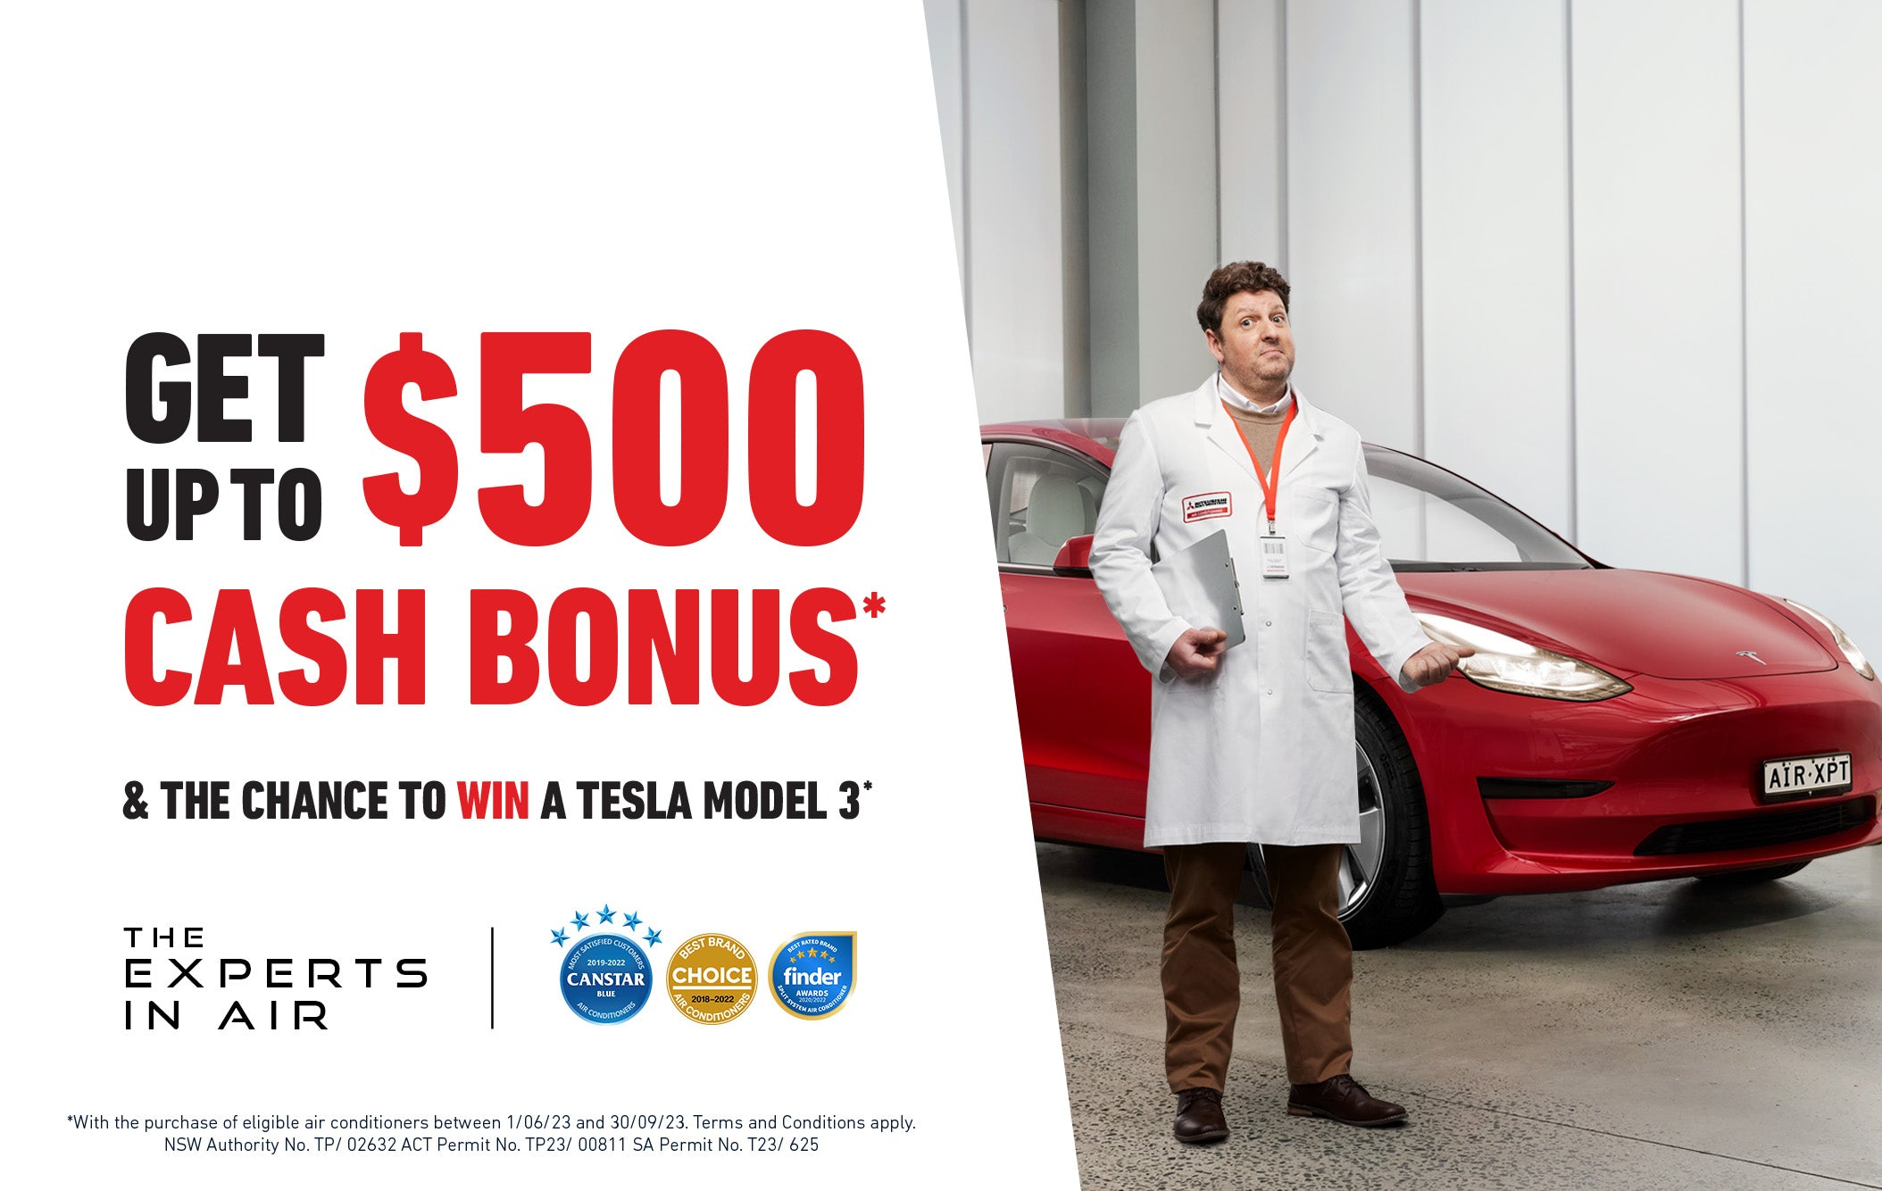
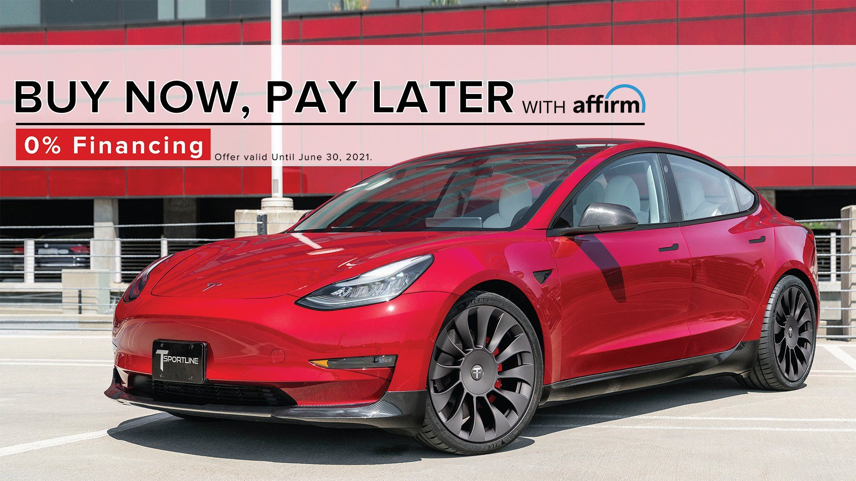
Promotion
Digital marketing, word of mouth, and Tesla's distinct brand image all play a role in the electric car company's successful promotion approach in the UK market. The firm generates buzz and interacts with environmentally sensitive target audience using social media and internet advertising. Media attention and consumer recommendations are consistently high due to Tesla's unique electric vehicles, cutting-edge technology, and dedication to sustainability (Pathak et al., 2022). Tesla also counts on its dedicated client base, which serves as an unofficial brand ambassador network. In addition, Tesla occasionally debuts new products and events, which create buzz and highlight the company's pioneering spirit.
Place
Tesla has a well-established network of dealerships, service centres, and charging infrastructure in prime locations around the United Kingdom. Having a physical presence in major metropolitan areas around the country, Tesla makes its products more accessible to a wider audience (Holland, 2023). Customers may learn more about Tesla's products, take a test drive, and get help at these brick-and-mortar shops. To further facilitate long-distance travel for Tesla customers, the company has spent heavily in constructing a widespread Supercharger network along important highways and routes. By taking a holistic view of location, Tesla is able to better serve its consumers in the UK and contribute to the expansion of the electric car industry there.
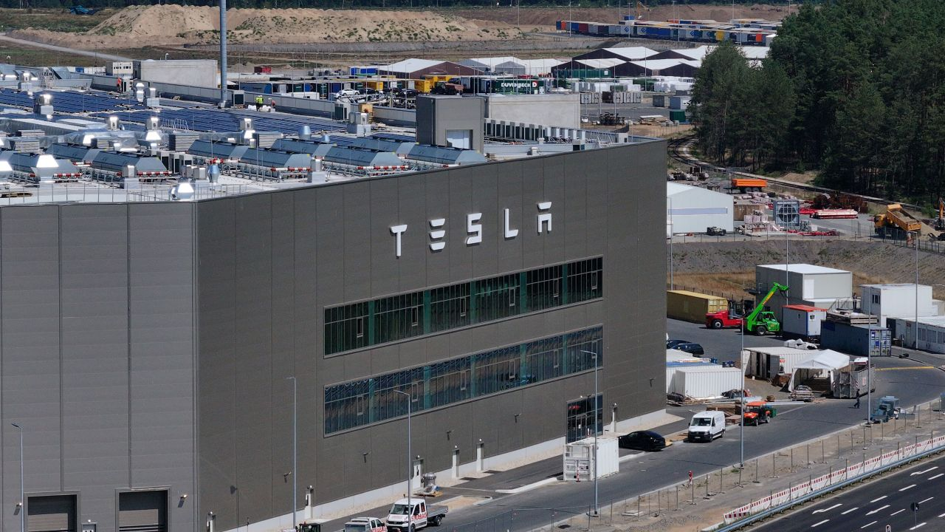
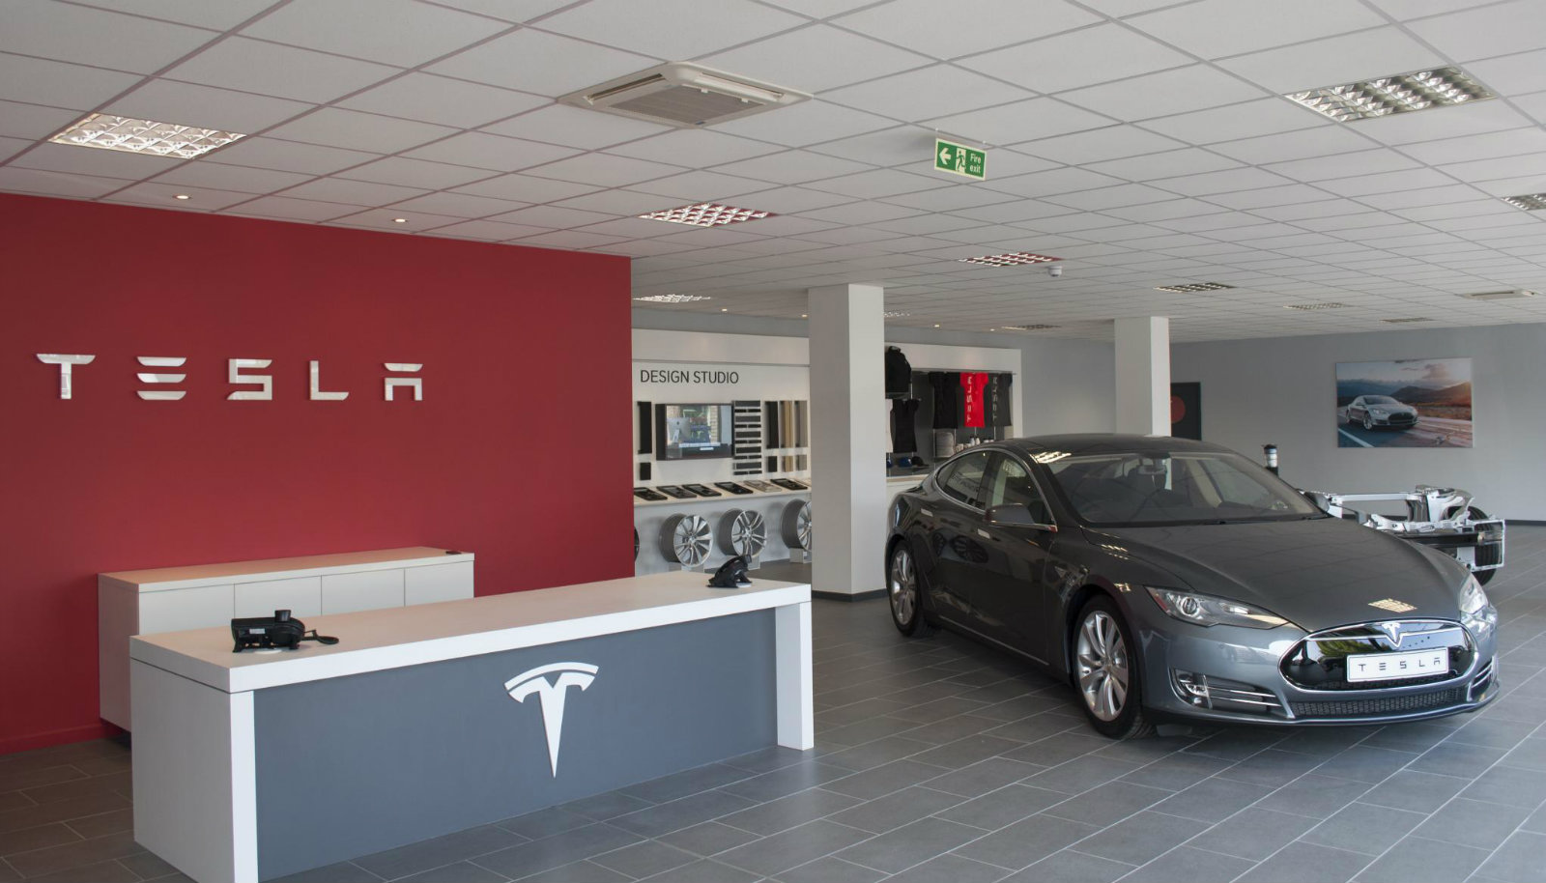
Process
Tesla's sales process is primarily conducted online, where buyers can easily select options and place orders for their automobiles. The company uses a business strategy known as "direct to consumer," which eliminates intermediaries like car dealerships while simultaneously decreasing transaction times and increasing price transparency (Karamitsios, 2013). In order to maintain excellent quality and for rapid expansion, Tesla's battery and car assembly procedures are highly automated and technologically sophisticated. Additionally, the over-the-air software upgrades provided by Tesla simplify servicing and boost vehicle performance.
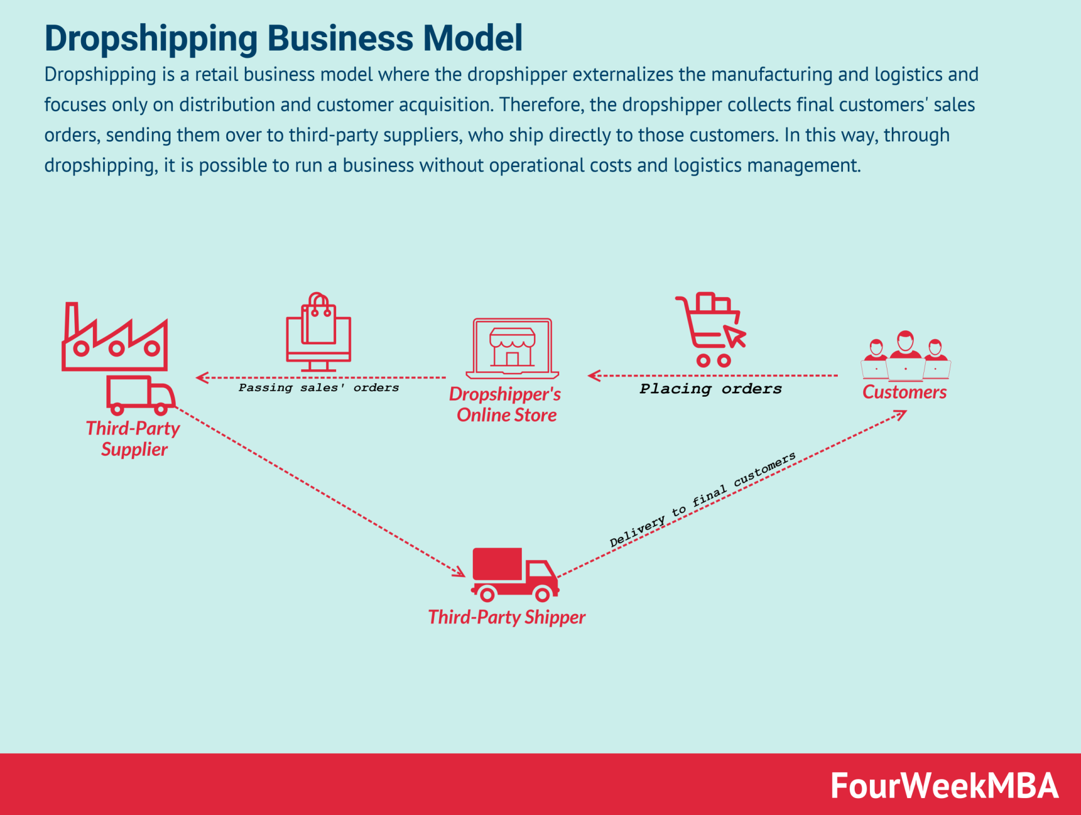
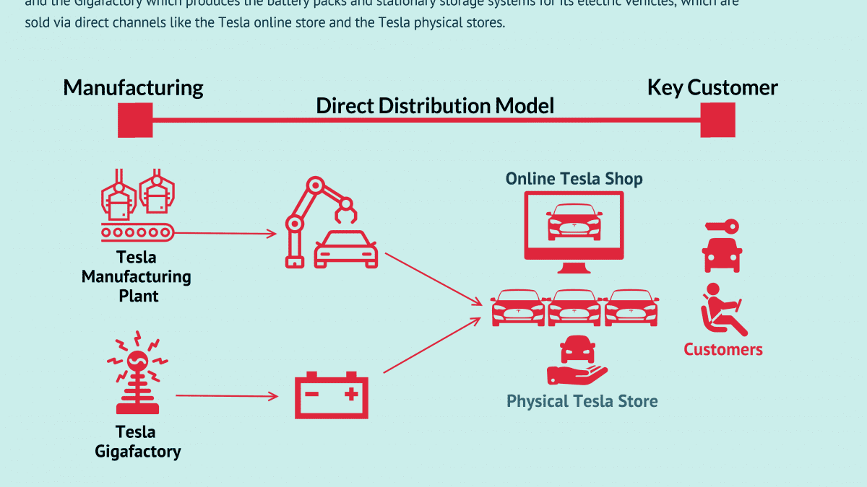
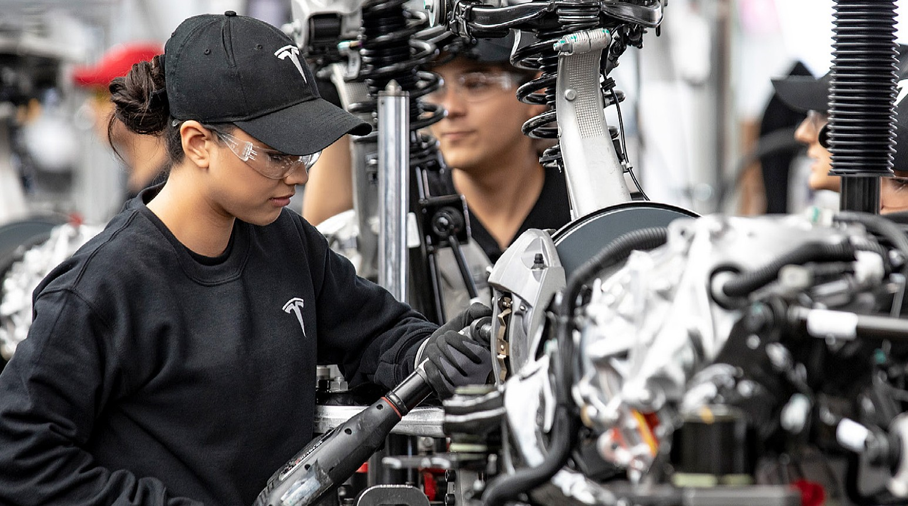
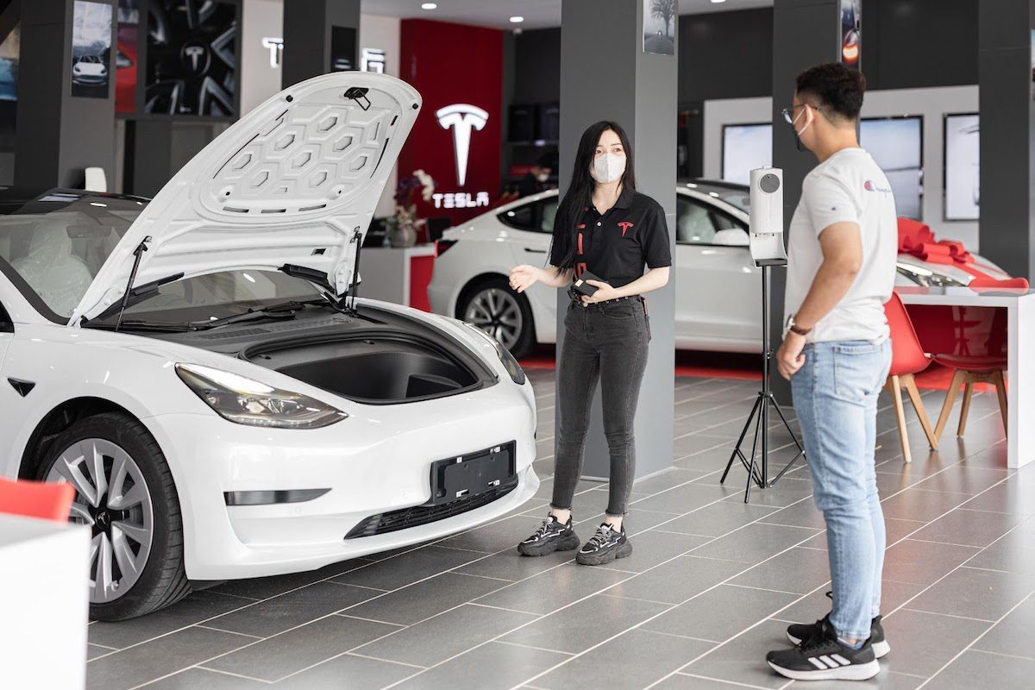
People
Tesla's places a premium on the value added by its workers and the relationships they build with consumers in the UK market. Tesla's personnel is well-versed in electric car technology and environmental sustainability, and the company benefits greatly from their expertise. During trips to the showroom and test drives, they offer helpful advice and direction (Perkins and Murmann, 2018). Tesla's dedication to its customers is on full display at its service centres and through its online support resources, which provide quick responses to questions and concerns.

References
Conclusion
Through an examination of the STP and 7P frameworks, Tesla's approach to the UK market reveals a dedication to originality, sustainability, and customer care. Tesla has positioned itself as a pioneer in the growing landscape of sustainable mobility, catering to the specific tastes and priorities of the UK customer base with its suite of innovative electric vehicles, extensive Supercharger network, and dedicated team.
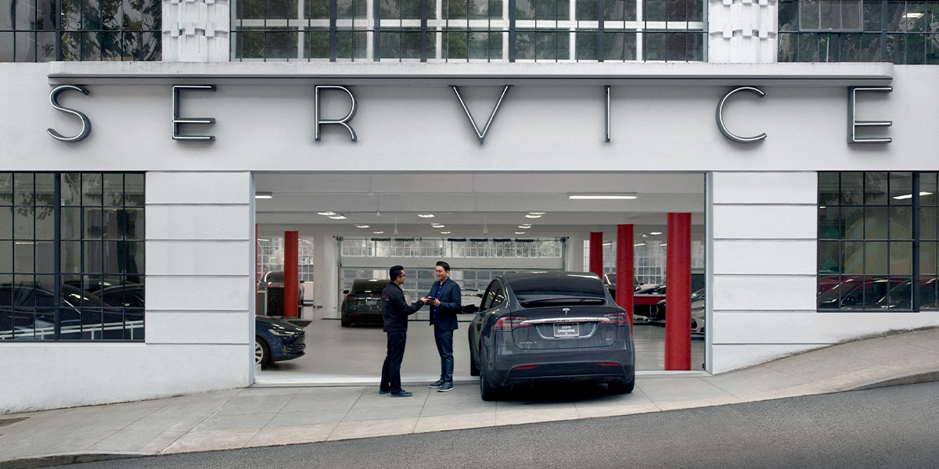
Physical Evidence
Tesla's commitment to innovation and environmental friendliness is embodied in the company's sleek and unique car designs, which feature straightforward lines and aerodynamic shapes. Proof of Tesla's premium status may be found in the high-quality materials utilised in the interiors and the cutting-edge technological interfaces (Bilbeisi and Kesse, 2017). The ever-growing Supercharger network, as well as conveniently positioned showrooms and service centres, further improve consumer convenience and accessibility in the UK.
Bilbeisi, K.M. and Kesse, M., 2017. Tesla: A successful entrepreneurship strategy. Morrow, GA: Clayton State University, 1(1), pp.1-18.
Car and Driver, 2023. Tesla Electric Vehicles: Reviews, Pricing, and Specs. [online] Car and Driver. Available at: &lt;https://www.caranddriver.com/tesla&gt; [Accessed 7 Sep. 2023].
Eberhard, M. and Tarpenning, M., 2006. The 21 st century electric car tesla motors. Tesla Motors, 17.
Fayvishenko, D., 2018. Formation of brand positioning strategy. Baltic Journal of Economic Studies, 4(2), pp.245-248.
Gu, X., Ieromonachou, P., Zhou, L. and Tseng, M.L., 2018. Developing pricing strategy to optimise total profits in an electric vehicle battery closed loop supply chain. Journal of cleaner production, 203, pp.376-385.
Holland, M., 2023. Tesla continues to dominate EV sales in the UK . [online] Push Electric Vehicles Forward. Available at: &lt;https://pushevs.com/2023/03/10/tesla-continues-to-dominate-ev-sales-in-the-uk/&gt; [Accessed 7 Sep. 2023].
Karamitsios, A., 2013. Open innovation in EVs: A case study of Tesla Motors.
Kotler, P and Armstrong, G.M., 2016. Principles of marketing. Pearson Education India.
Mangram, M.E., 2012. The globalization of Tesla Motors: a strategic marketing plan analysis. Journal of Strategic Marketing, 20(4), pp.289-312.
Maoheng, W., 2018. Research on the brand marketing of Tesla Electric Vehicle. Siam University.
Pathak, P., Yadav, V., Pillai, S., Das, S. and Kansal, G., 2022. Unveiling the Success Behind Tesla’s Digital Marketing Strategy. In Emerging Technologies in Data Mining and Information Security: Proceedings of IEMIS 2022, Volume 1 (pp. 251-260). Singapore: Springer Nature Singapore.
Perkins, G. and Murmann, J.P., 2018. What does the success of Tesla mean for the future dynamics in the global automobile sector?. Management and Organization Review, 14(3), pp.471-480.
Thomas, V.J. and Maine, E., 2019. Market entry strategies for electric vehicle start-ups in the automotive industry–Lessons from Tesla Motors. Journal of Cleaner Production, 235, pp.653-663.
Zhou, Z., 2023. Tesla Marketing Analysis. Academic Journal of Business & Management, 5(2), pp.171-177.

