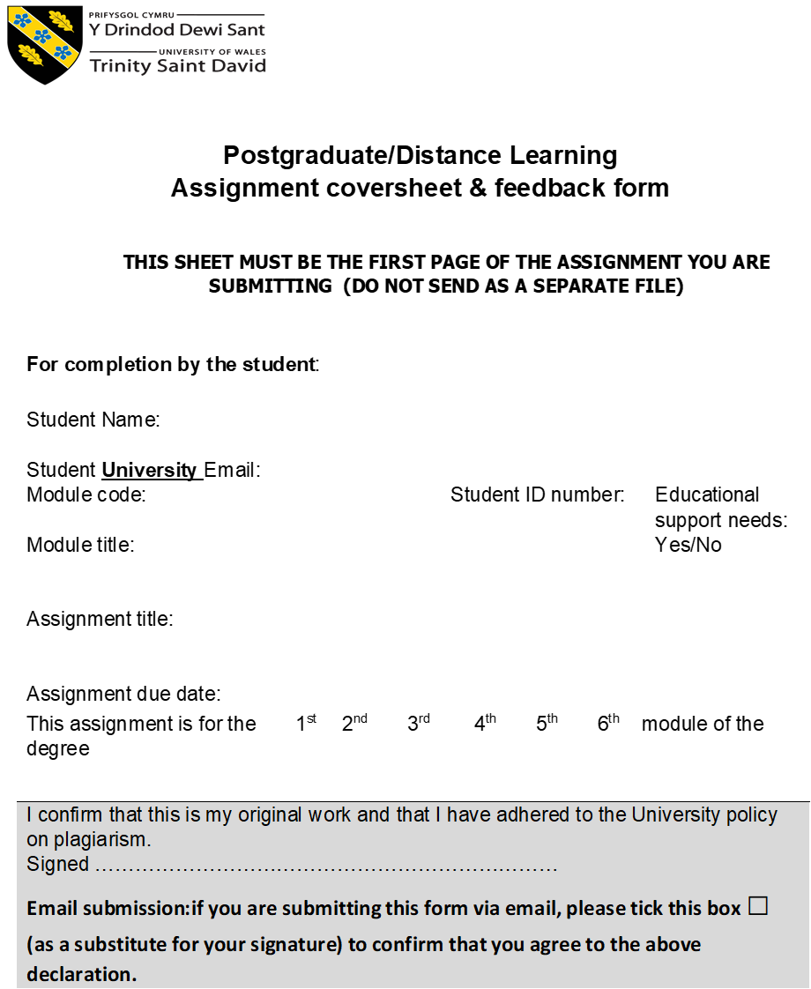

Compare and Contrast Three Works of Art

Introduction
The purpose of this research was to compare and contrast the representation of the sky in three pieces of artwork. These included Vincent Van Gogh’s (1853-1890) ‘The Starry Night’ (fig 1). Edvard Munch’s (1863-1944) ‘Starry Night’ (fig 2), and Georgia O’Keeffe’s (1887-1986) ‘Starlight Night’ (fig 3). More specifically, the aim of this paper was to examine the three different pieces of art through the representation of the starry night sky. The hope was to gain an understanding of the three pieces by exploring them through the following themes: their emphasis upon creativity, their night visions, their human potential, and to examine their wide range of human experiences that were shaped through these three visibly dramatic pieces of artistry. It also explored the artists motivation behind each piece of work in terms of the conscious effort into their thought-provoking creations, which in all three had typically dark meaning. As they seemingly chose to capture the night sky in a unique and arguably strange way.

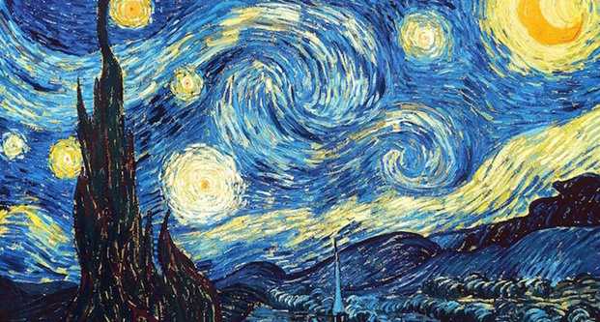
(Figure 1) The Starry Night, France, 1889. Oil on canvas: Vincent van Gogh.

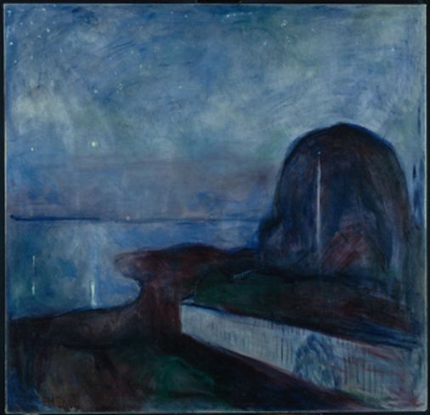
(Figure 2) Starry Night, Norway, 1893. Oil on canvas: Edvard Munch.

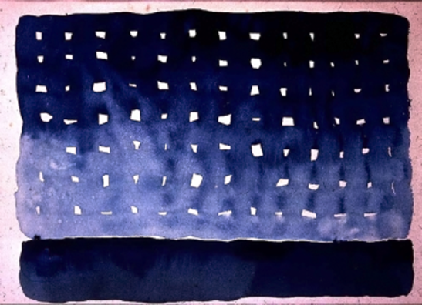
(Figure 3) Starlight Night, New Mexico, 1917. Water colour and graphite paper: Georgia O’Keeffe.

Emphasis upon Creativity
Artists work to create new forms of media and images to be built on the ruins of the old, works they considered to be more direct, honest and fundamentally more legitimate. An example of this, is Van Gogh’s painting – The Starry Night, created in Saint-Remy-Provence, Southern France in 1889. This piece is said to be one of the most well-known pieces of work he did, yet one of the most elusive, according to Robert H. Rough. It is through this painting that one can see emotional sorrow, though interestingly it was also painted purely form memory. This could have been a contributing factor to why this piece displays such strong emotional intensity and mental dislocation. It was as if he ‘longed for the night atmosphere, the stars and the moonlight.’ Thus, it could be argued that he was hardly able to contain his feelings as they seemingly spilled on to the canvas.
Likewise, were Munch’s scenes for many of his ‘Frieze’ artworks which were captured at Aasgaardstrand in Oslo, Norway. This also included his Starry Night piece, created in 1893. Munch adored the stone beaches and shoreline which separated the forest from the sea. In this painting the view is seen from his hotel window, where it is said he first feel in love. Munch’s success is based upon his body of work going to exhibit, this is known because of the ‘Munch Museum.’
Likewise, O’Keeffe viewed the heavens for its potential in being able to contribute to her great work of art – Starlight Night, created in 1917, of which was inspired by many visits to Lake Georgia, New Mexico. In this piece she has expressed effectively a little human order which is imposed throughout the motif. Yet, despite O’Keeffe’s painting’s symmetrical appearance, her 20th century motif is more inclined to the mystic heavens or that of the stars above, than several of her other artworks. O’Keeffe also had success based upon her body of work going to exhibit. This is known because of the ‘Georgia O’Keeffe Museum,’ according to Barbara L. Buhler.
However, in contrast, to both Munch and O’Keeffe was Van Gogh’s painting’s – The Starry Night. To which only one was sold in his lifetime. This was ‘The red Vines’ or ‘The Red Vineyard created in (1888). This is known because of it being sold in Brussels in 1890. Yet, none of his body of work was ever exhibited while he was living.

Night Visions
The first thing noticed in the Dutch artists’ oil-on-canvas painting is the dominate moon – emitting an orange brighter light from the rest of the stars and cypress tree which appears menacing. As its black-green complexion of colours stood out to the rest of the pastel painting, to which taking up a generous amount of the canvas’ forefront. Along with the village architecture being simple but strange, with no light illuminating, according to Jean Schwind.
Vincent’s deep blue starry night sky which captures three-quarters of his motif appears turbulent in design with swirling spirals of wave-like crests, rolling across the canvas to which blending in well with the mountains and forest. Venus is seen and the morning start which is encompassed by circular glowing yellow and white luminosities, or ‘luminosity itself,’ as Tim Ingold would say. Thus, contrasts well with the awe-inspiring fluid-like varying shades of colour.
Representing his style were his heavy and thick brushstrokes – which had a frantic, incessant rhythm. As a result, the painting displayed the illusion of constant motion. This could be argued of Vincent trying to express his own form of an improved reality - one much different from his troublesome one. He chose to emit these painted objects, as he felt they were important to him, though consequently this did distort his views.
Likewise, Norwegian artist Munch and his Starry Night piece, with its most prominent feature being the deep blue and black scenery. It expressed mysticism and landscape seemingly melancholy, that appeared full of premonitions. An abstract mound on the right represents a clump of three trees merged seamlessly, forming a single outline. A white fence runs diagonally in the forefront, with a stationary white flagpole, stood as if floating above water or standing out against the foliage.
The oddly depicted shape on the fence could be that of two shadow-like lovers, which is seen in many of Munch’s paintings. Munch also employed an undulating line to portray the continuing shoreline which carried into the trees at night. The reflection of stars in the water can also be seen, along with a blaze of light among the trees creating a luminescent scene. There are also different thicknesses of green and blue paint which were blended to form the impression of a night sky, with certain places being more thickly painted than others, along with some sections left empty to express the lighter places of his celestial phenomenon.
Munch’s sea and landscape seemingly embrace, to which each recedes and advances from one another, as John Zarobell said. Likewise, were Lynne Dozier words, that contained within the humanlike vision of the night sky and nature are the repeated themes of love and life, rendered through an objective story. This is testament to Munch’s timeless piece and nocturnal vision.
Similarly, is the American artist O’Keeffe’s painting, with its prominent feature of irregular white shaped grids left amongst a wash of water colour – fading from a bluey-black to pinkie-mauve. O’Keeffe not only encapsulated the night sky’s vastness, but also proposed her human instincts to try and depict order and pattern on what is viewed when looking at her Starlight Night masterpiece. The artwork – which appears to consist of a strong, level and deep blue skyline, delineated by the remnants of a pale-blue twilight night sky, which darkened up to the zenith – dotted with gleaming stars. This is described in O’Keeffe’s letters to Russel Vernon Hunter – a fellow artist, as O’Keeffe proposed to him the advice, she was practicing herself. To which she said ‘attempt to paint the world as if you are the first and only person viewing it…cold…wind…dust…and the vast starlight night.’ This description also echoes Van Gogh and Munch’s night visions.
Likewise, to Van Gogh, Munch and O’Keeffe were the musings of English poet Gerard Manley Hopkins (1844-1889). Night skies featured largely in Hopkin’s poems such as ‘The Starlight Night,’ to which shares the same name as O’Keeffe’s painting, and to Van Gogh and Munch’s nocturnal experiences. Therefore, it could be said their artworks bestow on the observer, the nocturnal landscape visions with that of animalistic qualities, which in all three pieces have been used with unexpected potency. The night sky and nature divided yet connected in greater unity. Thus, it would seem they all possessed incredible foresight, adopting natural scenes for their works and projected these different forms of art outward for the world to gaze upon, as they were all inspired by nature.

Human Potential
Nicholas Campion argued that every culture throughout human history began with a sense of wonder to which they have subsequently felt a sense of awe towards the sky. However, Tim Ingold argued that modern people tend to spend most of their lives inside, thus losing connection to the space outside. Still, it would seem people have always enjoyed experiencing a starry night that has inspired art, literature, philosophy, science and religion. This also being evident of numerous great night sky paintings across cultural and art history. For example, The Starry Night, Starry Night and Starlight Night – all captured whilst gazing at the heavens.
However, the contemporary night skies could be considered different to when the three artists were inspired to create their paintings. For example, when Van Gogh, Munch and O’Keeffe’s paintings are observed, they seem to express a much deeper meaning than many other night sky scenes, compared to similar modern works. It could be argued that they were able to better appreciate a night sky more than today’s artists. To which they may have been able to express it more open and honestly – visualising its beauty through their observations in more of an other-worldly fashion. Thus, the same lure that contemporary people see may be the same as what the three artists saw, which provoked their human potential to begin manifesting what is seen today as ‘phenomenal’ pieces of art.
Likewise, are Henry David Thoreau (1845-1847) and John Constable’s (1776-1837) works, that have produced arguably some of the greatest documented pieces of art and literature from Western culture. Thoreau of his time spent at Walden Pond whilst immersed in the sky and nature, and Constable of his time typically spent painting clouds from his ‘skying period.’ To which he wrote ‘I am a man of clouds.’ Likewise, was the artist Rene Magritte who cleverly parodied Ingold and Constable’s furnished view of the sky by often depicting turbulent cloudy scenes – liken to Van Gogh’s turbulent, perpetual cloudy scenes.
Similarly, to Van Gogh, Munch and O’Keeffe – who looked towards the night sky for inspiration, so too did Darrelyn Gunzburg who remarked that, the sky consists of half of our visibility, with that of landscape. However, although the sky is a ‘voice across cultures’ as Gunzburg said, still little attention is given to it. This can be likened to Van Gogh, Munch and O’Keeffe’s voice across cultures – represented through their paintings and literary works.
Furthermore, Van Gogh, Munch and O’Keeffe were not only artists, but also great writers of letters and literature, and linked frequently their three forms of art. For example, Vincent’s many letters to Theo Van Gogh describing his inspiring thoughts for The Starry Night painting. Remarking, ‘I witnessed this morning from my window…countryside before sunrise…nothing apart from the morning star…looking huge.’ Similarly, Munch once defined his ‘Frieze of Life’, as ‘a poem about life, love and death.’ While Vincent also wrote, ‘books…reality…art is the same kind of thing for me.’ Likewise, O’Keeffe’s imaginary process, did also play a role in motivating the work she produced - be it art or literature.
In addition, many people have tried finding the true nature behind Van Gogh’s piece. However, it would seem the most plausible reason for his painting can be seen from his correspondence with Theo Van Gogh. To which Vincent described his painting as a simple, ‘study of the night’, or ‘night effect.’ However, Theo said, he painted it to express, ‘style.’ Thus, it could be argued his painting was for himself, with no intended audience, as by this time he was convinced no one saw the world as he did.
Yet, it could be argued for its religious purposes, as Vincent was once an evangelist, and desired to help humankind. His religious beginnings could be connected to the merging scenes in his painting, which could also be likened to Jonathan Grossman saying that Joseph, in the book of Genesis dreamt of eleven stars, the moon and sun – appearing to be merged. Thus, it could be argued his painting communicates a love of God and all his creations. However, it could also be connected to the culture at that time, of which were captivated with ‘astronomy and astrology,’ liken to that of the French novelist Jules Verne (1828-1905) and his writings about travelling to the moon.
However, there seems to be an unmistakable loneliness to his painting, maybe because he was constantly being rejected by society as was his artwork. This loneliness can also be argued of Munch and O’Keeffe’s night-time pieces. It could also be argued that Van Gogh, Munch and O’Keeffe’s paintings lay bare the thoughts that are also felt and experienced by prior and modern artists alike. Thus, their art could be considered of being born of conceived ideas or rather the expression of that manifested idea, like that of Maurice Maeterlinck’s artistic ‘dramas or other literary works.’ Therefore, by no means of their skill as artists, they opened their souls to us, consequently revealing their inner secrets and depths of their minds’, akin to their night scenes.

Human Experience
It could also be argued that the human experience forms the basis to which post -impressionist and impressionist art was created. The difference between these both styles can be described as ‘post-modernist art as a reaction against impressionist art.’ It is also though that art should reflect accurately the realities of lighting and natural colour. This means that artists take subjective views of their perceived world and paint the visual surroundings given their own creative insights. This is also likened to Robert O. Morris’s words, who said that post impressionism painters believed art was not supposed to imitate form, however, to create form. Thus, this could be the reason post-impressionist paintings such as Van Gogh’s, The Starry Night and Munch’s, Starry Night, have no set style, as their creations reflect their observations and strange personas. Yet, this contrasts with O’Keeffe’s innovative impressionist style of art, that challenged perceptions evolving constantly throughout her career.
Yet, the post-impressionist style of art is consistent with Van Gogh’s and Munch’s thoughts that, we might achieve in establishing more exiting and comforting natural surroundings, that what we could distinguish with a single hint of reality. However, Vincent also confessed to his brother that instead of utilising different colours ‘realistically’ his preference was more of a ‘random form’ of expression. This he said, was in order to convey himself more powerfully. As particularly, Van Gogh enjoyed depicting landscape sceneries in reflection of this own soulful feelings. Therefore, it could be argued that he felt a sense of liberty, as he chose to leave his old-style of art behind.
However, if one wants to better grasp Van Gogh, Munch and O’Keeffe’s style of painting, one could look at numerous other influential artists who have also captured the compelling night sky in multiple forms through their wonderous, awe-inspiring night visions. For example, post-impressionist artists’ Paul Cézanne (1839-1906), and Paul Gauguin (1848-1903), and that of impressionist artist Claude Monet (1840-1926). To which were all equally as accomplished in terms of their artistic manifestations. Thus, is could be said that Van Gogh, Munch and O’Keeffe’s nocturnal visions were built upon ruins of former artists’ works, to which seemingly embody their unique expressional style of paintings, which may also be argued to have had major influences on modern art.

Though-Provoking Night Sky
Van Gogh, Munch and O’Keeffe’s mania filled minds could indeed be connected to their odd artistic expressions – which they depicted in their torment inspired starry night scenes. Form this notion, one may imagine an artist’s mind could be argued troublesome of their mental capacity for anything but their art. As they all had ‘titanic’ struggles with both art and indeed historically striking connections in terms of insanity. This can be seen of Munch’s words that, ‘insanity and disease linger at my cradle, were the black angels are on guard.’ Whilst Van Gogh also remarked, ‘the more decomposed I become, the sicker and more disjointed I am, the more artist-like I become.’
Furthermore, according to Norma S. Steinberg, ‘Munch lived an agitated existence.’ He could also be considered a ‘person of today,’ she suggested. This is also apparent of Van Gogh and O’Keeffe’s mind-set, as they too could be argued to have modern day concerns. Likewise, are Van Gogh’s words that, ‘I put my heart and soul into my art and lost my mind in the process.’ However, Munch saw his mental anguish as motivation for his Starry Night, remarking that, ‘necessary is my fear of life, as is my sickness, both identical from me, their obliteration would destroy my work.’ Likewise, are O’Keeffe’s words, to which she wrote, ‘I could not say in any other way, things I had no voice for than through the expression of colour and shapes.’ From these descriptions it could be argued that their artworks are connected, as one serves to clarify and illuminate the other, not just in name and depiction but of their dark imaginations.
Furthermore, O’Keefe could be considered to have lived quite a normal life. However, that cannot be said for Van Gogh and Munch, that believed if they devoted their lives to art, a normal life was not possible. This seems quite sad. Afterall, how can you convince someone to live a normal life, when an artist’s life, is all they have. Thus, one could imagine that their art brought them peace in some strange, dark and twisted way. From this, one can get the impression that their bold colours and brushstrokes emitted not only a tortured mind, but also an enormous talent for art.
Finally, it could be argued that mental anguish seems to be recurring of many greater artists. For Example, Louis Wain (1860-1939) who depicted ‘anthropomorphic cats’ and suffered from schizophrenia, and that of Francisco de Goya (1746-1828), that suffered hallucinations and delirium. However, like Van Gogh, Munch and O’Keeffe, were still able to create phenomenal artworks. Thus, one can get the sense that from the minds of these individuals, became living and breathing pieces of art, like O’Keeffe’s sensually painted stars, glorious, like Munch’s and Van Gogh’s night sky depictions.

Conclusion
The purpose of this research was to compare and contrast the representation of the sky in three pieces of artwork – The Starry Night, Starry Night and Starlight Night. More specifically, the aim – and hope of this paper was to examine the three different pieces of art through the representation of the starry night sky. Also, to gain an understanding by exploring them through the following themes: emphasis upon creativity, night visions, human potential, and human experiences. It also explored the artists motivation behind each piece of work in terms of the conscious effort into their thought-provoking creations.
Due to Van Gogh, Munch and O’Keeffe, their night sky paintings have crossed distant, lonely and desolate spaces, to which they immersed themselves within the lonesome canvas of our human hearts. Their art has inspired in those who observed it the same desire for otherworldliness that, in prior eras, has driven sinners to their knees and mystics to joy. If today they have become more socially acceptable, the experience their artwork portrays are remnants even more inquisitory and unsettling. Their works disturb our superficial presumptions of the way life is and expose for us the unexplored water of life’s primordial ocean. Their art also provides a place for disbelievers to consider the mystical dimensions of our existence. To which they clearly fall under the premise, of which could be considered some of the most influential pieces of art in representation of the night sky.
Their observations and depictions of their night visions also called into question the nature of their perceived reality and morality. The works could also be argued an odyssey of their dynamic human creation and offering insight into their inner psyche and outer world. The paintings are also consistent with some of the most fascinating and surprising works in art history. Whereby which captivating their own consciousness and that of fellow artists and art enthusiasts alike. Furthermore, their pieces offered a daring exploration and inspiring vision for individual fulfilment and a human basis for our interaction with each other and that of the natural world. This might lead us to believe that their depictions are an invitation to a long- though understanding of what more of today’s art should represent.
The works of art depicted in this paper challenge the reader to the deepest levels of though, which may also lead us to believe their works hold eternal laws of nature, which were evolved in their paintings. To which they have successfully depicted alternate realities, not just for themselves but which is also bestowed on the observer. However, this still leaves one pondering the connection between what they painted and what is seen, in terms of not only their perception, but their thinking to ours. The images seem to be the life force of the canvas - bursting with dynamism. The paintings express great emotional content with a variety of intensity throughout. Their works have left us ‘extraordinary gifts’ in their abundant collections of now-famous paintings hanging in the world’s museums and displayed in hundreds of art books that contain reproductions of their works.
They all led troubled lives, yet despite this, still chose to explore, through their unusually expressive brushwork the fear in their creative imaginations, but also love and death, solace and suffering with striking similarities. Furthermore, all sought novel ways to express their artistry through colour and dramatic composition, sharing the beauty of the universe through their incessant, mania filled psyches. As Munch said, ‘to capture strong emotions solely employed from nature – glowing with passion and infernal fire of soul, is unbelievably demanding for the nervous system.’
This may be the reason the three artists anguished over their creations, as have many others. Thus, by observing the seething life and their fluid brushstrokes, gives the impression of motion throughout their night sky paintings, their minds, and culture at that time. However, artistic talent often comes with a price, as many artists whose work is respected were also plagued by mental dislocation, sorrow and obsession. Furthermore, there is a risk of these three paintings being just as diverse and unpredictable as to any other pieces of art. However, the mere terms ‘beautiful’, or ‘perplexing’ do not describe the striking experience one gets from seeing their creations for the first time.
Many works of art are called great or captivating, due to their ability to change our imagination in various ways. Yet, none more so than the three pieces discussed in this paper. Thus, from their paintings we can truly see the world through their eyes. For Van Gogh, Munch and O’Keeffe the night sky was important to them for creating art, and certainly played a massive role in their lives. However, they seemed to observe the night sky as many artists have before and after them, to which knowing that they too shall pass, like the perpetual motion of clouds, across the evanescent, infinite night sky.

Bibliography
‘Van Gogh's Stars.’ The Wilson Quarterly (1976-), vol. 10, no. 5, 1986, pp. 36–38.
Barbre, Claude. ‘Constable's Skies.’ Journal of Religion and Health, vol. 43, no. 4, 2004, pp. 390–392.
Barksdale, W. Maynard. ‘Thoreau's House at Walden.’ The Art Bulletin, vol. 81, no. 2, 1999, pp. 303–325.
Billy, J. Denis, J. ‘Under the Starry Night.’ New Blackfriars, vol. 76, no. 889, 1995, pp. 43–48.
Buhler, L. Barbara. ‘Visiting Georgia O'Keeffe.’ American Art, vol. 20, no. 3, 2006, pp. 2–7.
Campion, Nicholas. The Dawn of Astrology: A Cultural History of Western Astrology. Volume 1: The Ancient and Classical Worlds (London & New York: Continuum Books, 2008), p. 5.
Cézanne, Paul (1839-1906). ‘The Burlington Magazine,’ vol. 148, no. 1242, 2006, pp. 583–585.
Coe, T. Ralph. ‘Impressionist and Post-Impressionist Paintings in Washington.’ The Burlington Magazine, vol. 101, no. 675, 1959, pp. 242–245.
Consolmagno, J. Guy. ‘Astronomy, Science Fiction and Popular Culture: 1277 to 2001’ (And beyond). Leonardo, vol. 29, no. 2, 1996, pp. 127–132.
Dozier, Lynne. ‘Art as Text: Seeing beyond the Obvious.’ The English Journal, vol. 106, no. 6, 2017, p. 32.
Fowlie, Wallace. ‘The Religious Experience of Van Gogh.’ College Art Journal, vol. 9, no. 3, 1950, pp. 317–324.
Frothingham, L. Arthur, Senior. ‘The Philosophy of Art.’ The American Journal of Archaeology and of the History of the Fine Arts, vol. 9, no. 2, 1894, pp. 165–201.
Grasso, M. Linda. ‘You Are No Stranger to Me: Georgia O'Keeffe's Fan Mail.’ Reception: Texts, Readers, Audiences, History, vol. 5, 2013, pp. 24–40.
Green, F. Vivian. ‘Georgia O'Keeffe's Radiator Building: Gender, Sexuality, Modernism, and Urban Imagery.’ Winterthur Portfolio, vol. 35, no. 4, 2000, pp. 269–289.
Grossman, Jonathan. ‘Different Dreams: Two Models of Interpretation for Three Pairs of Dreams (Genesis 37–50).’ Journal of Biblical Literature, vol. 135, no. 4, 2016, pp. 717–732.
Gunzburg, Darrelyn. The imagined sky: cultural perspectives. (2013).
Hawes, Louis. ‘Constable's Sky Sketches.’ Journal of the Warburg and Court auld Institutes, vol. 32, 1969, pp. 344–365.
Hekkert, Paul, and Wieringen Van, C. W. Piet. ‘Beauty in the Eye of Expert and Nonexpert Beholders: A Study in the Appraisal of Art.’ The American Journal of Psychology, vol. 109, no. 3, 1996, pp. 389–407.
Hellmanzik, Christiane. ‘Artistic Styles: Revisiting the Analysis of Modern Artists Careers.’ Journal of Cultural Economics, vol. 33, no. 3, 2009, pp. 201–232.
Henderson, Archibald. ‘Maurice Maeterlinck as a Dramatic Artist.’ Author(s): Source: The Sewanee Review, April., 1904, Vol. 12, No. 2 (April., 1904), pp. 207-216
Hoerger, Jacob. ‘Missing the Night Sky.’ The New Atlantis, no. 48, 2016, pp. 115–131.
House, John. The Art Bulletin, vol. 78, no. 2, 1996, pp. 365–367.
Ingold, Tim. (2005). ‘The eye of the storm: visual perception and the weather.’ Visual Studies (Abingdon, England), 20(2), pp. 97–104.
Ingold, Tim. ‘Bringing things to life: Creative entanglements in a world of materials.’ World 44 (2010): pp, 1-25.
Ingold, Tim. ‘Earth Sky, Wind, and Weather.’ The Journal of the Royal Anthropological Institute, 13 (2007), pp. 19-38, (p. 29).
Krippner, Stanley. ‘Ecstatic Landscapes: The Manifestation of Psychedelic Art.’ Journal of Humanistic Psychology. 2017;57(4): pp, 415-435.
Lankford, E. Louis. ‘A Phenomenological Methodology for Art Criticism.’ Studies in Art Education, vol. 25, no. 3, 1984, pp. 151–158.
Lathe, Carla. ‘Edvard Munch's Dramatic Images 1892-1909.’ Journal of the Warburg and Courtauld Institutes, vol. 46, 1983, pp. 191–206.
Laurie, Lisle. ‘Viewing O’Keeffe.’ Journal of the Southwest, vol. 30, no. 2, 1988, pp. 254–258.
Lee, K. Carroll. ‘Artistic Beginnings: The Work of Young Edvard Munch.’ Studies in Art Education, vol. 36, no. 1, 1994, pp. 7–17.
McCarty-Procopio, Cathy, Wade Richards, Anne Spackman, Carrie Sutton and Diane Brigham ‘Instructional Resources: Making Meaning with Your Eyes.’ Art Education, vol. 44, no. 4, 1991, pp. 28.
McGennis, Aiden. (1999). ‘Louis Wain: His life, his art and his mental illness.’ Irish Journal of Psychological Medicine, 16(1), pp. 27-28.
Moorman, Honor. ‘Backing into Ekphrasis: Reading and Writing Poetry about Visual Art.’ The English Journal, vol. 96, no. 1, 2006, pp. 46–53.
Morris, O. Robert. ‘Post Impressionism.’ The Sewanee Review, vol. 20, no. 2, 1912, pp. 191–200.
Olson, W. Donald., Russell L. Doescher, and Marilynn S. Olson. ‘Dating Van Gogh's Moonrise.’ (2003).
Powers, D. Edward. ‘From Eternity to Here: Paul Gauguin and the Word Made Flesh.’ Oxford Art Journal, vol. 25, no. 2, 2002, pp. 87–106.
Prioleau, Elizabeth. ‘The Nights of Gerard Manley Hopkins: A Mystical Starscape.’ Victorian Poetry, vol. 21, no. 1, 1983, pp. 85–91.
Richardson A. Bradford, Alexandra, M. Rusyniak., George, W. Rusyniak., Jr, and Charles, B. Rodning. ‘Neuroanatomical interpretation of the painting starry night by Vincent van Gogh.’ Neurosurgery 81.3 (2017): pp. 389-396.
Riefstahl-Meyer, R. ‘Vincent Van Gogh-I.’ The Burlington Magazine for Connoisseurs, vol. 18, no. 92, 1910, pp. 91–99.
Riefstahl-Meyer, R. ‘Vincent Van Gogh-II. Van Gogh's Style in Relation to Nature.’ The Burlington Magazine for Connoisseurs, vol. 18, no. 93, 1910, pp. 155–162.
Roberta, M. Alford. ‘Francisco Goya and the Intentions of the Artist.’ The Journal of Aesthetics and Art Criticism, vol. 18, no. 4, 1960, pp. 482–493.
Rough, H. Robert. ‘Metaphor in The Art of Vincent van Gogh.’ The Centennial Review, vol. 19, no. 1, 1975, pp. 362–379.
Schwind, Jean. ‘Van Gogh's Starry Night’ and Whitman: A Study in Source.’ Walt Whitman Quarterly Review 3 (Summer 1985), 1-15.
Scott, Nancy. ‘The O’Keeffe Correspondence, 1915-1917.’ Source: Notes in the History of Art, vol. 3, no. 1, 1983, pp. 34–41.
Soth, Lauren. ‘Van Gogh's Agony.’ The Art Bulletin, vol. 68, no. 2, 1986, pp. 301–313.
Stawell, F. Melian. ‘The Letters of Vincent Van Gogh.’ The Burlington Magazine for Connoisseurs, vol. 19, no. 99, 1911, pp. 152–154.
Steinberg, S. Norma. ‘Munch in Colour.’ Harvard University Art Museums Bulletin, vol. 3, no. 3, 1995, p. 154.
Stewart, F. Jack. ‘Expressionism in The Rainbow.’ Novel: A Forum on Fiction, vol. 13, no. 3, 1980, pp. 296–315.
Sullivan, Graeme. ‘Artistic Thinking as Transcognitive Practice: A Reconciliation of the Process-Product Dichotomy.’ Visual Arts Research, vol. 27, no. 1, 2001, pp. 2–12.
The Masterworks of Edvard Munch. (1979). MoMA (New York, N.Y.), 10, 6–6.
Tromp, Henk. A Real Van Gogh: How the Art World Struggles with Truth. Amsterdam University Press, 2010.
Udall, R. Sharyn. ‘Georgia O'Keeffe and Emily Carr: Health, Nature and the Creative Process.’ Woman's Art Journal, vol. 27, no. 1, 2006, pp. 17–25.
Van Gogh Starry Night. (1996). The Publishers Weekly, 243(9), p. 46.
Vojtěch, Jirat-Wasiutyński. ‘Vincent Van Gogh's Paintings of Olive Trees and Cypresses from St.-Rémy.’ The Art Bulletin, vol. 75, no. 4, 1993, pp. 647–670.
Weisman, Celia. ‘O'Keeffe's Art: Sacred Symbols and Spiritual Quest.’ Woman's Art Journal, vol. 3, no. 2, 1982, pp. 10–14.
Wright, S. Frederick. ‘Introduction to Edvard Munch.’ The Kenyon Review, vol. 12, no. 3, 1950, pp. 457–469.
Yeh-Fillin, Susan. ‘Dandies, Marginality and Modernism: Georgia O'Keeffe, Marcel Duchamp and Other Cross-Dressers.’ Oxford Art Journal, vol. 18, no. 2, 1995, pp. 33–44.
Zarobell, John. ‘A Year in Paris: Edvard Munch's Mermaid.’ Philadelphia Museum of Art Bulletin, vol. 93, no. 393/394, 2005, pp. 7–23.

Bradford, A. Richardson., Alexandra, M. Rusyniak., George, W. Rusyniak., Jr, and Charles, B. Rodning. ‘Neuroanatomical interpretation of the painting starry night by Vincent van Gogh.’ Neurosurgery 81.3 (2017): pp. 389-396.
Cathy, McCarty-Procopio, Wade Richards, Anne Spackman, Carrie Sutton and Diane Brigham ‘Instructional Resources: Making Meaning with Your Eyes.’ Art Education, vol. 44, no. 4, 1991, pp. 28.
Honor, Moorman. ‘Backing into Ekphrasis: Reading and Writing Poetry about Visual Art.’ The English Journal, vol. 96, no. 1, 2006, pp. 46–53.
Stanley, Krippner. ‘Ecstatic Landscapes: The Manifestation of Psychedelic Art.’ Journal of Humanistic Psychology. 2017;57(4): pp, 415-435.
Paul, Hekkert, and Wieringen, Van, C. W. Piet. ‘Beauty in the Eye of Expert and Nonexpert Beholders: A Study in the Appraisal of Art.’ The American Journal of Psychology, vol. 109, no. 3, 1996, pp. 389–407.
Robert, H. Rough. ‘Metaphor in The Art of Vincent van Gogh.’ The Centennial Review, vol. 19, no. 1, 1975, pp. 362–379.
Donald, W. Olson., Russell L. Doescher, and Marilynn S. Olson. ‘Dating Van Gogh's Moonrise.’ (2003).
Graeme, Sullivan. ‘Artistic Thinking as Transcognitive Practice: A Reconciliation of the Process-Product Dichotomy.’ Visual Arts Research, vol. 27, no. 1, 2001, pp. 2–12.
Jack, F. Stewart. ‘Expressionism in The Rainbow.’ Novel: A Forum on Fiction, vol. 13, no. 3, 1980, pp. 296–315.
Frederick, S. Wight. ‘Introduction to Edvard Munch.’ The Kenyon Review, vol. 12, no. 3, 1950, pp. 457–469.
Laurie, Lisle. ‘Viewing O’Keeffe.’ Journal of the Southwest, vol. 30, no. 2, 1988, pp. 254–258.
Vivian, F. Green. ‘Georgia O'Keeffe's Radiator Building: Gender, Sexuality, Modernism, and Urban Imagery.’ Winterthur Portfolio, vol. 35, no. 4, 2000, pp. 269–289.
Barbara, L. Buhler. ‘Visiting Georgia O'Keeffe.’ American Art, vol. 20, no. 3, 2006, pp. 2–7.
Henk, Tromp. A Real Van Gogh: How the Art World Struggles with Truth. Amsterdam University Press, 2010.
Jean, Schwind. ‘Van Gogh's Starry Night’ and Whitman: A Study in Source.’ Walt Whitman Quarterly Review 3 (Summer 1985), pp. 1-15.
‘Van Gogh's Stars.’ The Wilson Quarterly (1976-), vol. 10, no. 5, 1986, pp. 36–38.
Tim, Ingold. (2005). ‘The eye of the storm: visual perception and the weather.’ Visual Studies (Abingdon, England), 20(2), pp. 97–104.
Denis, J. Billy. ‘Under the Starry Night.’ New Blackfriars, vol. 76, no. 889, 1995, pp. 43–48.
Carla, Lathe. ‘Edvard Munch's Dramatic Images 1892-1909.’ Journal of the Warburg and Courtauld Institutes, vol. 46, 1983, pp. 191–206.
The Masterworks of Edvard Munch. (1979). MoMA (New York, N.Y.), 10, 6–6.
John, Zarobell. ‘A Year in Paris: Edvard Munch's Mermaid.’ Philadelphia Museum of Art Bulletin, vol. 93, no. 393/394, 2005, pp. 7–23.
Lynne, Dozier. ‘Art as Text: Seeing beyond the Obvious.’ The English Journal, vol. 106, no. 6, 2017, p. 32.
Celia, Weisman. ‘O'Keeffe's Art: Sacred Symbols and Spiritual Quest.’ Woman's Art Journal, vol. 3, no. 2, 1982, pp. 10–14.
Nancy, Scott. ‘The O’Keeffe Correspondence, 1915-1917.’ Source: Notes in the History of Art, vol. 3, no. 1, 1983, pp. 34–41.
Elizabeth, Prioleau. ‘The Nights of Gerard Manley Hopkins: A Mystical Starscape.’ Victorian Poetry, vol. 21, no. 1, 1983, pp. 85–91.
Nicholas, Campion. The Dawn of Astrology: A Cultural History of Western Astrology. Volume 1: The Ancient and Classical Worlds (London & New York: Continuum Books, 2008), p. 5.
Tim, Ingold. ‘Earth Sky, Wind, and Weather.’ The Journal of the Royal Anthropological Institute, 13 (2007), pp. 19-38, (p. 29).
Arthur, L. Frothingham, Senior. ‘The Philosophy of Art.’ The American Journal of Archaeology and of the History of the Fine Arts, vol. 9, no. 2, 1894, pp. 165–201.
Jacob, Hoerger. ‘Missing the Night Sky.’ The New Atlantis, no. 48, 2016, pp. 115–131.
Louis, E. Lankford. ‘A Phenomenological Methodology for Art Criticism.’ Studies in Art Education, vol. 25, no. 3, 1984, pp. 151–158.
Maynard, W. Barksdale. ‘Thoreau's House at Walden.’ The Art Bulletin, vol. 81, no. 2, 1999, pp. 303–325.
Claude, Barbre. ‘Constable's Skies.’ Journal of Religion and Health, vol. 43, no. 4, 2004, pp. 390–392.
Louis, Hawes. ‘Constable's Sky Sketches.’ Journal of the Warburg and Court auld Institutes, vol. 32, 1969, pp. 344–365.
Tim, Ingold. ‘Bringing things to life: Creative entanglements in a world of materials.’ World 44 (2010): pp, 1-25.
Darrelyn, Gunzburg. The imagined sky: cultural perspectives. (2013).
Jirat-Wasiutyński, Vojtěch. ‘Vincent Van Gogh's Paintings of Olive Trees and Cypresses from St.-Rémy.’ The Art Bulletin, vol. 75, no. 4, 1993, pp. 647–670.
Schwind, ‘Van Gogh's Starry Night,’ p. 1.
Green, ‘Georgia O'Keeffe's ‘Radiator Building,’ pp. 269–289.
Lauren, Soth. ‘Van Gogh's Agony.’ The Art Bulletin, vol. 68, no. 2, 1986, pp. 301–313.
Wallace, Fowlie. ‘The Religious Experience of Van Gogh.’ College Art Journal, vol. 9, no. 3, 1950, pp. 317–324.
Jonathan, Grossman. ‘Different Dreams: Two Models of Interpretation for Three Pairs of Dreams (Genesis 37–50).’ Journal of Biblical Literature, vol. 135, no. 4, 2016, pp. 717–732.
Guy, J. Consolmagno. ‘Astronomy, Science Fiction and Popular Culture: 1277 to 2001’ (And beyond). Leonardo, vol. 29, no. 2, 1996, pp. 127–132.
Archibald, Henderson. ‘Maurice Maeterlinck as a Dramatic Artist.’ Author(s): Source: The Sewanee Review, April., 1904, Vol. 12, No. 2 (April., 1904), pp. 207-216
Ralph, T. Coe. ‘Impressionist and Post-Impressionist Paintings in Washington.’ The Burlington Magazine, vol. 101, no. 675, 1959, pp. 242–245.
Robert, O. Morris. ‘Post Impressionism.’ The Sewanee Review, vol. 20, no. 2, 1912, pp. 191–200.
Susan, Fillin-Yeh. ‘Dandies, Marginality and Modernism: Georgia O'Keeffe, Marcel Duchamp and Other Cross-Dressers.’ Oxford Art Journal, vol. 18, no. 2, 1995, pp. 33–44.
Melian, F. Stawell. ‘The Letters of Vincent Van Gogh.’ The Burlington Magazine for Connoisseurs, vol. 19, no. 99, 1911, pp. 152–154.
Meyer-Riefstahl, R. ‘Vincent Van Gogh-II. Van Gogh's Style in Relation to Nature.’ The Burlington Magazine for Connoisseurs, vol. 18, no. 93, 1910, pp. 155–162.
Meyer-Riefstahl, R. ‘Vincent Van Gogh-I.’ The Burlington Magazine for Connoisseurs, vol. 18, no. 92, 1910, pp. 91–99.
Paul, Cézanne (1839-1906). ‘The Burlington Magazine,’ vol. 148, no. 1242, 2006, pp. 583–585.
Edward D, Powers. ‘From Eternity to Here: Paul Gauguin and the Word Made Flesh.’ Oxford Art Journal, vol. 25, no. 2, 2002, pp. 87–106.
John, house. The Art Bulletin, vol. 78, no. 2, 1996, pp. 365–367.
Christiane, Hellmanzik. ‘Artistic Styles: Revisiting the Analysis of Modern Artists' Careers.’ Journal of Cultural Economics, vol. 33, no. 3, 2009, pp. 201–232.
Wight. ‘Introduction to Edvard Munch,’ pp. 457–469.
Wight, ‘Introduction to Edvard Munch,’ p. 458.
Carroll, K. Lee. ‘Artistic Beginnings: The Work of Young Edvard Munch.’ Studies in Art Education, vol. 36, no. 1, 1994, pp. 7–17.
Norma, S. Steinberg. ‘Munch in Colour.’ Harvard University Art Museums Bulletin, vol. 3, no. 3, 1995, p. 154.
Steinberg, ‘Munch in Colour,’ p. 154.
McCay, and Baughman, ‘Art, Madness, and Human Interaction,’ p. 415.
Steinberg, ‘Munch in Colour,’ p. 154.
Linda, M. Grasso. ‘You Are No Stranger to Me: Georgia O'Keeffe's Fan Mail.’ Reception: Texts, Readers, Audiences, History, vol. 5, 2013, pp. 24–40.
Grasso. ‘You Are No Stranger to Me: Georgia O'Keeffe's Fan Mail,’ pp. 24–40.
Aiden, McGennis. (1999). ‘Louis Wain: His life, his art and his mental illness.’ Irish Journal of Psychological Medicine, 16(1), pp. 27-28.
Alford, M. Roberta. ‘Francisco Goya and the Intentions of the Artist.’ The Journal of Aesthetics and Art Criticism, vol. 18, no. 4, 1960, pp. 482–493.
Sharyn, R. Udall. ‘Georgia O'Keeffe and Emily Carr: Health, Nature and the Creative Process.’ Woman's Art Journal, vol. 27, no. 1, 2006, pp. 17–25.
Lathe, ‘Edvard Munch's Dramatic Images 1892-1909,’ pp. 191–206.
Van Gogh Starry Night. (1996). The Publishers Weekly, 243(9), p. 46.

