Introduction
  - The aim of this paper
The aim of paper is to analyse the Global Risk 2033 ‘Tomorrows Catastrophes’ report chapter two and asses the risks presented by the WEF and look at possible ways in the future to deal with these issues.
The hazards that we face Globally seem both recent and familiar, some of the most serious hazards that could affect us during the next ten years are examined in the Global Hazards Report 2023. Tougher trade-offs run the risk of undermining climate action, human development, and future resilience as we teeter on the brink of a low growth and low cooperation age. The report is supported by the yearly global risk perception survey, which gathers exceptional analysis from more than 1200 experts through the extensive network of the World Economic Forum. (Global Risks Report 2023 | World Economic Forum, 2023)
1.2 The World’s Economic Forum (WEF)
The International Organisation for Public-Private Cooperation is the World’s Economic Forum. A non-profitable foundation with headquarters in Geneva and Switzerland. Professor Klaus Schwab founded an organisation called European Management Forum, in 1973 the forum was growing steadily, and in January 1974 political leaders were invited to join the yearly meeting in Davos for the first time. 1976 seen the introduction of a membership system for over one thousand leading companies in the world. (World economic forum, 2023)
The first non-governmental organisation to establish a collaboration with Chinas economic development commissions, this spurred economic reform policies in China. The yearly event also includes regional gatherings held around the world.
The forum makes every effort to promote entrepreneurship in the service of general welfare on a global scale while respecting the highest standards of governance. Integrity on both a moral and intellectual level is at the core of the foundation.
The Forum works with the most influential figures in politics, business, culture, and other areas to develop agendas for the world, regions, and industries. (Our Mission, 2023)

2.0 Main findings
2.1 Top Ten Dangers and Risks

The top ten dangers and risks that are anticipated to materialise over the following ten years ranked by severity according to the results from the GRPS report are displayed in figure one below.
1 | Failure to mitigate climate change | 6 | Natural resources crisis
2 | Failure of climate change adaption | 7 | Erosion of social cohesion and societal polarization
3 | Natural disaster and extreme weather events | 8 | Widespread cybercrime and cyber insecurity
4 | Biodiversity loss and ecosystem collapse | 9 | Geoeconomic confrontation
5 | Large scale involuntary migration | 10 | Large scale environmental damage incidents
(Global Risks Report 2023 | World Economic Forum, 2023) Figure 1
Risk categories: Economic -Environmental -Geopolitical -Societal- Technological
GRPS differentiated these hazards as a separate one for the first time, The most serious hazards on a global scale are failure to curb climate change and failure to adapt to it, followed by natural disasters and extreme weather events, and biodiversity loss of ecosystem collapse.
According to the GRPS respondents, from comparing the two- and ten-year time frame it shows areas of increasing and decreasing concerns.
Figure 2 identifies the perceived world threats that are the most serious in the short and long terms. These persistent global problem areas are four environmental dangers scores that have been worsened over a 10-year period, whilst large-scale involuntary migration moves up to fifth position during a ten-year period, while societal polarization and social cohesiveness erosion are thought to worsen over time.
Long term risks are becoming more serious included “misinformation and disinformation” and Biodiversity loss and ecosystem collapse according to the report, Figure 2 extreme right corner also shows that the “cost of living crisis”, which is currently the biggest concern is expected to lessen in severity over the next few years. At the middle of figure 2 shows the use of weapons that cause mass destruction being a constant, mixed with state collapse and ineffectiveness of multilateral institutions.
The report states that this year it will look at five new quickly developing risk clusters that have been emerging, derived from several realms including economic, environmental, sociological, geopolitical, and technical that could potentially become tomorrow’s crisis.
Natural ecosystems – risks to natural capital such as forest, living organisms and water due to the increase of trade-offs.
Human Health – Hazzard’s that are being exacerbated by overburdened healthcare systems dealing with the covid nineteen pandemic.
Human Security – developing from new weapons and multi domain wars, there is a nascent reversal in demilitarization and increasing susceptibility of nuclear armed states of developing technology.
Digital rights- deceptive erosion of people’s digital autonomy and potential evolution of data and cyber insecurity, privacy is at risk.
Economic stability- emerging from global debt reckoning and causing social unrest is a developing debt crisis that has implications for financial contagion.

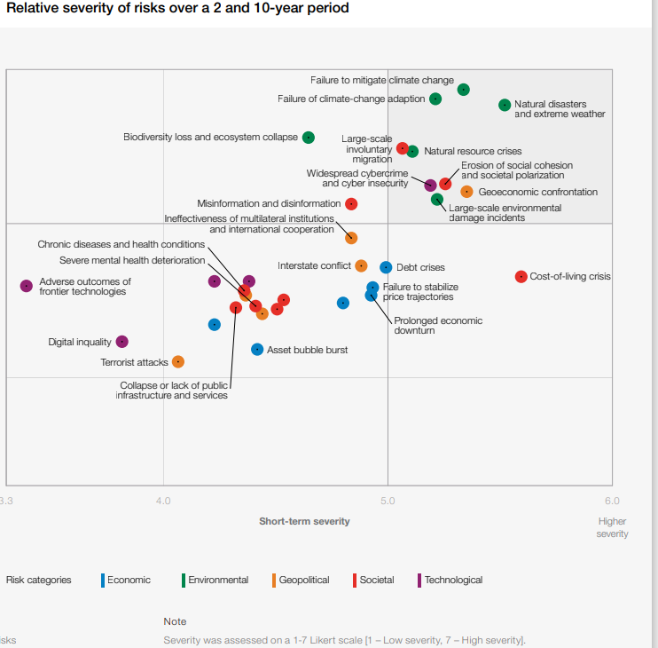
(Global Risks Report 2023 | World Economic Forum, 2023) Figure 2

2.2 The Seventeen Sustainable Development Goals

169 Targets-3811 Events-1344 Publications – 7525 Actions (United Nations, n.d.)
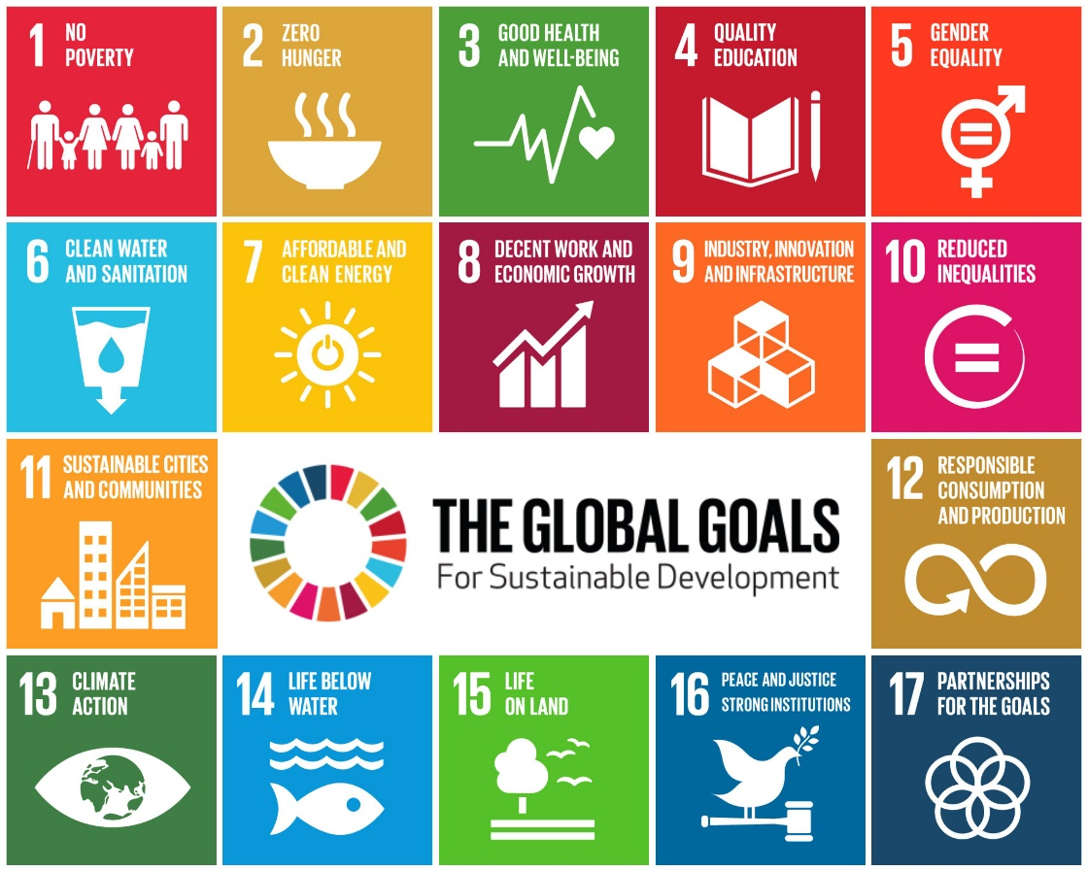
(Education for the Sustainable Development Goals at DMU, 2023)
DSDG is the Division for Sustainable Development and Goals in the UNDESA United Nations Department of Economic and Social Affairs, providing support and capacity strengthening for their aims and related thematic matter, these include water, energy, climate, oceans, urbanization, transport, science, and technology.
The United Nations endorsed goals in 2015 for all United Nations members, there were seventeen goals all together with the aim of transforming the world by 2030. The primary goal of the sustainable development goals is for all nations to work together to achieve the goals of creating wealth while also preserving the environment. (Measuring Progress Towards the Sustainable Development Goals - SDG Tracker, 2018)
Goal related factors of the utmost importance include poverty, zero hunger, health and wellbeing, whilst looking after the climate and the environment. Yearly the UN Secretary General introduces an annual SDG progress report, this is developed by a cooperation within the UN system, based on the data generated by national statistics systems, an information gathered at regional level and the global indicator framework.

2.3 Natural Ecosystem and Biophysical Limits to Economic Growth.
The rate of decline of biodiversity within and between ecosystems is already greater than at any other time recorded. Biodiversity loss and ecosystem collapse were not perceived by GRPS respondents as a significant worry over the short term, in contrast to other environmental hazards, however over the course of ten years it is perceived severity increases moving up to fourth place.
The interaction of biodiversity loss, pollution, natural resource consumption, climate change and socioeconomics forces will result in a hazardous combination over the following ten years. Rachel Carson a marine biologist states in her book Silent Springs ‘why humans have the right to control nature’ (Home | Rachel Carson, 2023)

Underlying all of these problems of introducing contamination into our world is the question of moral responsibility -- responsibility not only to our own generation but to those of the future.
- Rachel Carson

In October 2020 the EU Commission published a Up to date ‘chemical strategy for sustainability’ report, a part of the EU’s zero pollution goal. The plan called for revising the REACH Regulation, banning the use of the most dangerous chemicals in consumer goods, for example chemicals used in producing toys, cosmetics, detergents, and food contact materials, and promoting a safer and more sustainable use of all chemicals.
Considering that the world’s economic output is thought to be modestly to highly dependent on nature, the imminent demise of the ecosystem will have profound effects on the economy and society. A decrease in agricultural yields and nutritional quality, as well as increasing lack of water, with the increase population causing scarcity of natural resources.
Thomas Malthus, an economist, and theologian from England published an essay on the principles of population as it affects the future improvements of society in 1798, where he argued that a rapid expansion of the population would prevent food production from keeping up with demand.
“Population growth will always tend to outpace the supply of food.” (The Editors of Encyclopaedia Britannica, 2023)
He argues that there is need to control the rate of population to enable the economic activity to grow. (Meadows et al.1974)
An article by Artur MacEwan state that Malthus could not have imagined the world we live in now with over 7.8billion people. MacEwan. (2020). MacEwan also states that while economic growth of any kind can not go on for ever on a limited size planet, the nature of growth over the last 200 years plus has become very problematic, three features of growth that stand out is the reliance on fossil fuels, the extreme inequality it has produced, and the capacity of manufacturers to eternalize the environmental cost.

3.0 Climate Change
3.1 Failure to mitigate climate change.
The actions we take right now will determine the extent by which we will be affected by climate change and how effective these actions will be for us and future generations. Reducing greenhouse gas emissions and adaptation are critical actions to minimise climate impact, like extreme weather which affects the growth of crops, causes floods, and droughts.
Failure to mitigate and adapt are not ethically responsible options due to the global ramifications. Failure to act now and act boldly will have a serious impact over the next ten years, and will cause water shortages and widespread forced migration, which will be the two risks that are most likely to materialise before failure of climate change mitigation is adaptation.
3.2 Natural Resource Crisis the “Credit Crunch”
Causes of natural resource depletion include consumption habits, population growth, industrialisation, climate change, and pollution and we are currently experiencing a very grave resource crisis, some say we are going through an ecological “credit crunch”, this is caused by overuse of the Worlds natural and much needed elements, which for the future of humanity is far more a serious problem than any financial crisis. Many are oblivious to the fact that we are living beyond our means, for example countries such as Britain, Norway, the Netherlands, Austria and 23 other Industrialised countries are in effect importing more than half the water they consume when buying goods such as cotton, rice, wheat, and so on from developing countries. (Systems Change Alliance, 2020)
According to the website earth sky the Global Footprint Network sent an email out entitled Humanity Facing Ecological Credit Crunch. (Byrd, 2022). Two yearly the Global Footprint Network publishes Living Planet report, this looks at what the Earth offers versus what mankind feels it requires, two years ago the report suggest that if we carry on the way we are now by 2050 we would need two planets to live on not one, however more recent data and information suggests that this date has now moved closer to 2030(Home - Global Footprint Network, 2023)

4 Recommendations
4.1 Recommendations to help with climate change.
Speed up the decarbonisation of transport which accounts for approximately 24% of GHG emissions, with 99MtC02e (million tonnes of carbon dioxide equivalent) estimated to be emitted by domestic transport in 2022 according to the environmental statistics team. (Transport and Environment Statistics 2022, 2023)
The introduction of a global ‘Carbon Tax’ to discourage organisations, countries, and people from emitting carbon into the atmosphere, although countries have implemented this many countries have expressed concern that carbon tax on fossil fuel would impact poorer people more than the wealthier ones.
4.2 Recommendations Natural resources crisis
Intergrade policies and legal frameworks, regarding natural resources. Framework for responsible sourcing and management of natural resources.
Promote resource efficiency and circular economy, high levels of pollution and environmental degradation along with depletion of natural resources have been caused by past and present patterns of resource usage. Long standing EU waste policies have prioritized more ecologically friendly garbage handling.

5 Conclusions
Economic activity and environmental quality have a very complicated relationship.
According to Wilson it is evident that present human activities are destroying the environment at a magnitude and rate that are unmatched in human history. Wilson (1988)
More extreme weather events like floods, and drought will lead to more forest fires, water shortages and rising sea levels from the melting of our important glaciers. With the lack of food and fresh water in many countries will lead to human migration which will in turn increase the population in many overpopulated countries
Global risks such as climate change and many other environmental disasters and problems develop slowly and over the time, a solution to many of the existing problems would not be amenable to uncomplicated and effortless speedy solutions.
This report has found that there are policies in place in numerous countries regarding climate control crisis and problematic demise of natural resources, however unless the whole world adheres to the said policies and works as a collective the world, we currently know will not be the same in decades to come.

