
Assignment 2:
Operating Systems
CertHE Computing Skills for Workplace

Computer Architecture and Operating Systems. ACCA4022_LON
DR. Redhwan Al-Amri (Lecturer)
University of Wales Trinity Saint David
(London Campus)
Student Name: AL NATHIR HAMED
Student Number: 2525499
Group: 01
Date: 10/08/2026

Table of Contents
Introduction 1
1. Key functions of general Operating Systems 1
Systems 1
1.1 Process and Processor Management 1
1.2 Memory Management 3
1.3 File System Management 4
1.4 Security and Protection 5
2. Use of Windows OS CLI commands. 7
3. Use of Linux OS CLI commands. 15
4. Use of Windows OS scripts. 20
Script: System Health Check 20
Key Features Demonstrated 22
5. Use of Linux OS scripts. 23
Script: Log File Analyzer 23
Key Features Demonstrated 25
Conclusion 26
References 27
Appendices 29
Tutorial Activity on OS Types from OS Tutorial 1 29
1. LinkedIn Learning course: 29
2. Cisco Network Academy: 30
3. Cisco Network Academy : Operating Systems Basics 32

Introduction:
An operating system (OS) is a crucial piece of system software that controls the hardware and software resources of computers and offers a platform for user interaction. Process management, which regulates program execution, memory management, which distributes and keeps track of system memory, file management, which arranges and stores data, and device management, which regulates hardware like keyboards, printers and storges devices, are the main features of general operating systems. To guarantee that the computer runs effectively, safely, and dependably on users and applications, operating systems also offers networking capabilities, security, and user interface.

Key functions of general Operating Systems:
An operating system (OS) is type of system software that controls the hardware and software resources of a computer and offers a user interface. Linux, Apple macOS, and Microsoft Windows are well-known general-purpose operating systems. These operating systems carry out several crucial tasks that enable computers to run effectively and safely.
Process Management:
Process management is one of the operating system’s primary features. The OS assigns processing time to various tasks and manages application execution. Multitasking is supported by modern operating systems, enabling the simultaneous operation of multiple apps. For instance, Windows users can utilize the Task Manager to keep an eye on CPU use and active processes. [1]
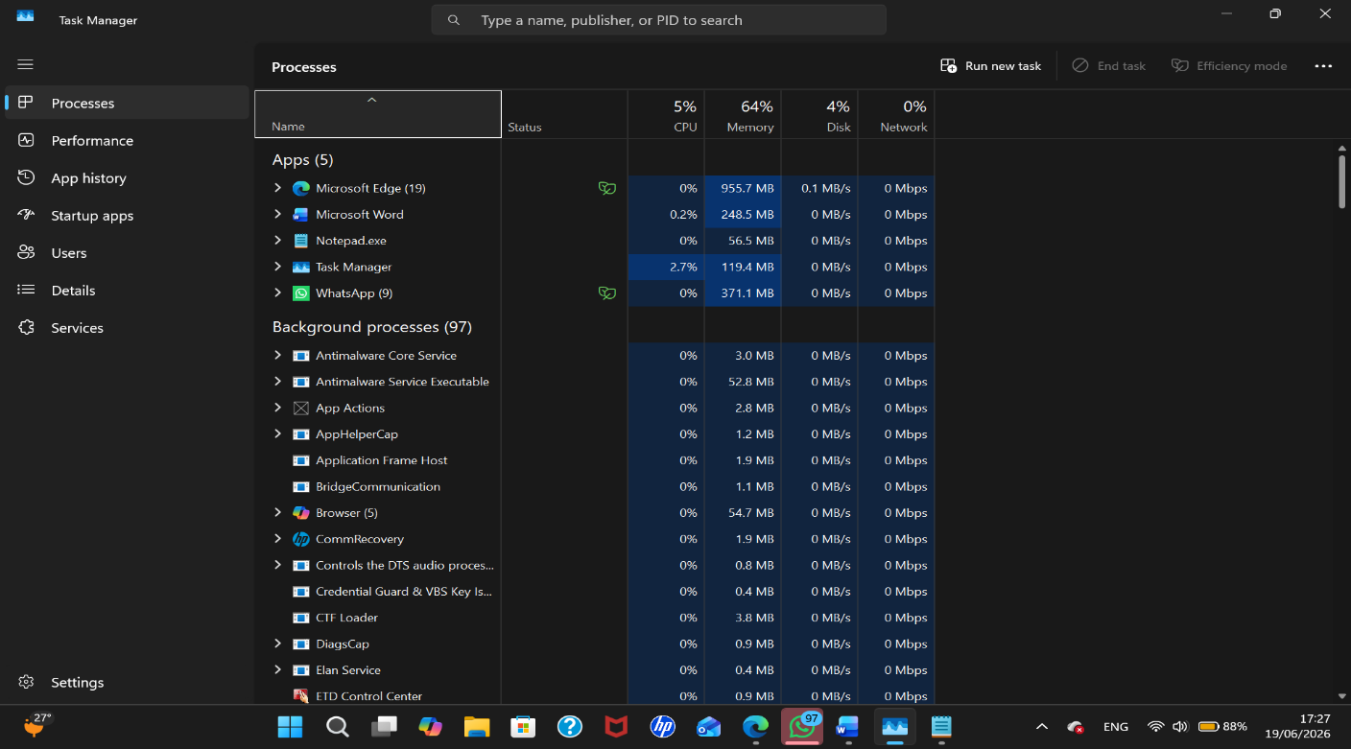

Figure [1] task manager showing running process and CPU usage.
Memory Management:
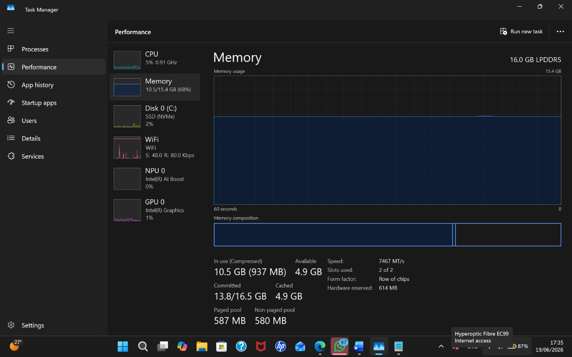
Memory management is another crucial function. By assigning memory to programs and releasing it when it is no longer required, the operating system controls the amount of RAM on the computer. Applications work smoothly and don’t crash the system, we should appreciate the effective memory management. Users may see system performance and memory utilization with Windows Task Manager and macOS activity monitor. [2]

Figure [2] Memory utilization is tracked using Task Manager’s performance tab.

File System Management:
Another important function of an operating system is file management. The operating system facilitates the creation, editing, moving, and deleting of data by organizing files and directions on storge media. File and directory management tools include Linux file managers, macOS finder, and Windows file Explorer. [3]

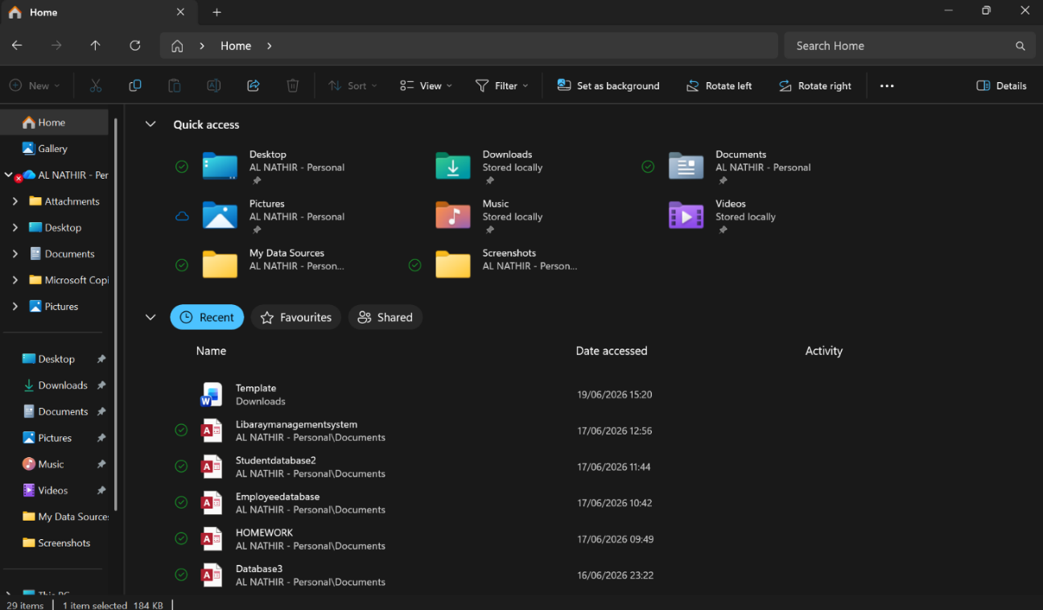

Figure [3] Utilizing Windows file explorer to manage files and folders.
Security and user Management:
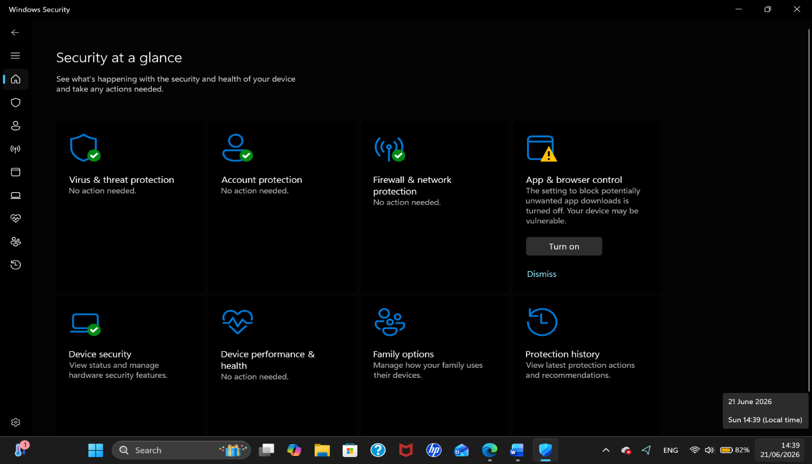
Security and user management are two more crucial functions. To safeguard data and prevent unwanted access, operating systems include authentication methods like usernames and passwords. Firewall and encryption are further security elements. Users can control these functions with Windows Security and MacOS Security and privacy settings. [4]

Figure [4] Security and protection features are displayed in the Windows security settings.
Device Management:
Device management is the responsibility of operating systems. Device drivers allow them to interact with physical devices like printers, keyboards, displays and storage drivers. Device management guarantees that hardware parts function properly with computer systems, you can inspect and control hardware devices in Windows using device manager. [5]

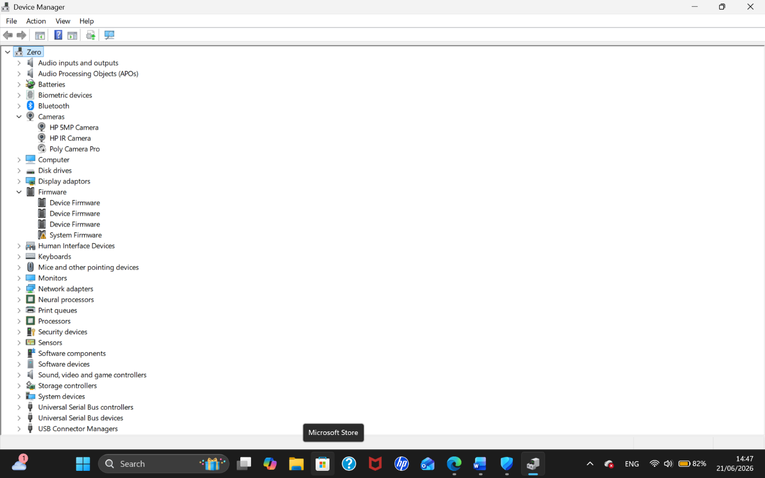

Figure [5] hardware that has been installed is shown via Windows device manager.
User interface:
Lastly, operating systems offer user interface that enables computer interaction. A Graphical user interface (GUI) featuring windows, icons, menus and pointers is used by most contemporary operating systems compared to command line interfaces, this facilitates computer use.

Use of Windows OS CLI commands.
Process Management:
- Tasklist: Program operating on a windows computer can be observed and managed with the help of process management commands. The task list command shows all running processes along with their memory utilization, session details, and process ID (PID). To make the output easier to read, the /FI switch filters the results so that only active process are shown to terminate an active process, use the task kill command. In this instance, /IM indicates the image name (Notepad.exe) and /F compels the program to terminate. System administrators frequently use these commands to stop unresponsive programs and address software issues. [6]
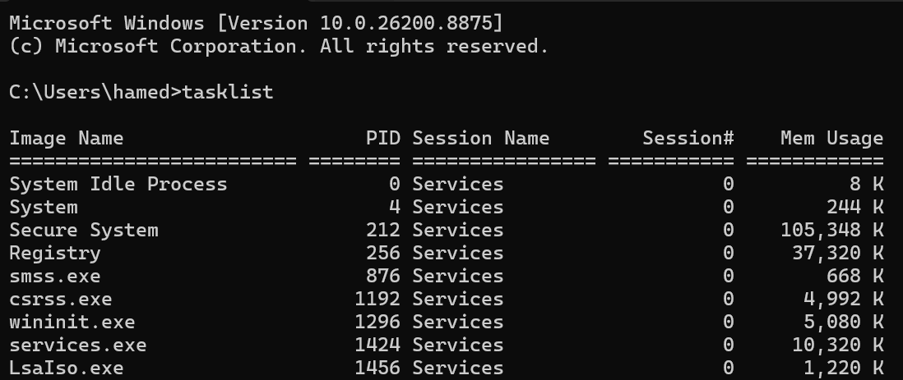
task list command:

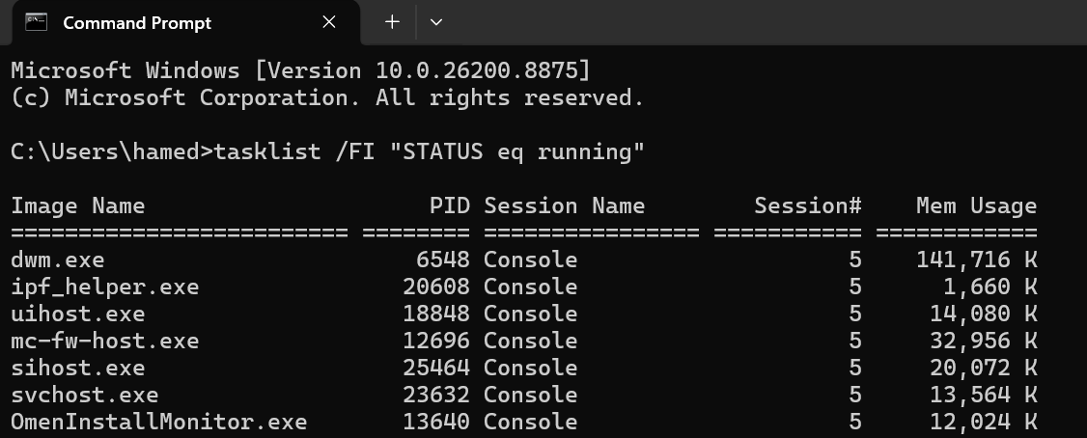
Figure [6] the task list command’s output displays the active Windows processes.
Figure [7] displays active processes that have been filtered by the /FI switch.
File directory Management:
Several commands for managing and creating files and folders are available in the windows command prompt. A new directory where files can be kept and arranged is created with the mkdir command. While the /A switched can be used to display files with various properties including hidden files, the dir command shows the contents of a folder. By writing text into a text file, the echo command instantly produces one. The /Y switch automatically overwrites an existing file without requesting consent, while the copy command copies files another. These commands facilitate effective file organization and enhance file management for users. [7]
Mkdir and dir command:

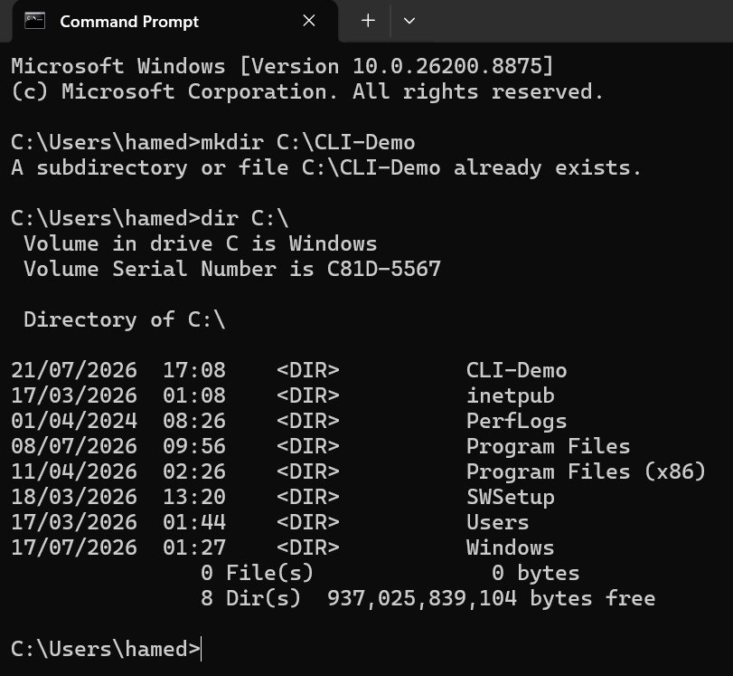

Figure [8] The dir command verifies the directory is on the C; disc, while the mkdir command creates a new directory called CLI- demo.

Dir command:
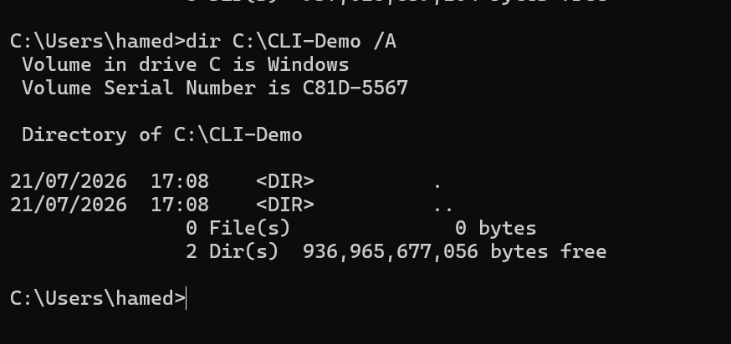

Figure [9] the CLI- Demo director’s contents including files with various attributes, are shown with the dir /A command.

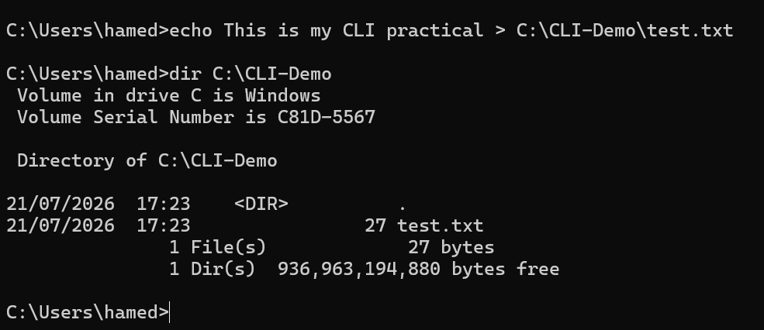

Figure [10] a text file called test.txt is created using the echo command, and its creation is verified by the dir command.
Network testing and Monitoring:
Ping google com-n 4command:In order to verify internet connectivity and identify network issues, network commands are crucial. To find out if another machine or website is reachable, the ping command sends test packets to it. Four packets are sent using the -n 4 switches, which also gives packets loss and response times.
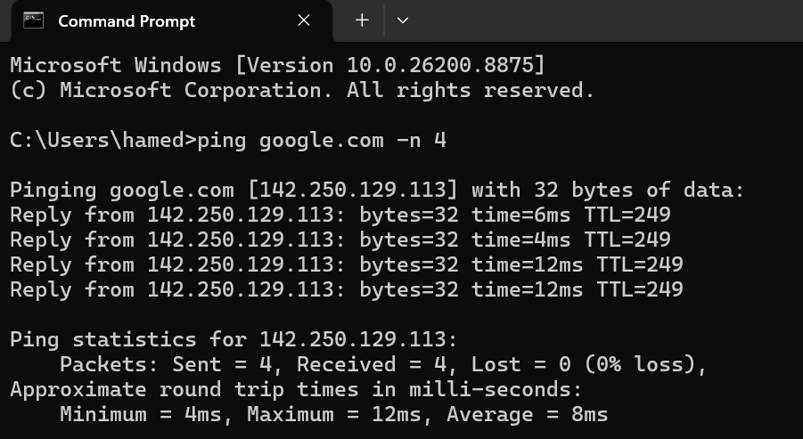
The IPv4 address, subnet mask, default gateway, DNS servers, and DHCP configuration are just a few of the comprehensive network details that may be seen with the ipconfig /all command Get-NeTCP Connection state established in PowerShell shows all open TCP connections, including process IDs, remote addresses, and local ports. Administrators can monitor network performance and find connectivity problems with the aid of these commands. [8]

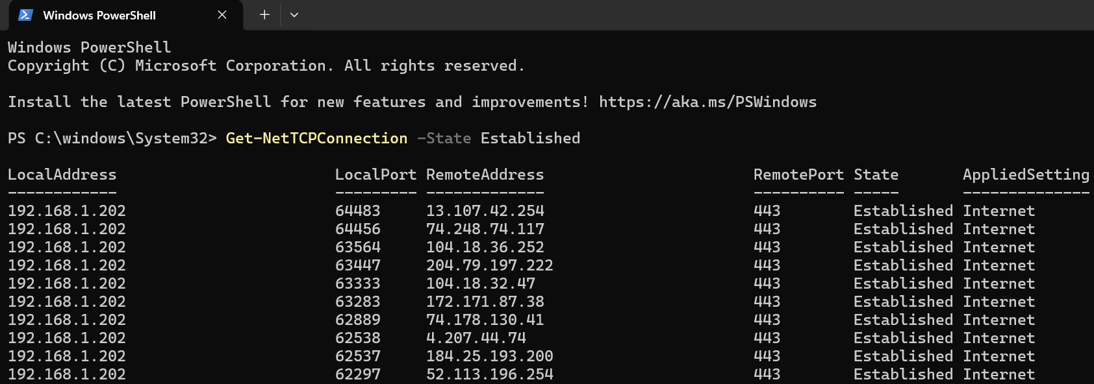
Figure [11] by sending four packets to Google’s server and reporting the response time and packet statistics, the ping googl.com -n 4 command assesses network connectivity.
Figure [12] the get network TCPC connection state established PowerShell command displays all active TCP connections, including local and remote addresses, ports and related process IDs.
User Management:
Net user command:User management commands display information about users and account permissions on a window computer; the Net User command lists all local user accounts saved on the system. The whoami /group command displays the security groups and permissions given to the currently signed-in suer. These commands are important for checking user accounts verifying administrator privilege and addressing permission related problems.
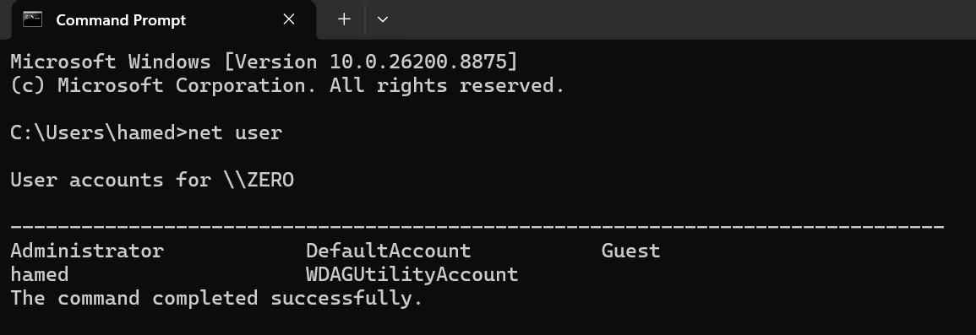
Figure [13] All of the Windows computer’s local user accounts are shown using the net user command.
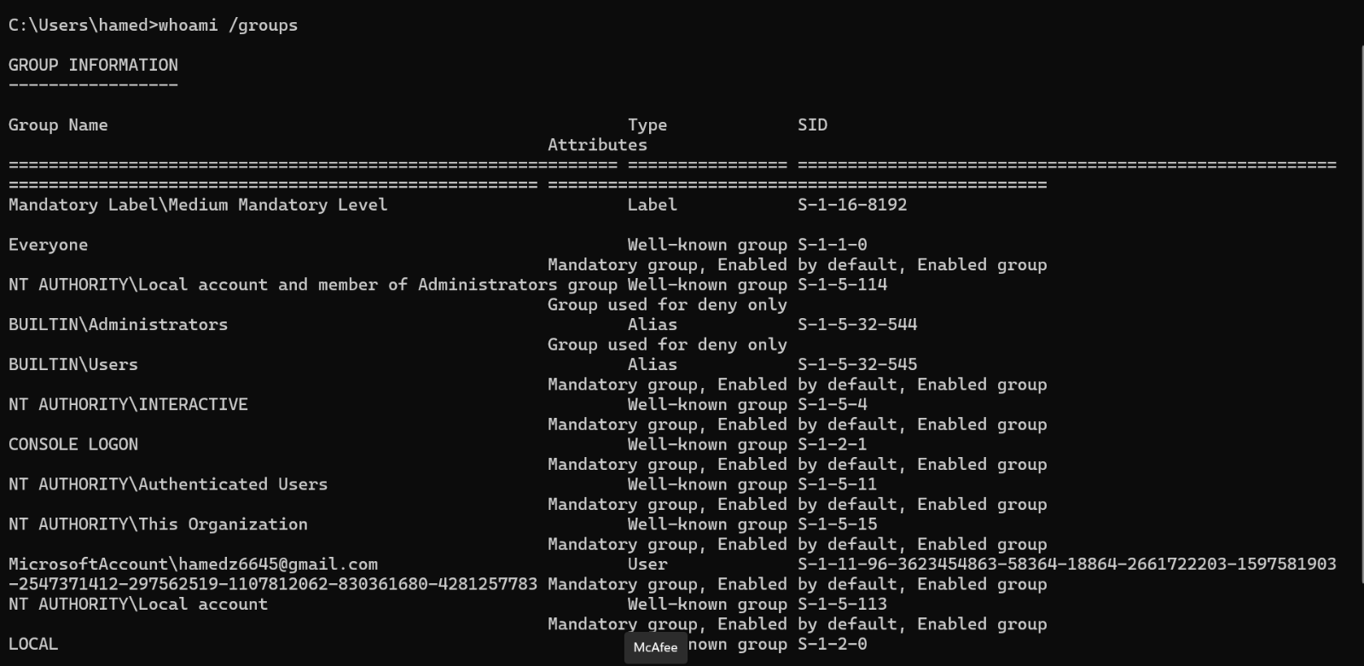

Figure [14] The security group and permissions granted to the user who is currently logged in are shown by the whoami/groups command.

Task Scheduling:
Schtasks/create command:To create and manage scheduled task give the command line =, windows comes with the schtasks command. While /SC daily sets up the job to run daily. The / create option creates a new scheduled task. The task name is specified by the /TN switch. The program or script to execute is identified by the /TR switch, and the start time is defined by the /ST switch. The schtasks / query command verifies that the task has been correctly scheduled after it has been created. Task scheduling makes it possible to automate repetitive tasks without the need for human interaction, such as launching programs, executing scripts, and carrying out normal system maintenance. [9]
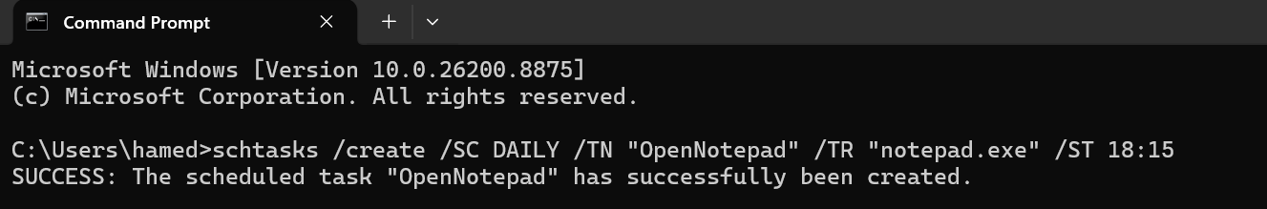
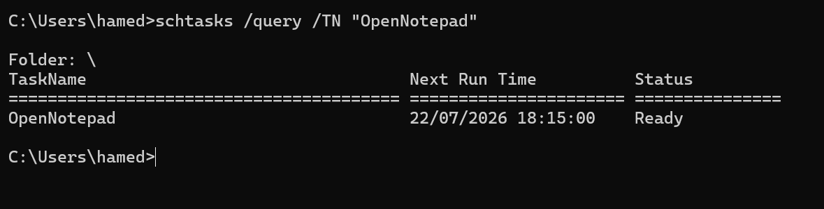
Figure[15] A daily scheduled task that includes Notepad automatically at the designated time is created via the scheduled tasks /create command.

Figure [16] The scheduled job is shown via the schedule tasks /query command, which also verifies that it was correctly established and gives its current status.

Use of Linux OS CLI commands.
Linx bash commands let users utilize a terminal to manage files, networks, accounts, process, and automated operations.
Process Management:
Top command:All active processes, including the user, process ID (PID), CPU use and memory consumption are shown by the PS aux command. The U option offers a comprehensive user- oriented format, the x option contains processes without controlling terminal, and an option displays processes for every user. Once a PID has been identified, kill -15 PID transmit the SIGTERM signal, enabling a safe process termination kill -15 2456, for instance ends process 2456. [10]
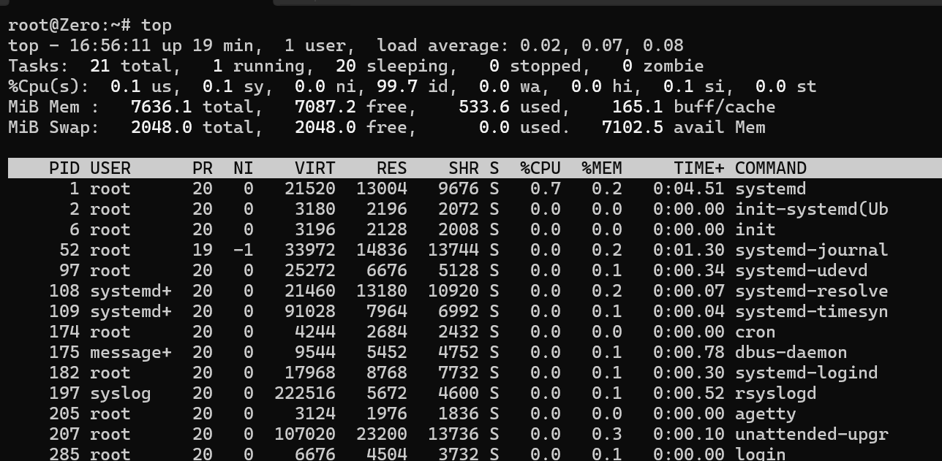
Figure [17] The top command shows the system resource utilization and running Linux processes.
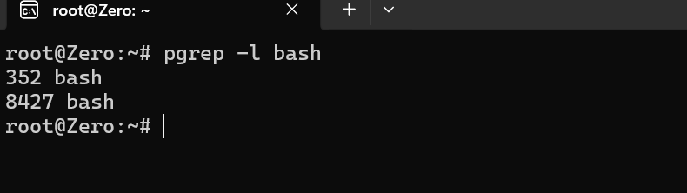

Figure [18] The process IDs of active Bash processes are shown by the group command.

File and Directory Management:
Mkdir,touch, and find commands:The main folder and any missing parent directories are created using the mkdir-p LinxTask/ screenshots command. All files, including hidden files are shown in a comprehensive format with permissions, ownership, size, and modification date when using the command is – la Linx Task. You can use CP-V notes.txt LinxTask/ to copy a file while the action is displayed. The rm-I Linux Task/notes.txt tool minimizes unintentional data loss by requesting conformation prior to deletion. GNU Cruelties has these commands. [11]

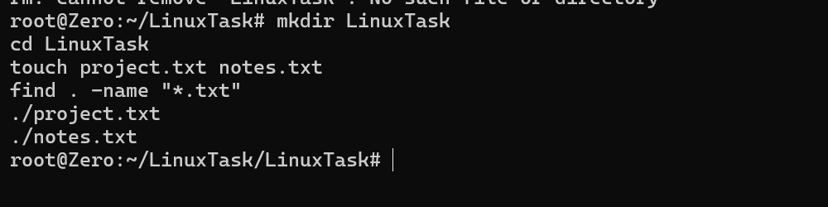
Figure [19] The command mkdir, cd, touch, and find are used to create directories, create text files, and find them in the current directory.
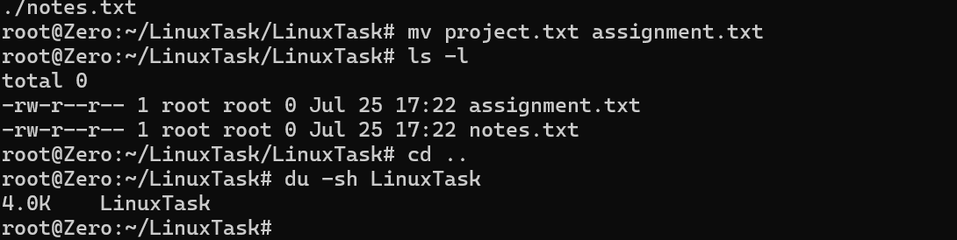

Figure [20] the program mv, Is-l, cd, and du -sh rename a file, list the contents of a directory, and show the size of the Linux Task directory.
Network Testing and Monitoring:
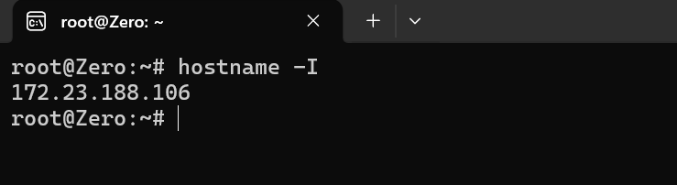
hostname-command:To determine whether a distant host can be reached, the ping -c 4 google.com program sends four test packets and returns packet loss and response time. An overview of network interface and their IP addresses can be obtained with the ip-br addr command. Listening TCP and UDP sockets are shown via the ss-tuln command. The t option chooses TCP, the u option chooses UPD, the I option displays listening sockets, and the n option stops service-name resolution. Network devices, addresses, and routes are managed by the IP utility.

Figure [21] the IP address allocated to the Ubuntu are shown using the hostname command.
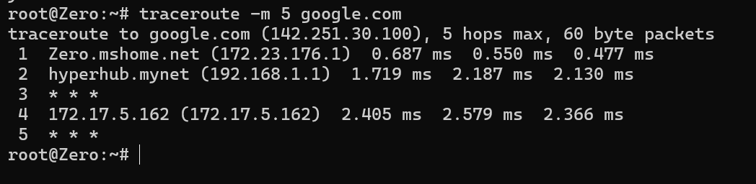
Figure [22] The network path and hops between the Ubuntu system and Google’s server are shown using the traceroute -m 5 google.com command.
User Management:
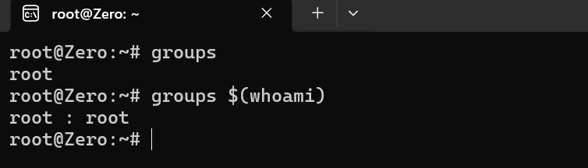
groups and groups$(whoami) commands:The current account’s username can be seen with the whoami command. While id without options reveals the user ID, primary group, and supplementary groups, id-u-in additionally shows the current username. Prior to administrative tasks, these commands aid in verifying account authenticity and command.

Figure [23] The whoami and finger command shows comprehensive details about the active user account.

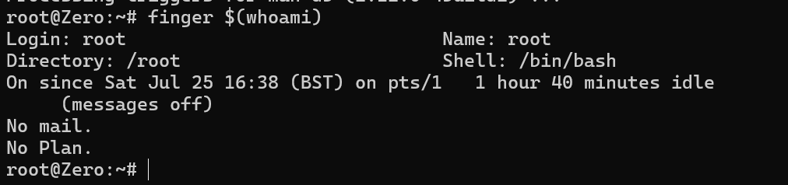

Figure [24] The finger $( whoami) command shows comprehensive details about the active user account.

Task Scheduling:
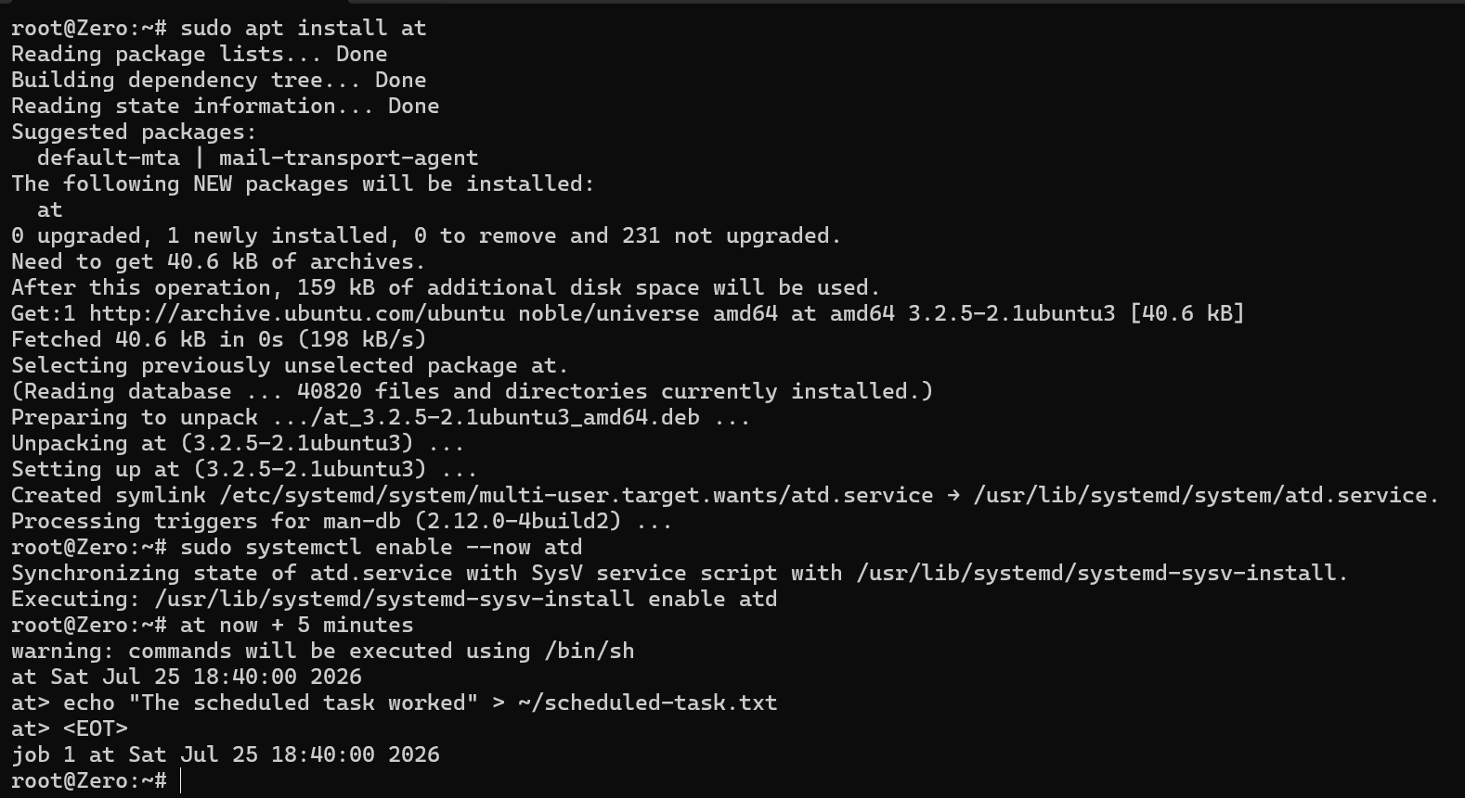
At command:The current user’s cron table can be edited with the crontab -e command. For instance, a backup script is executed daily at 6:00 pm by running 0 18 *** / home/student/backupsh. The saved scheduled tasks are then listed using the crontab- I command. Cron executes commands at the designated time and verifies schedules. These instructions show how to administer Linux practically. AS proof of testing, screenshots should clearly display every command and its result. [12]

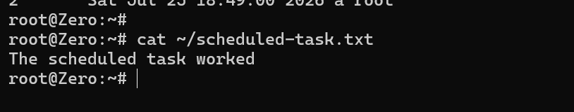
Figure [25] A one-time operation to create a text file is scheduled using the at command.

Figure [26] the text file was produced and the scheduled task was confirmed to have been completed successfully using the cat command.

Use of Windows OS scripts.
Text files with command line instructions that command prompt automatically executes are known as windows batch scripts. A simple text editor like notepad can be used to generate batch scripts, which typically have the. Bat file extension they are helpful for increasing consistency, decreasing manual labour, and automating repetitive operations. We have developed and tested two basic batch scripts that enable the user to verify whether a computer or website is reachable across a network, the first scrip makes a backup of chosen folder.
Script 1: Automatic Folder Backup:
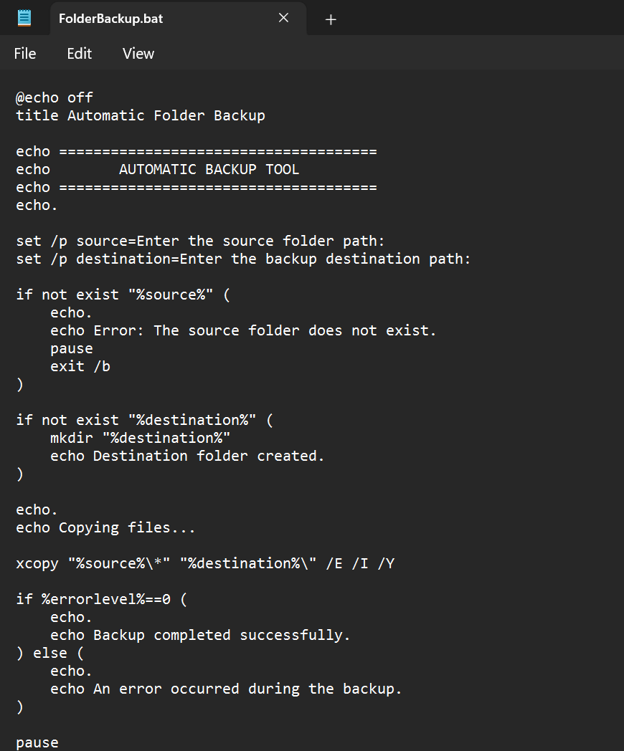
The location of the folder that the user wishes to backup is requested by this batch script. After requesting a destination folder, it copies the files using the xcopy command. The folder addresses are stored in variables, and the existence of the source folder is verified using a conditional statement. [13]
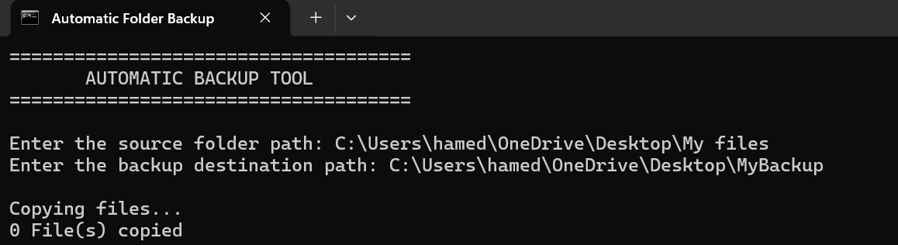
Figure [27] The automatic backup tool’s batch script code.

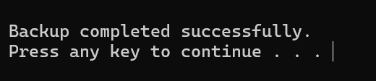
Figure [28] execution of the batch script displaying the user- entered source and destination directories.

Figure [29] After files were transferred to the target location, a successful backup notification was displayed.
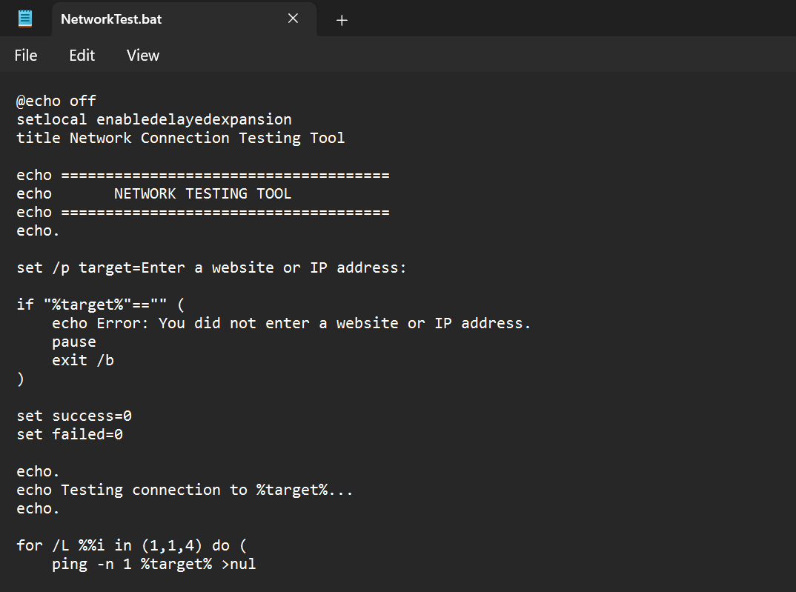
Script 2: Network Connection Testing Tool.

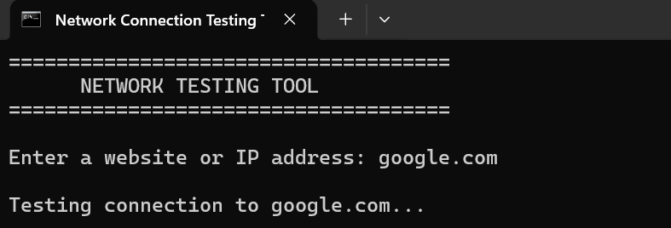
Figure [30] Notepad- created batch script code for the network connection testing tool.

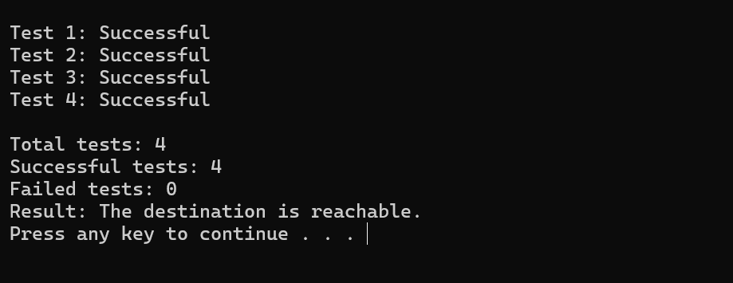
Figure [31] The network Connection Testing tool’s execution, where the user enters an IP address or website and script runs pig tests.

Figure [32] The network connection testing tool’s final results, which verifies the network connection status and shows the total number of successful and unsuccessful tests.

Use of Linux OS scripts.
In Linux operating system, repetitive processes can be automated with bash scripts. The commands can be kept inside a.sh file and run collectively rather than being manually entered. Variable, user input, arithmetic operations, loops. And conditional expressions are all demonstrated in the next two scripts.
Script 1: File Backup Script:
The user is prompted to enter a file name by this script. After determining whether the file is present, it uses a loop to make three backup copies. [14]
Bash Code:

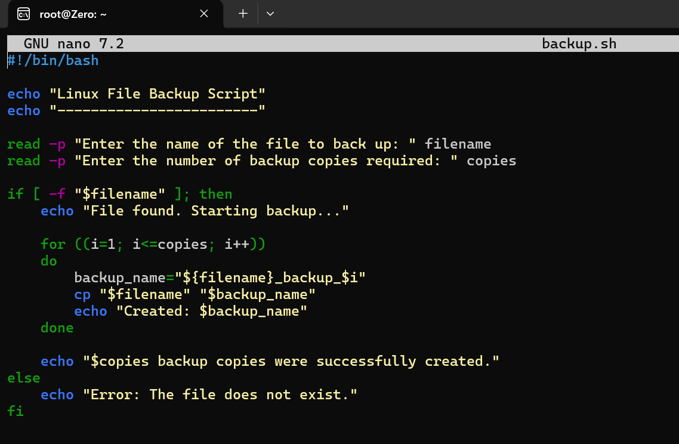
Figure [33] A script for a bash backup created with the Nano text editor.
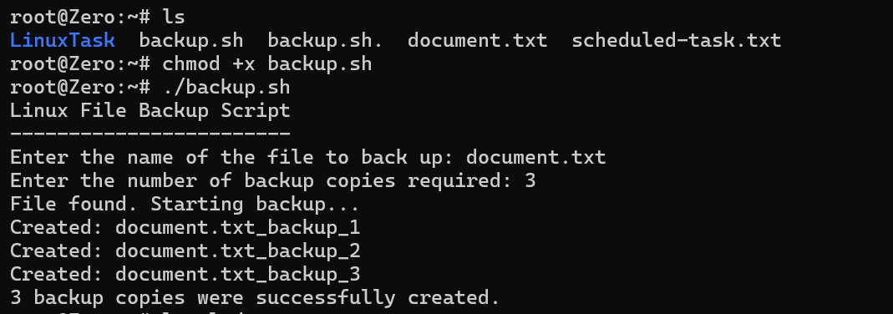

Figure [34] The bash backup script is executed, displaying file validation, user input, and the automatic generation of three backup copies.

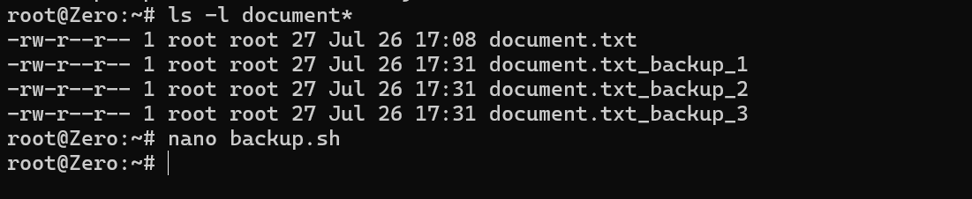
Figure [35] Terminal output verifying the successful creation of the original file and the three backup copies.
Script 2: Disk Usage Monitoring Script:
The user is prompted by this script to input a disc usage warning level. It determines whether the disc consumption is now blew or above the specified limit.
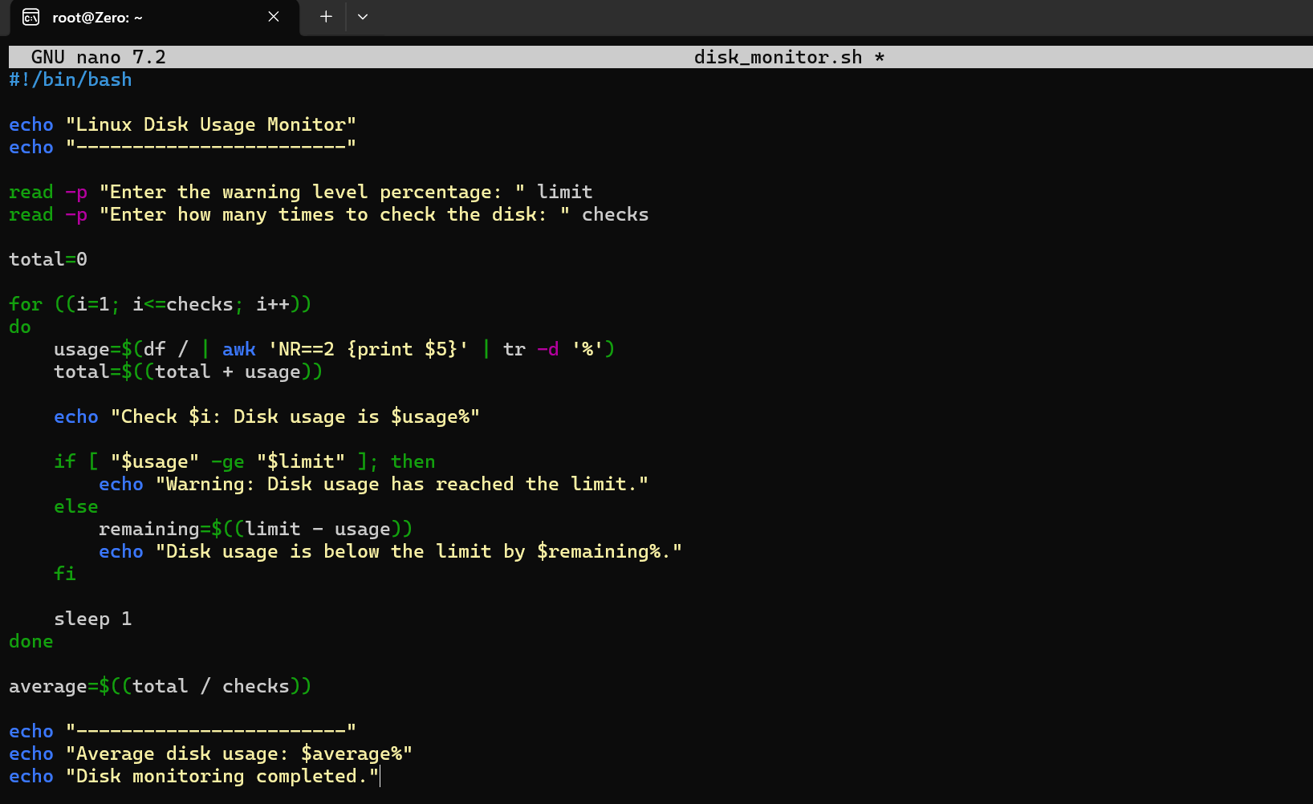

Figure [36] The Nano text editor displays as bash script that monitors disc consumption.

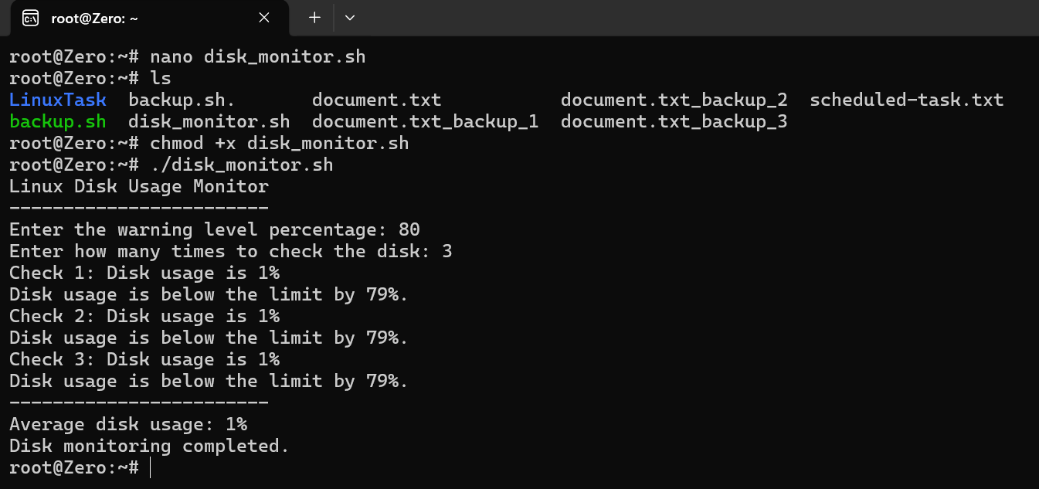
Figure [37] The bash disc monitoring script is executed, displaying conditional messages, frequent disc usage, checks, user input, and the computed average disc usage.

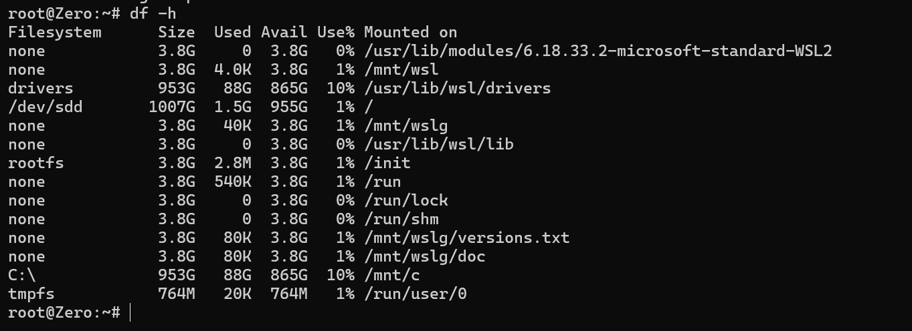

Figure [38] The Linux file system size, used space, available space, and disc utilization percentage are shown in the output of the df-h function.

Conclusion
This assessment gave a thorough overview of the main features of the Linux and Windows operating systems and showed how they handle vital resources like memory, files, users, networks, and processes. I obtained firsthand knowledge of how operating systems facilitate the effective safe, and dependable operation of computers by investigating both graphical management and command -line interface.
Using Linux Bash commands, PowerShell, and Windows command prompt, the practical exercises demonstrated the value of command- line administration process management, file and directory organization, network connectivity, monitoring user account management and scheduled task creation were all done via commands. This exercise demonstrated that, in contrast to depending exclusively on graphical interfaces, offer a quick and effective way to complete system administration chores.
The programming exercise for Linux Bash and Windows batch further illustrated how automation may make repetitive chores easier. The script effectively automated tasks like file backup and disc monitoring by using variables, user input, arithmetic operations, loops and conditional expressions. This demonstrated how scripting may increase productivity, lessen manual Labouré, decrease human error, and guarantee that activities are finished consistently.
Overall, this assessment improved my theoretical understanding of operating systems, command-line tools, and scripting as well as my practical abilities. My comfort in utilizing Linux and Windows environments has grown as result, and I’ve gained useful skills that are immediately applicable to jobs in networking, cybersecurity, system administration acquired from finishing these assignments will offer a solid basis for additional research and potential career advancement.

References

References

[1] | A. P. a. G. Siberschatz, Operating system Concepts, New York, (2018).
[2] | Operating system; internal and Design principles. 9th ed., Harlow: Pearson.
[3] | Modern Operating system Tanenbaum, A.S and Bos, H., Harlow pearson., (2015) Modern Operating systems. 4th ed..
[4] | W. Stallings, Operating system: internal and Design principles. 9th ed., Harlow: Pearson., (2018).
[5] | R. a. C. Elmasri, Operating system: A Spiral Approach. Boston: cengage Learning., (2014).
[6] | Microsoft, "tasklist," Microsoft Learn. [online]. available: https://learn.microsoft.com/window-server/administration/windows-commands/tasklist.[Accessed: 3-Aug -2026]..
[7] | ". c. Microsoft, Microsoft Learn,, https://learn.microsoft.com/en-us/windows-server/administration/windows-commands/, 2025. [online]. Available:.
[8] | Microsoft, "Windows command and PowerShell Networking cmdlets," Microsoft Learn ,, https://learn.microsoft.com/en-us/windows-server/administration/windows-commands/, 2025..
[9] | Microsoft, "schtasks," MicrosoftLearn,, https://learn.microsoft.com/en-us/windows-server/administration/windows-commands/schtasks, 2025..
[10] | M. kerrisk, "ps(1)- Linux manual page" and "kill(1) - Linux man-pages project., [Online]. Available: https://man7.org/linux/man-pages/.
[11] | GNU project, * GNU Coreutils Manual*., [Online]. Available: https://www.gnu.org/software/coreutils/manual/.
[12] | M. Kerrisk, "crontab(5) and crontab(1)- Linux manaul pages, "The Linux man-pages projects..
[13] | Microsoft, "set (envirment variable)," Microsoft Learn- SET command, Aug.10 2026]..
[14] | Free software foundation, "Bash coditional Expresstions," GNU project. GNU Bash Reference Manual., [Accessed: Aug. 10,2026]..

