Why it is important you understand these concepts
You need to learn the metalanguage of reading. This is the language that we use to talk and write about language.
If you do not know or understand the metalanguage then your explanations and writing will be unclear.
Implicit to explicit
- you know how to read
- you need to know how to teach children to read
- what is natural and intuitive needs to become visible and systematic to the children

Some useful definitions and explantation
Phonics
- is an approach to reading in which individual letters or groups of letters are linked with the sounds they represent and translated into meaningful wholes

Phoneme: the smallest unit of sound.
- a phoneme is the smallest unit of speech sound in a word that changes meaning
Thus,
//bed// has 3 phonemes (speech sounds)
If we change the ‘b’ to ‘r’ we have:
//red// which has a different meaning

- CONSONANT PHONEMES are those sounds where there is a degree of constriction of the air as it flows out of the mouth or nose.
- VOWEL PHONEMES are those sounds where the air flows out of the mouth without any constriction.

Morpheme
- is the smallest unit of meaning – a meaningful morphological unit of language that cannot be further divided ( e.g. in, come , -ing, forming incoming).

Grapheme
- a letter or a group of letters representing one sound. ‘s’ can be represented by the graphemes s, (sun) se (house), c (city), SC and cue (science)

A grapheme is the letter or combination of letters that represents a phoneme in a word.
Each word always has the same number of graphemes as phonemes but there may be more letters than phonemes.
Grapheme-phoneme correspondence (GPC): the relationship between sounds and the letters which represent those sounds; also known as 'letter-sound correspondences'

Blend
- to draw individual sounds together to pronounce a word, e.g. s-n-a-p, blended together, reads snap.
Cluster
- two (or three) letters making two (or three) sounds, e.g. the first three letters of 'straight' are a consonant cluster.
Segment
- to split up a word into its individual phonemes in order to spell it, e.g. the word 'cat' has three phonemes: /c/, /a/, /t/
Mnemonic
- a device for memorising and recalling something e.g. there is ‘a rat’ in separate

VC, CVC, CCVC
- the abbreviations for vowel-consonant, consonant-vowel-consonant, consonant-consonant-vowel-consonant, and are used to describe the order of letters in words, e.g. am, Sam, slam.

Onset and Rime (not referred to so much these days)
- onset: the initial sound in a word
- rime: the final vowel and consonant sound pattern
e.g., cat c / at
  - c = onset
  - at = rime
Digraphs
- are 2 letter graphemes ( 2 letters = one phoneme)

Split digraph
- Vowel, consonant, ‘E’ (VCE)
- Made
- Time
- Home

Left/right orientation
- the ability to read a line of print from left to right

Auditory perception
- the ability to be aware of sounds

Auditory discrimination
- the ability to appreciate the differences and similarities in sounds
Auditory memory
- the ability to remember a sound which has previously been perceived.

Phonology
- the way that the speech sounds are identified and combined to produce and understand spoken language
The phonological system of language – the speech sounds

Orthography
- the conventional writing system of language and how this relates to the spoken language. This includes spelling, punctuation and other text conventions
The orthographic system of language – the written language

The English language is difficult

- Beginner readers must learn how the orthographic system relates to the spoken system.
- The English orthographical system is difficult
- English orthography is difficult because of the presence of digraphs and three/four letter graphemes
- Children have to learn which grapheme represents the same phoneme in different words
- And that takes good, systematic teaching

About the English language
Although approximately 85% of the words in the English language are regular, in that they can be governed by rules which can be taught using the phonic method, (cat, bite, pail, bought), the remaining 15% are irregular and are not governed by rules (fuchsia, autumn, pneumonia). These must therefore be taught by other methods.

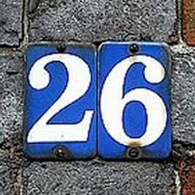


26 letters of the alphabet
21 consonants
5 vowels
44 speech sounds
24 consonant
20 vowels

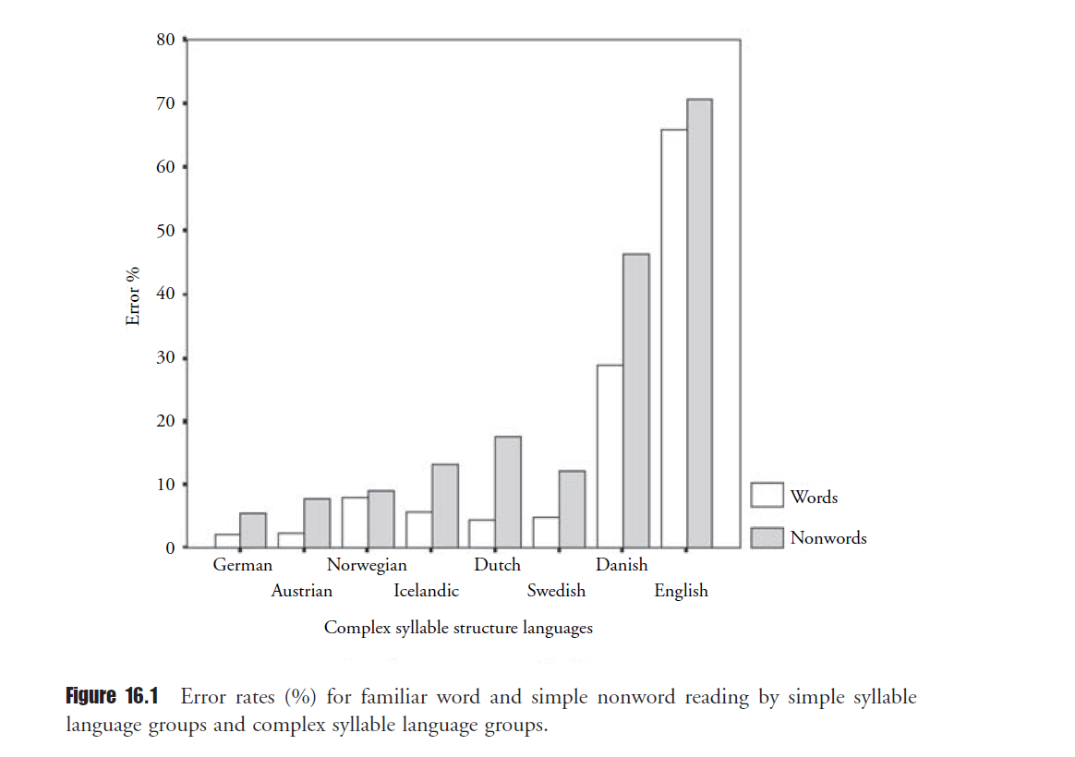

Additional material

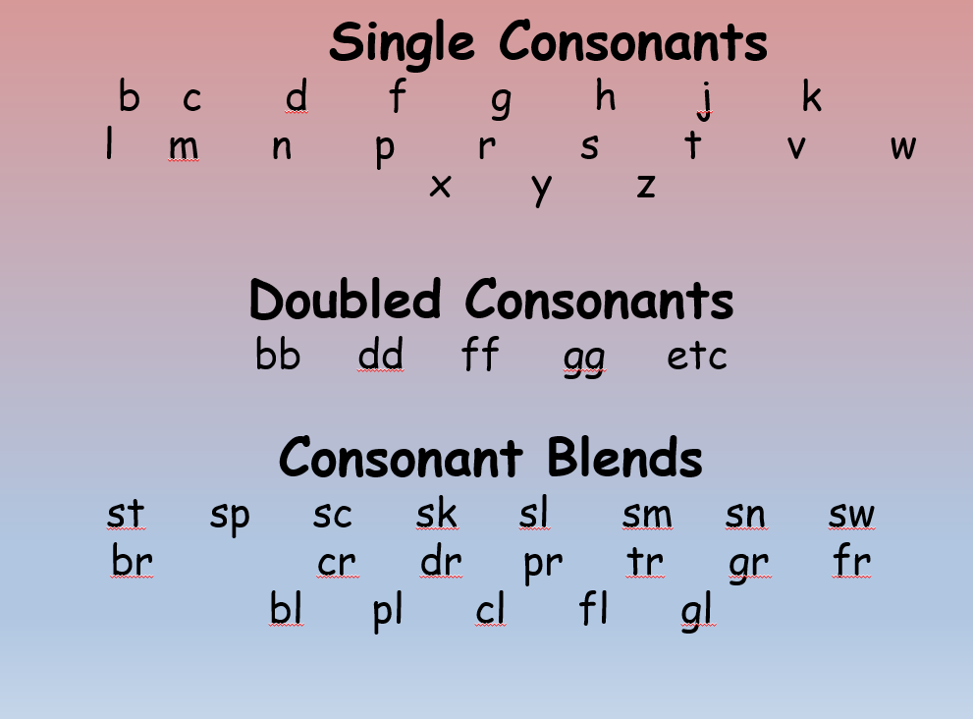

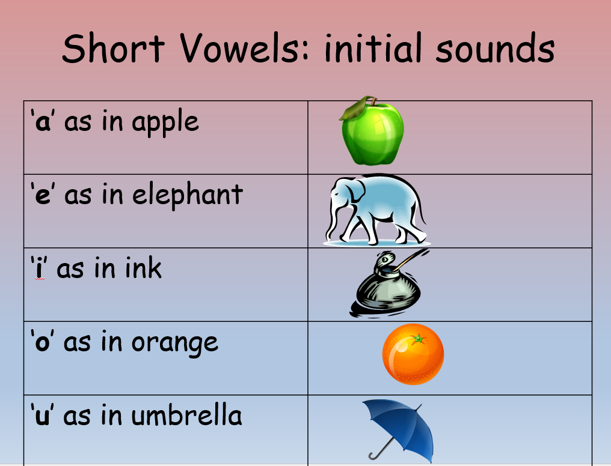

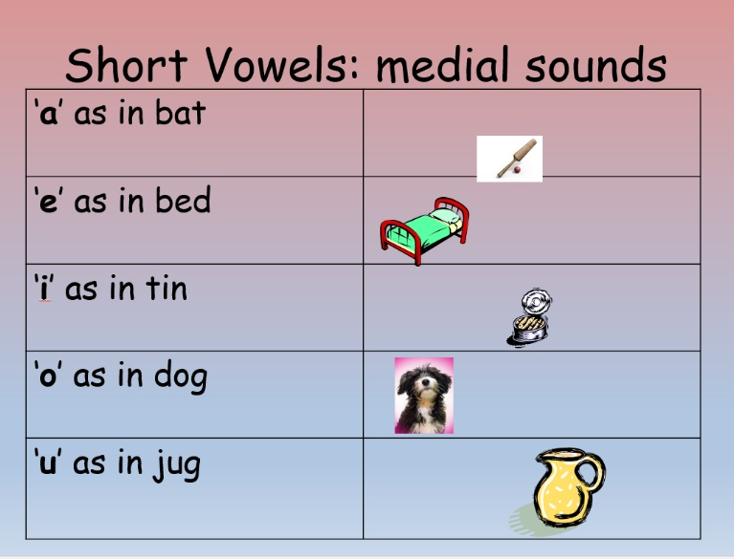

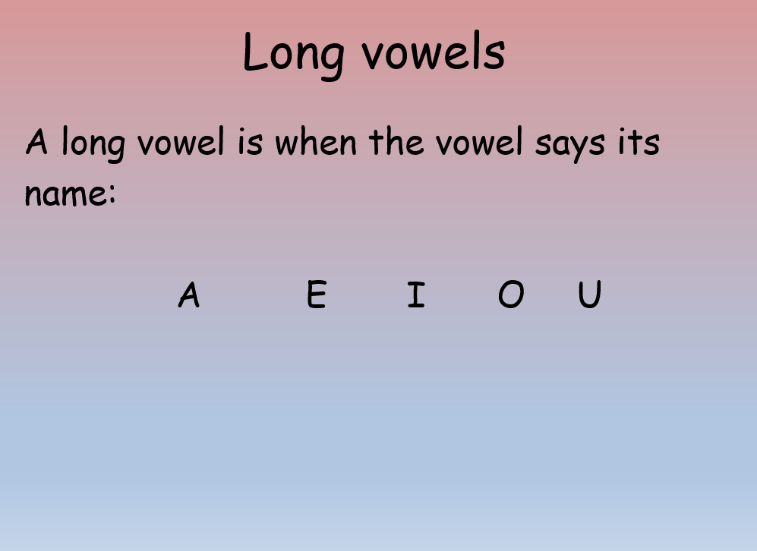

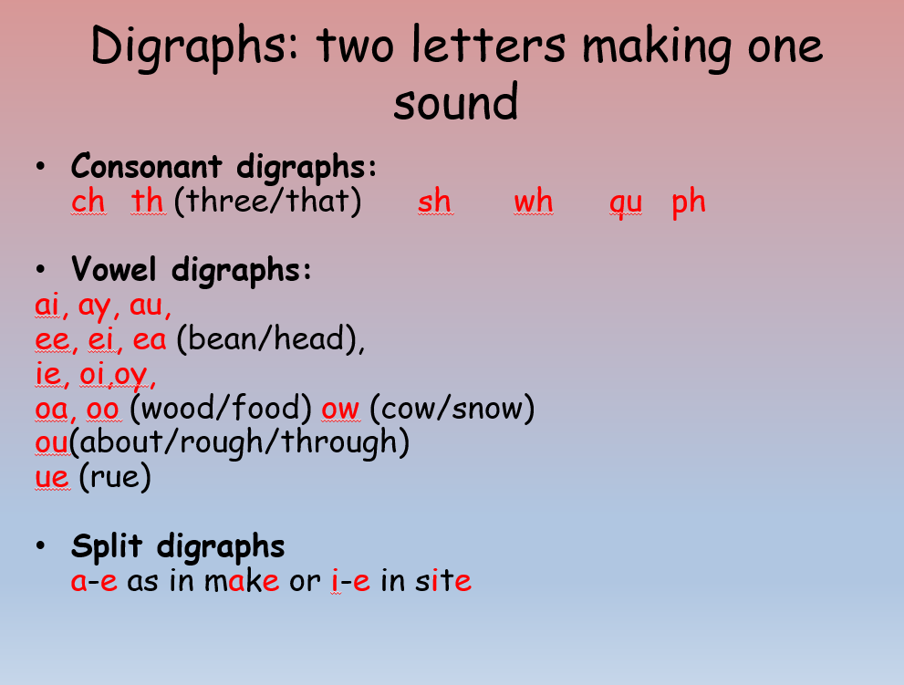

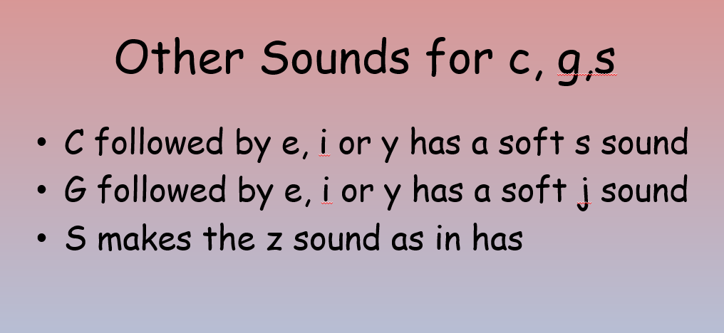

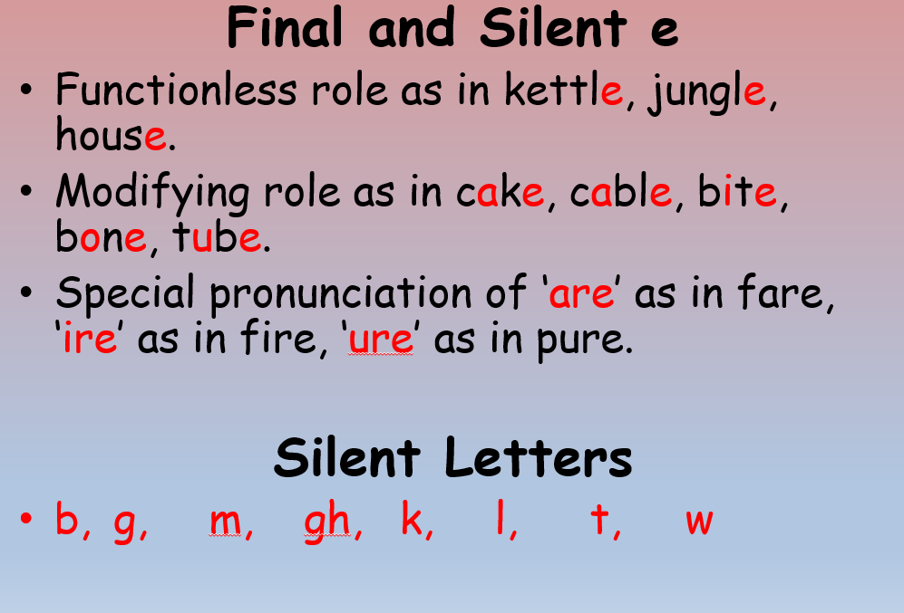

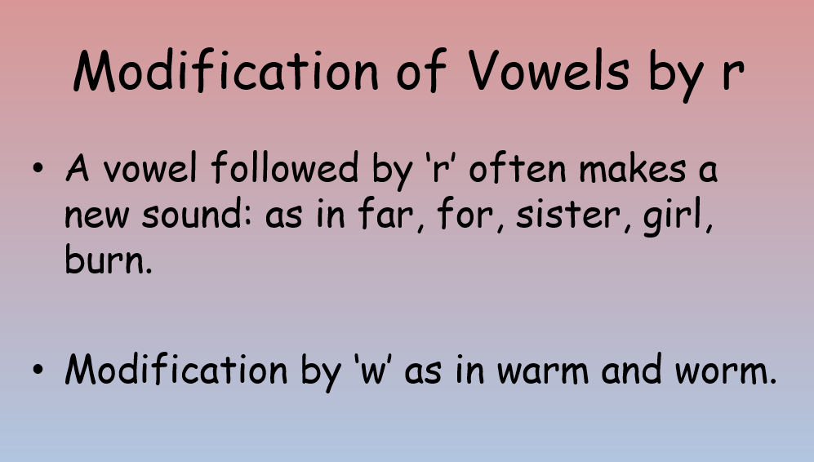

Analytic Phonics vs Synthetic Phonics:

To understand the difference, you have to understand the methodology behind analytic phonics and synthetic phonics for reading.
Traditionally, children were taught to read using ‘analytic phonics’. This method has children ‘analysing a word’, taking clues from recognition of the whole word, the initial sound and the context. This is a hit and miss approach which encouraged guessing as a first reading strategy! It is therefore no surprise that in the USA, Australia and the UK there are significant numbers of children failing to learn to read as well as they should; 38%, 20% and 20% respectively!
Synthetic Phonics on the other hand, involves no guessing! It is the synthesising, or blending of phonemes (sounds) to make a word, enabling children to read. Analytic Phonics vs Synthetic Phonics: To understand the difference, you have to understand the methodology behind analytic phonics and synthetic phonics for reading.
Traditionally, children were taught to read using ‘analytic phonics’. This method has children ‘analysing a word’, taking clues from recognition of the whole word, the initial sound and the context. This is a hit and miss approach which encouraged guessing as a first reading strategy! It is therefore no surprise that in the USA, Australia and the UK there are significant numbers of children failing to learn to read as well as they should; 38%, 20% and 20% respectively!
Synthetic Phonics on the other hand, involves no guessing! It is the synthesising, or blending of phonemes (sounds) to make a word, enabling children to read.

