Assignment feedback

Student Name: Patrick Sweeney
Student University Email: 1703060@student.uwtsd.ac.uk
Module code: AHAH4005  Module title: Introduction to Fieldwork | Student ID number:  1703060 |  | Educational support needs:  No
Assignment title: Reflexive Journal

Assignment due date: 27/03/2018
Assignment Number:
(i.e. 1,2,3) 1
Marker’s signature: |  | Date:
Provisional.
NB. All marks are provisional until confirmed by the final examination board.

REFLEXIVE JOURNAL

Of
Patrick Sweeney

Introduction to Fieldwork

This reflexive journal has been a struggle for me, to put my thoughts and experiences down on paper for others to read is challenging to my sense of privacy. An essay is for me, some of my thoughts and opinions for answering a question I have chosen, from a perspective I have found interesting. Different from a journal in that an essay is still potentially personal, but on a much more restricted and selective scale. So, saying this, I still had to bite the bullet and write it, here goes.
My essay will logically follow the course, “Introduction to Fieldwork” week by week, fleshing out what I observed, practised or discussed in class, with what reading material I found to expand upon this topic outside of class.
We were introduced to the ideas behind and uses of journals, for their practical and historical significance, by course director Ros Coard. She spoke of the journal she kept in 2012 whilst in Cypress on a dig with a colleague from the College. Ros Coard explained that the slideshow excerpt from Moodle we were shown would mean very little to anyone else but would act an aide memoire to her. This showed the practical use of the journal and then were shown a few excerpts from Howard Carter’s Journal. This helped to highlight the historical importance of a journal, Carter was understated in the extreme, with his description of finding and clearing the steps to the tomb of Tutankhamun in his telegram to Lord Caernarfon. This was an interesting introduction to keeping journals, I could see the practical relevance to jotting down information that could help to jog your memory after some years since being on a dig but finding the balance between practical relevance and self-consciousness developed over many decades of my barely legible handwriting was going to be a hurdle to overcome. Time to get on with it.
- 08.02.2018 Maps and Landscapes.
This first class was on the different types of maps;
- Topography (Ordnance Survey)
- Geological (Rock and Sediment)
- Soils
- Hydrological
We were shown examples of each of these types of maps in class by Martin Bates, in a variety of scales and Country of origin (French). The scales for some of the maps we were shown,1:50000 and 1:25000, led to the explanation of the possible level of detail that would be possible for each sized scale map. Scale can be described as the necessary means to reduce or enlarge the size of something to be able represent it in a drawing. We then spent time on map reading, learning how an OS map is divided up into grid squares, that the country is represented in map form by larger or smaller sized grid squares. Then it was explained the correct way to read a map using Eastings and Northings. The correct order of reading a grid reference- “Along the hall and Up the stairs”. We were given a map of Lampeter and surrounding area and had 8 questions to answer. I struggled with the map reading when we went from 8 grid references points, 4 Easting and 4 Northing, to 10. Martin explained the accuracy at this level was 1m square. We then completed a practise exercise on a map cross section with Quentin Drew, and how to take the line from the gradient on XY line to the height marking on the cross section and to join this up.
- 15.02.2018 Mapping a find, Laying out a trench and Dumpy levels.
“Because archaeology is fundamentally a destructive science, the records produced by excavators are extremely important” (Welch, 2016:51). This was explained to us in our first lecture of “Introducing archaeology”, and so it was emphasised the importance of recording to the best level of detail possible. We paired up for an exercise of drawing the Arts building. I paired up with Karen and she did the drawing. Once our time was up and it was explained to us the importance of certain details never to be missed from any site drawing; name, direction of North, date, scale and weather. Once we compared it was interesting to see the differences in emphasis, plan versus elevation and the different scales used.
- 22.03.2018 Graveyard survey.
Quentin Drew took us for a class on the graveyard survey of St Peter’s, that we would start and complete after Easter. Quentin spoke things to consider before doing the survey, firstly the obvious things, name, age, dob. Then more details, single grave or multiple occupants, Mason marks, style, typology, size and iconography. This in addition to the articles posted on Moodle and the reading list, was intended to prepare us for the survey.
- 8.03.2018 Dumpy level practise session.
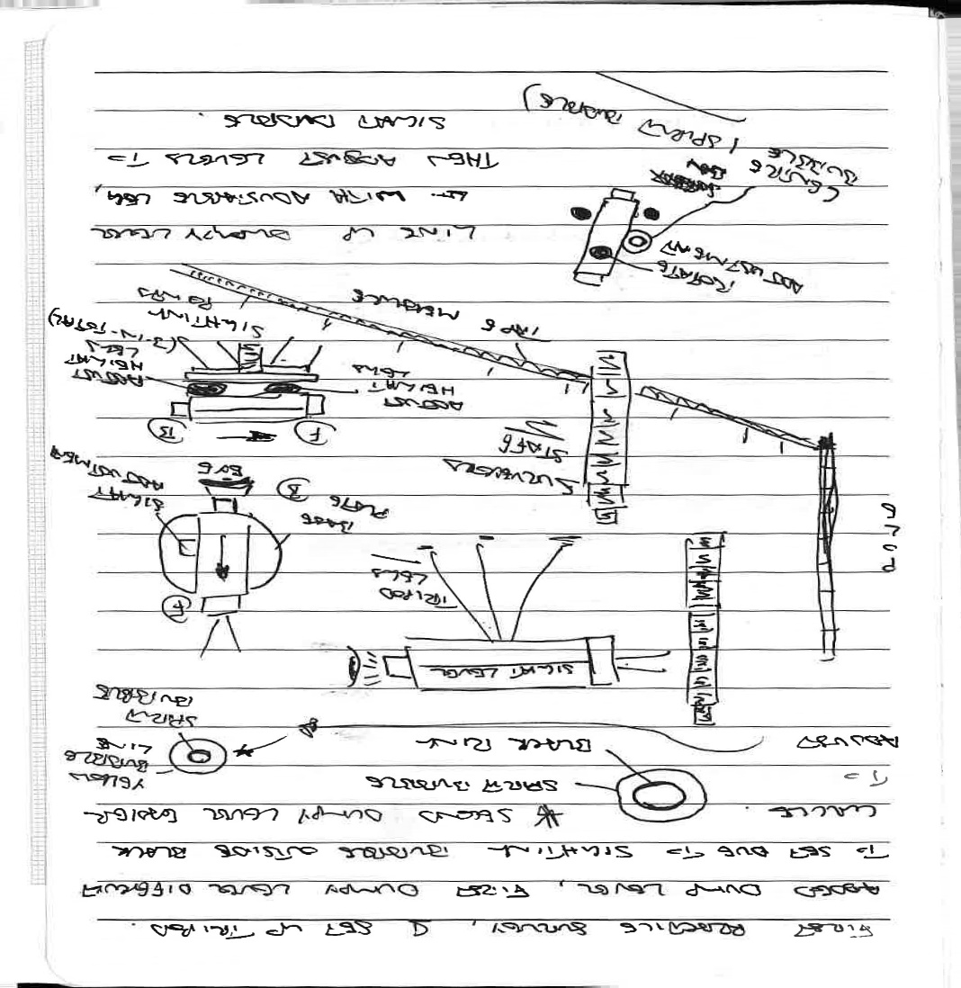
As I mentioned earlier, archaeology is destructive, once a find has been dug up from the site, anything uncovered, its location altered, it can never be put back. So, the critical importance of recording. Archaeologists will because of this importance, take a series of measurements during the excavation (Welch, 2016:51). Elevation is a regularly taken measurement (Welch, 2016:51), to be able to show the height of where something was found. Martin Bates took us for the practise session on using the Dumpy level, invented by William Gravatt (Malcolm, 1969:95). The importance of finding the level or levelling, which is all about determining the height of an objects location, but also the upper level and the corresponding lower level of the object in its location (Welch, 2016:51). Welch (2016) speaks of the daily importance of taking an elevation by archaeologists, because of the need to be able to record the change in soil consistency or colour as well as recording the level of the dig that day before commencing digging and the level at the end of digging that same day. These levels taken daily are to ensure a greater level of accuracy and record keeping for future generations benefit, once something has been moved there is no recording its location again.
Figure 1 Patrick Sweeney Reflexive Journal 08/03/2018
This is where our introduction to using the Dumpy level, during a practise session came in. We broke into groups of four, I was with Karen, Joe and Josh. We collected the components for this exercise from the Materialities lab, where everything was stored. Ros Coard explained Health and Safety practice for carrying the equipment, keep the pointy ends towards the floor so no one gets poked, and carry only one thing at a time, so you do not drop and damage the expensive equipment. We all trooped out to the surveying site, which was quite waterlogged in places and even with my wearing reasonable boots, one of my socks got squelchy.
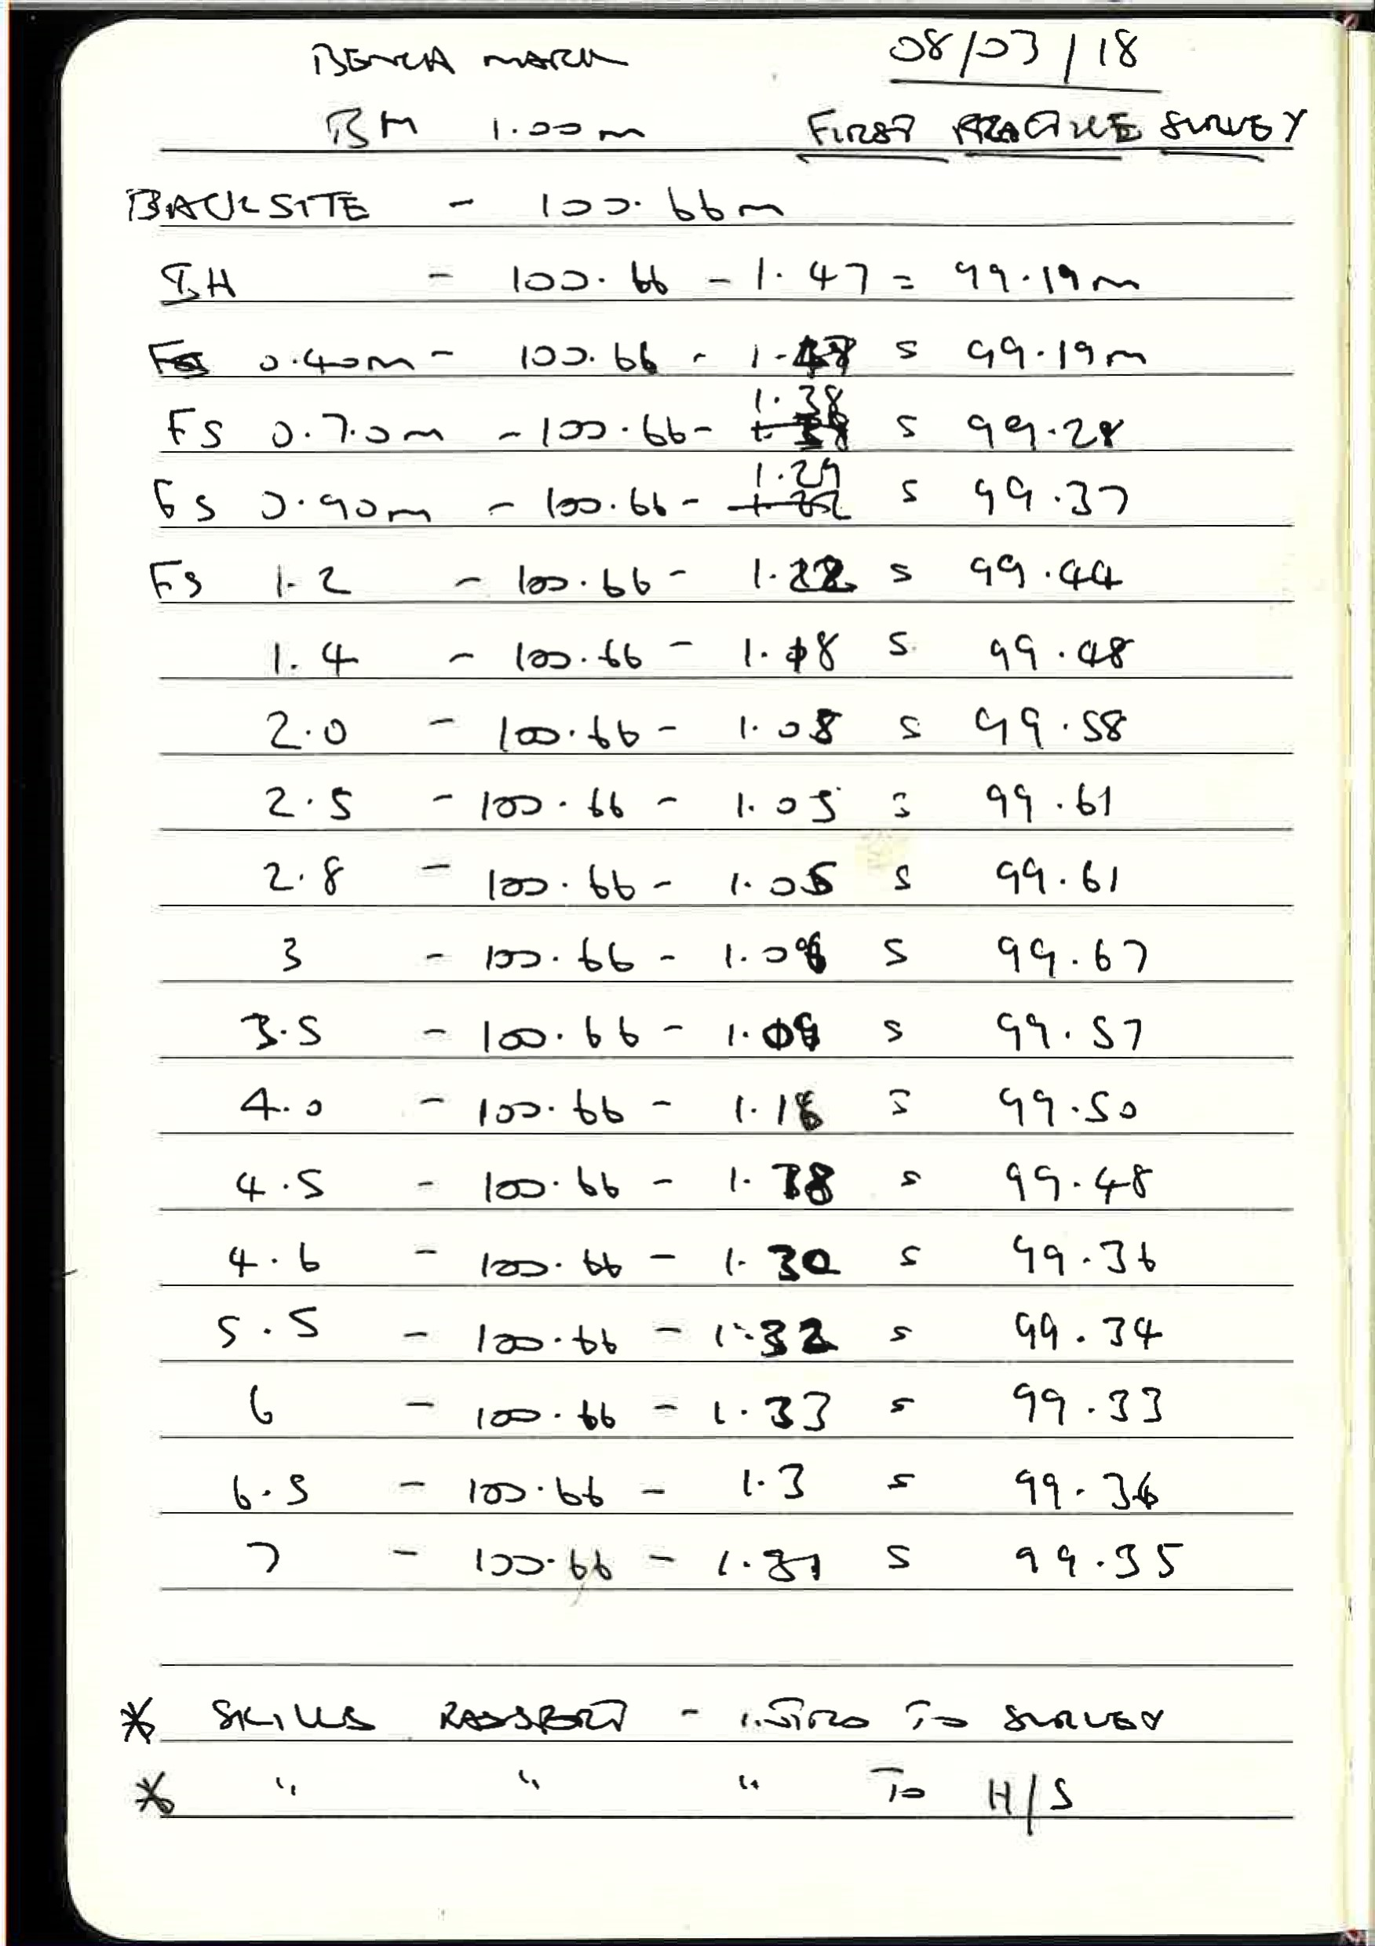
We each carried a tripod, dumpy level, levelling stave (in metric), 30 metre tape measure and 3 ranging poles. Martin Bates then proceeded to show us the technique for setting up the Dumpy level, starting with the tripod. The tripod started with the legs separated approximately a metre apart, then the dumpy level was attached to the base plate using the base plate screw. The dumpy level is basically a longitudinal telescope. The name Dumpy referring to its squat appearance, was the commonest levelling device used on archaeological digs (Coles, 1972:93). The Dumpy is composed of an eyepiece, eyepiece focus, instrument focus levelling screws (3) and bubble tube (Coles, 1972:93). Martin explained at this point the importance of getting the legs level, looking at the bubble all this while, so to reduce the need for adjusting the levelling screws. Martin then asked everyone what we would use as are Benchmark. This, as had been explained in a previous class session, was a fixed known point (Coles, 1972:97) “above Ordnance Survey Datum (mean sea level)” (Coles,1972:97). The Archaeological site manual, Museum of London 1994, in the section on surveying, describes the importance of taking levels. It explains the importance of determining the position of contexts in three dimensions (Zeibart and Westman, 1994). It goes onto say the need to establish a TBM- temporary bench mark on your site as soon as possible, preferably something permanent and or immovable (Welch, 2016:52). Zeibert and Westman (1994) further explain the need for accuracy in taking the levels, but not over the distance of 50m, to read off the staff the nearest whole division and to write it up to two decimal places of a metre. Any greater accuracy is unnecessary and unrealistic. Once a TBM was picked, Ros went and stood there with the levelling staff, once it was lined up, we all looked through the eyepiece at the level. This is when we saw and had it explained to us what we saw through the eyepiece. Drewett (1999) has a diagram representing the image through the eyepiece, it shows a circle with a vertical line and a horizontal line (line of collimation) forming a cross. Equidistant from the cross on the line of collimation are two cross hairs, one above and one below the central cross. These are used for measuring distances, which we would not be doing on this occasion.
Figure 2 Patrick Sweeney Reflexive Journal 08/03/2018
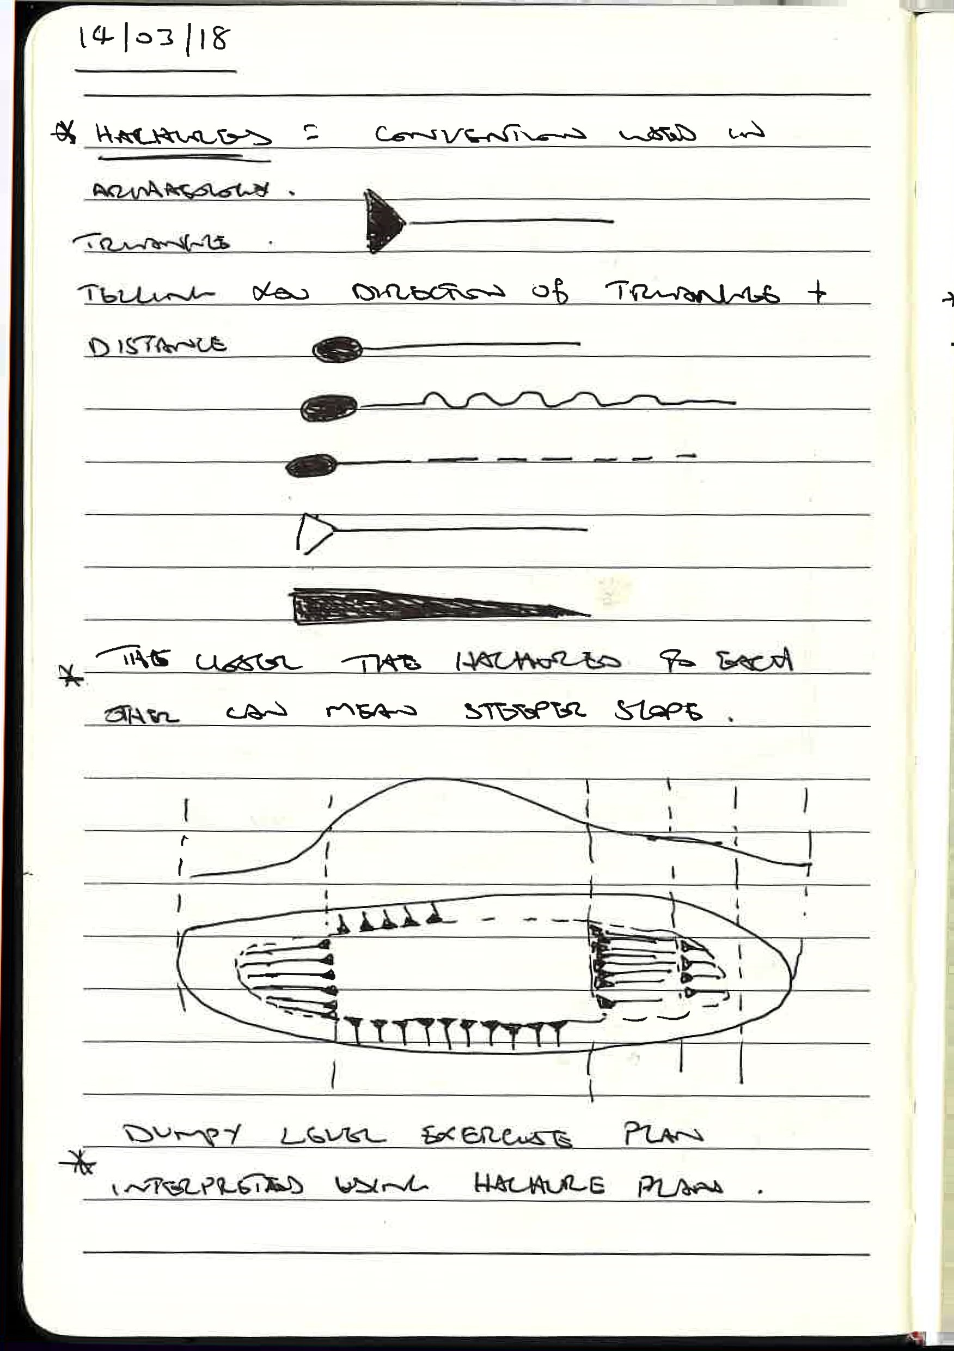
Now we divided back into our groups, deciding which small elevated piece of grassy mole hill we would measure. After deciding which piece of grass would be used, to take our readings for the contour survey that we would produce in class later. At first, we started with a dumpy level that had a spirit bubble that was tricky to adjust, so that was changed for another dumpy with spirit bubble inside a yellow ring (not easy to adjust but easier than the first one). Quentin explained, and I have since read in the BAJR survey basics guide 10(Connolly, 2005) the best way to adjust the dumpy. Start with the dumpy parallel to two of the levelling screws, turn both screws at the same time in the same direction, away or towards yourself until the bubble is centred. Then turn the dumpy until it is now pointing in the direction of the screw that has not been adjusted yet. This can then be used to complete the adjustment by placing the bubble directly in the centre. We were warned that what ever you do, do not kick the tripod, or pull on the dumpy or you will have to start adjustments all over again.
[
叫
。
コ
い
&
So, begins the fun, Welch (2016:52) speaks of the Height Of Instrument (HOI) looking through the dumpy lens. This would be the constant for all surveying that day, Martin spoke of it as the IH. Getting a bit ahead of myself here, I played with the telescope, Karen took the levelling staff (calibrated in metres) Joe took notes and Josh set up the ranging pole, attached the tape measure and called out the measured distances whilst producing the figures for the contour survey. The levelling staff according to Coles (1972:99) was the standard British metric, in metres and 10mms divisions, looks like capital E’s with two square full stops above each E the E’s alternating front facing and back facing going up the staff. The dumpy I forgot to mention has an eyepiece focus (which I did not use as I did not realise until I read it later in BAJR) and the instrument focus, which I had to use.
Figure 3 Patrick Sweeney Reflexive Journal 14/03/2018
Now we have decided on our TBM (we all used the same) and decided on an arbitrary height of 100 metres above sea level, added this to the first reading of the TBM, called the Backsight (BS). This then gives us the IH- Instrument height. Now Josh called out the distances and Karen took up position with the level at each of these subsequent points along the tape measure. I then read out the heights and Joe noted them down. Each of these elevations were called Foresight (FS). Eventually after being told we would be a week, taking the many FS’s we would need, if we did not increase the distance between elevations, to cover the contour we were mapping, so we sped up. Finished taking our elevations and dismantled the dumpy level and carried all the equipment back to the store room and cleaned anything that might have become wet or muddy before putting them away.
- 14/03/2018 Dumpy level contour graph and exercise and Hachures
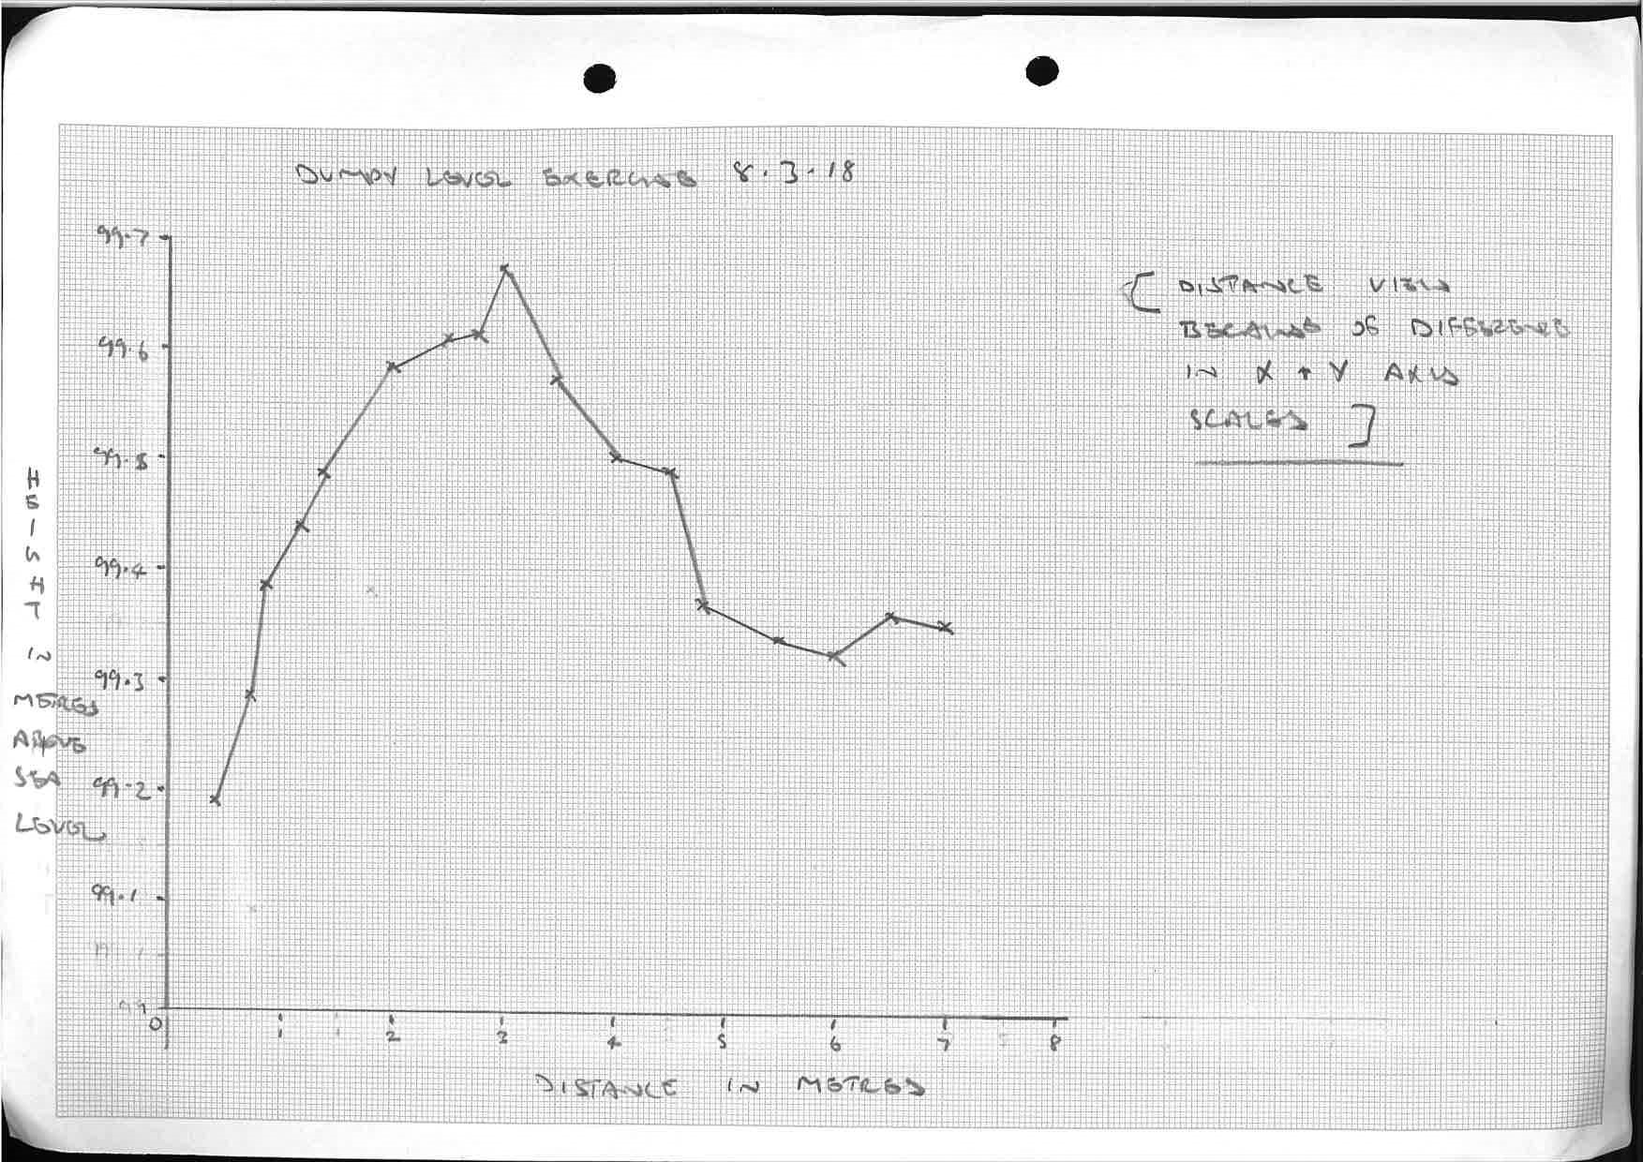
Martin told us to take are figures (figure 2) and to plot a graph from them. Quentin, Ros and Martin then went around the class and helped when we generally became confused with using the most appropriate x and y scales. I know I became confused, first attempt looked like a short take off ramp. Once that was overcome, I thought I might have misread a height level, I had, and it became obvious once I finished the graph, I had a mini spike on the top of my relatively gentle curve (figure 4). Quentin then gave us a demonstration on the use and purpose hachures (figure 3). These are a convention used in archaeology to demonstrate direction and steepness of slopes, gradients. The closer the hachures are to each other can mean a steeper slope. With this we went outside to practice drawing a section of landscape and using hachures. I went to abstract town when I did mine, Quentin kindly said it was a good first attempt, (at a bad Picasso probably). The importance of details such as Scale used (paces in my case) weather to be included with the direction of North, date, name of drawer and site.
Figure 4 Patrick Sweeney Reflexive Journal 08/03/2018

- 22/03/2018 Drawing to scale
This was a class on drawing to scale, the different scales used in archaeology (1:10 for bodies, small finds and features). Also discussed why draw and not just take photos, conclusion of which was the focus of your attention, looking at what you are drawing and not just snapping off a photo and being able to edit out which you do not want to add to your drawing, unlike a photo. We then went into the entrance to the Arts hall after broken into another group of four. One of us became a dead body so we could practise drawing to scale using them. Decided on a 1:10 scale, one of us started plotting the drawing and I did the measuring. It was not easy and after approximately an hour and a quarter, it was described as looking like a Golem but a Lord of the Rings kind. Karen was cold from lying on the floor and time was up (see figure 6 for fun).
I enjoyed the dumpy level experience the most so far, the setting up, adjusting and reading off the elevations. I am looking forward to the opportunity of further experience with it and using it for trench work next. I still find the journal difficult but will persevere because resistance is futile.
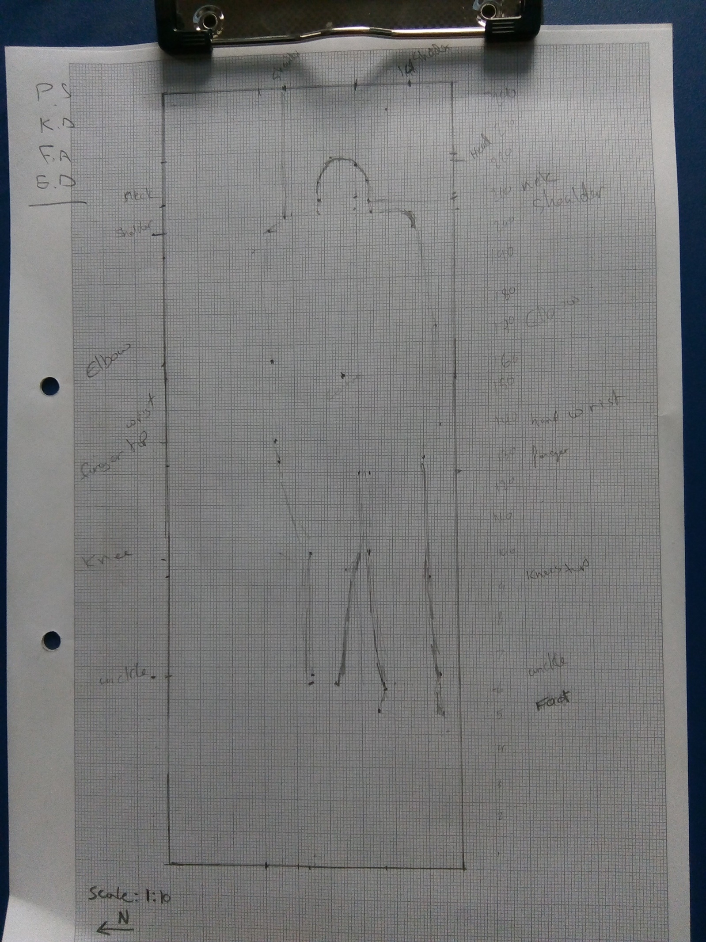
Figure 6 Patrick Sweeney Reflexive journal 2018 (Golem)

Reference
Coles, J. 1974. Field Archaeology in Britain. Cambridge: Methuen & Co Ltd. (2nd edition)
Connolly, D. 2005. Survey Basics Laying out Trenches and Levelling Guide 10: BAJR Practical Guide Series.
Drewett, P.L. 1999. Field Archaeology an Introduction. Cornwall: University College London.
Malcolm, J. (revised by Fryer, D.H.) 1969. Elementary Surveying including Mensuration, Road Construction and Drainage. Foxton: University Tutorial Press.
Welch, E.L. 2016. How are Measurements Taken and Why? In Shafer-Elliott, C (ed) 2016. The 5 Minute Archaeologist In The Southern Levant. 51-54..Milton Keynes: Equinox Publishing Ltd.
Zeibert, M and Westman, A. 1994. Surveying, in Archaeological Site Manual: Museum of London. 7.. Over Wallop: Museum of London (3rd edition)

