Marketing Assistant Placement: Critical Analysis Report
By Alyssia Frampton, 2327857
BMSP5022

Contents:
Introduction |  | 3
- Placement Overview |  | 4
- Critical Evaluation |  | 5
2.1 | Skills Development | 5
2.2 | Application of Academic Knowledge | 5
2.3 | Workplace Environment & Professional Practice | 5
2.4 | Challenges & Limitations | 6
- Reflection on Learning |  | 7
- Evaluation of Objectives |  | 8
- Recommendations for Personal Development |  | 9
Conclusion |  | 10
References |  | 11
Appendix |  | 13

Introduction:
This report provides a critical appraisal of my placement experience at Social Butterfly Strategic Marketing, evaluating the extent to which it contributed to my professional and academic development. The purpose of this appraisal is to reflect on pre-defined objectives (set prior to placement, see appendix A) and assess how effectively these were achieved in practice. The report adopts an academic and reflective approach, drawing on relevant theories to support the analysis of skill development, application of academic knowledge and the engagement within the professional working environment.
Key areas of focus include the development of transferable skills, the integration of marketing theory into practice tasks and the influence of workplace culture on learning outcomes. In addition, the report critically examines the challenges and limitations encountered throughout the placement and considered their impact on overall performance and development.
Through reflective evaluation, this report aims to identify strengths and areas of improvement by comparing expectations to experiences. From this, recommendations for future personal and professional development will be made to ensure continued progression for similar experiences.

    - Placement Evaluation
The placement at Social Butterfly was described as a marketing assistant role with the initial responsibilities of social media management, content creation, basic analytics reporting and networking with clients (experiencing both creative and analytical side to the role).
Prior to the placement, a set of career and personal objectives were established to guide focused development (appendix A). Career objectives included developing practical marketing skills, strengthening data-driven decision-making, gain insight into branding across different markets and identify industries of professional alignment. Personal objectives focused on building confidence in professional settings, demonstrating accountability, improve skills such as organisation and prioritisation, develop reflective practice and build upon professional relationships. These objectives were largely informal due to their self-directive nature; however, they allow personal motivation and self-regulation.
The goal-setting approach can be linked to Edwin Locke’s Goal Setting Theory, which suggests that setting clear and challenging goals enhance performance by providing concentration and motivation (Harrington, 2025). The theory suggests that goals influence behaviour in four ways: direction, effort, persistence and strategy development. These mechanisms help create goals which are relevant, challenging but attainable over time and offer a clear method of achieving the goal (Locke & Latham, 2002). Although the goals set for the placement were not formalised with specific timeframes, the expectation was to build on those objectives as skillsets throughout the 90-hour placement.

    - Critical Evaluation
2.1 Skills Development
Throughout the placement, several key skills were developed, including research and analytical skills, written communication, adaptability and independent working. Initially, the role focused on social media management and analytics, however, during Social Butterfly’s transition into a consultancy agency, responsibilities shifted significantly towards researching and designing course packages. This unexpected change required stronger critical thinking and the ability to synthesis research into structured and client-friendly materials. Written communication improved through producing professional content, while adaptability became essential in responding to evolving role expectations.
However, this shift also presented challenges, as the skills developed were not those originally anticipated. Practical marketing skills, such as content creation, editing and platform-based analytics, were less developed than expected. This shift aligns with Kolb’s Experiential Learning Theory, which suggests that meaningful learning occurs when individuals adapt to unanticipated situations. The movement from expectations (abstract conceptualisation) to real workplace demands (concrete experience) forms the basis for reflection and new learning (Morris, 2020). This demonstrates that although there was a misalignment in objectives, development on other skills were achieved.
2.2 Application of Knowledge
The placement enabled strong application of academic knowledge to real-world tasks, particularly when responsibilities shifted towards research and course design. Skills developed at university, such as conducting research, structuring information, and applying frameworks, became highly relevant. Tools such as SWOT analysis, SMART objectives and the marketing funnel were directly applicable in teaching marketing. This reflects the value of academic knowledge needed to fulfil the output of the courses within the timeframe given.
In this context, theory largely aligned with practice due to the subject being delivering academic knowledge. This can be linked to Donald Schön’s theory, knowledge is applied and refined through action (Schön, 1983). However, gaps were evident in more technical areas, particularly in ‘analytics platforms’ and ‘setting up paid ad campaigns’, which are not covered in academic study. This highlights a disconnect between theoretical knowledge and industry-specific tools. While conceptual understanding was strong, technical proficiency required further development.
2.3 Workplace Environment and Professional Practice
The workplace environment at Social Butterfly was remote, which influenced both professional practice and learning opportunities. Communication was largely limited to email and online meetings with the placement manager, resulting in a somewhat isolating experience that relied on organisations time to communicate. While a positive working relationship was established, consistent communication from the placement manager was a challenge due to competing prioritise. This made discussions for feedback and guidance difficult.
This experience reflects Schein’s (2010) view that communication and workplace structure are shaped by underlying cultural assumptions. Working remotely meant that previously established norms within the company influenced the level of feedback and guidance received. This means that the organisational culture of the business heavily impacted the communication pattern in the online environment. However, the remote setting offered flexibility and encouraged independent problem solving, which was a benefit in developing independent working.
2.4 Challenges and Limitations
Key challenges of the placement included limited communication, reduced access to feedback and restricted exposure to practical marketing activities. The lack of consistent interaction can be linked to communication theory, particularly the importance of clear channels and feedback in effective workplace practice. Similarly, the absence of regular feedback limited opportunities for improvement and disrupted Kolb’s Experiential Learning Cycle. Reflective observation is key for informed improvement (Kolb, 1984). This shows how essential feedback was during the experience to be able to effectively reflect and progress learning.
From a personal perspective, greater productivity could have improved the experience, such as voicing concerns and requesting involvement in marketing focused areas. From an organisational perspective, clearer role expectations and consistency in responsibilities should have been better supported and more of a priority.
While challenges limited certain aspects of skill development, they also highlighted the importance of communication, adaptability and reflective practice in professional growth.

    - Reflection on Learning
To support a structured reflection on the placement experience at Social Butterfly, Gibbs’ Reflective Cycle. The six-stage framework aims to examine experiences and curate an action plan for future application based on what was successful and what could be improved (The University of Edinburgh, 2024).
During my placement at Social Butterfly, I worked in a remote marketing assistant role for a marketing agency. The role was supposed to involve content creation, editing and analytical work. Initially, I felt motivated and interested in a developing career in marketing, however, as my responsibilities changed to consultancy-type work, my perspective on my career direction changed.
Evaluating my experience, I found positives in the flexibility of remote working and the independence it offered. However, I also experienced challenges related to limited structure, inconsistent communication and work that was very similar to my university work. These factors influenced my engagement and learning experience.
Analysing this further, I have learned that I work well independently but still require structure to remain productive and motivated. This insight has significantly changed my thinking towards the type of role I wish to have in the future such as structured remote or hybrid environments. I also generous practical skills such as creating structured learning materials, including course content and workbooks. This improved my ability to present information in a clear and engaging way. Additionally, my professional communication skills have developed through regular email and online meeting setups with my placement manager.
Concluding the experience, I have gained a clearer understanding of my strengths (independence, adaptability and communication). Moving forward, I will prioritise roles that combine flexibility and structure to allow for a varied combination of communication. My action plan is to further develop transferable skills, but in an environment that better aligns with my preferred working style.

    - Evaluation of Objectives
The evaluation of my placement objectives highlights a mixed level of achievement, with several goals fully met, others partially achieved and some not fully achieved due to changes in role structure at Social Butterfly. Initially, my objectives were framed using action-orientated infinitives such as “developing practical marketing skills,” “strengthening data-driven decision making,” and “building confidence in professional communication and networking.” According to Goal Setting Theory (Locke & Latham, 2002), specific and challenging goals improve performance by providing engagement and ambition. This supported my initial enthusiasm at the beginning of the placement.
Personal objectives such as improving organisation, accountability and reflective practice were largely achieved, particularly through independent and remote working due to practicing skills such as prioritisation, time management and professional communication. However, some career focused objectives were only partially met. While I gained experience in research and content development, practical marketing skills were limited in development due to the restructure of my responsibilities. As a result, exposure to data-driven marketing tools were reduced, meaning this objective was not achieved.
Overall, the objectives were realistic in intention but not fully aligned with the evolving nature of the placement. This inducted their achievability. The change in responsibility’s behave that some goals are less relevant for the experience. Despite this, the placement still supported significant transferable skill development and provided meaningful insight into professional practice, even if not all objectives were met.

    - Recommendations for Personal Development
My personal development should focus on both consolidating transferable skills and exploring alternative career paths to ensure long-term professional clarity. In relation to digital marketing, I should further develop technical skills in content creation, editing and analytics tracking, as these were minimally developed during my placement. This could be achieved through structured online training or through practical application through personal projects or freelance work.
From a professional growth perspective, increasing confidence in networking remains a key priority. This can be developed through active participation in industry events, LinkedIn events and setting measurable targets for initiating professional conversations. These actions align with CPD (Continuous Professional Development, which encourages self-directed learning to enhance employability and adaptability (Mann & Sargeant, 2013).
I recognise that I learn most effectively through active participation and structured reflection, a combination of activist and reflector styles (Honey & Mumford, 1994). Using the Learning Styles Theory, I should seek opportunities that allow me to ‘learn by doing’ while also critically evaluating experiences to refine performance.
Finally, I intent to explore alternative professionals beyond marketing to better understand where my strengths align. Overall, my development plan will focus on building technical digital skill, strengthening professional confidence and maintaining reflective CPD approach to support continuous career progression.

Conclusion:
Overall, my placement at Social Butterfly Strategic Marketing provided valuable insight into professional working practices and contributed to my personal and employment development. Despite changes in role direction, the experience strengthened my adaptability, independent working and ability to manage evolving responsibilities in a real-world context. It also developed my communication skills and my ability to curate learning materials that are client focused.
Although some unrest; objectives were only partially met, the placement offered important lessons in self-direction, resilience and understanding workplace dynamic. It also clarified my career preferences, particularly in work environment types and culture styles.
Overall, this experience has better portrayed me for my future employment by developing transferable skills, improving professional awareness and supporting more informed career decision-making.

References:
Frampton, A. (2026). Implementation Plan for Placement Module. University of Wales Trinity St David.
Harrington, L. (2025). What is goal setting theory? Locke and Latham’s model explained. Locus Assignments. https://www.locusassignments.com/blog/goal-setting-theory
Honey, P., & Mumford, A. (1986). The manual of learning styles. Peter Honey Publications.https://books.google.co.uk/books?hl=en&lr=&id=3UnrlWOCJlwC&oi=fnd&pg=PA101&dq=Honey+and+Mumford+Learning+Cycle&ots=z9BLp5c_Gp&sig=92h3C8-1YSiG572oW_K-7_3Tcss#v=onepage&q=Honey%20and%20Mumford%20Learning%20Cycle&f=false
Kolb, D. A. (1984). Experience as the source of learning and development. Experiential Learning. 20-38 http://www.learningfromexperience.com/images/uploads/process-of-experiential-learning.pdf
Locke, E. A. & Latham, G. P. (2002). Building a practically useful theory of goal setting and task motivation. American Psychologist, 57(9), 705-717 https://doi.org/10.1037///003-066X.57.9.705
Mann, K. V. & Sargeant, J. M. (2013). Continuing professional development. Oxford Textbook of Medical Education, 350-361 https://doi.org/10.1093/med/9780199652679.003.0030
Morris, T. H. (2020) Experiential learning- A systematic review and revision of Kolb’s model. Interactive Learning Environments, 28(8), 1744-5191 https://doi.org/10.1080/10494820.2019.1570279
Schein, E. L. (2010). Organisational culture and leadership. https://ia800805.us.archive.org/9/items/EdgarHScheinOrganizationalCultureAndLeadership/Edgar_H_Schein_Organizational_culture_and_leadership.pdf
Schön, D. A. (1983). How professionals think in action. The Reflective Practitioner. https://med.stanford.edu/content/dam/sm/s-spire/documents/PD.locke-and-latham-retrospective_Paper.pdf
The University of Edinburgh. (2024). Gibbs’ reflective cycle. Reflection Toolkit.https://reflection.ed.ac.uk/reflectors-toolkit/reflecting-on-experience/gibbs-reflective-cycle

Appendix:
  - Image of Goals and Objectives from Previous Assignment
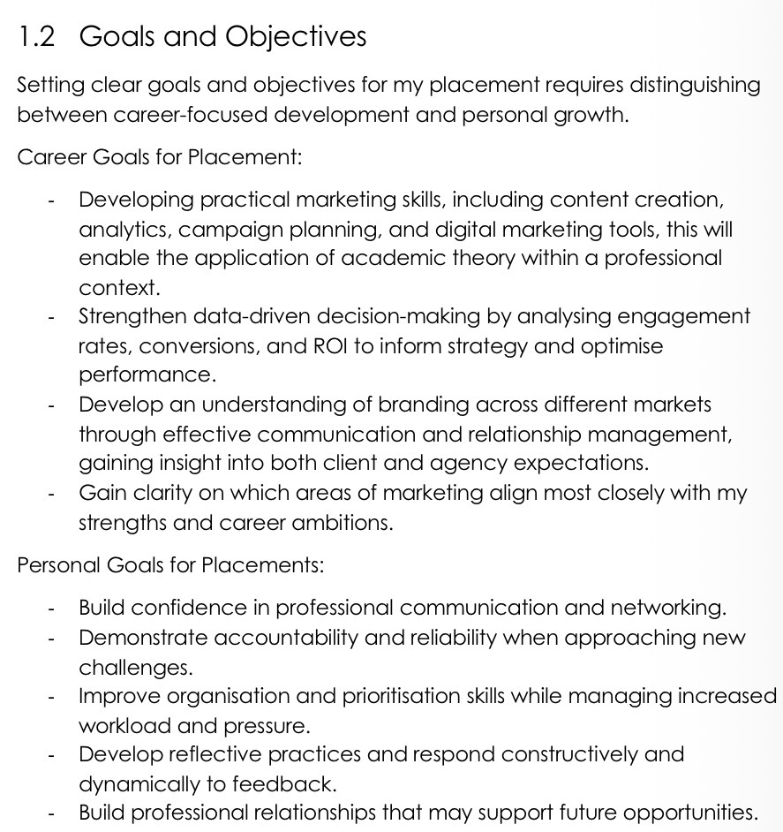
(Frampton, 2026).

