DS 1 Template

My Screenshots/Photos
- Please add 4–6 screenshots or photos of your digital life.
- You can use your phone or laptop.
- For each screenshot, write one or two sentences explaining what it shows.

Screenshot/Photo 1
Outlook email
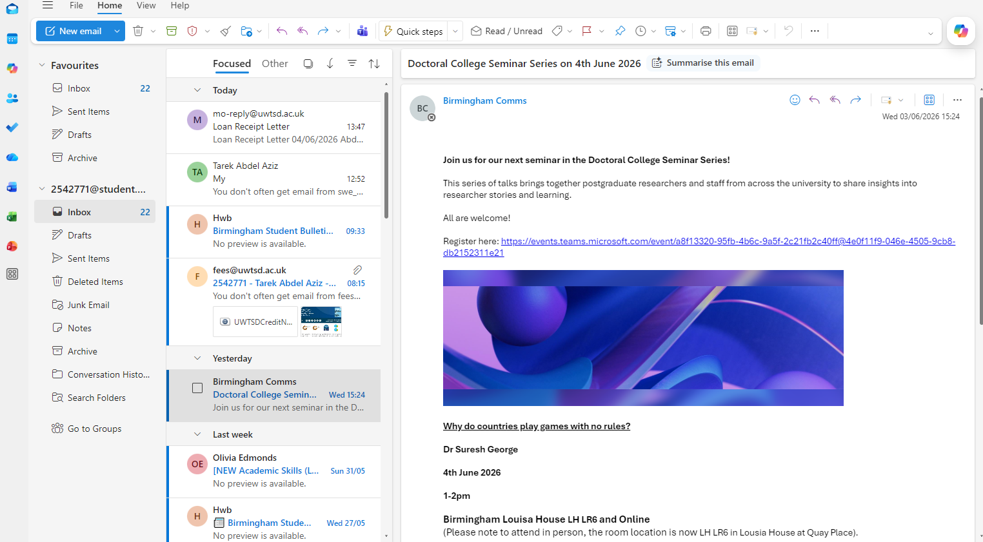
We use this digital tool now in many things like at work or when we need to share important information.it is really useful save us time and money .

Screenshot/Photo 2
CNN NEWS
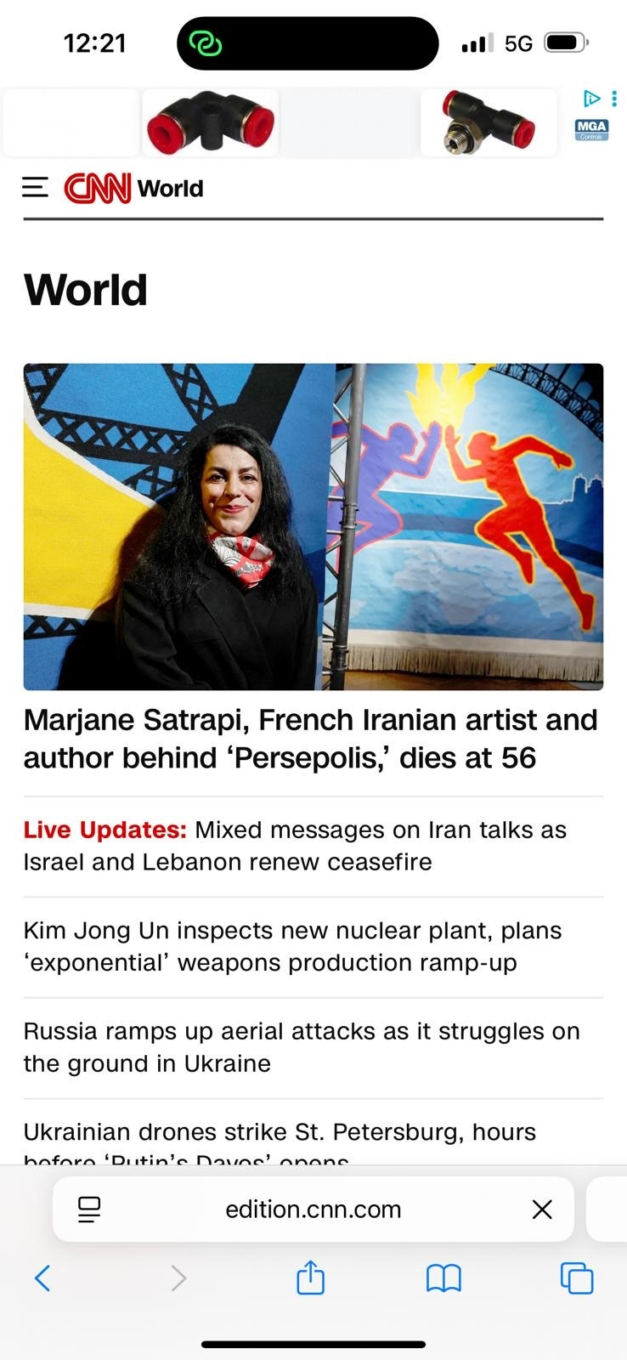I use this app to be UpToDate with everything happening in the world like I am there.

Screenshot/Photo 3
MESSENGER APP
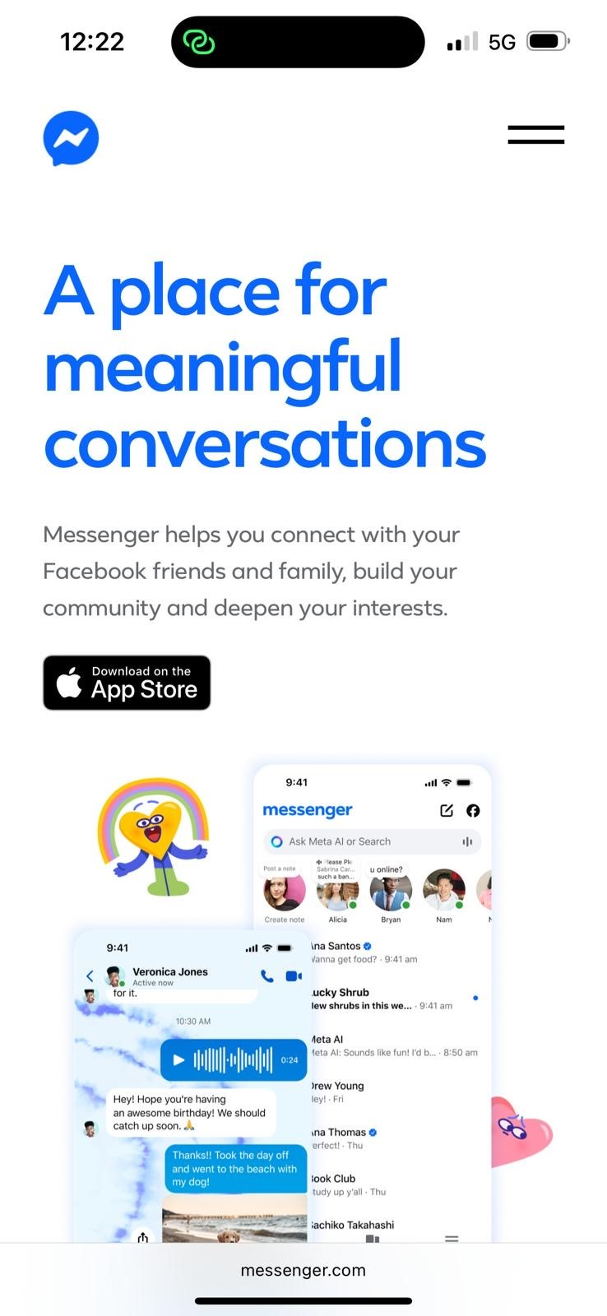 this messenger tool is very useful , it let me connect easily and smoothly with my family and friends abroad.

Screenshot/Photo 4
UBER APP
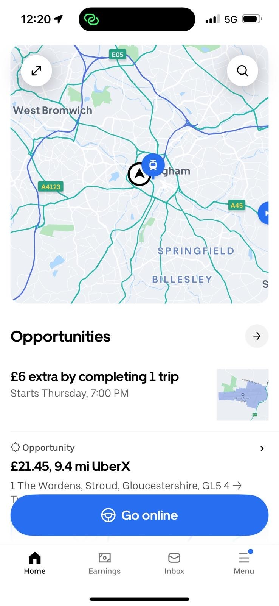
I use this digital tool every day specially the navigation tool which allow me reach my destination easily, safely and quickly.

Screenshot/Photo 5
NHS APP
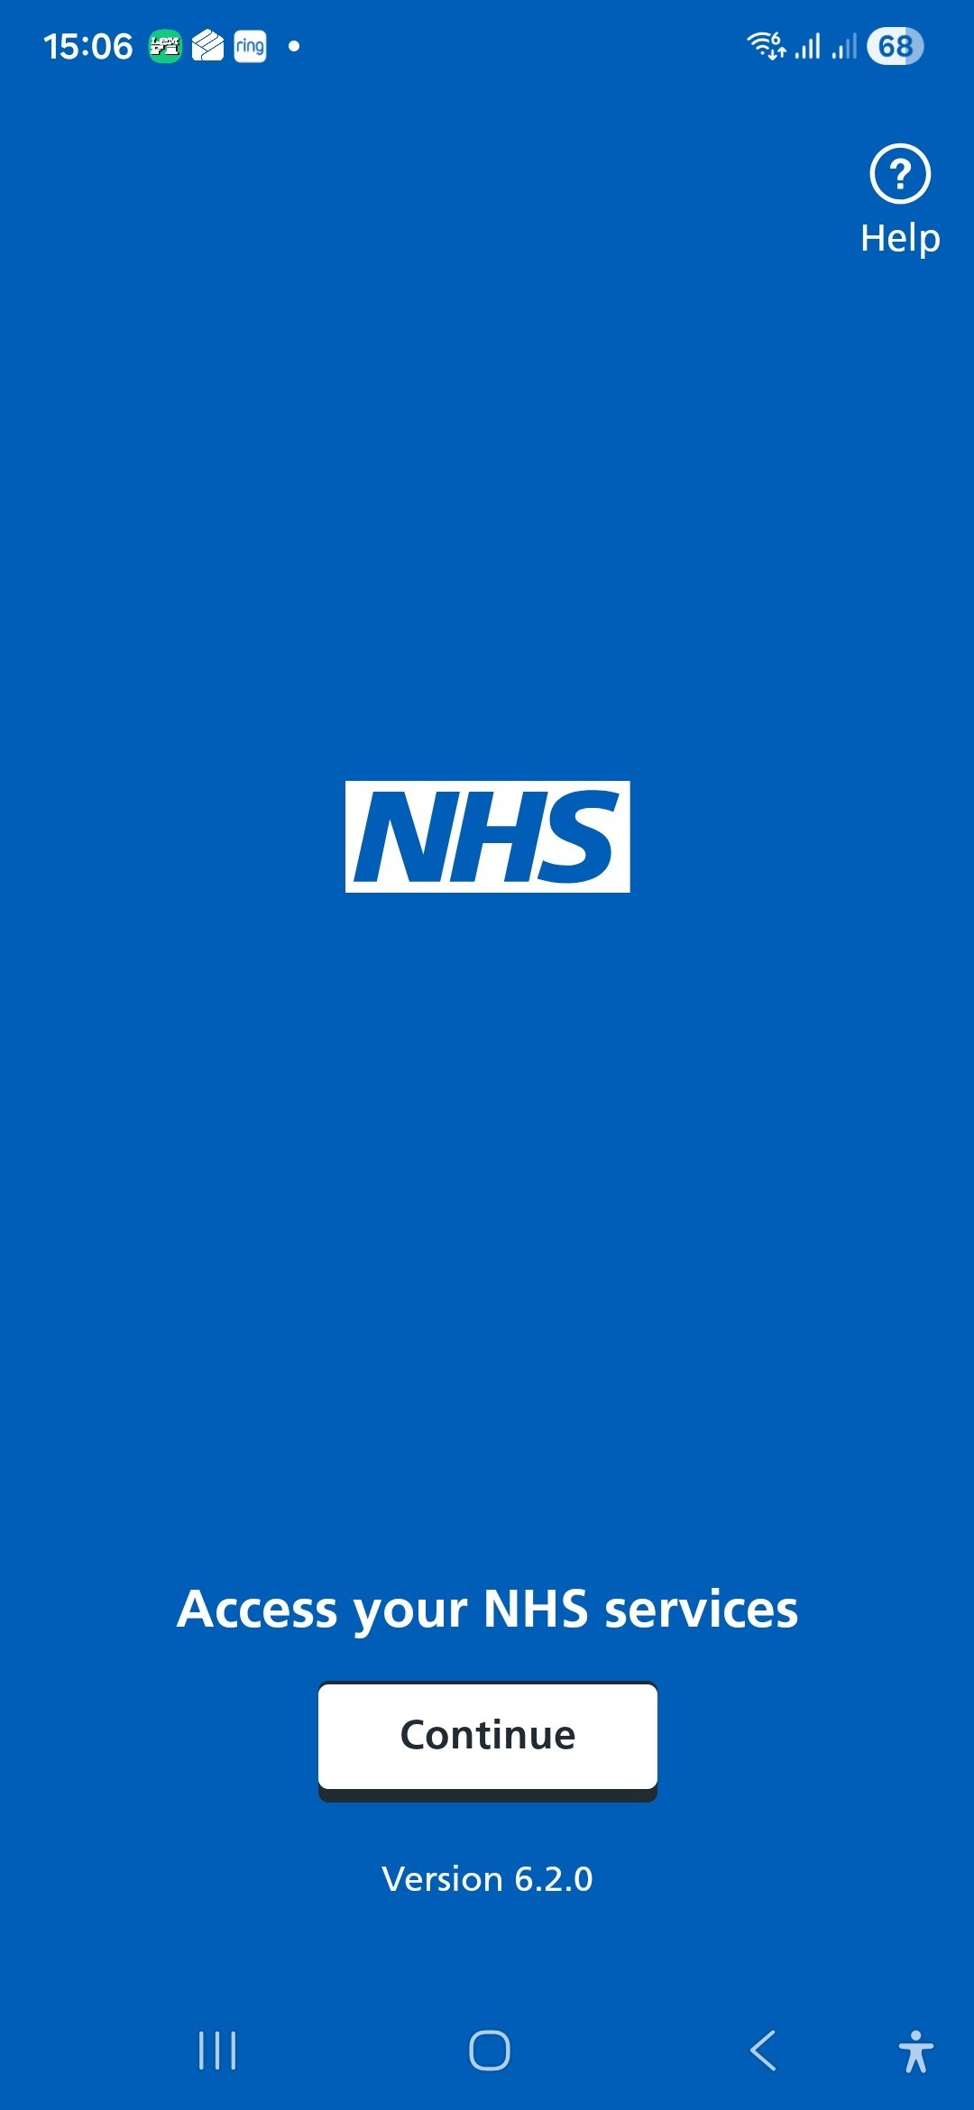
I use this nhs digital tool to monitor my health and to control my doctors appointments and to be up to date with my prescriptions.

Screenshot/Photo 6
UWTSD HUB
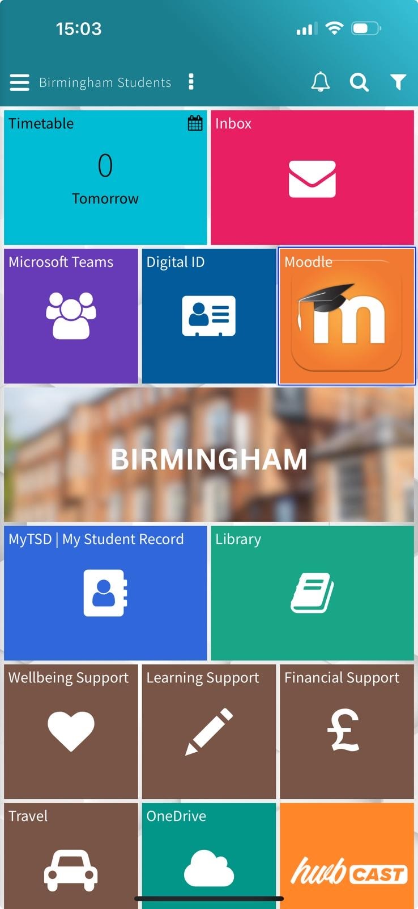
I use this digital tool to do my researches , to study, contact easily my teachers and university ,and to get quick help and support.

My Short Reflection
- Write 5–8 simple sentences about your digital life.
- You can use the sentence starters below if helpful.
I use digital tools everyday in different ways , to study ,to finish my work properly, to find my way and to communicate with others.
I feel confident when I am using it because it became part of my life which make it easier and smoother.
I want only to improve my writing on the apps to be faster ,and I am working on it .
I often use these tools in a daily basis.
I hope this module will help me improve my digital skills.
Digital skills is important to me because it will help me in improving and well maintained my business.

Sentence starters
- I use digital tools to …
- I feel confident when I …
- I want to improve …
- I often use these tools: …
- I sometimes feel nervous about …
- I hope this module will help me …
- Digital skills are important for me because …
You can write more if you want.

Submission Checklist
Before you submit, please check:
​​​ ☒ I added 4–6 screenshots
☒ I wrote short sentences for each screenshot
☒ I wrote my short reflection
☒ My work is my own
☒ My file opens correctly
​​☒ My file opens correctly

