Assignment Title: Properties of Framing Materials
Module: Construction Materials
Module Code: ACBA4016
Lecturer: Allan Nantel
Submission Deadline: 26/03/2026
Word Count: 2054
Student Number: 2512680

Contents
Introduction 3
Building Overview and Original Design 3
Architectural Design 4
Construction Methodology 5
Strength, Durability and Climatic Resistance 5
Time, Labour, Programme and Cost Compared with Steel Framing 6
Ease of Assembly and Adaptability 6
Integration of Services 7
Demolition and End-of-Life Considerations 7
Environmental and Community Impacts of Concrete Production 7
Conclusion 8
Reference List 9
Sieve Analysis 11
Particle Size Distribution Chart 12
Graph Analysis 13

Introduction
The development of reinforced concrete frame construction has played a vital role in the evolution of modern high-rise architecture. Since the early twentieth century, reinforced concrete has evolved from a material primarily used for bridges and mid-rise buildings, into one capable of supporting extremely tall structures (Ali, 2001). Advances in structural engineering, high-performance materials and construction technologies have enabled engineers to design buildings that exceed heights once considered structurally impossible (Ali & Moon, 2007).
Reinforced concrete has become particularly significant in the construction of tall buildings due to its high compressive strength, durability and resistance to environmental degradation. The combination of concrete and steel reinforcement allows the material to resist both compressive and tensile forces, making it suitable for complex structural systems. Developments such as post-tensioned floor systems, high-strength concrete mixes and improved form work technologies have further enhanced the efficiency and performance of reinforced concrete structures (Mehta & Monteiro, 2014).
Modern computational modelling and wind engineering have also contributed significantly to the feasibility of supertall buildings. Sophisticated digital analysis allows engineers to simulate structural behaviour under wind loads, seismic forces and long-term material deformation, which enables safer and more efficient structural solutions. In combination with modern construction methods such as slip-form construction and high-capacity concrete pumping, reinforced concrete structures can now be constructed at unprecedented heights.
This report will critically evaluate the Burj Khalifa in Dubai as a case study of advanced reinforced concrete frame construction. The discussion examines the building’s structural design and construction methodology before analysing the performance of reinforced concrete in relation to strength, durability and environmental exposure. A comparison with steel framing is provided with regards to construction time, labour requirements, programme duration and cost. This report will also evaluate the adaptability of reinforced concrete structures, the integration of building services and the challenges associated with demolition at the end of the building’s life cycle. Finally, the environmental and community impacts associated with cement and concrete production are discussed using contemporary sustainability research.

Building Overview and Original Design
Construction of the Burj Khalifa was completed in 2010, designed by Adrian Smith of Skidmore, Owings & Merrill (SOM), rises to 828 metres and is the tallest building in the world (Institute of Civil Engineers, N.D.). The tower contains a mix of residential apartments, corporate offices, hospitality facilities and public observation decks. This vertical integration of different functions reflects the increasing demand for high density urban developments in rapidly growing cities (Ali & Moon, 2007). Constructing a building of this scale required integration of architectural design, structural engineering and advanced construction methods.

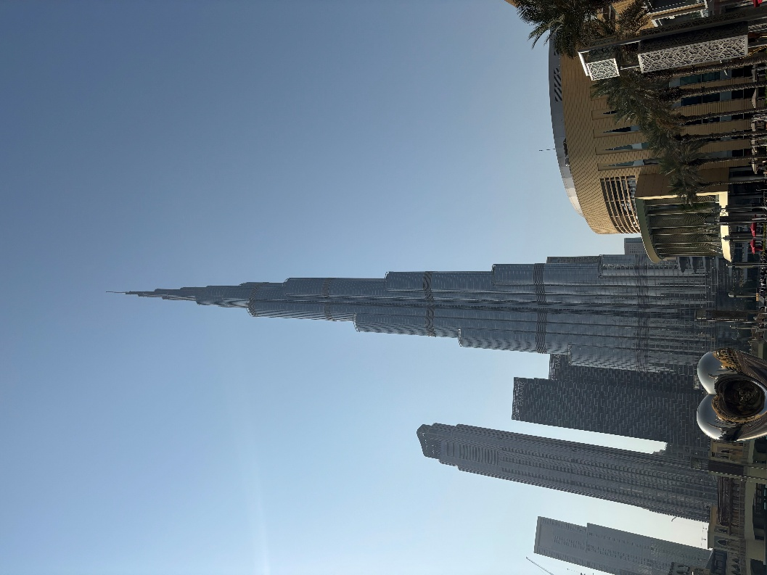

Figure 1: Burj Khalifa daytime (personal collection, 2025)

Architectural Design
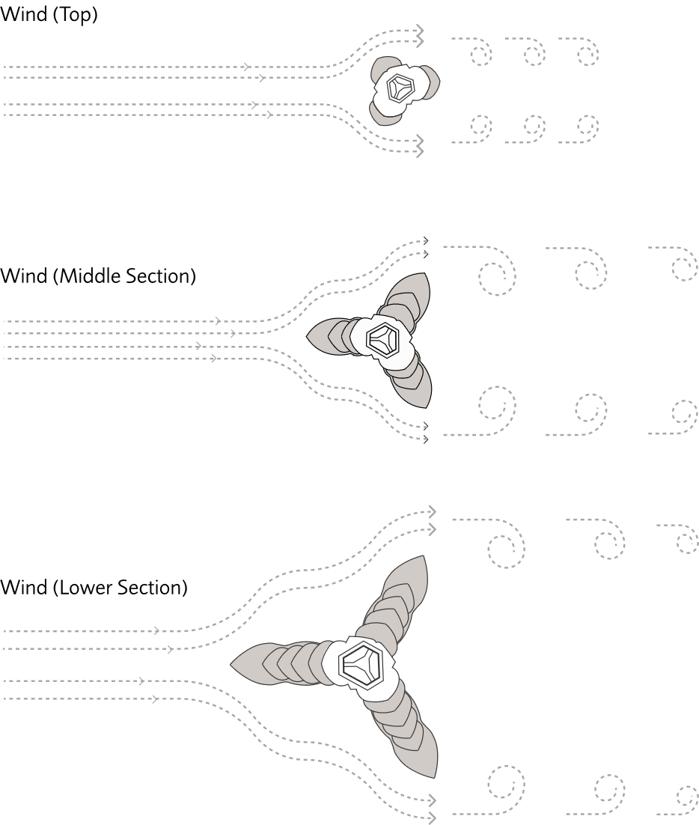
The plan concept was inspired by the Hymenocallis flower (Yahya et al, 2023). The Y-shaped floor platform forms three wings arranged around a central hexagonal core (burjkhalifa.ae/the-tower/architecture-design website). This design is structurally strategic rather than primarily aesthetic. Each wing acts as a buttress support to the others which enhances torsional stability and improves lateral stiffness. As the building increases in height, the wings are set back to create a spiral effect. This arrangement disrupts vortices and reduces wind-induced oscillations (Baker et al., 2007). Extensive wind tunnel testing helped inform the final design.

Figure 2: Wind effects on the Burj Khalifa (Available: https://www.burjkhalifa.ae/the-tower/architecture-design/)
The structural system is known as the buttressed core which comprises of a reinforced concrete hexagonal central core connected to three reinforced concrete wings positioned at 120 degrees. Each wing contains perimeter columns which form a continuous load-bearing system (Baker et al., 2007). Considering the gravitational effect on the building, vertical forces are transferred through the walls and columns into a raft foundation supported by bored piles. Under lateral wind loading, each wing supports the others which limit drift and torsional rotation. Compared with framed tube systems used in earlier skyscrapers, the buttressed core provides superior stiffness with efficient material distribution. This structural innovation was essential in enabling the unprecedented height the Burj Khalifa achieved.

Construction Methodology
Construction of the Burj Khalifa required concrete that could achieve high strength whilst remaining workable in extreme climatic conditions. The concrete mix incorporated low water-cement ratios, supplementary cementitious materials like fly ash and silica fume, and superplasticisers such as polycarboxylate ether polymers which improved the flow of concrete and helped the material withstand high pressures.
To reduce the risk of thermal cracking during the curing process, chilled water and ice were added to the concrete mix and concrete was poured predominantly at night when the temperatures were lower (Aldred. J, 2010). Strict quality control ensured consistent rheological properties, particularly for high-level pumping operations.
Slip-form construction was used to construct the central concrete core. This method allows concrete to be poured continuously whilst formwork gradually moves upwards as the concrete gains sufficient strength. The use of slip-form construction accelerated the building’s vertical progress. Concrete pumping operations were also highly advanced. Specialised high-pressure pumping equipment enabled concrete to be transported to heights that exceeded 600 metres. Maintaining the correct rheological properties of the concrete mix was essential to ensure successful pumping over large distance. The constructions process followed a repetitive floor cycle of approximately three days. Post-tensioned concrete slabs were used for floor construction, allowing thinner slabs which consequently reduced the overall weight of the building (Posten et al., 2008). At higher elevations, structural steel elements were introduced to reduce structural mass and minimise cumulative vertical loading.

Strength, Durability and Climatic Resistance
Reinforced concrete provides high compressive strength combined with tensile capacity through embedded steel reinforcement. In the Burj Khalifa, the buttressed core system effectively distributes both vertical and horizontal loads throughout the building. The tower was designed to withstand wind speeds exceeding 200 km/h, with predicted lateral displacements remaining within acceptable serviceability limits (Baker et al., 2007). Another important factor that affects the structural performance of reinforced concrete is creep and shrinkage behaviour. Concrete gradually deforms under sustained loads, meaning strain continues to increase gradually after the initial application of loading known as creep. Engineers accounted for these long-term deformations during the design stage by modelling creep and shrinkage effect in structural analysis software. This allowed shortening of structural elements to be incorporated into the construction process which ensured that floor level and façade components remained aligned as the tower increased in height. The relatively high density of concrete also contributes to improved structural damping. High-rise buildings can experience wind-induced vibration which may affect occupant comfort. Concrete structures dissipate energy more effectively than lighter materials such as steel, reducing the perception of building movement. Durability was another vital consideration due to Dubai’s extreme climate. High humidity, airborne chlorides and wind-blown sand create aggressive and unpredictable environmental conditions and can therefore assist in the acceleration of material degradation. Water, oxygen and chloride ions are vital components in the corrosion of embedded steel and the cracking of concrete, therefore it can be deduced that the permeability of concrete is key to ensuring control of the various processes involved (Mehta & Monteiro, 2014).

Time, Labour, Programme and Cost Compared with Steel Framing
Reinforced concrete construction generally needs more on-site labour compared with steel framing, which can be prefabricated off-site and can be assembled quickly. Reinforcement placement, form work assembly and the curing of concrete increases labour requirements, although labour costs in the Middle East are cheaper which makes labour-intensive construction methods economically and commercially justifiable.
A further advantage of reinforced concrete is that the structural frame and flooring system can often be constructed simultaneously. Steel framing does provide advantages with regards to faster structural erection and reduced structural weight. Lighter structures require smaller foundations and can therefore reduce the overall construction time. The Burj Khalifa uses a hybrid approach which combines reinforced concrete in the lower structure up to Level 156, with steel framing used at higher levels up to Level 163 which optimises structural performance.

Ease of Assembly and Adaptability
Reinforced concrete offers significant flexibility in shaping complex architectural forms. The stepped setbacks and tapering profile of the Burj Khalifa demonstrates how concrete can be used to construct geometrically complex structures efficiently.
Post-tensioned floor systems allow relatively large column spacing, which therefore creates open interior spaces that can accommodate multiple building uses. However, reinforced concrete structures can be difficult to modify once constructed due to the monolithic structure, therefore altering load-bearing walls or structural cores can compromise stability. Steel structures may provide greater flexibility for structural modifications because components can be replaced more easily.

Integration of Services
Integrating building services in supertall buildings can have significant engineering challenges. Mechanical floors are distributed throughout the tower to divide the building into service zones. These floors house equipment such as pumps, chillers and ventilation systems necessary for building operation.
Water must be pumped to extreme heights, which requires complex high-pressure pumping systems. An innovative feature of the Burj Khalifa is its condensation recovery system. Wong (2016), says that around half of the 138 cubic meters of water required each year for landscape irrigation comes from the Burj Khalifa’s air conditioning condensation.

Demolition and End-of-Life Considerations
Demolishing a supertall reinforced concrete structure presents considerable technical challenges. High-strength concrete is difficult to crush and recycle, and embedded steel reinforcement must be separated from the concrete mix. Explosive demolition would likely be impractical due to the dense urban environment surrounding the building, therefore controlled dismantling methods would be required which would significantly increase demolition time and cost. Some recycling opportunities do exist, with steel reinforcement potentially being recovered and reused, whilst crushed concrete can be used as recycle aggregate in new construction projects.

Environmental and Community Impacts of Concrete Production
Cement production is one of the largest industrial sources of carbon dioxide emissions, amounting to approximately 7-8% of global CO₂ emissions (Andrew, 2018; Scrivener at al., 2018). These emissions originate from two primary sources; the chemical process of limestone calcination and the combustion of fossil fuels used to heat cement kilns. Cement manufacturing also requires extremely high temperatures, typically around 1450°C which results in significant energy consumption (Gagg, 2014). The extraction of raw materials such as limestone and aggregates can also damage natural landscapes and ecosystems. Quarrying operations may disrupt habitats and alter local landforms (Mehta & Monteiro, 2014). Concrete production can also affect nearby communities. Residents living close to cement plants may experience noise pollution, airborne dust and increased traffic from heavy goods vehicles transporting raw materials (WBCSD), 2018).
Water consumption is another environmental concern. Cement manufacturing and concrete mixing requires significant volumes of water which can place pressure on water resources, particularly in arid regions (Scrivener et al., 2018). To reduce these impacts, the construction industry is developing alternative low-carbon cement technologies, supplementary cementitious materials and carbon capture systems.

Conclusion
The Burj Khalifa represents one of the most significant achievements in modern reinforced concrete construction. The innovative buttressed core structural system provides exceptional stability and efficiency, allowing the building to reach unprecedented heights. High-performance concrete materials enabled the structure to withstand extreme environmental conditions whilst maintaining long term durability. Although reinforced concrete construction can involve greater labour requirements and presents challenges related to adaptability and demolition, it remains a high effective structural solution for tall buildings. However, the environmental impacts associated with cement production remains a challenge for the construction industry. Continued research into low-carbon cement technologies and sustainable construction practices will be essential to reduce the environmental footprint of reinforced concrete structures in the future.

Reference List
Aldred, J. (2010) ‘Burj Khalifa – a new high for high-performance concrete’, Proceedings of the Institution of Civil Engineers: Civil Engineering, 163(2), pp. 66-73
Available at: https://www.researchgate.net/publication/245407762_Burj_Khalifa_-_A_new_high_for_high-_Performance_concretej

Ali, M.M. (2001) Evolution of Concrete Skyscrapers: from Ingalls to Jin Mao. Electronic Journal of Structural Engineering, 1(1), pp. 2-14.
Available at: https://doi.org/10.56748/ejse.1111

Ali, M. and Moon, K. (2007) ‘Structural Developments in Tall Buildings: Current Trends and Future Prospects’, Architectural Science Review, 50(3), pp. 205–223.
Available at: https://doi.org/10.3763/asre.2007.5027

Andrew, R. (2018) ‘Global CO₂ emissions from cement production’, Earth System Science Data, 10(1), pp. 195–217.
Available at: https://doi.org/10.5194/essd-10-195-2018

Baker, W., Korista, D. and Novak, L. (2007) ‘Engineering the World’s Tallest: Burj Dubai’, Structural Engineering International, pp. 1–10.
Available at: https://global.ctbuh.org/resources/papers/download/1326-engineering-the-worlds-tallest-burj-bubai.pdf

Institution of Civil Engineers (No Date)
Available at: https://www.skyscrapercenter.com/building/burj-khalifa/3

Gagg, C. (2014) ‘Cement and concrete as an engineering material’, Construction and Building Materials, 68, pp. 522–532.
Available at: https://doi.org/10.1016/j.engfailanal.2014.02.004

Mehta, P. and Monteiro, P. (2014) Concrete: Microstructure, Properties and Materials. 4th edn. New York: McGraw-Hill, pp. 181 – 183
Available at: https://worksaccounts.com/wp-content/uploads/2020/08/Concrete-Microstructure-Properties-and-Materials.pdf

Scrivener, K., John, V. and Gartner, E. (2018) ‘Eco-efficient cements’, Cement and Concrete Research, 114, pp. 2–26.
Available at: https://doi.org/10.1016/j.cemconres.2018.03.015

WBCSD (2018) The Cement Sustainability Initiative. Geneva: World Business Council for Sustainable Development.
Available at: https://docs.wbcsd.org/2002/06/TheCementSustInitiative.pdf

Wong, J. (2016) Landscape Record: Ground-scapes for the Supertalls. SWA Group, p. 76
Available at: https://www.swaaengineers.com/wp-content/uploads/2021/02/SWAat60-Landscape_Record.pdf

Yahya, D.A. et al. (2023) ‘A review of conceptual design and self health monitoring program in a vertical city: A case of Burj Khalifa, U.A.E. ‘Buildings, 13(4), p. 12.
Available at: https://mdpi-res.com/d_attachment/buildings/buildings-13-01049/article_deploy/buildings-13-01049-v2.pdf?version=1681781467

Zhang, C., Zhu, Z., Zhu, S., He, Z., Zhu, D., Liu, J. and Meng, S. (2019) ‘Nonlinear Creep Damage Constitutive Model of Concrete Based on Fractional Calculus Theory’, Materials, 12(9), pp. 1-14
Available at: https://doi.org/10.3390/ma12091505

Sieve Analysis

The following particle size distribution was obtained from a sieve analysis on an ‘all-in’ aggregate used for concrete production.

The original sample size was 1250g.
Sieve Size (mm) | Mass(g) | % on sieve | % Passing
125 | 0 | 0 | 100
75 | 0 | 0 | 100
63 | 0 | 0 | 100
37.5 | 120 | 9.6 | 90.4
20 | 137 | 10.96 | 79.44
10 | 143 | 11.44 | 68
6.3 | 105 | 8.4 | 59.6
3.35 | 45 | 3.6 | 56
2 | 130 | 10.4 | 45.6
1.18 | 63 | 5.04 | 40.56
0.6 | 105 | 8.4 | 32.16
0.3 | 102 | 8.16 | 24
0.212 | 109 | 8.72 | 15.28
0.15 | 98 | 7.84 | 7.44
0.063 | 55 | 4.4 | 3.04

Percentage of Coarse Aggregate
Coarse aggregates have a particle size of greater than 4.7mm:
105g + 143g + 137g + 120g = 505g
505g / 1250g = 0.404 = 40.4%
Percentage of Fine Aggregate
Fine aggregates have a particle size of less than 4.7mm, and but greater than 0.063mm:
45g + 130g + 63g + 105g + 102g + 109g + 98g + 55g = 707g
707g / 1250g = 0.5656 = 56.56%
Total Remaining (Silt and Clay components)
Total mass of coarse aggregate = 505g
Total mass of fine aggregate = 707g
Total fine and coarse proportions = 1,212g
Total remaining silt and clay = 1,250g – 1,212g = 38g
38g / 1250g = 0.0304 = 3.04%

Particle Size Distribution Chart

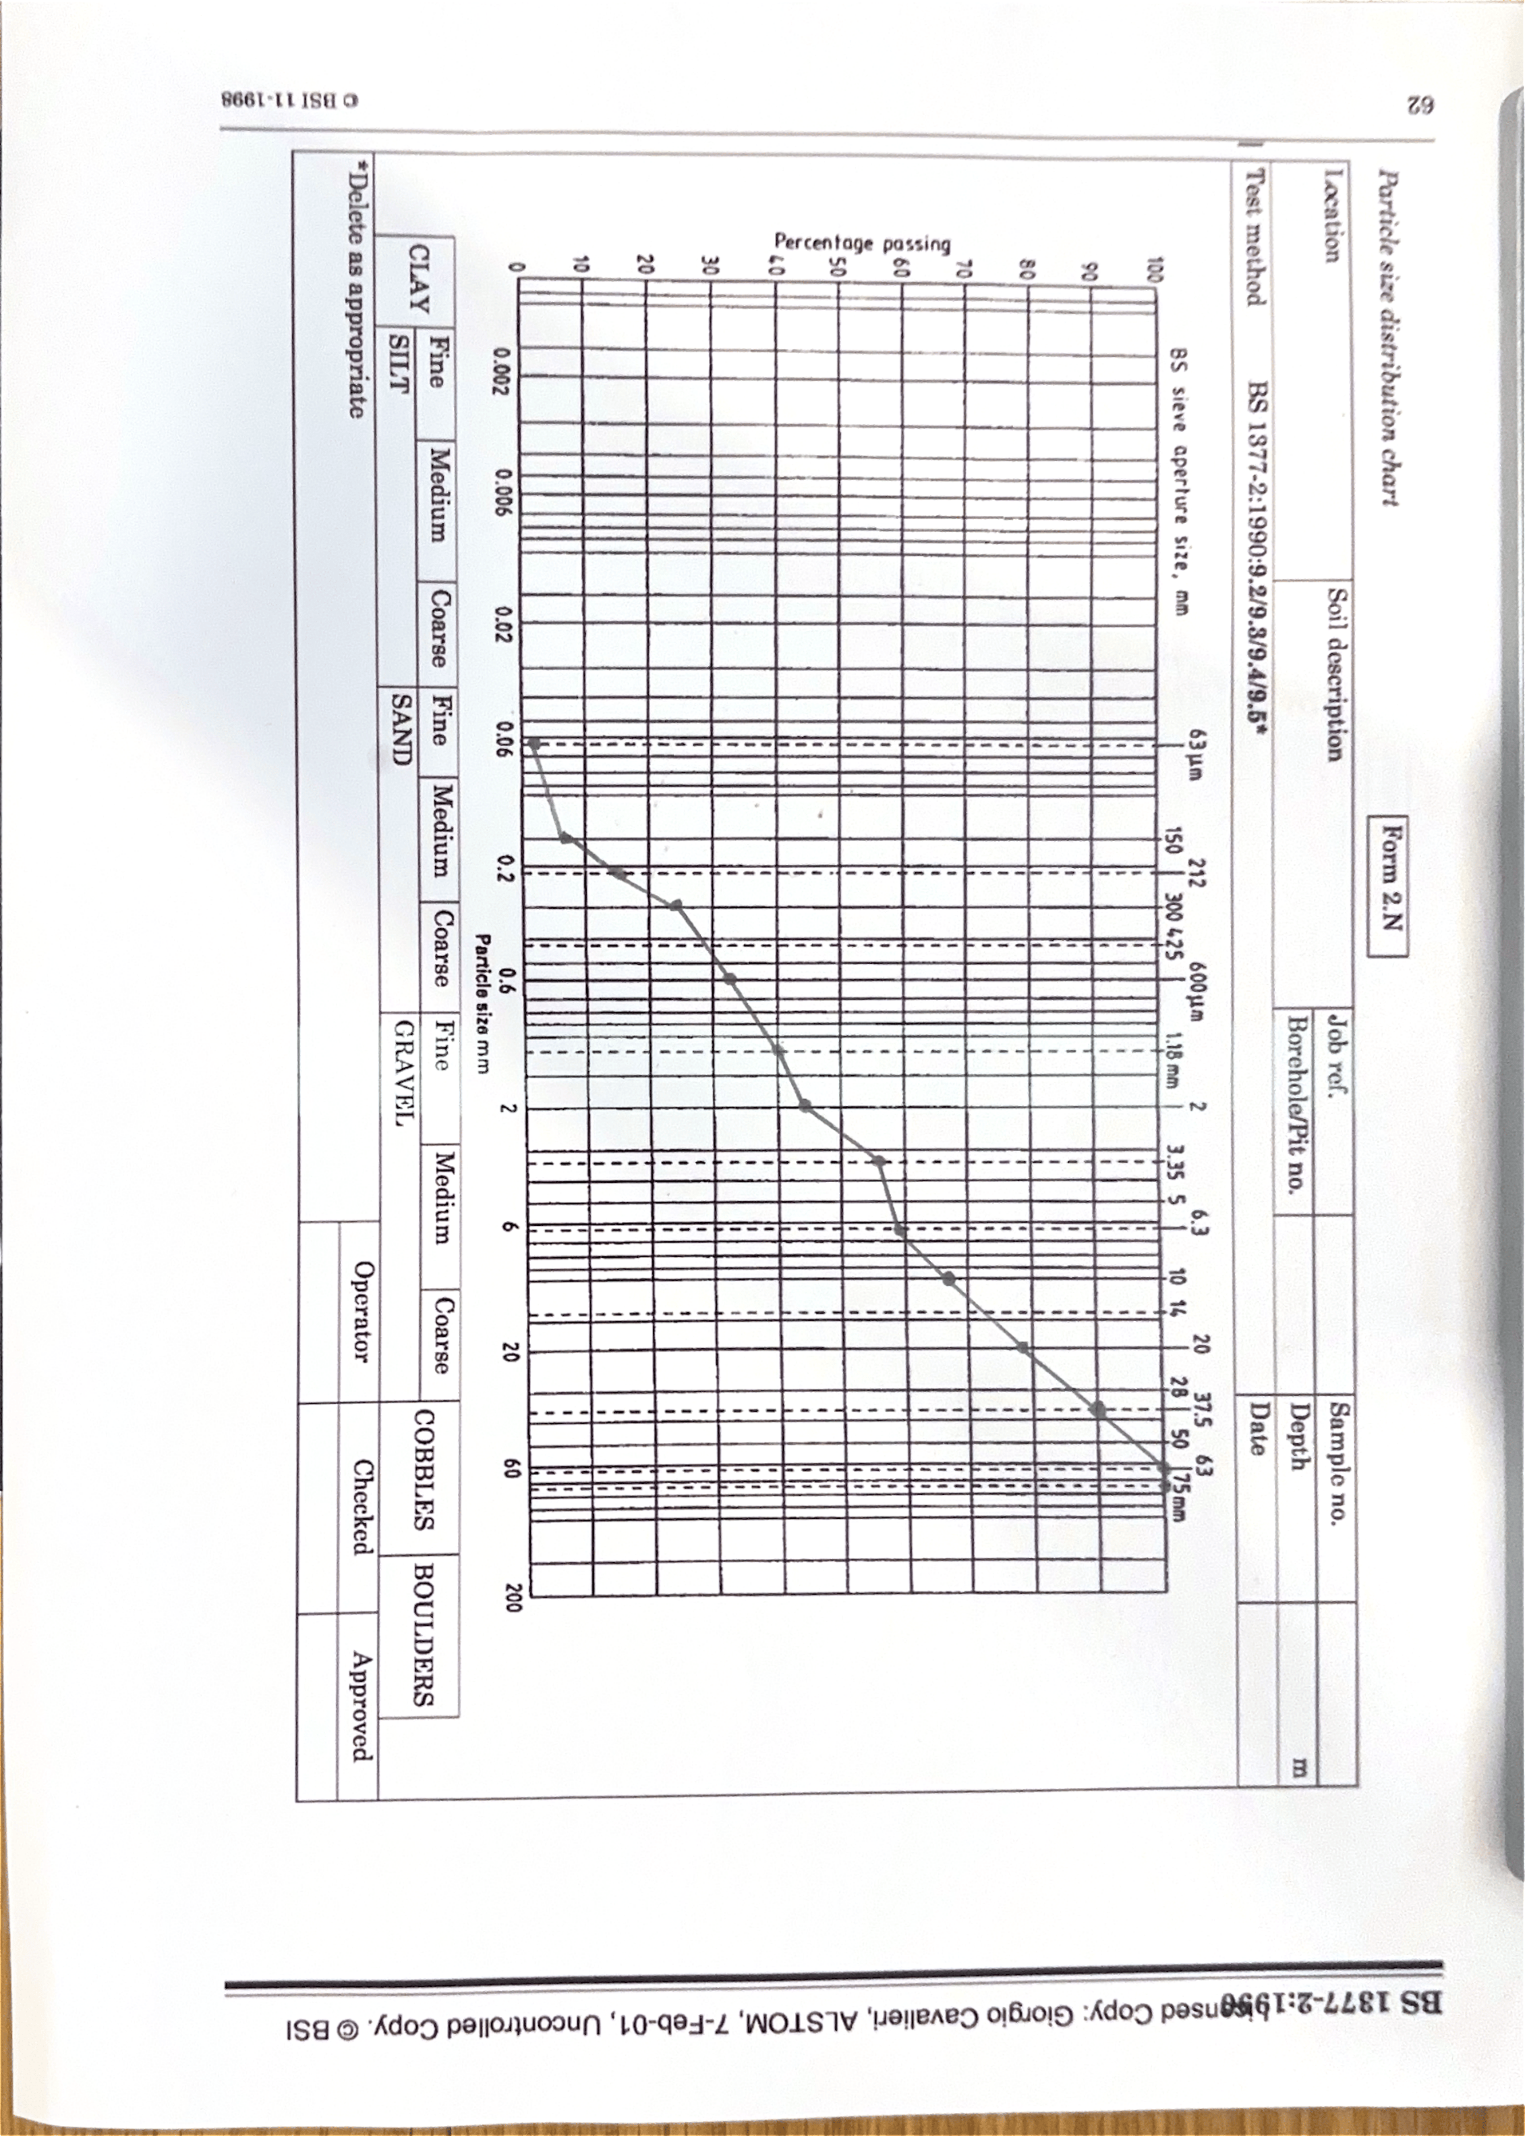

Graph Analysis
The plotted particle size distribution curve is smooth and continuous which indicates that the sample is well graded with a wide range of particle sizes and no noticeable gaps. The material ranges from approximately 0.6mm up to around 63mm, covering both sand and gravel fractions, with very little material passing through the smaller sized sieves which suggests a low fines content. This implies the aggregate has low plasticity, good drainage properties and minimal cohesion. The overall shape of the curve shows good particle size distribution which would promote effective interlocking and high strength when compacted. As a result, the sample is generally suitable for direct use as an aggregate, particularly in applications such as sub-base, general fill, or drainage layers. On the contrary, due to its low fines content, it may have limited natural binding and could require blending or adjustment if a specific grading specification is needed for more demanding uses such as concrete or asphalt.

