Define what makes a monster in Graeco-Roman mythology. What are the artistic challenges in representing these monsters?

The Oxford Dictionary defines a monster as “a large, ugly, and frightening imaginary creature” (Simpson, 1884). Now, for the most part, this definition rings true, but for examining what made a monster in Greco-Roman mythology it glosses over other important aspects that were presented in the representation of these fascinating creatures. There are many different characteristics of what makes a monster in Greco-Roman myth making it difficult to find one definition, some common denominators include being spawned or made by the gods. Whether the result of the gods consorting such as the Pegasus the offspring of Poseidon and Medusa. Or simply the result of slighting the gods such as the Lamia being a woman who enraged Hera and had her children taken resulting in madness twisting her into a creature. These characteristics, as well as many others, show the underlining meanings of these monsters feeding into the definition of a monster only highlighting the challenges that lie in representing these complex creatures. In this essay, I aim to carefully examine all of these individual aspects to answer this question.
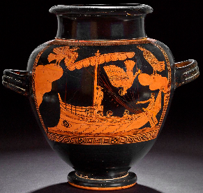
To answer the question of what made a monster in Graeco-Roman mythology we must first examine a number of monsters and from this examine the challenges in representing them. The first monster is the Siren. There are various depictions of the Siren nonetheless one appearance of these creatures is found in the Odyssey, now although this is one of the first appearances of these creatures no real description is given other than of their powers “If anyone unwarily draws in to close and hears the singing of the Sirens, his wife and children will never welcome him home again” (Homer, 2017). Homers representation of the Sirens in the Odyssey is an interesting one as they do not really fit into any of the traditional expectations of a monster but instead, their monstrous title lays in the power to bring men to their deaths with nothing but a song. Furthermore, Homer also writes about the self-destructive cycle of the sirens that were so distraught seeing Odysseus sail away they drown themselves. In addition to Homer's representation, we have Apollonius’s representation in The Argonautica. Apollonius presents a much clearer picture of the sirens “they looked in part like birds and in part like young girls” (Apollonius, 1993). This version of the siren is closer to the more traditional expectations of a monster, by introducing a hybrid creature of half bird and half woman it shares common features with other more well-known monsters, for example, the Minotaur a half man half bull creature featured in the story of Theseus. Apollonius draws upon one of the many origin stories for his representation of the sirens in which the goddess Demeter gave the once handmaidens wings to search for Persephone. The siren although not as perhaps as impressive as the other terrifying monsters that appear in Graeco-Roman mythology serves as an important example of what made a monster, the siren is a hybrid creature with a body of a bird and head of a woman placing it within the ugly and frightening categories of the Oxford dictionaries criteria. The deeper aspects of their monstrosity, however, lie in what they represent, temptation, risk and self-destruction. There are a few artistic challenges in representing these monsters one being the differentiating origin stories of these creature’s making it difficult for artists to settle on one representation author Apollodorus writes “Melpomene had by Achelous the Sirens” (Apollodorus, 1998), Melpomene originally being the muse of chorus and Achelous being the river god. However, Hyginus Gromaticus writes that after “wandering away after the rape of Persephone were made flying creatures by the will of Demeter because they had not brought help to her daughter” (Gromaticus, 2019). Gromaticus telling of the Sirens origins feeds into the self-destructive nature of the sirens shown in the Odyssey as Gromaticus writes that the sirens “would live only until someone who heard their singing would pass by” (Gromaticus, 2019). Sirens function as an interesting monster combining something familiar with something foreign expressing the primal power women have over men in a cautionary tale meant to educate Greek men.
Figure 1: Pottery (red figured stamnos0
Source from:https://www.britishmuseum.org/collection/object/G_1843-1103-31
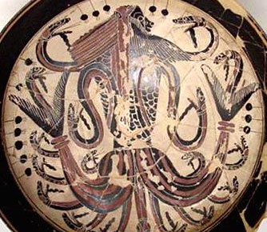
The next monster from Graeco-Roman mythology I have chosen is Typhoeus or Typhon, this monstrous creature would fit into the traditional definition of a monster in Greco mythology. Said to have been the most fearsome creature to have been created Typhon’s origins differ, with some writing of him being one of Gaea’s sons, and other’s Hera’s to spite Zeus after him birthing Athena. As with varying origins there comes varying representations one common feature that writers and artists agree on is that Typhon is represented as having one hundred snake heads which are also a feature of another monster seen in Graeco-Roman mythology known as Medusa. Writer Apollodorus describes this monster as being “Down to the thighs he was human in form, one hundred heads of serpents … such the size of Typhon he hurled red-hot rocks at the sky itself” (Apollodorus, 1998). Apollodorus’s representation of the monster Typhon focuses on more traditional descriptions of a monster in Graeco-Roman mythology, a creature of unimaginable proportions such that some representations mistake him for a giant with some representations having one hundred dragon heads instead of snakes according to writer Hyginus Gromaticus. One of the more infamous representations of Typhon is him being the father of all monsters, along with his equally as monstrous mate Echidna described as a “half-woman, half-snake creature” (GreekMythology.com, 2020). Together they spawned some of the most fearsome monsters represented in Graeco-Roman mythology including Cerebus described as a three-headed dog who guards the gates of the underworld, as well as the Chimera, said to have been part lion, goat and snake. This representation demonstrates not only the monstrous characteristics of Typhon but also places him as the father of all other monsters only solidifying his place as the most “fearsome” monster in all of Graeco-Roman mythology. In addition to this there is also the representation of Typhon challenging Zeus, both Typhon and Echidna lay siege to the gods as the writer Hesiod describes “Typhoeus, would have been master of gods and of mortals, had not the father of gods and men been sharp to perceive it” (Hesiod, 2006). Hesiod’s representation is important as Zeus prevails over monsters and in his anger imprisons them in Tartaros some writers, however, wrote that Zeus imprisoned them beneath Mt. Etna accrediting it’s volcanic nature as him trying to break free of his imprisonment, this detail is important as it has been speculated that Echidna and her children were spared to continue challenging future heroes. This detail poses the idea that the definition of a monster in Graeco-Roman mythology lies in its ability to be fought by a hero in order for them to prove their worth rather than in the qualities that they possess.
Figure 2: Laconian Black Figure
Source from: https://www.theoi.com/Gallery/M10.2.html
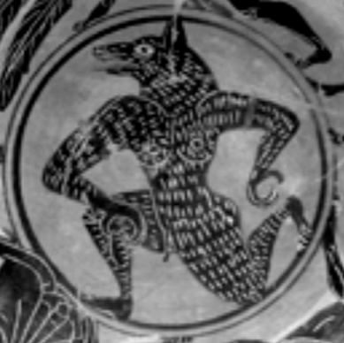
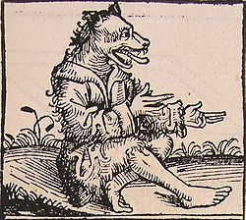
The next monster I have chosen to examine is Lykons, Lycons or more commonly known today as werewolves. Throughout Graeco-Roman mythology, there are many representations of hybrid dog men from the traditional tale of the King of Arcadia or the tales of the Greek traveller Megasthenes these representations have unique characteristics and hold different aspects for what made a monster in Graeco-Roman mythology. The first representation for this monster is the tale of King Arcadia Lycaon, like many other myths in Graeco mythology there are many different versions each presenting its own challenges, writer Pausanias “Lykaon brought a human baby to the altar of Zeus and sacrificed it, pouring out its blood upon the altar and he was changed from a man to a wolf” (Pausanias, 2012). Pausanias’s representation is interesting as it introduces the idea that if the wolf does not consume human flesh for 9 years that he could become a man again, this representation may be a warning against one of the biggest taboo’s cannibalism. However, writer Apollodorus writes the tale differently “Lykaon begat 50 sons exceeding all men in pride … Zeus came as a day labourer and was offered a bowl of a slaughtered child in disgust Zeus blasted them with a lightning bolt” (Apollodorus, 1854). This representation introduces different aspects to the definition of a monster in Graeco-Roman myth, it represents a cautionary tale for the prideful, and those who try to outsmart the gods as in some versions of the myth Lycaon was an impious king who tried to trick Zeus, furthermore, it serves as a cautionary tale to respect the ancient Greek custom of hospitality or Xenia (which Zeus is the god of). And finally, the Lycaon represents the danger of enraging the gods a characteristic seen in many other monsters in Graeco myth. This, however, is not the only instance of hybrid dog men seen in Graeco-Roman mythology, in addition to the Lycaon reports of dog-men can be traced back to late antiquity each time their characteristics change but the main representation remaining the same. More commonly referred to as Cynocephali or Kynokephalos these dog-like hybrids were said to have been a tribe of dog-headed men native to Africa and India who shared similar characteristics with that of Lycans. In his representation writer Ctesias, “Indian mountains there live men with the head of a dog, they are called by the Indians Kalystrii in Greek Kynocephaloi. They live in caved and live longer than other men 170 sometimes 200 years" (Ctesias, 1957). This representation of Cynocephali has a number of challenges the first being that this monster denotes the attitudes that the Greeks held towards people from distant places and the Cynocephali monster acting not only as a cautionary tale for travellers but also as the superiority complex the Greeks held over those they deemed as “Barbaric”. Although it is also believed that these monsters steamed from ancient travellers mistaking African Baboons as men.
Figure 3: Dancing Wolf
Source from: https://ralphhaussler.weebly.com/wolf-mythology-italy-greek-celtic-norse.html
Figure 4: A cynocephalus
Source from: https://www.ancient-origins.net/myths-legends/cynocephaly-and-mythological-dog-headed-human-002577

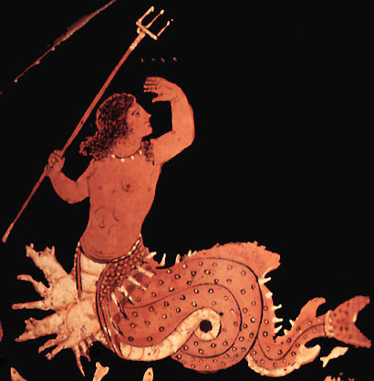
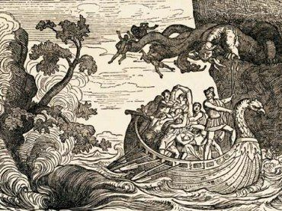
The final monster I have chosen to examine is Skylla or Scylla, said to have been one of the most fearsome sea monsters in all of Grace-Roman mythology Scylla is often represented as having both a woman’s torso and fish’s tail as well as the heads of dogs on her waist some representations, however, depict her as possessing with 12 feet and six heads on long snaky necks. As established with many monsters in Graeco-Roman mythology there are different representations each stemming from different versions of the myths, however, Virgil writes that “Scylla guards the right shore, insatiable Charybdis to the left. Her upper part is human--a girl's beautiful body down to the privates; below, she is a weird sea-monster, with dolphin's tail and a belly of wolverine sort” (Virgil, 2010). Virgil’s representation of Scylla possesses a few artistic challenges, one being that this representation could be inspired by one of Scylla’s myths being that she was originally a beautiful maiden loved by Glaucus a river god but the sorceress Circe jealous poisoned her bathing water. This representation also introduces Charybdis an equally as fearful sea monster described to have been based on a whirlpool, an interesting representation of Charybdis poses the story that as punishment for her lustful character Zeus threw her thereafter striking her. These two representations share similar characteristics in that the portrayal of women in mythology is often dangerously seductive and deceitful such portrayals only mirror the Greek patriarchal society. Another challenge that Scylla poses is the danger that Greek mariners may face venturing into unfamiliar waters. Another representation of Scylla is that in the story of Jason and The Argonauts as Ovid writes “Scylla the ravening submerged us [the Argonauts] in the deep to be devoured by her dogs--fit were it for Scylla to work woe to ingrate men!” (Murgatroyd, 2017). Ovid’s representation of Scylla holds its own artistic challenges one being that the choice between Charybdis and Scylla is meant to represent being caught between two equally unpleasant alternatives but in the tale of Jason he chooses to navigate the Planctae which was described as a group of Wandering Rocks which caused the sea to be particularly rough. Scylla is another example of a hybrid monster in Graeco-Roman myth fitting into both the more traditional definition of a monster with representations describing Scylla as 12 foot sharing the proportions as others, however, the hybrid nature being part woman, part fish, as well as the dogs on her waist, make it unique as no other monster possesses these characteristics dogs in ancient Greece were meant to represent protection often portrayed in mythology protecting things such as Cerberus guarding the gates of the underworld, as in some representations of Scylla she is depicted being one of the monsters guarding the gates of Hades.
Figure 5: Scylla, Paestan red-figure krater
Source from: https://www.theoi.com/Pontios/Skylla.html
Figure 6: Scylla and Charybdis
Source from: https://www.gettyimages.co.uk/detail/news-photo/the-perilous-trip-of-the-ship-of-ulysses-between-scylla-and-news-photo/530844208?adppopup=true

To conclude on what made a monster in Graeco-Roman mythology and the artistic challenges in representing these monsters, examining the Sirens raised the issue that not all monsters shown in Graeco mythology are represented with unimaginable proportions as Sirens challenge the traditional characteristics of a monster as their title lies in the deeper meaning of their abilities, these abilities being the artistic challenges in representing them. However, do also share similar aspects with other monsters in myth as they are hybrid creatures created by the gods. Typhon however shows the more tradition expectations of a definition of a monster being one of the biggest and most fearsome monsters in all mythology challenging even Zeus, he represents a constant reminder of not challenging the gods. The artistic challenges in representing him stem from changing mythology. Lycons share similar characteristics with Sirens in that both are hybrid creatures created by enraging the gods (depending on mythology). Their artistic challenges stem again from changing mythology as well as representing moral stories such as hubris and the dangers of cannibalism. And finally, Scylla who again shares similar characteristics with Sirens being a hybrid monster, the artistic challenges being the changing mythos as well as the deeper meaning to it being the dangers of the sea to Greek sailors. The broad denominator after individually examining these monsters lies in their ability to be useful to a hero to fight or overcome them as well as warn people about dangers through the mean of storytelling.

Bibliography
Simpson, J., 1884. Oxford English Dictionary. s.l.:Oxford University Press.
Homer, 2017. The Odyssey. s.l.:Aegitas.
Figure 1: Painter, T. S., 480-460 BC. The Siren Vase. [Art] (The British Museum).
Apollonius, 1993. The Argonautica. s.l.:OUP Oxford.
Apollodorus, 1998. The Libary of Greek Mythology. s.l.:Oxford University Press.
Gromaticus, H., 2019. Hyginus Fabulae. s.l.:Creative Media Partners .
Figure 2: (Theoi Project © Copyright 2000 - 2017 Aaron J. Atsma, Netherlands & New Zealand)
GreekMythology.com, 2020. Echidna. [Online]
Available at: https://www.greekmythology.com/Myths/Creatures/Echidna/echidna.html
[Accessed 29 05 2020].
Hesiod, 2006. Theogony. s.l.:University of Michigan Press.
Pausanias, 2012. Descriptions of Greece. s.l.:Cambridge University Press.
Figure 3: Raph Häussler (2016) Wolf & Mythology, retrieved from https://ralphhaussler.weebly.com/wolf-mythology-italy-greek-celtic-norse.html
Apollodorus, 1854. Bibliotheca. s.l.:sumptibus et typis BG Teubneri .Ctesias, 1957. Indica. s.l.:CUP Archive.
Ctesias, 1957. Indica. s.l.:CUP Archive.
Figure 4: Schedel, Hartmann. “Man, with a Dog Head,” Wikimedia Commons, 1493, commons.wikimedia.org/wiki/File:Schedel’sche_Weltchronik-Dog_head.jpg. Accessed 30 May 2020.
Figure 5: “Scylla, Paestan Red-Figure Krater.” Theoi Project ©, www.theoi.com/Pontios/Skylla.html. Accessed 31 May 2020.
Virgil, 2010. Aeneid. s.l.:A&C Black.
Murgatroyd, P., 2017. Ovid's Heroides: A New Translation and Critical Essays. s.l.:Taylor & Francis.
Figure 6: Rinhart, George. “Print of The Ship of Ulysses,” © 2020 Getty Images, 1 Jan. 1900, www.gettyimages.co.uk/detail/news-photo/the-perilous-trip-of-the-ship-of-ulysses-between-scylla-and-news-photo/530844208?adppopup=true. Accessed 31 May 2020.
‌

