Name | Student Number | Date | Lecturer’s Name | Your score
Kariol Lohore | 2441747 | 30/06/2025 |  | To be filled by the marker  ___/40
You will have 90 minutes to complete this assessment. It is divided into three sections: note-taking, paraphrasing and writing a paragraph.
---------------------------------------------------------------------------------------------------------------------
1. Take diagrammatic notes from the passage below using the space provided:

The university experience is not just about subject knowledge, but also about developing skills that will equip you for your future life. For starters, it's impossible to graduate without a range of people skills under your belt. You'll meet new people from different backgrounds. You'll also interact with lecturers, tutors and university staff almost daily. Another life lesson that university teaches you is taking responsibility for yourself, your own schedule and learning. A lot of university study is self-directed - it's up to you to plan and organise your work, juggle multiple projects and manage deadlines – you will need to develop self-motivation if you want to succeed. Let’s not forget learning how to overcome obstacles; whether academic, work-related or personal, you'll face your fair share of hurdles as a student, but you will develop resourcefulness and resilience in the process. If you were a bit unorganised before you went to university, you won't be by the time you leave. To successfully navigate student life you'll need to handle a variety of study, work, social and personal commitments and the only way to do this is with organisation and time management. Finally, university provides plenty of opportunities to work on and boost your confidence: you'll work in groups, deliver presentations, complete assessments and maybe even become a class representative.
Adapted from: https://www.prospects.ac.uk/applying-for-university/university-life/7-life-skills-youll-learn-at-university

Space for your notes (max 12 marks):
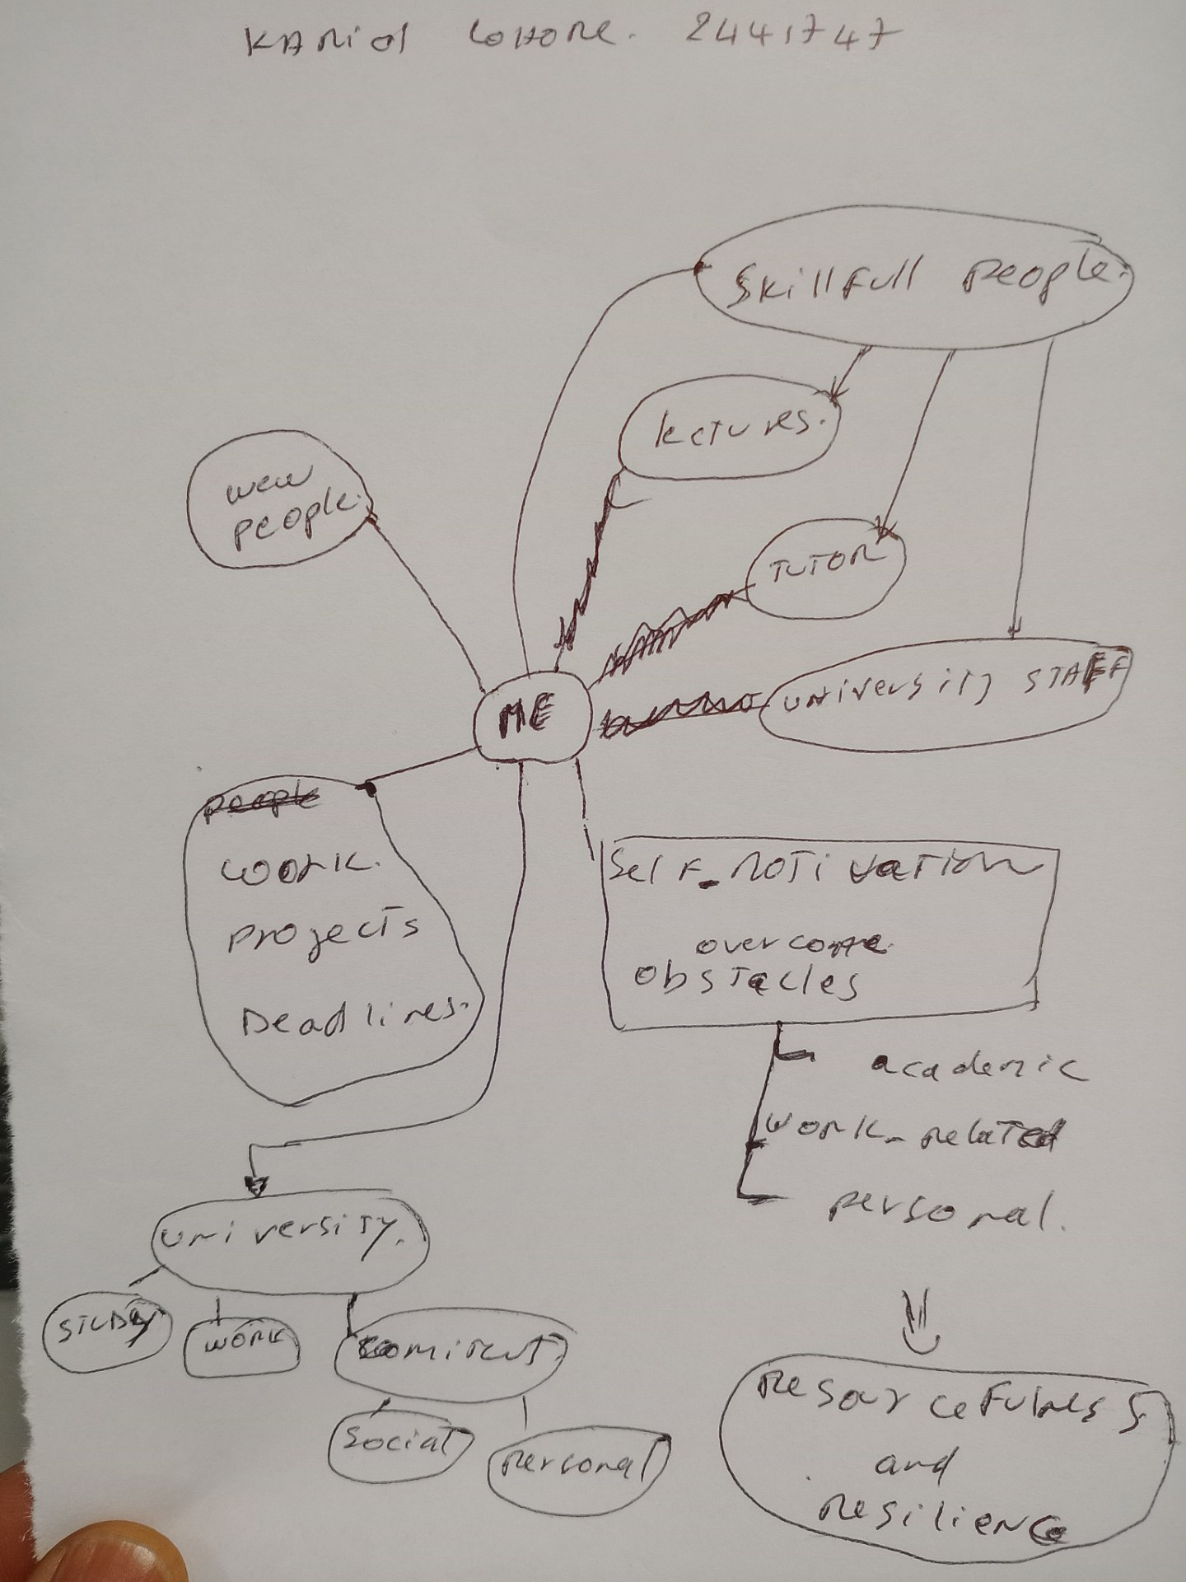

2. Paraphrase the following sentences (max 3 marks for each, max 12 marks in total):

a) To successfully navigate student life you will need to handle a variety commitments.

To effectively go though student life you will need to handle a diversity obligations.

b) You will need to develop self-motivation if you want to succeed at university.
Sel-drive is key to achive great result as student.

c) Many students find it challenging to manage stress during assessment periods.
It is demanding to handle stress throughout assessment periods.

d) Frequent reading can help you become a more effective communicator.

Repeated reading developed a further successful communicator

3. Write a well-structured paragraph (8 sentences) on the following topic:

Effective time management techniques for university students

Your paragraph must be written in full sentences (no bullet points) and in an academic style.

(max 16 marks in total)

We will start by the tasks not all of them are created equal. Some tasks are urgent and important, while others can be postponed or even eliminated. Tasks must be manageable, by break them down into smaller, actionable steps. One of the first steps in effective time management is setting clear, achievable goals and well-structured schedule. Time-blocking is a effetif technique where you assign specific time blocks for different activities. Productivity apps can help to manage time effectively like Trello, Asana, and Google Calendar allow to organize students tasks. Procrastination is a challenge for many students, that can be overcome with a right strategies. Distractions are everywhere, from social media to notifications on students phone in this digital age and must be stop for progress.

