School of Hospitality and Tourism Management

BA International Hotel Management

BMIH5004
Management and Organisational Behaviour
LEVEL 5
Module Lead: Lola Villard-Coles

Report

Student Name: Adina Cirmaciu
ID: 2233579

I confirm that I have not used any AI tools in the research and creation of this assignment. I confirm that I have not presented any AI generated materials as my own work. I confirm I have copies of my drafts, notes, and other resources I used, which I may be asked to provide in evidence

Executive Summary
The Hyatt Hotel is one of the biggest multinational hotel brands in the world. The brand is promoting wellness of the employees and the customers to provide them the best service and encourage them to perform well in the organization. At the same time the brand is building capacity to ensure betterment for future and create an example for the hospitality industry to follow. Here in the report the structure, culture, mission and vision of the Hyatt Hotel is analysed and find out their future prospect through their taken strategies. By following the pathway of the Hyatt Hotel, it is possible to bring revolution to the hospitality industry and make it grow in future for the better tomorrow.

Table of Contents
Introduction 4
Organisation Structure, Culture, and Goals 4
Corporate culture of Hyatt and its influence on operations 5
The goals of the organisation at both corporate and individual unit levels 6
Recent Change Initiatives 6
Strategic Direction 8
Recommendation 8
Conclusion 9
Reference list 10

Introduction
The hospitality industry is one of the most dynamic and growing industries of the decade. Over the time, the industry has gone through various changes and development process. Hyatt Hotels Corp (Hyatt) is one of the leading key players of the global hospitality industry. The company has many hotels, resorts, and residential properties and they also operate multiple brands in the name. The company’s hotels are usually located in high-density areas such as urban, airport, suburban, and convention and resort destinations to make it customer friendly and ensure the convenience of the target groups (Baum, 2019). Hyatt is headquartered in Chicago, Illinois, the US. The company has almost 1,335 managed, franchised, and owned properties in more than 75 countries worldwide with the large number of employee base. The report will focus to understand the relationship between structure, culture, people and organisational performance; and the nature of managerial works to ensure better and efficient performance to ensure better communication and perform the role of leadership (Baum, 2019). The report will also emphasize on evaluating the behavioural approach to management and the factors that affect differences in individual behaviour of the business.

Organisation Structure, Culture, and Goals
The hotel operates with a hybrid organizational structure combining the elements of both a functional and a divisional structure. It helps the organization to efficiently manage its diverse range of hotels and services and maintain the responsibility and accountability of the business.
At the corporate level, Hyatt hotels group employ a functional organizational structure to focus on the finance, marketing, human resources, legal, and operations, and different departments of the business. In each department there are individuals are responsible for specific tasks, functions with their areas of expertise to ensure the best service for the customers (Bohdanowicz and Zientara, 2016).
Within the divisional component, the hotel management is structured based on the brand or geographic region. Each brand unit operates as a semi-autonomous unit, under the leadership of the regional management and report their daily operations in the area. Hyatt is also geographically split into three areas: Americas, Asia Pacific, and Europe, Middle East, and Africa (EMEA), to enable their employees for providing their best efforts in those regions by fulfilling the unique wants and needs of customers which varies in different areas (Demsetz, 2020).
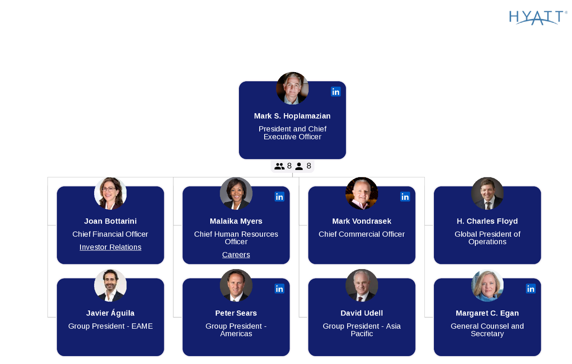
Figure: Organizational Structure (DiJulius, 2021).

Corporate culture of Hyatt and its influence on operations
Culture of Hyatt’s is focused on care, inclusivity, and integrity to promote a friendly, amicable and diverse workforce development process. It is a way to bring all the people together, by forging a powerful employer brand through growth and hospitality.
The company has some sprawling portfolio of iconic brands which are rooted under a strong vision. This connection manifests the way of treating guests and nurture their employees with care and growth to enhance their opportunity for better possibilities (DiJulius, 2021).
The core values of the business work as the foundation of everything to create a cooperative and connected workplace by making the employees feel valued, respected, and empowered to use their full potential and bring out the best outcome. Such kind of culture also influence people to betterment of the operations and ensure best services and care. The company also promote work life balance for the employees to bring better outcome of the business and provide employees with flexible work arrangements, generous leave policies, and promote employee wellness programs, prioritize their well-being and ensuring a sustainable career path for business growth process (Fevzi Okumus and Levent Altinay, 2019).

The goals of the organisation at both corporate and individual unit levels
Hyatt Hotels focuses to care for the people and bring out their best version. The company emphasizes on the growth and development of the people and increase the betterment of their services by creating an inclusive environment. The mission of the Hyatt Hotel is to provide authentic management of hospitality by creating a significant difference to focusing on secure the most preferred brand title in each segment. The company wants to achieve the number one position by creating happy and healthy environment for their guests and also dedicated to serve all the related associates, guests, and owners (Ford and Sturman, 2023). Hyatt support their mission and goal by adhering to a set of core values that characterizes their culture and promoting the best outcome for the individual business unit. The company enhance the opportunities for the corporate and individual unit by maintaining safe and secure environment for the business (Holliday and Sheffield, 2022).

Recent Change Initiatives
There are some significant initiatives are visible in the organisations to make a certain development for the business. The company has selected some core areas to work on and trying to implement significant initiatives which can bring positive results for the business organization. Such kind of recent change initiatives are mentioned below:
1. Climate change and water conservation: A healthy environment is the prime concern for all the people. Hyatt is committed to ensure better destinations around the world which are vibrant for the guests, colleagues, and communities. The company decided to ensure maximum water conservation for the drought-prone areas, focus to ensure increase the use of renewable energy and grey water. The company focuses to promote betterment of the climate change and reduce the adverse effect through their actions (Ionel, 2021).
2. Waste & Circularity: The Hyatt group is also focused to reduce waste generated at hotels, including food waste and single-use items. The hotel wants to increase recycling and composting to ensure better management of the food waste and reduce environmental pollution (Ivanova and Ivanov, 2018). The hotel is developing monitoring opportunities for source prevention, optimizing sourcing and preparation practices, modifying menu design and rethinking buffet setups to ensure efficient management and use of food.
3. Reducing wastage: Hyatt is working on preventing food waste by using training materials for the industry. Based on the training the data is collected and used for identifying and executing improvement opportunities related to purchasing ingredients, menu planning and preparations for the overall industry development (Iversen, 2018). The hotels are becoming trained and advanced with the help of efficient and dedicated employees of the business. It is a great opportunity for the business of Hyatt hotel to help the hospitality industry to promote better days ahead. The hotels are also reducing the use of single use plastics with large format bathroom amenities and adding hydration aminations which is a significant step for the hotel (Kayhan Tajeddini and Ratten, 2019).
4. Responsible Sourcing: The Hyatt hotel is also focusing on collaborating and communicating with suppliers to increase responsible sourcing of products and services in the processing of the resources. The company is concern about the changes of climate, deforestation, human rights, waste management, public health, resource scarcity, biodiversity and animal welfare for the betterment of the people and the culture of the business organization (Martinez-Martinez and Cegarra-Navarro, 2019).
Impacts of the initiatives and changes:
Hyatt was the first multinational hotel brand to work with World Wildlife Fund (WWF) on sustainable seafood and promote the business for the betterment. The brand is committed to act responsible to sourced seafood, with a focus on Marine Stewardship Council (MSC) and Aquaculture Stewardship Council (ASC) certifications which is a significant achievement for any multinational hotel brand (Olsen and Zhao, 2018).
Hyatt and Hyatt hotels are advancing responsible sourcing by increasing FSC-certified or recycled content paper products. They are also using reusable items, products made from post-consumer recycled materials which are readily recyclable or compostable items. The hotel is also serving coffee from Rainforest Alliance Certified™ farms in the U.S. and Canada. They are also working on advancing animal welfare criteria to promote better management (Olsen and Eliza Ching-Yick Tse, 2018).
They are also incorporating more environmentally sustainable practices at many of our hotels, such as installing electric vehicle charging stations in almost 170 properties, offering straws only upon request, to transform into environmentally preferable substitutes like paper. Using digital key entry solutions, reducing the need for plastic cards in maximum Hyatt hotels worldwide.

Strategic Direction
To increase the level of effective hospitality, Hyatt focused on specifically improving their strategic directions for the management department which includes innovation, sustainability and guest experience. Hyatt is constantly passing new work policies in the hope of exploration by the management authorities for reaching the point where they can offer their consumers the best stay experience in their hotels facilities. In this process, being sustainable in a necessary key feature of the strategic decisions (Otieno, 2022). As in this modern world, everyone is concerned about the environment and the impacts of global warming. Therefore, reducing environmental impacts through controlling the usage of environment harmful substants, making positive contribution and following the sustainable goals will be guidance towards achieving it. Lastly, prioritizing guest by creating a welcoming and personalized atmosphere for them which will make them fell extra special will be able to provide the management feedbacks that will guide them towards better hospitality experience (Reich, 2017).
During the recent times, Hyatt has been going through a number of issues which are now increase into critical situations with in the organizations because of poorly directed human resources management across the accommodation system in the hotels. For example, in the year 2012, housekeepers across the Hyatt corporation, accused the management board of hospitality department for their gigantic Policy over the heavy work and overtime exploitation policies depending on terms of Health and safety (Roque and Ramos, 2020). There was no mere policies or steps which has been taken to resolve the situation or managed any type of compensation for the housekeepers which raise against such policy. Furthermore, due to a press release on the polices and regulations of Hyatt’s management board, Hyatt corporation was voted and considered as the worst hospitality employer in America in 2012 (Sabourin, 2021). In addition to that Hyatt show lacking in the department of providing proper working environment to their employees as they have no proper planning for the health and safety of the hotel workers including injuries that took place during working hours. Although such policies have changed during the time that helped the hotel to improve their services and management.

Recommendation
The overall view of the Hyatt hotels should need some major and minor updates in their hospitality management system to maintain brand value and structure of implemented policies. First of all, the management board should take secure steps to ensure health and safety of the employees working day and night for the betterment of the hotel’s reputation and launch new policies which will oversee the matters of rewards based on hard work and dedication of the staffs of every branch (Teare and Olsen, 2018). Secondly, prioritizing treading matters of recent times for global marketing of the hotel which will include environmental issues, sustainable goals, effective initiative by any international organization which will boost the profitability of the Hotels overall image in front of the potential consumers. Thirdly, Hyatt should follow the famous philosophical view of the recent time which is known as leadership theories for having more accuracy in the management of hotel hospitality policies which includes their reputation. Exploring different theories as one should not be enough for providing proper solution for every situation (Walker, 2020).

Conclusion
Therefore, after an overall analysis, it is evident that maintaining proper hospitality system is very crucial for earning reputation is global market. To maintain the earned reputation becomes a tough challenge for any hotel as the demands and expectations of the consumers will be changing through the course of time. Hospitality is the key feature of a hotel industry that ensures the demand of the general people (Walker, 2020). Providing guests with the proper treatment which they hope to get by paying the hotel management is the things that maintains the reputation. Adopting throughout the time does not mean that a hotel should give up their culture and things they are famous for. Culture of the hotels maintains the tradition and adaptation through the course of time becomes as valuable contribution which ensures attraction and possibility of having new loyal customers (Olsen and Zhao, 2018). So, to conclude it can be stated that although there is a long line of list which can ruin the reputation of hotel through not having proper hospitality management system but there are number of philosophical theories and strategies depending on which it can be resolve through proper hospitality management system.

Reference list
Baum, T. (2019). Hospitality management. 3 The management of people and service in hospitaliy. Los Angeles, Calif. Sage Publ. Ltd.
Bohdanowicz, P. and Zientara, P. (2016). Hotel companies’ contribution to improving the quality of life of local communities and the well-being of their employees. Tourism and Hospitality Research, 9(2), pp.147–158.
Demsetz, H. (2020). Industry Structure, Market Rivalry, and Public Policy. The Journal of Law and Economics, 16(1), pp.1–9.
DiJulius, J.R. (2021). What’s the secret? : to providing a world-class customer experience. Hoboken, N.J.: Wiley.
Fevzi Okumus and Levent Altinay (2019). Strategic Management in the International Hospitality and Tourism Industry. Routledge.
Ford, R.C. and Sturman, M.C. (2023). Managing Hospitality Organizations. SAGE Publications.
Holliday, S.J. and Sheffield (2022). Hospitality management. Sheffield: Sheffield Hallam University, School Of Leisure And Food Management.
Ionel, M. (2021). Accommodation Service and its Importance in the Hospitality Sector. Ovidius University Annals Economic Sciences Series, 21(1), pp.319–323.
Ivanova, M. and Ivanov, S. (2018). The Routledge Handbook of Hotel Chain Management. Routledge.
Iversen, P.L. (2018). Molecular basis of resilience : adapting to a changing environment. Cham, Switzerland: Springer.
Kayhan Tajeddini and Ratten, V. (2019). Tourism, Hospitality and Digital Transformation. Routledge.
Martinez-Martinez, A. and Cegarra-Navarro, J.-G. (2019). Knowledge agents as drivers of environmental sustainability and business performance in the hospitality sector. Tourism Management, 70(1), pp.381–389.
Olsen, M. and Zhao, J. (2018). Handbook of Hospitality Strategic Management. Routledge.
Olsen, M.D. and Eliza Ching-Yick Tse (2018). Strategic management in the hospitality industry. New York: J. Wiley.
Otieno, F. (2022). Principles of Hospitality Management.
Reich, A.Z. (2017). Marketing management for the hospitality industry : a strategic approach. Chichester: Wiley.
Roque, H.C. and Ramos, M. (2020). The importance of cultural training in the hospitality sector. European Journal of Tourism, Hospitality and Recreation, 9(2), pp.58–67.
Sabourin, V. (2021). Strategic Management for the Hospitality and Tourism Industry. CRC Press.
Teare, R. and Olsen, M.D. (2018). International Hospitality Management. John Wiley & Sons.
Walker, J.R. (2020). Introduction to hospitality management. Boston: Pearson.

