

Strategic Analysis of the 2025 M&S and Co-op Cyber Incidents and Red-Team Penetration Testing of a Virtualised ABCD Ltd Environment

MSc Cybersecurity and Digital Forensics
ACCA7033
Ethical Hacking
[Lecturer: Dr. Dipo Dunsin]
Komal Nakum
2537633

Abstract
This report provides strategic analysis of cyber-threats and a controlled red-team assessment to be integrated. Task 1 looks at the events of the 2025 cyber incidents that occurred at both Marks & Spencer AND The Co-operative Group, reconstructing the timeline, mapping adversary behaviours to the MITRE ATT&CK, identifying the root cause(s) of the incidents, understanding if these incidents were carried out by Marks & Spencer's or The Co-operative Group's adversaries, Scattered Spider and Octo Tempest, and prioritising remediation work. The analysis ultimately shows that shortfalls in software alone were not as significant as problems with identity recovery, help-desk verification, privilege separation or split telemetry. In Task 2, you will consider ABCD Ltd's simulated retail environment in authorised penetration testing. The exercise also verified remote root compromise of Metasploitable 2 via VSFTPD 2.3.4 and failed to exploit Windows XP for MS08-067, and showed authenticated Active Directory share write via LAB\Komal. Together, these results demonstrate a greater likelihood of operational, confidentiality, and lateral-movement risks with legacy systems, overtrust, weak segmentation, insecure file sharing and lack of monitoring. The key capabilities apportioned to priority controls are phishing resistant authentication, least privilege, segmentation, centralised logging and validated recovery.

Table of Contents
Abstract 2
Task 1- Strategic Threat Analysis of the 2025 M&S and Co-op UK Retail Cyberattacks 4
1. Introduction 4
2. Research Method and Evidence Base 4
3. Incident Summary and Timeline 4
4. Adversary TTP Mapping 6
5. Root Causes and Security Control Failures 8
6. Threat Actor Profile and Motive 9
7. Detection and Incident Response Analysis 9
8. Strategic Recommendations 10
9. Conclusion 11
Task 2: Red Team Engagement: ABCD Ltd 12
1. Introduction 12
2. Scope, Rules of Engagement and Success Criteria 12
3. Methodology and Threat Emulation 13
4. Laboratory Architecture and Safety 13
5. Reconnaissance and Attack-Surface Analysis 14
6. Exploit 1: Metasploitable 2 14
7. Exploit 2: Windows XP 15
8. Exploit 3: Authenticated SMB Share Exposure 16
9. Detection and Forensic Gap Analysis 18
10. Risk Evaluation and Recommendations 19
11. Limitations and Required Retesting 21
12. Conclusion 21
References 21
Task 1- Appendix 23
Task 2- Appendix 26

Task 1- Strategic Threat Analysis of the 2025 M&S and Co-op UK Retail Cyberattacks

1. Introduction
The April 2025 incidents demonstrate how cyber risk can escalate into an enterprise-resilience crisis. M&S has said it was dealing with a cyber incident [1] that caused disruption to its online services without keeping stores closed on 22 April. Three days later, it stopped accepting website and application orders due to precautionary reasons [2]. Attacks were then confirmed to have copied member data, and there were reported access restrictions that meant that some data wasn't exposed [5]. The results extended beyond information technology and included impacting on customer trust, as well as supply operations and revenue.
This report reviews the incidents as a whole where there have been some commonalities in timing, targets, and tradecraft but none as direct as an association. The goals are to mimic the campaign's execution and identify at least ten potential TTPs, along with proximate and systemic causes, detection and response, and risk-prioritised controls. Any and all technical assumptions are identified as having a level of confidence since the consequences provided in the corporate disclosures are easier to identify than the forensic detail.

2. Research Method and Evidence Base
Triangulation is achieved across corporate announcements, NCSC guidance, NCA reporting and government/vendor threat intelligence. authorized impact statements from corporate sources either lack or leave out sensitive investigative detail. NCSC and NCA material should contain a national context but does not substantiate all the technical points. CISA and Microsoft reporting is not actual proof of the victims reported by Scattered Spider or Octo Tempest, but rather established behaviours of these parties. Therefore, evidence is categorized as confirmed, strongly supported and inferred evidence. Where unsupported malware, persistence or exploitation claims are listed, it was done to a defensible degree based on the facts of the incidents and recognised actor's tradecraft.

3. Incident Summary and Timeline
On 22 April, M&S made the first disclosure to the market about a cyber incident under-going management and the impact on some contactless payment and click and collect processes [1]. On 25 April, M&S put measures in place to prevent M&S from taking any orders on their website or for their mobile app [2]. The ruling took away a significant source of revenue and illustrated the implications for operations of separating out susceptible digital services. M&S had previously stated the incident was highly sophisticated, they identified that there will be ongoing disruption on the Internet up until July and had put an estimated £300 Million on the operating profit loss in 2025/26 before mitigation [3]. This transforms cyber impact into a tangible strategic loss—a loss of sales, stock management, recovery cost and lost transformation.
Malicious parties gained access to one of those systems and retrieved members' names, addresses, email addresses, telephone numbers and dates of birth, but not passwords, payment information or transaction information, Co-op reported. Closures of the system reduced others' access, which also had an impact on internal operations. In a press release on 1 May, the NCSC mentioned it had helped impacted retailers [6]. It said explicitly on 4 May that it had not yet drawn links between the attacks, yet the media had been speculating about how to link the attacks to the now-infamous Scattered Spider and helpdesk manipulation [7]. On 10th July, four individuals were arrested for attacks on M&S, Co-op and Harrods, which further supported the tenet of an attack campaign rather than specific attribution [8].
Table 1. Evidence based incident timeline
Date | Organisation | Confirmed event | Strategic significance
22 April 2025 | M&S | Incident disclosed; stores remained open while selected services were disrupted [1]. | Public acknowledgement established operational impact and active containment.
25 April 2025 | M&S | Website and application ordering paused as a protective measure [2]. | Containment directly removed a major revenue channel.
1 May 2025 | NCSC | National support for affected retailers was publicly confirmed [6]. | The incidents reached sector and national resilience significance.
21 May 2025 | M&S | Estimated operating profit impact reached approximately £300 million [3]. | Cyber loss became financially material at board level.
10 July 2025 | NCA | Four suspects were arrested concerning M&S, Co-op and Harrods [8]. | Common investigation strengthened, but did not prove, campaign linkage.
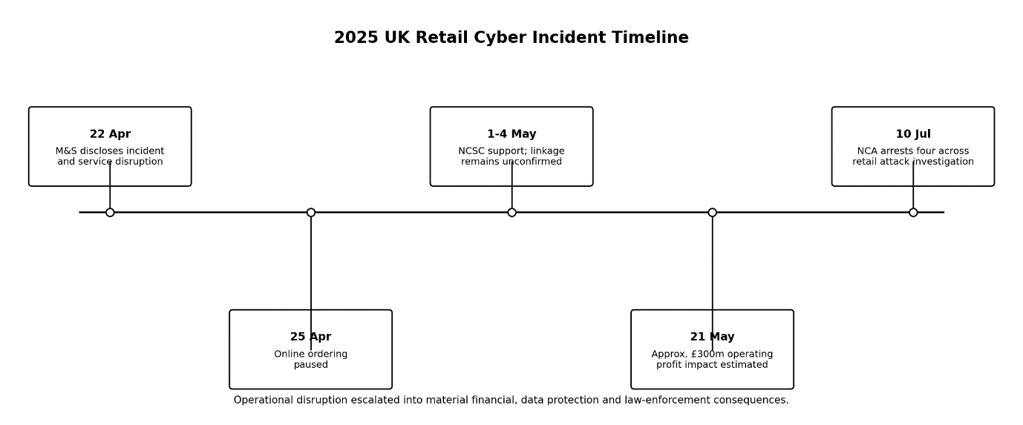
Figure 1 Chronology and escalating business consequences of the retail campaign.

4. Adversary TTP Mapping
While some victim disclosure will be made public, the ATT&CK mapping will need to differentiate between what was observed by the victim and what was hypothesized based on government and vendor profiles of the Scattered Spider and Octo Tempest. Therefore, historical actor behaviour is not used for statistics on techniques that have been supported by observations in the past, but rather, are assigned as medium to low confidence rather than as confirmed incident activity. A plausible initial-access hypothesis is service-desk social engineering. Octo Tempest: Researchers study employees, impersonate users and dupe helpdesk by resetting passwords or enrollment new MFA factors. [10] This is used to support Phishing: Spearphishing Voice, T1566.004, and Valid Accounts, T1078, as likely methods, as well as summarizes the collection of personal information as preparation, Gather Victim Identity Information, T1589. If a reset has taken place and an additional authentication method or privilege is added by the attacker, this will be considered to meet the definition of Account Manipulation: Additional Cloud Roles, T1098.003.
If successful, the discovery of Account Discovery, T1087, and Permission Groups Discovery, T1069, would find valuable identities. Cloud Infrastructure Discovery (T1580) and Network Service Discovery (T1046) match with actor documentation of environment enrichment of hybrid enclosures. Low-friction lateral movement and persistence with blending to administrative activity are provided by Remote Services, T1021 and Remote Access Software, T1219. Access to corporate document stores is provided based on Data from Information Repositories, T1213, and Data from Cloud Storage, T1530, is a documentation of the group’s collecting habits, as established. T1567 - Exfiltration Over Web Service - enables transfer via the use of Web Services or a Web hosting/storeroom provider. Data Encrypted for Impact – not publicly confirmed for either victim; T1486 is actor-consistent, but should be viewed as observed campaign context, not as an observed technique.
The mapping exhibits a control-path issue. While the attacker may well have a new attack, all the security components of identity restoration do not need to be there to supply secure credentials, the tools don't need to be new but must be legitimate, and the permissions in the cloud must expose the data at a scale. Therefore, technique confidence should also influence the design of Detection Engineering – high-confidence identity events, trigger rules immediately, while low-confidence identity ransomware guesses should be prepared, but shouldn't alter the facts.
Table 2. MITRE ATT&CK campaign mapping
Technique | ID | Confidence | Campaign relevance
Spearphishing Voice | T1566.004 | Medium | Helpdesk impersonation provides probable initial access.
Valid Accounts | T1078 | High | Reset credentials make malicious access appear legitimate.
Gather Victim Identity Information | T1589 | Medium | Personal research strengthens employee impersonation.
Account Manipulation | T1098 | Medium | New factors or roles sustain access.
Account Discovery | T1087 | Medium | Directory enumeration identifies privileged targets.
Permission Groups Discovery | T1069 | Medium | Role mapping exposes escalation paths.
Cloud Infrastructure Discovery | T1580 | Medium | Hybrid resource enumeration expands attack scope.
Remote Access Software | T1219 | Medium | Legitimate tools support covert control.
Data from Information Repositories | T1213 | Medium | Repositories provide business and identity intelligence.
Exfiltration Over Web Service | T1567 | Medium | Trusted cloud services can conceal extraction.

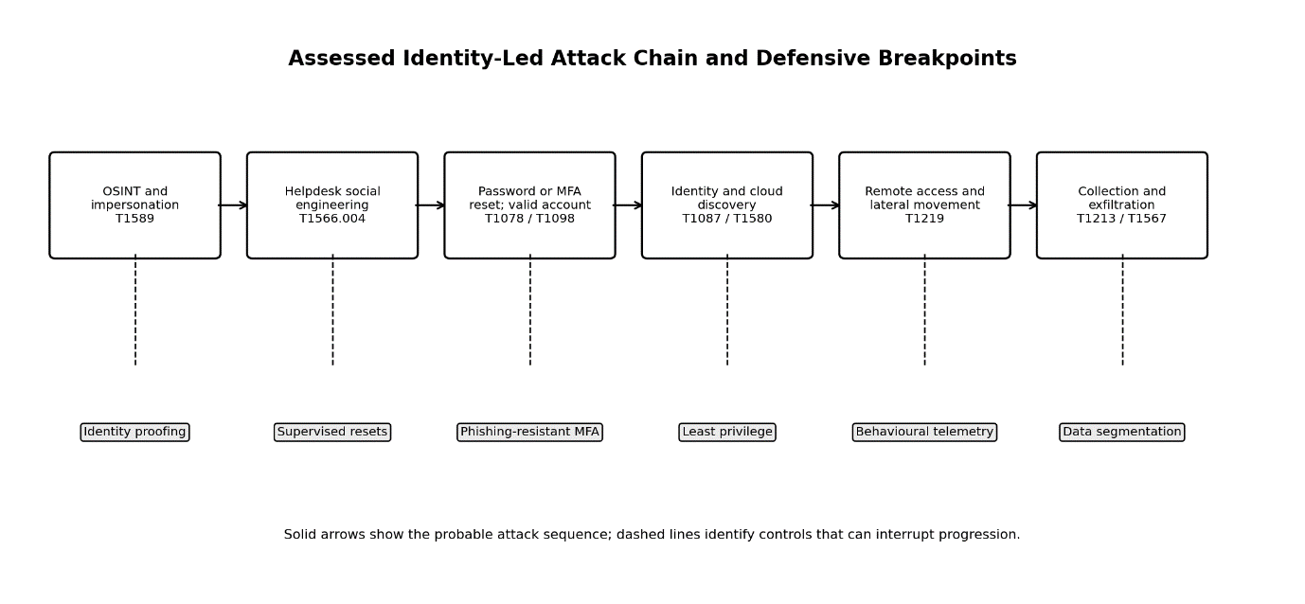
Figure 2 Assessed identity led attack chain and principal control breakpoints.

5. Root Causes and Security Control Failures
The likely immediate cause was the misuse of identity recovery, instead of exploiting a software vulnerability revealed. With regards to resetting passwords or MFA, NCSC guidance specifically advised right retailers to verify user identities prior to resetting passwords or MFA, especially for elevated accounts [7]. A knowledge-based reset, through questions and/or caller knowledge and/or easily researched personal data makes the help desk an authentication bypass. By this time, MFA fails to provide protection, as the foe has become a legitimate factor-holder.
Technical failures that contributed included too much standing privilege in the system, the combination of service-desk and high-value administrative user accounts being too close together, failing to monitor conditional access controls, and not properly identifying the changes in accounts followed by unusual activity. If each individual log event wasn't linked to its identity, endpoint, VPN, cloud or data-access, then each could look like it's legitimate. Even though co-op has limited their ability to open systems, it actually seems they have been able to copy the data associated with members to a certain extent indicating some containment ability but not enough to get the information that was accessible to be copied by successful attackers [4].
The systemic cause is governance focused on perimeter protect, and treating it as control of trusted identities. Dropped prices and availability of retail force wide administration access, speedy resets and linked platforms. It is the blast radius that is formed by those design decisions. To prove this, M&S estimate the cost of resilience architecture, resilience recovery, and digital-channel dependence as a £300m finance risk, not the technical debt [3].

6. Threat Actor Profile and Motive
The most likely public identification for the spider is Scattered Spider. The NCSC admitted speculation, and was aware of the group's past social engineering actions on the helpdesk front without yet being able to establish any connection between the retail incidents [7]. The NCA arrests reveal an investigation that apparently shows a link between the three retailers and organised crime; however, no evidence was cited that proved attribution or guilt [8].
CISA describes Scattered Spider as financially motivated, real accounts, discovery in the cloud, access through Remote Access Software (RAS), Data Theft and Ransomware actor with techniques of Social Engineering [9]. Operators, who are native English speakers, SIM swapping, adversary-in-the-middle phishing, and aggressive extortion form overlapping areas that Microsoft describes as Octo Tempest for its native English-speaking operators [10]. This represents a behavioural alignment of the attribution, which is of medium confidence. There was a strong temptation by both parties to profit from the theft, exortion or even encryption of the data—and for the attacker, leverage for operational disruption. Financial gain appears more likely than espionage as spies are chosen, their behaviours studied and good business noted.

7. Detection and Incident Response Analysis
The incidents reveal the typical vulnerability: one-way controls are designed to protect against malware but not an advanced attack via the network using legitimate credentials and proper administrative pathways. Anomalous behaviours in the helpdesk resets, rapid MFA re-registration, privileged sign-in from residential VPN ranges, new device enrollment, mass directory queries, remote management installation and abnormal access of member or customer repositories were examples of high-dollar detections that should have been included. NCSC suggestions to keep an eye on risky logons and scrutinize activity of Domain, Enterprise and Cloud Administrator ensure that Identity Telemetry is a strong defence [7].
These decisions included suspending online ordering and segregating internal systems, both of which required significant operational expense, as well as vulnerability to business interruption. Suspension of online ordering and isolation of internal systems are decisions for decisive containment, but with significant operational cost and vulnerabilities to business interruption. Cross-channel resilience is all but absent, while M&S kept stores open. While stores remained open in M&S, its stores were weak in its channel resilience, as prolonged disruption online reveals. An important benefit of the data-separation in co-op was limiting the sensitivity of exposed information - passwords and payment records were not part of the exposed system [5].
So overall response effectiveness was a mixed picture; a good aspect was “decisive containment”, a weak aspect was “late visibility of ID misuse”, another was “broad operational coupling” and a third was “longer times to recovery”. A fully developed response model would streamline out-of-band communications instead, and pre-authorize isolation decisions and gather forensic identity logs prior to withdrawal of access.

8. Strategic Recommendations
First, both retailers should shore up the use of resettable MFA by privileged users with phishing-resistant FIDO2 credentials and demand supervised, out-of-band verification prior to password or factor changes. The measure of success is to have zero privileged resets completed by telephony, and quarterly adversarial testing. Second, any administrator accounts need to have standing rights removed and privileges elevated for limited periods of time, and helpdesk privileges shouldn't be able to change top-level accounts. This programme is of medium impact and costs.
Third, ensure that security activities are correlated with helpdesk tickets, identity-provider changes, VPN origin, enrolment of the devices, endpoint activity, and cloud data accessed. Priority analytics should identify reset, followed by an unknown sign-in, privilege changes, repository enumeration, and/or bulk export. Fourth, there must be network and identity segmentation of retail operations, eCommerce, member data, security tooling and backup administration. Do not rely on a review of configurations to validate segmentation, but rely instead on attack-path testing to validate segmentation.
Fifth, there must be mock disaster operations for critical digital services; calls for identifiability compromises and recovery plans must be non-trivially considered, and necessary backups must be unreceptive. Last but not least, boards should monitor enterprise risk indicators such as identity attack paths and mean time to contain and service recovery objectives. The NCSC recommended a strategy between prevention and recovery, detection, containment and recovery, which has been an appropriate strategic approach [7].
Table 3. Prioritised strategic controls
Control | Priority | Effort | Expected effect
FIDO2 privileged authentication and supervised resets | Critical | Medium | Blocks password and MFA reset abuse.
Time limited privileged access management | Critical | High | Reduces standing privilege and lateral reach.
Identity, endpoint and cloud telemetry correlation | High | Medium | Detects legitimate account misuse earlier.
Service and data segmentation | High | High | Contains compromise and preserves operations.
Immutable recovery and executive exercises | High | Medium | Accelerates restoration and decision making.

9. Conclusion
The M&S and Co-op incidents were much more than just a problem with their websites – they were a challenge to identity governance and organisational resilience. Indications point to a campaign of related, financially driven activity, and intermediate levels of confidence for Scattered Spider tradecraft, but not towards definitive attribution. The main problem is probably the secure translation of social engineering into trusted access, coupled with poor and unchecked privilege and data access. Minor damage was mitigated with containment, but at high-cost operations. Some of the key factors that retailers should consider are phishing resistant identity recovery, privilege separation, integrated behavioural telemetry, segmented services and rehearsed recovery. These controls are not only directed against the symptoms of the attack, but also against the path of the attack that was observed in this campaign.

Task 2: Red Team Engagement:
ABCD Ltd

1. Introduction
This report analyses an authorised penetration test, against a virtualised ABCD Ltd environment consisting of Kali Linux, Metasploitable 2, Windows XP and a Windows Server domain controller. The aim being to determine if there is scope for an external operator to detect vulnerable services and gain access and valuable information on the internal system without doing any damage and retaining evidence. Today, penetration testing should include not only technical validation, but also repeatable methodology and risk communication, and not be equated with scanner results to a compromise [19]. The report distinguishes confirmed exploitation from failed execution and authenticated enumeration, failure to execute it, authenticated enumerations and exposure of shares. This is important because the provided screenshots showed a successful attack on one remote shell and one imposed limitation on the access-control, whereas the Windows XP attack had failed.

2. Scope, Rules of Engagement and Success Criteria
Testing was restricted to the private 192.168.37.0/24 laboratory, and virtual machines named prior to the test: name0, name1, name2 and name3. Host discovery, version identification, controlled execution of Metasploit, SMB and RPC interrogation were allowed, as were sanitised images of the screen. Denial-of-service, persistence, destructive modification, real personal data and attacks against external infrastructure were omitted. A kill condition for any test that caused an unstable VM or excessive traffic out of scope required a test to be stopped. The intended success criterion is to be three separate tasks to compromise, later proof of identity, privilege and business impact. Research into penetration-taxonomy has shown justifiable separation of research steps, including planning, discovery, exploitation, post-exploitation, and reporting phase [20]. The proof fulfilled discovery conditions and exposed a Linux compromise along with exposed, authenticated shares, but yet it failed to produce to the end goal of the three exploits.
Table 1. In-scope virtual assets and observed attack surface.
Asset | Address | Role | Observed exposure
Kali Linux | 192.168.37.129 | Authorised red-team workstation | Nmap, Metasploit, smbclient, rpcclient
Metasploitable 2 | 192.168.37.130 | Legacy Linux service host | FTP, SSH, Telnet, Samba, databases, VNC
Windows XP | 192.168.37.131 | Unsupported corporate client | RPC, NetBIOS, SMB
Windows Server 2022 | 192.168.37.132 | LAB domain controller | DNS, Kerberos, LDAP, SMB, WinRM

3. Methodology and Threat Emulation
The use of threat information was followed in the engagement, beginning with defining scope, discovering a host, enumerating services, researching a plausible attack path, running controlled attacks, collecting results, and analysing defensive visibility. MITRE ATT&CK does not purport to imply threats or threat-actor attribution but rather descriptions of behaviour. ATT&CK techniques provide a way to consistently map the various ways to perform scanning, valid account usage, command execution, remote-service exploitation, and domain/account discovery in order to achieve tactical goals [11]. The MITRE centre for Threat-Informed Defence (CTID) suggests repeating the emulation and testing the defenders whether they gather the appropriate data, and if they detect specific techniques [12]. Therefore, the test used observations rather than "stealth claims". A command-and-control arrangement, or an evasion method, or a persistence mechanism was not demonstrated; no such were reported as completed.
Metasploit was able to replicate testings, but created notable traffic. Realistic pivoting was avoided by directly scanning a flat subnet and supplied domain credentials evaluated authorisation boundaries rather than credential acquisition. These restrictions limit the use of claims of adversary-emulation.

4. Laboratory Architecture and Safety
Kali Linux used 192.168.37.129; Metasploitable 2 used .130; Windows XP used .131; and the domain controller used .132. The targets were all accessible directly on one subnet, and reconnaissance did not involve pivoting. There was no pivoting needed, and targets were all accessible directly on one subnet, thus a flat architecture was the reality. This setup is good for teaching but is not a defensible Internet facing Trust zone-Client Trust Zone-Identity Services arrangement as all are located in one trust zone. CISA's Zero Trust Maturity Model requires access decisions to be network-location granular, identity-aware, and continually evaluated instead of relying on network location [16]. Note that the other thing that is clearly bad in this thesis is that it displays a gateway of 192.168.37.2, which corresponds to what VMware NAT does. Host-only isolation, snapshots, and rollback are not guaranteed to be present in the package supplied. These controls should be taken prior to submission.
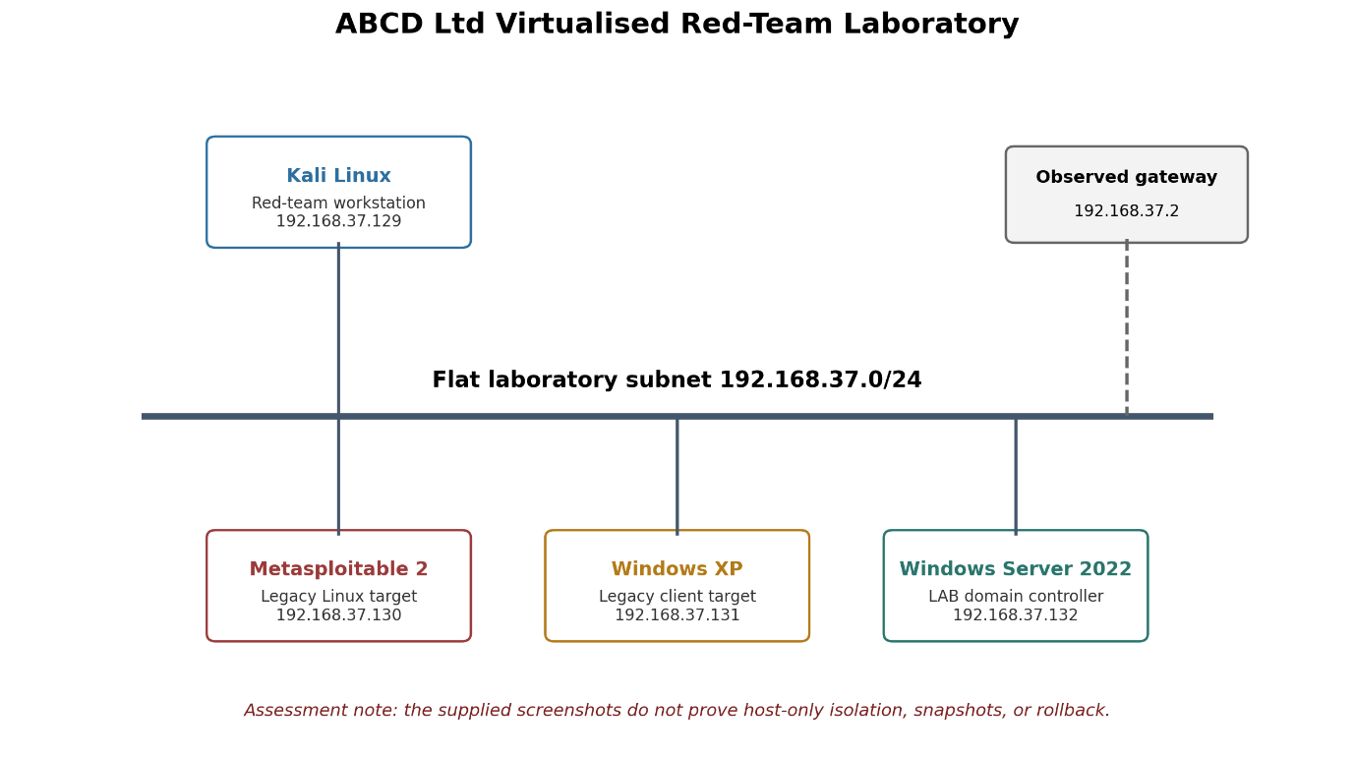
Figure 3 Network and virtual-machine configuration used for the ABCD Ltd penetration-testing laboratory.

5. Reconnaissance and Attack-Surface Analysis
ICMP test was able to reach all three targets individually. Numerous old services were exposed in Metasploitable 2 such as FTP, Telnet, Samba, databases, VNC, and application servers which were found by nmap. Windows XP has opened up ports 135, 139, and 445 for RPC, NetBIOS, and SMB. The services exposed by the server included domain-controller related services, such as DNS, Kerberos, LDAP, services related to Global Catalog, RPC over HTTP, and WinRM, which validated its domain-controller role. The attack-surface decision was based on known remote command-execution paths in VSFTPD 2.3.4, the apparent vulnerability of Windows XP to MS08-067, and the presence of authenticated SMB and RPC discovery in the domain controller. The 2025 categories, along with the scope of the causes, are provided by OWASP which define them as security misconfiguration, authentication failure, broken access control and logging failure [13]. However, a product version, open port or visible share is not indicative of a product being vulnerable to an exploit, so they were all evaluated individually [17].

6. Exploit 1: Metasploitable 2
Metasploitable 2 is found to have VSFTPD (version 2.3.4) running on TCP port 21. Nmap scans have revealed that VSFTPD/2.3.4 is listening on TCP port 21 on Metasploitable 2. The module, called vsftpd_234_backdoor modifies the daemon to accept commands and returns back the same login details as in the original login as UID=0(root) and GID=0(root), and launches the command Shell session 1 on the compromised Daemon. So, the Exploit 1 has already been completed and it worked as desired without any authentication, and with the full root privileges. It satisfies the activities of Network Service Discovery (T1046), Exploitation of Remote Services (T1210), and Unix Shell (T1059.004). This compromise is the consequence of exposing outdated and backdoored FTP service with no segmentation, no patching and no compensating monitoring controls. The session is closed off at the end of the session, but the command is still accepted by the session, as the console output indicates. The outcome translates to total compromise of the Linux target, and shows the dire harm of keeping the vulnerable legacy services inside an accessible network zone.
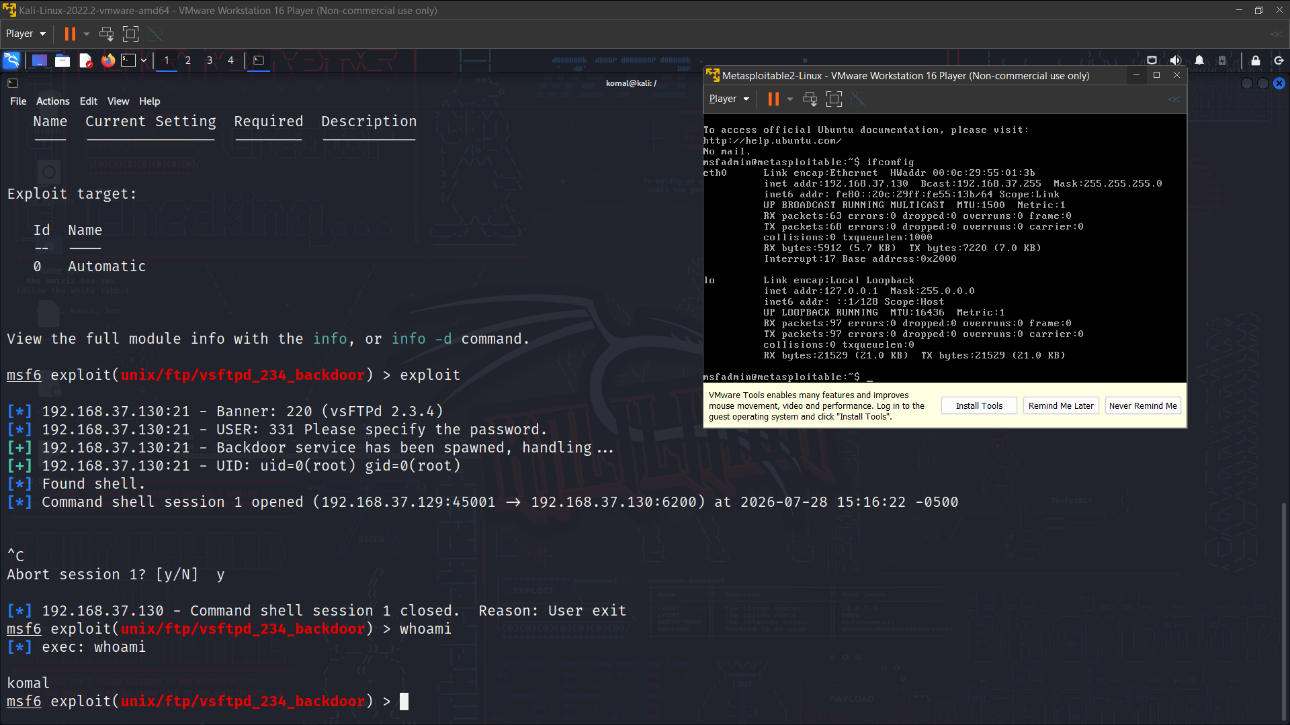
Figure 4 Successful exploitation of VSFTPD 2.3.4 on Metasploitable 2 using the vsftpd_234_backdoor module, returning a root-level shell.

7. Exploit 2: Windows XP
This second exercise used the MS08-067 NetAPI Metasploit module to test the Windows XP SMB service. After reconnaissance, the operator chose to find TCP ports 135, 139, and 445, before selecting the Windows XP SP3 target profiles, and setting the `RHOSTS`, `LHOST`, and specifying a reverse TCP Meterpreter payload. The exploit was executed on the authorized target beginning with the discovery, selection of the module, configuration of the payload, selection and execution of the target. Metasploit tried to exploit the vulnerability, but reported no remote session created. The exercise to exploit the system in practice was therefore dismissed, though a successful hack of the operating system is not explicitly shown by the screenshots found for analysis. Activity would be Exploitation of Remote Services (T1210) as the executor was trying to exploit the exposed SMB service. Possible reasons for this failure: the patch might be incorrect, there was a mismatch of service packs or languages, your firewall policy might block sites, target profiling may be wrong, or reverse connections to the site have failed. A controlled retest shall be done in a manner that accurately identifies the Windows build, verifies callback reachability, then match the profile and finally record the data for the `sysinfo`, `getuid`, and `ipconfig` commands after a remote session has been formed.
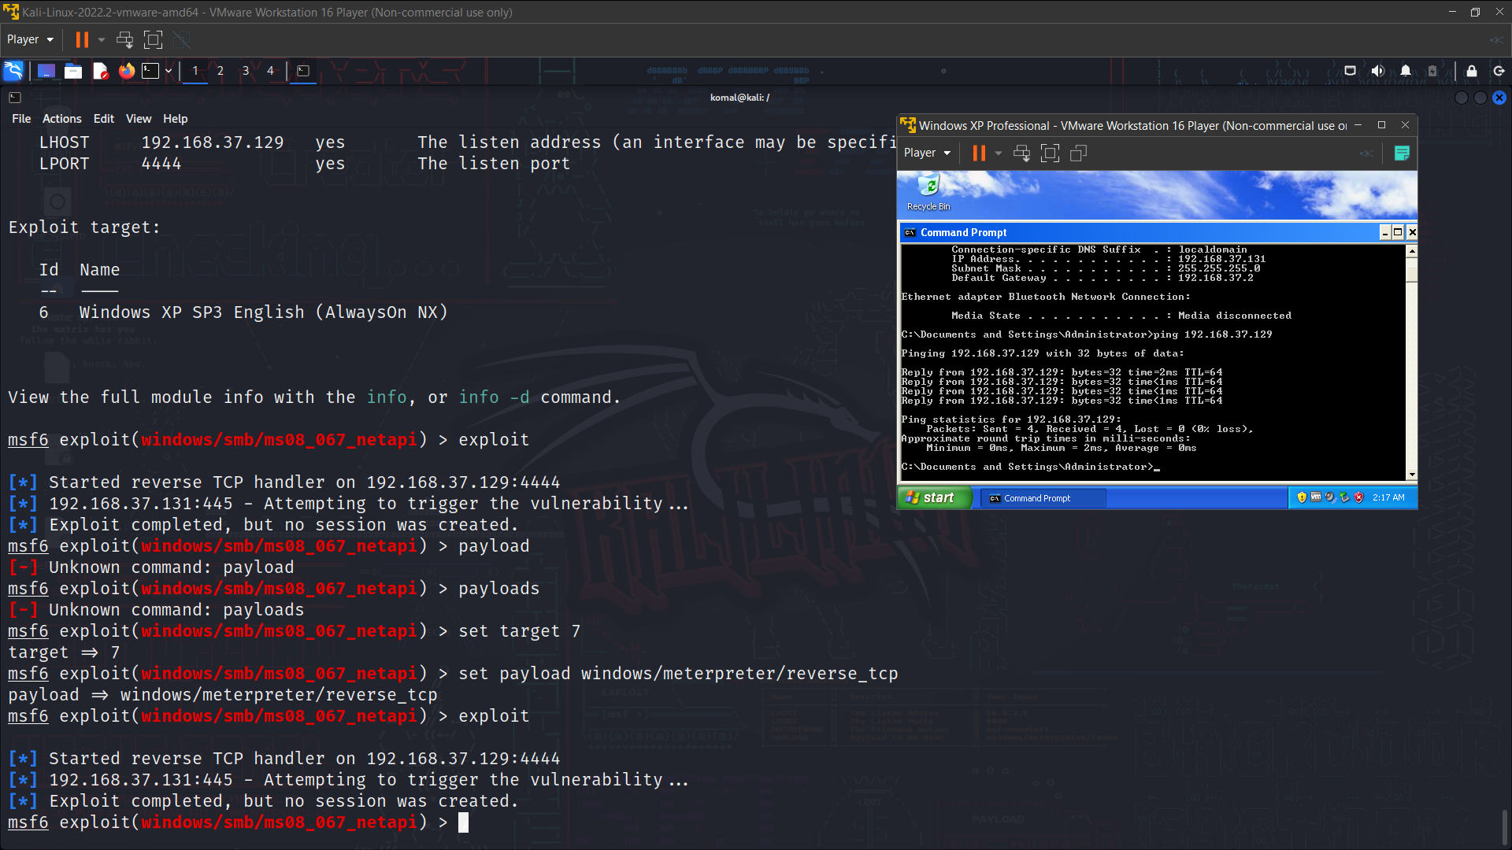
Figure 5 Attempted exploitation of Windows XP via the MS08-067 NetAPI module; no remote session was established.

8. Exploit 3: Authenticated SMB Share Exposure
The third exploit was carried out with the use of the authorised domain account "LAB\Komal", which was used to attack the Windows Server domain controller. Nmap was able to identify Kerberos, LDAP, SMB, DNS, and WinRM, and authenticated enumeration revealed the nondefault “Personal files” share as well as the shares: ADMIN$, C$, IPC$, NETLOGON, and SYSVOL. The mapping host shared points home folder provided had been configured to have a desktop folder with high level permissions to read, list, modify and write to given to all Authenticated Users, as verified by the server-side configuration. Kali Linux was able to connect to the share, and an enumeration of LAB\Komal was able to grab a copy of Admins.txt, Confidential.txt and passwords.txt. The result shows that an authenticated authentication attack has been recorded and that sensitive files have been exposed, but that the screen shot does not show a downloading of files or a library's level of jurisdiction. Activity maps to Domain Accounts (T1078.002), SMB/Windows Admin Shares (T1021.002), Network Share Discovery (T1135), File and Directory Discovery (T1083) and Data from Network Shared Drive (T1039). The authenticated SMB share compromise was henceforth successfully implemented as 3. The cause of the control failure was due to share and ntfs privileges that gave an average domain user access to resources that were located under an administration managed location. This configuration minimized the effort required by the attacker, provided an opportunity for compromise, modification, targeting of credentials, and movement across the network.
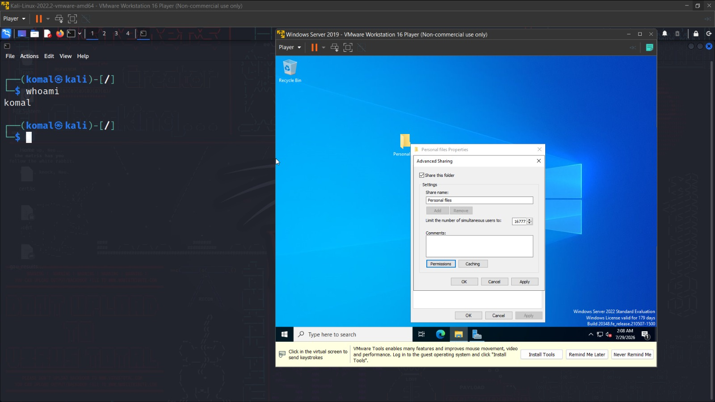
Figure 6 Authenticated enumeration of the Windows Server domain controller, showing Kerberos, LDAP, SMB, DNS and WinRM services and the exposed share list.
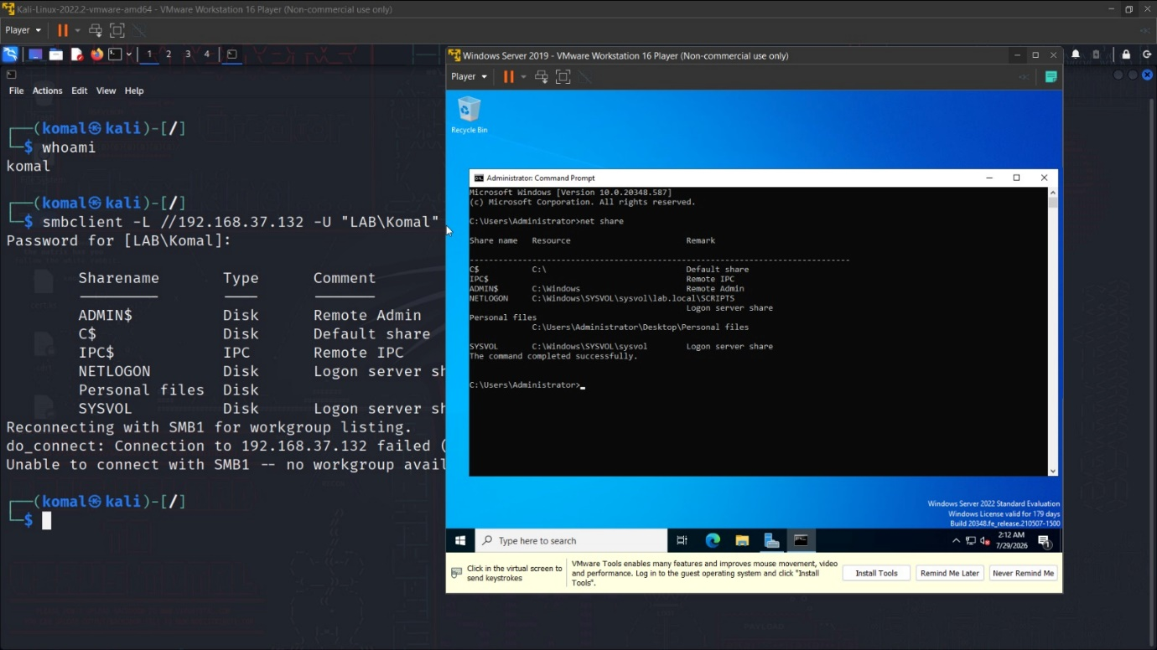
Figure 7 Share and NTFS permissions on the "Personal files" repository, showing elevated access granted to Authenticated Users.
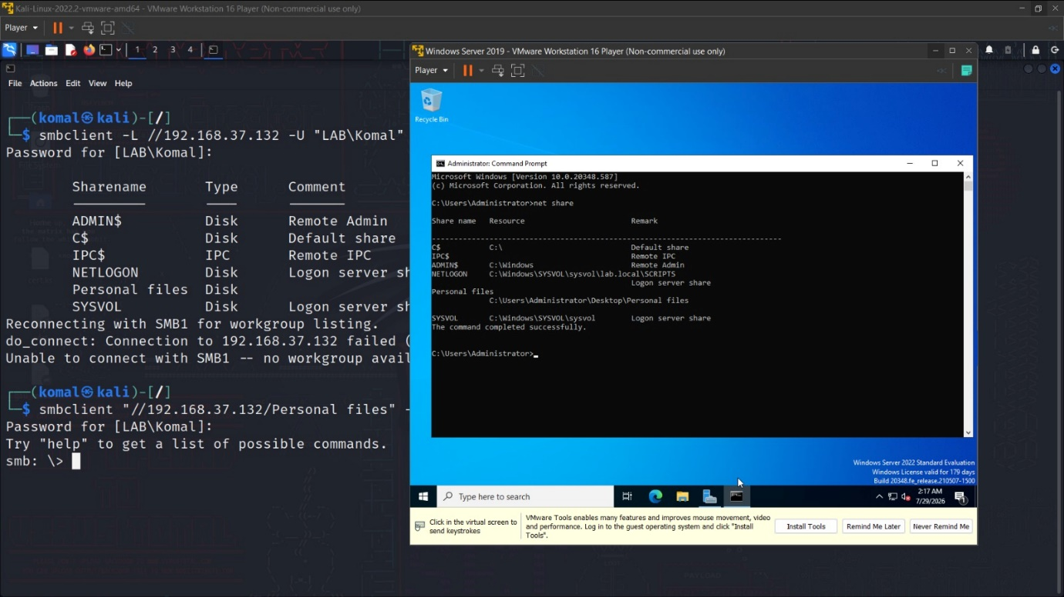
Figure 8 Authenticated SMB connection from Kali Linux to the domain-controller share (LAB\\Komal).
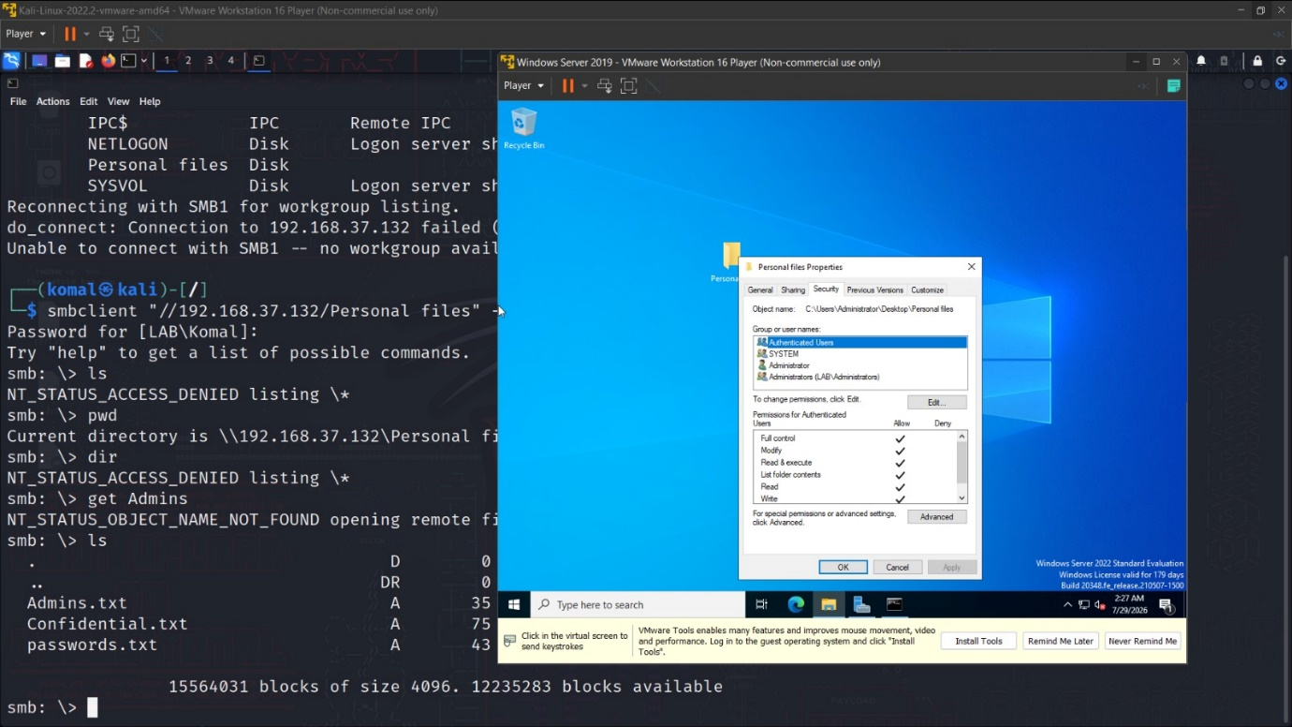
Figure 9 Directory listing showing exposure of Admins.txt, Confidential.txt and passwords.txt within the share.

9. Detection and Forensic Gap Analysis
All three of the legally approved exploitation strategies were traversed, though in the evidence presented only screenshots of the base of the computer are used, not screenshots of the computer invaded. The Windows XP MS08-067 exercise tried to complete the exploit without establishing a session, which succeeded, and the Windows Server exercise was successful in exploiting the “Personal files” SMB share, after gaining authenticated access. FTP logs, exports to event log, Linux authentication, SMB audit, packet capture, process information, and SIEM alerts were not retained, however. This makes it difficult to determine later if the activities completed were identified by the existing controls. The NIST SP 800-61r3 considers incident response to be an activity that relies on evidence preservation, lessons learned, coordinated response, and event analysis, and is essential as a capability of the organisation [15]. In Metasploitable 2, defenders should match up the FTP connections, unusual traffic on TCP port 6200, the creation of new shells and root logon actions of processes. Even if a session is not formed, the Windows XP test shall produce SMB, RPC, firewall or endpoint evidence. The Windows Server exercise will examine successful domain logons, accesses to the “Personal files” repository, SMB shares, RPC account discovery and directory listing related to this exercise. But there is also living-off-the-land advice, which aids in the establishment of behavioural baselines, centralised logging, command-line visibility, and hides malicious activity behind legitimate administrative procedures [18].
Table 3. Detection and Forensic-Evidence Analysis
Completed attack phase | Required telemetry | Evidence limitation | Recommended detection action
Successful VSFTPD exploitation | FTP connections, TCP port 6200 traffic, shell creation, root-level process execution | No Linux, FTP, process, or network logs were preserved | Alert on unexpected FTP backdoor listeners, shell spawning, and root processes initiated by network services
Completed MS08-067 exploit test | SMB and RPC requests, exploit signatures, firewall events, process crashes, endpoint telemetry | No PCAP, Windows event logs, or endpoint records were supplied | Correlate malformed SMB/RPC traffic, repeated exploit attempts, service instability, and abnormal reverse-connection activity
Successful authenticated SMB share access | Domain logon events, SMB share-access records, RPC account queries, directory-listing activity | No Security, Directory Service, or SMB audit logs were preserved | Detect standard-user access to administrator-controlled shares, unusual RPC discovery, and enumeration from non-administrative hosts
Post-engagement recovery | Session termination, artefact removal, permission restoration, VM rollback records | No cleanup or restoration evidence was supplied | Require documented closure of sessions, restoration of share permissions, and verified return to the clean baseline

10. Risk Evaluation and Recommendations
The highest level of risk is for the Metasploitable host because they are vulnerable to unauthorized root login, therefore compromising the three primary aspects of security at risk, confidentiality, integrity, and availability. Although the exploit failed, Windows XP is still at high risk due to unsupported systems, vulnerable SMB, and doubt about patches. The domain-controller finding is medium to high: The account did not have privileged access, but revealed identities, administrative share names and a custom repository under an Administrator profile [14].
Remove or isolate obsolete platforms and implement remediation service levels. Secondly, use deny-by-default east-west rules for separating public services, clients, and identity infrastructure. Third – work around managed hosts with SMB and RPC, assess SMB and NTFS permissions, and block access to sensitive repositories for standard accounts. Fourth, use phishing-resistant multifactor authentication, privileged workstations, graduated privileges and ongoing monitoring of the domain-controller. Fifth, include ATT&CK aligned detections for telemetry data of Linux, Windows, networks, and authentication [16]. Sixth, practice containment, evidence preservation, credential revocation and recovery. The features of NIST CSF 2.0 that support comparing current and target profiles, and prioritising actions based on governance expectations, will be used in this paper. Work with comparison of current and target profiles and prioritisation of actions in accordance with the expectations for governance is supported by attributes of NIST CSF 2.0.
Table 4. Prioritised Remediation Roadmap
Priority | Control | Timeframe | Success measure
Critical | Remove VSFTPD 2.3.4, retire unsupported platforms, and patch exposed services | 0–30 days | No critical remotely exploitable legacy services remain reachable
Critical | Correct SMB share and NTFS permissions for the “Personal files” repository | 0–30 days | Standard domain users cannot enumerate, read, modify, or write administrator-controlled files
High | Segment public services, legacy clients, and identity infrastructure using deny-by-default rules | 30–90 days | Unauthorised east-west communication is blocked and validated through retesting
High | Restrict SMB, RPC, LDAP, and WinRM access to approved administrative hosts and accounts | 30–60 days | Non-administrative systems cannot access management protocols or sensitive shares
High | Centralise Linux, Windows, identity, SMB, and network telemetry | 30–90 days | ATT&CK-aligned alerts are generated for FTP exploitation, SMB attacks, RPC discovery, and share access
Medium | Conduct a controlled remediation retest and preserve forensic evidence | 60–120 days | All findings are retested, logs and PCAPs are retained, and remediation effectiveness is formally verified

11. Limitations and Required Retesting
No attempt can be made to show three successful exploits on the packaged (current) practical. Exploit 1 was successful and provided limited (or partial) remote attack verification was performed, but Exploit 2 failed and Exploit 3 achieved authenticated discovery of a custom share but did not demonstrate file-content access, privilege escalation or remote attack execution. There is a lack of evidence to substantiate the goals of network isolation, snapshots and rollback, telemetry and cleanup or a goal of end-to-end. Before submission, the operator must capture host-only network setup information, maintain pre-test backups, perform a successful, second exploit on an authorised vulnerable target, connect to the “Personal files” share and list or retrieve a dummy file, gather logs and PCAPs, and document restoration. These additions may be required to meet the practical requirement or simply to enhance the presentation.

12. Conclusion
The engagement has revealed significant weaknesses in the simulated environment concerning legacy-service and identity-exposures through ABCD Ltd. The attack with VSFTPD enabled had opened a root shell, which was a clear indication of the direct compromise of the Linux host. The Windows XP challenge didn't create any session, but the domain user account did expose SMB shares, a domain identity and a custom “Personal files” repository, without much sign of any administrative control or ability to take files. The most prevalent, fundamental problem is an under-provision of telemetry and lack of a supporting technology for a weak and flat architecture at the system level. The key action is to isolate and remove vulnerable assets, set the permissions on the shared assets and retest using a known Rules of Engagement with detailed forensic evidence. For the time being, Task 2 is not considered to be finished until three distinct, successfully validated exploits have been made. There should be a second controlled retest to confirm remediation effectiveness and gather defence evidence from telemetry.

References
[1] Marks and Spencer Group plc, “Cyber incident update,” London Stock Exchange, Apr. 22, 2025. [Online]. Available: https://www.londonstockexchange.com/news-article/MKS/cyber-incident-update/16999905. [Accessed: Jul. 27, 2026].
[2] Marks and Spencer Group plc, “Cyber incident—Further update,” Apr. 25, 2025. [Online]. Available: https://corporate.marksandspencer.com/newsroom/press-releases/cyber-incident-further-update-0. [Accessed: Jul. 27, 2026].
[3] Marks and Spencer Group plc, “Full year results for the 52 weeks ended 29 March 2025,” May 21, 2025. [Online]. Available: https://corporate.marksandspencer.com/newsroom/press-releases/full-year-results-52-weeks-ended-29-march-2025 . [Accessed: Jul. 27, 2026].
[4] The Co-operative Group, “Cyber incident,” 2025. [Online]. Available: https://www.coop.co.uk/cyber-incident . [Accessed: Jul. 27, 2026].
[5] The Co-operative Group, “Cyber incident member FAQs,” 2025. [Online]. Available: https://www.coop.co.uk/cyber-incident-faqs . [Accessed: Jul. 27, 2026].
[6] U.K. National Cyber Security Centre, “NCSC statement: Incident impacting retailers,” May 1, 2025. [Online]. Available: https://www.ncsc.gov.uk/news/retailers-incident. [Accessed: Jul. 27, 2026].
[7] J. Ellison and O. Whitehouse, “Incidents impacting retailers—Recommendations from the NCSC,” National Cyber Security Centre, May 4, 2025. [Online]. Available: https://www.ncsc.gov.uk/blog-post/incidents-impacting-retailers. [Accessed: Jul. 27, 2026].
[8] U.K. National Crime Agency, “Retail cyber attacks: NCA arrest four for attacks on M&S, Co-op and Harrods,” Jul. 10, 2025. [Online]. Available: https://www.nationalcrimeagency.gov.uk/news/retail-cyber-attacks-nca-arrest-four-for-attacks-on-m-s-co-op-and-harrods . [Accessed: Jul. 27, 2026].
[9] Cybersecurity and Infrastructure Security Agency, Federal Bureau of Investigation, Australian Signals Directorate’s Australian Cyber Security Centre, Canadian Centre for Cyber Security, and U.K. National Cyber Security Centre, “Scattered Spider,” Cybersecurity Advisory AA23-320A, Nov. 16, 2023, updated Jul. 29, 2025. [Online]. Available: https://www.cisa.gov/news-events/cybersecurity-advisories/aa23-320a. [Accessed: Jul. 27, 2026].
[10] Microsoft Incident Response and Microsoft Threat Intelligence, “Octo Tempest crosses boundaries to facilitate extortion, encryption, and destruction,” Microsoft Security Blog, Oct. 25, 2023. [Online]. Available: https://www.microsoft.com/en-us/security/blog/2023/10/25/octo-tempest-crosses-boundaries-to-facilitate-extortion-encryption-and-destruction/ . [Accessed: Jul. 27, 2026].
[11] MITRE, “Enterprise techniques,” MITRE ATT&CK. [Online]. Available: https://attack.mitre.org/techniques/enterprise/. [Accessed: Jul. 27, 2026].
[12] MITRE Center for Threat-Informed Defense, “Adversary Emulation Library.” [Online]. Available: https://ctid.mitre.org/resources/adversary-emulation-library/. [Accessed: Jul. 27, 2026].
[13] OWASP Foundation, “OWASP Top 10:2025,” 2025. [Online]. Available: https://owasp.org/Top10/2025/. [Accessed: Jul. 27, 2026].
[14] C. Pascoe, S. Quinn, and K. Scarfone, The NIST Cybersecurity Framework (CSF) 2.0, NIST CSWP 29. Gaithersburg, MD, USA: National Institute of Standards and Technology, Feb. 2024, doi: 10.6028/NIST.CSWP.29. [Online]. Available: https://doi.org/10.6028/NIST.CSWP.29.
[15] A. Nelson, S. Rekhi, M. Souppaya, and K. Scarfone, Incident Response Recommendations and Considerations for Cybersecurity Risk Management: A CSF 2.0 Community Profile, NIST SP 800-61r3. Gaithersburg, MD, USA: National Institute of Standards and Technology, Apr. 2025, doi: 10.6028/NIST.SP.800-61r3. [Online]. Available: https://doi.org/10.6028/NIST.SP.800-61r3.
[16] Cybersecurity and Infrastructure Security Agency, Zero Trust Maturity Model, Version 2.0, Apr. 2023. [Online]. Available: https://www.cisa.gov/sites/default/files/2023-04/zero_trust_maturity_model_v2_508.pdf. [Accessed: Jul. 27, 2026].
[17] Australian Signals Directorate’s Australian Cyber Security Centre, Cybersecurity and Infrastructure Security Agency, National Security Agency, and international partners, “Detecting and mitigating Active Directory compromises,” Sep. 2024. [Online]. Available: https://www.cisa.gov/resources-tools/resources/detecting-and-mitigating-active-directory-compromises. [Accessed: Jul. 27, 2026].
[18] Cybersecurity and Infrastructure Security Agency, National Security Agency, Federal Bureau of Investigation, and international partners, “Identifying and mitigating living off the land techniques,” Joint Guidance, Feb. 2024. [Online]. Available: https://www.cisa.gov/sites/default/files/2025-03/Joint-Guidance-Identifying-and-Mitigating-LOTL508.pdf. [Accessed: Jul. 27, 2026].
[19] M. Alhamed and M. M. H. Rahman, “A systematic literature review on penetration testing in networks: Future research directions,” Applied Sciences, vol. 13, no. 12, Art. no. 6986, 2023, doi: 10.3390/app13126986. [Online]. Available: https://doi.org/10.3390/app13126986 .
[20] K. U. Sarker, F. Yunus, and A. Deraman, “Penetration taxonomy: A systematic review on the penetration process, framework, standards, tools, and scoring methods,” Sustainability, vol. 15, no. 13, Art. no. 10471, 2023, doi: 10.3390/su151310471. [Online]. Available: https://doi.org/10.3390/su151310471.

Task 1- Appendix
Table A1. Detailed Timeline of the 2025 M&S and Co-op Cyber Incidents
Date | Organisation | Event | Evidence status | Strategic significance
22 April 2025 | Marks & Spencer | M&S publicly disclosed that it was managing a cyber incident affecting selected services, including some contactless-payment and click-and-collect processes [1]. | Confirmed | Established the beginning of publicly acknowledged operational disruption.
25 April 2025 | Marks & Spencer | Website and mobile-application orders were suspended as a precautionary containment measure, while physical stores remained open [2]. | Confirmed | Containment protected the environment but removed a major revenue channel.
Late April 2025 | Co-operative Group | Co-op detected malicious activity and restricted access to parts of its IT environment [4]. | Confirmed | Early isolation reduced the attacker’s access but disrupted internal operations.
1 May 2025 | NCSC | The NCSC confirmed that it was supporting affected UK retailers [6]. | Confirmed | Elevated the incidents from individual organisational events to a national retail-resilience concern.
4 May 2025 | NCSC | NCSC guidance warned retailers about help-desk impersonation, password resets and MFA-reset abuse [7]. | Confirmed guidance; incident linkage unconfirmed | Indicated that identity-recovery processes were a material sector-wide attack surface.
May 2025 | Co-operative Group | Co-op confirmed that attackers obtained members’ names, contact details and dates of birth, but not passwords, payment-card details or transaction information [5]. | Confirmed | Demonstrated a confidentiality breach while showing that data separation limited the most sensitive exposure.
21 May 2025 | Marks & Spencer | M&S estimated an approximately £300 million impact on 2025/26 operating profit before mitigation [3]. | Confirmed | Demonstrated board-level financial materiality and dependence on digital retail operations.
May–July 2025 | Marks & Spencer | Online disruption and recovery activity continued over an extended period [3]. | Confirmed | Revealed weaknesses in operational resilience and service-recovery capability.
10 July 2025 | National Crime Agency | Four individuals were arrested in connection with attacks affecting M&S, Co-op and Harrods [8]. | Confirmed arrest; guilt not established | Strengthened the assessment of a related retail campaign but did not constitute final attribution.
July 2025 onward | UK retail sector | Organisations reviewed identity controls, service-desk procedures, privileged access and monitoring [7]. | Confirmed recommendation | Shifted defensive priorities from perimeter-only controls toward identity-centred resilience.

Table B1. Expanded ATT&CK Mapping with Evidential Confidence
Tactic | Technique | ATT&CK ID | Confidence | Evidence and justification
Reconnaissance | Gather Victim Identity Information | T1589 | Medium | Scattered Spider and overlapping Octo Tempest reporting describes detailed collection of employee information before impersonation [9].
Initial Access | Phishing: Spearphishing Voice | T1566.004 | Medium | NCSC guidance emphasised service-desk impersonation and telephone-based social engineering in the retail incidents [7].
Defence Evasion/Initial Access | Valid Accounts | T1078 | Medium–High | Actor reporting describes abuse of reset or compromised credentials to make malicious access resemble legitimate activity [10].
Persistence | Account Manipulation | T1098 | Medium | Attackers associated with the assessed actor cluster have added authentication factors or altered accounts after successful social engineering [9].
Discovery | Account Discovery | T1087 | Medium | Directory enumeration would identify valuable users and administrative accounts after initial access [10].
Discovery | Permission Groups Discovery | T1069 | Medium | Group and role enumeration supports privilege escalation and identification of highly privileged identities [9].
Discovery | Cloud Infrastructure Discovery | T1580 | Medium | The actor profile includes discovery of cloud resources and hybrid identity infrastructure [10].
Command and Control | Remote Access Software | T1219 | Medium | Scattered Spider and Octo Tempest have used legitimate remote-access tools to blend with administrative activity [9].
Collection | Data from Information Repositories | T1213 | Medium | Corporate document repositories and member-data systems provide operational and identity intelligence [10].
Exfiltration | Exfiltration Over Web Service | T1567 | Low–Medium | Actor reporting describes use of trusted web or cloud services for data transfer; victim-specific public evidence remains incomplete [9].
Impact | Data Encrypted for Impact | T1486 | Low/Unconfirmed | Encryption is consistent with historical actor behaviour but was not publicly confirmed as a technique used against both victims [10].
Table C1. OSINT Source Evaluation
Source | Information extracted | Reliability | Limitation
M&S cyber-incident update [1] | Initial disclosure and operational impact | High | Limited technical detail due to ongoing investigation
M&S further update [2] | Suspension of online ordering and containment | High | Does not disclose attack vector
M&S annual results [3] | Financial impact and recovery implications | High | Primarily investor-focused
Co-op cyber-incident page [4] | Containment and operational disruption | High | Limited forensic detail
Co-op member FAQs [5] | Categories of member data accessed | High | Does not fully describe attacker progression
NCSC retailer statement [6] | Government support and sector context | High | Does not attribute the incidents
NCSC retailer guidance [7] | Identity-reset and help-desk risks | High | Guidance is not proof that every listed technique occurred
NCA arrest statement [8] | Arrests connected with affected retailers | High | Arrest is not equivalent to conviction or final attribution
CISA Scattered Spider advisory [9] | Actor capabilities and TTPs | High | Describes the broader actor cluster rather than victim-specific evidence
Microsoft Octo Tempest analysis [10] | Extortion, social engineering and identity compromise | High | Vendor nomenclature may overlap with other actor names

Task 2- Appendix
Threat Emulation Plan
Phase | Activity | MITRE ATT&CK
Discovery | Identify hosts and services using Nmap | T1046
Initial access | Exploit VSFTPD 2.3.4 | T1210
Command execution | Establish Unix root shell | T1059.004
SMB testing | Execute MS08-067 test against Windows XP | T1210
Valid-account access | Authenticate using LAB\Komal | T1078.002
Share discovery | Identify the “Personal files” share | T1135
File discovery | Enumerate confidential filenames | T1083
Domain discovery | Enumerate Windows domain accounts | T1087.002

Laboratory Configuration
System | IP address | Role
Kali Linux | 192.168.37.129 | Red-team workstation
Metasploitable 2 | 192.168.37.130 | Vulnerable Linux server
Windows XP | 192.168.37.131 | Legacy Windows client
Windows Server 2022 | 192.168.37.132 | Domain controller and file server

Exploitation Evidence Summary
Exploit | Target | Result
Exploit 1 | Metasploitable 2 | VSFTPD 2.3.4 produced a root command-shell session
Exploit 2 | Windows XP | MS08-067 procedure executed; no remote session was created
Exploit 3 | Windows Server 2022 | LAB\Komal accessed the “Personal files” share and listed Admins.txt, Confidential.txt, and passwords.txt

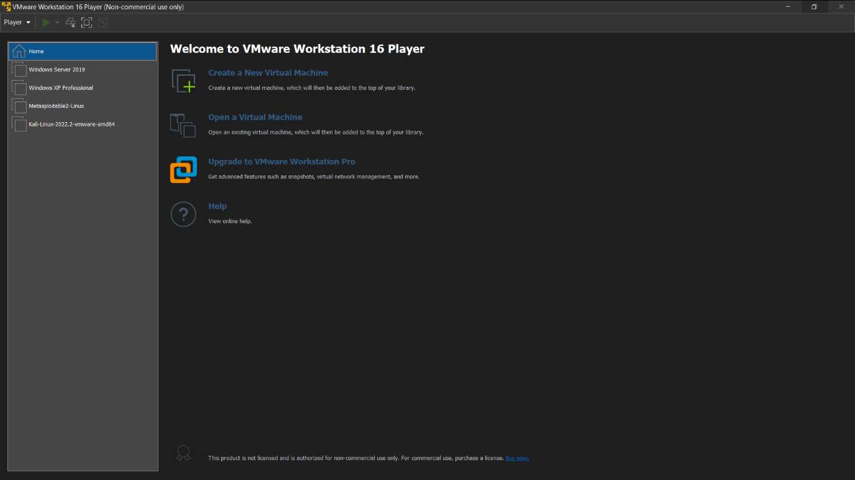
Figure 10 All authorised laboratory devices used in the ABCD Ltd engagement (Kali Linux, Metasploitable 2, Windows XP and the Windows Server domain controller).
All the devices used
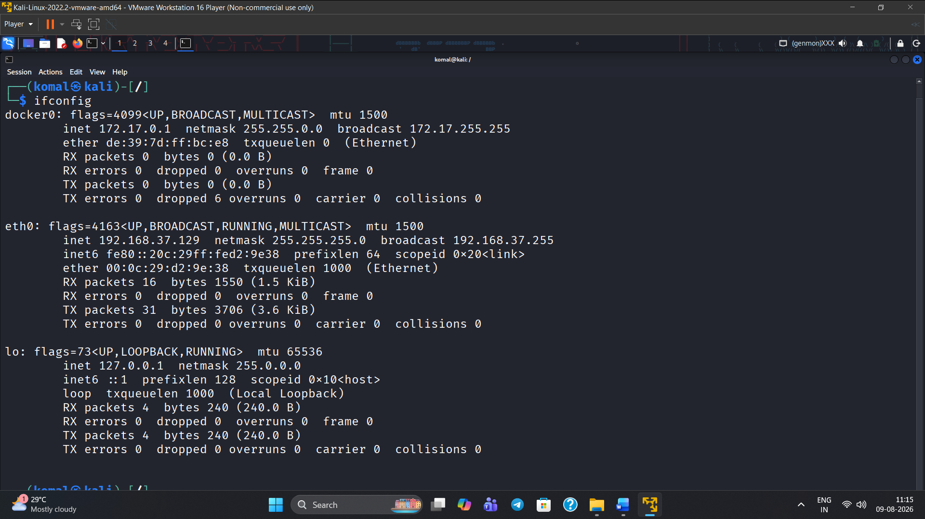
Figure 11 kali IP Address

Exploit 1 (metasploitable2)
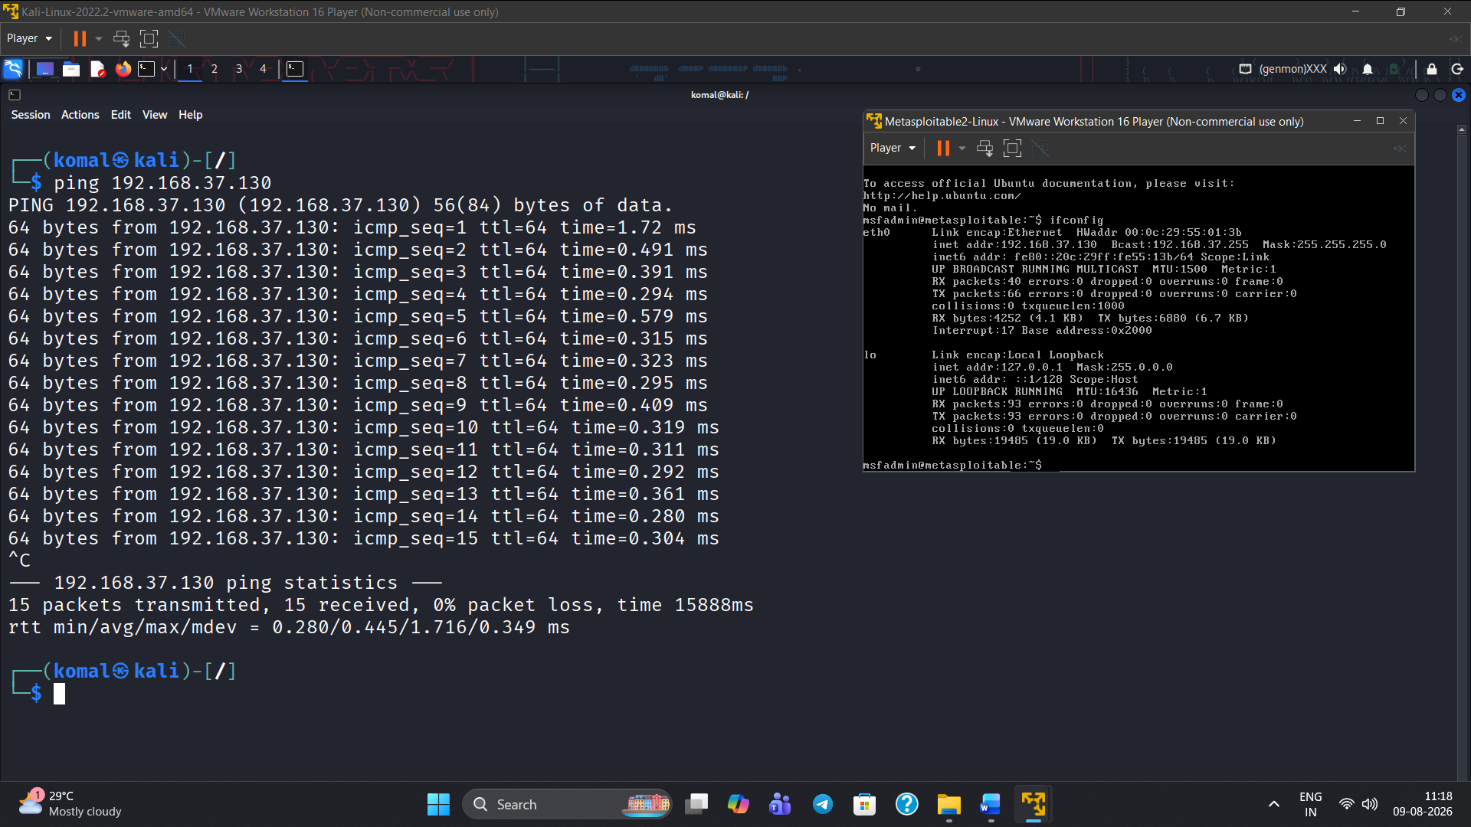
Figure 12 Exploit 1 (metasploitable2) evidence screenshot
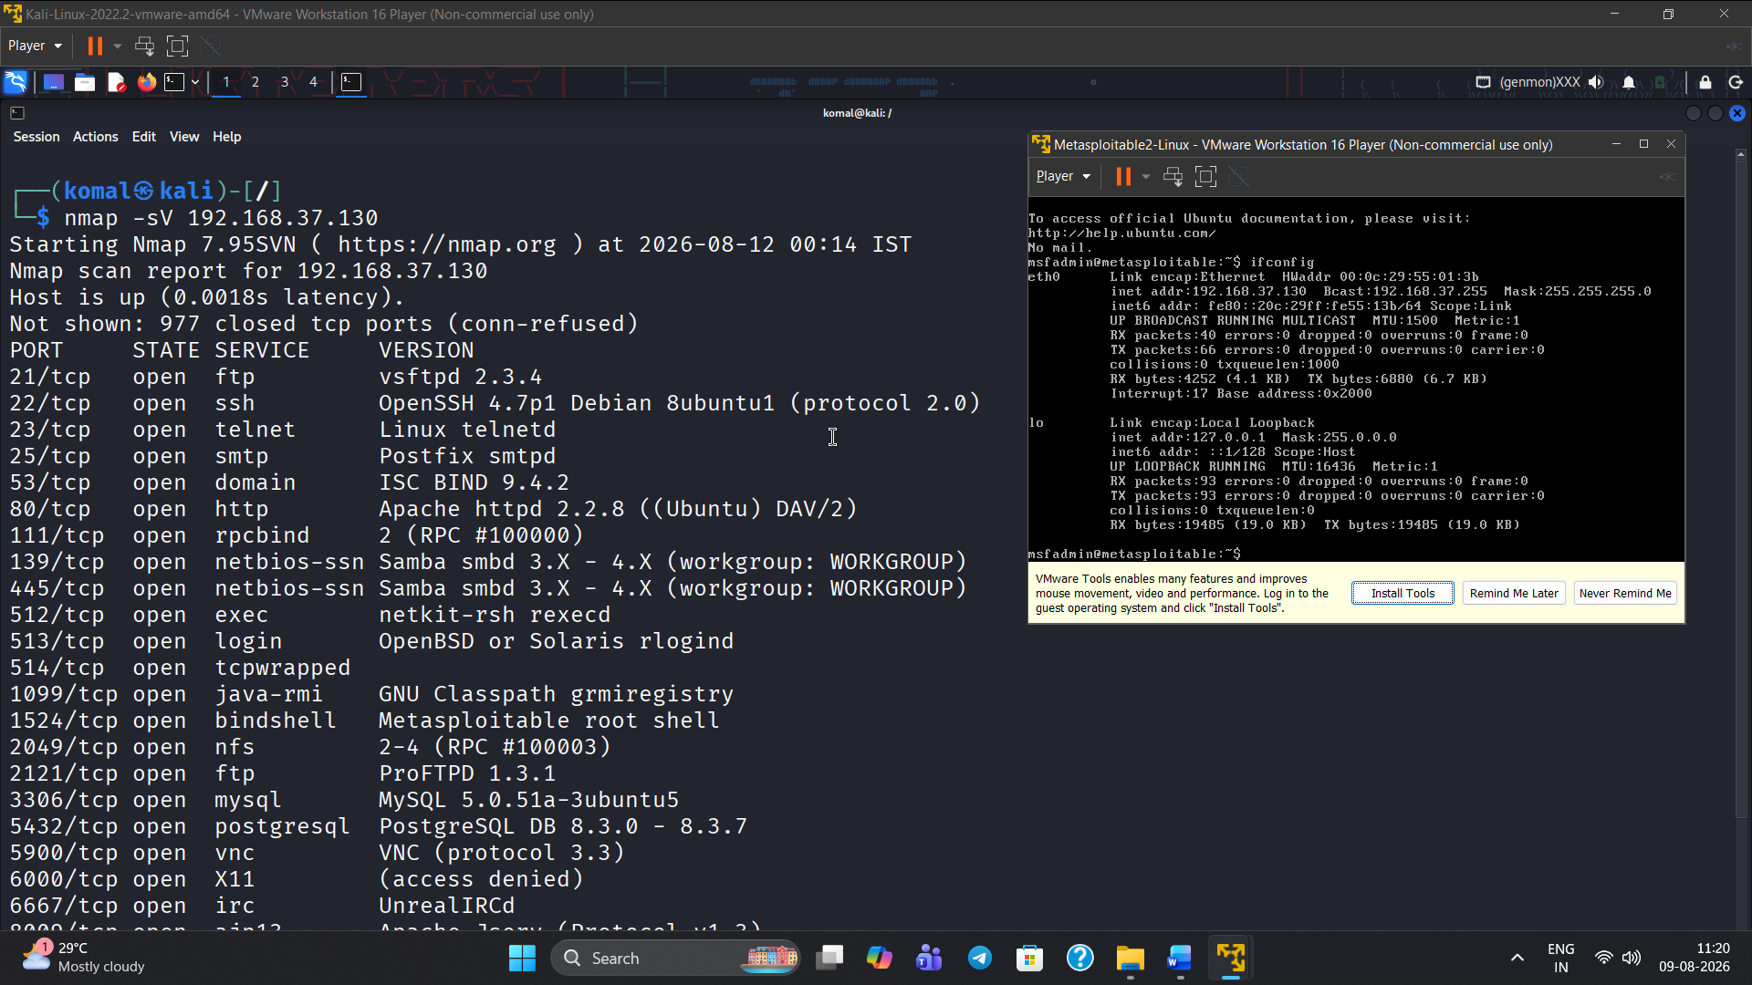
Figure 13 Exploit 1 (metasploitable2) – supporting evidence, screenshot 2 of 6.
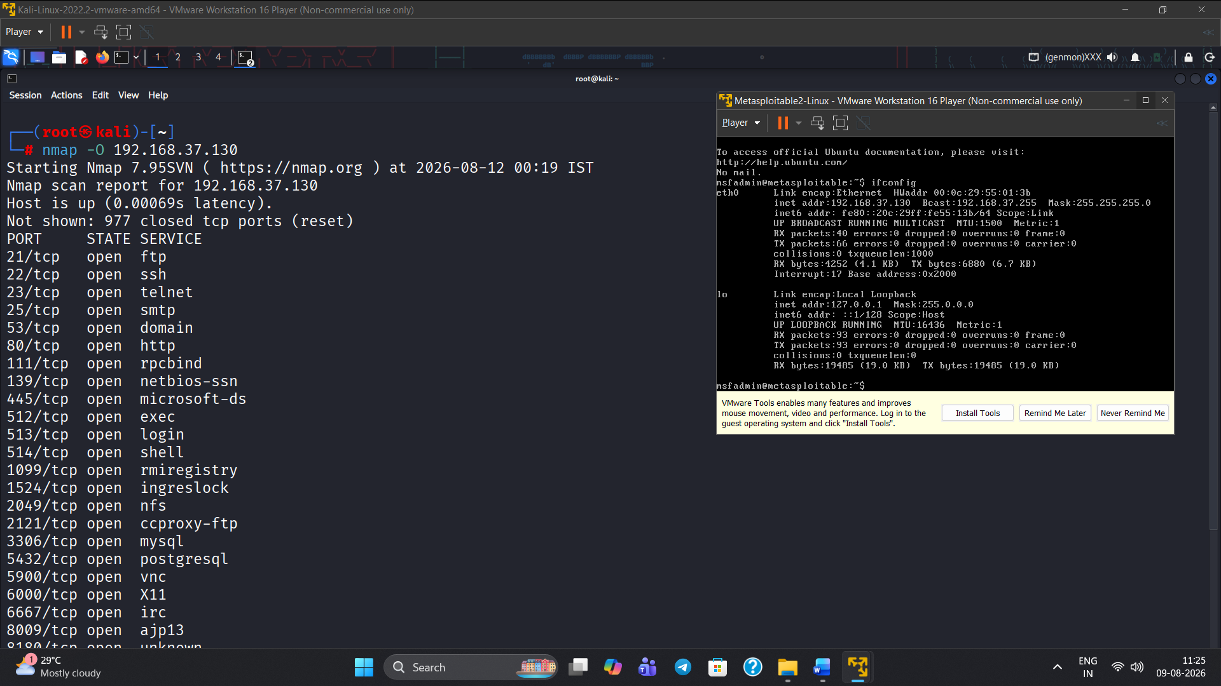
Figure 14 Exploit 1 (metasploitable2) – supporting evidence, screenshot 3 of 6.
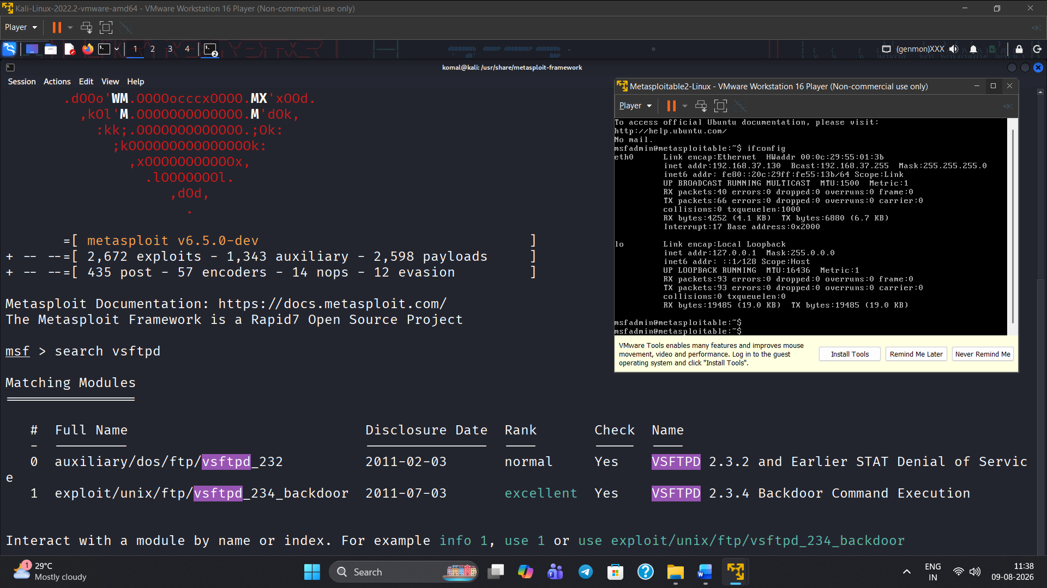
Figure 15 Exploit 1 (metasploitable2) – supporting evidence, screenshot 4 of 6.
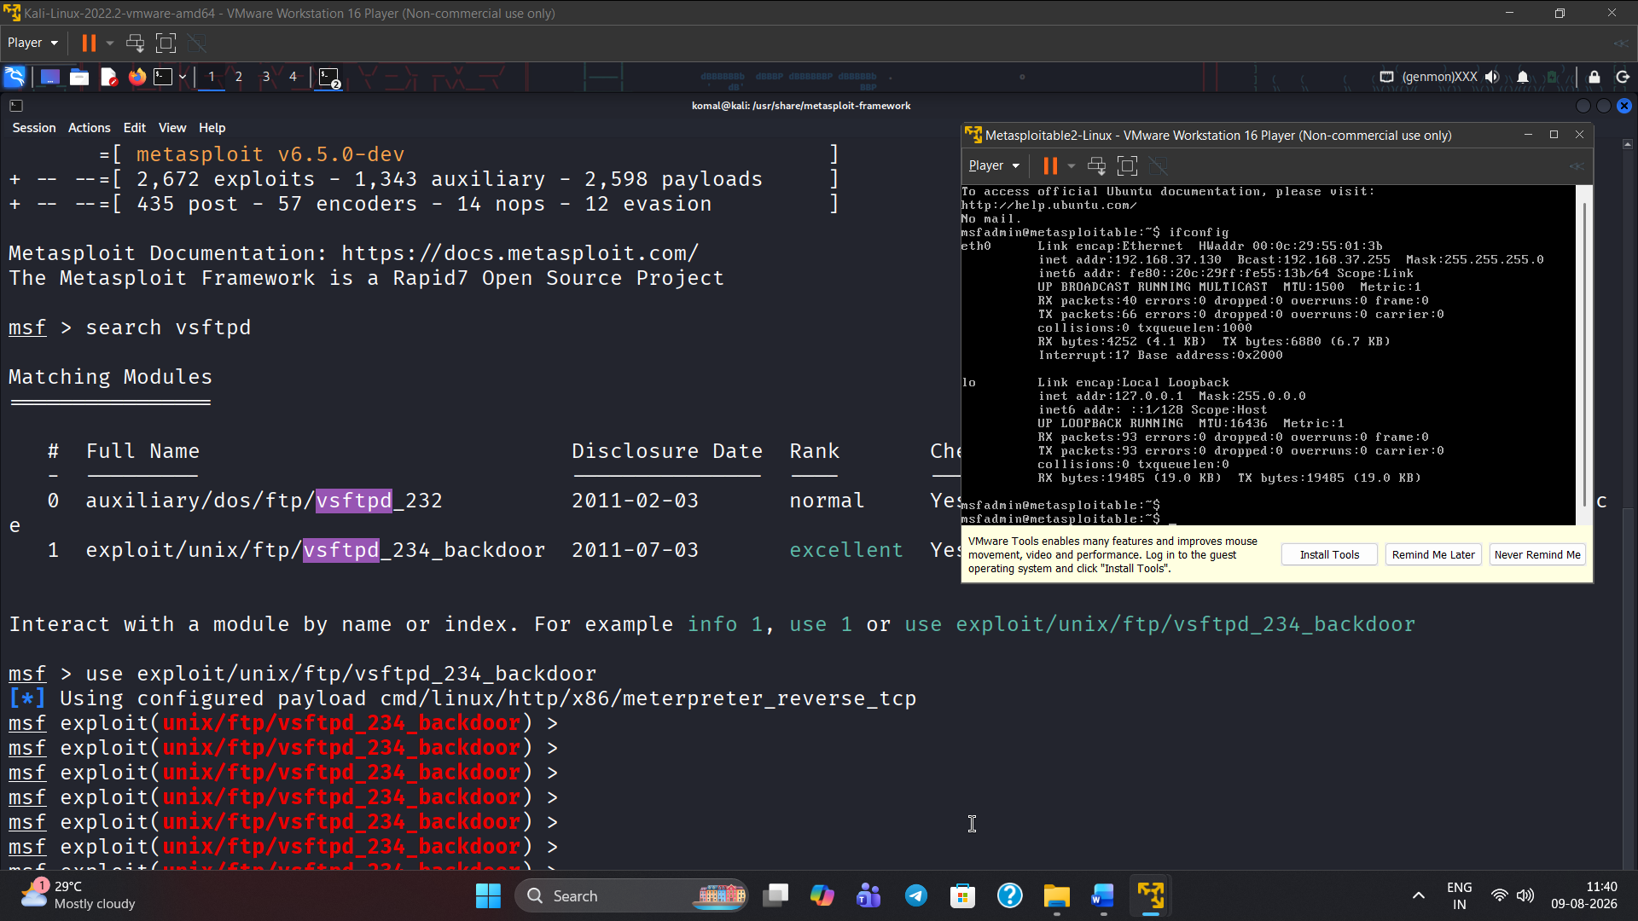
Figure 16 Exploit 1 (metasploitable2) – supporting evidence, screenshot 5 of 6.
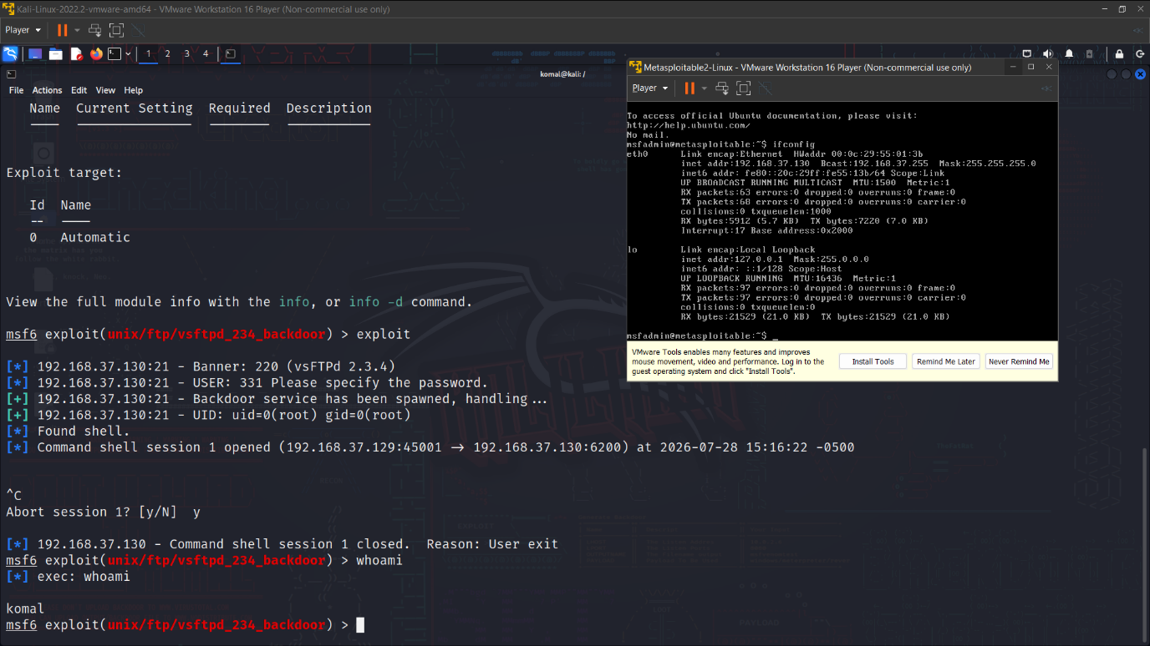
Figure 17 Exploit 1 (metasploitable2) – supporting evidence, screenshot 6 of 6.

Exploit 2 (windows xp)
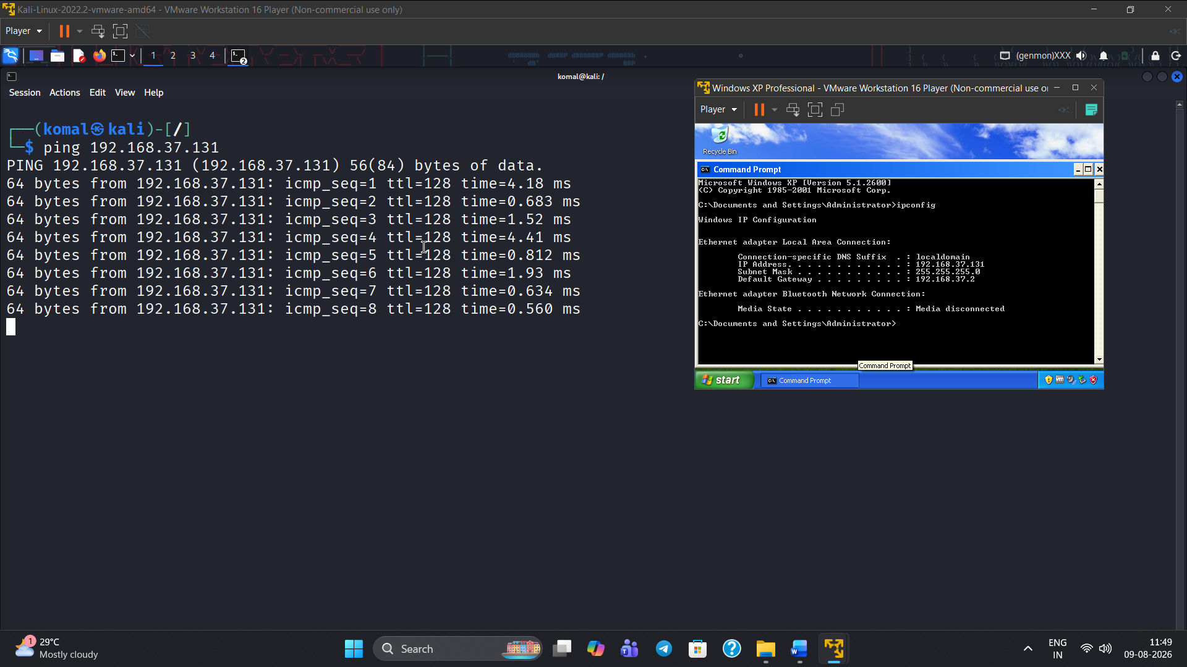
Figure 18 Exploit 2 (Windows XP) – supporting evidence, screenshot 1 of 8.
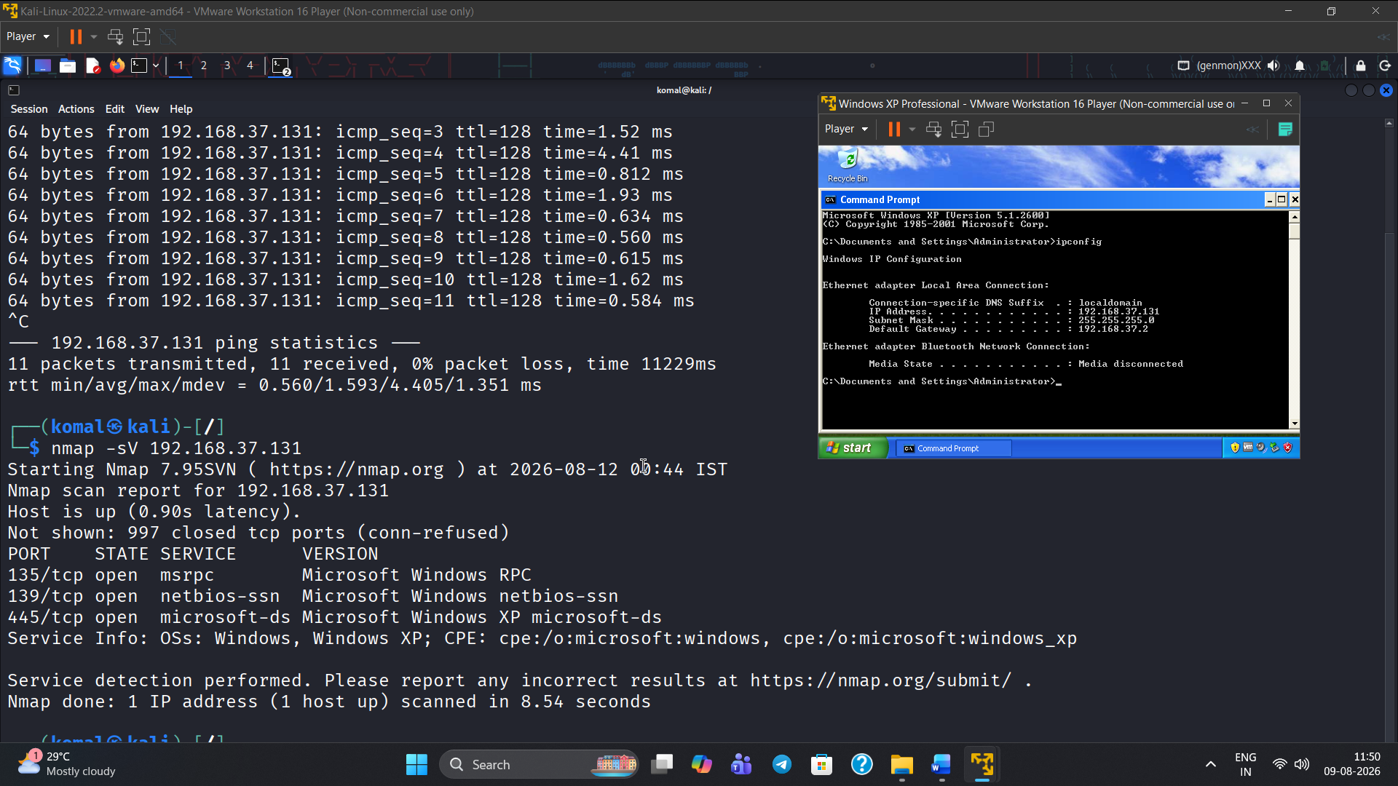
Figure 19 Exploit 2(Windows XP) – supporting evidence, screenshot 2 of 8.
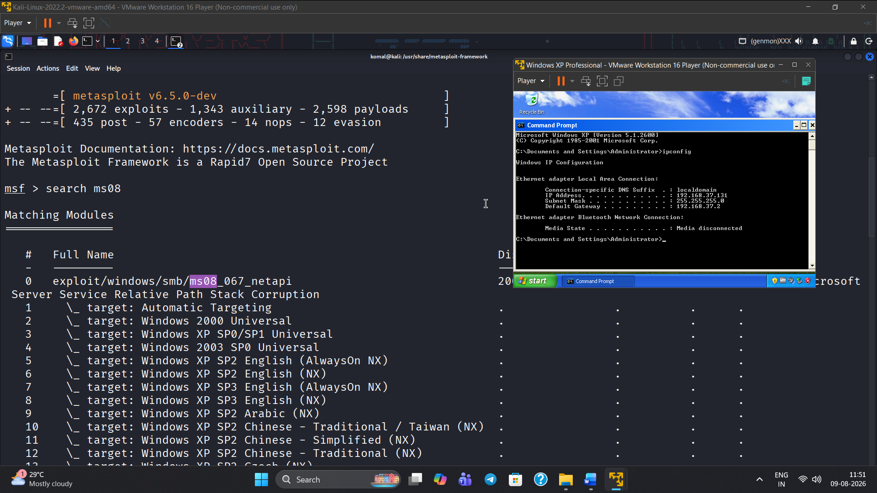
Figure 20 Exploit 2 (Windows XP) – supporting evidence, screenshot 3 of 8.
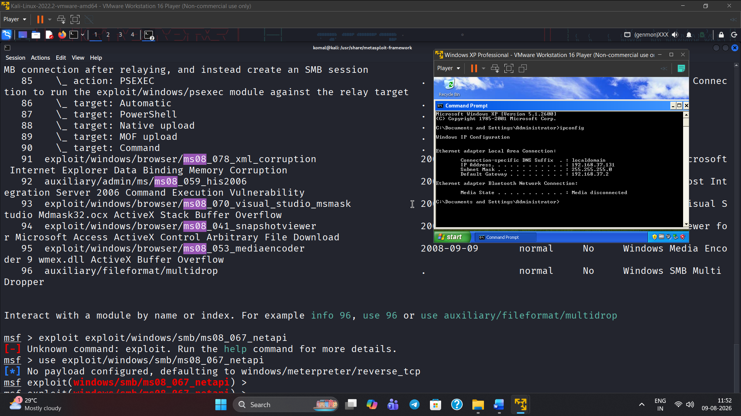
Figure 21 Exploit 2 (Windows XP) – supporting evidence, screenshot 4 of 8.
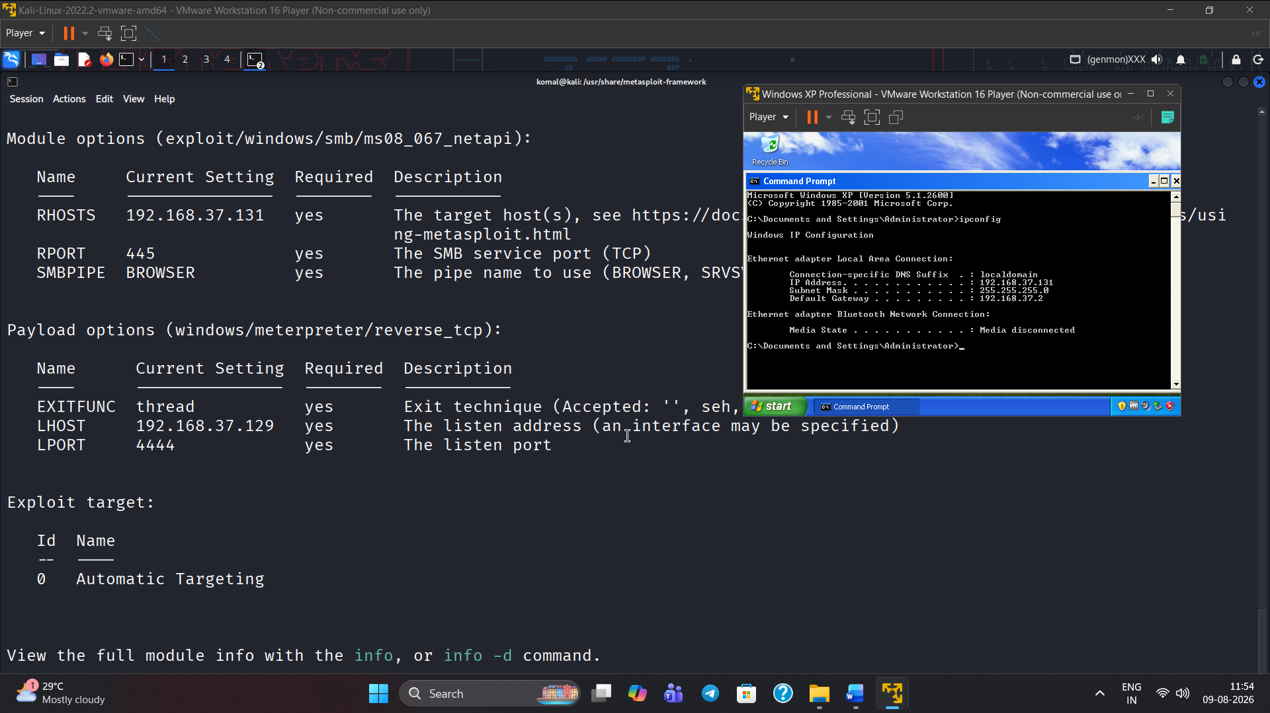
Figure 22 Exploit 2 (Windows XP) – supporting evidence, screenshot 5 of 8.
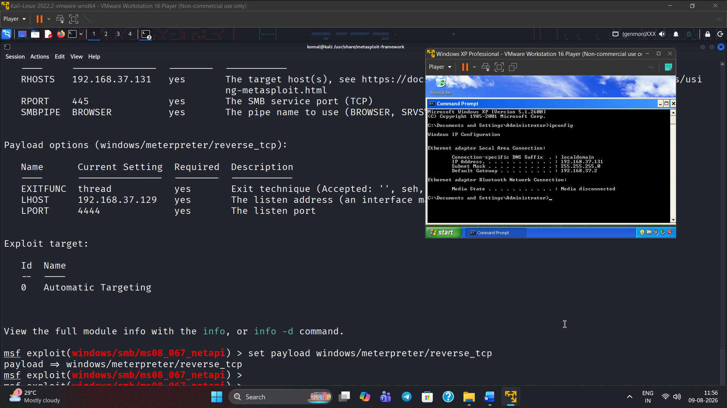
Figure 23 Exploit 2 (Windows XP) – supporting evidence, screenshot 6 of 8.
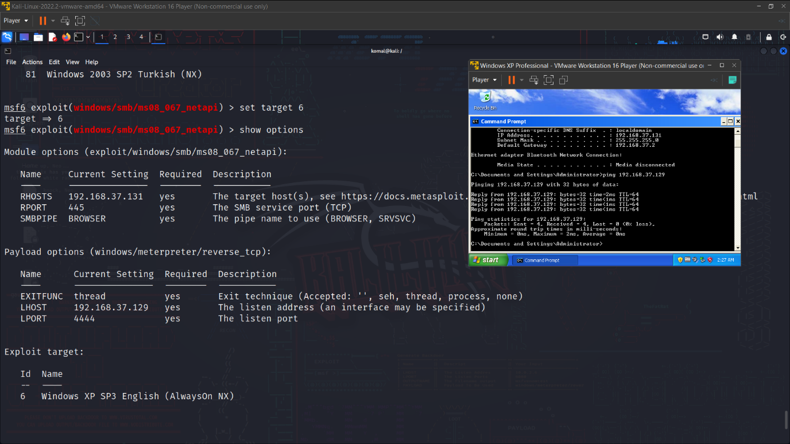
Figure 24 Exploit 2(Windows XP) – supporting evidence, screenshot 7 of 8.
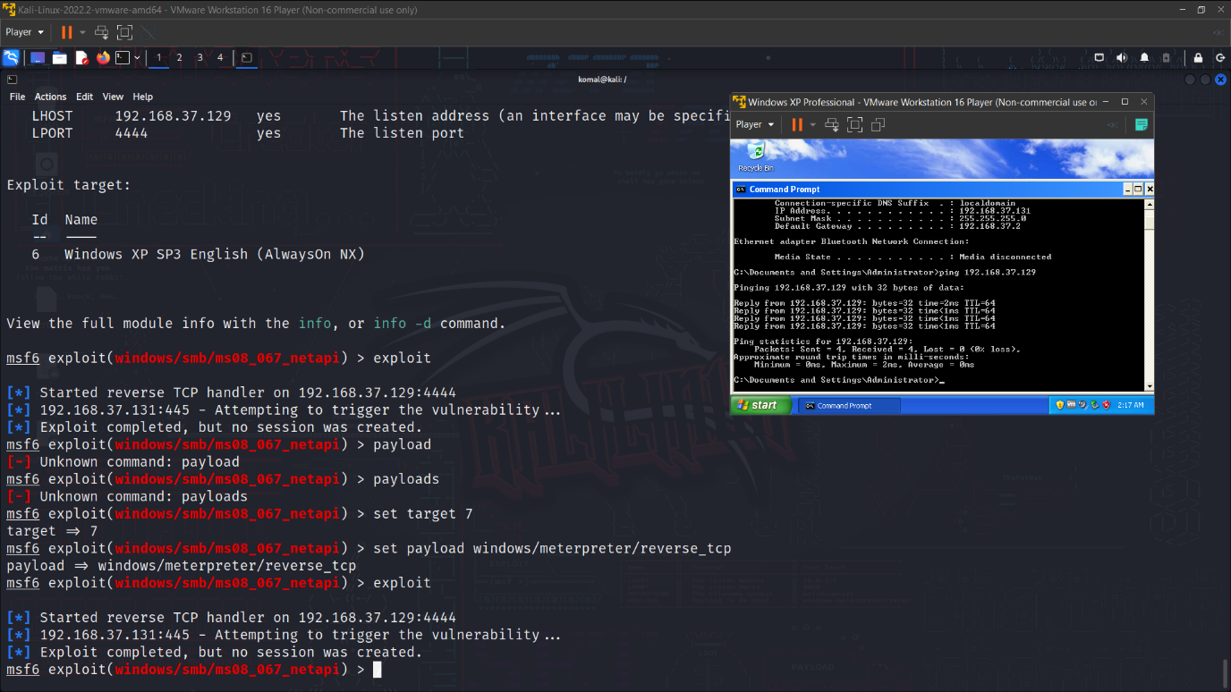
Figure 25 Exploit 2 (Windows XP) – supporting evidence, screenshot 8 of 8.

Exploit 3 (windows server 2019)
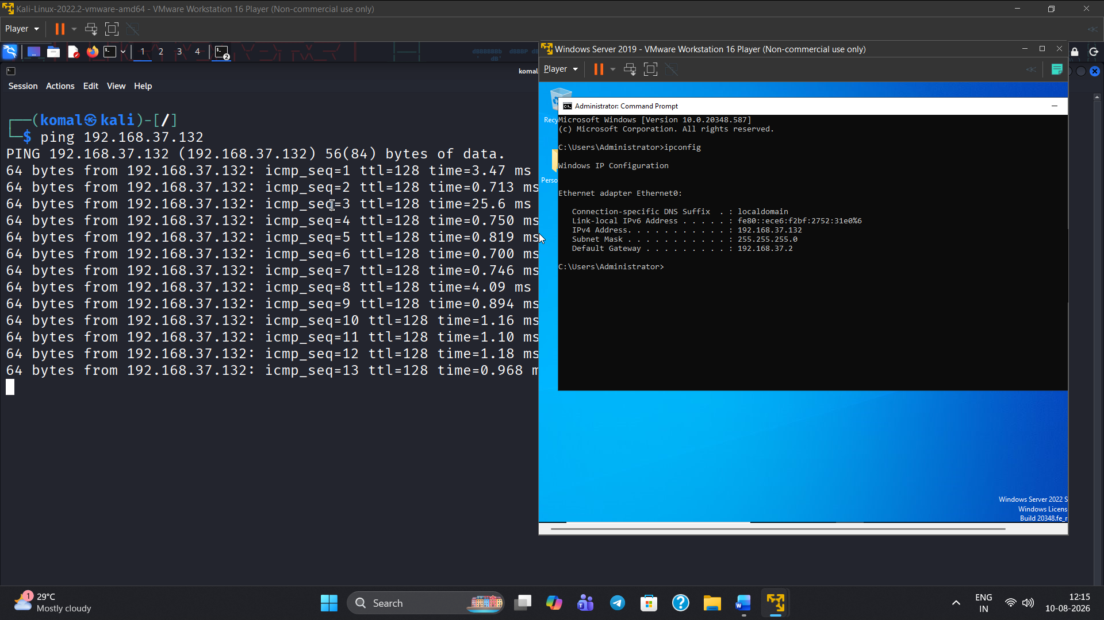
Figure 26 Exploit 3 (windows server) – screenshot 1 of 17.
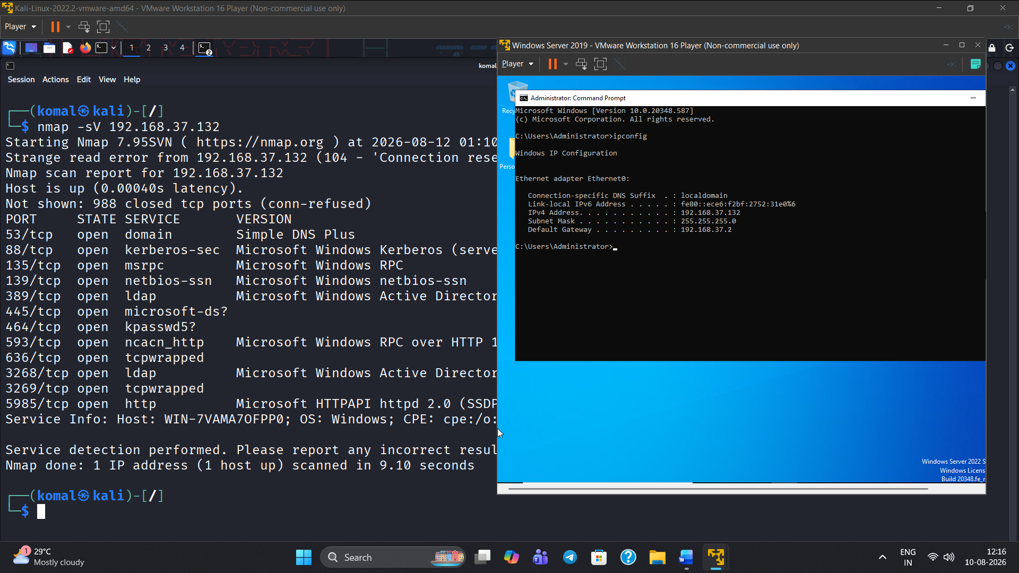
Figure 27 Exploit 3 (windows server) – screenshot 2 of 17.
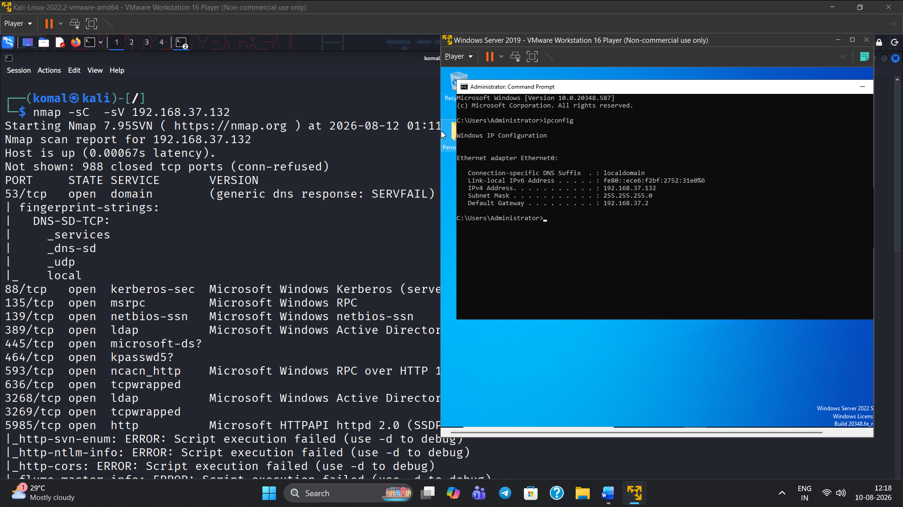
Figure 28 Exploit 3 (windows server) – screenshot 3 of 17.
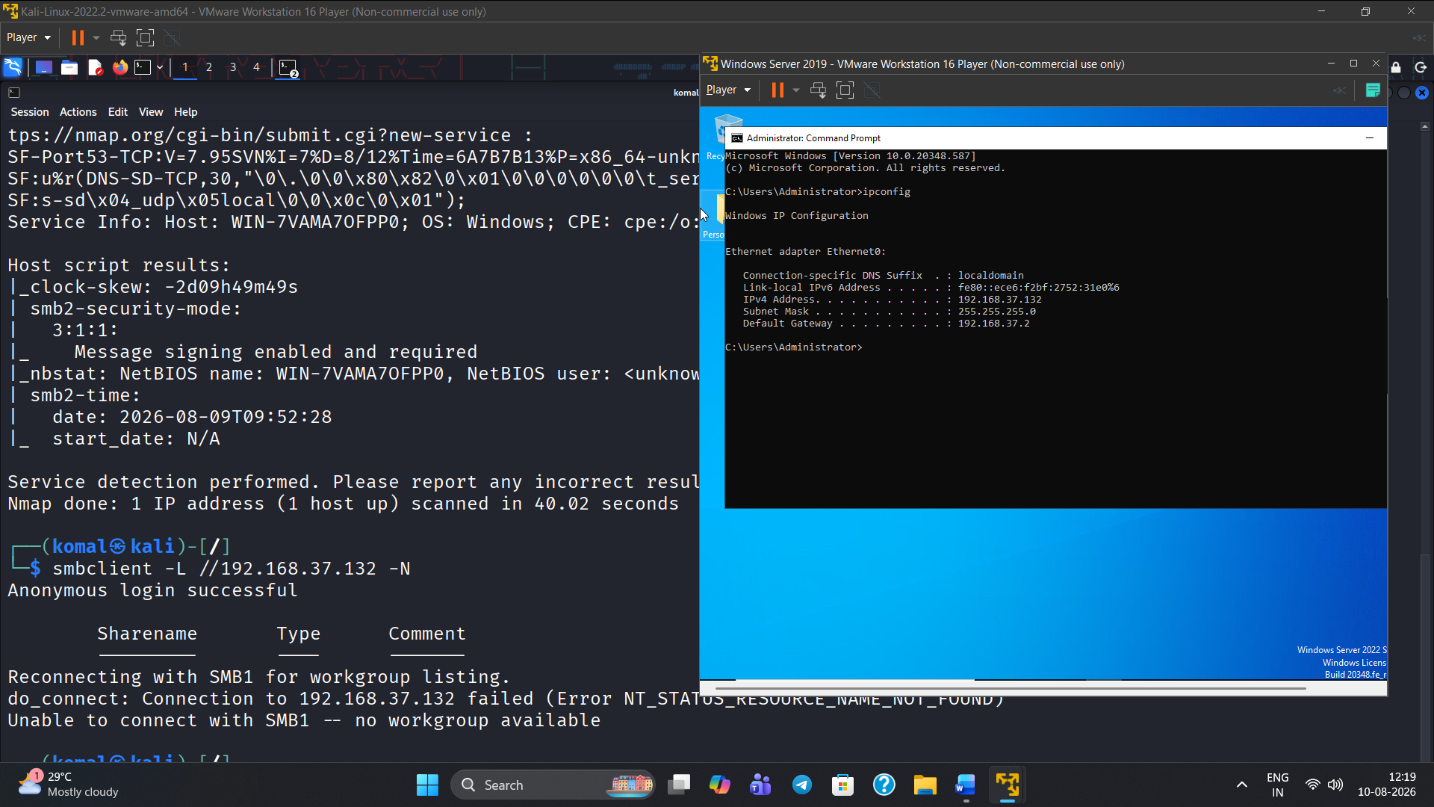
Figure 29 Exploit 3 (windows server) – screenshot 4 of 17.
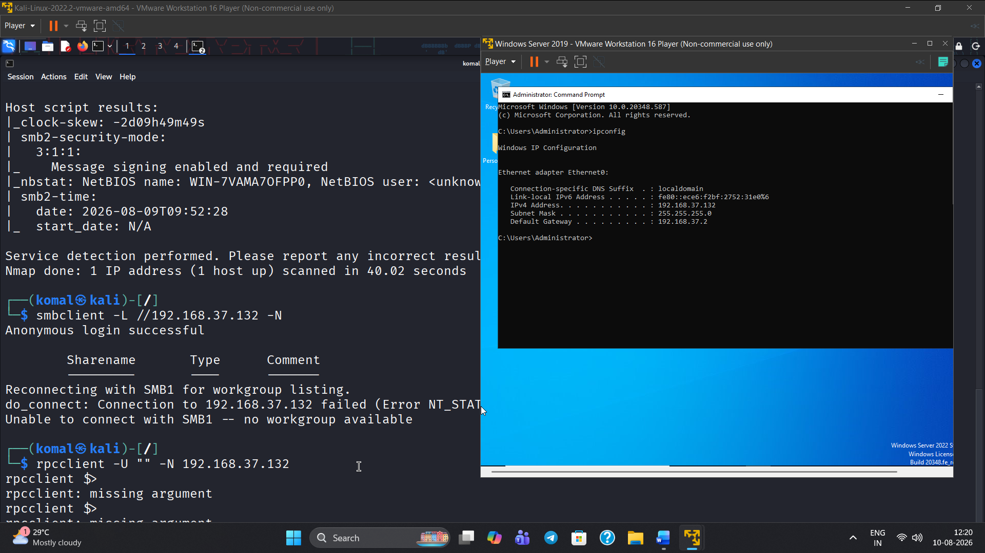
Figure 30 Exploit 3 (windows server) – screenshot 5 of 17.
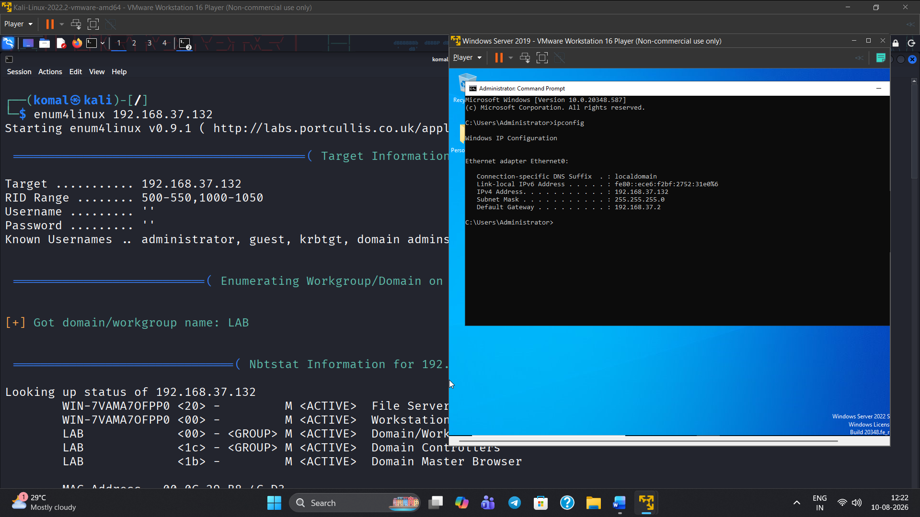

Figure 31 Exploit 3 (windows server) – screenshot 6 of 17.
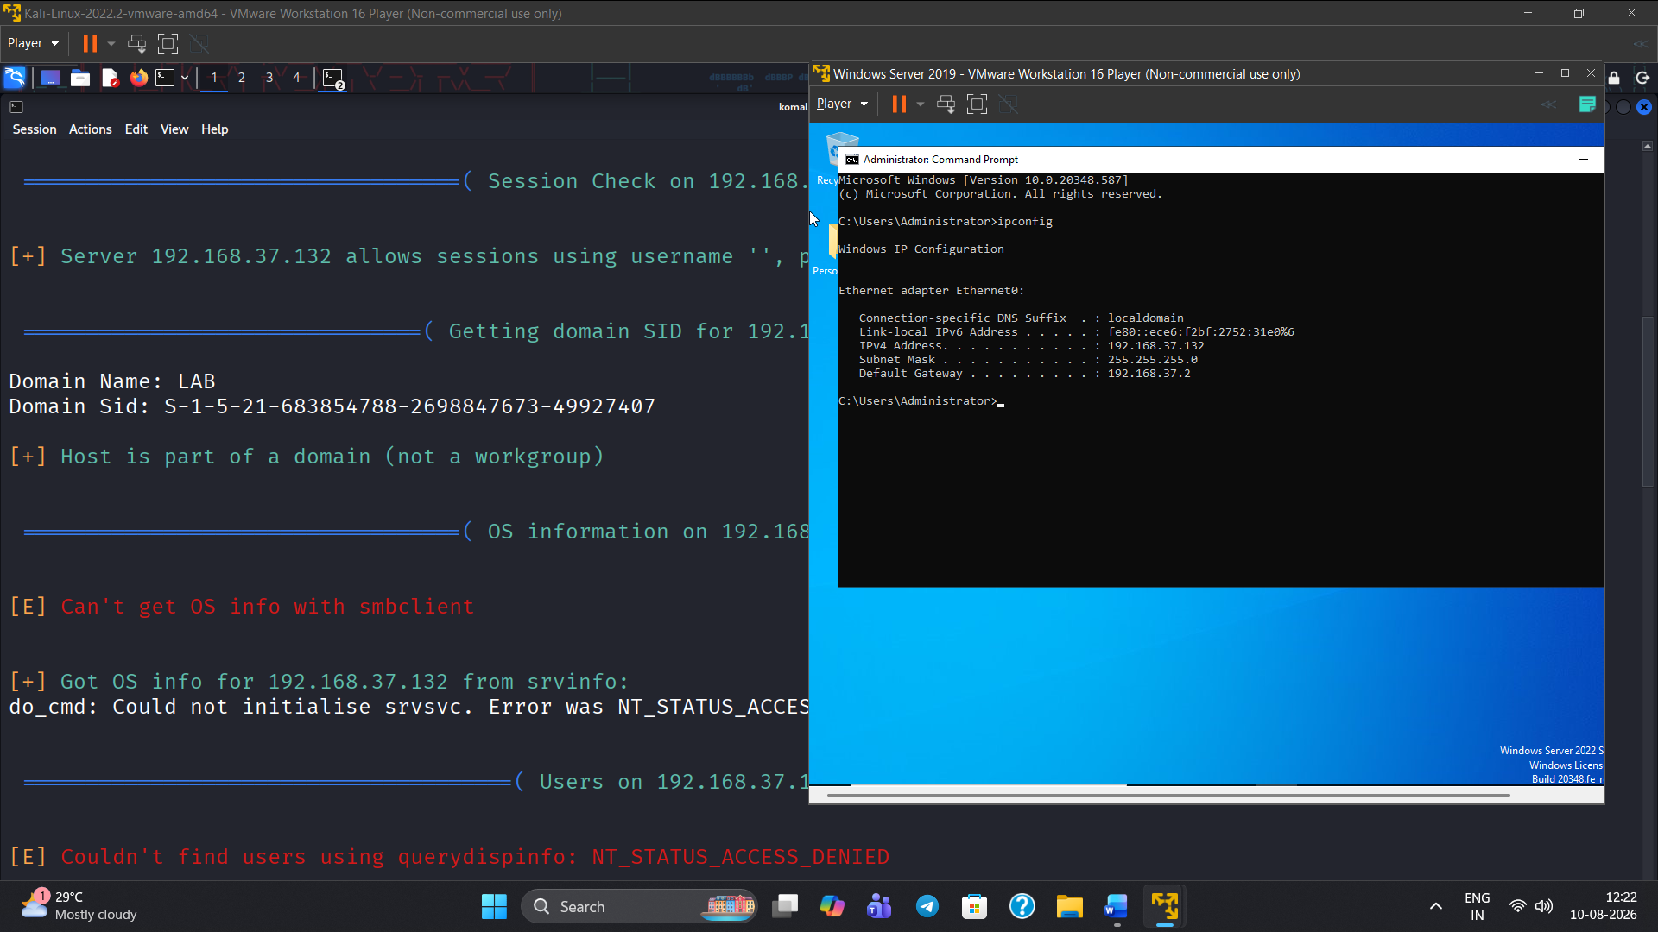
Figure 32 Exploit 3 (windows server) – screenshot 7 of 17.
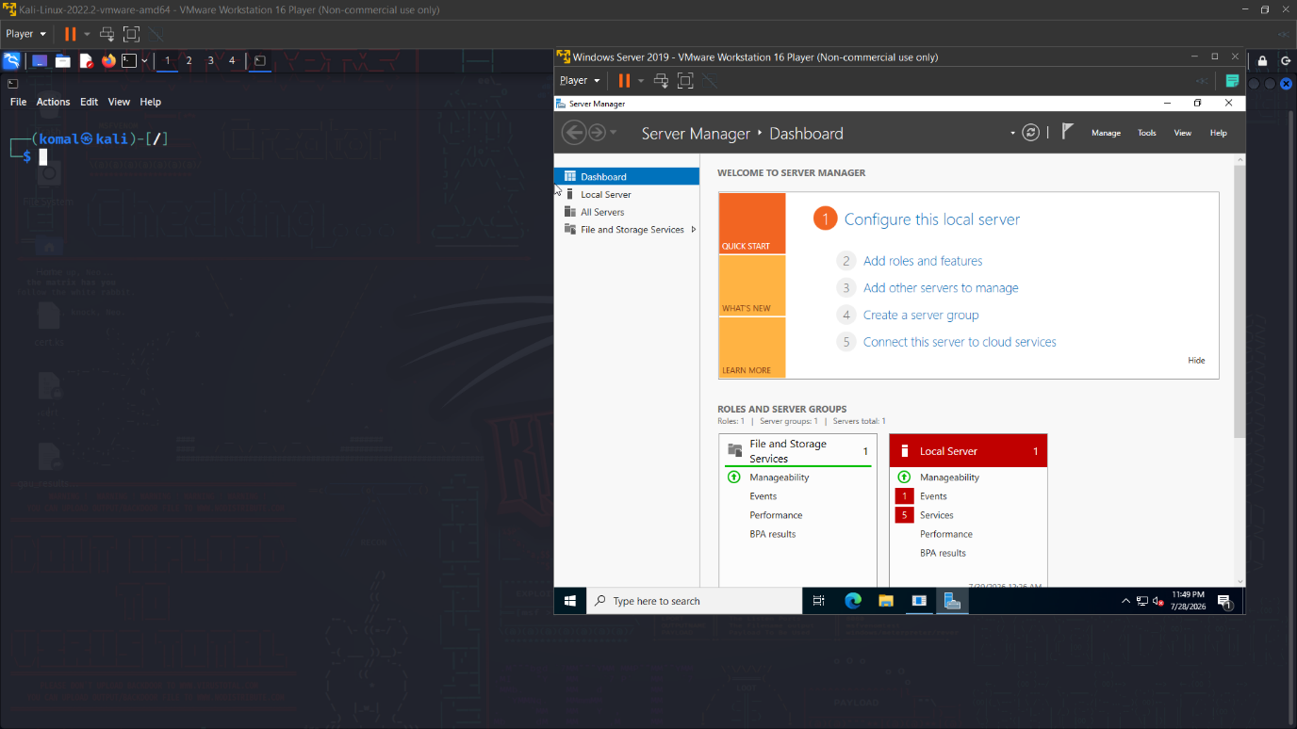
Figure 33 Exploit 3 (windows server) – screenshot 8 of 17.
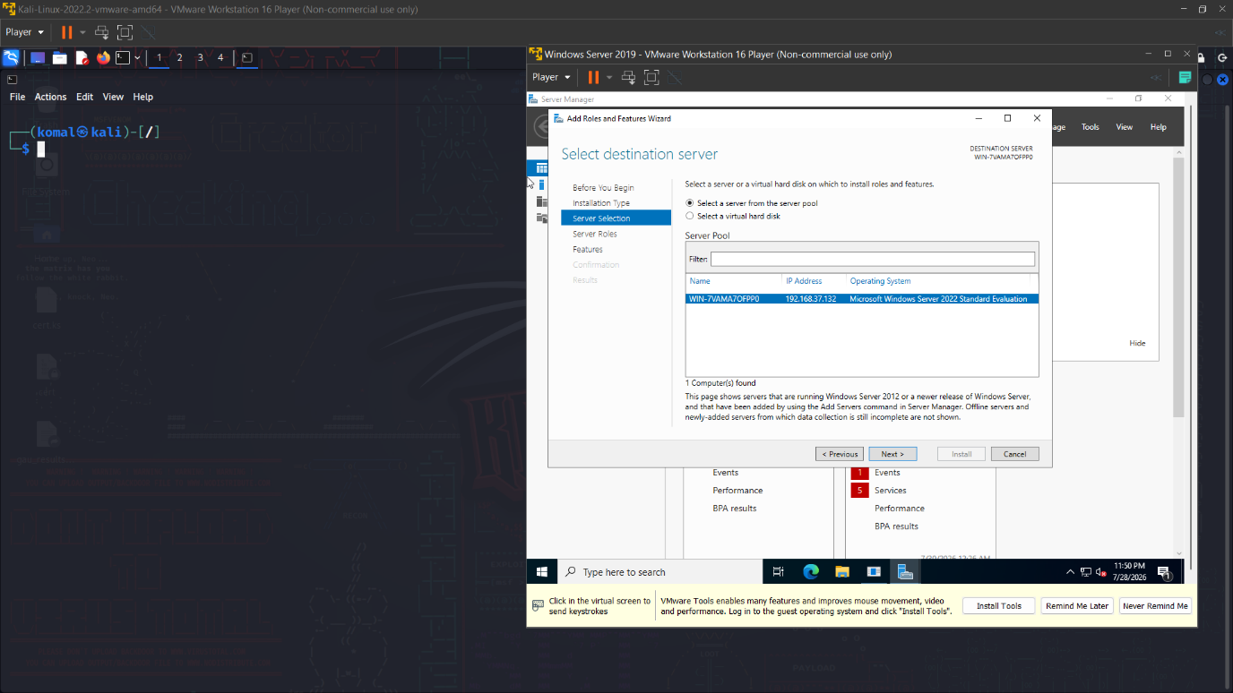
Figure 34 Exploit 3 (windows server) – screenshot 9 of 17.
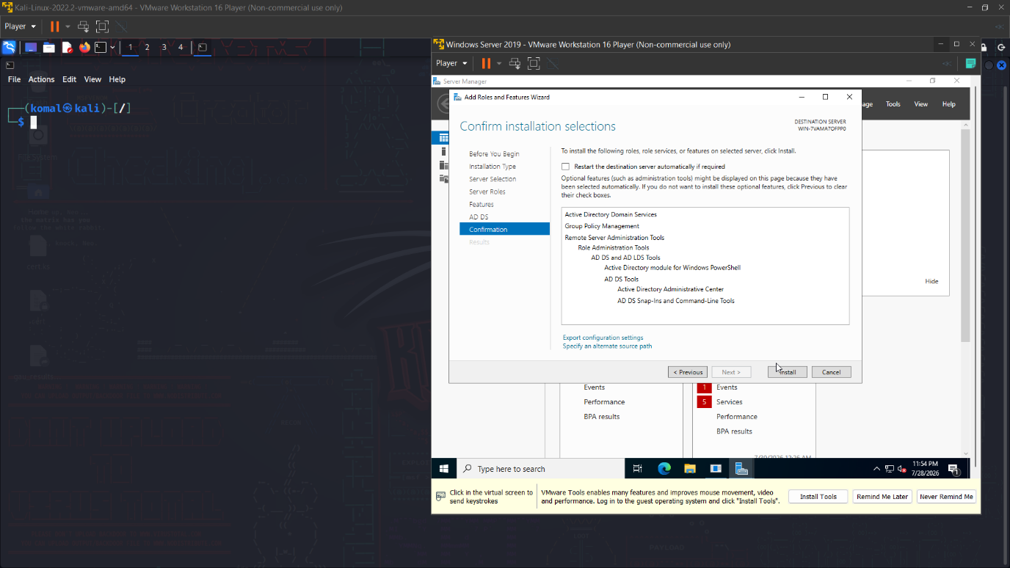
Figure 35 Exploit 3 (windows server) – screenshot 10 of 17.
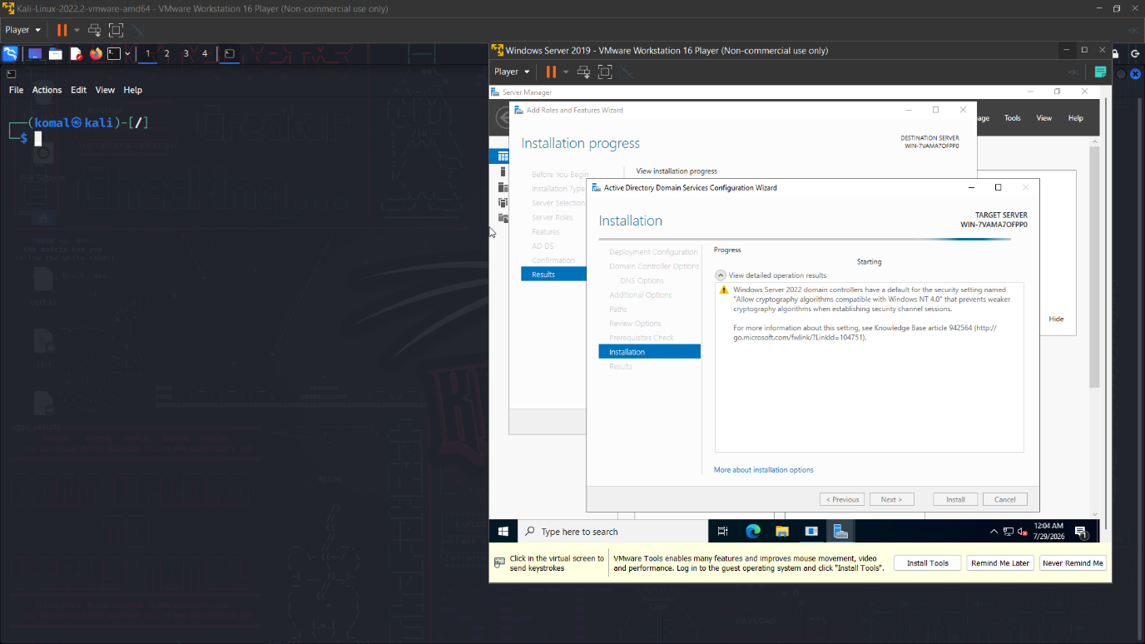
Figure 36 Exploit 3 (windows server) – screenshot 11 of 17.
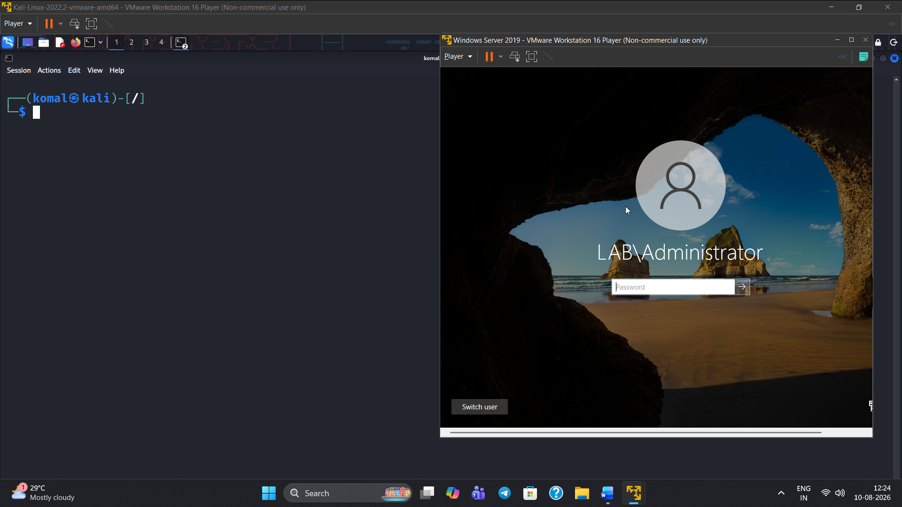
Figure 37 Exploit 3 (windows server) – screenshot 12 of 17.
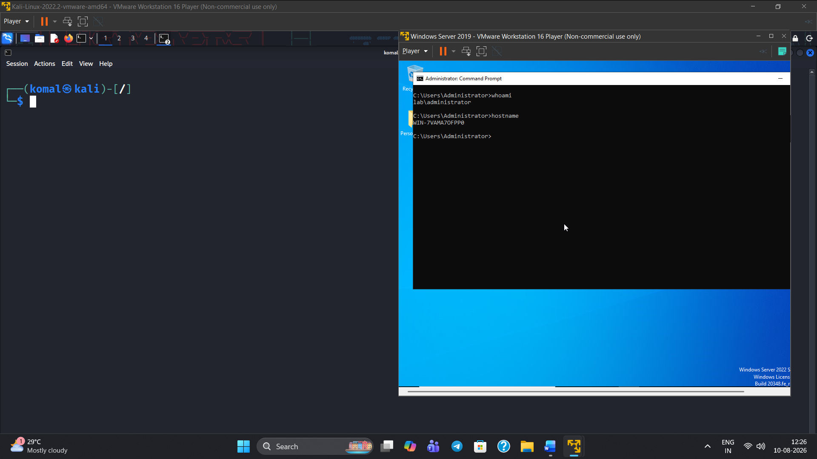
Figure 38 Exploit 3 (windows server) – screenshot 13 of 17.
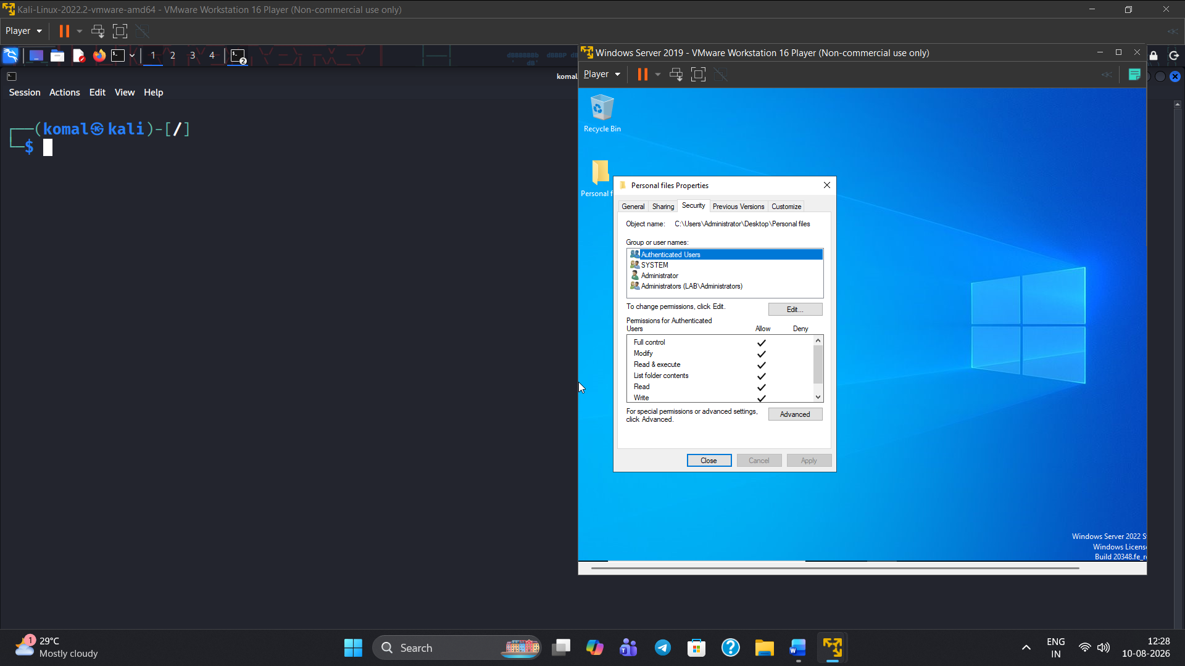
Figure 39 Exploit 3 (windows server) – screenshot 14 of 17.
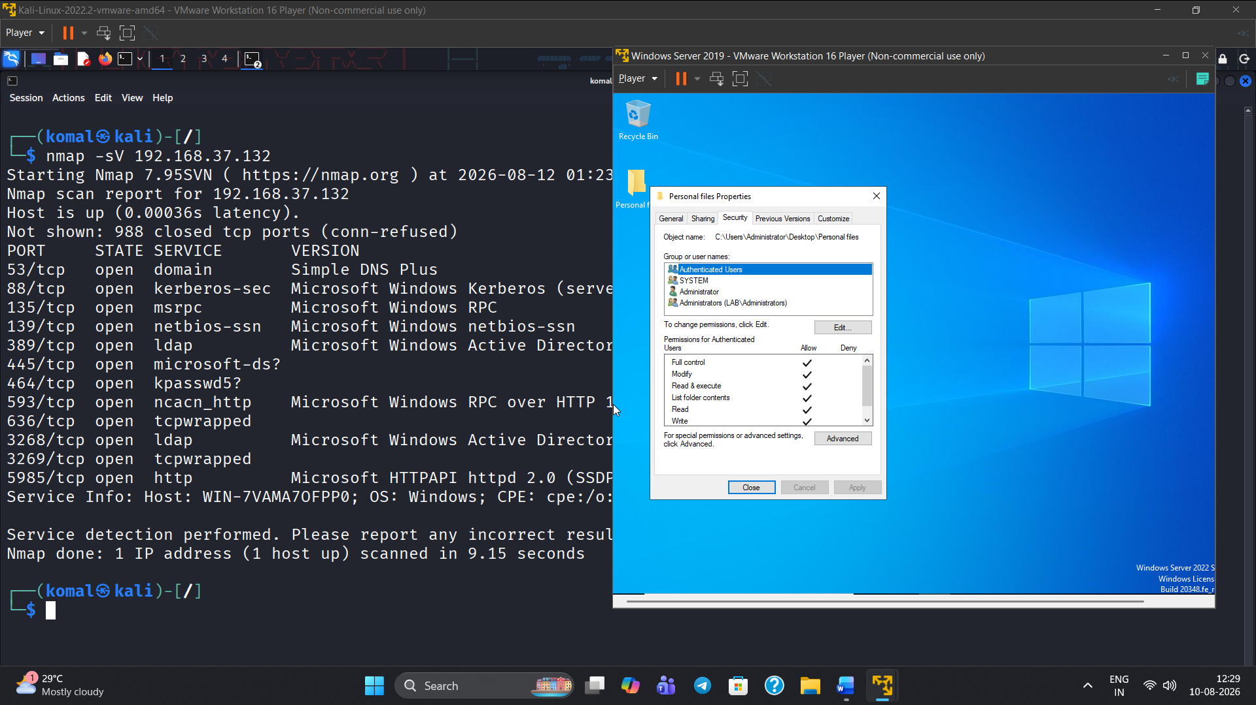
Figure 40 Exploit 3 (windows server) – screenshot 15 of 17.
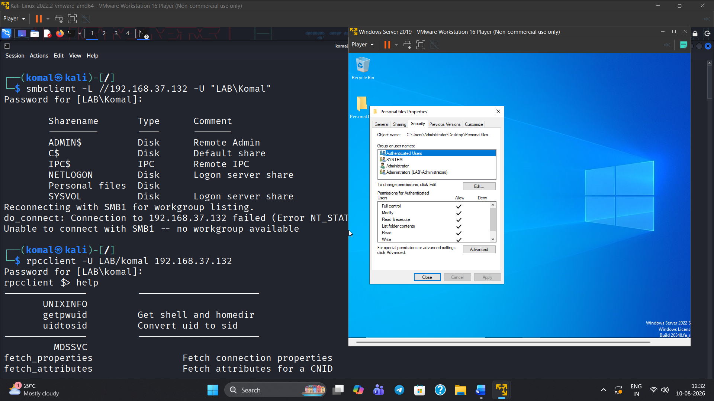
Figure 41 Exploit 3 (windows server) – screenshot 16 of 17.
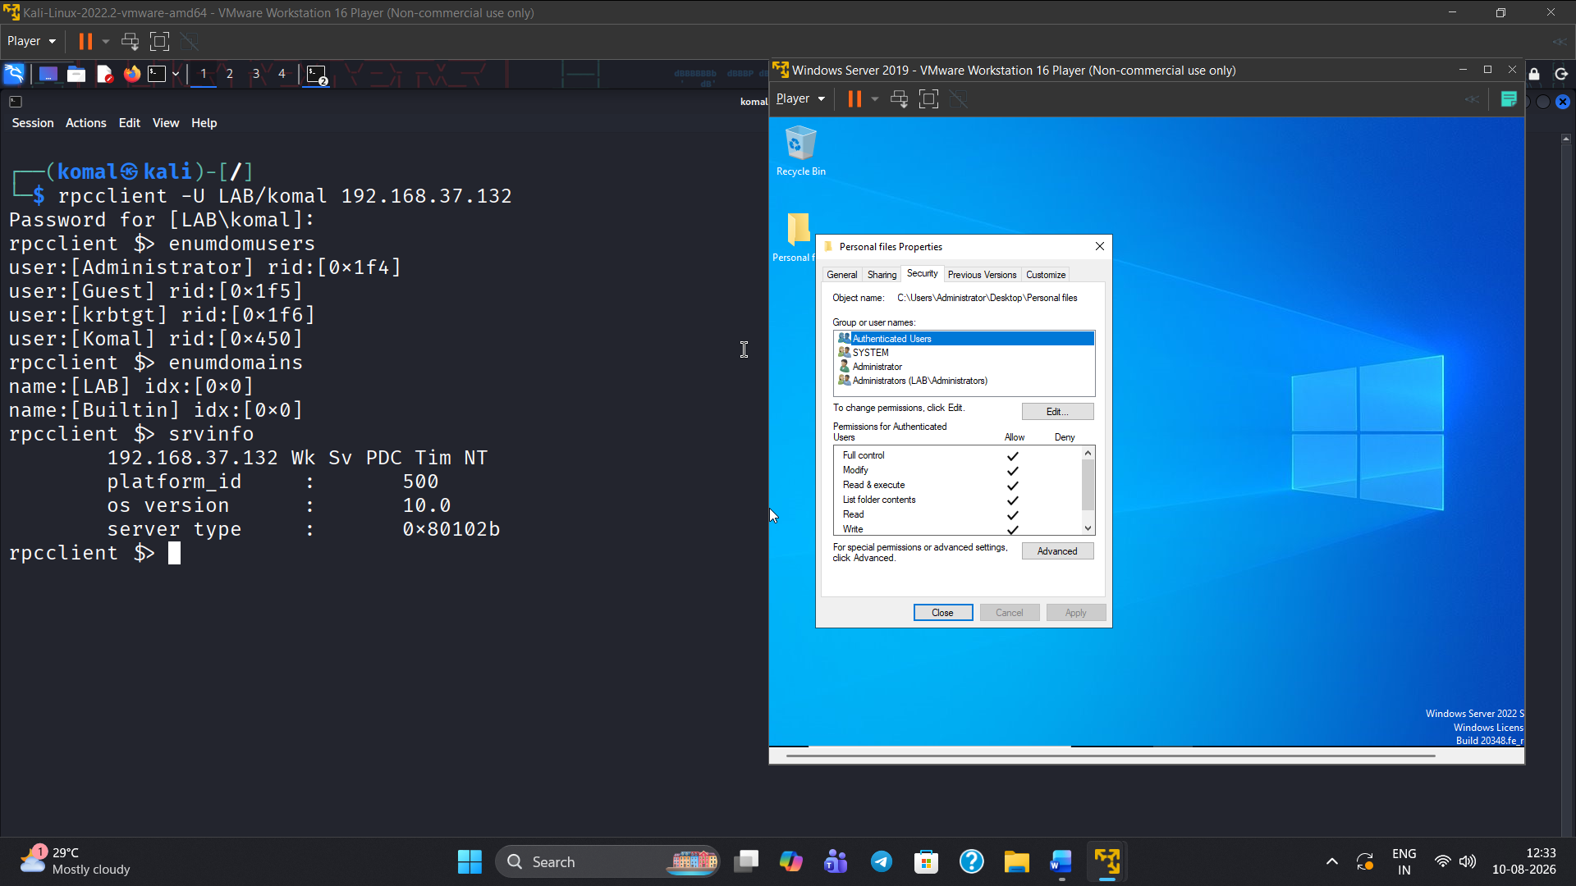
Figure 42 Exploit 3 (windows server)

