Cowley_1700561_HPHE6003_2

Q. Discuss the issue of authenticity in relation to battlefield / military memorials.

War has been a continuous part of human history right from its inception, and with it has come the need for soldiers to fight these conflicts as well as locations for them to be fought. As such, memorials have been established over the years, usually at these battle sites, to commemorate those who fought and died in war (Otterbein, 2004, pp. xi – 5 & 127 – 260). In terms of what we mean by memorial in this essay, I will be using the Oxford English Dictionary’s (Stevenson, 2010, p. 1105) definition of “a statue or structure established to remind people of a person or event”. Similarly, the term authenticity in this work will refer to how similar something is to the original counterpart it is representing (Stevenson, 2010, p. 107). As such, the authenticity of monuments relating to various battlefields, such as those commemorating the conflicts at Hafrsfjord, Stamford Bridge, and Lewes, as well as the more modern example of the Cenotaph relating to the First World War, will be analysed in this examination.

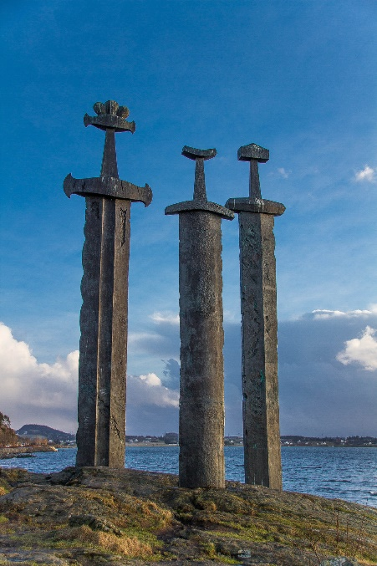
The first battlefield memorial that we will look at in relation to the issue of authenticity is that of the Battle of Hafrsfjord in the southwest of Norway. This naval battle occurred in c. 872 and is famous for traditionally signifying the unification of Norway under King Harald Fairhair of Vestford. It is believed that various petty Norwegian kings and earls, attempting to halt the expansion of King Harald, rallied together and sailed their large fleet south to meet Harald at the bay of Hafrsfjord near Stavanger. By the end of the battle, many of the leading petty kings and earls opposing Harald lay dead, leaving him as the sole ruler of a unified Norway (Grant, 2017, p. 121). Over 1,100 years later, the now famous Sverd i fjell monument, which is also known as the ‘3 Swords Monument’ and literally translates to the ‘Swords in the Rock’, (see Figure 1) was designed by Fritz Røed, a local Norwegian sculptor, before finally being unveiled in 1983 to commemorate the beforementioned battle (Mis, 2005, p. 30). These three, 10-metre-tall bronze swords protrude from the earth and are each topped with a different pommel, which according to David Nickel (2019, pp. 50 – 350), represents the three areas of the country that united under King Harald. Mis (2005, p. 30) supports this idea by linking the pommel designs to specific geographical areas, with the pommel mimicking a crown representing King Harald and his original kingdom of Eastern Norway, while the other two pommels are meant to depict the tribes of Western and Central Norway that were conquered by the first king of a unified Norway.
Figure 1: Image of Sverd i fjell. Taken by Dueland (2014).
In terms of the authenticity of this battlefield memorial, the main issue is simply the sheer size of these monuments, in that these swords, in their current state, would be unwieldable if they were to be used as an actual weapon, as something that shares authenticity with a sword should be. However, it can be claimed that this memorial has authenticity since the swords, at least on an initial inspection, do seem to represent Viking Age sword typology. This does seem to be the case regarding the central of the three monuments, in that this sword can be categorised as a Type P sword based on Petersen’s typology (Peirce & Oakeshott, 2002, pp. 18 – 19). However, this style of design only seems to be present between c. 900 and c. 950, which puts it outside of when the Battle of Hafrsfjord occurred, meaning that although this design can be claimed as having authenticity due to dating from the correct era, it does not date to the time of the battle and as such, the authenticity of this third of the monument is flawed. Continuing from this, the other two swords that create this memorial also seem to lack authenticity following a more in-depth analysis of their style. This is because they seem to be a mixture of sword designs rather than an officially categorised design, as evident with the sword on the right that seems to have a pommel associated with a Petersen Type H blade, but a guard that resembles that of a Petersen Type C sword. Although both swords seem to develop from the Petersen Type B design, they do diverge from one another with the former having a thinner guard and pommel than its latter Type C counterpart. It is for this reason that this second part of the memorial cannot be considered to have authenticity, as it is the combining of two distinct designs (Peirce & Oakeshott, 2002, pp. 18 – 19). Finally, the left sword in this battlefield memorial also lacks authenticity due to its design. This monument predominantly mimics that of a Petersen Type S sword, with its curved guard and flared ends, however, it seems the sculptor has taken some artistic liberty when he has come to crafting the pommel of this sword. Although the three lobes are consistent between the original Type S blade and its scaled-up version, the ones on the memorial have been squashed together to create gaps between the lower guard and the sides of the pommel, which the original does not have (Peirce & Oakeshott, 2002, pp. 18 – 19). The reason for this change was likely due to needing to distinguish the crown that represents King Harald Fairhair from the rest of the pommel, as well as from the other two structures (Mis, 2005, p. 30). Furthermore, the dating of the Type S design also leads to this memorial lacking authenticity in that this design was present around c. 925 – c. 1099, which is again at least 50 years after the battle occurred. Due to all the above, whether it be the design of these monuments or when the styles used for them date from, the Sverd i fjell monument in Norway demonstrates the issue of authenticity regarding battlefield and military memorials (Peirce & Oakeshott, 2002, pp. 18 – 19).

Continuing from this, another battlefield memorial that relates to the issue of authenticity is that of the Battle of Stamford Bridge, which occurred on the 25th September 1066 (Marren, 2004, pp. 1 – 50). This battle, which usually marks the end of the ‘Viking Age’, was fought between the forces of King Harold Godwinson of England and King Harald Hardrada of Norway for the crown of England following the death of Edward the Confessor at the beginning of the year. By the end of the battle, King Harald Hardrada, as well as the traitorous brother of the King of England, Tostig Godwinson, lay dead along with a large proportion of the 5,000 men who made up the Norwegian forces (McLynn, 1998, p. 204). It was not until the 1950’s however that a memorial to the battle appeared with the establishment of an upright stone set upon a stone plinth (see Figure 2), marked with the inscription that ‘THE BATTLE OF STAMFORD BRIDGE WAS FOUGHT IN THIS NEIGHBOURHOOD ON September 25th 1066’, in both Norwegian and English (Cooke, 2006, pp. 194 – 196).
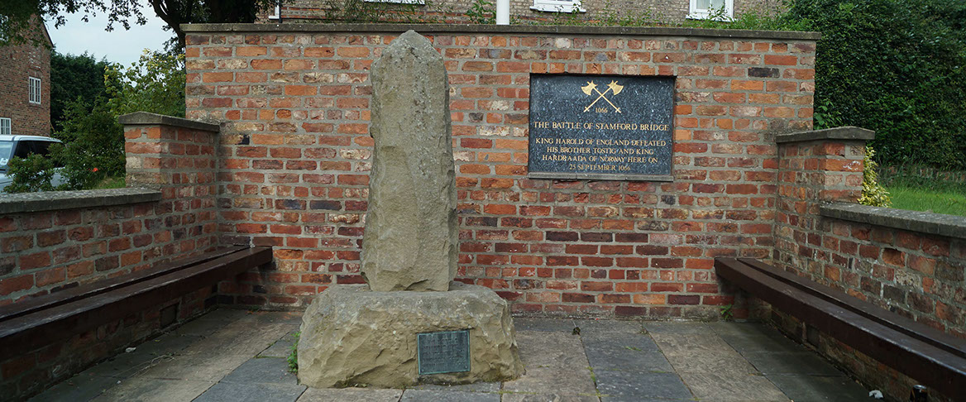
In terms of the authenticity of this battlefield memorial, the fact that this inscription is in both languages does suggest that this memorial has authenticity, in that the languages used belong to the sides who fought one another. However, this is really the extent of how authentic the monument is, as the stones that make up the Stamford Bridge memorial do not have any relation to the battle itself, and it would not be possible to identify this monument as a memorial if not for the beforementioned plaque at the bottom of the structure. Furthermore, this memorial is also located in the centre of town, rather than at the site of the actual battlefield, which means that the authenticity of this memorial is decreased as it is misdirecting remembrance to a site that is separate to that of the battle (Cooke, 2006, pp. 194 - 197). Continuing from this, Cooke (2006, pp. 194 – 196) states that the extension to the memorial, which consists of the surrounding brickwork as well as the secondary plaque positioned on part of the new wall, was funded by a American historian, which could be used to diminishes the authenticity of this site further as America has no connection what so ever to the Battle of Stamford Bridge. The closest you could get regarding a possible connection would be the Viking inhabitants of Greenland and Vinland who encountered the Native Americans around the turn of the century (Chartrand, et al., 2016, pp. 128 – 140). However, apart from this tenuous link, there is no other connection between the Battle of Stamford Bridge and America so the fact that an American funded part of this memorial removes some more of the monument’s authenticity. Finally, the last aspects of authenticity that this memorial had are removed due to the secondary plaque mentioned above. Not only does this plaque display weapons inaccurate to the period, mimicking the beforementioned issues regarding the Sverd i fjell design, but it also outlines incorrect information in the form of calling King Harald of Norway by his nickname, so the inscription says ‘King Hardraada’ instead of King Harald (Cooke, 2006, pp. 194 – 196). Although this may not seem a major issue, Cooke (2006, pp. 194 – 196) again points out that this is like calling King Alfred or King William I King Great or King Conqueror respectively, which is completely incorrect and as with many royal nicknames, King Harald’s did not appear until after his death, which again contributes to decreasing the authenticity of this memorial to almost zero. As is evident with this example, the issue of authenticity in relation to a battlefield memorial can be demonstrated by the location and information presented by such monuments.
Figure 2: Image of the Battle of Stamford Bridge Memorial. Taken by Lancaster (2014).
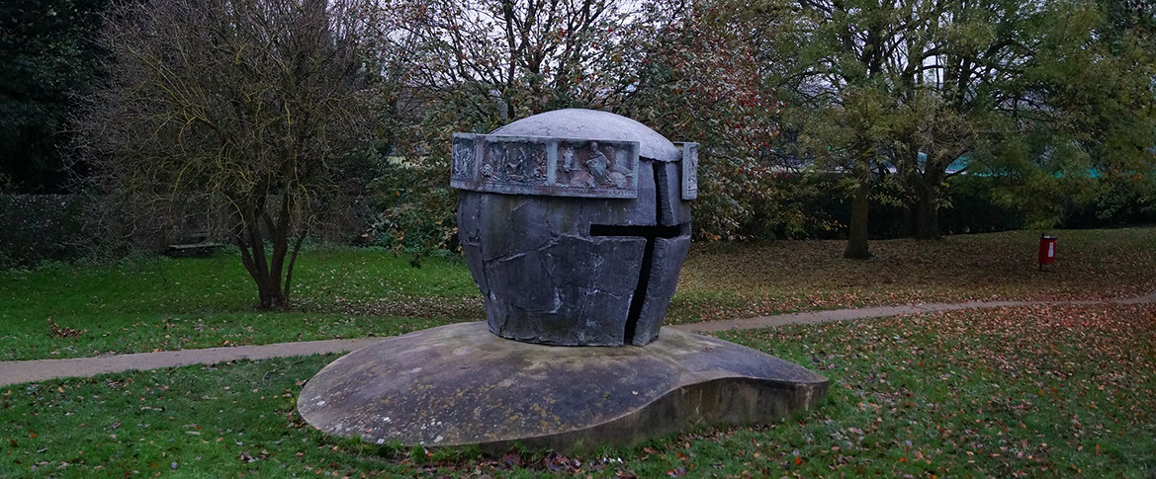
Figure 3: Image of the Battle of Lewes Memorial. Taken by Lancaster (2012).
Moving forward a couple of hundred years, we come across the Battle of Lewes on the 14th May 1264, whereby the rebels under Simon De Montfort defeated and captured King Henry III as part of the aptly named Barons’ War (Bradbury, 2004, p. 215). This conflict was a result of Henry’s lack of respect for his counsellors, who he frequently ignored, as well as his favour for individuals external to the kingdom, such as the relatives of his French wife. Tensions had continued to rise before finally culminating in 1258 with several of the English elite and clergy getting together in an attempt to limit the King’s power and authority with the Provisions of Oxford. However, by 1261, Henry, with Papal backing, had regained his autonomy and caused many of his nobility who still opposed him, such as the Earl of Leicester, Simon De Montfort, to leave the country. Despite this, De Montfort returned to his estates in 1263 and reintroduced the beforementioned Provisions, leading to a break down in law and order before all out civil war occurred, including the Battle of Lewes (Brooks, 2015, pp. 1 – 25). To mark the 700-year anniversary of the battle, a sculptor by the name of Enzo Plazotta designed a battlefield memorial (see Figure 3), in the form of a large helmet shaped topped with a bronze tapestry of text and images, which was unveiled in the grounds of Lewes Priory where the structure still stands today (Sadler, 2008, pp. 150 – 192).
Regarding the authenticity of this memorial, one major issue, as pointed out by Brooks (2015, pp. 1 – 25), is the depiction of Simon De Montford on the bronze circlet of the helmet, in that like most people dating from the Medieval period, his appearance remains an enigma to us. Despite this, De Montfort is presented as a bearded warrior in plate armour, even though the former characteristic cannot be proven, and the latter is incorrect to the time period of the battle (Brooks, 2015, pp. 1 – 25). As such, the depiction of De Montfort on this memorial decreases the monuments authenticity as it is based upon historical inaccuracies. Continuing from this, the physical appearance of this memorial also raises questions regarding its authenticity, in that great helms, which is what the Lewes memorial is attempting to represent (Sadler, 2008, pp. 150 – 192), were used during the 13th Century, however they would only have had a horizontal slit or two for vision, instead of horizontal and vertical slits as depicted on the monument (Lepage, 2005, pp. 88 – 90). Although this inaccuracy decreases the authenticity of the monument, the symbolism behind it does aid in increasing its legitimacy somewhat, in that the horizontal and vertical slits form the shape of the cross, the symbol of Western Christianity, which was the definitive religion of Western Europe during the Medieval period that dominated every important aspect of an individual’s life (Madigan, 2015, pp. xvii – xix). As such, the presence of this symbol intwined with that of the memorial does increase the authenticity of this monument. However, here is again another example of the issue of authenticity in relation to battlefield memorials in that although symbolism within a monument can indicate authenticity, the image and iconography of a structure can ruin its authenticity if they are presented in an inaccurate way.

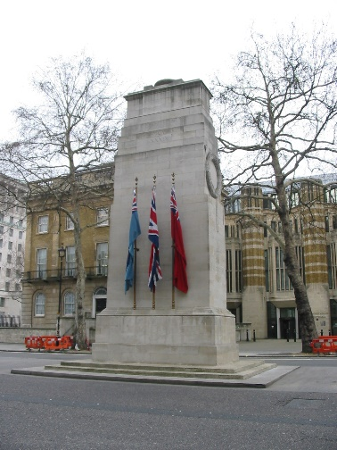
One final and more modern example of the issue of authenticity regarding a battlefield or military monument are those that commemorate those who sacrificed themselves during the First and Second World Wars, such as the Cenotaph (see Figure 4). This memorial dates to the end of World War One and was originally unveiled as a temporary structure in celebration of the signing of the Treaty of Versailles. The idea behind this 10 metre tall, sarcophagus topped, monument, which was designed by Sir Edwin Lutyens, was to mark a point at which the Allied Forces, who were performing a ceremonial march through London, could salute in unison to commemorate their fallen comrades during the Peace Day parades on the 19th July 1919 (Lloyd, 1998, pp. 49 – 59). Although initial plans to remove the Cenotaph following the parade, public opinion regarding the structure caused Parliament to reconsider their decision, before finally concluding to erect a permanent version of the monument, which was unveiled in November 1920, and quickly became a place of mourning where many would go on pilgrimage to pay their respect to the dead (Lloyd, 1998, pp. 49 – 69).
Figure 4: Image of the Cenotaph. Taken by Encyclopædia Britannica (2008).
Regarding the issue of authenticity, the Cenotaph is an interesting memorial in that, as highlighted by Stamp (2007, pp. 40 – 55), the monument does not contain any religious iconography or references to triumph or glory, which is important as the war was not defined by religion. Whether a soldier was a Christian, Jew, or follower of another faith, they all fought side by side for the British forces, so the fact that there is no religious symbolism on this memorial represents this and suggests some level of authenticity for the Cenotaph (Snape, 2007, pp. 250 – 336). Likewise, the fact that this memorial does not glorify the First World War is another aspect that increases the authenticity of such a structure as the war was one of the worse horrors to befall mankind, (Lloyd, 1998, pp. 49 – 69) with Poole (2019, pp. 1 – 150) going as far as to claim that the concepts within modern horror developed from this conflict, so the Cenotaph is still representing the authenticity of the war by not glorifying it. However, questions must be raised over the authenticity of the shape and structure of the actual memorial, in that although other nations have used similar monuments to commemorate those who died in the World Wars, with the term Cenotaph actually originating from the French ‘cénotaphe’, the structure itself of the monument does not seem to mimic an item or aspect used or synonymous with World War One (Lloyd, 1998, pp. 49 – 52). Continuing from this, the minimalistic nature of this memorial has two main effects in regards to the issue of authenticity, in that its simplicity prevents distraction from contemplating anything other than those who have perished, and that it also harkens back to more classical monuments of commemoration, which could be seen as a way of linking those who died more recently to the great legends of Ancient Greece. Of these, it is only really the latter concept that highlights the issue of authenticity, in that by linking the ‘present’ with a bygone time, you are not confining what is represented to a specific period or situation, which is necessary in order to maintain a high level of authenticity (Goebel, 2007, pp. 62 – 70). As such, it must be claimed that the Cenotaph is lacking authenticity. The final aspect of the Cenotaph monument that raises the issue of authenticity is the sarcophagus situated at the top of the structure (Lloyd, 1998, pp. 49 – 52). Interestingly though, this coffin is uninhabited, which according to Goebel (2007, p. 65), is clearly evidence from the name of the monument, which means ‘empty tomb’. This again raises questions regarding the authenticity of this memorial as the missing inhumation can be seen in both a positive and negative way regarding legitimacy. For example, the fact that the tomb is empty causes the public to admire and commemorate something that is not physically there, which can be seen as an inaccuracy on the part of the monument (Goebel, 2007, pp. 62 – 68). However, it can also be claimed that the emptiness of this coffin does not matter, and it is there more to demonstrate the idea of belonging to all those who have passed, rather than only one specific individual. As such, the symbolism and connotations behind the Cenotaph suggest that it does have some authenticity as a monument tasked with fostering commemoration, despite its physical appearance suggesting somewhat less so (Lloyd, 1998, pp. 49 – 67). As has been evident, the Cenotaph is another monument that demonstrates the issue of authenticity, in relation to a physical structure rather than a symbolic one, regarding military memorials.

In conclusion, the issue of authenticity in relation to battlefield and military monuments is one of importance and controversy. Whether it be in commemoration of a specific battle or an overarching confrontation, authenticity, in representing something in an accurate manner, must be applied to our commemorative structures. As has been evident, this issue can manifest itself in a variety of ways, whether it be in the design or style of the physical monument, as evident with the Sverd i fjell memorial and the Cenotaph, to where it is located and what information it presents, as seen with the memorials of Stamford Bridge and Lewes. No matter how though, the issue of authenticity usually comes down to not presenting the memorial in a correct and appropriate way, regarding the time period it is attempting to represent (Brooks, 2015, pp. 1 – 45). That said, as has been evident, sometimes this is done in order to symbolise an important aspect of the battle or period, however, on the whole, when this is done, it overshadows the underlying details that are important to portraying the correct period, as evident with the latter two memorials looks at in this study (Stamp, 2007, pp. 40 – 55). Overall, all the battlefield and military memorials analysed in this study, as well as most battlefield memorials in general, suffer from the issue of authenticity in one way or another.

Word Count: 3,204.

Bibliography
Secondary Sources

Bradbury, J. (2004) The Routledge Companion to Medieval Warfare. London: Routledge.

Brooks, R. (2015) Lewes and Evesham 1264 – 65: Simon De Montfort and the Barons’ War. London: Bloomsbury Publishing.

Cooke, D. (2006) Battlefield Yorkshire: From the Romans to the English Civil Wars. Barnsley: Pen & Sword Military.

Chartrand, R. et al. (2016) The Vikings. Oxford: Osprey Publishing.

Goebel, S. (2007) The Great War and Medieval Memory: War, Remembrance and Medievalism in Britain and Germany, 1914 – 1940. Cambridge: Cambridge University Press.

Grant, R. G. (2017) 1001 Battles That Changed the Course of History. New York: Chartwell Books.

Lepage, J. G. G. (2005) Medieval Armies and Weapons in Western Europe: An Illustrated History. London: McFarland & Company, Inc., Publishers.

Lloyd, D. W. (1998) Battlefield Tourism: Pilgrimage and the Commemoration of the Great War in Britain, Australia and Canada, 1919 – 1939. London: Bloomsbury Publishing.

Madigan, K. (2015) Medieval Christianity: A New History. New Haven: Yale University Press.

Marren, P. (2004) 1066: The Battles of York, Stamford Bridge & Hastings. London: Grub Street Publishers.

McLynn, F. (1998) 1066: The Year of the Three Battles. London: Jonathan Cape.

Mis, M. S. (2005) How to Draw Norway’s Sites and Symbols: A Kid’s Guide to Drawing the Countries of the World. New York: The Rosen Publishing Group, Inc.

Nickel, D. (2019) Moon Norway. London: Hachette UK.

Otterbein, K. F. (2004) How War Began. Texas: Texas A&M University Press.

Peirce, I. and Oakeshott, E. (2002) Swords of the Viking Age. Woodbridge: The Boydell Press.

Poole, W. S. (2019) Wasteland: The Great War and the Origins of Modern Horror. Berkeley: Counterpoint Press.

Sadler, J. (2008) The Second Barons’ War: Simon De Montfort and the Battles of Lewes and Evesham. Barnsley: Pen & Sword Military.

Snape, M. (2007) God and the British Soldier: Religion and the British Army in the First and Second World Wars. London: Routledge.

Stamp, G. (2007) The Memorial to the Missing of the Somme. London: Profile Books Ltd.

Stevenson, A. (2010) Oxford English Dictionary. 3rd edn. Oxford: Oxford University Press.

Williams, G. (2019) Weapons of the Viking Warriors. Oxford: Osprey Publishing.

Electronic Sources
Dueland, S. (2014) Sverd i fjell (2). Available at: https://www.flickr.com/photos/stendueland/12535970435 (Accessed: 08/03/2020).

Encyclopædia Britannica (2008) Cenotaph: Architecture. [website]. Available at: https://www.britannica.com/technology/cenotaph (Accessed: 08/03/2020).

Lancaster, J. (2012) Battle of Lewes: 1264. [website]. Available at: http://www.battlefieldsofbritain.co.uk/battle_lewes_1264.html (Accessed: 08/03/2020).

Lancaster, J. (2014) Battle of Stamford Bridge: 1066. [website]. Available at: http://www.battlefieldsofbritain.co.uk/battle_stamford_bridge_1066.html (Accessed: 08/03/2020).

