

GRADUATE CERTIFICATE in Consolidation of Social Work Practice
LEVEL 6 - 60 Credits
BMPF6044

LEARNER PORTFOLIO
(PORTH AGORED and UNIVERSITY OF WALES TRINITY SAINT DAVID)

Learner’s name: Osian Evans

Email address: osian.evans@hotmail.co.uk; 2236138@student.uwtsd.ac.uk

Learner’s University Registration Number:
2236138

Cohort: 21 onwards

Task 1
Part a

Developmental review

Guidance:
Task 1 part a asks you to use a model of reflection to reflect on your past practice and future developmental needs. It should be completed by taking into account the work you have undertaken since qualifying. In discussions with your mentor and/or supervisor/line manager identify your future developmental needs as part of your First Three Years of Practice Individual Plan under each of the 3 learning outcomes below.
You must meet the Learning Outcomes for this task (see appendix 4 of the handbook).

Please answer all elements of the question below.

Question:

Using a reflective model critically reflect on your professional development since qualifying as a social worker. Based on this and in discussion with your mentor/supervisor/line manager go on to identify and justify your future developmental needs over the coming 12 months under each of the 3 Social Care Wales (SCW) learning outcomes listed below providing at least one developmental need for each of the learning outcome below:

- Applying analysis in assessment to inform interventions.
- Working collaboratively with people in need of care and support, their carers and other professionals.
- Intervention and application of professional judgement in increasingly complex situations.

This task must make reference to how the supervision, training, learning and research has and will inform your practice.

750 words (+/- 10%: include your actual word count at the end of each section).

I was recruited as a newly qualified Supervising Social Worker 01 October 2021 for the Fostering Wales Anglesey team. My duties involve the assessment, support and supervision of connected person’s foster carers, whom are family or close friends of children who become looked after by the local authority.

I will be reflecting on my first year in practice using Borton’s ‘What, so what and now what’ model (Borton, 1970). The framework includes three questions (What? So what? And Now what?) which are asked in a chair reaction to interventions:

Using this reflective practice as part of my First Three Years of Practice Individual Plan, has enabled my line manager and I agree on my future developmental needs over the coming 12 months. We have considered how I can better achieve the three Social Care Wales (SCW) learning outcomes as numbered in the remainder of this document;

Mistrust is ‘what’ I initially sense from carers wary of the power the department may possess. The ‘so what’ I must consider is how to overcome this barrier and ensure they fully understand the objectivity of the assessment. I need to be emotionally intelligent and exhibit understanding and empathy of their emotions to build trust. Emotional intelligence (Grant and Kinman’s, 2009) means I reflect and monitor how my actions effect my feelings and emotions as well as those of the families and individuals I support.

Foster carers’ are often reluctant to discuss their own Adverse Childhood Experiences (ACEs), relationships and parenting abilities as part of the assessment. The ‘now what’ conclusion is to explain objectively of the assessment due to the regulations. Training on Motivational interviewing has therefore been identified in my professional learning and development plan.

I’ve realised ‘what’ makes me become frustrated with individuals and the decision-making process. ‘So what’ I’ve found enhances my ability to understand, control, and evaluate my emotions is taking time out to reflect and debrief. ‘so what’ I intend on avoiding is becoming overwhelmed and self-care avoids compassion fatigue. I have reflected how my own experiences can be triggers so have considered my how own resilience relate to practice. The Trauma Informed and Mental Health Schools Practitioner Training I completed 2022/2023 made me consider I need to ensure carers overcome their own trauma before they can be emotionally available adults nurturing the resilience of children with ACEs. To meet this learning need of avoiding being overwhelmed in the next 12 months, I aim to use supervision, do more research and training on emotional intelligence.

Foster carers often ask ‘what’ will happen to them, or ‘what’ I could do on their behalf? Empowerment, and strength based social work values prompts ‘so what’ we can achieve together. ‘Now what’ works to enable carers to make decisions themselves, is to prepare them for meetings, so they contribute to decision making.

Reflecting on practice within a supportive team and in supervision sessions has enhanced my resilience to stress and builds a positive team. I discuss which theories are most effective with my practice lead, colleagues, and other professionals. I find the shared experience of taking a child centred approach encourages synergy between the families and the multidisciplinary team. As the nature of my work is task centred and involves co-production, I have asked in my annual appraisal for training on solution based social work. Looking forward to the next 12 months, I will be therefore plan training to develop my skills in working collaboratively with people.

I critically reflect on ‘what’ the fostering panel, judges and Independent Reviewing Officers comment on my assessments and casework. My practice lead encourages me to be open an honest regarding constructive criticism and questions ‘so what’ needs to change or improve. Reflecting on ‘what’ I feel and respond on feedback/comments has changed since I qualified as I now feel it is important to learn from feedback and welcome it to develop professional judgement (Vibeke & Turney 2017; Taiwo, 2022).

Awareness of professional accountability leads me to challenge decisions appropriately with the foster carers and in meetings with managers and shows and understanding of policies and regulations (Brown, Sebba & Luke 2014). I will be following further training on the litigation regarding my work and participate in fostering events and activities which are also critical in building trust and collaboration with the connected persons foster carers. I therefore intend to further become critically reflective by exploring my own role and incorporate collaborative conversation training in my training plan for the next 12 months.

747 Words

Task 1
Part b
Developmental Review

Guidance:
Task 1 part b is a 2-part question and a continuation of task I part a and you must refer to a reflective model in this task.
Please ensure that you meet the required learning outcomes for this task (See appendix 4 of the handbook) and that you answer both parts of the question.

Please answer all elements of the question below.

Question
Use a reflective model to critically reflect on the learning needs you identified in task 1 part a under each of the 3 SCW learning outcomes.
This must include reference to training, learning, research and supervision and reflection with your mentor/supervisor/line manager on the extent to which your learning outcomes has been achieved.
Identify your learning needs to support your development in the transition to becoming an experienced practitioner in your future career following the completion of this programme.

650 words (+/- 10%: include your actual word count at the end of each section).

I consider that I have developed my skills and knowledge in a number of areas of social work practice over the last year. I will reflect on the last year using the Boud (1985) Reflective Model.

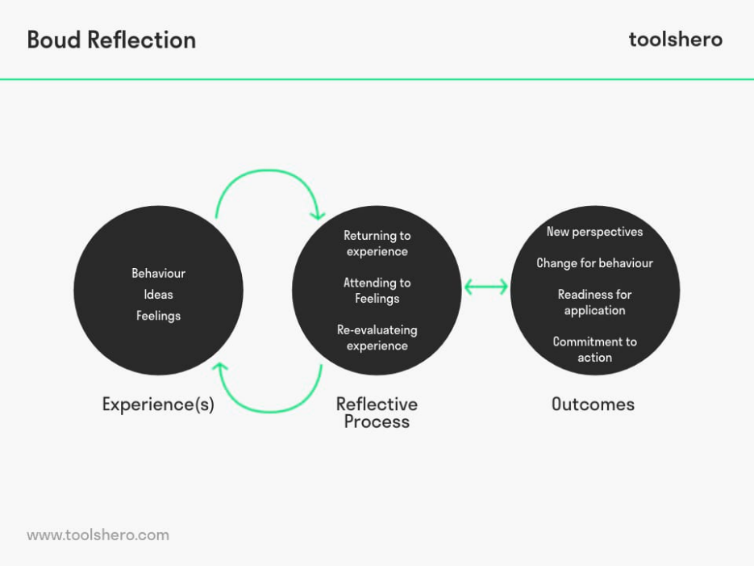
Looking back on my experiences since section 1a, I can appreciate how the different behaviours, ideas and feelings experienced whilst assessing and supporting are progressively informing my interventions. I have continuously reflected and examined both positive and negative feelings after having to have difficult conversations with kinship carers and guiding them to deal with complex and sensitive situations. I have acknowledged that reflecting on encouraging and negative situations in supervision, has enabled me to build on my strengths and build professional resilience which in turn modify my conduct in dealing with situations effectively, but with suitable empathy (Grant, 2013).

I recognise that I developed analytical skills within social work assessments and ongoing support following The Trauma Informed and Mental Health Schools Practitioner Training I completed 2022/2023. This training enabled me to support carers overcome their own trauma and be emotionally available adults for children with trauma. I have
recognised I have strengths in supporting carers to show empathy to children with trauma so to build their resilience. I have had positive comments from carers about my listening and reflecting skills and they agree with my commentaries about them in my assessments. I attended a collaborative communication training programme August 2023. This training helped me increase my skills in identifying individual needs as well as articulating myself more effectively in meetings with professionals.

Having recognised the benefit in better recognising and collaborating children’s and carers’ need for resilience, I enrolled in Level 1 Dyadic Developmental Psychotherapy (DDP). This has given me a deeper understanding of how to make the child carer relationship work in difficult situations and making placements more sustainable. It has been agreed in my future training and development plan that I progress to level 2. My supervisor recognised I have strong interpersonal and we believe that training on developing a therapeutic approach better suits me compared to pursuing management training.

I have gained skills in working collaboratively with colleagues and management as well as legal professionals in preparing Special Guardianship assessments for court. I have had to report on the children’s voice within my assessment as well as ensuring that the kinship carers understand the legal implications of my recommendations. I had to articulate my observations and recommendations to the guardian in pre court discussions as well to the judge. Supervision sessions helped me prepare my assessments and clarify professional judgements as well as reflecting on how the assessments had progressed. It had become apparent that I had achieved areas of good practice but also due to time restraints, I needed to acknowledge I needed to schedule enough time to gather as much evidence to reinforce my recommendations. Advice was also given in supervision on how to sustain a constructive relationship with carers in reaching outcomes despite having to initiate difficult conversations.

Refer to my identified learning need in section 1a which recognised my need to Motivational interviewing training to build mutual trust with carers. I have completed collaborative conversations training and DDP training which I feel have provided further knowledge and skills which assist me in building mutual trust with carers. I have also added self-confidence in working collaboratively with other professionals and agencies and more aware of other agencies and the support they offer families.

575/650

Question
Reflect on feedback that you have received from individuals in need of care and support and/or their carers and explain how this information has helped shape your practice and future professional development.

100 words (+/- 10%: include your actual word count at the end of each section).

Initial feedback from carers and children was that I spoke quickly and factually. I’ve now combined knowledge from training to help carers better relate with children. One family commented that my guidance was a ‘game changer’ and they were glad they opened about their difficulties and seek advice.

The training identified has developed my empathy and interpersonal skills. One carer declined professional counselling because opening to myself allowed her to reflect sufficiently to accept the situation and move on. I have strengthened relational skills to confidently work with individuals in challenging situations. This encourages me to continue with the DDP training as part of my professional development.

107 words

Total task 1 part b 750 words (+/- 10%: include your actual word count at the end of each section).

