Deliveroo: From Kangaroo to Unicorn
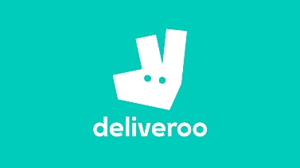
When Will Shu, a former investment banker, spent long hours working in London’s Canary Wharf offices, he was forced to live off grocery store sandwiches for lack of an equally convenient option, he was struck with an idea. He saw that London had an abundance of high quality restaurants but that very few of them offered deliver services. Existing food delivery platforms like JustEat were found lacking by Shu due to a sub-optimal customer experience.
So, in 2013, Shu started Deliveroo with a simple mission: provide prompt takeaway services for a variety of restaurants. With a cartoon kangaroo logo and a recognizable color scheme, he effectively changed the way we think about delivery food and saw astronomical growth in a very short timeframe. The startup reported a staggering £277 million in revenue between 2013 and 2017, its most recent reported year. Reported was an incredible growth from £18 million in 2016 to £129 million; 611 percent in just over a year and more remarkably, 107,117 percent average revenue growth over the four years since its inception, earning itself the rank of the United Kingdom’s fastest growing and most valuable startup.

A lot of this growth can be attributed to Deliveroo’s rapid international expansion. Though originating from and headquartered in London, most of their growth came from outside the United Kingdom—84 cities in 12 countries that they now operate in. Deliveroo is still poised to be Europe’s fastest growing tech company and continue to grow their list of over 120,000 restaurant partners.
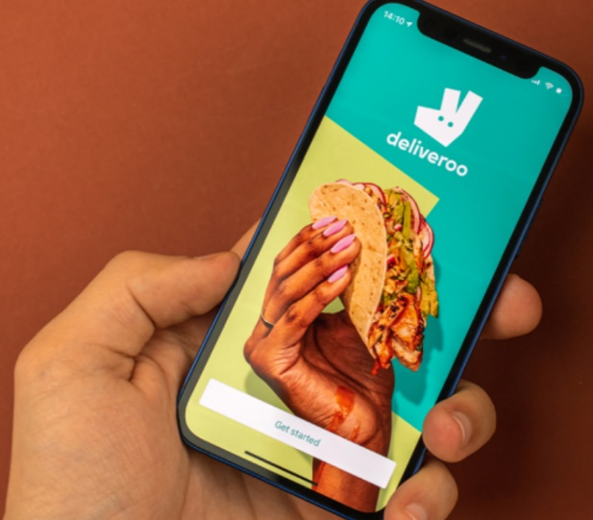
What was Deliveroo’s recipe for growth? They deftly employed strategic management and demonstrated a clear and focused understanding of technology, the market, the food delivery industry, and the ability to adapt and act decisively in the uncharted gig economy. However, it was not smooth sailing from the start. In fact, an early attempt of the concept by Shu and a friend, Deliveroo’s co-founder Greg Orlowski, in 2007 was a failure as smartphones were a new phenomenon and apps were yet to become ubiquitous in everyday life. It wasn’t till 2012, when smartphones had cemented their place at the center of everyone’s lives that Shu and Orlowski reworked the platform to take advantage of the prevailing technology and focus on its functionality as an app. By 2013, the pair had assessed the needs going forward to turn their idea into reality, such as the fleet of couriers and strategically decided to make use of the then burgeoning gig-economy. Shu even worked as Deliveroo’s first “rider,” delivering the first order, a pizza, to a friend in order to better understand the logistics of the delivery process. Over the years following their modest London launch with just 3 restaurants, Deliveroo went on to repeatedly attract investments through several rounds of funding and expand into more cities both in and outside the United Kingdom. Even e-commerce giant Amazon got involved with a $575 million investment, putting the value of Deliveroo upwards of $2 billion.
The journey to this valuation required more than just a strong initial strategy and benefitted from Shu’s willingness to adapt and plan for the future. As the scale and vastness of their operations grew, Shu went from the hands-on leader who undertook deliveries himself every day to one that focused more on nurturing and growing a team and hiring talent while recognizing the need for clear internal communications without micromanaging.
Aside from internal hurdles, meteoric growth in size and scale like this also brought on pressures from unions, governments, and industry competitors. The novel and ambiguous nature of the gig-economy and self-employment has embroiled Deliveroo in several controversies around worker rights and entitlements. The start-up has maintained that they aim to work with government on navigating the new rules of the gig-economy, but it begs the question as to whether tighter regulation would have allowed for such growth. Moreover, as competition grows from the likes of Uber and local delivery platforms the need to adapt and carefully consider management strategy is paramount for Deliveroo.

Discussion questions:
- How is strategic management illustrated by Deliveroo’s growth—from its inception to becoming a multi-billion-dollar business?
- How might SWOT analysis be helpful for Deliveroo in the context of entering a new city today, which may already have an existing local delivery platform?
- What competitive advantage might Deliveroo have over UberEats, or a new local entrant to the food delivery business? What competitive advantages might it want to develop?
- Do you think Deliveroo’s success is due to external or internal factors? If enacted now, would its strategy from 2013 be as successful? Explain.
- How might Deliveroo be affected by changes in regulation relating to self-employment? What corporate strategies would be most relevant?

Source: Robbins, S., and Coulter, M. (2020) Management, Global Edition. 15th edn. Pearson. Pp. 271-272

