Matthew Satterthwaite
Student: 1910496

ACDA5015 – L5 Advanced Physics of OME Assignment

Document: Utilisation of Shape Charge Modelling Techniques

Next Generation Tank Munitions

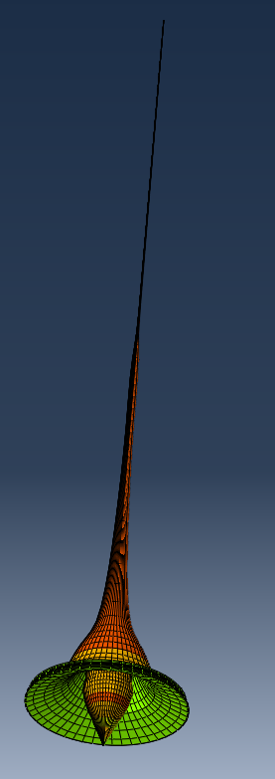

29 October 2021

Contents
Contents ii
Executive Summary 1
1 Introduction 2
1.1 Document Scope 2
1.2 Direct Requirement 2
1.3 Shaped Charges 3
2 Components 3
2.1 Shaped Liner 3
2.2 Explosive Fill 5
2.3 Steel Liner 6
2.4 Assembly 6
3 Test Set Up 7
3.1 Mesh Convergence 7
3.2 Interactions 8
3.3 Boundary Conditions 8
3.4 Specific Energy 9
3.5 Display 9
4 Test Events 10
4.1 Detonation Wave 10
4.2 The Explosion 11
4.3 Incremental Jet Formation 12
4.4 Simulation Overview 14
5 Potential 15
5.1 Product 15
5.2 Package 15
5.3 Phase 2 16
6 Conclusion 17
7 Annex 18
8 References 19

List of Figures
Figure 1-1: GD M830 HEAT Round [1] 2
Figure 1-2: Shaped Charge Example [2] 3
Figure 2-1: Jet Lengths VS Cone angle 4
Figure 2-2: Liner Drawing 4
Figure 2-3: Octanitrocubane [14] 5
Figure 2-4: Cast Explosive Fill 5
Figure 2-5: Demonstration Shape Charge [15] 6
Figure 3-1: Abaqus Mesh Screenshot 7
Figure 3-2: Surface to Surface Contact 8
Figure 3-3: Boundary Condition 8
Figure 4-1: Detonation Pressure Wave 10
Figure 4-2: Detonation Wave – Pressure vs Time 10
Figure 4-3: Explosive Sequence 11
Figure 4-4: Cone Inverting 12
Figure 4-5: Cone Separation 12
Figure 4-6: Negative Velocity 13
Figure 4-7: Jet Velocity 14
Figure 4-8: 10 Microsecond Timesteps 14
Figure 5-1: Phase 2 Model 16
Figure 7-1: Kinetic Energy of Jet formation 18
Figure 7-2: EOS Data 19

List of Tables
Table 2-1: Tantalum Material Properties [8] 4

Executive Summary

As the decision been made to modify all existing Challenger 2 Main Battle Tanks (MBT) to utilize a new 120mm smoothbore barrel, the requirement for smoothbore ammunition has now become a priority within the Ministry of Defence.
This document has been created by the engineering team to demonstrate the abilities of finite element analysis software and the advantages it can give at the bid stage.
Throughout this report, the engineering team designed and simulated a nose mounted Shaped Charge using known industry data. Commonly used materials were replaced with those with superior properties.
A 50-microsecond test was carried out and analyzed at 10 microsecond increments to demonstrate the important stages of jet formation and explosive separation.
The results were then compared to the current in service “kinetic energy” round, where it demonstrated superior kinetic energy figures and promising penetrative capabilities.
The utilization of this software allowed the engineers to propose a superior product to the end customer with evidence behind it, without having to do any physical testing.
The engineering team had difficulty completing all experiments during this report owing to simulations crashing or aborting. These turned out to be related to excessive nodes, caused by intricate mesh sizes and lack of computer storage for input and output files.
As a result of this, the engineering team are now requesting further investment in the FEA facility to allow them to run full scale simulations without limitations. Further funding will also be required to support a package of physical tests that will run alongside FEA simulations to determine the absolute the accuracy of the simulations against real world events.

Introduction

Document Scope

During 2021 the British ministry of defence (MoD) decided that they were going to upgrade and modify all in service Challenger 2 tanks so that their barrels are the same as those used by other North Atlantic Treaty Organization (NATO) nations. This outcome renders all currently Rifled barrels and ammunition for the 120mm Tanks obsolete from 2027. As a result of this, a new suite of smoothbore ammunition must be developed to compete with current off the shelf products.

As this is a new nature for the engineering team, this document will be used to demonstrate the capabilities of the modelling software “Abaqus” by demonstrating its ability to quicky develop superior products.

Direct Requirement

With the decision rendering the current tank munitions obsolete it is essential that there is a replacement available that can match or outperform the competition.

The ideal candidate would be a High Explosive Anti-Tank (HEAT) round such as the M830, manufactured by General Dynamics. This round utilized a nose mounted shaped charge to penetrate enemy armour.

Shaped charges can vary between different materials, explosives, cone designs etc. The engineering team have designed a basic shaped charge to simulate within the finite element analysis (FEA) software to determine its outputs and relevance to real life data.

Throughout this document, the engineering team referred to known in service data and assessed how the product could be improved at a basic level so that they could propose a high performing round at the bid stage and supply theoretical evidence.

These basic improvements were used to create a model that should return similar or superior results to the known data.

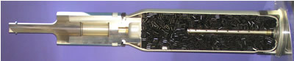
Figure 1-1: GD M830 HEAT Round [1]

Shaped Charges

To put it simply, a Shaped Charge can be described as a cylinder filled with high explosive. At one end of the cylinder is a detonator whilst the other end contains a hollow cavity, of almost any shape. Cones are most used but other shapes can also be utilized.
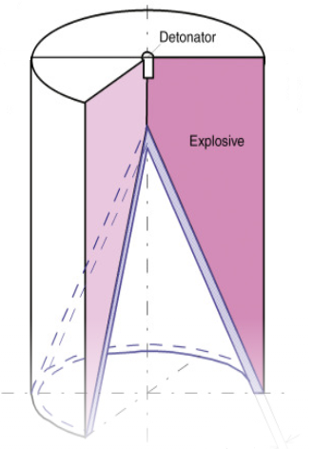
Figure 1-2: Shaped Charge Example [2]

If the hollow cavity is lined with a thin layer of ceramic, aluminium, copper or even glass, then that liner can form a “jet” if certain properties of the liner are satisfied. [3]

The above-mentioned materials and very commonly used as Shaped Charge liners, especially copper and aluminium due to their relatively high ductility at high strain rates.

Components

Shaped Liner

The effectiveness of the Shaped Charge relies mainly upon the Liner materials ability be manipulated whilst possessing density high enough to overcome the target using kinetic energy alone. [4]

An effective liner must possess a High density, High melting point, High strength and ductility and be readily available [5]. A material properties search was conducted on “matweb” and it was found that TANTALUM (TA) was found to be a good candidate as it held all of these qualities.

Tantalum is a very heavy metal which when pure, is highly ductile and malleable. [6]. For several years It has been recommended as the optimal liner material by the United States Ballistic Research Laboratory (US BRL). [7]

Table 2-1: Comparable Material Properties [8]
Material Comparison | Tantalum | Copper
Density | 16.65g/cc | 8.77g/cc
Ultimate Tensile Strength | 900 MPa | 241 MPa
Modulus of Elasticity | 179 GPa | 92 GPa
Shear Modulus | 69 GPa | 43 GPa
Poissons Ratio | 0.35 | 0.33
Melting Point | 2,996°C | 1,085°C
Elongation at break | 70% | 55%
EOS – c0 | 3740m/s | 3933m/s
EOS – S | 1.470 | 1.489
EOS – Gamma0 | 2.11 | 2.02

The engineers determined that it would be important that the specific material properties for the material – in the conditions it is likely to see - were vital to an accurate model. Figures for the Johnson Cook flow stress model and the equation of state for the material as a fluid where sourced to satisfy this.

The cone angle is also considered important design feature as the Jet will be formed along its centerline. [9] A wider cone angle will result in a short, thick jet. Alongside the kinetic energy, the penetrative ability of the jet is directly proportional to its length, a smaller angle would be preferably when attacking thick tank armour.

During 2002, an experiment was carried out to determine the difference in penetration when the angle of the cone is changed [10]. Material properties and thickness where all identical during this experiment and the results are detailed below.
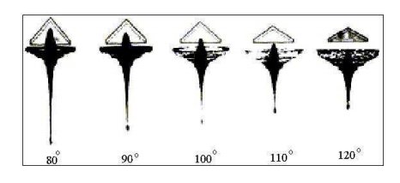
Figure 2-1: Jet Lengths VS Cone angle

These results shown superior jet length – and therefore penetration – using the 80° cone which was the smallest angle tested. Using this evidence, the Engineering team decided to select an 80° cone for this experiment to provide optimal penetrative performance.
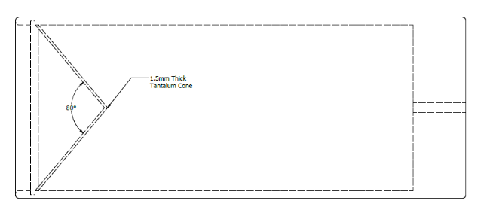
Figure 2-2: Liner Drawing

Explosive Fill

RDX/TNT is the most used Shaped Charge explosive with an approximate detonation value of 7500 m/s. [11] Due to the extra weight of the liner, the potential velocity of the Jet would be lower than a copper liner, so a more powerful explosive would be preferential.

This detonation velocity is more than enough for the sequence to be considered a detonation [12]. For faster detonations over 10000m/s the explosive Octanitrocubane (ONC) could be used [13]. As this demonstration is focusing on Tank munitions that must defeat heavy armour, the engineering team selected this as their explosive fill to provide the maximum amount of kinetic energy.

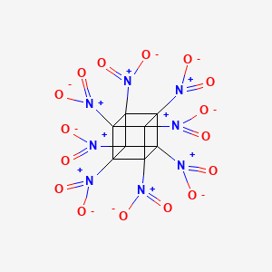
Figure 2-3: Octanitrocubane [14]
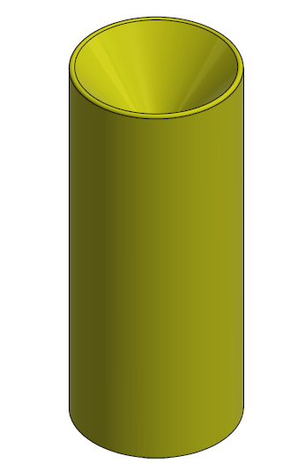
Figure 2-4: Cast Explosive Fill

Steel Liner

During this phase of the experiment, the steel liner is only to be considered as a vehicle for the shape charge. Material deformation is expected but perfecting the energy focus will come under “Phase 2 Development” therefore the liner will be omitted from this stage.

Assembly

For this demonstration the following dimensions were used to create the model.

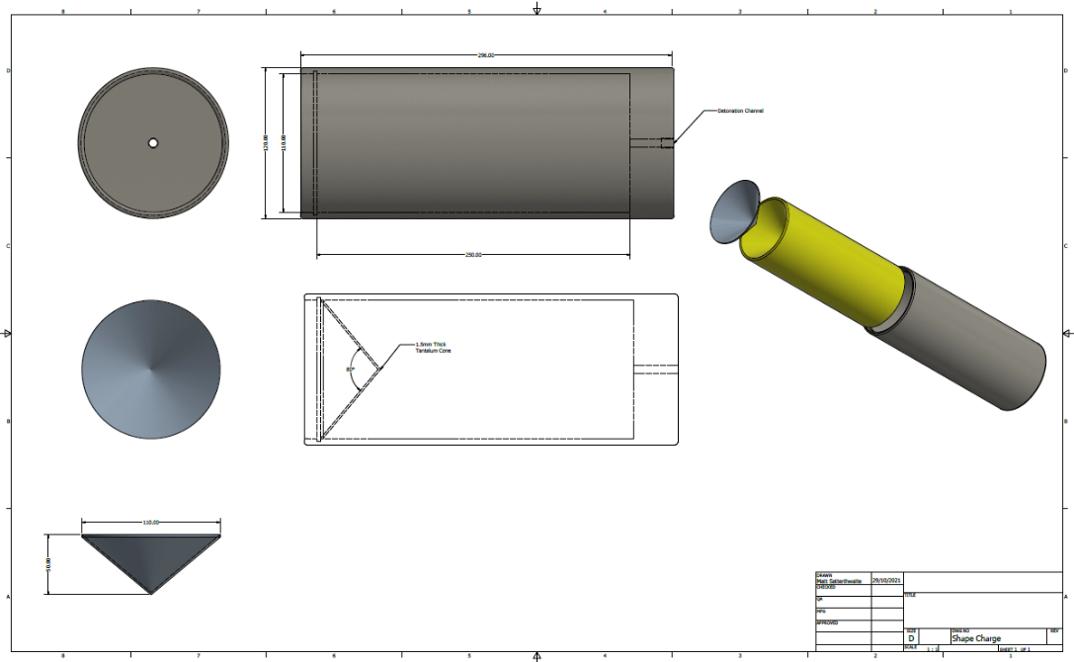
Figure 2-5: Demonstration Shape Charge [15]

Test Set Up

Mesh Convergence

Meshing is the process in which the continuous space of an object is separated into thousands of more shapes to properly define the objects physical shape. Each shape is then a separate point that can be used to measure data from the shape being tested. [16]

Whilst modelling it is important that a sufficiently refined mesh is used to ensure that the results are accurate. A very coarse mesh will simulate quickly but may lack accuracy in intricate areas, such as the cone. [17]

To attempt to satisfy the requirement for both an accurate analysis and a reasonable solve time, the engineers installed the fine meshing on the cone whilst the explosive fill had a coarse mesh.
Fine Cone Liner mesh

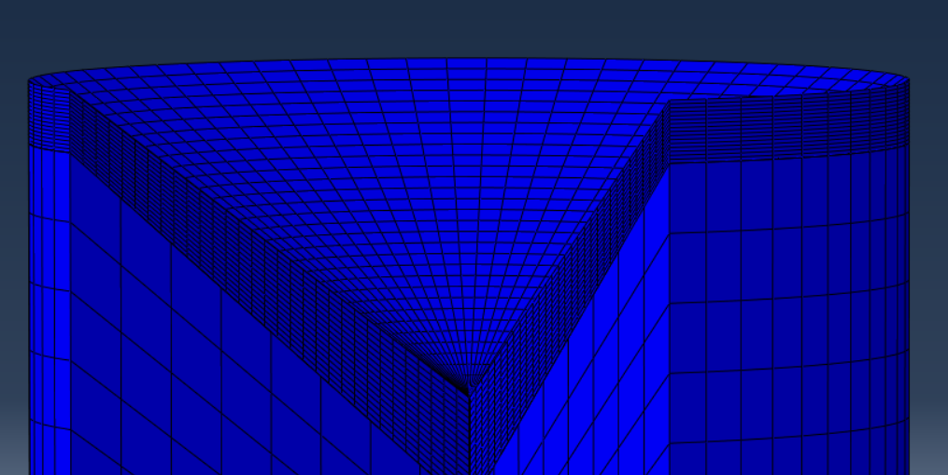
Coarse Explosive fill mesh
Figure 3-1: Abaqus Mesh Screenshot

Originally, the model was created as a 3D component which required thousands of individual shapes to fill the space. This resulted in a very long solve time and multiple distortion errors. For a fast-solving demonstration model the engineers redrew the components as axisymmetric components on a half plane. This enabled the model to solve in minutes as it uses a fraction of the nodes and mirrors the results around the axis to create a 3D visualization.

Interactions

For this experiment, a surface to surface (explicit) interaction was utilized between the top and side faces of the explosive fill, and the bottom face of the Tantalum Liner. Detailed below in Figure 3-2.

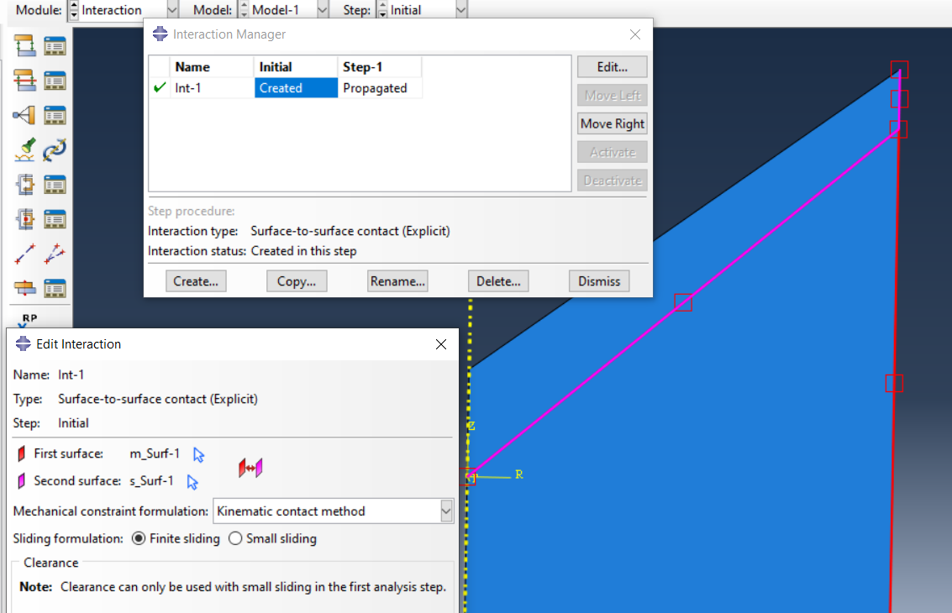
Figure 3-2: Surface to Surface Contact

Boundary Conditions

An Antisymmetric boundary condition has been used for this simulation. This boundary condition will run up the entire centerline of the explosive fill and liner.
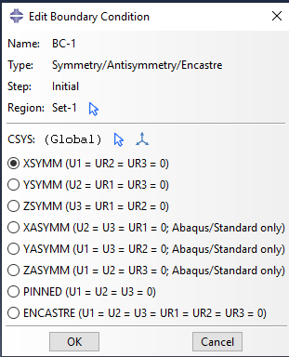
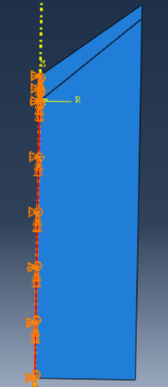

Figure 3-3: Boundary Condition

Specific Energy

For added accuracy the specific energy of the explosive was sourced and included. The specific energy figure [18] for ONC was logged in the material properties under detonation energy density.

The specific energy of the tantalum cone however, had to be entered manually in the keywords due to it not being a predefined field within the material inputs.

Display

For the visualization section of this experiment, the engineers swept the display through 270° to allow the reader to see the detonation wave pass through the explosive whilst also demonstrating the expansion of the cylindrical objects.

Test Events

Detonation Wave

The first event that was observed during the experiment was the progression of the detonation wave throughout the explosive and contacting the cone. A detonation is a supersonic combustion wave that is powered by the energy released in a chemical reaction. [19]

The pressures involving the detonation wave have been observed during this experiment as it was vitally important that the pressure created was enough to complete surpass the material properties. A high enough pressure would allow the Cone to invert and create a jet, whereas a high enough velocity would give the jet high amounts of kinetic energy.
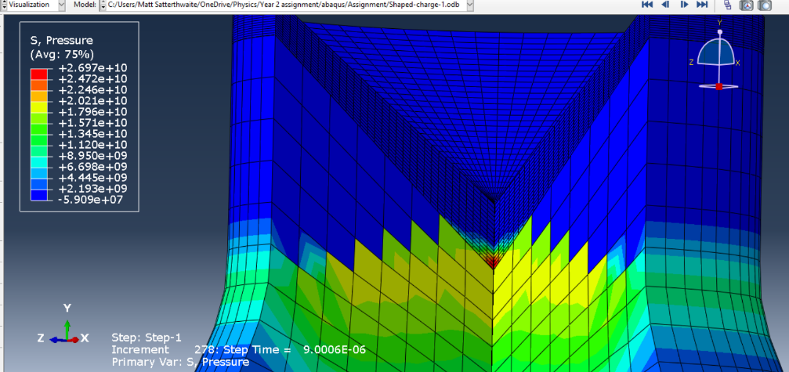
Figure 4-1: Detonation Pressure Wave

Figure 4-1 shows the detonation waves first interaction with the Tantalum Cone. The cone instantly sees 26.9GPa. At this point, the material is experiencing such high pressures – in such a short amount of time that the liner is now being treated as an inviscid fluid.

The engineers created a Pressure Vs Time graph to demonstrate how long the detonation wave took to reach the cone.

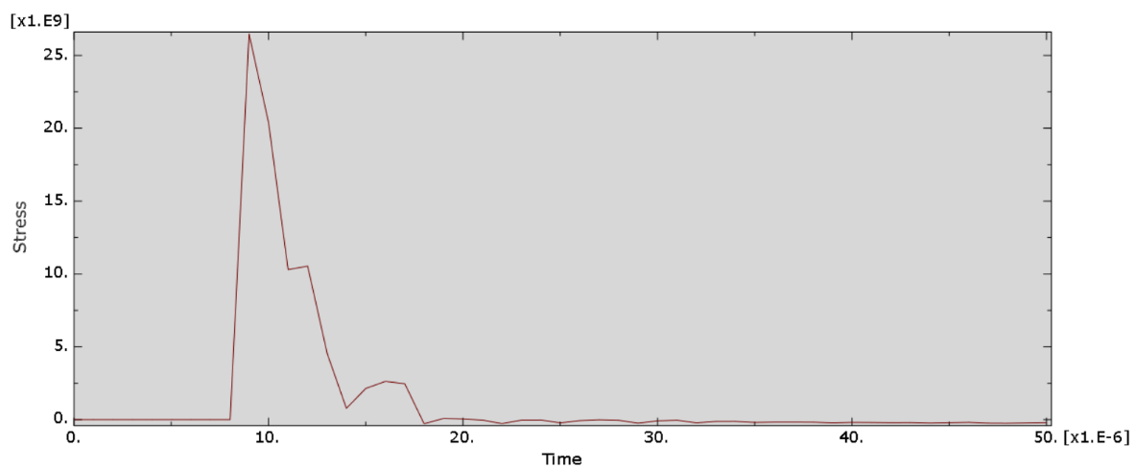
Figure 4-2: Detonation Wave – Pressure vs Time

The Detonation

At this stage it is impossible to manipulate or direct the explosive to ensure the maximum amount of energy is directed to the tip of the cone.

The blue section shows a negative velocity which would be the product exploding away from the detonation point, which is the datum for measurement.

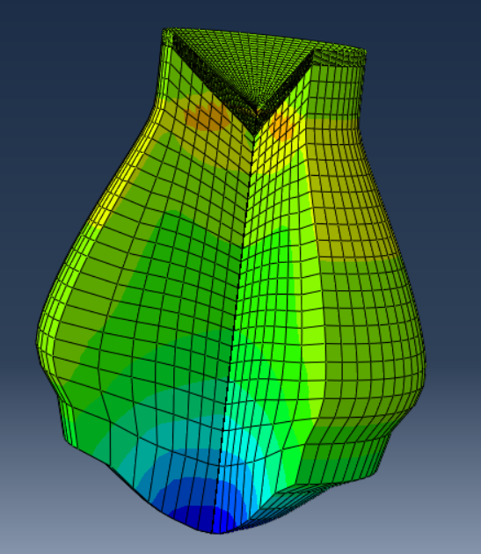
Figure 4-3: Explosive Sequence

Jet Formation

As this sequence of the experiment happened very quickly, the assessments were taken in 10 microsecond increments.

At 10 microseconds, the cone began to invert as the detonation pressure wave passes through. This is the start of the jet formation.

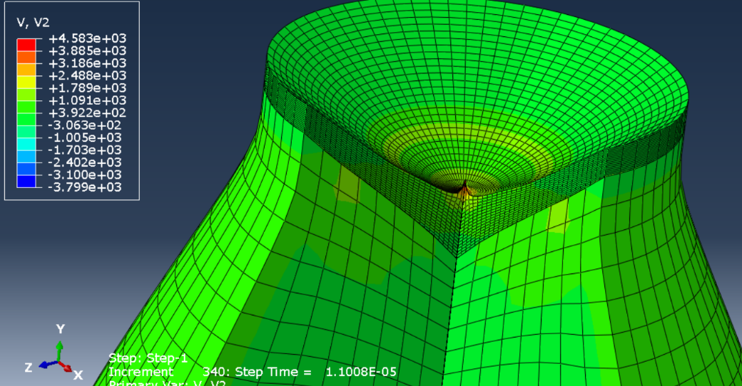
Figure 4-4: Cone Inverting

Ten microseconds later, the Cone and Fill start to separate and the cone begins to form a high velocity, molten jet. At this point, the jet formation achieved its peak velocity of 6246m/s. The rear surface of the cone can be seen forming a “slug” which will add itself to the jet, increasing its length and overall mass.
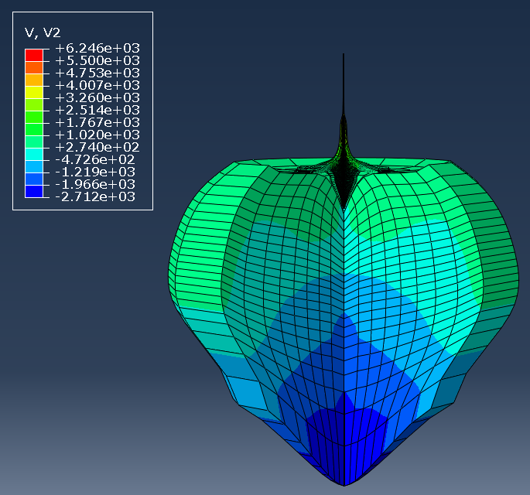
Figure 4-5: Cone Separation

At 30 microseconds, the cone has now completely separated from the fill and most of the cone is now inverted, leaving a small cone shaped void in the explosive fill.
Stretching Jet
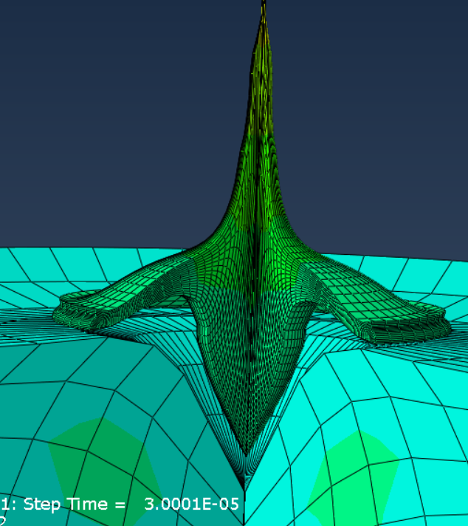
Slug

At 40 microseconds, a large high velocity jet was visible as the cone continued to invert. Negative velocity is being recorded but this is due to the explosive separating in all directions from the detonation point. This is a behavior that could potentially be dampened when designing the steel liner. The jet is now completely independent.

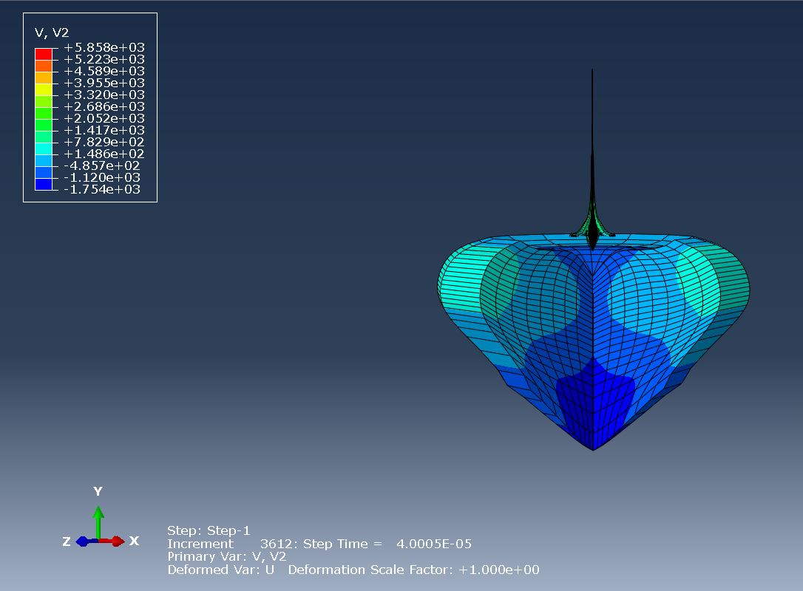
Figure 4-6: Negative Velocity

At 50 microseconds, a fully formed penetrative jet recoded a velocity of approximately 5500m/s at the tip. This Jet was measured using the query-distance tool and was 320mm long at this point. The tip of the jet was measured as 3.1mm wide.
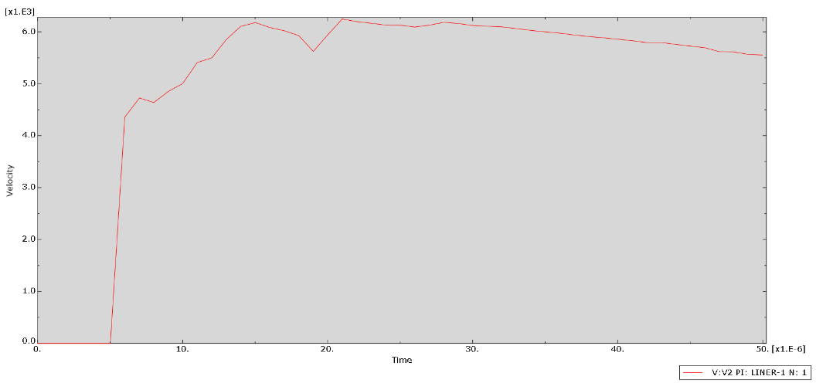
Figure 4-7: Jet Velocity

Figure 4-7 shows the velocity experienced at the tip of the cone throughout the entire experiment.

Simulation Overview

It took approximately 5 microseconds for the detonation wave to reach the cone before the material began aggressively accelerating up to 4500m/s. The gradual decrease in gradient could be the inversion of the cone or some numerical issues within the simulation, which would be ironed out by adjusting the bulk viscosity settings.

Complete separation happened at approximately 21 microseconds as the cone moved away from the explosive fill and formed a jet. At this time the velocity peaked at 6300m/s.

At 50 microseconds the jet was completely formed and satisfactory, travelling at a velocity of 5500m/s. To demonstrate the transformation of the cone, the full 50 microsecond progression from zero is shown below.

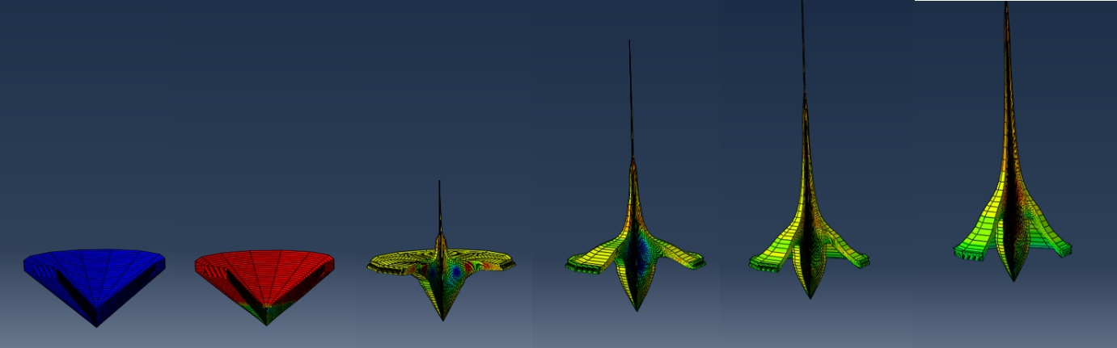
Figure 4-8: 10 Microsecond Timesteps

Potential

Product

A standard armour piercing tank round will travel at a maximum of 1300m/s and have an average penetrator mass of 4.5kg. [20] This would give them the potential for 3800kJ of kinetic energy.

In comparison, the penetrative jet created during this experiment would generate 5556kJ of kinetic energy, albeit over a smaller area (providing all the cone material is converted into the Jet). This is established by using the mass properties from the Cad model and the maximum velocity of the jet.

The major benefit to the Shaped Charge headed round is that the kinetic energy created is completely unrelated to the range of the target. Meaning that the Kinetic Energy Penetrators are decelerating – albeit slightly - over distance, losing kinetic energy whereas the Shape Charge accelerates when required, usually via an offset initiator.

Package

The engineering team found that the product gave them the ability to quickly test different materials and cone angles to fine tune their product without having to do any physical testing. Although, physical testing will still determine how accurate this experiment has been.

All parts were drawn as axisymmetric-deformable parts and originally as a 2D shape against a centerline. This made the interaction selection and meshing much easier and then aloud the engineers to sweep the model 270° to create a 3D visualization. This made for a fast solving and smooth model but it did not allow for an extremely intricate meshing system so the numerical results may differ to those created on a 3D model with sufficient meshing. For this initial development stage though, the visual results were sufficient.

It was found that obtaining a vast amount of material properties was vitally important to the behavior of the jet. Obtaining data with regards to the fluid behavior of the metal, as well as the stress and stress figures benefited the experiment enormously.

The most critical material data that would produce a smooth jet were those listed under Mie Grüneisen Equation of State. The figures used for this experiment were taken at ambient temperature (20°) and the density stated in table 2-1. Pressures cannot be states as the grade being used it classified until qualified [21].

Phase 2

Given the proven capabilities of the software and Shaped Charge set up, phase 2 would involve analyzing the behavior of the Steel liner. This would involve encasing the current model as shown below in Figure 5-1.

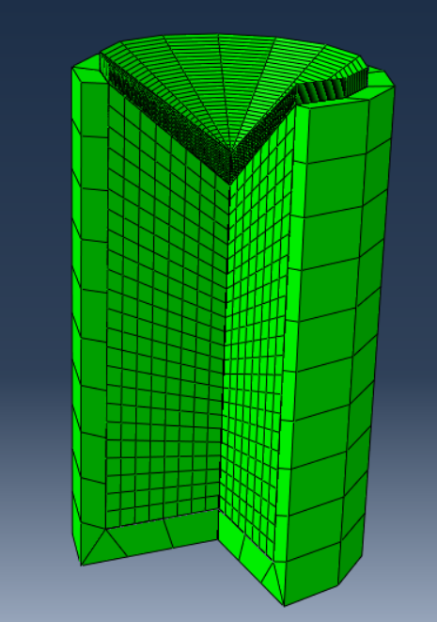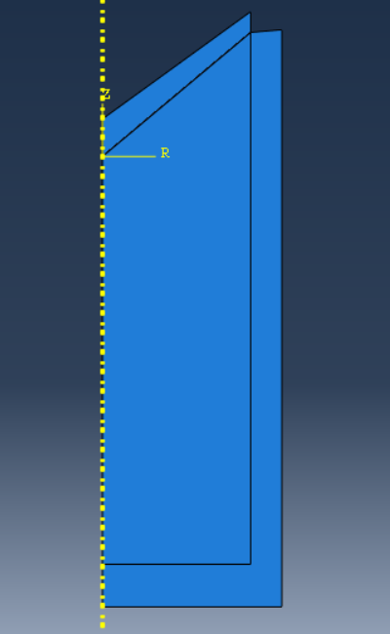
Figure 5-1: Phase 2 Model

The outcome of the phase 2 experiment would be to:

- Contain and protect the shaped charge during transport and firing
- Manipulate and focus the detonation wave towards the cone
- Not interrupt the function of the jet formation

It is vitally important that any energy that cannot be manipulated towards the cone be dissipated outwards as it is highly likely that the Shaped Charge could be followed in tandem by a secondary payload (either penetrator or HE detonation) that will require protecting from the initial blast.

Conclusion

The engineering team found that the correct use of FEA software enabled them to hit the ground running with new product introductions. It is also very possible to reverse engineer current products to identify where weaknesses are and improve them without having to invest in physical parts and dangerous testing programs.

To enable the software to deliver realistic and referenceable the engineering team used an ultra-fine mesh which allowed several layers of mesh to form over a 3.5mm thickness. But, to allow the test to run without the risk of crashing they had to fit a course mesh to the explosive fill and remove the steel liner entirely. It was found that the types of material properties chosen affected the running of the simulation enormously. The Johnson Cook plasticity model was used to specify the hardening behavior and the strain rate dependence of the yield stress.

At this stage the main objective was to create a high velocity molten jet with high penetrative power and demonstrate its capability against an off the shelf product available today. Given the results from this experiment, it can be concluded that with the product configuration mentioned throughout this report a Shaped Charge headed munition would be the suggested replacement to the current in-service Kinetic Energy round as it can produce higher levels of kinetic energy over its entire firing range.

All products brought into service by the UK MoD must satisfy all criteria stated within Standardized Agreement (STANNAG) 4526 [22]. Within the document, several requirements are mentioned as desirable, including:
- A jet straightness exhibiting less than 1.2 of a jet diameter deviation is desired
- Products must have a strong symmetric initiation
- Jet target diameter shall be between 2.5 and 3.5mm.

These criteria can be satisfied and proven within minutes using the axisymmetric method, meaning that a high-quality product can be promised during this initial development/bid stage.

Annex

Kinetic Energy Formula

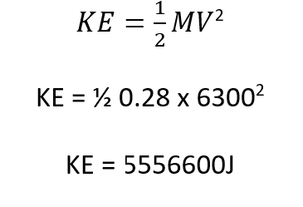
Figure 7-1: Kinetic Energy of Jet formation

Equation of State Data

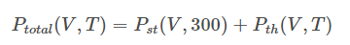
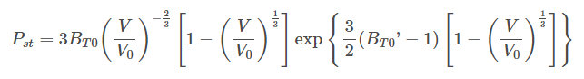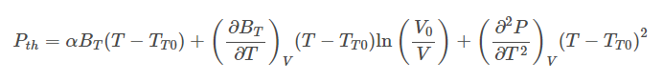
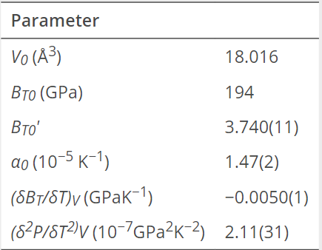
Figure 7-2: EOS Data

References

[1] | Admin, "Land Systems - 120mm Tank HE Ammunition," 20 October 2004. [Online]. Available: https://defense-update.com/20041020_120mm-tank-gun-he-ammunition.html.
[2] | Z.-X. Zhang, "Shaped Charges / Special Blasting Techniques," Science Direct, 2016. [Online]. Available: https://www.sciencedirect.com/topics/engineering/shaped-charge. [Accessed 21 10 29].
[3] | W. P. W. &. J. A. Zukas., "Introduction to Shaped Charges," in Fundamentals of Shaped Charges, pp. 16-17.
[4] | O. Facts, Director, Shaped Charge. [Film]. Youtube, 2020.
[5] | T. E. Elshenawy, "Thesis," in Design improvements of Shape Charges, Manchester, 2021, pp. 49 - Table 2-2.
[6] | A. Inc, "Facts and Tantalum," Admat Refractory Metals, 17 07 2020. [Online]. Available: https://www.admatinc.com/facts-about-tantalum/. [Accessed 2021 11 01].
[7] | E. L. V. D. V. J. M. D. D. J. S. James F Muller, "Conical Shaped Charge Liner Development," University of California, Los Alamos Scientific Laboratory, New Mexico, California, 1995.
[8] | Admin, "Cold Rolled Tantalum," [Online]. Available: http://www.matweb.com/search/DataSheet.aspx?MatGUID=d2d75c4b1c394724a8dbe08f039d3e83&ckck=1. [Accessed 2021 10 29].
[9] | Z. Zhang, "Finite element modeling of the shaped charge jet and design of the reusable perforating gun," Springer Link, 2020. [Online]. Available: https://link.springer.com/article/10.1007/s12182-020-00468-4. [Accessed 1 11 2021].
[10] | W. LEE, "Oil Well Perforator Design Using 2D Eulerian Code," Internation Journal of Impact Engineering, no. 5, pp. 553-559, 2002.
[11] | J. Munition, Janes Manual of Ammunition, Janes, 2002.
[12] | M. D. P. Ph.D., "Safety Designs for Space Systems," Science Direct, [Online]. Available: https://www.sciencedirect.com/science/article/pii/B9780750685801000130.
[13] | ". O. S. INFORMATION", "Nitrocarbon Lab Tests," Published for the UK Ministry of Defence, 2013.
[14] | PubChem, "Octanitrocubane," 2021 10 23. [Online]. Available: https://pubchem.ncbi.nlm.nih.gov/compound/Octanitrocubane#section=Structures. [Accessed 2021 10 29].
[15] | M. Satterthwaite, Demonstration Shape Charge, Glascoed: Drawn on Autodesk Inventor 2020, 2021.
[16] | S. Group, "What is Meshing," Simutech , [Online]. Available: https://simutechgroup.com/why-is-meshing-important-for-fea-fluid-simulations/. [Accessed 2021 11 24].
[17] | A. Docs, "Mesh Convergence," Abaqus, [Online]. Available: https://abaqus-docs.mit.edu/2017/English/SIMACAEGSARefMap/simagsa-c-ctmmeshconverg.htm. [Accessed 2021 11 03].
[18] | Z.-Y. W. Xue-Hai Ju, "Propellants, Explosives, Pyrotechnics," WILEY-VCH Verlag GmbH & Co., Weinheim, 2009.
[19] | D. A. Rosato, "Stabilized detonation for hypersonic propulsion," PNAS - Research Article, 18 05 2021. [Online]. Available: https://www.pnas.org/content/118/20/e2102244118.
[20] | J. A. [. Official], APFSDS Rounds, Janes.
[21] | I. o. Research, "First-principles molecular dynamics calculations of the equation of state for tantalum," International Journal of Molecular Science, 2009. [Online]. Available: https://europepmc.org/article/PMC/2790112. [Accessed 2021 11 06].
[22] | D. o. Defence, "Shape Charge jet, Test Procedure (unclassified)," Department of Defence, [Online]. Available: https://ndiastorage.blob.core.usgovcloudapi.net/ndia/2016/IMEM/18775fuchs.pdf. [Accessed 01 12 2021].

