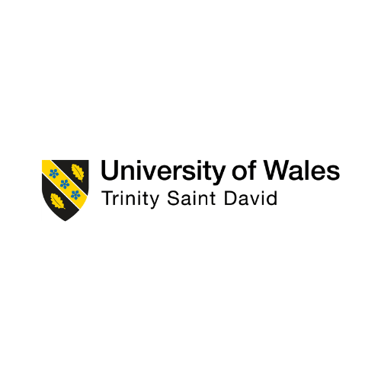
Assignment 1: Essay
Google’s headquarters in london, uk
By Linda Roze
(2219027)
Module: Project Management
(LCBB5005)

Lecturer: Dr. Molly Jack

Contents
Introduction 2
Mixture of Methodologies for Great Success 3
Project Team 5
PMBOK Core Elements Implementation 7
Risk Assessment 9
Potential Risks Solutions 11
Learning from Actual Cases 12
Conclusion 13

Introduction
A significant turning point in the history of corporate architecture and urban planning is Google's ambitious plan to build its new headquarters in London, UK. This essay reviews the project's methodology, underlining the most important parts of risk assessment and project management and offering suggestions supported by real examples.
Designed by Heatherwick Studio and Bjarke Ingels Group, the new headquarters, called "Platform G," is expected to become a King's Cross landmark. The project intends to not only create a cutting-edge workspace, but also to blend perfectly into London's urban environment, supporting sustainability and creativity. This essay will analyse the methods used to control risks and guarantee successful delivery in an in-depth review of the project's planning and execution phases (Arieff, 2020).
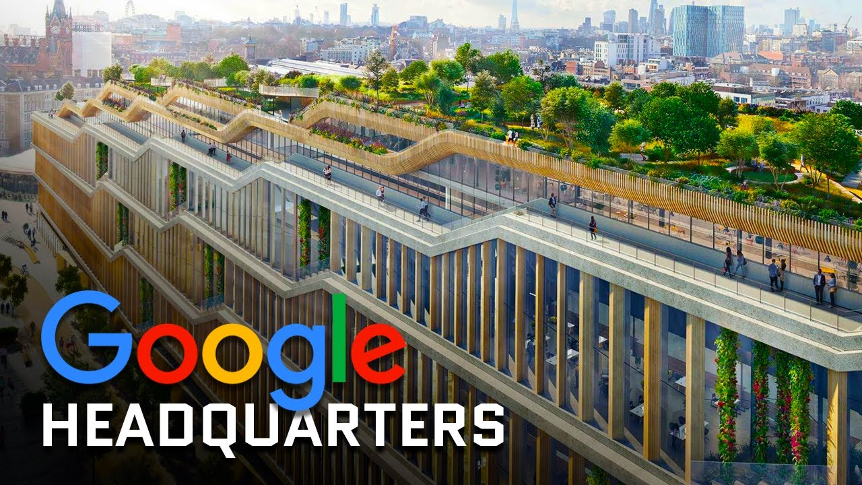
Figure 1:Google's Headquarters in London, UK (animated)

Gantt Chart of The Google’s Project
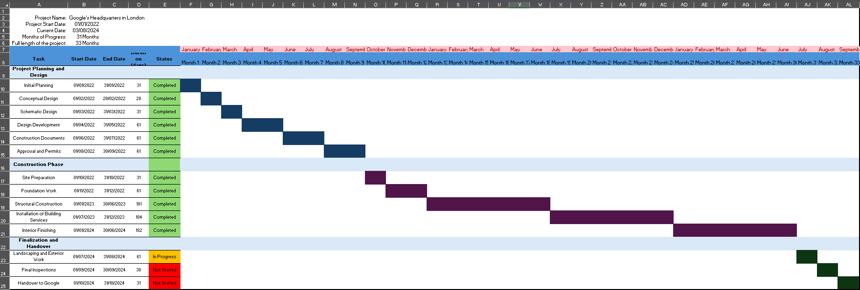
Figure 2:Gantt Chart Inserted from Excel

Mixture of Methodologies for Great Success

Modern amenities include a rooftop garden, a running track, a gym, and a swimming pool will be available in the headquarters. These facilities are intended to enhance Google employees' productivity and well-being. In order to lessen its influence on the environment, the project also places a strong emphasis on sustainability. Features like solar panels, rainwater harvesting systems, and large green spaces are included (Bosetti and Brown, 2019).
To achieve all the goals and objectives Google’s project management team are implementing 5 core frameworks and methodologies. Blenden together these methods allowing all the areas to be cover. Brief overview of the project management methodologies is stated bellow:
Business Information Modelling (BIM)
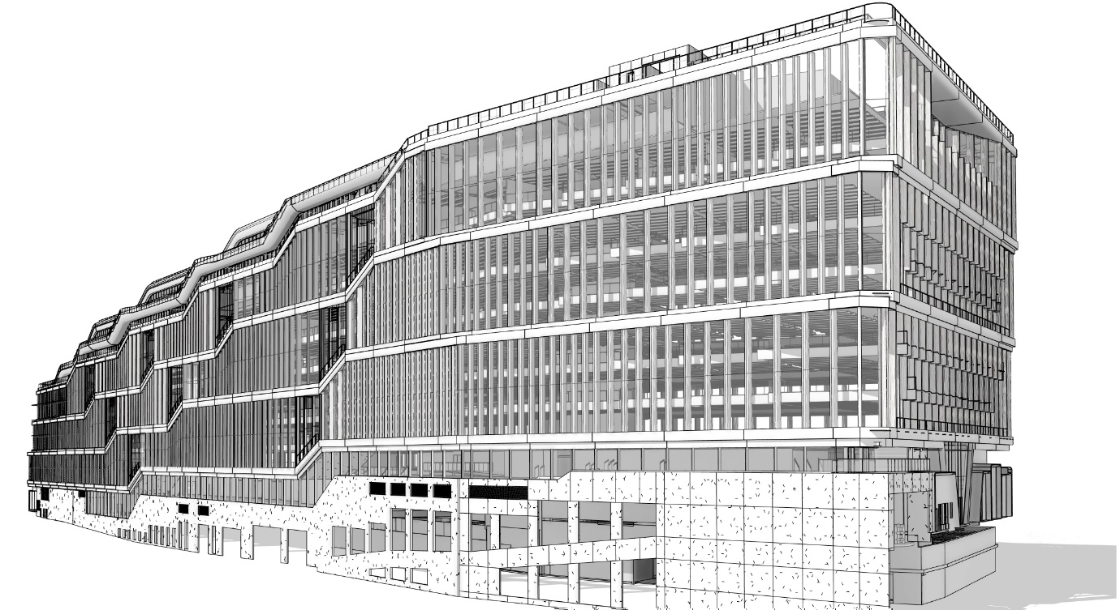
Figure 3: Google's Headquarter BMI Model
A building's functional and physical attributes can be represented digitally with BIM. It offers a common knowledge base for data about a facility, creating a solid foundation for choices made across its period of operation. For Google's head office, building information modelling (BIM) played a crucial role in organising the highly creative building infrastructure design and guaranteeing the early participation of specialist contractors. The project team was able to visualise the entire building process, spot potential issues before they occurred, and improve stakeholder communication by utilising BIM (Karasu, Aaltonen and Haapasalo, 2022).
Agile Methodology
The project's dynamic and ever-changing character was managed through the application of agile concepts. This strategy enabled flexibility and iterative progress, ensuring that the project can effectively adjust to changes and new requirements. Agile project management divides the project into smaller, easier to accomplish tasks and involves ongoing plan review and modification. This approach made it possible for the project team to react quickly to obstacles or changes in the project's scope, keeping it on course and in line with its objectives (Chathuranga et al., 2023).

Lean Methodology
In order to reduce waste and increase value, lean principles were applied. This approach put a focus on cutting expenses without sacrificing quality by optimising procedures and raising productivity. To make sure that resources were used efficiently and that any potential inefficiencies were quickly fixed, strategies like just-in-time delivery and continuous improvement were employed. Lean Construction ensured effective resource utilisation and waste reduction throughout the building of Google's headquarters (Chathuranga et al., 2023).

Integrated Project Delivery (IPD)
The implementation of Integrated Project Delivery (IPD) improved collaboration between architects, engineers, contractors, and clients, among other parties. This cooperative strategy made sure that everyone could cooperate well and agreed with the project's objectives. IPD encourages open communication and shared accountability, which reduced conflict and improved the project's overall coordination. The team benefit from the knowledge and perspectives of important stakeholders by involving them early in the project, which would guarantee a more unified and effective project delivery (Karasu, Aaltonen and Haapasalo, 2022).

Risk Management Framework
During the course of the project, comprehensive risk management procedures were put into place to recognise, evaluate, and reduce potential hazards. This proactive strategy assisted in resolving problems before they had an adverse effect on the project's advancement. The project management process included regular risk assessments and contingency planning to make sure the team was ready for any unexpected difficulties (Siraj and Fayek, 2019).

Project Team
Lendlease
As the principal contractor, Lendlease was in charge of directing the building process and guaranteeing that the project would be completed on schedule and within budget. They were able to efficiently organise the numerous trades and subcontractors because to their vast experience overseeing complex building projects. The conversion of the engineering and architectural blueprints into a physical building was made possible in large part by Lendlease (Parsons, 2022).

Bjarke Ingels Group and Heatherwick Studio (BIG)
Bjarke Ingels Group (BIG) and Heatherwick Studio were in charge of the headquarters' conceptual design. The building's overall visual and functional qualities are a result of their unique vision and innovative approach. The partnership between these well-known architectural firms produced a design that encourages flexibility and sustainability while blending in seamlessly with King's Cross' urban environment (Parsons, 2022).

Atelier Ten
The environmental design, energy analysis, and building services design were all handled by Atelier Ten. Their responsibilities included making sure the project's sustainability objectives were fulfilled, optimising energy efficiency, and integrating cutting-edge building technology. In order to create a high-performance structure that is in line with Google's commitment to environmental responsibility, Atelier Ten's efforts were essential (Pearson, 2023).

BDP (Building Design Partnership)
BDP (Building Design Partnership) took on the role of design delivery architect, translating the conceptual designs into detailed construction plans. They ensured that the design intent was preserved throughout the development process and that all technical aspects were meticulously addressed. BDP’s expertise in architectural design and project management was instrumental in bringing the project to life (Pearson, 2023).

Gardiner and Theobald
For cost management, Gardiner & Theobald was in control of the project's financial planning and budget. To make sure the project remained financially feasible, their responsibility included financial reporting, value engineering, and cost estimation. The cost management experience of Gardiner & Theobald made resource allocation and expense control easier (Pearson, 2023).

AKT II
In order to guarantee the stability and integrity of the building, AKT II offered structural engineering services. Their proficiency in structural design and analysis was crucial in tackling the particular difficulties brought forth by the project's avant-garde design. The building's ability to endure the challenges of its intended usage without sacrificing its architectural attractiveness was made possible by AKT II's innovations (Pearson, 2023).

PMBOK Core Elements Implementation
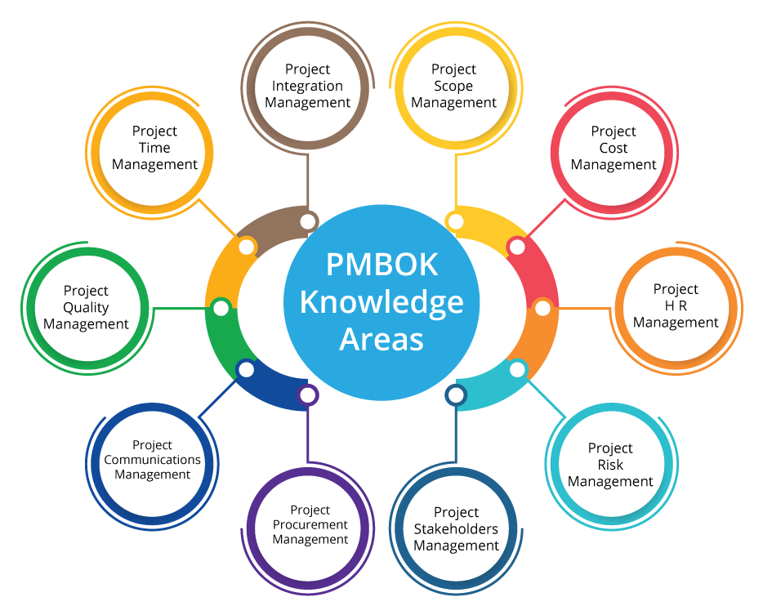
Figure 4: The 10 core elements of PMBOK
Integration
This included creating an extensive project management strategy that combined Agile, Lean, BIM, and IPD approaches for the Google headquarters project. The project team made sure that the work was in line with Google's goals and vision by closely monitoring and controlling it (Hartney, 2019).
Scope
By using scope management, the project was guaranteed to contain all the work required to properly finish the headquarters. The project team provided a precise definition of the scope, outlining the specifications for the creative design, eco-friendly elements, and staff facilities. Regular reviews and modifications helped to prevent scope creep and keep the project on schedule by maintaining scope control (Hartney, 2019).

Time
For the Google headquarters project to reach its lofty timetables and milestones, time management was essential. The project team created a thorough timetable by outlining, prioritising, and calculating the durations of each task. Agile principles ensured that the project could adjust to changes without major delays by allowing for incremental development and flexibility (Hartney, 2019).
Quality
Quality Control made that the project met Google's exacting requirements. According to Hartney, (2019) to maintain the required level of quality, the project team put quality planning, assurance, and control procedures into place. To make sure that every component of the construction satisfied the required quality standards, routine inspections and evaluations were carried out (Project Management Institute, 2018).
Cost
To make sure the project remained financially feasible, cost management required meticulous planning, estimating, budgeting, and cost control. The project team-controlled costs and allocated resources optimally by using cost management approaches. In order to make sure the project stayed within the approved budget, Gardiner & Theobald was instrumental in managing the financial planning and budget (Project Management Institute, 2018).
Human Resources
Coordination of the broad group of architects, engineers, contractors, and other project stakeholders required human resource management. The project team found the required talent, created a human resource plan, and successfully led the team. IPD promoted cooperation and teamwork, ensuring that all stakeholders collaborated effectively (Hartney, 2019).

Communication
Effective collaboration was made possible via communication management, which also informed all parties involved. To guarantee that project information is created, distributed, and stored in a timely and suitable manner, the project team created a communication plan. To keep everyone informed about the project's progress and to ensure openness, regular meetings, reports, and updates were used (Project Manager, 2014).
Risk
Across the project's lifecycle, risk management entailed locating, evaluating, and responding to possible hazards. The project team put thorough risk management techniques into practice, such as ongoing risk analyses and backup plans. This proactive strategy ensured a seamless project execution by addressing problems before they could affect the project's development (Landau, 2023).
Procurement
Purchasing premium supplies and labour for the project required the use of procurement management. In addition to conducting solicitations and source selection, the project team prepared a procurement plan. All purchased items and services were guaranteed to meet the project's criteria and requirements thanks to efficient contract administration (Landau, 2023).
Stakeholder
In accordance with Landau, (2023) stakeholder management made sure that everyone's requirements and expectations were satisfied. The project team determined who the key players were, examined their expectations, and devised plans for productive communication. Maintaining the support and alignment of stakeholders with the project's objectives was facilitated by consistent communication and interaction.

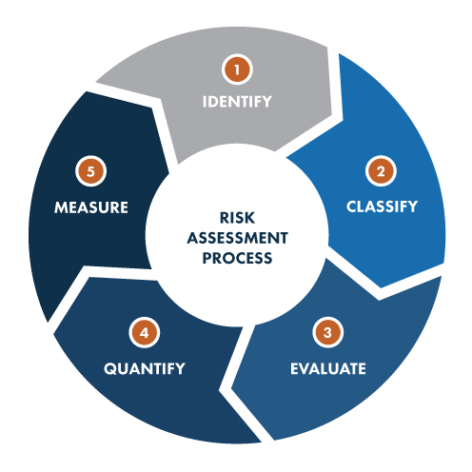
Risk Assessment
Figure 5: Risk Assessment Process

Construction Risks
Unexpected construction difficulties or design errors may cause serious delays and raise expenses. The project team used Building Information Modelling (BIM) to find and fix design flaws early on in order to reduce this risk. BIM made it possible to visualise and coordinate in great detail, so that any issues could be resolved before work started. In-depth planning and frequent progress reports were also carried out to guarantee the project's timely completion (Siraj and Fayek, 2019).

Quality Control Issues
According to Siraj and Fayek (2019) the building's integrity and functionality may be endangered by variable standards for the materials or production, which made quality control issues a serious danger. The project team implemented routine inspections and tight quality control methods in order to prevent this. High standards were upheld throughout the building process by working with seasoned suppliers and contractors with a record of success.
Operational Risks
Operational risks included the potential for delays to operations and cost increases due to difficulties integrating advanced technological systems. Google's project team tested all technological systems extensively and ensured their quality in order to address this. To further reduce this risk, specialised knowledge in technology integration was enlisted, and solid support and maintenance plans were made sure of (Sullivan, 2024).

Environmental Risks
Another major risk was failing to meet sustainability targets, which might have an impact on Google's standing and effectiveness of operations. In order to lessen this, the project included environmentally friendly design elements like solar energy, rainwater collection systems, and large green areas. Consistent tracking and reporting of sustainability measures guaranteed that the project remained on course to fulfil its environmental goals. In order to reduce this risk, detailed environmental impact analyses were carried out, and sustainable building techniques were used. In order to address issues and guarantee adherence to environmental standards, the project team interacted with local communities and regulatory organisations (Siraj and Fayek, 2019).

Financial Risks
Large-scale building projects always include a financial risk, and budget overruns are a regular worry. Unexpected costs or inadequate cost control could cause the Google headquarters project to go over budget. Experts in cost management, including Gardiner & Theobald, were brought in to manage the project's finances and make sure it didn't go over the allocated spending limit. The project team took steps to address this by securing sufficient funds and keeping a safety net to handle unforeseen costs. Plan modifications were possible in a timely manner because to routine evaluations of the project's financial situation (Sullivan, 2024).

Potential Risks Solutions
Technological
All technical systems should undergo extensive testing and quality assurance procedures in order to reduce this risk. It's crucial to work with professionals in technology integration and to make sure that support and maintenance schedules are solid. By introducing new technology gradually, problems can be found and fixed early on, causing the least amount of disruption (Sullivan, 2024).
Environmental
It is essential to carry out thorough environmental impact evaluations and use sustainable building techniques. The environmental impact of a design can be decreased by integrating green spaces and using renewable energy sources, such solar panels. It is also critical to interact with local authorities and communities to resolve issues and guarantee adherence to environmental laws (Eastwood, 2023).
Financial
It is essential to implement strict cost management procedures, such as comprehensive budgeting, frequent financial assessments, and emergency planning. Financial gaps can be avoided by obtaining sufficient funds and keeping a reserve to cover unforeseen costs. Effective financial control is ensured by involving cost management specialists in the project's financial oversight (Magarey, 2017).
Health and Safety
It is vital to implement detailed health and safety procedures, carry out frequent safety training, and make sure the workplace is safe. Safety measures can be improved even further by utilising modern technology, such as wearables that monitor worker health and safety in real-time. (Eastwood, 2023).

Learning from Actual Cases

Microsoft’s Headquarters at Redmond, Washington
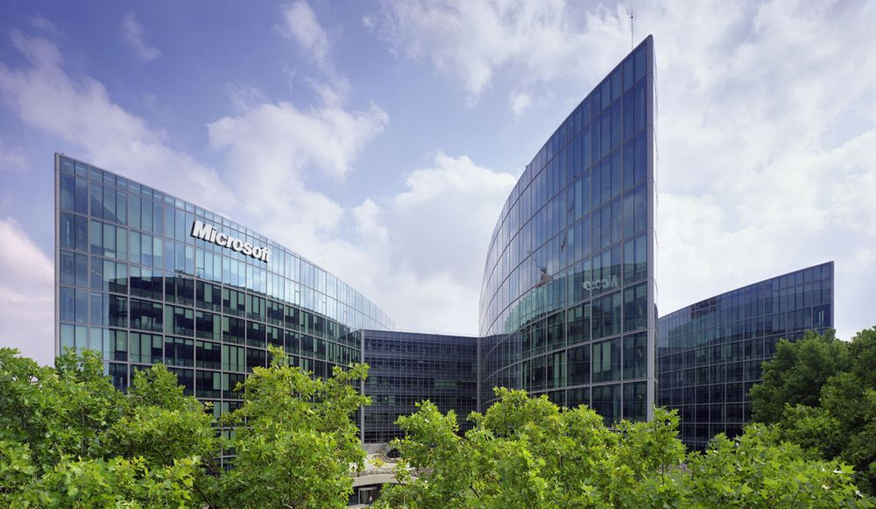
Figure 6: Microsoft's Headquarters in Redmond, Washington
Due to a lack of collaboration spaces, the original headquarters design had problems with space utilisation and employee satisfaction. This emphasised how crucial it is to create work environments that encourage flexibility and teamwork. Microsoft discovered how to build workspaces with the requirements of their employees first. Open areas, lots of natural light, and other amenities are part of the most recent campus renovations, which aim to improve worker productivity and well-being.
Microsoft has built a campus that promotes creativity, teamwork, and worker well-being by fixing early design problems and placing a high priority on sustainability. Other businesses facing comparable large-scale headquarters projects can benefit from the lessons learnt from this initiative (Schroer, 2018).

Amazon’s Headquarters (Seattle, Washington)

Figure 7: Amazon's Headquarters in Seattle, Washington
The fast growth of Amazon in Seattle resulted in heightened traffic jams and an impact on the surrounding infrastructure. The city's public services and transport networks are under pressure due to the influx of workers and construction projects. The surrounding areas experienced increased housing costs as a result of Amazon's headquarters' explosive expansion. Community opposition and worries about long-term inhabitants being displaced resulted from this. In response Amazon invested in local infrastructure upgrades and worked with city planners. In order to reduce traffic congestion, this involved building a new highway junction and creating mobility options such providing free public transportation for staff members and paying for bike sales and maintenance. The company also communicated with the community and made investments in community development and affordable housing programs. Furthermore, Amazon showed its dedication to being a responsible corporate citizen by partnering with and supporting regional companies and charities via a number of initiatives and partnerships (Amazon Staff, 2024) (Brownell, 2018).

Conclusion
A forward-thinking standard for upcoming advancements is set by the building of Google's new London headquarters, "Platform G." Through the integration of innovative project management methodologies, including Agile, Lean, BIM, and IPD, the project showcases modern techniques that guarantee adaptability, effectiveness, and durability. The project team, which consisted of many companies such as Google, Heatherwick Studio, Bjarke Ingels Group, BDP, and Lendlease, was diversified and showed the value of careful planning and quality control. Companies such as Amazon and Microsoft have demonstrated the value of innovation, proactive risk management, and stakeholder management during their prior projects. This initiative sets the stage for upcoming innovations by demonstrating how adopting advanced methods and constant improvement may result in excellence and establish new benchmarks for the sector.

References
- Amazon Staff (2024). How to tour Seattle offices at Amazon’s headquarters. [online] www.aboutamazon.com. Available at: https://www.aboutamazon.com/news/amazon-offices/amazon-headquarters-tour-seattle.
- Arieff, A. (2020). What Google’s new London building says about Big Tech’s plan for cities. [online] New Statesman. Available at: https://www.newstatesman.com/business/2020/12/what-googles-new-london-building-says-about-big-techs-plan-for-cities .
- Bosetti, N. and Brown, J. (2019). Head Office: London’s rise and future as a corporate centre. [online] Centre for London. Available at: https://centreforlondon.org/reader/head-office / [Accessed 3 Aug. 2024].
- Brownell, B. (2018). Amazon’s Seattle Spheres and the Evolution of the Architectural Biosphere. [online] Architectmagazine.com. Available at: https://www.architectmagazine.com/practice/amazons-seattle-spheres-and-the-evolution-of-the-architectural-biosphere_o.
- Chathuranga, S., Jayasinghe, S., Antucheviciene, J., Wickramarachchi, R., Udayanga, N. and Weerakkody, W. a. S. (2023). Practices Driving the Adoption of Agile Project Management Methodologies in the Design Stage of Building Construction Projects. Buildings, [online] 13(4), p.1079. doi:https://doi.org/10.3390/buildings13041079.
- Eastwood, A. (2023). 6 Steps For Planning a Successful Headquarters Project. [online] dbsi. Available at: https://blog.dbsi.com/branch-transformation-blog/6-steps-for-planning-a-successful-headquarter-project [Accessed 3 Aug. 2024].
- Hartney, J. (2019). The 10 PMBOK Knowledge Areas. [online] Projectengineer.net. Available at: https://www.projectengineer.net/the-10-pmbok-knowledge-areas/.
- Karasu, T., Aaltonen, K. and Haapasalo, H. (2022). The interplay of IPD and BIM: a systematic literature review. [online] Emerald. Available at: https://www.emerald.com/insight/content/doi/10.1108/CI-07-2021-0134/full/html.
- Landau, P. (2023). The 10 Project Management Knowledge Areas. [online] ProjectManager. Available at: https://www.projectmanager.com/blog/10-project-management-knowledge-areas.
- Magarey, A. (2017). 7 Lessons to Learn from a Failed Project. [online] Project-Management.com. Available at: https://project-management.com/7-lessons-to-learn-from-a-failed-project/.
- Parsons, J. (2022). Google is opening new HQ in London that will span 11 floors and 1,000,000 sq ft. [online] Metro. Available at: https://metro.co.uk/2022/04/19/googles-massive-kings-cross-hq-will-span-11-floors-and-1000000-sq-ft-16494552/
- Pearson, A. (2023). Arriving on Platform G: Google’s new King’s Cross office. [online] CIBSE Journal. Available at: https://www.cibsejournal.com/case-studies/arriving-on-platform-g-googles-new-kings-cross-office/.
- Project Management Institute (2018). Guide to the Project Management Body of Knowledge (PMBOK® Guide)–Sixth Edition (SIMPLIFIED CHINESE). [online] Google Books. Project Management Institute. Available at: https://books.google.co.uk/books/about/Guide_to_the_Project_Management_Body_of.html?id=f0ZNDwAAQBAJ&redir_esc=y [Accessed 3 Aug. 2024].

- ProjectManager (2014). - What Is Risk Management in Projects? [online] YouTube. Available at: https://www.youtube.com/watch?v=x7A9idByPA4&t=229s [Accessed 3 Aug. 2024].
- Schroer, A. (2018). A Guide To The Microsoft Redmond Campus | Built In Seattle. [online] Built In. Available at: https://www.builtinseattle.com/articles/microsoft-redmond-campus-headquarters.
- Siraj, N.B. and Fayek, A.R. (2019). Risk Identification and Common Risks in Construction: Literature Review and Content Analysis. Journal of Construction Engineering and Management, [online] 145(9), p.03119004. doi:https://doi.org/10.1061/(asce)co.1943-7862.0001685.
- Sullivan, N. (2024). Guide to Managing Construction Risks Effectively. [online] CHAS. Available at: https://www.chas.co.uk/blog/managing-construction-risks/.

